Supplementary material for

Distinctive mechanisms of soil priming in different stages and its response to nitrogen addition along a temperate forest elevation gradient
Qiuxiang Tian¹, Rudong Zhao¹, Qiaoling Lin^{1, 2}, Xiaoxiang Zhao^{1, 2}, Yu Wu³, Feng Liu¹*

¹Laboratory of Plant Diversity and Specialty Crops, Wuhan Botanical Garden, Chinese Academy of Sciences, Wuhan 430074, China
²University of Chinese Academy of Sciences, Beijing 100049, China
³Hubei International Scientific and Technological Center of Ecological Conservation and Management in the Three Gorges Area, Engineering Research Center of Eco-Environment in Three Gorges Reservoir Region, China Three Gorges University, Yichang 443002, China

*Corresponding author. Wuhan Botanical Garden, Chinese Academy of Sciences, Wuhan 430074, China.
Email: liufeng@wbgcas.cn (Feng Liu). ORCID: 0000-0003-3383-7598.

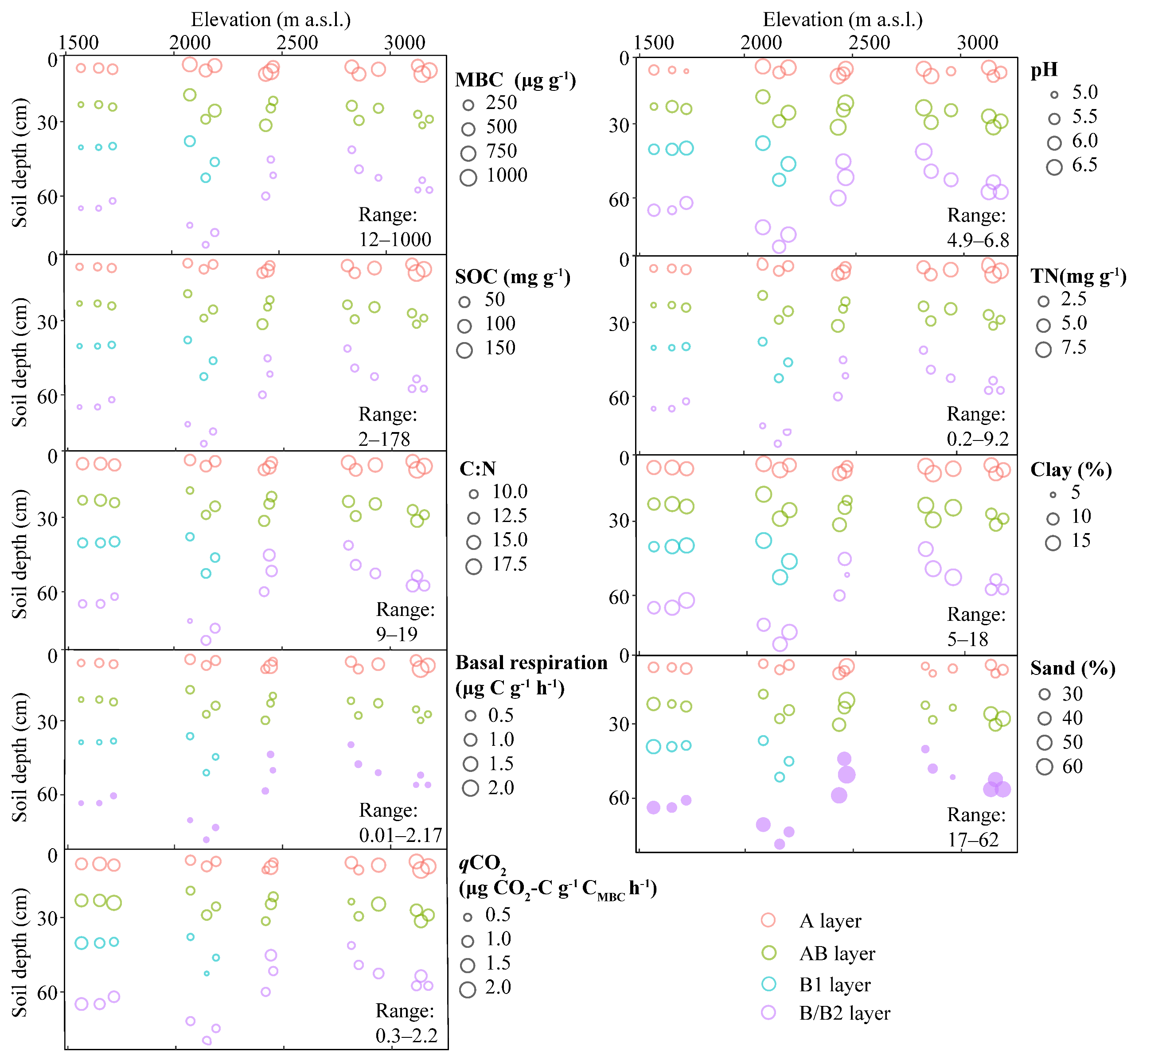
Fig. S1 Bubble plots of soil basal physico-chemical properties for the profiled soil samples along the northern slope of Taibai Mountain. MBC, microbial biomass carbon; qCO₂, soil metabolic quotient; DOC, dissolved organic carbon; DN, dissolved nitrogen; DOC:DN, the ratio of dissolved organic carbon and nitrogen. For soil pits from 1571–2300 m, four layers of soils were collected according to their genetic horizons (mineral A, AB, B1, and B2). For soil pits from 2300–3175 m, three layers of soil were collected according to their genetic horizons (mineral A, AB, and B).

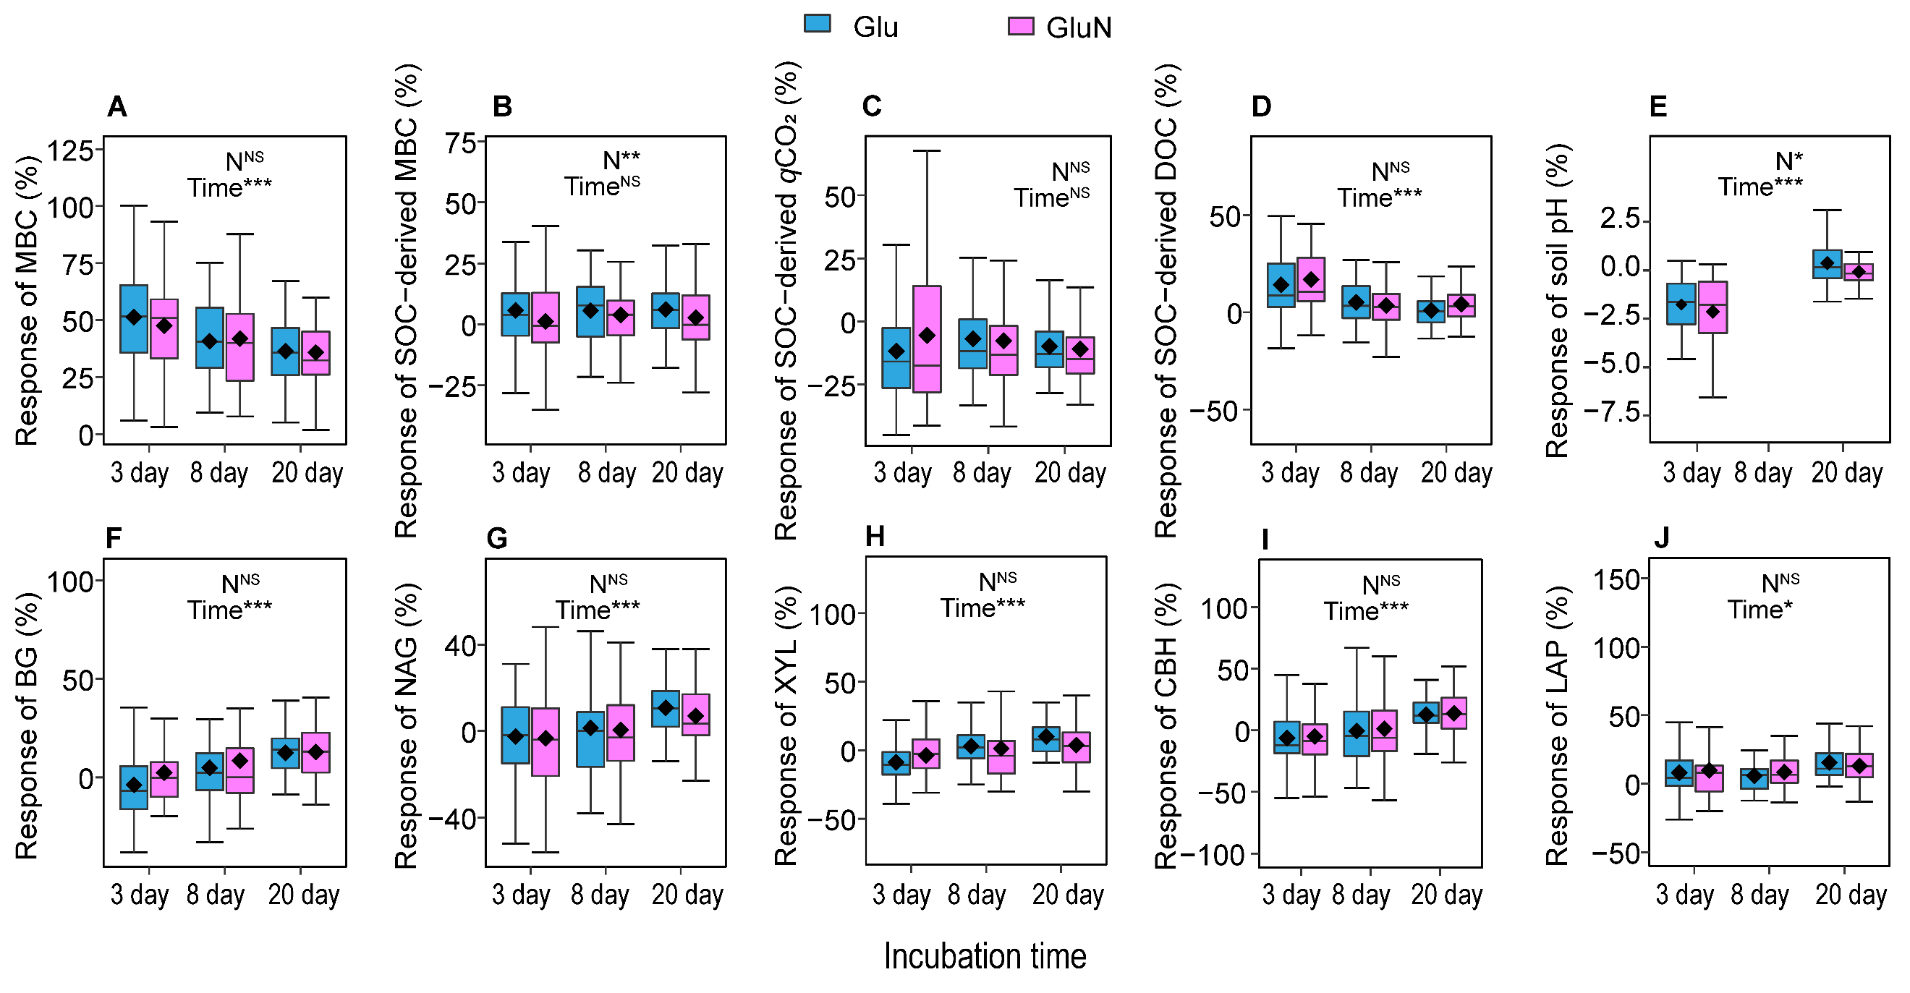
Fig. S2 The responses of soil microbial properties, carbon sources, soil pH, and extracellular enzyme activities after 3 days, 8 days and 20 days incubation (n=51). Soil pH data after 8 days incubation was unavailable due to insufficient retained samples. Glu: glucose addition, GluN: glucose plus nitrogen addition. MBC: soil microbial biomass carbon, DOC: dissolved organic carbon, BG: β-1,4-glucosidase, NAG: β-1,4-N-acetylglucosaminidas, XYL: xylosidase, CBH: cellobiohydrolase, LAP: leucine aminopeptidase. The response of each parameter was the percentage change in treatments with glucose addition compared with no glucose addition, but the same amount of mineral nitrogen. *, **, *** indicated significant effects according to linear mixed-effects models at the p < 0.05, p < 0.01, p < 0.001 level, respectively. NS indicated no significant effect. Interaction effect was not displayed if p > 0.05.

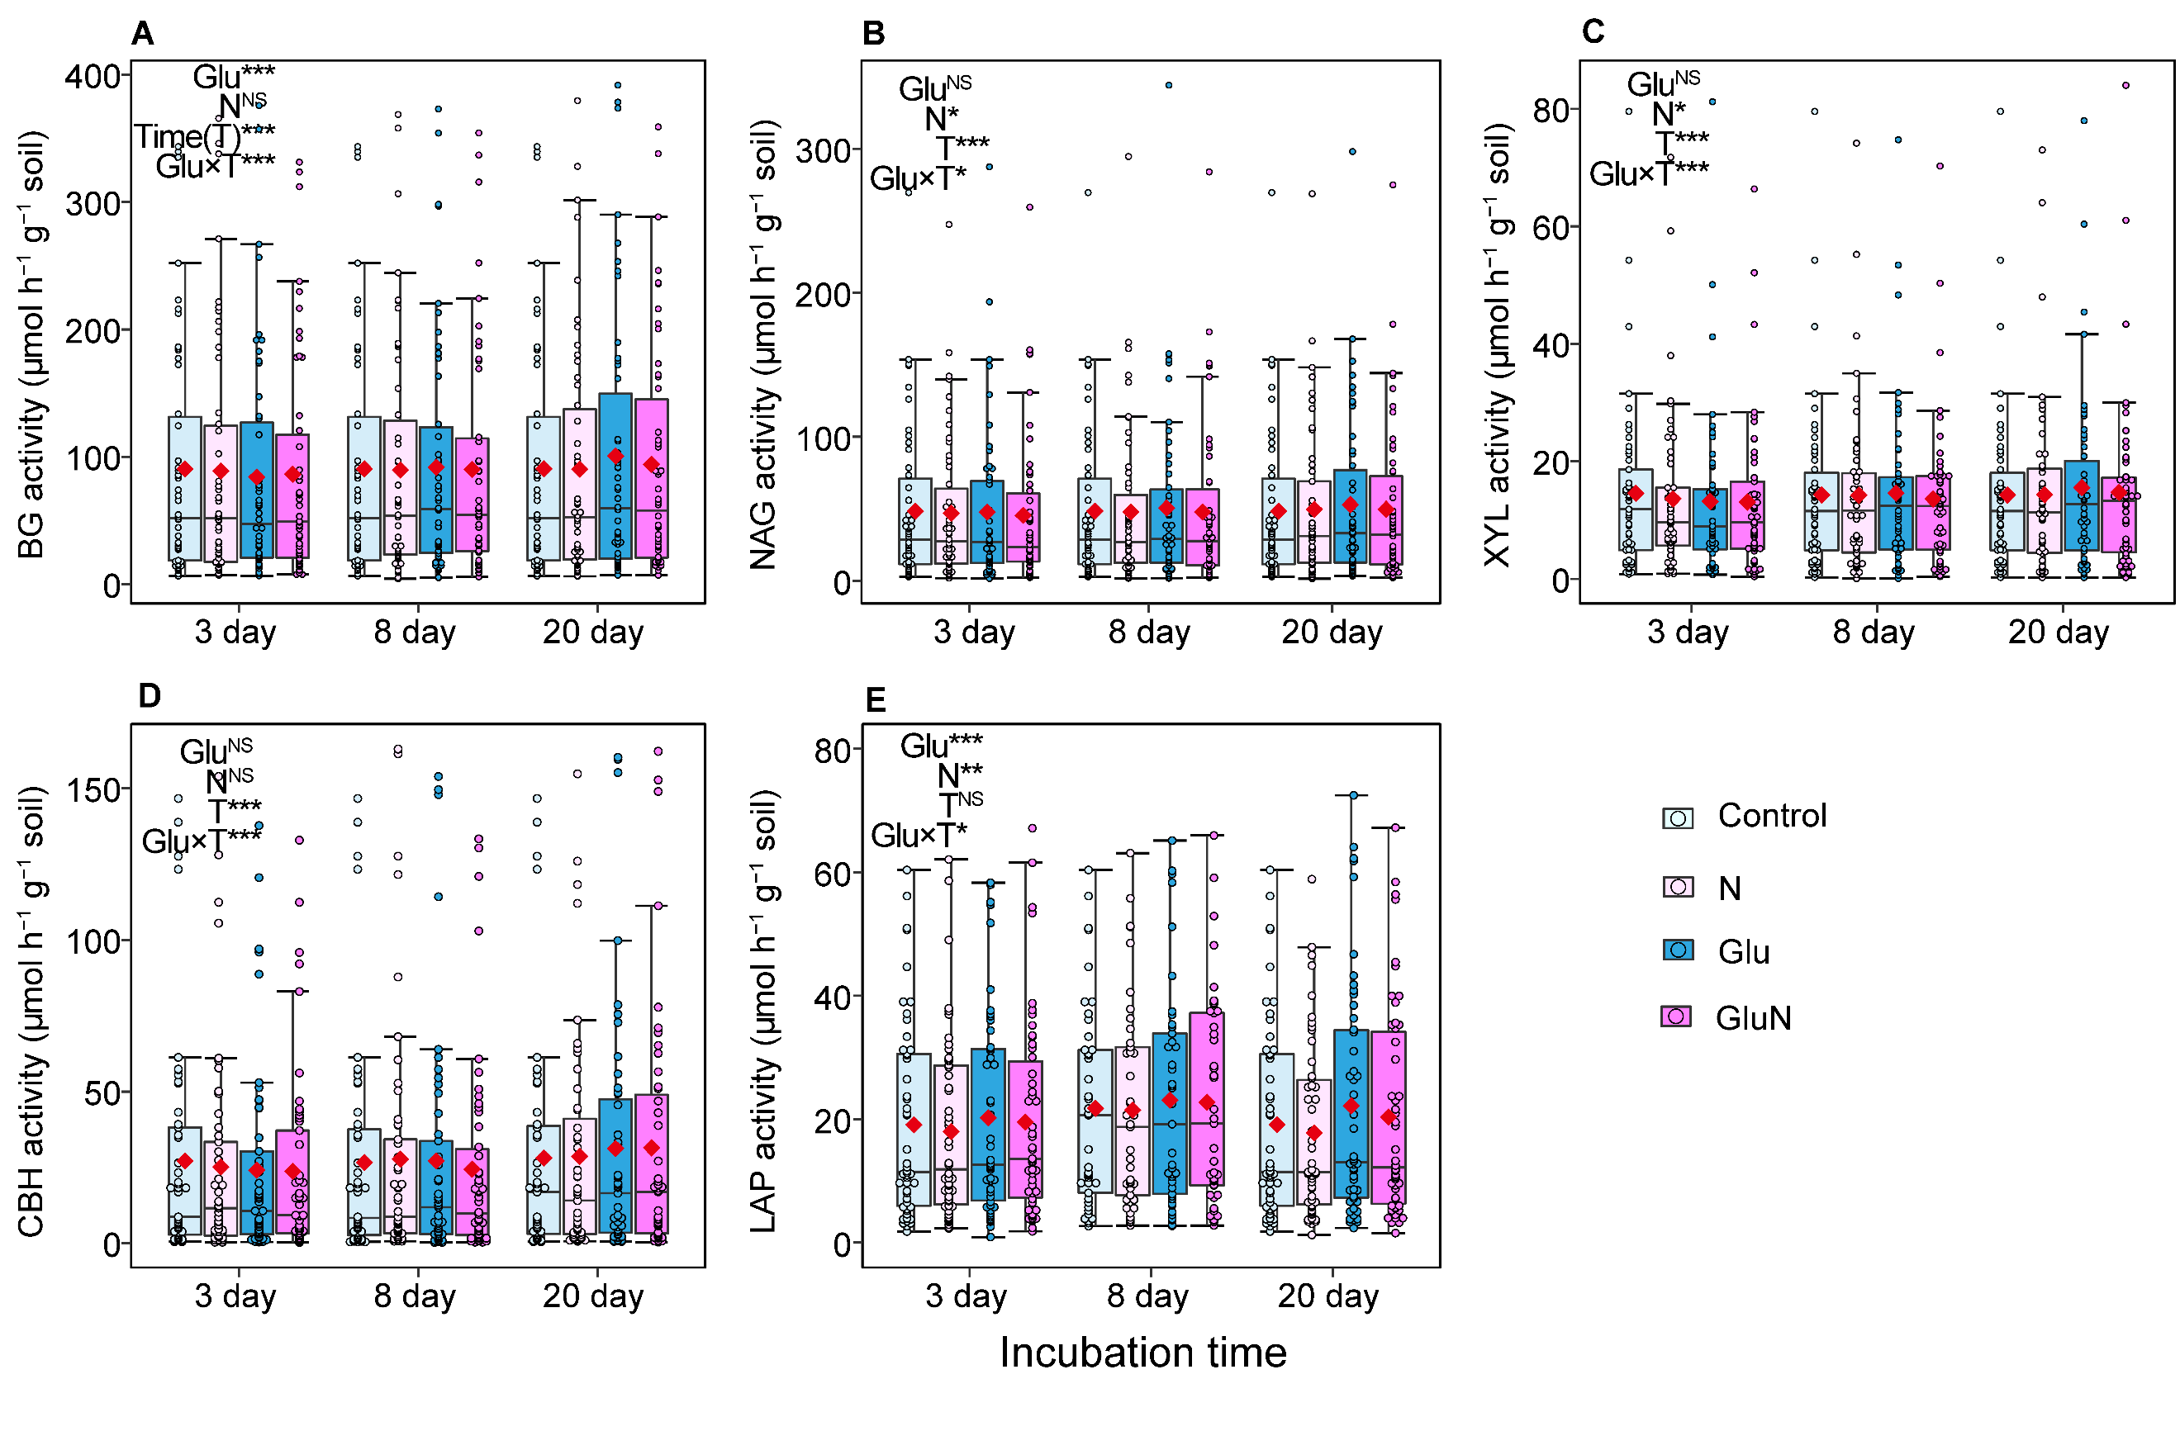
Fig. S3 Activities of extracellular enzymes β-1,4-glucosidase (BG, A), β-1,4-N-acetylglucosaminidase (NAG, B), xylosidase (XYL, C), cellobiohydrolase (CBH, D), and leucine aminopeptidase (LAP, E) after 3 days, 8 days and 20 days incubation (n=51). Control: no addition, N: nitrogen addition, Glu: glucose addition, GluN: glucose plus nitrogen addition. The symbol “♦” in the box–whisker plot represents the mean value. *, **, *** indicated significant effects according to linear mixed-effects models at the p < 0.05, p < 0.01, p < 0.001 level, respectively. NS indicated no significant effect. Interaction effect was not displayed if p > 0.05.

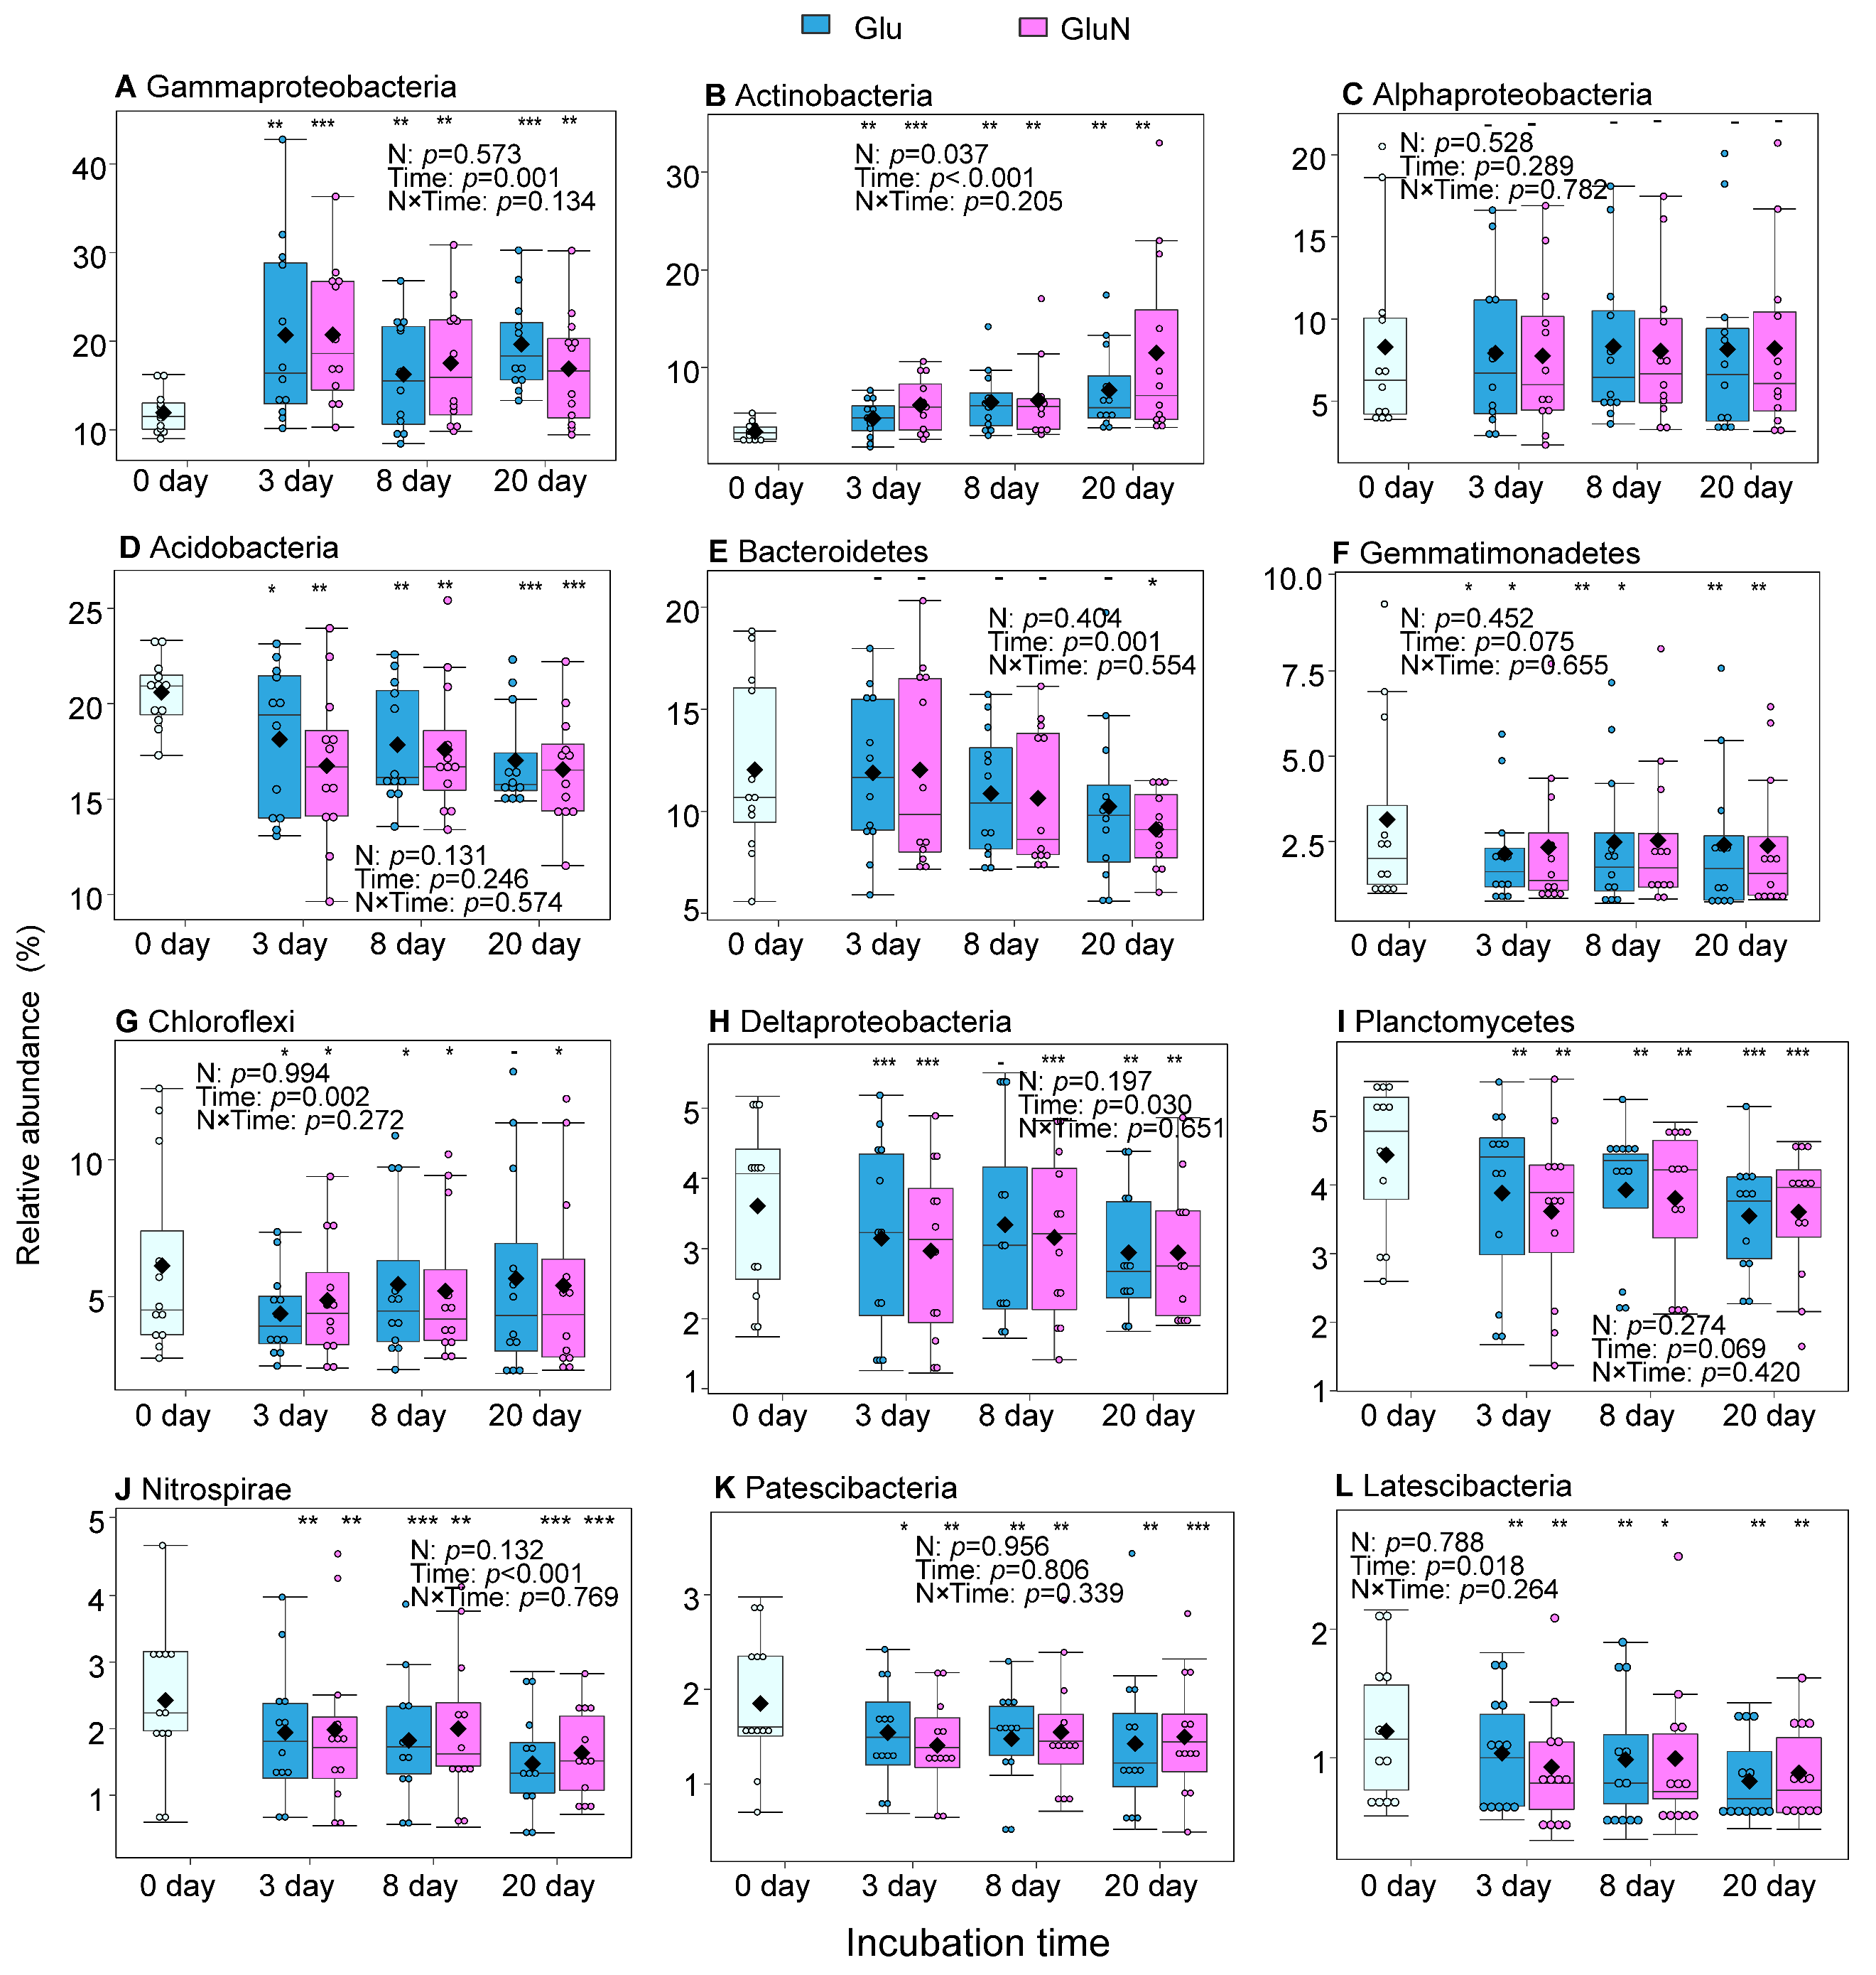
Fig. S4 Relative abundances of the dominant bacterial taxa after glucose addition (n=12). Glu: glucose addition, GluN: glucose plus nitrogen addition. We only detected soil microbial communities for soils from Quercus liaotungensis forest and Larix chinensis forest. The symbol “♦” in the box–whisker plot represented the mean value. *, **, *** indicated significant differences with the value in control (0 day) at the p < 0.05, p < 0.01, p < 0.001 level, respectively. – indicated no significant differences with the value in control (0 day). p value was from two-way linear mixed-effects models with nitrogen addition (N) and incubation time (Time) as fixed effects and soil as a random effect.

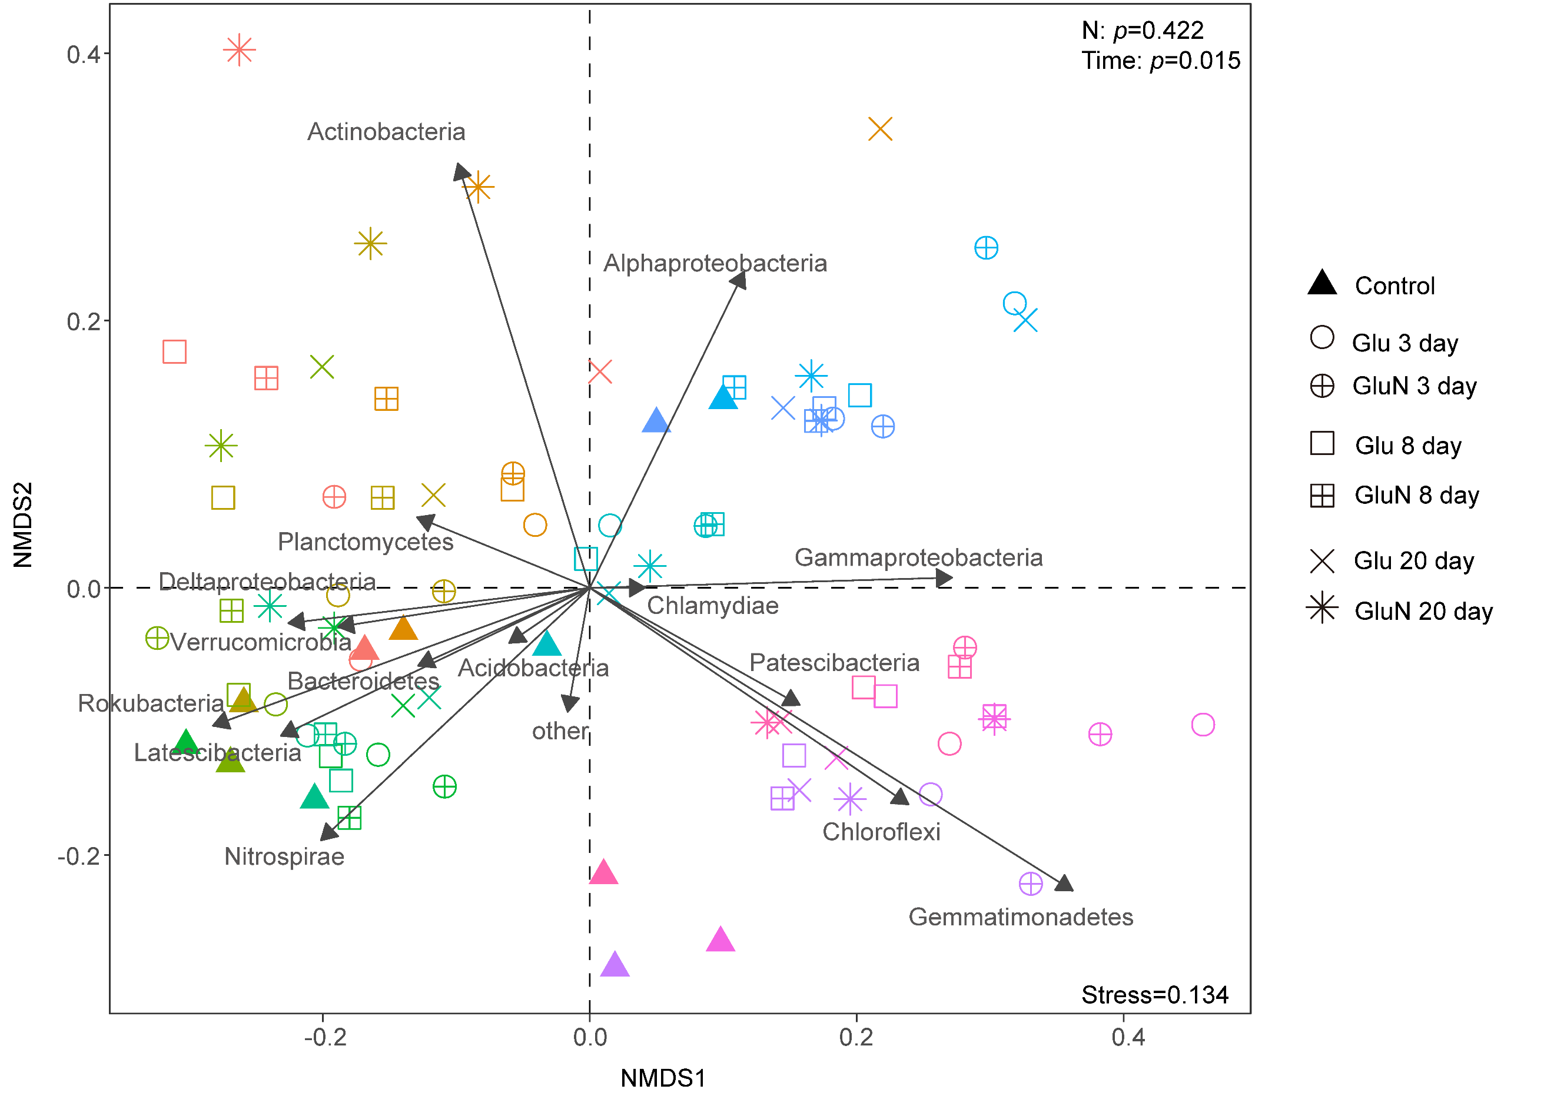
Fig. S5 Non-metric multidimensional scaling (NMDS) ordinations of soil bacterial community composition based on Bray-Curtis distances. Different colors mean different soil samples (12 soil samples from Quercus liaotungensis forest and Larix chinensis forest). Glu: glucose addition, GluN: glucose plus nitrogen addition.

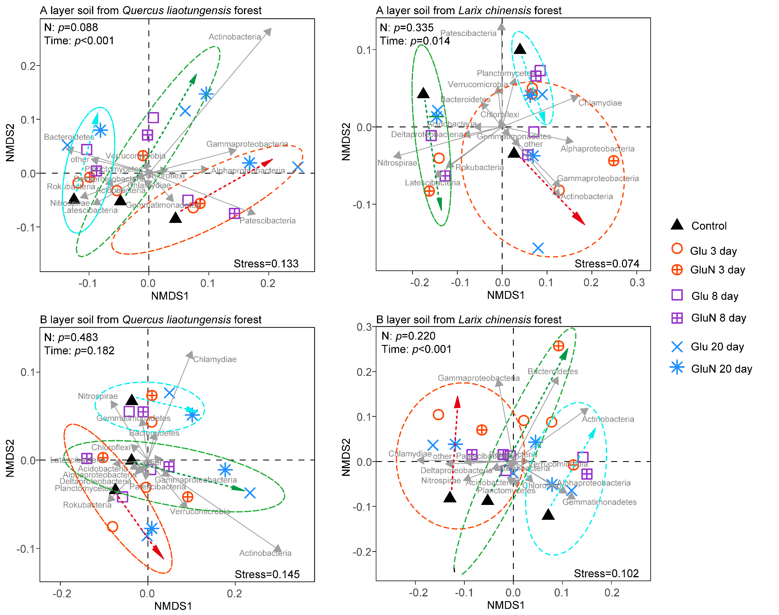
Fig. S6 Non-metric multidimensional scaling (NMDS) ordinations of soil bacterial community composition based on Bray-Curtis distances. Each graph showed the result for soils from the same forest and the same soil layer. Ellipses show 95% confidence limits for delimitation of each group. The arrow line indicates the change trend over the 30-day incubation for each sampling soil. Glu: glucose addition, GluN: glucose plus nitrogen addition.
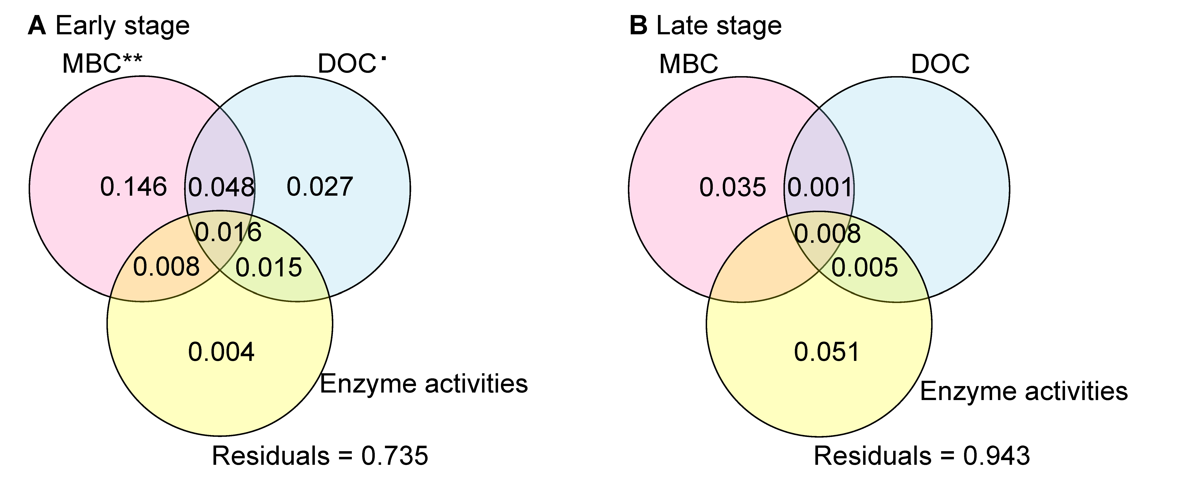
Fig. S7 Variation partitioning results of priming effect against the responses of MBC, microbial physiology, DOC content and extracellular enzyme activities after glucose addition int the earlier (A) and later (B) incubation stages in GluN treatment (n=51). Values<0 were not shown. Significant values (p < 0.05) after 999 permutations are indicated with asterisk. Residuals meant the unexplained variation. MBC: soil microbial biomass carbon, DOC: dissolved organic carbon.

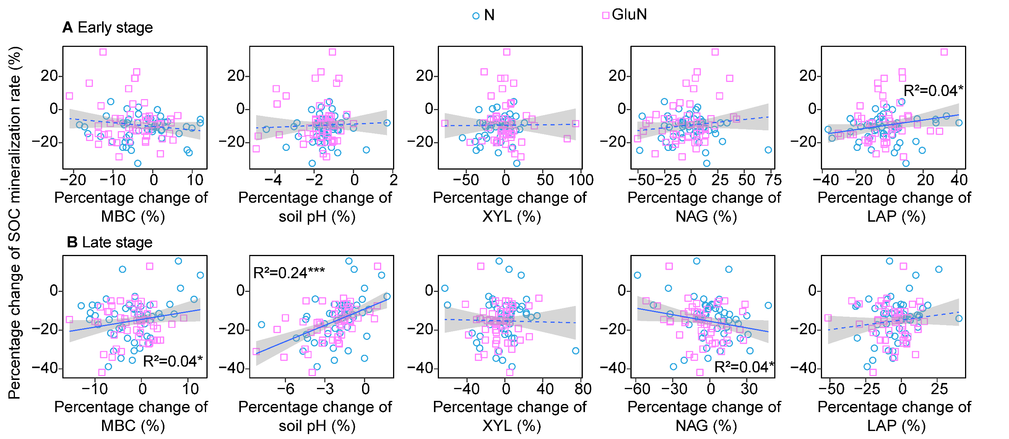
Fig. S8 The relationships of percentage change of SOC mineralization rate after nitrogen addition with the percentage change of MBC content, soil pH and extracellular enzyme activities in the early (A) and late (B) incubation stages (n=51). Each parameter in nitrogen without or with glucose addition were compared with the corresponding unamended control or sole glucose addition treatment to calculate its percentage change. Data in the early and late stage were from soil samples after 3 days and 20 days incubation, respectively. Significant relationships are shown as *p < 0.05, **p < 0.01, ***p < 0.001. Dashed line indicates no significant relationship at p > 0.5.

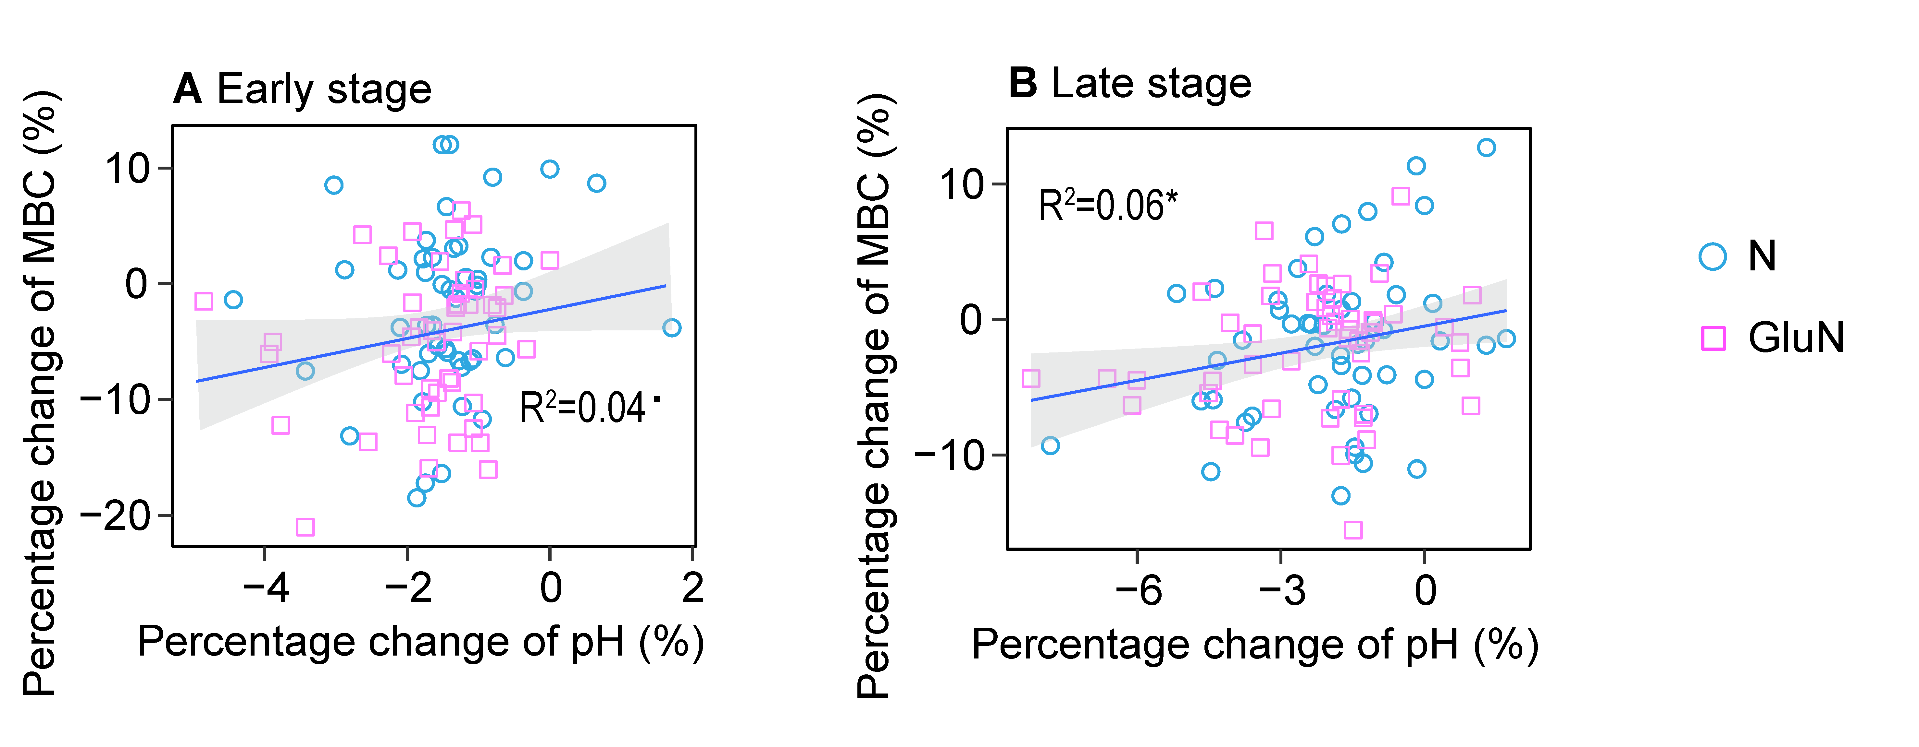
Fig. S9 The relationships of percentage change of soil pH after nitrogen addition with the percentage change of MBC in the early (A) and late (B) incubation stages (n=51). Each parameter in nitrogen without or with glucose addition were compared with the corresponding unamended control or sole glucose addition treatment to calculate its percentage change. Data in the early and late stage were from soil samples after 3 days and 20 days incubation, respectively. Significant relationships are shown as ·p < 0.1, * p < 0.05.

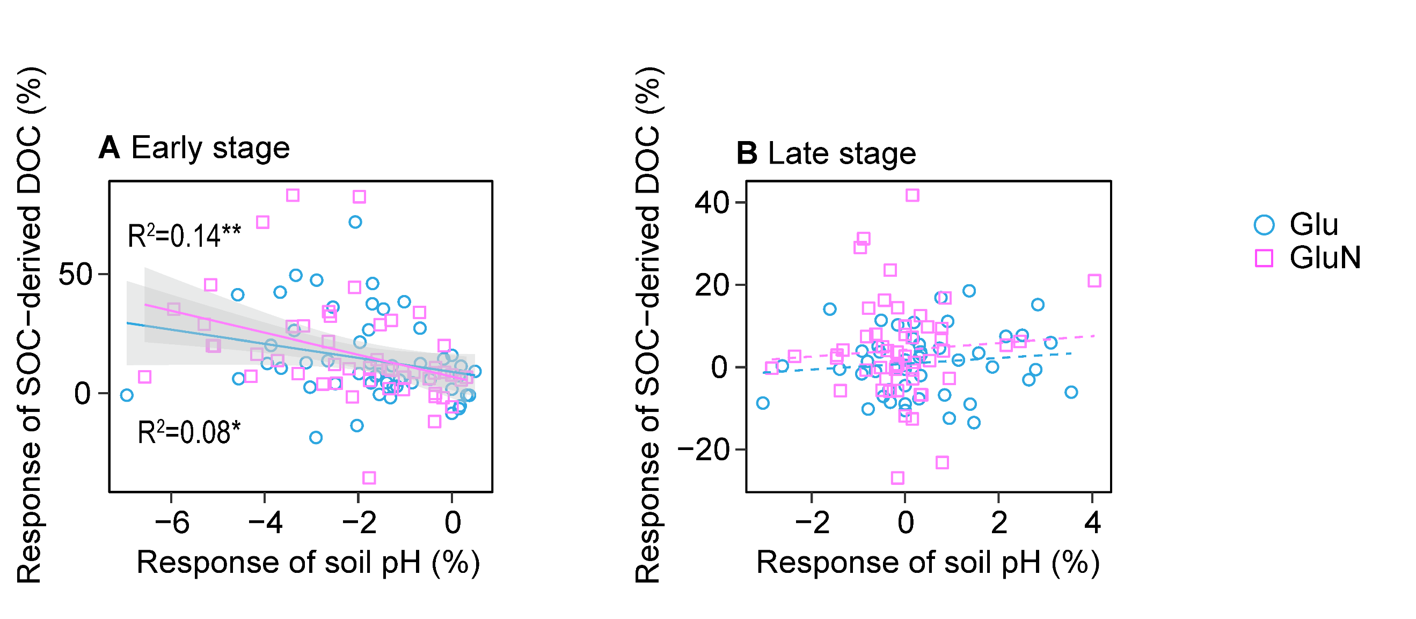
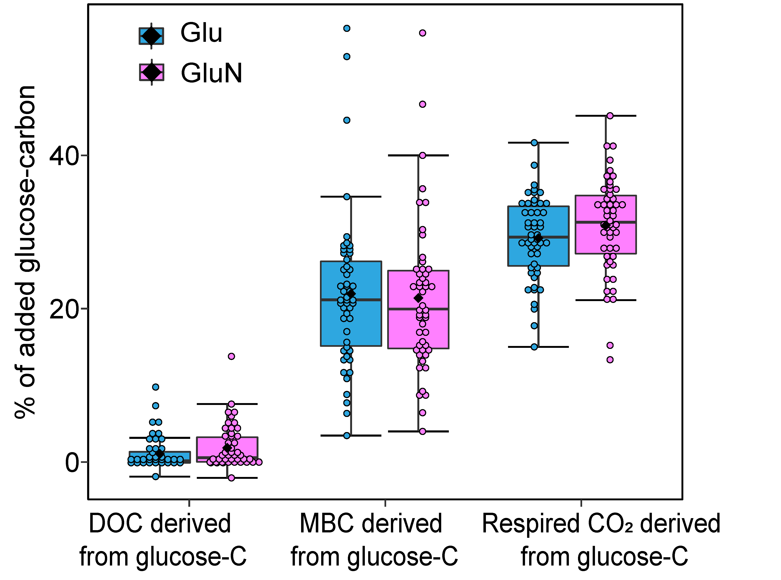
Fig. S10 The relationships between the responses of soil pH and SOC-derived DOC after glucose addition in the early (A) and late (B) incubation stages (n=51). The response of each parameter was the percentage change in glucose without or with nitrogen addition compared with the corresponding unamended control or sole nitrogen addition treatment. Data in the early and late stage were from soil samples after 3 days and 20 days incubation, respectively. Significant relationships are shown as *p <0.05, **p < 0.01, ***p < 0.001. Dashed line indicates no significant relationship at p > 0.5.
Fig. S11 The fate of glucose-carbon after 3 days incubation. DOC derived from glucose-C meant glucose-carbon existed as dissolved carbon, MBC derived from glucose-C meant glucose-carbon incorporated in MBC, and Respired CO₂ derived from glucose-C meant glucose-carbon released as CO₂.

Table S1 The properties of the sampling sites along the northern slope of Mt. Taibai, Qinling Mountains
Sampling sites | Elevation  (m a.s.l.) | MAT (°C) | MAP  (mm) | Forest type | Basal area of trees  (cm² m⁻²) | Tree density  (Trees ha⁻¹) | Shannon index of trees | Soil type
Qa-1 | 1571 | 9.4 | 845 | Qa | 34.49 | 1150 | 1.134 | Luvisols
Qa-2 | 1655 | 9.0 | 855 | Qa | 33.97 | 1240 | 0.869 | Luvisols
Qa-3 | 1721 | 8.7 | 862 | Qa | 43.73 | 1620 | 0.394 | Luvisols
Ql-1 | 2075 | 6.9 | 888 | Ql | 28.83 | 1200 | 0.973 | Luvisols
Ql-2 | 2150 | 6.5 | 890 | Ql | 34.87 | 1730 | 0.980 | Luvisols
Ql-3 | 2193 | 6.3 | 891 | Ql | 36.52 | 2010 | 1.513 | Luvisols
Ba-1 | 2423 | 5.2 | 891 | Ba | 18.34 | 390 | 1.317 | Luvisols
Ba-2 | 2447 | 5.1 | 890 | Ba | 11.43 | 360 | 1.409 | Luvisols
Ba-3 | 2458 | 5.0 | 890 | Ba | 10.56 | 920 | 1.190 | Luvisols
Af-1 | 2819 | 3.2 | 868 | Af | 24.51 | 2640 | 1.260 | Cambisols
Af-2 | 2853 | 3.1 | 865 | Af | 17.92 | 1180 | 0.733 | Cambisols
Af-3 | 2945 | 2.6 | 855 | Af | 29.50 | 1940 | 1.170 | Cambisols
Lc-1 | 3120 | 1.7 | 832 | Lc | 25.96 | 1180 | - | Cambisols
Lc-2 | 3141 | 1.6 | 829 | Lc | 13.65 | 820 | - | Cambisols
Lc-3 | 3175 | 1.5 | 824 | Lc | 20.49 | 560 | - | Cambisols
Qa, Quercus aliena var. acuteserrata forest; Ql, Quercus liaotungensis forest; Ba, Betula albo-sinensis forest; Af, Abies fargesii forest; Lc, Larix chinensis forest.

Table S2 The depth for profiled soil samples taken from the five forest types along the northern slope of Taibai Mountain
Layer | Depth range  (cm)
Layer | Qa-1 | Qa-2 | Qa-3 | Ql-1 | Ql-2 | Ql-3
A | 0-15 | 0-15 | 0-16 | 0-12 | 0-17 | 0-13
AB | 15-30 | 15-30 | 16-31 | 12-25 | 17-40 | 13-37
B1 | 30-50 | 30-50 | 31-48 | 25-50 | 40-65 | 37-55
B2 | 50-80 | 50-80 | 48-76 | 50-94 | 65-95 | 55-95
 | Ba-1 | Ba-2 | Ba-3 | Af-1 | Af-2 | Af-3 | Lc-1 | Lc-2 | Lc-3
A | 0-20 | 0-15 | 0-14 | 0-14 | 0-18 | 0-10 | 0-13 | 0-20 | 0-17
AB | 20-45 | 15-26 | 14-28 | 14-32 | 18-36 | 10-32 | 13-33 | 20-40 | 17-40
B | 45-78 | 26-45 | 28-70 | 32-50 | 36-56 | 32-73 | 33-75 | 40-65 | 40-75
Qa, Quercus aliena var. acuteserrata forest; Ql, Quercus liaotungensis forest; Ba, Betula albo-sinensis forest; Af, Abies fargesii forest; Lc, Larix chinensis forest.

