Moss-dominated crusts death increases soil phosphorus availability in a temperate desert, Northwest China

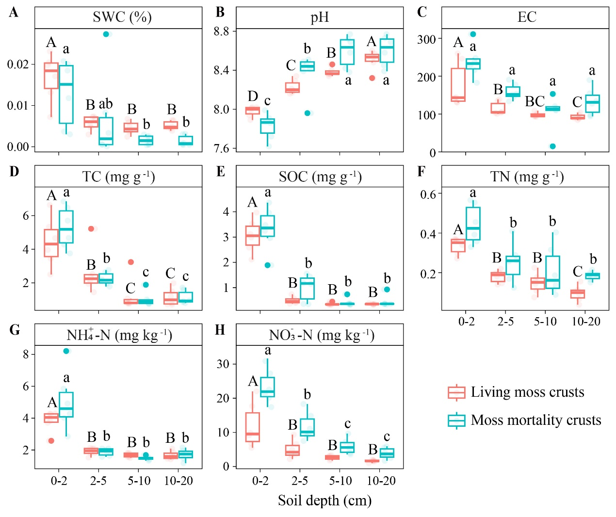
Fig.S1 Characteristics of soil physicochemical properties under different states of moss crusts.
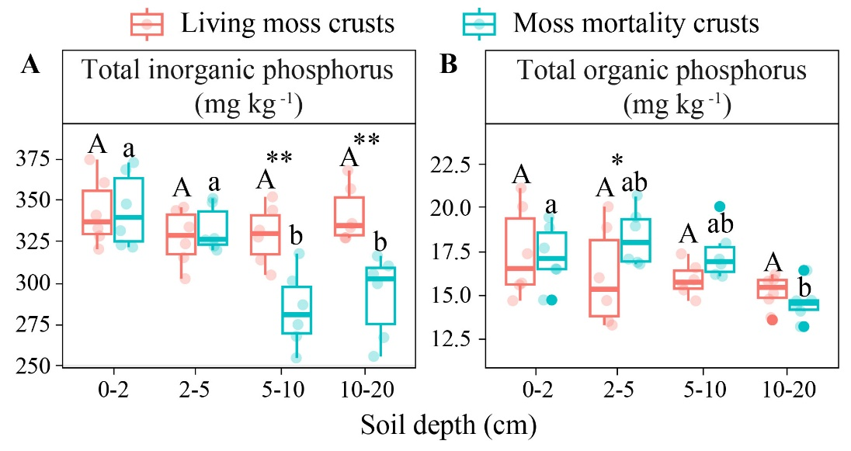
Fig.S2 Proportion of P fractions to total P under different states of moss crusts
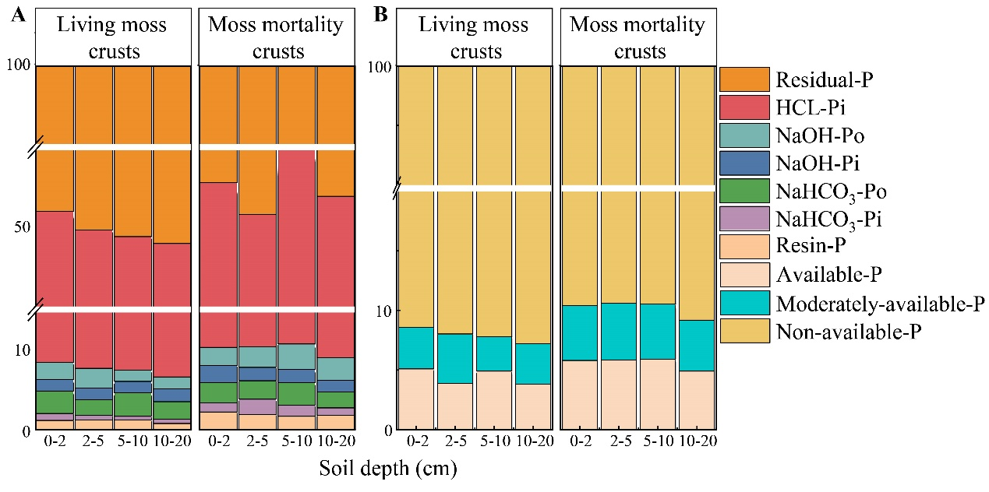
Fig.S3 Characteristics of total organic phosphorus and total inorganic phosphorus under different states of moss crusts

