Supplementary material
Linking soil nematode communities to plant- and microbial-derived carbon under organic and inorganic fertilization practices
Jigao Wang^{1,2}, Yanli Jing³, Tao Wang¹, Kai Wei^{1,*} Rui Yang^{1,2}, Jinlong Yan^{1,2}, Jialiang Tang¹, Bo Zhu¹
¹ Key Laboratory of Mountain Surface Processes and Ecological Regulation, Institute of Mountain Hazards and Environment, Chinese Academy of Sciences, Chengdu, 610213, China
² University of Chinese Academy of Sciences, Beijing, 100049, China
³ Ecological Security and Protection Key Laboratory of Sichuan Province, Mianyang Normal University, Mianyang, 621000, China
*Corresponding author:
Corresponding author at: Institute of Mountain Hazards and Environment, Chinese Academy of Sciences, Chengdu 610233, China.
Email: weikai@imde.ac.cn (Kai Wei).

This file includes:
Supplementary Methods
Figures S1-S10
Table S1
Supplementary methods
Soil DNA Extraction and Quality Assessment
Total genomic DNA was extracted from 0.25 g of fresh soil using the MoBio PowerSoil™ DNA Isolation Kit (Mo BIO Laboratories, USA) following the manufacturer's protocol. DNA concentration and purity were measured using a NanoDrop® ND-2000 spectrophotometer, with an average A260/A280 ratio of 1.8–2.0 indicating high purity. DNA integrity was verified by 1.0% agarose gel electrophoresis (100 V, 30 min in 1×TAE buffer) with GelRed staining, and clear, high-molecular-weight bands were observed, indicating minimal degradation. DNA aliquots were stored at -80 °C for subsequent analysis.
Quantitative PCR Analysis
Bacterial and fungal abundances were quantified through 16S rRNA and 18S rRNA gene copy numbers, respectively. The 16S rRNA gene was amplified using primers 515F (5′-GTGYCAGCMGCCGCGGTAA-3′) and 909R (5′-CCCCGYCAATTCMTTTRAGT-3′) (Li et al., 2018). The V5-V7 region of the fungi 18S rDNA (SSU_0817F, 5′-TTAGCATGGAATAATRRAATAGGA 3′; SSU_1196R, 5′-TCTGGACCTGGTGAGTTTCC-3′) (Long et al., 2025). All qPCR reactions (20 μL) contained 10 ng DNA template, SYBR Green Master Mix, and 0.5 μM of each primer, performed in triplicate on a QuantStudio 3 system (Applied Biosystems). The PCR amplification procedure was as follows: 3-min denaturation at 94°C, followed by 40 cycles of 30-s denaturation at 95 °C, 60-s annealing at 56 °C, and 60-s extension at 72 °C, followed by melting curve analysis. All samples were analyzed in triplicate alongside negative controls (no-template), with no amplification detected in controls. The average cycle threshold (Ct) values and standard deviations were calculated for each sample to assess the reproducibility of the qPCR results.
Soil properties Analysis
The ratio of soil to water suspension was set at 1:2.5 (w:v) to determine soil pH, while the Walkley-Black potassium dichromate sulfuric acid oxidation technique was used to determine SOC content (Nelson and Sommers, 1982). Potassium chloride (1 M) was utilized to extract soil ammonium nitrogen and nitrate nitrogen, and then their contents were detected using an AA3 flow analyzer (SEAL, Germany) (water-soil ratio 5:1). We analyzed soil available phosphorus content following 0.5 M NaHCO₃ (pH 8.5) extraction (Olsen et al. 1954). The available potassium content was extracted using 1 M NH₄OAC for 30 min (1:10 of soil solution ratio) and then analyzed via atomic absorption spectrometry (Lanyon and Heald 1982).
References
Li, J.B., Shen, Z.H., Li, C.N., Kou, Y.P., Wang, Y.S., Tu, B., Zhang, S.H., Li, X.Z., 2018. Stair-step pattern of soil bacterial diversity mainly driven by pH and vegetation types along the elevational gradients of Gongga mountain, China. Frontiers in Microbiology 9, 569. https://doi.org/10.3389/fmicb.2018.00569
Long, X.W., Li, J.N., Liao, X.H., Zhang, W., Wang, K.L., Zhao, J., 2025. Linking microbial metabolism and ecological strategies to soil carbon cycle function in agroecosystems. Soil & Tillage Research 251, 106562. https://doi.org/10.1016/j.still.2025.106562
Nelson, D.W., Sommers, L.E., 1982. In: Total Carbon, Organic Carbon, and Organic Matter. Methods of Soil Analysis II. American Society of Agronomy, Madison, pp. 539–579.
Olsen, S.R., Cole, C.U., Watanabe, F.S., Deen, L.A., 1954. Estimation of Available Phosphorus in Soil by Extracting With Sodium Bicarbonate. USDA Circular 939, Washington.
Lanyon, L.E., Heald, W.R., 1982. Methods of soil analysis. Agronomy Monograph Part 2. Agronomy Society of America and Soil Sci ence Society of America, Madison.

Fig. S1. Taxonomic composition of bacterivores community under different fertilization treatments. CK, no fertilizer; NPK, nitrogen, phosphorus, potassium fertilizers; SNPK, NPK with straw; MNPK, NPK with pig manure.

Fig. S2. Root biomass (a), bacterial abundance (b) and fungal abundance (c) under different fertilization treatments. Different letters in the figure indicate significant differences between different fertilization treatments (P < 0.05). Data in the figure are mean ± standard deviation (n=3). CK, no fertilizer; NPK, nitrogen, phosphorus, potassium fertilizers; SNPK, NPK with straw; MNPK, NPK with pig manure.
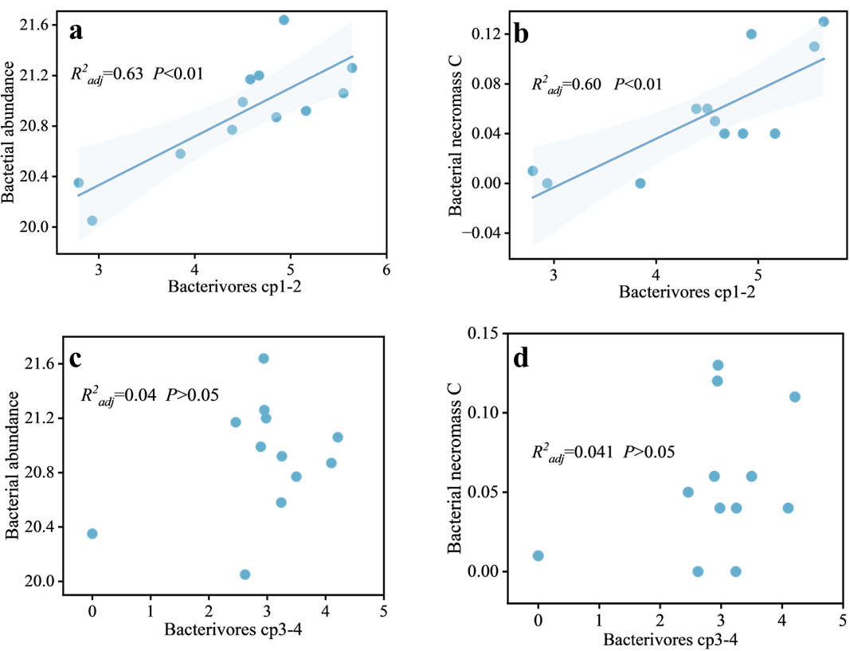
Fig. S3. Relationships between soil bacterivores cp1-2 (a, b), cp3-4 (c, d), bacterial abundance and bacterial necromass C.
Fig. S4. Relationships between soil bacterivores and plant- and microbial-derived carbon to soil organic C ratio. TMNC, total microbial neceomass C; BNC, bacterial necromss C; FNC, fungal necromass C; SOC, soil organic C. P<0.05; **, P<0.01.

Fig. S5. Relationships between soil bacterivores genera, bacterial abundance, and bacterial necromass C. *, P<0.05; **, P<0.01.

Fig. S6. Relative influence of the soil bacterivores on the bacterial neceomass C revealed by aggregated boosted tree analysis.
Fig. S7. Relationships between soil fungal abundance and bacterial necromass C (a), bacterivores and fungal necromass C (b).

Fig. S8. Relationships between soil lignin phenols and bacterial abundance (a), bacterivores (b), bacterivores and acid/aldehyde ratios of vanillyl and bacterivores (c).

Fig. S9. Relationship between soil plant parasites and lignin phenols to soil organic C ratio. SOC, soil organic C.
Table S1 Soil properties under different fertilization regimes.

Treatments | CK | NPK | SNPK | MNPK
pH | 8.31 ± 0.07a | 7.97 ± 0.15b | 7.89 ± 0.01b | 8.07 ± 0.08b
N0₃⁻-N (mg kg⁻¹) | 6.83±0.32c | 11.87 ± 1.17b | 16.83 ± 3.37a | 17.15 ± 1.27a
NH₄⁺-N (mg kg⁻¹) | 0.82 ± 0.03a | 1.05 ± 0.24a | 0.96 ± 0.16 a | 1.05 ± 0.07a
AP (mg kg⁻¹) | 0.39±0.06c | 6.24±0.51b | 5.95±1.69b | 10.02±1.72a
AK (mg kg⁻¹) | 75.63±9.94b | 88.99±12.20b | 145.69±20.1a | 134.14±29.52a
CK, no fertilizer; NPK, nitrogen, phosphorus, potassium fertilizers; SNPK, NPK with straw; MNPK, NPK with pig manure. N0₃⁻-N, nitrate nitrogen; NH₄⁺-N, ammonium nitrogen; AP, available phosphorus; AK, available potassium.
The values present the average ± standard deviation (n = 3). Different letters in the same line indicate the difference (P<0.05) among different fertilization regimes.

Fig. 10. Relationships between soil properties, microbial abundance, microbial necromass C and nematodes. NH₄⁺-N, ammonium nitrogen; N0₃⁻-N, nitrate nitrogen; AP, available phosphorus; AK, available potassium. P<0.05; **, P<0.01.

