Contrasting goethite effects on the priming effect of organic carbon mineralization in sandy loam and loam soils

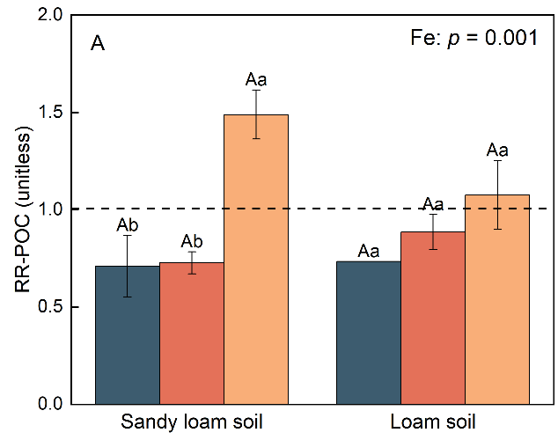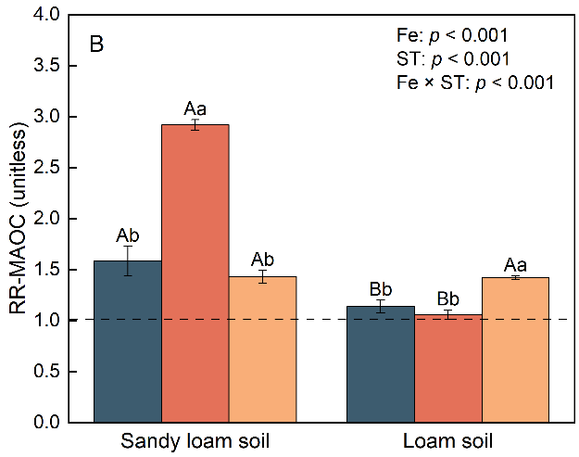
Fig. S1 Response ratios of (A)POC and (B) MAOC in the glucose addition treatment compared to the non-glucose treatment under the same goethite addition situation. RR: response ratio; POC: particulate organic carbon; MAOC: mineral-associated carbon.

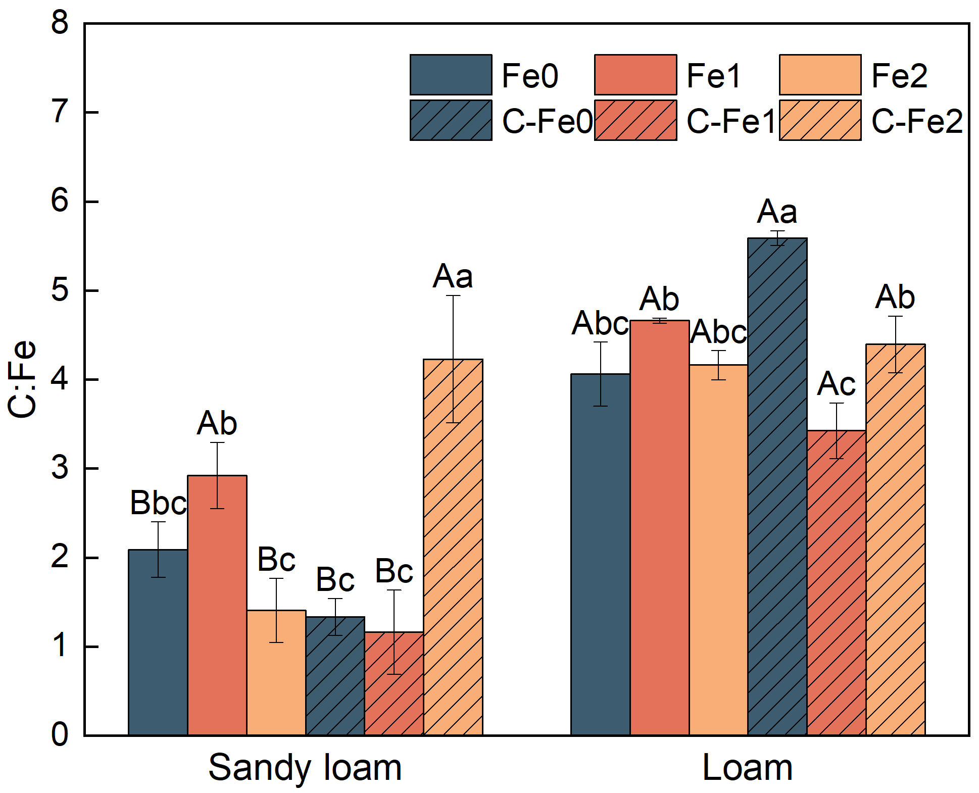
Fig. S2 The molar ratio of Fe-OC to Fed at the end of incubation. Fe-OC: Fe-bound organic carbon; Fed: extractable iron oxide. The dashed black lines indicate C:Fe = 1.

