Supplementary Material
Livestock-induced changes in soil properties and microbial dominance determine soil microbial diversity in a conifer forest
Fan Fan¹, Jiangling Zhu^{1*}, Kai Dong¹, Suhui Ma², Chengjun Ji¹, Zhiyao Tang¹, Shaopeng Wang¹, Xiaoli Shen³, Sheng Li⁴, Jingyun Fang¹
¹ State Key Laboratory for Vegetation Structure, Function and Construction (VegLab), Institute of Ecology, College of Urban and Environmental Sciences, Peking University, Beijing, 100871, China
² School of Ecology and Environmental Science, Yunnan University, Kunming 650500, China
³ State Key Laboratory of Vegetation and Environmental Change, Institute of Botany, Chinese Academy of Sciences, Beijing 100093, China
⁴ School of Life Sciences, Peking University, Beijing 100871, China

Corresponding author: Jiangling Zhu. Email: jlzhu@urban.pku.edu.cn
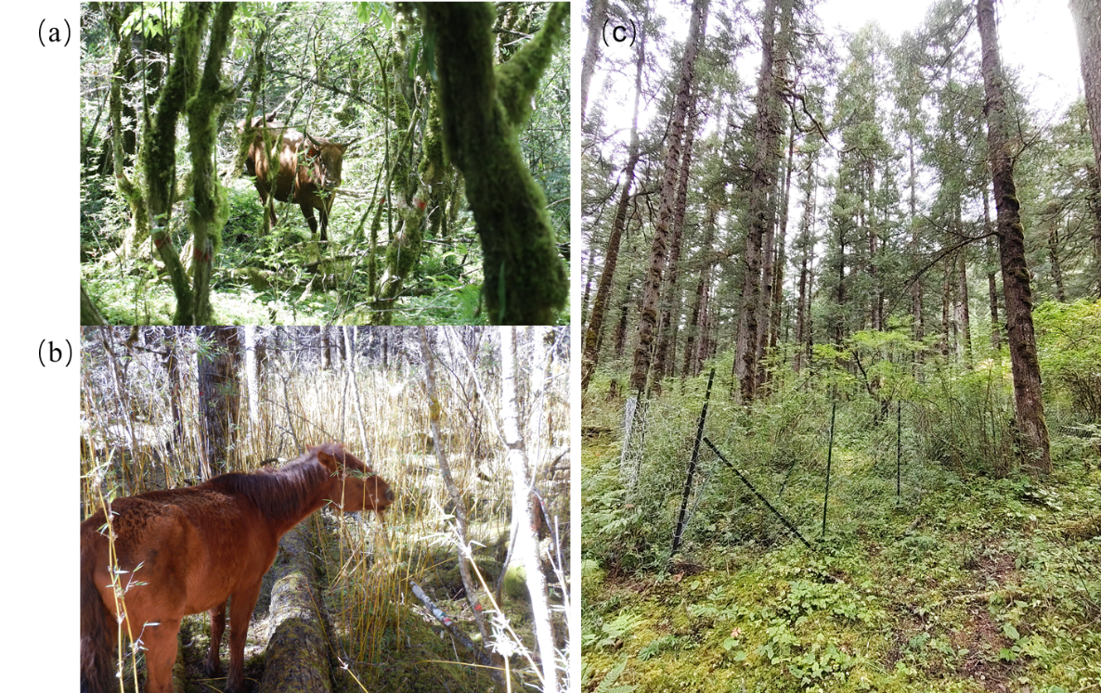
(B)
(A)
（）（）
（）（）
Fig. S1. Free-ranging livestock (cattle and horse) feeding in the forest and fence treatment excluded all herbivory in the WL Plot.

Fig. S2. Pearson correlations between microbial community, soil properties and livestock intensity (N = 170). Significant (P < 0.05) correlations are shown. The numbers in the quadrats are the corresponding correlation coefficients. Pairwise correlations of these variables are shown with a color gradient indicating Pearson’s correlation coefficients. Soil variables include soil organic matter (SOM), total phosphorus (TP), available phosphorus (AP), total nitrogen (TN), available nitrogen (AN), and pH.

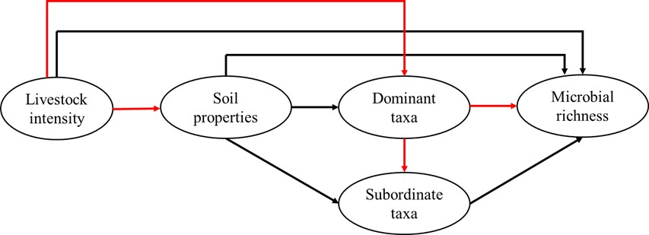
Fig. S3. Structure equation model showing hypothesized probabilistic expectations based on the results of manipulative and mensurative experiments, and literature related to the direct and indirect relationship from livestock intensity to soil microbial richness. Black lines represent expected positive effects, red lines represent expected negative effects.

