Supplementary materials.

Table S1 Plant community composition in our experiments.
Family | Species
Gramineae | Carex duriuscula
Gramineae | Hemarthria sibirica
Gramineae | Phragmites australis
Gramineae | Calamagrostis epigejo
Gramineae | Leymus chinensis
Gramineae | Setaria viridis
Compositae | A. mongolica
Compositae | Kalimeris integrifolia

Table S2 Linear mixed-effects models were used to evaluate the effects of livestock dung deposition, distance, year and their interaction on soil fungal diversity; dung deposition, distance and their interaction on soil bacterial diversity in the field experiment, with block considered as a random effect.
 | Factors | df | F | P
Fungal diversity | Dung | 2 | 11.22 | < 0.001
Fungal diversity | Distance | 2 | 2.81 | 0.06
Fungal diversity | Year | 1 | 192.75 | < 0.001
Fungal diversity | Dung*Distance | 4 | 3.25 | 0.01
Fungal diversity | Dung*Year | 2 | 5.81 | 0.004
Fungal diversity | Distance*Year | 2 | 1.19 | 0.31
Fungal diversity | Dung*Distance*Year | 4 | 0.15 | 0.96
Bacterial diversity | Dung | 2 | 1.36 | 0.27
Bacterial diversity | Distance | 2 | 4.16 | < 0.05
Bacterial diversity | Dung*Distance | 4 | 1.99 | 0.11

Table S3 Two-way ANOVA was performed to analyze the effects of cattle dung deposition (dung with and without live microbiota), sampling time, and their interaction on soil fungal diversity in the microcosm experiment. Significance levels: *** P < 0.001.
Index | Microcosm experiment
Index | Factors | df |  | F | P
Fungal diversity | Dung | 2 | 17.61 |  | < 0.001***
Fungal diversity | Time | 2 | 0.78 |  | 0.48
Fungal diversity | Dung*Time | 4 | 9.07 |  | < 0.001***

Fig. S1 Total organic carbon (TOC), total nitrogen (TN) and C:N ratio of cattle and sheep dung.

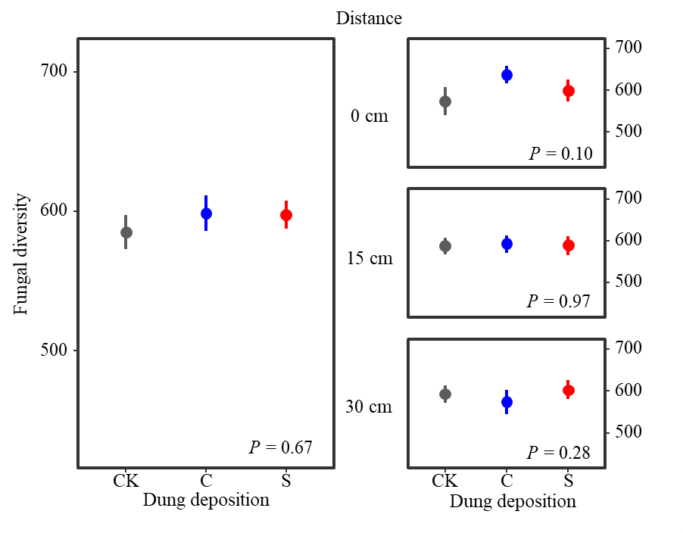
Fig. S2 Effects of grazing livestock dung deposition (CK: no dung, C: cattle dung, S: sheep dung) on soil microbial diversity at varying distances (0, 15, 30 cm) from dung pads on soil fungal diversity in 2023. Values are means ± SE (n = 24 for overall effect of per treatment, n = 8 for per treatment at each distance).

Fig. S3 Effects of grazing livestock dung deposition on the diversity of soil fungal functional guilds based on the FungalTraits database in 2022. (a) Saprotroph diversity. (b) Pathogen diversity (CK: no dung, C: cattle dung, S: sheep dung).

Fig. S4 Relative abundance of main bacterial phyla (a) and genera (b) at different distances from dung pads following grazing livestock dung deposition in 2022 (CK: no dung, C: cattle dung, S: sheep dung).

Fig. S5 Relative abundance of main fungal phyla (a) and genera (b) at different distances from dung pads following grazing livestock dung deposition in 2022. (CK: no dung, C: cattle dung, S: sheep dung)

Fig. S6 Nonmetric multidimensional scaling (NMDS) showing bacterial (a), and fungal (b) communities based on the Bray-Curtis dissimilarity distance in 2022. (CK: no dung, C: cattle dung, S: sheep dung)

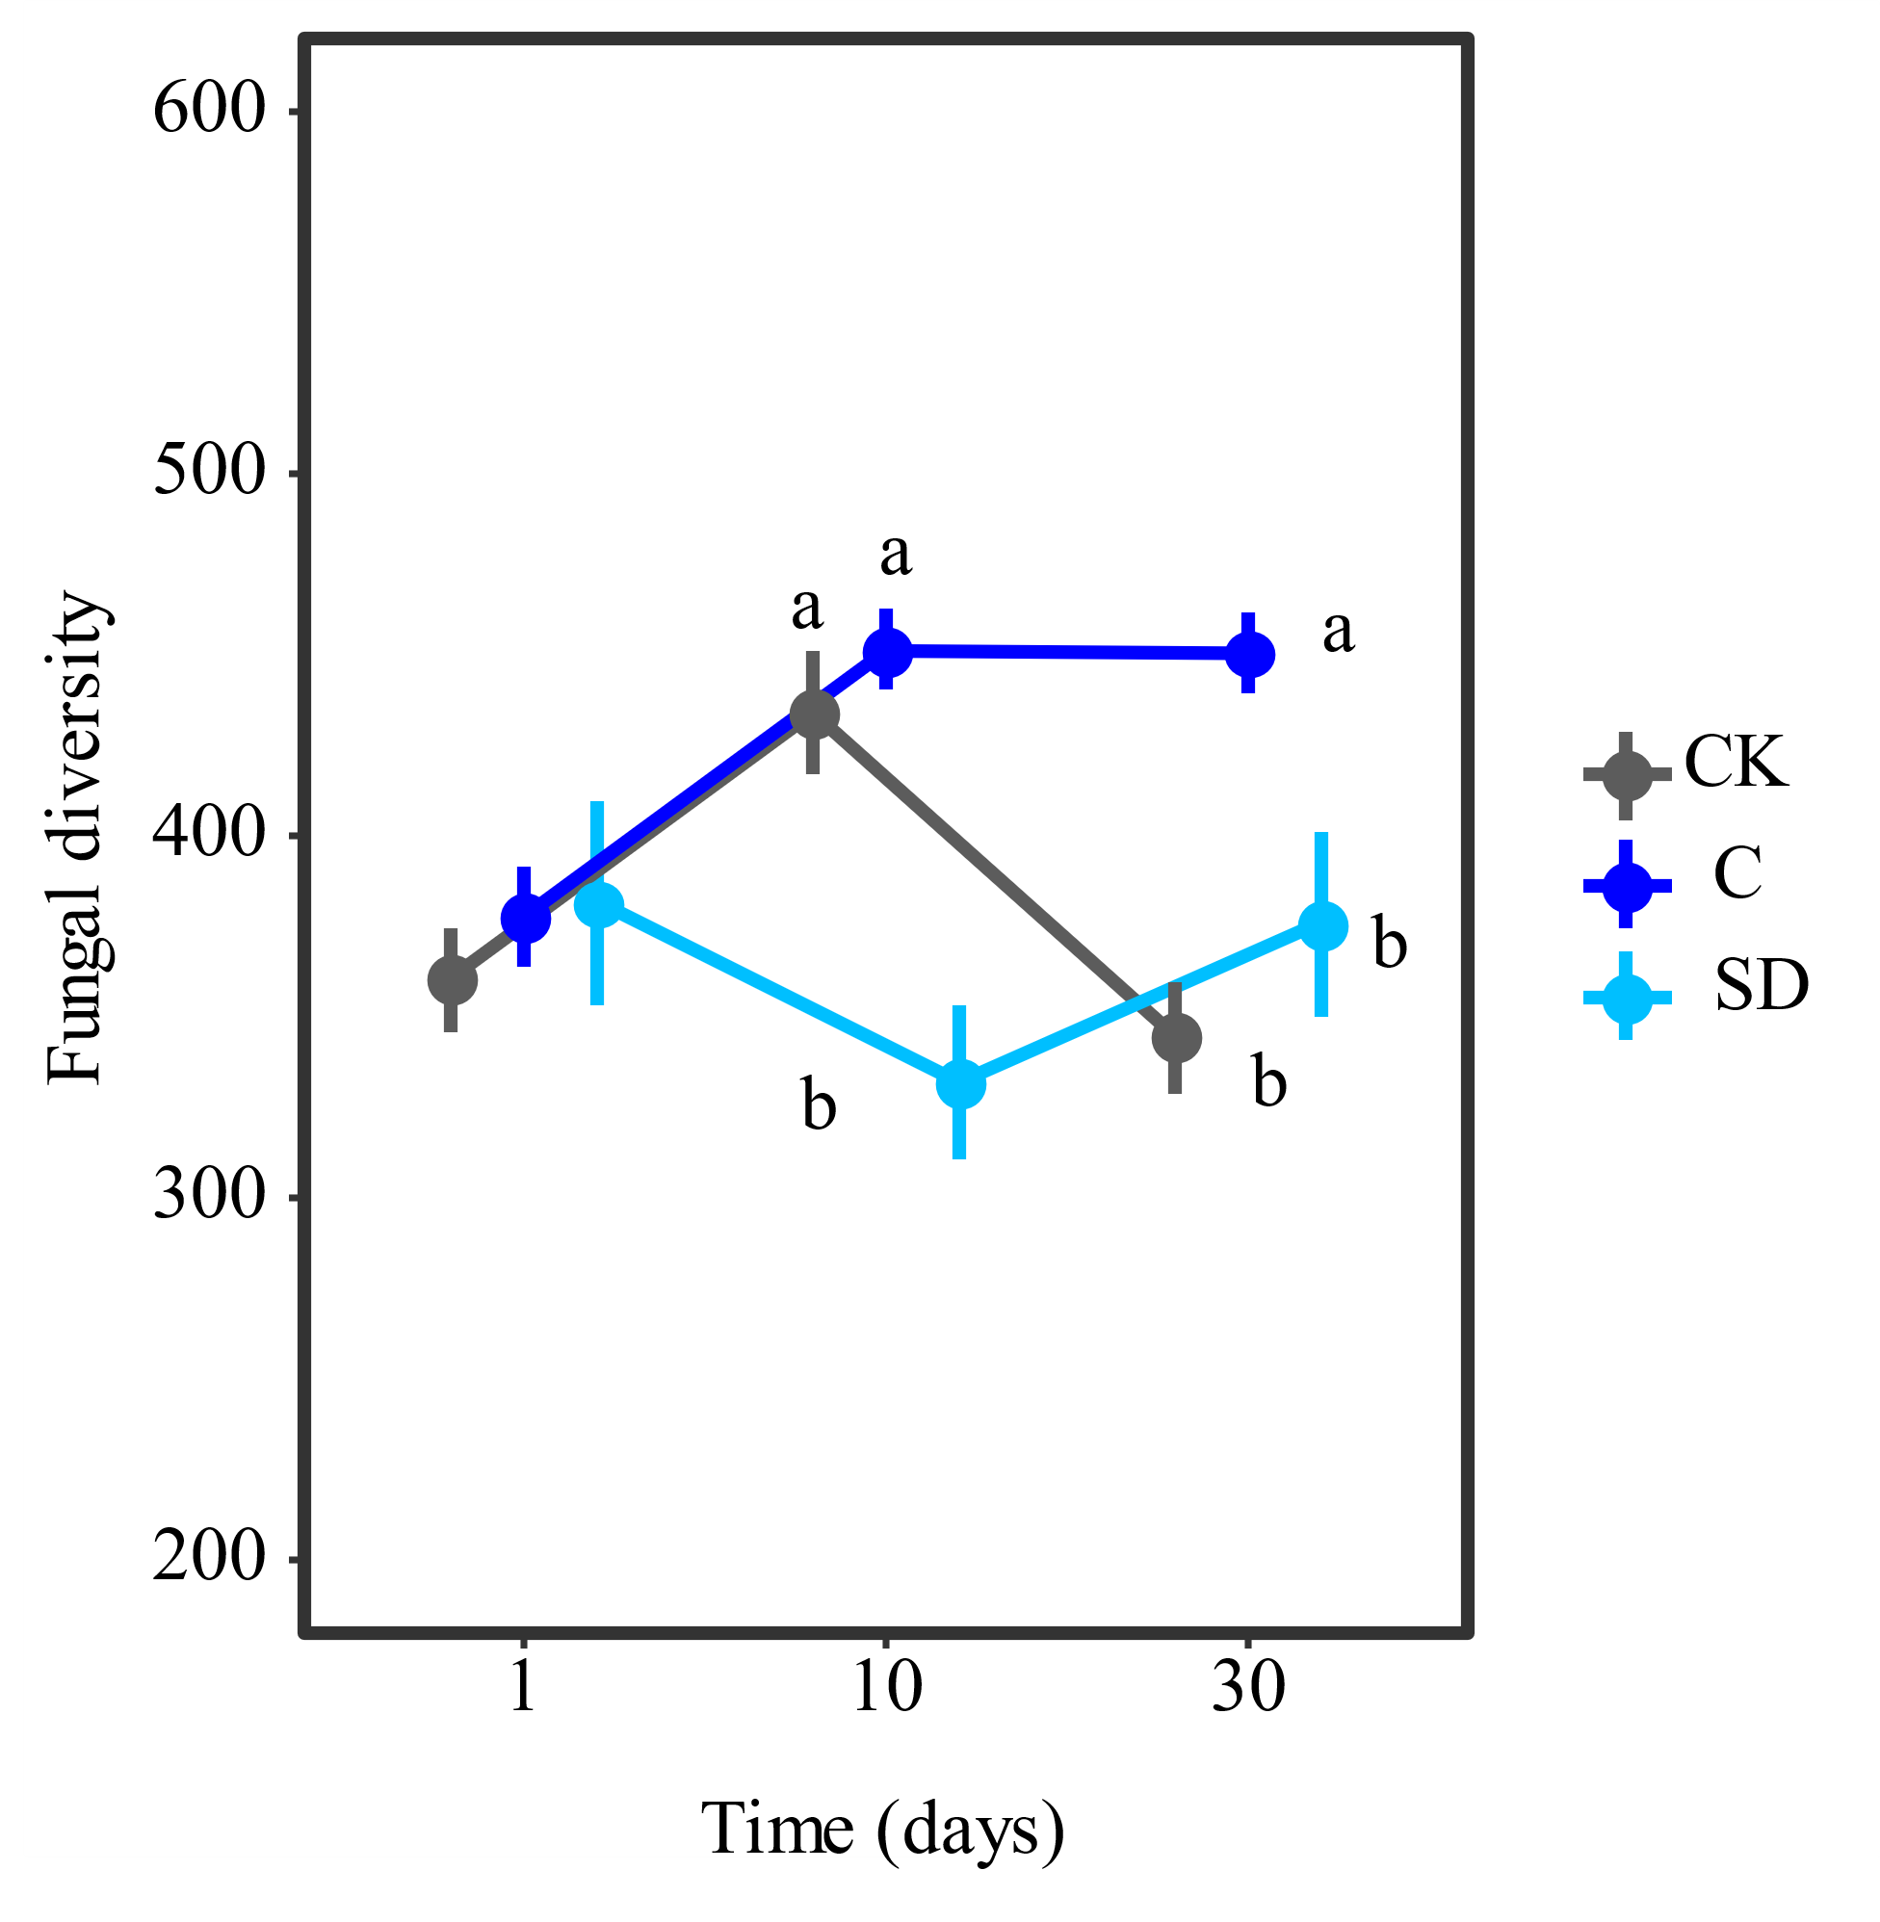
Fig. S7 Temporal dynamics of soil fungal diversity in response to cattle dung deposition at 1, 10 and 30 days of the microcosm experiment. CK: no dung, C: cattle dung with live microbiota, SD: cattle dung without live microbiota. Values are means ± SE (n = 4 per treatment at each sampling time). Different letters indicate significant differences among treatments (P < 0.05).

