Supplementary Materials

Characterization of microbial structure and function in the rhizosphere of Boehmeria nivea L.：A comparative study of volcanic cone and crater
Jin Chen^{1, a, b, c}, Yiming Zhang^{1, a, b, c}, Qingchen Xiao ^{a, b, c}, Boyan Wang ^{a, b, c}, Zishan Li ^{a, b, c}, Keqing Lin ^{a, b, c}, Xiaowan Geng ^{a, b, c}, Xiaoyu Li^{* a, b, c}

Author Contributions: ¹J.C and Y.Z. contributed equally to this work.

a. School of Life Sciences, Anhui Agricultural University, Hefei, 230036, China.
b. National Engineering Laboratory of Crop Stress Resistance Breeding, Anhui Agricultural University, Hefei, 230036, China.
c. Key Laboratory of Crop Stress Resistance and High Quality Biology of Anhui Province, Anhui Agricultural University, Hefei 230036, China.

*Corresponding authors Address:
Xiaoyu Li, Schools of Life Sciences, Anhui Agricultural University, Hefei, Anhui, 230036, China. E-mail address: lixiaoyu@ahau.edu.cn

Supporting Information Includes:
- 5Figures
Figure captions:
Fig. S1. The rarefaction curve analysis of the bacterial (a) and fungal (b) sequences. The curves were constructed using the Shannon index values of the ASVs and the number of reads.
Fig. S2. The functional composition characteristics of ramie rhizosphere microbial communities with significant differences between volcanic cones and the crater sites. a, KEGG (Level 2) category has significant differences, highlighted using PICRUSt. b, FUNGuild-based differences at volcanic cones and the crater sites correspond to fungal trophic patterns. The data were visualized using STAMP (Error bars represent Welch's t-test).
Fig. S3. The co-occurrence networks of bacterial and fungal communities on the volcanic crater and cones of B. nivea. a and b represent the network relationship of bacterial volcanic cones (a) and the crater (b), respectively. c and d represent the network relationship of fungal sites on volcanic cones (c) and the crater (d), respectively. The colors of the nodes indicate different phyla, and we only label nodes with microbial keystone taxa (generalists); node size was proportional to its degree. e represents the major topological properties of rewired random networks.
Fig. S4. The Zi-Pi plots show the distribution of topological roles of the core microorganisms. a and b show the topological rolse of the bacterial core microbiome in the volcanic cone (a) and the crater (b) sites networks, respectively. c and d show the topological roles of the fungal core microbiome in the volcanic cone (c) and the crater (d) sites networks, respectively.
Fig. S5. The barplots show the nodes and edges of bacteria and fungi in different volcanic regions. a and b show the nodes and links of bacteria and fungi in different volcanic regions, respectively.

Fig. S1. The rarefaction curve analysis of the bacterial (a) and fungal (b) sequences. The curves were constructed using the Shannon index values of the ASVs and the number of reads.

Fig. S2. The functional composition characteristics of ramie rhizosphere microbial communities with significant differences between volcanic cones and the crater sites. a, KEGG (Level 2) category has significant differences, highlighted using PICRUSt. b, FUNGuild-based differences at volcanic cones and the crater sites correspond to fungal trophic patterns. The data were visualized using STAMP (Error bars represent Welch's t-test).

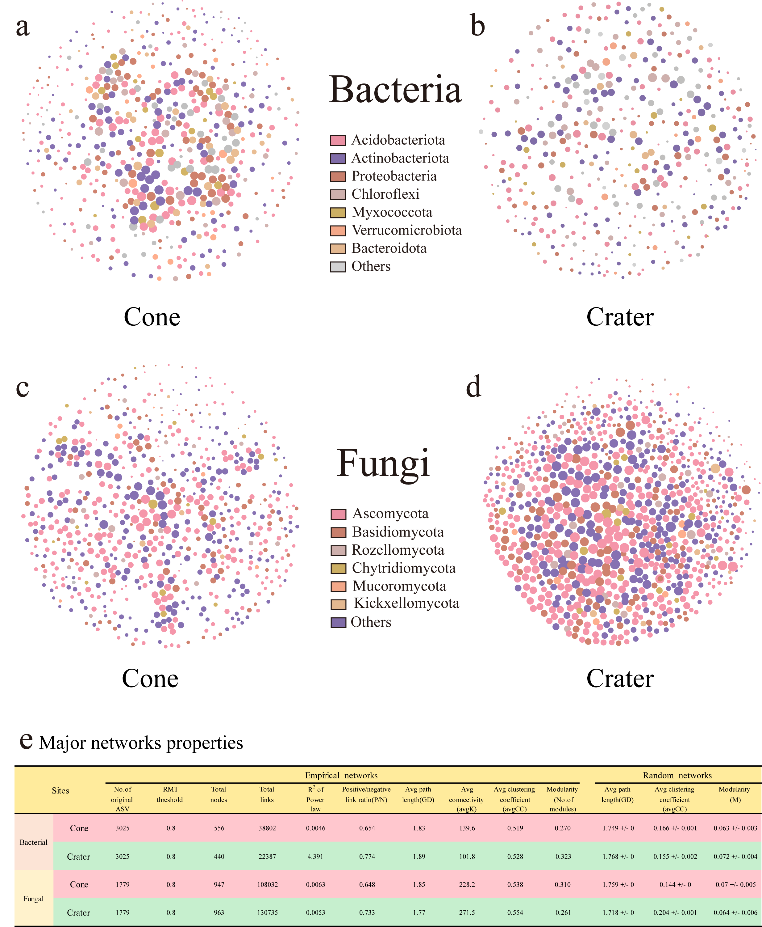
Fig. S3. The co-occurrence networks of bacterial and fungal communities on the volcanic crater and cones of B. nivea. a and b represent the network relationship of bacterial volcanic cones (a) and the crater (b), respectively. c and d represent the network relationship of fungal sites on volcanic cones (c) and the crater (d), respectively. The colors of the nodes indicate different phyla, and we only label nodes with microbial keystone taxa (generalists); node size was proportional to its degree. e represents the major topological properties of rewired random networks.
Fig. S4. The Zi-Pi plots show the distribution of topological roles of the core microorganisms. a and b show the topological rolse of the bacterial core microbiome in the volcanic cone (a) and the crater (b) sites networks, respectively. c and d show the topological roles of the fungal core microbiome in the volcanic cone (c) and the crater (d) sites networks, respectively.
Fig. S5. The barplots show the nodes and edges of bacteria and fungi in different volcanic regions. a and b show the nodes and links of bacteria and fungi in different volcanic regions, respectively.

