Supplemental Materials
Title:
Soil Animal Ecology in China: Two Decades of Progress and Future Prospects

Authors:
Xin Sun^{1,2,6,#}, Zhihong Qiao^{1,2,#}, Weixin Zhang³, Qi Li⁴, Yuanhu Shao³, Haifeng Yao^{1,2,5}, Jihua Wu⁶, Manqiang Liu⁷, Donghui Wu^{8,9}, Wenju Liang⁴, Feng Hu¹⁰, Stefan Scheu^{11,12}, Shenglei Fu^{3,*}, Yong-Guan Zhu^{1,2,13,*}

Data source, literature search strategy and software for bibliometric and visualization analysis
A comprehensive literature search was conducted using the Web of Science Core Collection (WoSCC) database to ensure a broad and representative coverage of studies related to soil fauna. The search query was (TS = (("soil*" OR "edaphic*" OR "pedosphere" OR "belowground" OR "below-ground" OR "litter" OR "humus") AND ("fauna*" OR "animal*" OR "invertebrate*" OR "microfauna" OR "mesofauna" OR "macrofauna" OR "megafauna" OR "nematode*" OR "nematoda" OR "earthworm*" OR "oligochaeta" OR "lumbricid*" OR "enchytraeid*" OR "potworm*" OR "arthropod*" OR "springtail*" OR "collembola*" OR "mite" OR "mites" OR "acari*" OR "oribatid*" OR "gamasid*" OR "spider*" OR "araneae" OR "pseudoscorpion*" OR "opiliones" OR "centipede*" OR "chilopoda" OR "millipede*" OR "diplopoda" OR "pauropoda*" OR "symphyla*" OR "protura*" OR "diplura*" OR "insect*" OR "beetle*" OR "coleoptera" OR "carabid*" OR "staphylinid*" OR "ant" OR "ants" OR "formicidae" OR "termite*" OR "isoptera" OR "snail" OR "snails" OR "slug" OR "slugs" OR "gastropoda" OR "protozoa*" OR "rotifer*" OR "tardigrade*" OR "isopoda" OR "woodlice") AND ("ecology*" OR "ecosystem*" OR "diversity" OR "biodiversity" OR "richness" OR "abundance" OR "density" OR "community" OR "communities" OR "assemblage*" OR "composition" OR "structure" OR "distribution*" OR "spatial" OR "pattern*" OR "biogeograph*" OR "function*" OR "process*" OR "service*" OR "decomposition" OR "interaction*" OR "trait*" OR "functional diversity*" OR "functional group*" OR "morpholog*" OR "life histor*" OR "body size" OR "biomass" OR "trophic" OR "feeding guild*" OR "diet*" OR "food web*" OR "ecosystem engineer*" OR "epigeic" OR "endogeic" OR "hemiedaphic")) AND CU=(China) AND PY=(2006-2025)), with a restriction on article as document and review types, English as the language, and a time span from January 1, 2006, to December 15, 2025. To ensure disciplinary relevance, the results were further refined to the following Web of Science Categories: Soil Science, Ecology, Biodiversity Conservation, and Geography. Subsequently, search queries were executed for Japan, the USA, and Germany by replacing 'China' with the respective country names in the 'Countries/Regions' (CU) field to facilitate comparative analysis. The exported data include "full records and citations", and are saved in "plain text" or "refworks" formats respectively for subsequent analysis (Fig. S1). Specifically, we assessed the global publication volume in soil fauna research to determine the relative contribution of each major country.
The data analysis and visualization software employed in this study utilized Microsoft Office Excel 2016 and Vosviewer1.6.20. Specifically, Microsoft Office Excel 2016 was employed to compile data, analyse publication trends, and create related tables. The plain text file literature data was then imported into VOSviewer 1.6.20 software to create cooperative, co-citation, and co-occurrence network knowledge maps. For the WOS database, our timeline spans from 2006 to 2025, with each time slice set to 1 year (years per slice).
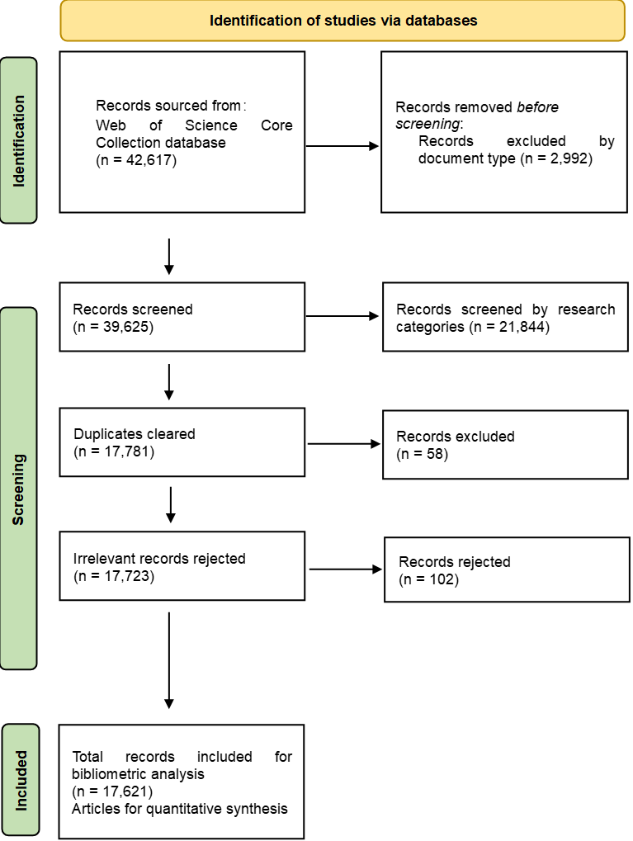
Fig. S1 The PRISMA flow diagram
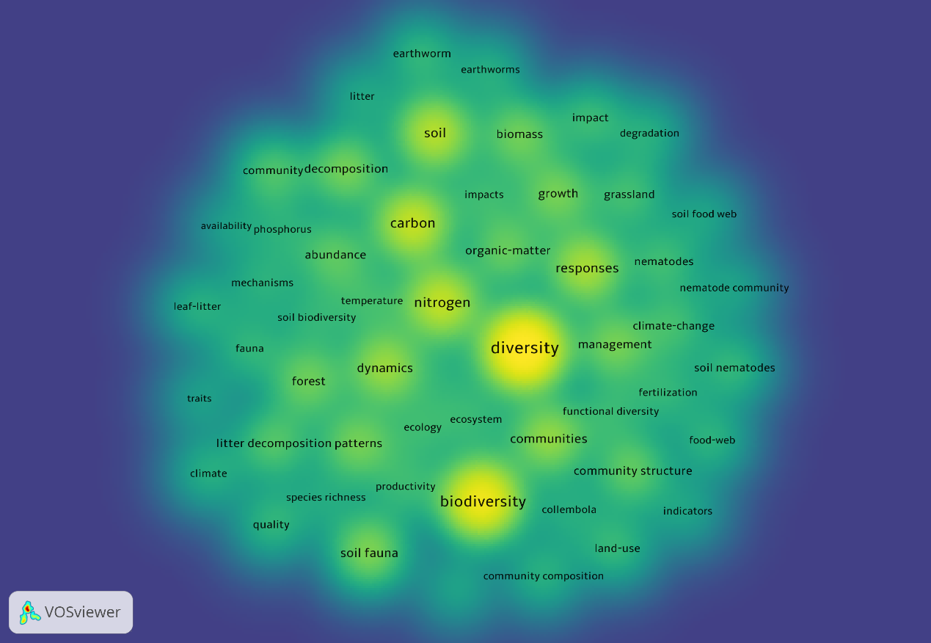
Fig. S2 Density map of keyword co-occurrence in Chinese soil animal ecology research, based on WoSCC data (2006-2025).
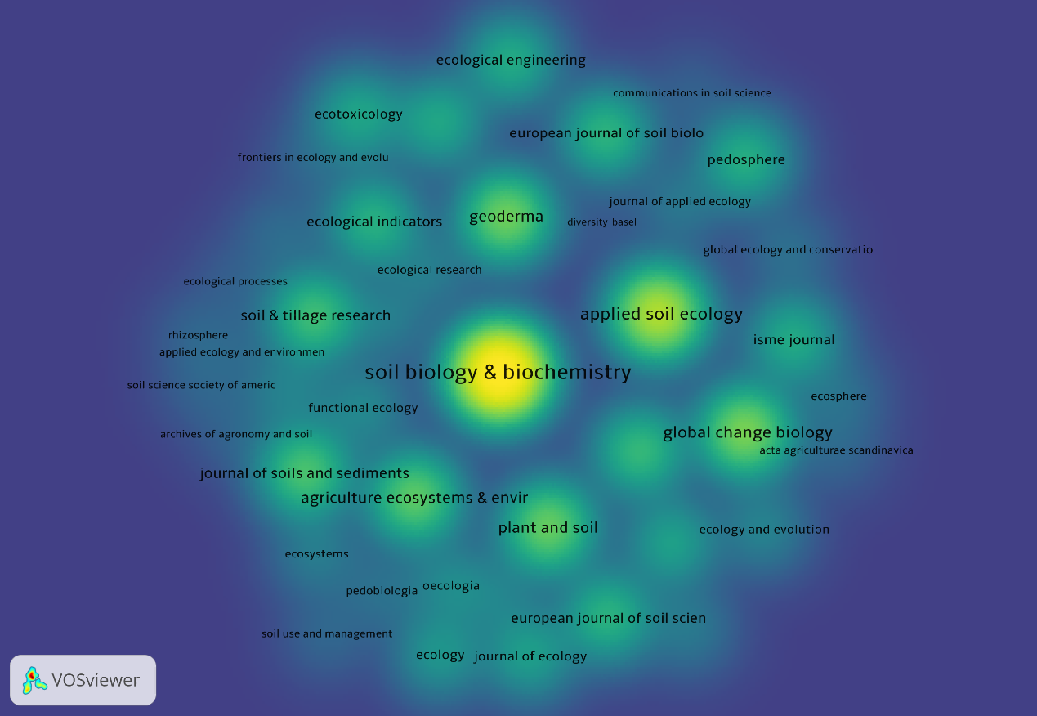
Fig. S3 Density map of journal co-citations revealing the core cluster of journals in China's soil animal ecology research (Source: WoS Core Collection, year: 2006-2025).

Table S1 Annual number of publications and percentage share of major contributing countries (2006–2025) based on Web of Science (December 15, 2025)
Publication year | Annual publications | China |  | Japan |  | USA |  | Germany
Publication year | Annual publications | Number of papers | Percentage | Number of papers | Percentage | Number of papers | Percentage | Number of papers | Percentage
2025 | 1094 | 298 | 27.24% | 20 | 1.83% | 213 | 19.47% | 153 | 13.99%
2024 | 1106 | 272 | 24.59% | 23 | 2.08% | 212 | 19.17% | 132 | 11.93%
2023 | 960 | 209 | 21.77% | 19 | 1.98% | 199 | 20.73% | 118 | 12.29%
2022 | 1018 | 249 | 24.46% | 19 | 1.87% | 222 | 21.81% | 127 | 12.48%
2021 | 1157 | 188 | 16.25% | 34 | 2.94% | 271 | 23.42% | 144 | 12.45%
2020 | 1014 | 183 | 18.05% | 27 | 2.66% | 236 | 23.27% | 129 | 12.72%
2019 | 1056 | 154 | 14.58% | 20 | 1.89% | 279 | 26.42% | 118 | 11.17%
2018 | 916 | 132 | 14.41% | 18 | 1.97% | 218 | 23.80% | 115 | 12.55%
2017 | 898 | 104 | 11.58% | 25 | 2.78% | 234 | 26.06% | 128 | 14.25%
2016 | 926 | 106 | 11.45% | 19 | 2.05% | 235 | 25.38% | 124 | 13.39%
2015 | 807 | 112 | 13.88% | 36 | 4.46% | 221 | 27.39% | 107 | 13.26%
2014 | 840 | 72 | 8.57% | 30 | 3.57% | 210 | 25.00% | 106 | 12.62%
2013 | 765 | 68 | 8.89% | 20 | 2.61% | 213 | 27.84% | 87 | 11.37%
2012 | 775 | 60 | 7.74% | 27 | 3.48% | 198 | 25.55% | 69 | 8.90%
2011 | 737 | 50 | 6.78% | 17 | 2.31% | 197 | 26.73% | 93 | 12.62%
2010 | 747 | 42 | 5.62% | 24 | 3.21% | 186 | 24.90% | 93 | 12.45%
2009 | 731 | 45 | 6.16% | 17 | 2.33% | 190 | 25.99% | 92 | 12.59%
2008 | 653 | 33 | 5.05% | 21 | 3.22% | 176 | 26.95% | 69 | 10.57%
2007 | 696 | 26 | 3.74% | 15 | 2.16% | 201 | 28.88% | 77 | 11.06%
2006 | 725 | 27 | 3.72% | 24 | 3.31% | 222 | 30.62% | 81 | 11.17%

Table S2 Summary statistics of top keywords in the co-occurrence network with a frequency threshold of 50.
Keyword | Links | Total link strength | Occurrences
Diversity | 54 | 1804 | 566
Biodiversity | 53 | 1484 | 426
Carbon | 54 | 1054 | 292
Nitrogen | 54 | 931 | 283
Responses | 54 | 789 | 238
Dynamics | 54 | 769 | 211
Soil fauna | 54 | 751 | 180
Communities | 53 | 711 | 204
Decomposition | 54 | 577 | 167
Patterns | 53 | 551 | 159
Forest | 54 | 541 | 151
Soil | 53 | 530 | 263
Biomass | 54 | 517 | 157
Litter decomposition | 53 | 504 | 126
Management | 53 | 483 | 161
Community structure | 51 | 442 | 140
Organic-matter | 52 | 439 | 145
Abundance | 53 | 432 | 129
Growth | 53 | 428 | 162
Soil nematodes | 48 | 358 | 90
Nematodes | 51 | 352 | 98
Grassland | 53 | 350 | 105
Community | 51 | 349 | 120
Fauna | 51 | 348 | 81
Impacts | 53 | 347 | 87
Climate | 48 | 336 | 76
Food-web | 48 | 331 | 82
Quality | 46 | 320 | 88
Climate-change | 50 | 318 | 98
Productivity | 51 | 313 | 87
Community composition | 47 | 304 | 80
Leaf-litter | 47 | 297 | 76
Soil biodiversity | 52 | 293 | 73
Functional diversity | 51 | 290 | 80
Land-use | 52 | 288 | 93
Fertilization | 50 | 288 | 79
Temperature | 52 | 279 | 85
Impact | 49 | 260 | 98
Ecosystem | 51 | 255 | 76
Collembola | 48 | 247 | 66
Ecology | 47 | 246 | 80
Climate change | 48 | 244 | 60
Soil food web | 46 | 233 | 59
Indicators | 48 | 232 | 59
Traits | 43 | 229 | 54
Nematode community | 48 | 219 | 58
Mechanisms | 49 | 217 | 70
Litter | 47 | 213 | 65
Species richness | 51 | 196 | 56
Phosphorus | 48 | 182 | 60
Soil properties | 47 | 179 | 51
Earthworms | 50 | 174 | 73
Earthworm | 37 | 168 | 89
Degradation | 45 | 151 | 73
Availability | 44 | 139 | 50

Table S3 Summary statistics of top journals in the co-citation network with a citation threshold of 10.
Journal | Number of papers | Total citation | Average citation | Total link strength | Impact factor
Soil Biology & Biochemistry | 213 | 10369 | 48.68 | 1655 | 10.3
Applied Soil Ecology | 260 | 4783 | 18.40 | 1240 | 5.0
Geoderma | 109 | 3012 | 27.63 | 621 | 6.6
Plant and Soil | 132 | 2826 | 21.41 | 608 | 4.1
European Journal of Soil Biology | 87 | 1630 | 18.74 | 490 | 3.3
Agriculture Ecosystems & Environment | 94 | 2625 | 27.93 | 394 | 6.4
Ecological Indicators | 86 | 1497 | 17.41 | 308 | 7.0
Catena | 72 | 1809 | 25.13 | 301 | 5.7
Global Change Biology | 40 | 3276 | 81.90 | 293 | 12.0
Land Degradation & Development | 59 | 1230 | 20.85 | 229 | 3.7
Biology and Fertility of Soils | 42 | 1059 | 25.21 | 206 | 5.6
Soil & Tillage Research | 48 | 1993 | 41.52 | 204 | 6.8
Pedosphere | 63 | 1432 | 22.73 | 193 | 7.3
Ecology and Evolution | 60 | 468 | 7.80 | 183 | 2.3
Functional Ecology | 31 | 546 | 17.61 | 176 | 5.1
Journal of Ecology | 35 | 1001 | 28.60 | 155 | 5.6
Journal of Soils and Sediments | 83 | 2240 | 26.99 | 140 | 3.0
Global Ecology and Conservation | 37 | 223 | 6.027 | 137 | 3.4
Journal of Applied Ecology | 19 | 310 | 16.36 | 112 | 4.8
European Journal of Soil Science | 17 | 1571 | 92.41 | 107 | 3.8
ISME Journal | 14 | 1319 | 94.21 | 107 | 10
Ecology | 24 | 809 | 33.71 | 105 | 4.3
Ecosystems | 13 | 369 | 28.38 | 98 | 3.3
Journal of Soil Science and Plant Nutrition | 31 | 364 | 11.74 | 83 | 3.1
Journal of Animal Ecology | 10 | 341 | 34.10 | 79 | 3.7
Global Ecology and Biogeography | 13 | 444 | 34.15 | 67 | 6.0
Pedobiologia | 20 | 222 | 11.10 | 67 | 2.2
Ecological Processes | 11 | 85 | 7.73 | 63 | 3.9
Archives of Agronomy and Soil Science | 16 | 108 | 6.75 | 61 | 1.8
Oecologia | 19 | 550 | 28.95 | 60 | 2.3
Ecological Engineering | 30 | 1344 | 44.80 | 54 | 4.1
Frontiers in Ecology and Evolution | 29 | 153 | 5.28 | 52 | 2.6
Ecological Research | 16 | 353 | 22.06 | 42 | 1.7
Ecosphere | 11 | 235 | 21.36 | 40 | 2.9
Journal of Plant Ecology | 16 | 186 | 11.63 | 39 | 3.9
Diversity-Basel | 14 | 44 | 3.14 | 31 | 2.4
Ecotoxicology | 33 | 1167 | 35.36 | 31 | 2.4
Acta Agriculturae Scandinavica Section B | 13 | 133 | 10.23 | 26 | 1.8
Applied Ecology and Environmental Research | 21 | 80 | 3.81 | 26 | 0.6
Soil Use and Management | 10 | 145 | 14.50 | 23 | 3.7
Biochar | 12 | 370 | 30.83 | 19 | 13.5
Soil Science Society of America Journal | 10 | 113 | 11.30 | 17 | 2.4
Rhizosphere | 10 | 125 | 12.50 | 12 | 3.5
Communications in Soil Science and Plant Analysis | 14 | 102 | 7.29 | 4 | 1.4

Table S4 Share of contributions from China in major soil science and ecology journals over four 5-year periods (2006–2025).
Journal | 2006-2010 | 2011-2015 | 2016-2020 | 2021-2025
Applied Soil Ecology | 6.02% | 13.01% | 18.11% | 32.66%
Biology and Fertility of Soils | 7.79% | 22.81% | 28.00% | 30.00%
European Journal of Soil Science | 7.55% | 14.75% | 20.39% | 20.63%
Global Change Biology | 2.70% | 4.44% | 13.21% | 31.94%
Geoderma | 10.34% | 11.43% | 23.81% | 43.33%
Nature and other Nature Portfolio journals | 0.00% | 0.00% | 7.69% | 25.00%
Pedobiologia | 2.46% | 0.85% | 3.41% | 13.13%
Soil Biology and Biochemistry | 7.69% | 13.85% | 27.91% | 34.98%

Table S5 Representative research projects related to soil fauna ecology in Mainland China over the past 20 years and the key research objectives.
Project Title | Funding Sources | Focus Area | Duration
Effects of soil fauna functional groups on soil C-N dynamics and plant rhizosphere characteristics in subtropical forests | CAS Knowledge Innovation Program Key Directional Project | How soil fauna functional groups influence key ecological processes | 2007-2009
Soil ecology | National Science Foundation for Distinguished Young Scholars | Soil biological research in the context of global climate change | 2010-2013
Mechanisms maintaining plant and soil biodiversity in subtropical forest ecosystems | NSFC Major International (Regional) Joint Research Project | Linking above- and belowground biodiversity | 2013-2017
Mechanisms by which soil biota influence aggregate stability under long-term fertilization | NSFC Key Project | How long-term fertilization affects soil aggregation mediated by soil biota | 2014-2018
Investigation of soil fauna diversity in agricultural regions of Eastern China | National Science & Technology Basic Resources Survey Project of China | How agricultural activities affect soil fauna diversity | 2019-2023
Effects and mechanisms of nitrogen deposition on soil biodiversity in forests of the climate transition zone | NSFC Joint Fund Key Project | How long-term nitrogen deposition affects the soil food web | 2020-2023
Impact and mechanisms of Spartina alterniflora invasion on the geographical distribution pattern of soil biodiversity in China's salt marsh wetlands | NSFC Key Project | How invasive plants affect wetland soil nematode communities | 2021-2025
Biological maintenance mechanisms and scale effects of soil nutrient heterogeneity in tropical forests: A forest transect from Southwest China to the Indochina Peninsula | NSFC-UNEP International Cooperation Project | How Soil biota Influences soil nutrient heterogeneity in tropical forests | 2021-2025
Mechanisms by which maize-peanut intercropping in the Liaohe Plain affects soil biological health | NSFC Joint Fund Key Project | How legume intercropping in black soil farmland affects soil biological health | 2023-2026
Key technologies for enhancing soil biological health and productivity in dryland soils of the Songnen Plain | National Key Research and Development Program of China | How soil biota affects black soil productivity | 2024-2027
The regulation of soil biodiversity on human and livestock pathogens and its risks to human health in urban ecosystems | NSFC-UNEP International (Regional) Cooperation and Exchange Project | How soil biota regulates pathogens and thus human health | 2024-2028
Soil fauna ecology | National Science Foundation for Distinguished Young Scholars | Soil food webs and their functions to ecosystem health | 2025-2029

