Organic fertilizer substitution alleviates microbial resource limitations to enhance soil function and crop yields
Changwei Zhua, Renzhuo Wanga, Guiying Jianga*, Kees Jan van Groenigenb, Minggang Xuc, Jin Yanga, Yueying Lia, Mengru Wanga, Xiaolei Jiea, Beibei Wanga, Haitao Liua, Shiliang Liua*

ªKey Laboratory of Arable Land Quality Conservation in the Huanghuaihai Plain, Ministry of Agriculture and Rural Affairs, College of Resources and Environment, Henan Agricultural University, Zhengzhou, 450046, China.
^{b}Department of Geography, Faculty of Environment, Science and Economy, University of Exeter, Exeter, EX4 4QE, UK.
^{c}Soil Health Laboratory of Shanxi Province, Institute of Eco-environment and Industrial Technology, Shanxi Agricultural University, Taiyuan, 030031, China
Corresponding author:
Guiying Jiang, Tel/Fax: +86-0371-68555200; E-mail: jgy9090@126.com
Shiliang Liu, Tel/Fax: +86-0371-685555200; E-mail: shlliu70@163.com
Changwei Zhu and Renzhuo Wang contributed equally to this work.

Supporting Materials: Tables= 6, Figures= 5.

Supplementary caption：
Table S1 Nutrient contents of organic fertilizers.
Table S2 The fertilization rate under each treatment
Table S3 SOC, TN, TP contents and ratios under different fertilization measures.
Table S4 DOC, DON, AP contents and ratios under different fertilization measures.
Table S5 NH₄⁺-N, NO₃⁻-N contents and pH, EC, BD under different fertilization measures.
Table S6 MBC, MBN, MBP contents and ratios under different fertilization measures.
Fig. S1 Changes in soil C-related enzyme activities among different treatments. (a, b) BG, (c, d) CBH. (Mean and standard deviation are shown as error bars, n = 3).
Fig. S2 Changes in soil N-related enzyme activities among different treatments. (a, b) NAG, (c, d) LAP. (Mean and standard deviation are shown as error bars, n = 3).
Fig. S3 Changes in soil alkaline phosphatase activity among different treatments. (Mean and standard deviation are shown as error bars, n = 3).
Fig. S4 Linear regression analysis to identify the relationships between soil C-acq, N-acq, and P-acq enzyme activities with MBC (a), (d), and (g), with MBN (b), (e), and (h), and with MBP (c), (f), and (i) in 2022 and 2023. Shaded areas show 95% confidence intervals of the fit. Pearson correlations among vector length, vector angle, C, N, and P acquisition enzyme activities and soil biochemical properties in 2022 and 2023 (j). Significance levels are as follows: * p < 0.05, ** p < 0.01.
Fig. S5 Line regression analysis to identify the relationship of ecosystem multifunctionality (EMF) and soil quality index (SQI). Shaded areas show 95% confidence intervals of the fit.

Materials and Methods
Text S1. Soil enzyme activity determination
Briefly, the sample suspensions of all soil enzymes were prepared by mixing 1 g fresh soil with 50 ml deionized water and shaking at 180 r for 30 min at 25 ◦C. Soil suspensions (50 μl) were mixed with buffer (100 μl) and corresponding substrates (100 μl) unique to each enzyme in a 96-well microplate. Fluorescence was measured at an excitation wavelength of 365 nm and an emission wavelength of 450 nm using a Thermo1510, MULTISKAN Sky fluorometer (Thermo Fisher Scientific, USA). Enzymatic activity was then calculated and expressed as nanomoles per hour per gram dry soil (nmol g⁻¹ dry soil h^{–1}).

Table S1 Nutrient contents of organic fertilizers.
 | SOC  (g kg⁻¹) | TN  (g kg⁻¹) | TP  (g kg⁻¹) | TK  (g kg⁻¹) | SOC:TN | Moisture  (%)
Straw | 591.14 | 6.65 | 15.32 | 17.54 | 88.89 | 14.02
Chicken organic fertilizer | 306.35 | 20.70 | 26.74 | 38.42 | 14.80 | 39.97
Cow organic fertilizer | 343.18 | 15.50 | 15.23 | 18.63 | 22.14 | 10.75

Table S2 The fertilization rate under each treatment
Treatment | Mineral fertilizer (kg ha⁻¹) |  |  |  | Organic fertilizer (kg ha⁻¹) |  |  |  | Total (kg ha⁻¹)
Treatment | N | P₂O₅ | K₂O |  | N | P₂O₅ | K₂O |  | N | P₂O₅ | K₂O
CF | 205 | 101.25 | 101.25 |  | 0 | 0 | 0 |  | 205 | 101.25 | 101.25
NF | 0 | 101.25 | 101.25 |  | 0 | 0 | 0 |  | 0 | 101.25 | 101.25
RF | 164 | 101.25 | 101.25 |  | 0 | 0 | 0 |  | 164 | 101.25 | 101.25
FF | 164 | 70.5 | 70.5 |  | 41 | 52.98 | 76.12 |  | 205 | 123.48 | 146.62
MF | 164 | 70.5 | 70.5 |  | 41 | 40.29 | 49.29 |  | 205 | 110.79 | 119.79

Table S3 SOC, TN, TP contents and ratios under different fertilization measures.
Year | Depth  (cm) | Treatment | SOC  (g kg⁻¹) | TN  (g kg⁻¹) | TP  (g kg⁻¹) | SOC/TN | SOC/TP | TN/TP
2022 | 0-20 | CF | 10.44±0.15b | 0.86±0.01b | 0.74±0.01bc | 12.12±0.17b | 14.19±0.29b | 1.17±0.01ab
2022 | 0-20 | NF | 9.90±0.33c | 0.77±0.01c | 0.72±0.01c | 12.88±0.41a | 13.84±0.64b | 1.07±0.02c
2022 | 0-20 | RF | 10.61±0.16b | 0.86±0.01b | 0.74±0.01b | 12.35±0.3ab | 14.24±0.37b | 1.15±0.01b
2022 | 0-20 | FF | 10.84±0.05ab | 0.90±0.01a | 0.77±0.02a | 12.07±0.22b | 14.09±0.37b | 1.17±0.02ab
2022 | 0-20 | MF | 11.23±0.33a | 0.88±0.00a | 0.74±0.01b | 12.71±0.41ab | 15.14±0.29a | 1.19±0.02a
2022 | 20-40 | CF | 5.07±0.05b | 0.63±0.02c | 0.47±0.01c | 8.06±0.14b | 10.82±0.17b | 1.34±0.03a
2022 | 20-40 | NF | 4.40±0.29c | 0.50±0.01e | 0.47±0.01c | 8.85±0.61a | 9.45±0.50c | 1.07±0.03c
2022 | 20-40 | RF | 5.03±0.10b | 0.61±0.00d | 0.48±0.01c | 8.32±0.19ab | 10.59±0.10b | 1.27±0.02b
2022 | 20-40 | FF | 5.54±0.08a | 0.66±0.01a | 0.52±0.01a | 8.43±0.12ab | 10.67±0.26b | 1.27±0.02b
2022 | 20-40 | MF | 5.72±0.09a | 0.64±0.01b | 0.49±0.01b | 8.90±0.17a | 11.60±0.15a | 1.30±0.02ab
2023 | 0-20 | CF | 10.52±0.02c | 0.87±0.00bc | 0.74±0.01bc | 12.04±0.04b | 14.19±0.09c | 1.18±0.00b
2023 | 0-20 | NF | 9.72±0.07d | 0.73±0.02d | 0.71±0.01d | 13.24±0.23a | 13.76±0.05d | 1.04±0.02d
2023 | 0-20 | RF | 10.56±0.02c | 0.86±0.01c | 0.75±0.01b | 12.21±0.1b | 14.06±0.11c | 1.15±0.00c
2023 | 0-20 | FF | 11.15±0.10a | 0.92±0.01a | 0.78±0.01a | 12.18±0.02b | 14.37±0.05b | 1.18±0.00b
2023 | 0-20 | MF | 10.82±0.07b | 0.89±0.01b | 0.73±0.01c | 12.12±0.01b | 14.8±0.07a | 1.22±0.01a
2023 | 20-40 | CF | 5.05±0.02c | 0.62±0.01b | 0.47±0.00c | 8.13±0.07c | 10.64±0.05b | 1.31±0.01b
2023 | 20-40 | NF | 4.05±0.06d | 0.46±0.01c | 0.47±0.01c | 8.80±0.01a | 8.53±0.11e | 0.97±0.01d
2023 | 20-40 | RF | 5.03±0.02c | 0.61±0.01b | 0.48±0.00c | 8.22±0.04b | 10.44±0.04c | 1.27±0.00c
2023 | 20-40 | FF | 5.41±0.02a | 0.67±0.01a | 0.53±0.00a | 8.11±0.10c | 10.21±0.05d | 1.26±0.01c
2023 | 20-40 | MF | 5.32±0.03b | 0.65±0.01a | 0.49±0.01b | 8.13±0.10c | 10.81±0.09a | 1.33±0.01a
Notes: All data are presented as means ± standard error. Lowercase letters represent significant differences (p < 0.05) different fertilization measures.
Table S4 DOC, DON, AP contents and ratios under different fertilization measures.
Year | Depth  (cm) | Treatment | DOC  (mg kg⁻¹) | DON  (mg kg⁻¹) | AP  (mg kg⁻¹) | DOC/DON | DOC/AP | DON/AP
2022 | 0-20 | CF | 63.23±0.51c | 17.57±0.38c | 18.53±0.80d | 3.60±0.09a | 3.42±0.13a | 0.95±0.06b
2022 | 0-20 | NF | 39.86±0.69d | 14.76±0.23d | 12.61±1.38e | 2.70±0.08b | 3.19±0.40ab | 1.18±0.12a
2022 | 0-20 | RF | 61.52±1.15c | 16.99±0.47c | 22.36±0.67c | 3.62±0.15a | 2.75±0.11cd | 0.76±0.04c
2022 | 0-20 | FF | 67.36±3.19b | 19.22±0.45b | 26.38±0.86a | 3.51±0.20a | 2.55±0.07d | 0.73±0.04c
2022 | 0-20 | MF | 72.63±0.91a | 20.41±0.54a | 24.27±0.58b | 3.56±0.11a | 2.99±0.04bc | 0.84±0.04bc
2022 | 20-40 | CF | 37.11±0.52c | 13.87±0.25b | 6.68±0.57c | 2.68±0.08b | 5.59±0.55a | 2.09±0.17a
2022 | 20-40 | NF | 19.30±0.48e | 11.26±0.37c | 5.45±0.43c | 1.71±0.03c | 3.56±0.28c | 2.07±0.12a
2022 | 20-40 | RF | 33.52±1.32d | 13.44±0.35b | 9.79±0.85b | 2.49±0.09b | 3.44±0.38c | 1.38±0.16b
2022 | 20-40 | FF | 42.51±0.60b | 14.70±0.55a | 11.33±1.04a | 2.89±0.09a | 3.78±0.41bc | 1.31±0.13b
2022 | 20-40 | MF | 45.27±0.77a | 15.18±0.41a | 10.22±0.99ab | 2.99±0.13a | 4.46±0.46b | 1.50±0.17b
2023 | 0-20 | CF | 57.41±0.75c | 18.75±0.32c | 19.93±0.58c | 3.06±0.02b | 2.88±0.05b | 0.94±0.04b
2023 | 0-20 | NF | 34.26±1.19d | 16.99±0.33d | 13.31±0.38e | 2.02±0.03d | 2.57±0.02d | 1.28±0.01a
2023 | 0-20 | RF | 58.78±1.47c | 18.58±0.25c | 19.17±0.29d | 3.16±0.04a | 3.07±0.04a | 0.97±0.02b
2023 | 0-20 | FF | 63.61±1.17b | 21.85±0.27a | 25.16±0.38a | 2.91±0.02c | 2.53±0.01d | 0.87±0.01c
2023 | 0-20 | MF | 66.61±1.29a | 21.23±0.15b | 24.01±0.19b | 3.14±0.04a | 2.77±0.03c | 0.88±0.01c
2023 | 20-40 | CF | 34.25±0.71b | 14.81±0.19c | 7.95±0.38c | 2.31±0.02c | 4.31±0.12a | 1.87±0.11ab
2023 | 20-40 | NF | 18.18±0.87c | 10.74±0.16e | 5.28±0.19d | 1.69±0.06d | 3.44±0.05d | 2.04±0.1a
2023 | 20-40 | RF | 32.79±1.08b | 14.05±0.23d | 8.78±0.29b | 2.33±0.04c | 3.73±0.01c | 1.6±0.07c
2023 | 20-40 | FF | 39.04±1.27a | 16.37±0.33a | 9.86±0.19a | 2.38±0.03b | 3.96±0.05b | 1.66±0.03c
2023 | 20-40 | MF | 39.97±1.87a | 15.79±0.31b | 9.23±0.48b | 2.53±0.07a | 4.33±0.03a | 1.72±0.12bc
Notes: All data are presented as means ± standard error. Lowercase letters represent significant differences (p < 0.05) different fertilization measures.

Table S5 NH₄⁺-N, NO₃⁻-N contents and pH, EC, BD under different fertilization measures.
ear | Depth  (cm) | Treatment | NH₄⁺-N  (mg kg⁻¹) | NO₃⁻-N  (mg kg⁻¹) | pH | EC  (μS cm⁻¹) | BD  (g cm⁻³)
2022 | 0-20 | CF | 5.28±0.19c | 20.95±0.07c | 8.28±0.01c | 131.73±1.40b | 1.55±0.01b
2022 | 0-20 | NF | 4.69±0.08e | 14.79±0.34e | 8.30±0.01ab | 136.80±1.95a | 1.59±0.02a
2022 | 0-20 | RF | 5.06±0.04d | 19.66±0.27d | 8.29±0.01bc | 134.40±1.05ab | 1.53±0.01c
2022 | 0-20 | FF | 6.63±0.19a | 25.38±0.46a | 8.25±0.02d | 124.50±1.08d | 1.52±0.01c
2022 | 0-20 | MF | 6.50±0.14b | 22.42±0.19b | 8.31±0.01a | 128.27±1.37c | 1.52±0.01c
2022 | 20-40 | CF | 3.85±0.06b | 12.12±0.18c | 8.31±0.01c | 139.90±1.60c | 1.62±0.01b
2022 | 20-40 | NF | 3.44±0.03c | 7.71±0.21e | 8.33±0.01ab | 151.37±1.91a | 1.66±0.02a
2022 | 20-40 | RF | 3.59±0.03c | 11.10±0.28d | 8.32±0.01bc | 146.37±1.12b | 1.60±0.00c
2022 | 20-40 | FF | 4.25±0.06a | 15.71±0.62a | 8.31±0.01c | 131.73±1.50d | 1.57±0.01d
2022 | 20-40 | MF | 3.93±0.49b | 13.97±0.24b | 8.34±0.01a | 134.73±1.89d | 1.57±0.01d
2023 | 0-20 | CF | 4.75±0.05b | 23.95±0.22c | 8.26±0.01c | 125.80±1.37bc | 1.52±0.01b
2023 | 0-20 | NF | 3.92±0.07d | 13.56±0.39d | 8.32±0.01a | 135.87±1.72a | 1.56±0.01a
2023 | 0-20 | RF | 4.48±0.07c | 23.38±0.41c | 8.28±0.02bc | 127.30±1.31b | 1.48±0.02d
2023 | 0-20 | FF | 5.85±0.19a | 29.43±1.15a | 8.20±0.02d | 122.03±1.27d | 1.49±0.01c
2023 | 0-20 | MF | 5.62±0.23a | 27.90±0.67b | 8.29±0.01b | 124.40±0.6cd | 1.48±0.01d
2023 | 20-40 | CF | 3.97±0.07c | 15.51±0.55b | 8.58±0.02d | 141.03±1.59b | 1.66±0.03b
2023 | 20-40 | NF | 3.33±0.06e | 10.80±0.57d | 8.65±0.02b | 151.63±1.94a | 1.72±0.02a
2023 | 20-40 | RF | 3.74±0.07d | 14.41±0.45c | 8.62±0.03c | 142.30±1.71b | 1.65±0.01b
2023 | 20-40 | FF | 4.61±0.11a | 18.33±0.76a | 8.58±0.02d | 134.20±1.57c | 1.64±0.01c
2023 | 20-40 | MF | 4.24±0.13b | 17.72±0.68a | 8.70±0.02a | 137.07±1.76c | 1.61±0.01d
Notes: All data are presented as means ± standard error. Lowercase letters represent significant differences (p < 0.05) different fertilization measures.
Table S6 MBC, MBN, MBP contents and ratios under different fertilization measures.
Year | Depth  (cm) | Treatment | MBC  (mg kg⁻¹) | MBN  (mg kg⁻¹) | MBP  (mg kg⁻¹) | MBC/MBN | MBC/MBP | MBN/MBP
2022 | 0-20 | CF | 203.47±2.07c | 46.38±0.83c | 9.63±0.57b | 4.39±0.10b | 21.19±1.51b | 4.83±0.25b
2022 | 0-20 | NF | 161.86±2.17e | 32.01±1.17e | 5.25±0.41c | 5.06±0.12a | 30.96±2.59a | 6.13±0.62a
2022 | 0-20 | RF | 192.70±1.77d | 43.13±0.43d | 8.51±0.77b | 4.47±0.03b | 22.77±1.95b | 5.10±0.43b
2022 | 0-20 | FF | 244.32±4.18b | 49.15±1.10b | 12.36±0.54a | 4.97±0.19a | 19.80±0.92b | 3.98±0.21c
2022 | 0-20 | MF | 264.11±3.67a | 51.46±0.99a | 11.23±0.53a | 5.13±0.03a | 23.55±1.11b | 4.59±0.23bc
2022 | 20-40 | CF | 152.98±2.94c | 22.72±0.72b | 5.66±0.07ab | 6.74±0.33b | 27.02±0.41b | 4.01±0.17c
2022 | 20-40 | NF | 135.36±1.70d | 17.14±1.42c | 3.04±0.16c | 7.94±0.78a | 44.63±3.01a | 5.63±0.17a
2022 | 20-40 | RF | 147.79±4.77c | 22.19±0.59b | 5.19±0.73b | 6.66±0.27b | 28.78±3.21b | 4.32±0.52bc
2022 | 20-40 | FF | 169.38±2.54b | 27.93±1.73a | 6.29±0.28a | 6.08±0.30b | 26.97±0.81b | 4.44±0.11bc
2022 | 20-40 | MF | 176.94±3.81a | 28.54±0.79a | 6.07±0.08a | 6.20±0.21b | 29.13±0.71b | 4.70±0.07b
2023 | 0-20 | CF | 193.48±2.47c | 50.05±1.91c | 10.85±0.38c | 3.87±0.10bc | 17.85±0.40bc | 4.61±0.04b
2023 | 0-20 | NF | 151.09±2.94e | 34.60±1.05e | 4.24±0.32e | 4.37±0.05a | 35.69±1.96a | 8.17±0.36a
2023 | 0-20 | RF | 180.35±3.00d | 47.22±1.68d | 9.93±0.34d | 3.82±0.07c | 18.17±0.33bc | 4.76±0.02b
2023 | 0-20 | FF | 223.79±3.11b | 56.97±1.43a | 13.44±0.43a | 3.93±0.05b | 16.66±0.32c | 4.24±0.08c
2023 | 0-20 | MF | 241.52±4.34a | 54.62±0.77b | 12.70±0.19b | 4.42±0.03a | 19.02±0.12b | 4.30±0.04c
2023 | 20-40 | CF | 146.91±1.07c | 30.91±1.16b | 5.11±0.25bc | 4.76±0.15c | 28.78±1.23c | 6.05±0.08c
2023 | 20-40 | NF | 126.40±4.06d | 20.19±1.01c | 2.70±0.18d | 6.26±0.15a | 46.87±1.60a | 7.48±0.14a
2023 | 20-40 | RF | 140.28±2.43c | 29.32±1.00b | 4.90±0.34c | 4.79±0.08bc | 28.69±1.45c | 5.99±0.23c
2023 | 20-40 | FF | 160.90±4.19b | 36.08±1.40a | 5.62±0.18a | 4.46±0.06d | 28.62±0.53c | 6.42±0.17b
2023 | 20-40 | MF | 173.18±4.87a | 35.45±1.14a | 5.58±0.19ab | 4.89±0.04b | 31.05±0.21b | 6.36±0.06b
Notes: All data are presented as means ± standard error. Lowercase letters represent significant differences (p < 0.05) different fertilization measures.

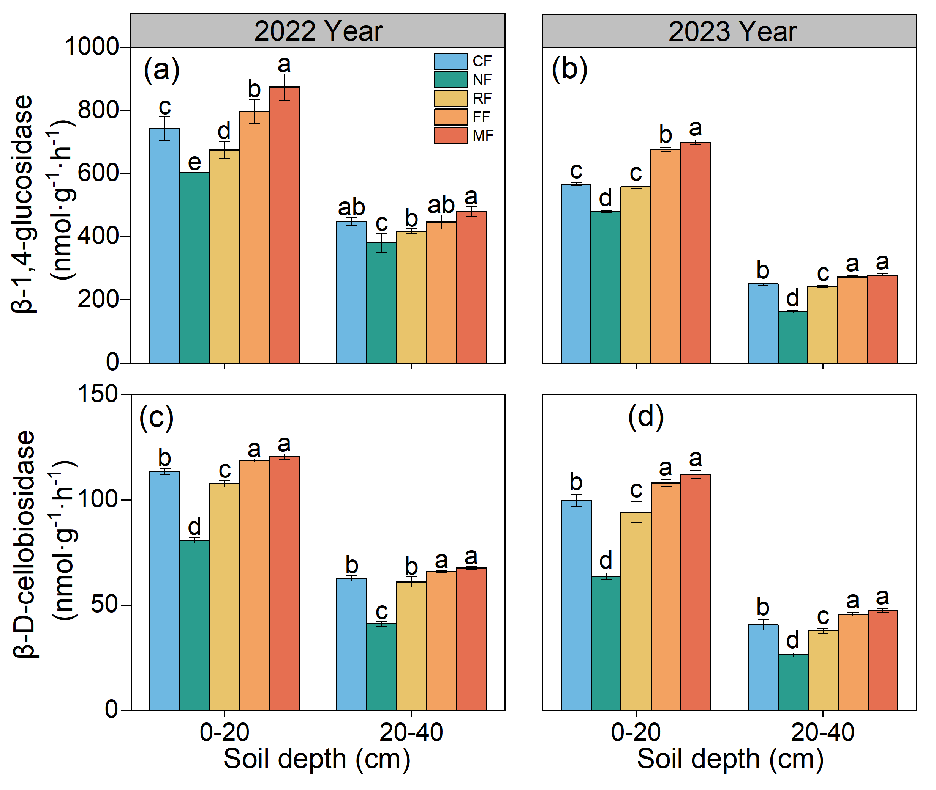
Fig. S1 Changes in soil C-related enzyme activities among different treatments. (a, b) BG, (c, d) CBH. (Mean and standard deviation are shown as error bars, n = 3).

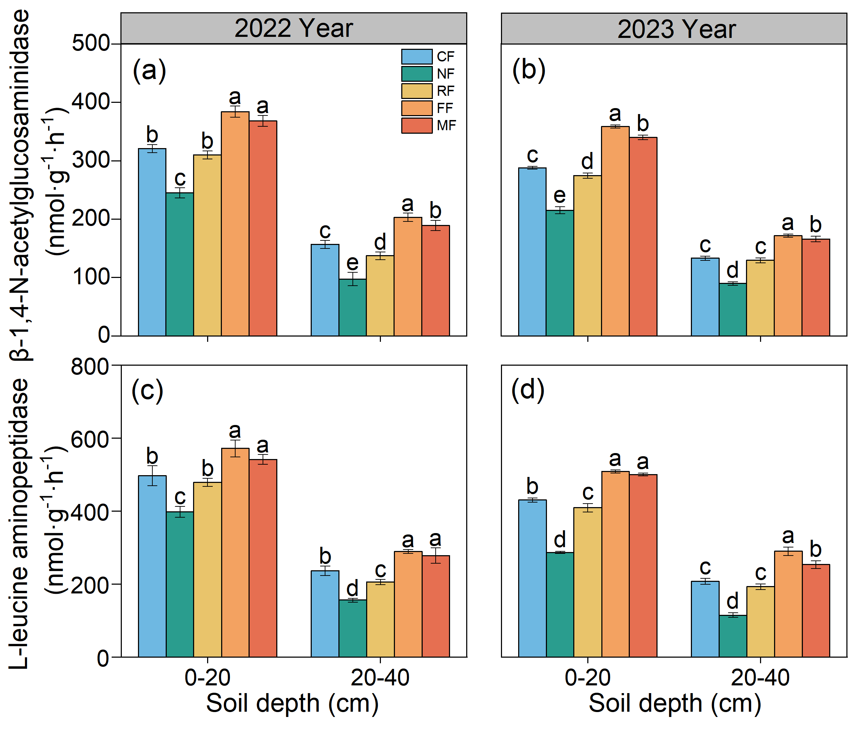
Fig. S2 Changes in soil N-related enzyme activities among different treatments. (a, b) NAG, (c, d) LAP. (Mean and standard deviation are shown as error bars, n = 3).

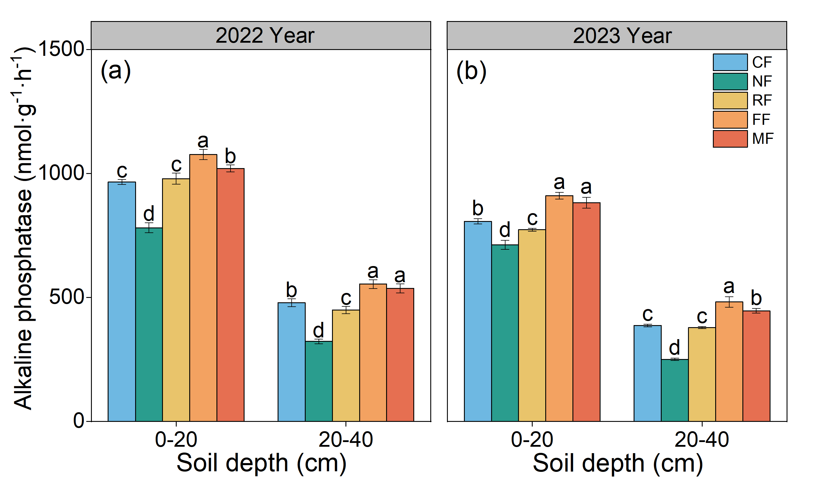
Fig. S3 Changes in soil alkaline phosphatase activity among different treatments. (Mean and standard deviation are shown as error bars, n = 3).
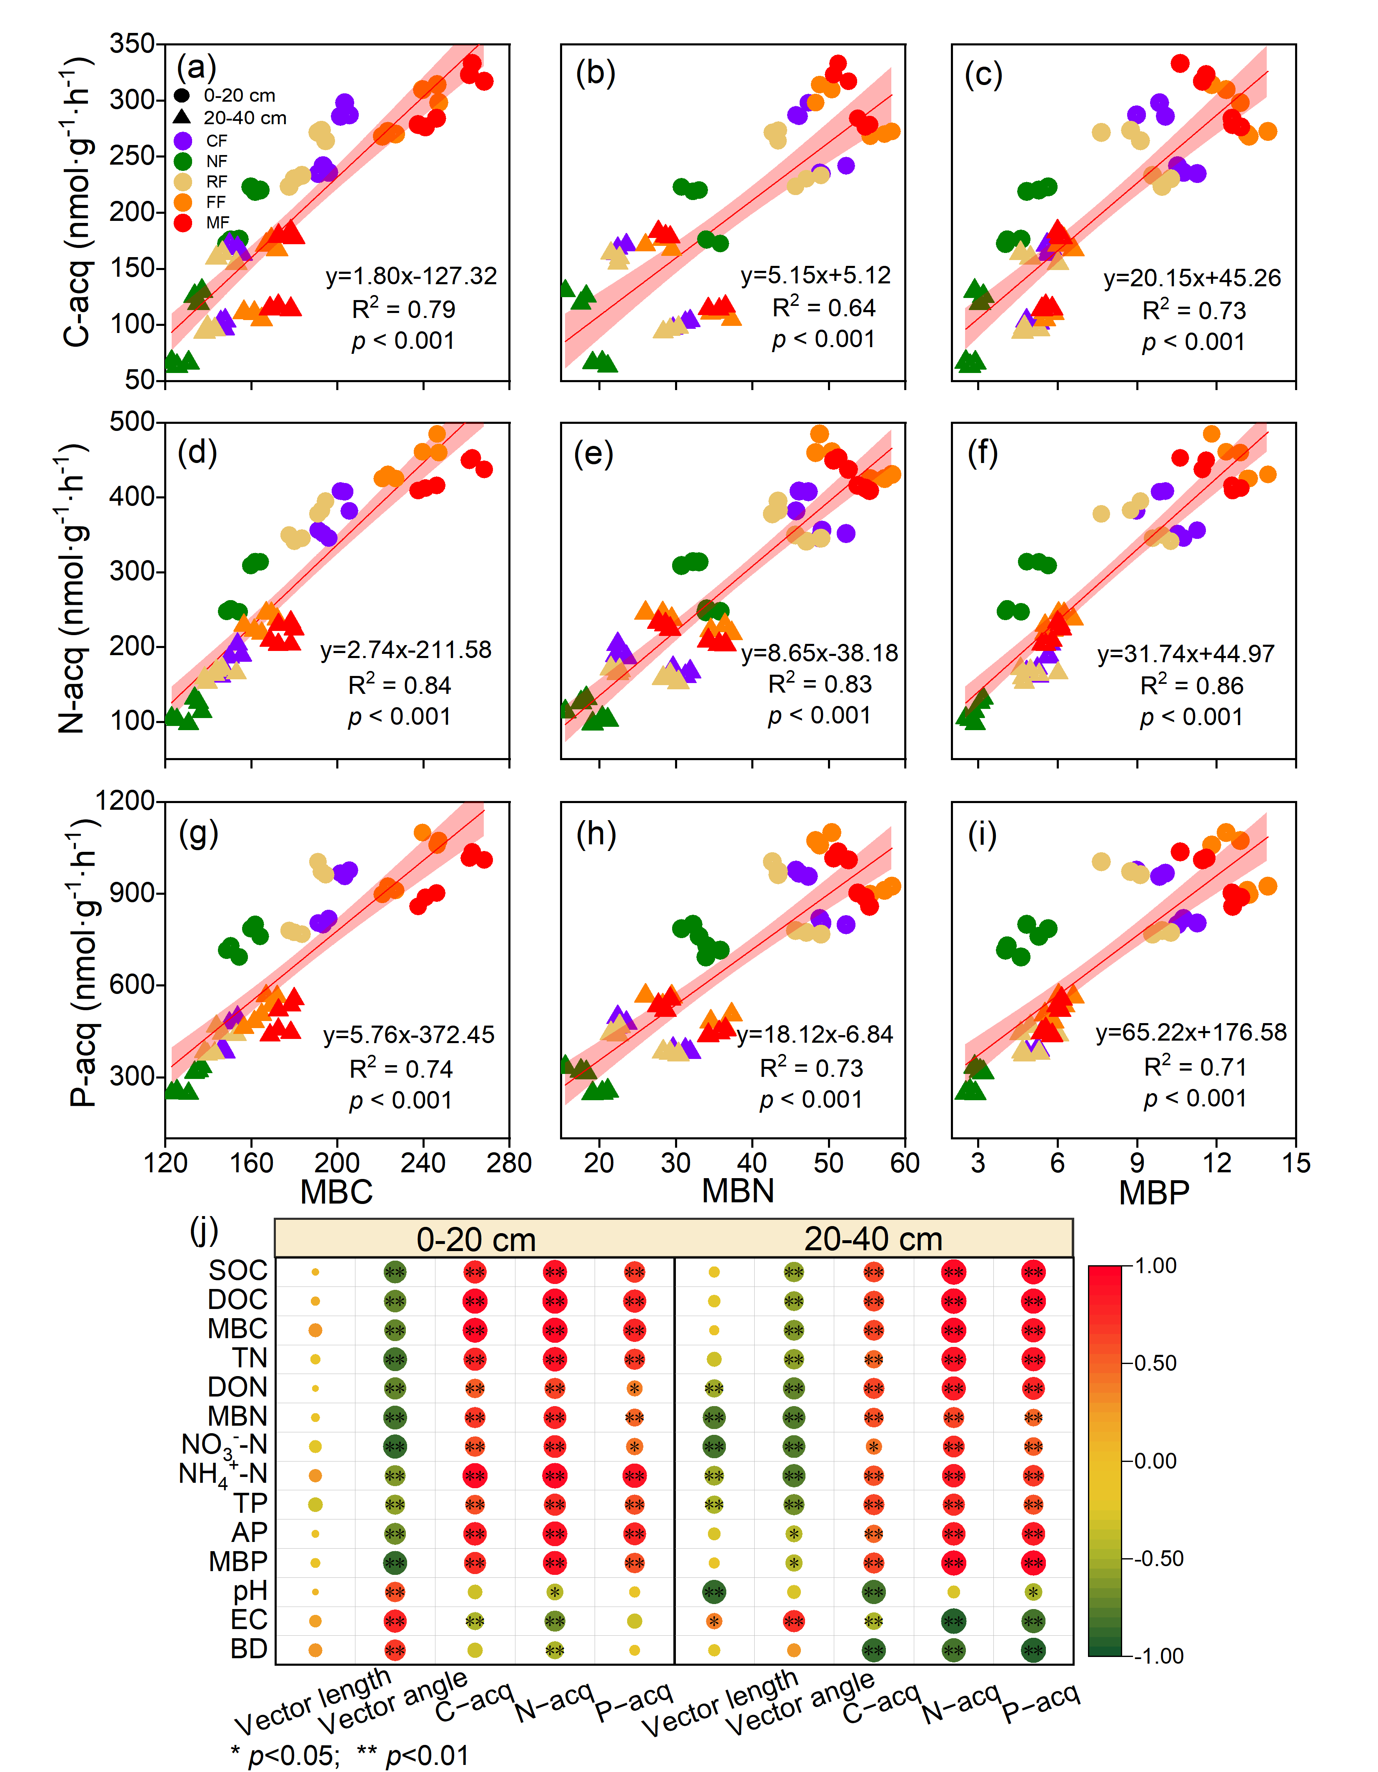
Fig. S4 Linear regression analysis to identify the relationships between soil C-acq, N-acq, and P-acq enzyme activities with MBC (a), (d), and (g), with MBN (b), (e), and (h), and with MBP (c), (f), and (i) in 2022 and 2023. Shaded areas show 95% confidence intervals of the fit. Pearson correlations among vector length, vector angle, C, N, and P acquisition enzyme activities and soil biochemical properties in 2022 and 2023 (j). Significance levels are as follows: * p < 0.05, ** p < 0.01.
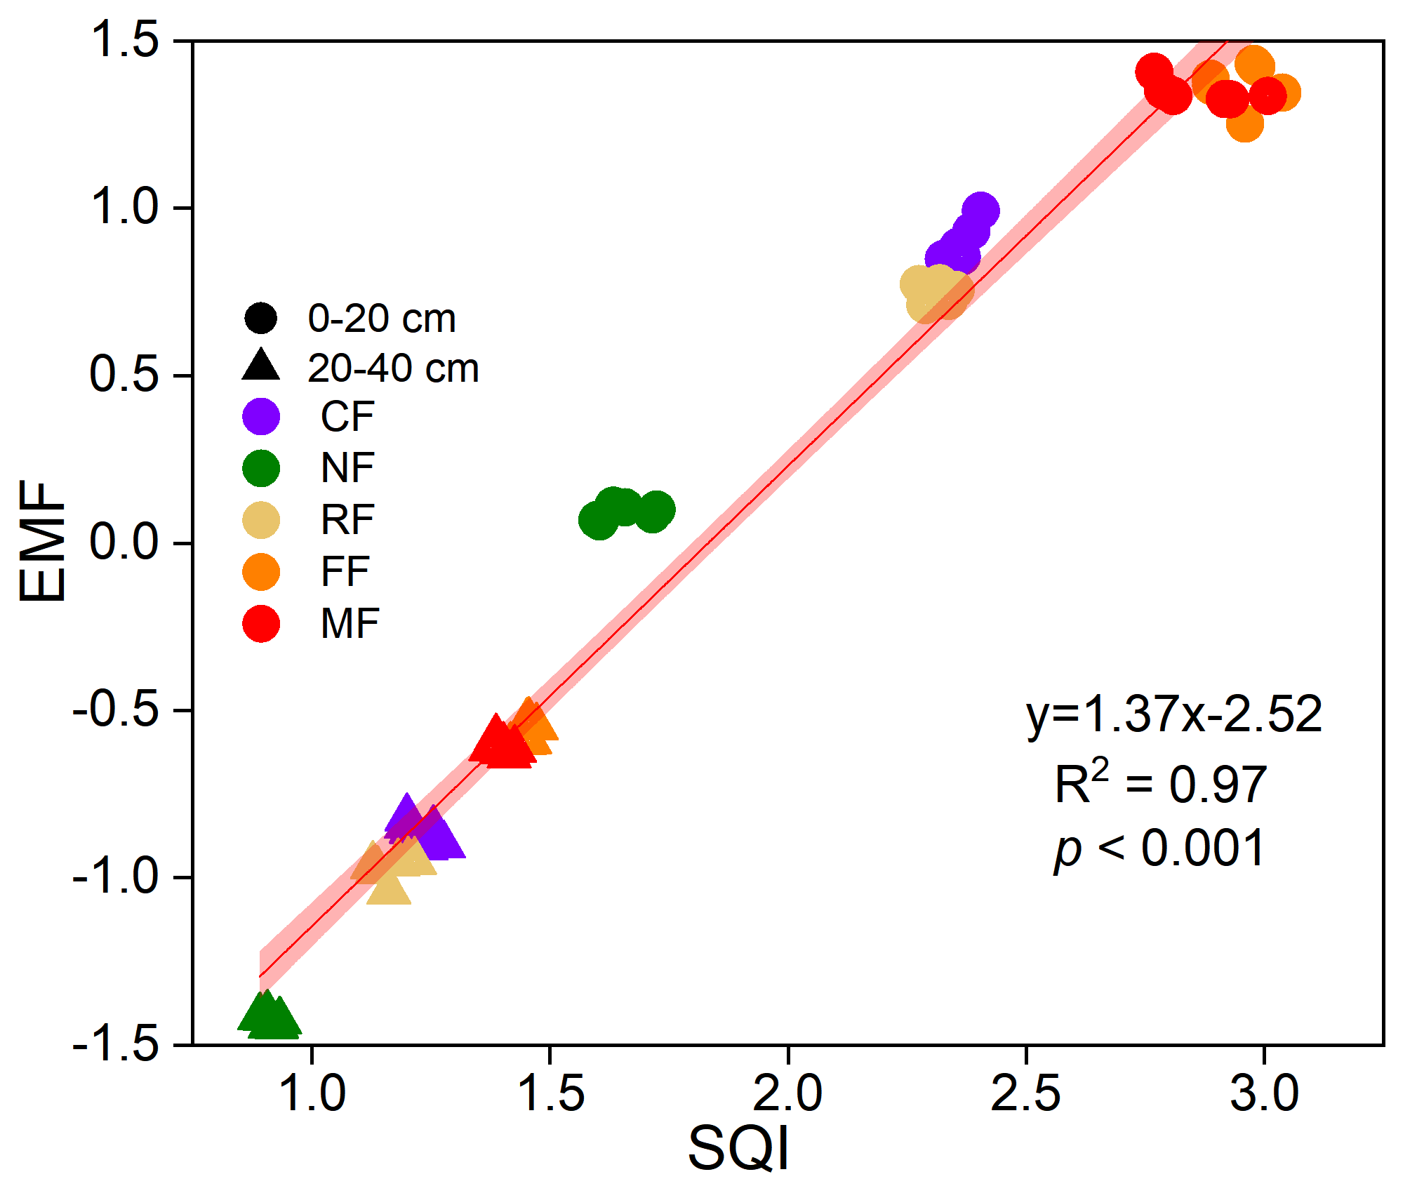
Fig. S5 Line regression analysis to identify the relationship of ecosystem multifunctionality (EMF) and soil quality index (SQI). Shaded areas show 95% confidence intervals of the fit.

