Supplementary materials

Contrasting patterns of protists on accumulation of fungal and bacterial necromass in arable soil: Result of a long-term field experiment

Yuncai Miaoª, Guiping Yeª, Tiehu Heª, Junji Yuanª, Deyan Liuª, Weixin Ding^{a,}*

ª State Key Laboratory of Soil and Sustainable Agriculture, Institute of Soil Science, Chinese Academy of Sciences, Nanjing 211135, China

*Corresponding author. Institute of Soil Science, Chinese Academy of Sciences, Nanjing 211135, China. Tel.: +86 25 8688 1527. Fax: + 86 25 8688 1000.
E-mail address: wxding@issas.ac.cn (W. Ding)
Determination of fungal and bacterial necromass:
Bacterial and fungal necromass were estimated according to Appuhn and Joergensen (2006) and Engelking et al. (2007). Briefly, fungal necromass C was determined by subtracting bacterial glucosamine from total glucosamine, assuming muramic acid and glucosamine occur at a 1 to 2 molar ratio in bacterial cells. The calculations were as follows:
Fungal necromass C (mg g⁻¹soil) = (glucosamine (mmol g⁻¹soil) −2×muramic acid (mmol g⁻¹soil )) ×179.2 g mol⁻¹ ×9 (1)
Bacterial necromass C (mg g⁻¹soil) = muramic acid (mg g⁻¹soil) ×45 (2)
where 179.2 is the molecular weight of glucosamine and 9 is the conversion value of fungal glucosamine to fungal necromass C, and 45 is the conversion factor for converting bacterial muramic acid into bacterial necromass C. Total microbial necromass C was estimated as the sum of fungal necromass C and bacterial necromass C.

Appuhn, A., Joergensen, R.G., 2006. Microbial colonisation of roots as a function of plant species. Soil Biology and Biochemistry 38, 1040–1051.
Engelking, B., Flessa, H., Joergensen, R.G., 2007. Shifts in amino sugar and ergosterol contents after addition of sucrose and cellulose to soil. Soil Biology and Biochemistry 39, 2111–2118.

Table S1 Basal characteristics of soils subjected to different fertilization.
Properties | Control | N | NL | NPS | NRS | NRR | NPM
pH | 4.96d | 5.20c | 6.59a | 5.13c | 5.16c | 5.17c | 5.58b
SOC (g C kg^{–1}) | 5.69d | 6.44c | 6.32c | 6.62bc | 7.13b | 6.76bc | 8.21a
TN (g N kg^{–1}) | 0.59d | 0.70c | 0.72c | 0.78b | 0.82ab | 0.82ab | 0.85a
AP (mg P kg^{–1}) | 5.25d | 15.00bc | 16.40b | 10.30c | 10.78c | 11.63bc | 156.73a
AK (mg K kg^{–1}) | 84.65c | 177.59b | 203.10a | 178.02b | 206.69a | 204.84a | 170.77b
DOC (mg C kg^{–1}) | 4.27b | 4.38b | 5.33b | 4.35b | 5.83b | 5.63b | 12.25a
DC_{o} (× 10⁻⁶ m² s⁻¹) | 12.58a | 10.71b | 9.95b | 9.96b | 8.20c | 9.70bc | 2.81d
Large macroaggregates  (%) | 7.80c | 8.20c | 8.15c | 9.14bc | 11.80b | 9.36bc | 30.60a
Fungal abundance  ( × 10⁶ g⁻¹) | 10.6c | 17.7b | 17.4b | 20.3b | 18.2b | 21.2b | 27.7a
Bacterial abundance  ( × 10⁸ g⁻¹) | 13.9ab | 11.5bc | 5.8c | 15.1ab | 16.3ab | 22.4a | 12.6bc
Data are represented as means (n = 3). Different letters within the same row indicate significant differences among treatments at p < 0.05.
SOC, soil organic carbon; TN, total nitrogen; AP, available phosphorus; AK, available potassium; DOC, dissolved organic carbon; DC_{o}, effective
diffusion coefficient of oxygen.

Table S2 Microbial necromass in soils subjected to different fertilization.
Treatment | Microbial necromass  (g C kg^{–1}) | Fungal necromass  (g C kg^{–1}) | Bacteria necromass  (g C kg^{–1}) | Fungal necromass/  bacteria necromass | Fungal necromass/  SOC (%) | Bacterial necromass/  SOC (%)
Control | 2.63f | 1.77f | 0.86c | 2.06b | 31.09b | 15.14a
N | 3.03d | 2.10d | 0.82bc | 2.29ab | 32.69ab | 14.35a
NL | 2.85e | 1.98e | 0.87c | 2.26ab | 31.29b | 13.85ab
NPS | 3.21c | 2.19cd | 1.02ab | 2.16b | 33.09a | 15.41a
NRS | 3.45ab | 2.39b | 1.07a | 2.24ab | 33.52a | 14.94a
NRR | 3.34bc | 2.27bc | 1.06a | 2.15b | 33.71a | 15.71a
NPM | 3.62a | 2.58a | 1.03ab | 2.51a | 31.50b | 12.58b
Data are represented as means (n = 3). Different letters within the same column indicate significant differences among treatments at p < 0.05.

Table S3 Effects of protistan community structure and Shannon index on fungal and bacterial properties through regression analysis.
Microbial properties | Protistan structure |  | Protistan Shannon index
Microbial properties | R² | p | R² | p
Fungal structure | 0.032 | 0.005 | 0.003 | 0.218
Fugal Shannon index | 0.026 | 0.011 | 0.000 | 0.712
Fungal abundance | 0.033 | 0.005 | 0.213 | 0.020
Bacterial structure | 0.254 | 0.000 | 0.065 | 0.000
Bacterial Shannon index | 0.059 | 0.000 | 0.311 | 0.005
Bacterial abundance | 0.023 | 0.016 | 0.000 | 0.589

Table S4 Global network properties of the cross-trophic networks in soils subjected to different fertilization.
Network properties | P-F network P-B network |  | P-B-F network
Number of nodes | 541 | 756 | 1018
Total links | 966 | 19471 | 19952
Positive links | 813 | 17489 | 17002
Negative links | 153 | 1982 | 2950
Average path length | 6.516 | 2.839 | 3.501
Diameter | 15 | 8 | 8.696
Degree centralization | 0.029 | 0.168 | 0.142
Clustering coefficient | 0.295 | 0.559 | 0.537
Betweenness centralization | 0.070 | 0.021 | 0.020
Closeness centralization | 0.003 | 0.018 | 0.004
Abbreviations: P-F network, protistan-fungal network; P-B network, protistan-bacterial network; P-B-F network, protistan-bacterial-fungal network.

Table S5 Regressions among the fungal and bacterial necromass with the relative abundance of the main ecological clusters from protistan-fungal network and protistan-bacterial network.
Microbial properties | Fungal necromass |  | Bacterial necromass
Microbial properties | R² | p | R² | p
Module 1 | 0.065 | 0.139 | 0.311 | 0.005
Module 2 | 0.000 | 0.715 | 0.000 | 0.867
Module 3 | 0.000 | 0.640 | 0.000 | 0.547
Module 4 | 0.000 | 0.539 | 0.000 | 0.907
Module 5 | 0.021 | 0.248 | ─ | ─
Module 6 | 0.278 | 0.008 | ─ | ─

Fig. S1 Principal-coordinate analysis (PCoA) of bacterial, fungal and protistan
communities based on Bray-Curtis distances.

Fig. S2 The differences in the Shannon index of protistan community in soils subjected to different fertilization.

Fig. S3 Relative abundance of protistan communities (at the phylum level) in soils subjected to different fertilization.

Fig. S4 Microbial community composition at the phylum level of the main clusters in protistan-fungal network.
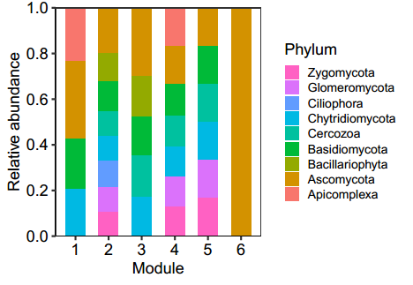

Fig. S5 Microbial community composition at the phylum level of the main clusters in protistan-bacteria network.
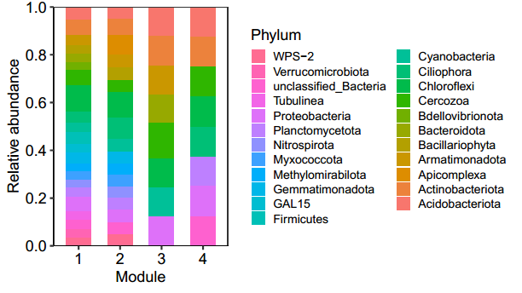

Fig. S6 The relative abundance of Gram-positive and Gram-negative bacteria among the top 10 bacterial taxa at the phylum level (a) and the relationship between bacterial necromass and abundance (copy number) of Gram-positive bacteria (b).

Fig. S7 The relationship between fungal necromass and abundance (copy number) of Ascomycota in Module 1 from the protistan-fungal network.

Fig. S8 The co-occurrence network of bacterial, fungal and protistan communities in the soil subjected to 27 year of fertilization. Red, blue and green nodes represent associated protistan, fungal and bacterial taxa, respectively. Node size is proportional to relative abundance. A connection represents a strong (Spearman's r > 0.7) and signiﬁcant (p < 0.01) correlation. Red and blue edges indicate positive and negative correlations, respectively.


