Supporting Information
Manuscript title: Response Patterns of Soil Protist Community to Long-term Precipitation Increased and Nitrogen Addition
Author Names:
Yaru Nie^{1,4 5}, Jiajia Zhang^{3,5}, Binghai Lei^{1,2}, Zhongjie Sun^{1,4}, Junqiang Zheng^{1,4}, Yanyan Yu^{1,4*}, Shiqiang Wan^{3*}, Shijie Han^{1,2*}
¹School of Life Sciences, Henan University, Kaifeng 475004, Henan, China
²School of Life Sciences, Qufu Normal University, Qufu 273100, Shandong, China
³School of Life Sciences, Institute of Life Science and Green Development, Hebei University, Baoding, Hebei 071002, China.
⁴Yellow River Floodplain Ecosystems Research Station, School of Life Sciences, Henan University, Kaifeng 475004 Henan, China
*Corresponding authors: Yanyan Yu, Shiqiang Wan, Shijie Han
- mails: Yanyan Yu: yuyanyan@henu.edu.cn
This file includes:
Table S1 to S5
Fig S1 to S6

Table S1 Results (F-values) of two-way ANOVAs on the effects of increased precipitation (P) and N (N) addition, and their interactions on soil and plant parameters.
Treatment | SWC | pH | NH₄⁺-N | NO₃⁻-N | AN | TC | TN | C/N | TP | AP | Grass Cover | Forb Cover | Cover | AGB | BGB
N | 0.094 | 5.852*↓ | 1.426 | 54.886***↑ | 38.232*↑ | 0.001 | 0.502 | 0.730 | 2.500 | 12.573***↓ | 7.534**↑ | 6.687**↓ | 9.638**↑ | 4.502*↑ | 2.623
P | 6.133*↑ | 0.496 | 1.592 | 0.556 | 0.695 | 0.007 | 0.054 | 0.090 | 0.260 | 0.063 | 0.070 | 0.805 | 0.080 | 11.685***↑ | 17.345***↑
N*P | 0.115 | 0.141 | 0.025 | 0.939 | 1.145 | 0.136 | 0.003 | 0.060 | 1.099 | 2.715 | 1.229 | 1.348 | 9.992**↑ | 11.685***↑ | 4.336*↑
Notes: SWC, soil water content; soil pH; NH₄⁺-N, soil ammonium nitrogen; NO₃–-N, soil nitrate nitrogen; AN, available nitrogen; TC, total carbon; TN, total nitrogen; TP, total phosphorus; AP, available phosphorus; AGB, aboveground biomass; BGB, belowground biomass. Number of replicates (n = 6). Significance levels: * P < 0.05, ** P < 0.01, *** P < 0.001; ↑: significantly increase；↓: significantly decrease.

Table S2 Effects of different treatments on the relative abundances of key genera of protists.
Treat | Chlamydaster | Platyophrya | Pseudocyrtolophosis | Bresslauides | Gonostomum | Monocystis | Pseudoplatyophrya | Hartmannella
C | 0.345±0.045 | 0.204±0.028 | 0.123±0.017 | 0.076±0.012 | 0.087±0.022 ab | 0.128±0.030 a | 0.063±0.008 | 0.062±0.014
N | 0.324±0.040 | 0.187±0.035 | 0.155±0.016 | 0.076±0.011 | 0.120±0.020 a | 0.031±0.008 b | 0.072±0.010 | 0.052±0.010
P | 0.292±0.030 | 0.214±0.019 | 0.180±0.022 | 0.089±0.013 | 0.043±0.005 b | 0.068±0.022 ab | 0.070±0.010 | 0.072±0.009
NP | 0.248±0.028 | 0.215±0.033 | 0.132±0.018 | 0.095±0.014 | 0.106±0.031 a | 0.090±0.031 ab | 0.062±0.008 | 0.082±0.011

Notes: C: Control, N: N addition, P: increased precipitation, NP: N addition and increased precipitation.

Table S3 The PCR reaction system
Reagent | Amounts
2x Premix Taq | 25 μl
Primer-F (10 μM) | 1 μl
Primer-R (10 μM) | 1 μl
DNA | 50 ng
Nuclease-free water | Add to 50 μl

Table S4 Permutational multivariate analysis of variance (PERMANOVA), based on Bray-Curtis distances, of the Soil protist community in different treatments.
Treatments | Df | Sum of Squares | R² | F | P
N | 1 | 0.204 | 0.017 | 1.202 | 0.096
P | 1 | 0.244 | 0.020 | 1.441 | 0.015*
N:P | 1 | 0.159 | 0.013 | 0.935 | 0.613
Residual | 68 | 11.526 | 0.950
Total | 71 | 12.133 | 1.000
Notes: C: Control, N: N addition, P: increased precipitation, N:P: N × P interaction. Significance levels: * P < 0.05, ** P < 0.01, *** P < 0.001.

Table S5 Permutational multivariate analysis of variance (PERMANOVA), based on Bray-Curtis distances, of the Soil protist community in the effects of different treatments
Treatments | Df | Sum of Squares | F | R² | P
NP vs N | 1 | 0.183 | 1.073 | 0.031 | 0.261
NP vs P | 1 | 0.182 | 1.041 | 0.030 | 0.320
NP vs C | 1 | 0.234 | 1.343 | 0.038 | 0.044*
N vs P | 1 | 0.214 | 1.299 | 0.037 | 0.039*
N vs C | 1 | 0.181 | 1.099 | 0.031 | 0.217
P vs C | 1 | 0.219 | 1.306 | 0.037 | 0.043*
Notes: C: Control, N: N addition, P: increased precipitation, NP: N addition and increased precipitation. Significance levels: * P < 0.05, ** P < 0.01, *** P < 0.001.

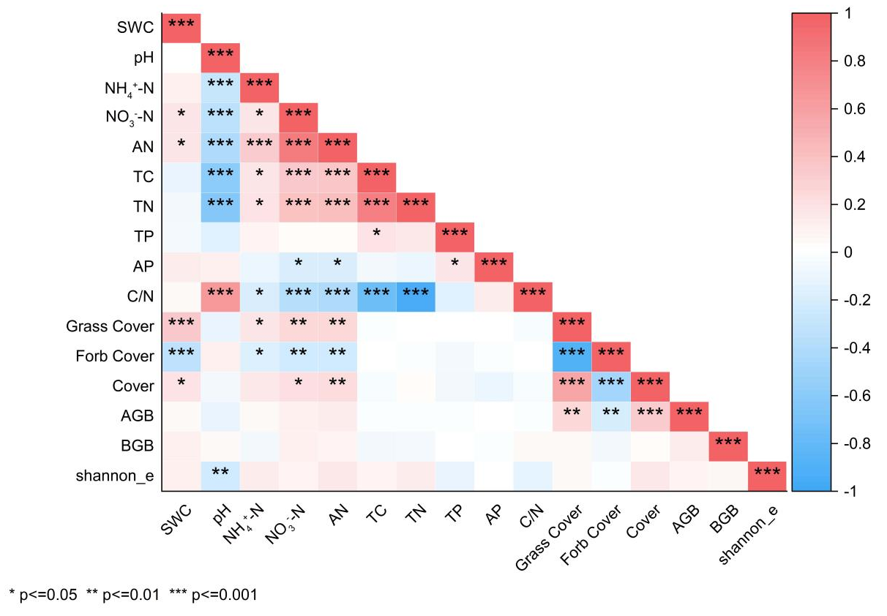
Figure S1 Correlation coefficient matrix of soil physicochemical properties and plant community characteristics. SWC soil water content; soil pH; NH₄⁺-N, soil ammonium nitrogen; NO₃–-N, soil nitrate nitrogen; AN, available nitrogen; TC, total carbon; TN, total nitrogen; TP, total phosphorusroot; AP, available phosphorusroot; AGB, aboveground biomass; BGB, belowground biomass; Cover, Cover of the plant community; shannon_e, shannon_e of plant community. *** means the significant correlation at P < 0.001, ** means the significant correlation at P < 0.01, * means the significant correlation at P < 0.05.

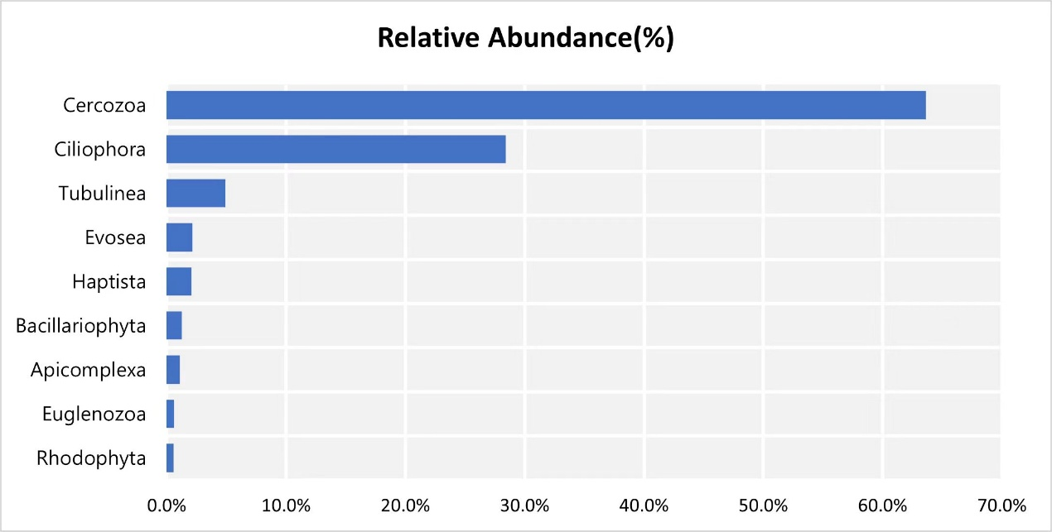
Figure S2 the relative abundance of protist supergroups.

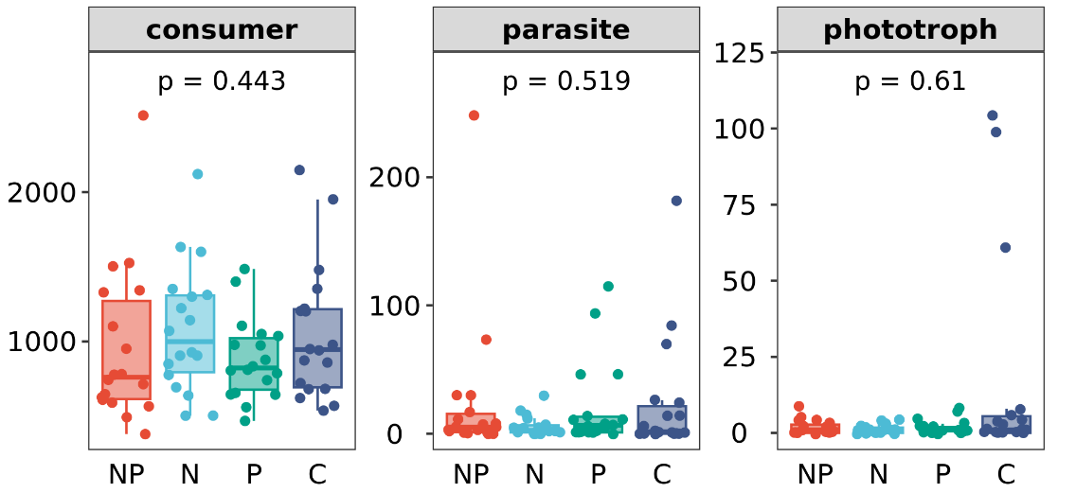
Figure S3 Effects of C, P, N, and NP on protist life history strategy (consumer, parasite, and phototroph). C: Control, N: N addition, P: increased precipitation, NP: N addition and increased precipitation. Significance levels of each predictor are *P < 0.05, **P < 0.01.

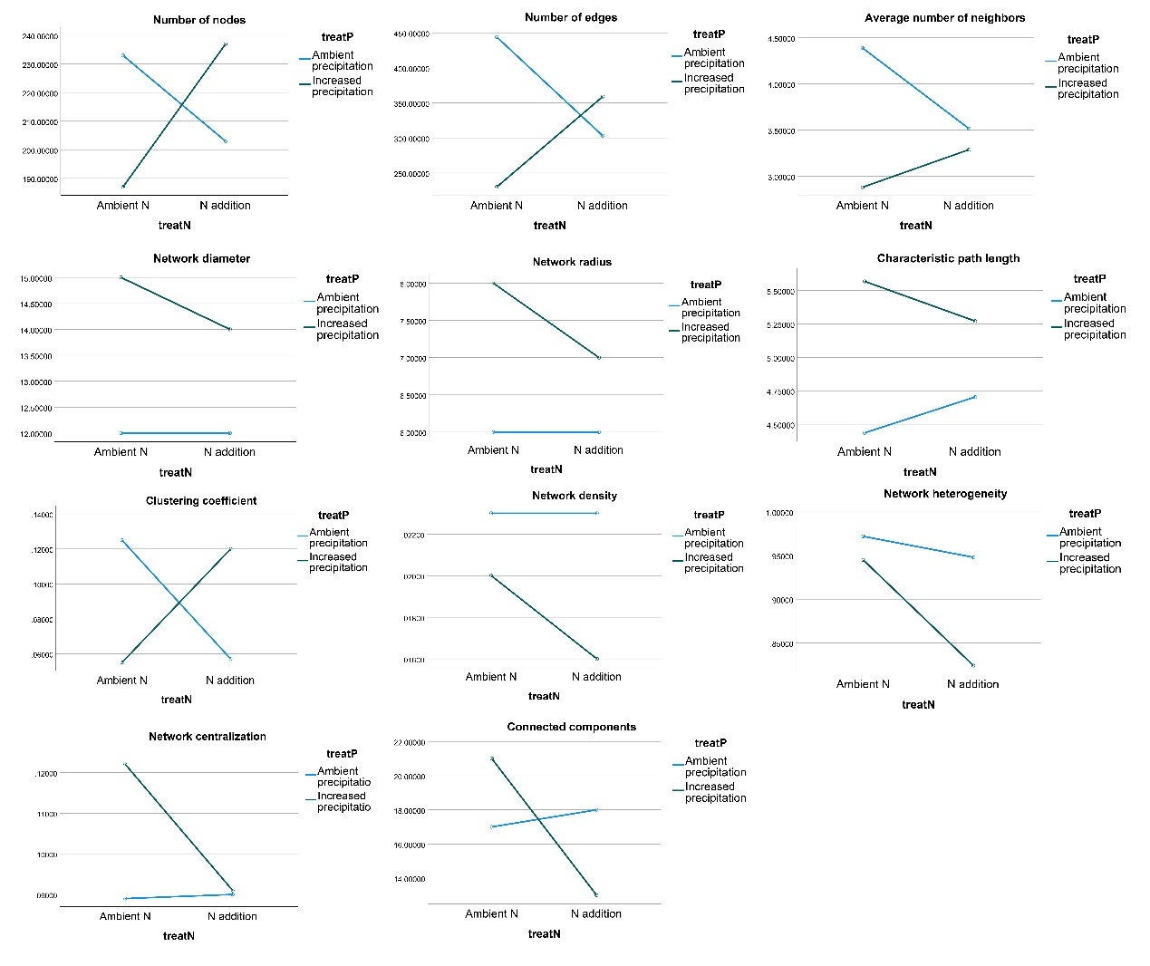
Figure S4 Interactive effects of nitrogen addition and increased precipitation on network topological parameters. Notes:The horizontal axis represents nitrogen addition levels (ambient vs. added), and the lines of different colors represent ambient precipitation and increased precipitation, respectively.

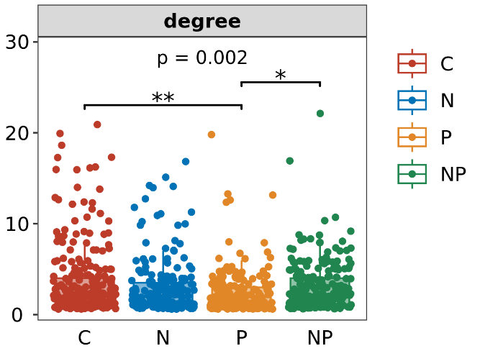
Figure S5 Boxplot of degree in protist co-occurrence networks among different treatments. The boxplot shows the median, interquartile range, and outliers. Asterisks indicate the significance levels of differences between treatments (Kruskal-Wallis test; * P<0.05, ** P<0.01, *** P<0.001). C: control; N: nitrogen addition; P: increased precipitation; NP: combined treatment.

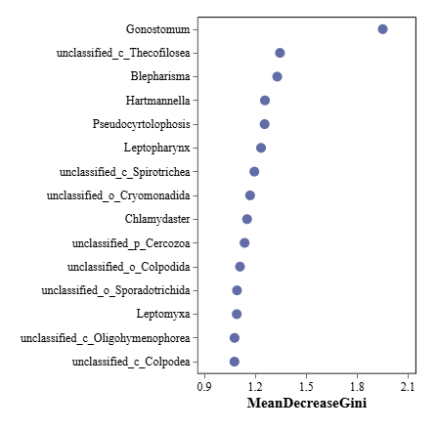
Figure S6 Ranking of predictor variables by their importance in the Random Forest model, as measured by the Mean Decrease Gini index.

