1. Extraction of genome DNA and amplicon generation
DNA was extracted using DNA extraction kit for the corresponding sample. The concentration and purity were measured using the NanoDrop One (Thermo Fisher Scientific, MA, USA). 16S rRNA gene and the ITS fragment were amplified using specific primers (799F: AACMGGATTAGATACCCKG and 1193R: ACGTCATCCCCACCTTCC for bacteria; ITS3-F: GCATCGATGAAGAACGCAGC and ITS4-R: TCCTCCGCTTATTGATATGC for fungi). PCR reactions, containing 25 μl 2x Premix Taq (Takara Biotechnology, Dalian Co. Ltd., China), 1 μl each primer (10 μM) and 3 μl DNA (20 ng/μl) template in a volume of 50 μl, were amplified by thermocycling: 5 min at 94°C for initialization; 30 cycles of 30 s denaturation at 94°C, 30 sannealing at 52°C, and 30 s extension at 72°C; followed by 10 min final elongation at 72°C. The PCR instrument was BioRad S1000 (Bio-Rad Laboratory, CA, USA). The length and concentration of the PCR product were detected by 1% agarose gel electrophoresis. PCR products was mixed in equidensity ratios according to the GeneTools Analysis Software.
2. Library preparation and sequencing
Sequencing libraries were generated using NEBNext® Ultra™ II DNA Library Prep Kit for Illumina® (New England Biolabs, MA, USA) following manufacturer's recommendations and index codes were added. The library quality was assessed on the Qubit@ 2.0 Fluorometer (Thermo Fisher Scientific, MA, USA). At last, the library was sequenced on an Illumina Nova6000 platform and 250 bp paired-end reads were generated (Guangdong Magigene Biotechnology Co.,Ltd. Guangzhou, China).
3. Sequencing data processing
Fastp (https://github.com/OpenGene/fastp) was used to control the quality of the Raw Data by sliding window. The primers were removed by using cutadapt software (https://github.com/marcelm/cutadapt/) according to the primer information at the beginning and end of the sequence to obtain the paired-end Clean Reads. Paired-end clean reads were merged using usearch-fastq_mergepairs (http://www.drive5.com/usearch/) according to the relationship of the overlap between the paired-end reads, when at least 16 bp overlap the read generated from the opposite end of the same DNA fragment, the maximum mismatch allowed in overlap region was 5 bp, and the spliced sequences were called Raw Tags. Fastp (https://github.com/OpenGene/fastp) was used to control the quality of the Raw Data by sliding window to obtain the paired-end Clean Tags. During the clustering, usearch could remove the chimera sequence and singleton OTU at the same time. The taxonomic assignment of the 16S rRNA gene and ITS fragment sequencies was performed based on the SILVA database and UNITE database, respectively. The raw reads were deposited into the NCBI Sequence Read Archive database under the accession code PRJNA1101723.

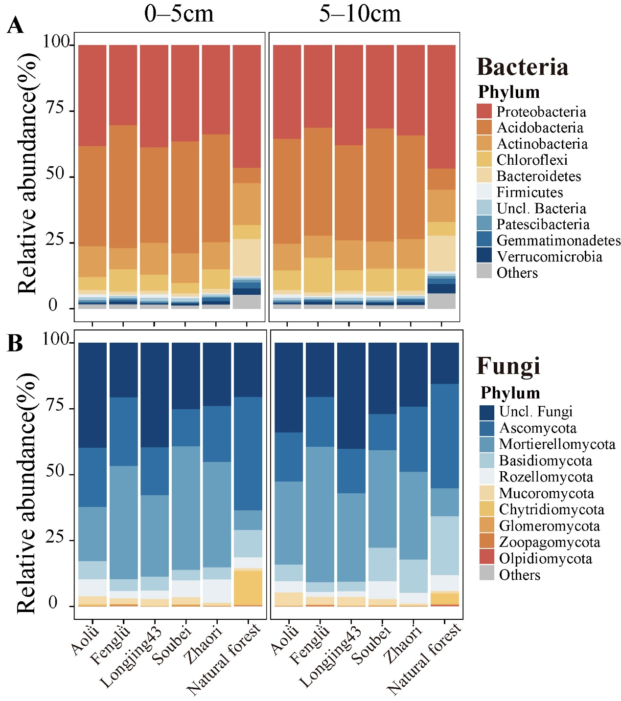
Figure S1 The relative abundance of soil microbial communities at phylum level in natural forest and various tea gardens on two soil layers (0–5 cm and 5–10 cm) based on 16S and ITS sequencing. (A) Bacterial community. (B) Fungal community.

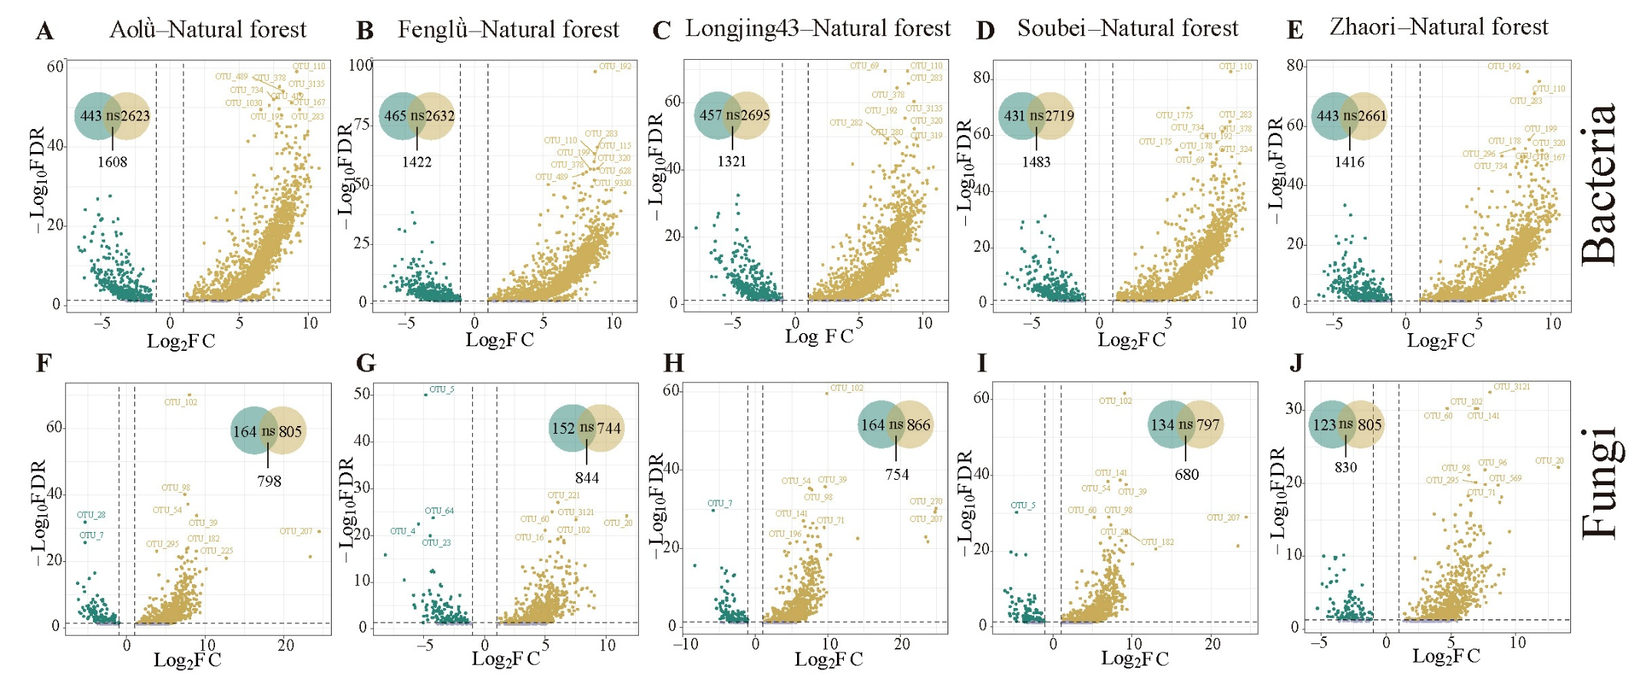
Figure S2 The microbial enrichment analysis based on 16S and ITS on OTU-level, with the venn diagram which shows the enriched and depleted OTUs between natural forest and different tea gardens. (A-E) Bacterial enrichment analysis. (F-J) Fungal enrichment analysis.
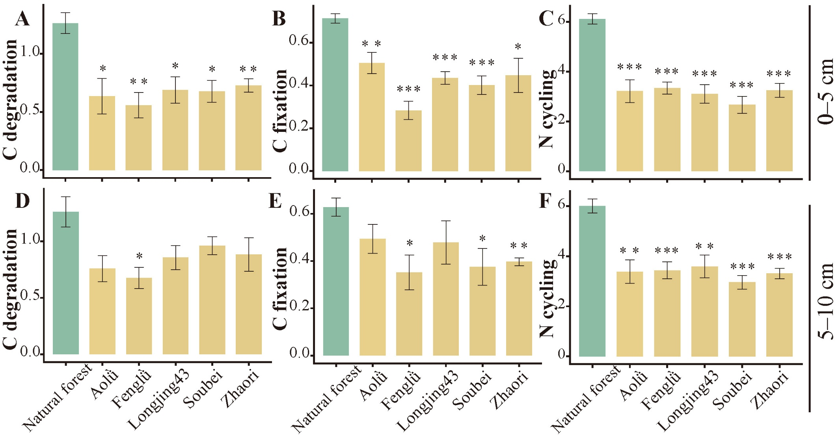
Figure S3 The relative abundance of predicted soil bacterial functional groups in natural forests and various tea gardens on two soil layers (0–5 cm and 5–10 cm) based on 16S. C degradation: Carbon degradation, C fixation: Carbon fixation, N cycling: Nitrogen cycling. *0.01 ≤ P < 0.05. **0.001 ≤ P < 0.01. ***P < 0.001
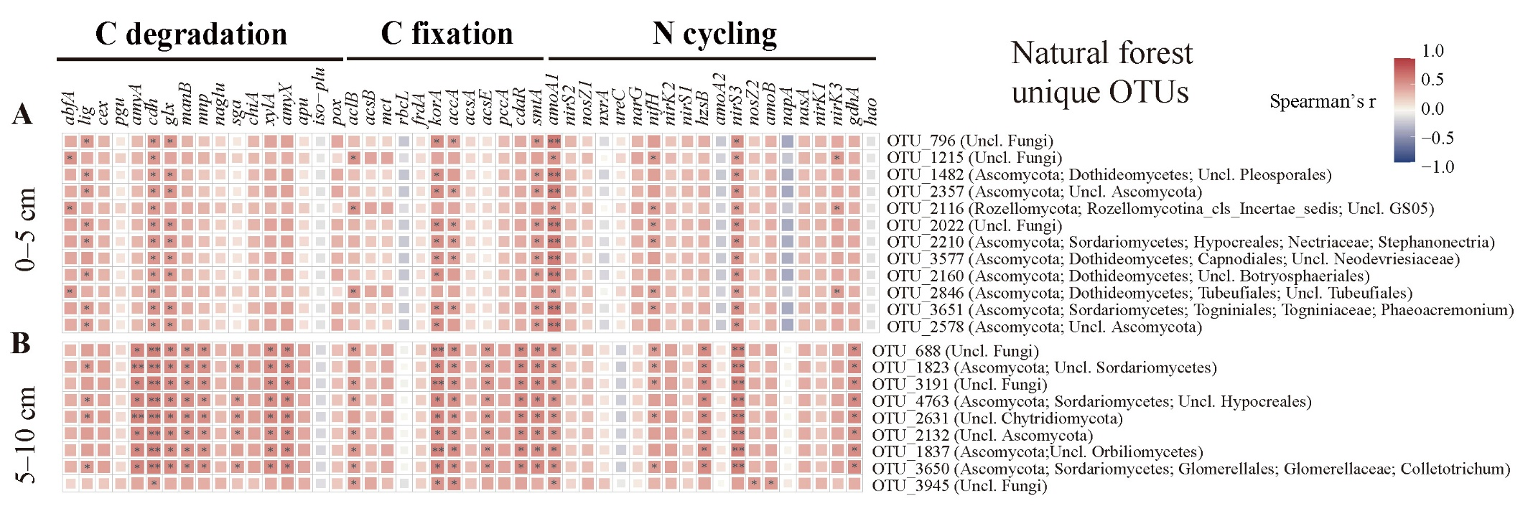
Figure S4 The relationships between fungal unique OTUs with their phyla and soil functional genes related with carbon degradation, carbon fixation and nitrogen cycling on two soil layers (0-5cm, 5-10cm). (A-B) The heatmaps between fungal unique OTUs in natural forest along with their corresponding phyla and soil functional genes on each layer. There were no unique fungal OTUs were found following the standard. See statistical analysis section. C degradation: Carbon degradation, C fixation: Carbon fixation, N cycling: Nitrogen cycling. *: 0.01 ≤ P < 0.05. **: 0.001 ≤ P < 0.01. ***: P < 0.001.
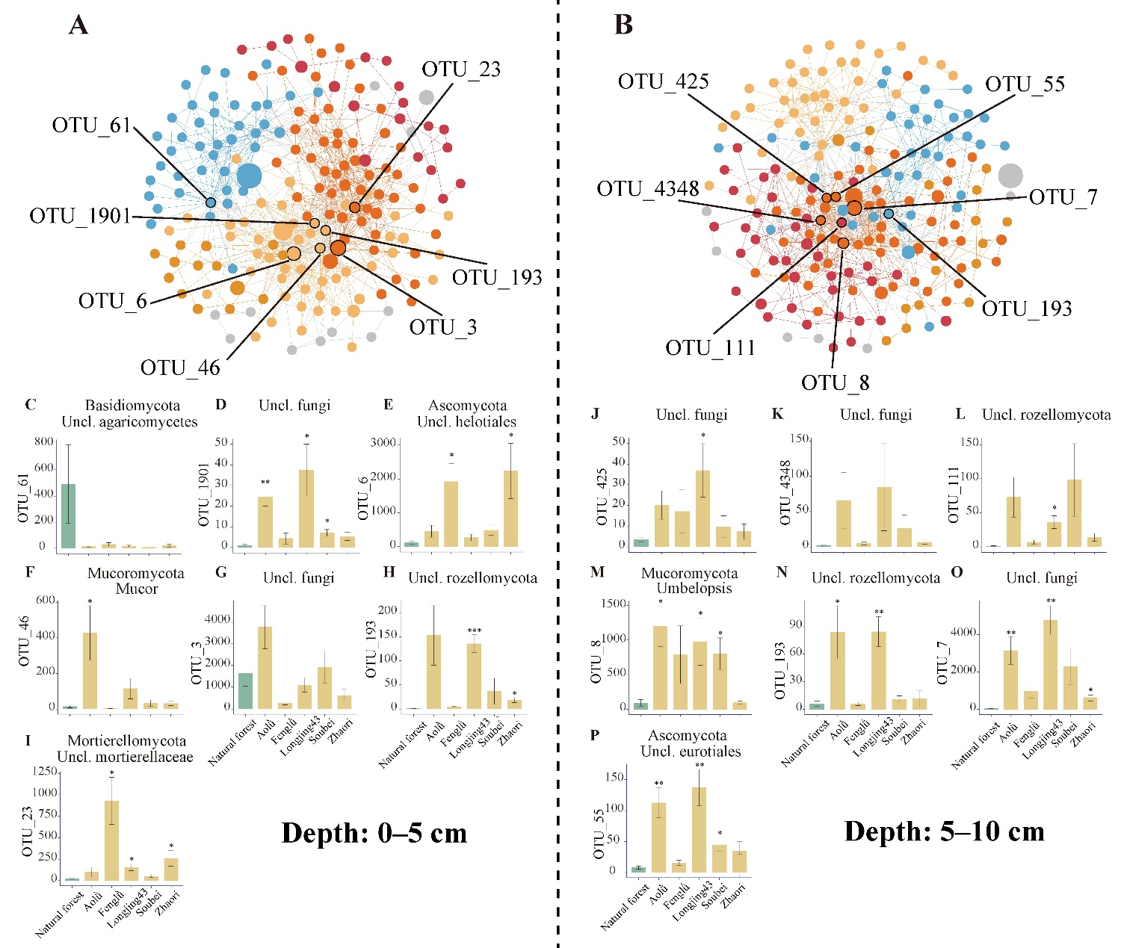
Figure S5 The co-occurrence network and potential core OTUs of fungal community in tea gardens. (A-B) The co-occurrence fungal networks in tea gardens. Each node represented an OTU. Different colour represented different modules in the network. The OTUs listed in the network were the potential core OTUs. (C-O) The relative abundance of potential core OTUs between natural forest and each tea gardens. *: 0.01 ≤ P < 0.05. **: 0.001 ≤ P < 0.01. ***: P < 0.001

