Supporting Information for
Long-term organic fertilization fosters modular microbial networks: a global analysis of soil bacteriome responses
Authors: Shu-Le Li ^{a, b, c}, Cai Chen ^{c, d}, Xiang-Yu Dai ^{a, c, e}, Hai-song Yan ^{b,d}, Yao-Yang Xu ^{a, f}, Meili Feng ^{e,*}, Jun He ^{g}, Jianfeng Ren ^{h, i}, Wan-Ying Xie ^{j,*}, Fang-Jie Zhao ^{j}

Affiliations:
ª State Key Laboratory for Ecological Security of Regions and Cities, Ningbo Observation and Research Station, Institute of Urban Environment, Chinese Academy of Sciences, Xiamen 361021, China
^{b} University of Chinese Academy of Sciences, Beijing 100049, China
^{c} Tsientang Institute for Advanced Study, Hangzhou 310024, China
^{d} State Key Laboratory of Regional and Urban Ecology, Research Center for Eco-Environmental Sciences, Chinese Academy of Sciences, Beijing, 100085, China
^{e} School of Geographical Sciences, Faculty of Science and Engineering, University of Nottingham Ningbo China, Ningbo 315100, China
^{f} Zhejiang Key Laboratory of Pollution Control for Port-Petrochemical Industry, CAS Haixi Industrial Technology Innovation Center in Beilun, Ningbo 315830, China
^{g} Department of Chemical and Environmental Engineering, University of Nottingham Ningbo China, Ningbo, 315100, China
^{h} The Digital Port Technologies Lab, School of Computer Science, University of Nottingham Ningbo China, 199 Taikang East Road, Ningbo 315100, China
^{i} Nottingham Ningbo China Beacons of Excellence Research and Innovation Institute, University of Nottingham Ningbo China, 199 Taikang East Road, Ningbo 315100, China
^{j} Jiangsu Key Laboratory for Organic Waste Utilization, Jiangsu Collaborative Innovation Center for Solid Organic Waste Resource Utilization, College of Resources and Environmental Sciences, Nanjing Agricultural University, Nanjing 211800, China

*Corresponding author: Wan-Ying Xie (wyxie@njau.edu.cn); Meili Feng (Meili.Feng@nottingham.edu.cn)
Number of Pages: 59
Number of Figures: 5
Number of Tables: 27
Table of Contents
1. Supplementary Figures 4
Fig. S1 The geographic distribution of the 16S rRNA soil samples in this study. 4
Fig. S2 Bacterial alpha diversity (Richness index) among treatments across different variable ranges (organized by rows): inorganic fertilization (IF) (a-d), inorganic-organic fertilization (IFOF) (e-h), and organic fertilization (OF) (i-l). 5
Fig. S3 Bacterial alpha diversity (Shannon index) among treatments in different variable ranges (organized by rows): IF (a-d), IFOF (e-h), and OF (i-l). 6
2. Supplementary Tables 7
Table S1. Bacterial relative abundance at the phylum level under inorganic fertilization practices, grouped by different soil total nitrogen levels (unit: g·kg⁻¹). 7
Table S2. Bacterial relative abundance at the phylum level under inorganic fertilization practices, grouped by different soil organic carbon levels (unit: g·kg⁻¹). 9
Table S3. Bacterial relative abundance at the phylum level under inorganic fertilization practices, grouped by different pH levels. 11
Table S4. Bacterial relative abundance at the phylum level under inorganic fertilization practices, grouped by different duration years. 13
Table S5. Bacterial relative abundance at the phylum level under inorganic-organic fertilization practices, grouped by different soil total nitrogen levels (unit: g·kg⁻¹). 15
Table S6. Bacterial relative abundance at the phylum level under inorganic-organic fertilization practices, grouped by different soil organic carbon levels (unit: g·kg⁻¹). 17
Table S7. Bacterial relative abundance at the phylum level under inorganic-organic fertilization practices, grouped by different soil pH levels. 19
Table S8. Bacterial relative abundance at the phylum level under inorganic-organic fertilization practices, grouped by different duration years. 21
Table S9. Bacterial relative abundance at the phylum level under organic fertilization practices, grouped by different soil total nitrogen levels (unit: g·kg⁻¹). 23
Table S10. Bacterial relative abundance at the phylum level under organic fertilization practices, grouped by different soil organic carbon levels (unit: g·kg⁻¹). 25
Table S11. Bacterial relative abundance at the phylum level under organic fertilization practices, grouped by different soil pH levels. 27
Table S12. Bacterial relative abundance at the phylum level under organic fertilization practices, grouped by different duration years. 29
Table S13. Number of microorganisms detected exclusively in inorganic fertilization samples, organized by phylum level. 31
Table S14. Number of microorganisms detected exclusively in inorganic-organic fertilization samples, organized by phylum level. 32
Table S15. Number of microorganisms detected exclusively in organic fertilization samples, organized by phylum level. 33
Table S16. Data for the variables used in the random forest model developed to predict differences between inorganic fertilization (IF) and control (CK) groups. 34
Table S17. Data for the variables used in the random forest model developed to predict differences between inorganic-organic fertilization (IFOF) and control (CK) groups. 38
Table S18. Statistical data for the variables used in the random forest model developed to predict differences between organic fertilization (OF) and control (CK) groups. 43
Table S19. Key results from the threshold indicator taxa analysis (TITAN), illustrating the response of keystone taxa to soil organic carbon (unit: g·kg⁻¹). 46
Table S20. Key results from the threshold indicator taxa analysis (TITAN), illustrating the response of keystone taxa to soil total nitrogen (unit: g·kg⁻¹). 47
Table S21. Key results from the threshold indicator taxa analysis (TITAN), illustrating the response of keystone taxa to organic fertilization addition (unit: t·yr⁻¹·ha⁻¹). 48
Table S22. Key results from the threshold indicator taxa analysis (TITAN), illustrating the response of keystone taxa to soil pH. 49
Table S23. Key results from the threshold indicator taxa analysis (TITAN), illustrating the response of keystone taxa to mean annual temperature, MAT (℃). 50
Table S24. Key results from the threshold indicator taxa analysis (TITAN), illustrating the response of keystone taxa to nitrogen fertilization addition (kg·yr⁻¹·ha⁻¹). 51
Table S25. PERMANOVA results for the effects of fertilization type and environmental variables on bacterial community composition (Bray-Curtis distance, 9,999 permutations). 52
Table S26. Type III ANOVA results for the interaction between fertilization type and soil pH class on Chao1 alpha diversity index. 53
Table S27. Type III ANOVA results for the interaction between fertilization type and fertilization-duration class on Chao1 alpha diversity index. 54

Supplementary Figures
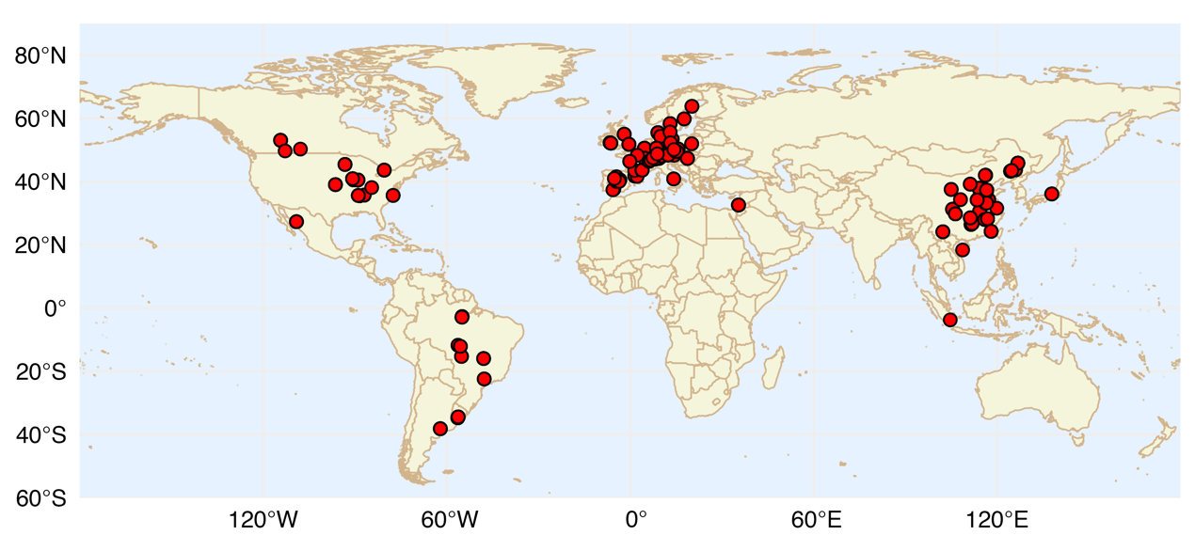

Fig. S1 The geographic distribution of the 16S rRNA soil samples in this study.
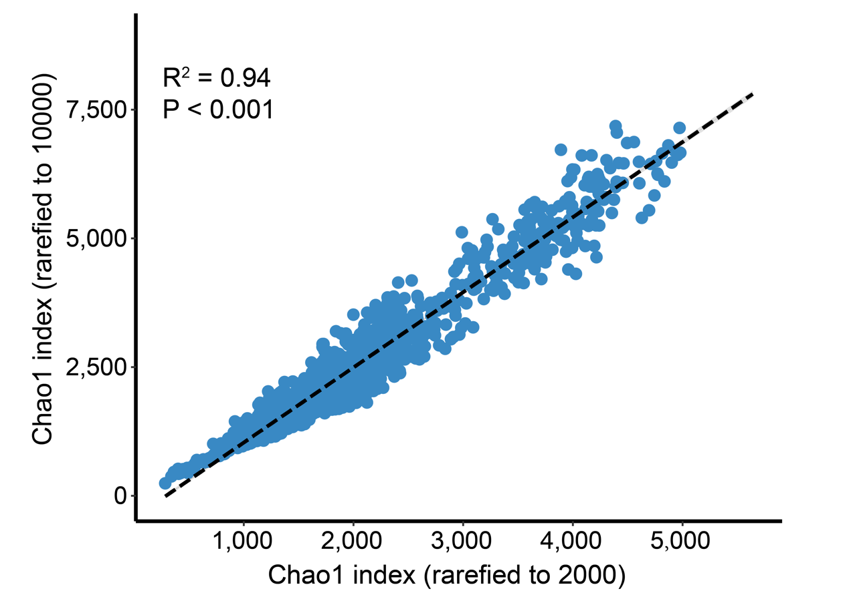

Fig. S2 Comparison of Chao1 index obtained at 2,000 and 10,000 reads.

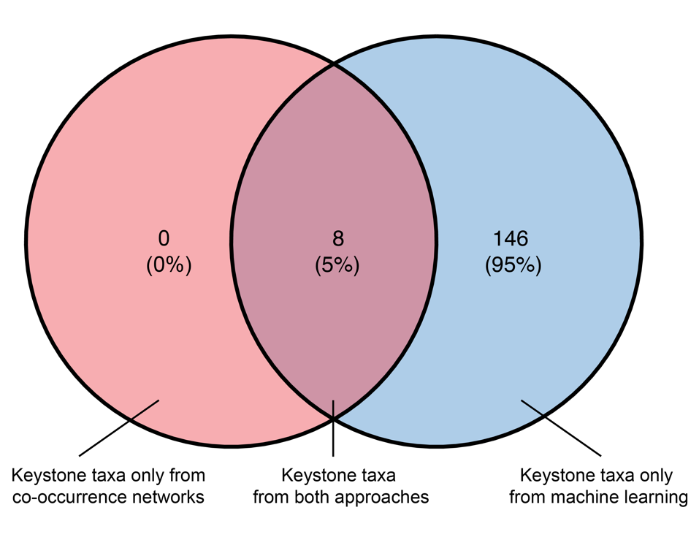

Fig. S3. Venn diagrams of the overlap between network-derived keystone taxa (blue) and random forest (RF)-derived indicator taxa (red).

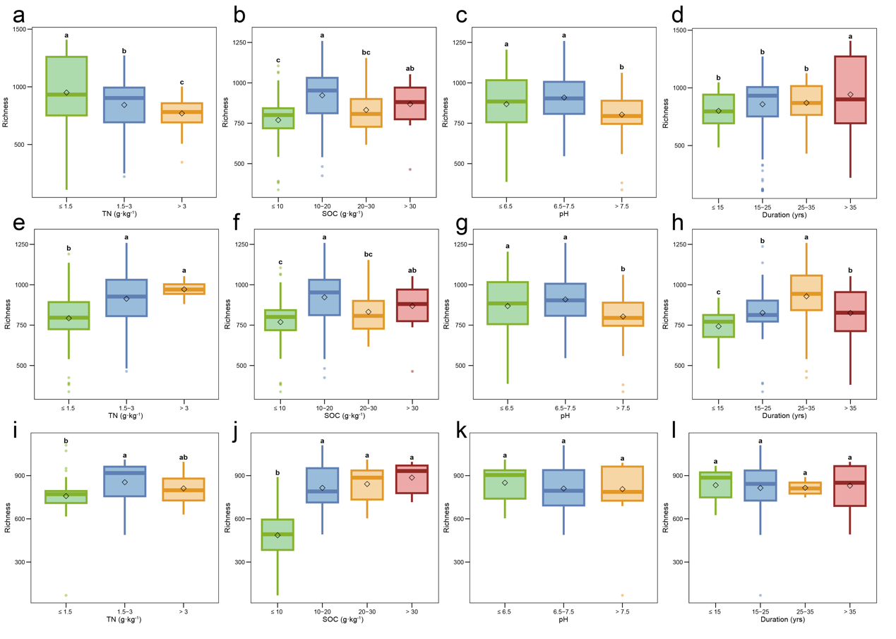

Fig. S4 Bacterial alpha diversity (Richness index) among treatments across different variable ranges (organized by rows): inorganic fertilization (IF) (a-d), inorganic-organic fertilization (IFOF) (e-h), and organic fertilization (OF) (i-l). IF refers to inorganic fertilization only, OF refers to organic fertilization only, and IFOF denotes a combination of inorganic and organic fertilization. The same structure applies to the panels below.
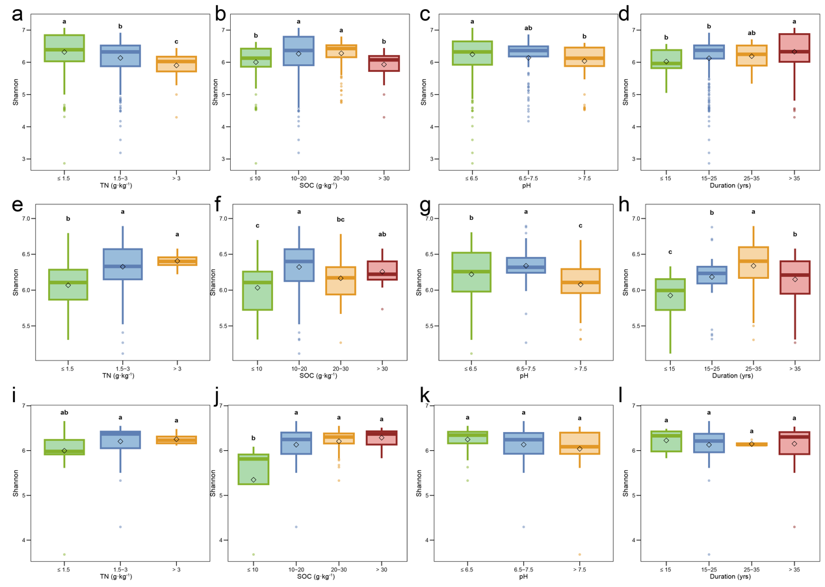

Fig. S5 Bacterial alpha diversity (Shannon index) among treatments in different variable ranges (organized by rows): IF (a-d), IFOF (e-h), and OF (i-l).

2. Supplementary Tables

Table S1. Bacterial relative abundance at the phylum level under inorganic fertilization practices, grouped by different soil total nitrogen levels (unit: g·kg⁻¹).

Phylum | ≤ 1.5 | 1.5-3 | > 3
Proteobacteria | 0.24567077 | 0.28127061 | 0.16874223
Actinobacteriota | 0.16507893 | 0.16286689 | 0.19513004
Acidobacteriota | 0.18837813 | 0.15923122 | 0.17359481
Chloroflexi | 0.08876206 | 0.08698837 | 0.09600464
Verrucomicrobiota | 0.04132916 | 0.0431108 | 0.10962001
Bacteroidota | 0.04540142 | 0.07603111 | 0.03466165
Planctomycetota | 0.04012467 | 0.04771445 | 0.05549546
Gemmatimonadota | 0.05119785 | 0.03594088 | 0.04373979
Firmicutes | 0.03132472 | 0.01681189 | 0.05190278
Myxococcota | 0.02790192 | 0.03145735 | 0.02612844
Methylomirabilota | 0.01055072 | 0.01148829 | 0.00951136
Latescibacterota | 0.00616929 | 0.00871066 | 0.00672597
Nitrospirota | 0.00971859 | 0.00484668 | 0.0056944
Cyanobacteria | 0.0104743 | 0.00354156 | 0.00377471
Patescibacteria | 0.00855425 | 0.00762654 | 0.00120663
Armatimonadota | 0.006655 | 0.00359926 | 0.00467798
Desulfobacterota | 0.00624929 | 0.00450553 | 0.00372873
GAL15 | 0.00463516 | 0.00244734 | 0.00027443
Bdellovibrionota | 0.00172423 | 0.00187354 | 0.00279699
WPS-2 | 0.0023001 | 0.00175641 | 0.00098505
Entotheonellaeota | 0.00169873 | 0.00055299 | 0.00113951
RCP2-54 | 0.0009312 | 0.00102285 | 0.00095803
Elusimicrobiota | 0.00105202 | 0.00119669 | 0.00056677
NB1-j | 0.0010606 | 0.00115534 | 0.00023682
Fibrobacterota | 0.00037419 | 0.00161617 | 0.00027434
MBNT15 | 0.00073879 | 0.00063054 | 0.00035583
Dependentiae | 0.0007756 | 0.00037772 | 0.00038282
Spirochaetota | 8.73E-05 | 0.00035395 | 0.00048346
Sumerlaeota | 0.00031904 | 0.00026309 | 0.00014586
Deinococcota | 1.07E-05 | 3.69E-05 | 0.00060386
WS2 | 0.00016569 | 0.00025453 | 9.10E-06
Dadabacteria | 0.00025538 | 0.00014243 | 0
Abditibacteriota | 6.59E-05 | 0.00016761 | 0.00015516
FCPU426 | 0.00010146 | 0.00015108 | 8.21E-05
SAR324_clade(Marine_group_B) | 9.83E-05 | 8.16E-05 | 7.32E-05
Zixibacteria | 2.61E-05 | 1.39E-05 | 5.48E-05
Hydrogenedentes | 1.38E-05 | 7.39E-05 | 0
Sva0485 | 1.53E-06 | 8.17E-05 | 0
TX1A-33 | 0 | 0 | 3.66E-05
Synergistota | 0 | 0 | 2.74E-05
WS4 | 6.14E-06 | 0 | 1.82E-05
Halanaerobiaeota | 4.59E-06 | 7.69E-06 | 0
Deferrisomatota | 1.23E-05 | 0 | 0

Table S2. Bacterial relative abundance at the phylum level under inorganic fertilization practices, grouped by different soil organic carbon levels (unit: g·kg⁻¹).

Phylum | ≤ 10 | 10-20 | 20-30 | > 30
Proteobacteria | 0.21065602 | 0.28316686 | 0.2529607 | 0.1607414
Acidobacteriota | 0.20315804 | 0.16615127 | 0.16251976 | 0.2049955
Actinobacteriota | 0.16627254 | 0.16026877 | 0.17919959 | 0.17096515
Chloroflexi | 0.12021287 | 0.08196169 | 0.07478002 | 0.11399624
Bacteroidota | 0.04602765 | 0.06105157 | 0.07129899 | 0.02673302
Gemmatimonadota | 0.0614891 | 0.03806204 | 0.03894325 | 0.06179042
Planctomycetota | 0.04069839 | 0.03891559 | 0.05688482 | 0.0585751
Verrucomicrobiota | 0.0139479 | 0.04897444 | 0.06071507 | 0.06502317
Firmicutes | 0.0262139 | 0.02715062 | 0.01489516 | 0.05647246
Myxococcota | 0.02667628 | 0.02948271 | 0.03048692 | 0.03109732
Methylomirabilota | 0.01516764 | 0.01061371 | 0.00959306 | 0.00812743
Latescibacterota | 0.00479233 | 0.0062579 | 0.01170416 | 0.00732033
Cyanobacteria | 0.01254875 | 0.0061594 | 0.00440983 | 0.00652597
Nitrospirota | 0.00844226 | 0.00737447 | 0.00620982 | 0.00595931
Armatimonadota | 0.01023633 | 0.00397977 | 0.00375281 | 0.00677152
Patescibacteria | 0.00598843 | 0.01046937 | 0.00354352 | 0.00214673
Desulfobacterota | 0.00233411 | 0.00610985 | 0.0061277 | 0.00224811
GAL15 | 0.01295745 | 0.00226422 | 0.00018153 | 0.00028642
Bdellovibrionota | 0.00119879 | 0.00183292 | 0.0019759 | 0.00333444
WPS-2 | 0.00301998 | 0.00218257 | 0.00116014 | 0.00044307
Entotheonellaeota | 0.0023857 | 0.00060485 | 0.00124752 | 0.00196036
NB1-j | 0.00167036 | 0.00071542 | 0.00162223 | 0.00022659
RCP2-54 | 0.001178 | 0.00084458 | 0.00116725 | 0.00089683
Elusimicrobiota | 0.0006001 | 0.00113642 | 0.00133962 | 0.00085779
Fibrobacterota | 0.00025196 | 0.00128783 | 0.00078112 | 0.00029614
MBNT15 | 0.0003761 | 0.00081857 | 0.00059414 | 0.00028612
Dependentiae | 0.00021071 | 0.00073718 | 0.00050328 | 0.00019722
Spirochaetota | 1.83E-05 | 0.00018633 | 0.00042682 | 0.00052188
Sumerlaeota | 0.00041618 | 0.00027594 | 0.00023016 | 0.00017742
Deinococcota | 4.56E-06 | 2.88E-05 | 2.42E-05 | 0.00065185
Dadabacteria | 0.00053794 | 0.00018469 | 3.04E-06 | 0
WS2 | 8.23E-05 | 0.00027377 | 0.00012714 | 5.90E-05
Abditibacteriota | 8.22E-05 | 0.00011681 | 0.00016945 | 5.92E-05
FCPU426 | 2.75E-05 | 0.00013037 | 0.00019705 | 2.95E-05
SAR324_clade(Marine_group_B) | 2.29E-05 | 0.00010918 | 8.79E-05 | 7.90E-05
Zixibacteria | 4.60E-05 | 9.18E-06 | 2.73E-05 | 5.92E-05
Hydrogenedentes | 9.11E-06 | 3.28E-05 | 9.08E-05 | 0
Sva0485 | 4.58E-06 | 6.96E-05 | 0 | 0
TX1A-33 | 0 | 0 | 0 | 3.96E-05
Deferrisomatota | 3.68E-05 | 0 | 0 | 0
Synergistota | 0 | 0 | 0 | 2.96E-05
WS4 | 0 | 5.26E-06 | 0 | 1.97E-05
Halanaerobiaeota | 0 | 2.62E-06 | 1.82E-05 | 0

Table S3. Bacterial relative abundance at the phylum level under inorganic fertilization practices, grouped by different pH levels.

Phylum | ≤ 6.5 | 6.5-7.5 | > 7.5
Proteobacteria | 0.26272227 | 0.24975541 | 0.22361225
Actinobacteriota | 0.15580311 | 0.18256764 | 0.21141087
Acidobacteriota | 0.1728366 | 0.17819048 | 0.17493334
Chloroflexi | 0.08623426 | 0.09481024 | 0.09510526
Bacteroidota | 0.06132598 | 0.06811698 | 0.0325935
Gemmatimonadota | 0.04210079 | 0.04275431 | 0.05339214
Planctomycetota | 0.04511733 | 0.03424499 | 0.05445205
Verrucomicrobiota | 0.05487518 | 0.0323798 | 0.01996415
Myxococcota | 0.03006286 | 0.02829926 | 0.02667323
Firmicutes | 0.0267629 | 0.03054001 | 0.01855393
Methylomirabilota | 0.00870251 | 0.01237318 | 0.02229081
Latescibacterota | 0.00742314 | 0.00790896 | 0.006561
GAL15 | 0.00064295 | 0.00082344 | 0.02160611
Nitrospirota | 0.00719427 | 0.00883617 | 0.00518283
Cyanobacteria | 0.00680932 | 0.00322545 | 0.01035131
Patescibacteria | 0.00823951 | 0.00548728 | 0.00577177
Armatimonadota | 0.00498556 | 0.00665408 | 0.00405876
Desulfobacterota | 0.00611134 | 0.00304866 | 0.00256441
Entotheonellaeota | 0.00054886 | 0.00265097 | 0.00289908
NB1-j | 0.00066155 | 0.00118956 | 0.0031147
Bdellovibrionota | 0.00210835 | 0.00153836 | 0.00087166
WPS-2 | 0.00247263 | 0.0002453 | 0.00069668
RCP2-54 | 0.00101027 | 0.00065733 | 0.00111492
MBNT15 | 0.0006369 | 0.00090231 | 0.00052757
Elusimicrobiota | 0.00134743 | 0.00051635 | 0.00011898
Fibrobacterota | 0.0011363 | 0.00055288 | 0.0001814
Dependentiae | 0.00066653 | 0.00025599 | 0.00027768
Dadabacteria | 0.00010407 | 0.00022899 | 0.00060417
Sumerlaeota | 0.00029053 | 0.00035946 | 0.00013039
WS2 | 0.00020072 | 0.0002817 | 6.22E-05
Spirochaetota | 0.00031514 | 4.69E-05 | 1.13E-05
Abditibacteriota | 0.00013508 | 0.00010924 | 3.96E-05
Sva0485 | 6.77E-06 | 0.00023974 | 5.67E-06
SAR324_clade(Marine_group_B) | 0.00010178 | 7.30E-05 | 2.84E-05
FCPU426 | 0.00015939 | 2.62E-05 | 1.13E-05
Hydrogenedentes | 3.26E-05 | 4.68E-05 | 7.91E-05
Deinococcota | 8.35E-05 | 2.08E-05 | 3.39E-05
Zixibacteria | 1.64E-05 | 2.61E-05 | 5.67E-05
Deferrisomatota | 0 | 0 | 4.56E-05
Halanaerobiaeota | 2.87E-06 | 1.56E-05 | 1.13E-05
WS4 | 5.75E-06 | 0 | 0
TX1A-33 | 3.85E-06 | 0 | 0
Synergistota | 2.88E-06 | 0 | 0

Table S4. Bacterial relative abundance at the phylum level under inorganic fertilization practices, grouped by different duration years.

Phylum | ≤ 15 | 15-25 | 25-35 | > 35
Proteobacteria | 0.22778085 | 0.24202711 | 0.24943817 | 0.27813212
Acidobacteriota | 0.16511297 | 0.19170815 | 0.16004796 | 0.16515836
Actinobacteriota | 0.17869339 | 0.17712764 | 0.15932184 | 0.15603743
Chloroflexi | 0.0877282 | 0.10467808 | 0.10646855 | 0.06879012
Bacteroidota | 0.0470835 | 0.06304592 | 0.04557994 | 0.06225738
Planctomycetota | 0.07666665 | 0.03110235 | 0.05627395 | 0.0443111
Verrucomicrobiota | 0.06353215 | 0.03133617 | 0.05333141 | 0.05516593
Gemmatimonadota | 0.035667 | 0.04033841 | 0.06037538 | 0.04310926
Myxococcota | 0.03828563 | 0.02308436 | 0.03231192 | 0.03151968
Firmicutes | 0.01493149 | 0.02636854 | 0.01653367 | 0.03239981
Methylomirabilota | 0.00753562 | 0.01789011 | 0.00847548 | 0.00653457
Patescibacteria | 0.01419315 | 0.00735203 | 0.00263293 | 0.00754197
Latescibacterota | 0.00516748 | 0.00804667 | 0.00786986 | 0.00724481
Cyanobacteria | 0.00608135 | 0.00326452 | 0.00894806 | 0.0092814
Nitrospirota | 0.00349164 | 0.00779749 | 0.00592174 | 0.00802204
Desulfobacterota | 0.00856856 | 0.00223457 | 0.00468412 | 0.00715812
Armatimonadota | 0.00412204 | 0.00484314 | 0.00675406 | 0.00503861
GAL15 | 1.29E-05 | 0.00903396 | 0.00041989 | 0.00012787
WPS-2 | 0.00282978 | 0.00145012 | 0.00322378 | 0.00172353
Bdellovibrionota | 0.00160708 | 0.00125089 | 0.00177241 | 0.0025269
Elusimicrobiota | 0.00223619 | 0.00038625 | 0.00154279 | 0.00121944
Entotheonellaeota | 0.00147314 | 0.0013917 | 0.00189991 | 0.00055339
NB1-j | 0.00088303 | 0.00109536 | 0.00246061 | 0.00057025
RCP2-54 | 0.00169788 | 0.0006722 | 0.001366 | 0.00091482
Fibrobacterota | 0.00170834 | 0.00034172 | 0.00025736 | 0.00146857
MBNT15 | 0.00041884 | 0.00033033 | 0.0009105 | 0.00092837
Dependentiae | 0.00012194 | 0.00043313 | 0.00044936 | 0.0008308
Spirochaetota | 0.00125305 | 5.62E-05 | 4.28E-05 | 0.00019062
Sumerlaeota | 0.00019294 | 0.00025127 | 0.00020333 | 0.00035338
Dadabacteria | 0.00049817 | 0.00027884 | 0 | 7.54E-05
WS2 | 2.57E-05 | 0.00041088 | 6.42E-05 | 9.46E-05
FCPU426 | 0.00028956 | 6.85E-05 | 4.83E-05 | 0.00014898
Abditibacteriota | 6.45E-06 | 0.00012863 | 6.95E-05 | 0.00015896
SAR324_clade(Marine_group_B) | 5.14E-05 | 3.82E-05 | 0.00014452 | 0.00012442
Deinococcota | 0 | 2.61E-05 | 0 | 0.00014712
Hydrogenedentes | 0 | 7.83E-05 | 5.36E-05 | 1.40E-05
Sva0485 | 5.19E-05 | 0 | 0 | 8.04E-05
Zixibacteria | 0 | 1.61E-05 | 5.91E-05 | 2.27E-05
Deferrisomatota | 0 | 0 | 4.30E-05 | 0
Halanaerobiaeota | 0 | 1.61E-05 | 0 | 0
WS4 | 0 | 0 | 0 | 1.05E-05
TX1A-33 | 0 | 0 | 0 | 7.02E-06
Synergistota | 0 | 0 | 0 | 5.25E-06

Table S5. Bacterial relative abundance at the phylum level under inorganic-organic fertilization practices, grouped by different soil total nitrogen levels (unit: g·kg⁻¹).

Phylum | ≤ 1.5 | 1.5-3 | > 3
Proteobacteria | 0.26592965 | 0.19862393 | 0.17924963
Acidobacteriota | 0.15462055 | 0.21372225 | 0.19987311
Actinobacteriota | 0.20468259 | 0.17315877 | 0.15941961
Chloroflexi | 0.09627962 | 0.12078511 | 0.09052912
Gemmatimonadota | 0.04646917 | 0.04075658 | 0.07446493
Verrucomicrobiota | 0.03057414 | 0.04202765 | 0.05981334
Bacteroidota | 0.03613528 | 0.05617541 | 0.02752449
Firmicutes | 0.02539741 | 0.01220899 | 0.07550773
Planctomycetota | 0.03165661 | 0.03309768 | 0.04234908
Myxococcota | 0.02634559 | 0.0231766 | 0.03591709
Methylomirabilota | 0.01906469 | 0.01873752 | 0.00874676
Patescibacteria | 0.01171169 | 0.02459108 | 0.0034439
Latescibacterota | 0.00510664 | 0.01575803 | 0.00542717
Nitrospirota | 0.00708028 | 0.00587581 | 0.00883176
GAL15 | 0.01635059 | 0.00029493 | 0.00077554
Armatimonadota | 0.0036636 | 0.00280797 | 0.00951875
Cyanobacteria | 0.00460841 | 0.00167467 | 0.00267056
WPS-2 | 0.00488166 | 0.00331252 | 0.00012905
Bdellovibrionota | 0.00094175 | 0.00137598 | 0.00538344
Desulfobacterota | 0.00175225 | 0.00322831 | 0.0027139
Entotheonellaeota | 0.00196789 | 0.00159982 | 0.00081869
NB1-j | 0.0020277 | 0.00159483 | 0.00056032
Elusimicrobiota | 0.00059248 | 0.001177 | 0.00133575
RCP2-54 | 0.00060229 | 0.00068594 | 0.00150775
MBNT15 | 0.00017801 | 0.00117649 | 0.00073239
Fibrobacterota | 0.00028612 | 0.00049353 | 0.00124789
Dependentiae | 0.00037612 | 0.00061964 | 0.00017218
Deinococcota | 0 | 0 | 0.00064648
Sumerlaeota | 0.00021206 | 0.00023922 | 4.31E-05
WS2 | 4.94E-05 | 0.00032945 | 0
FCPU426 | 0.00011908 | 0.0002359 | 0
TX1A-33 | 0 | 0 | 0.00030184
Abditibacteriota | 0.00011864 | 9.78E-05 | 8.61E-05
Dadabacteria | 0.00012929 | 9.41E-05 | 0
SAR324_clade(Marine_group_B) | 1.48E-05 | 3.13E-05 | 0.00012931
Spirochaetota | 3.94E-05 | 0.00012536 | 0
Zixibacteria | 0 | 3.91E-06 | 0.00012925
Sva0485 | 4.93E-06 | 7.45E-05 | 0
Hydrogenedentes | 9.88E-06 | 2.75E-05 | 0
Deferrisomatota | 1.98E-05 | 0 | 0
Halanaerobiaeota | 0 | 3.92E-06 | 0

Table S6. Bacterial relative abundance at the phylum level under inorganic-organic fertilization practices, grouped by different soil organic carbon levels (unit: g·kg⁻¹).

Phylum | ≤ 10 | 10-20 | 20-30 | > 30
Proteobacteria | 0.24657454 | 0.22030395 | 0.2392931 | 0.17784395
Acidobacteriota | 0.18207852 | 0.18506953 | 0.19192679 | 0.20953945
Actinobacteriota | 0.18831562 | 0.17294033 | 0.20965372 | 0.19130487
Chloroflexi | 0.09663426 | 0.13255075 | 0.07703712 | 0.08906159
Gemmatimonadota | 0.04266606 | 0.03882725 | 0.04648385 | 0.07673692
Bacteroidota | 0.02321958 | 0.05378842 | 0.06430999 | 0.01949203
Planctomycetota | 0.03760902 | 0.03055803 | 0.02413902 | 0.05485988
Verrucomicrobiota | 0.02205736 | 0.04783622 | 0.02914966 | 0.04477585
Myxococcota | 0.02149201 | 0.0201629 | 0.03430758 | 0.03805258
Firmicutes | 0.03065573 | 0.01258133 | 0.01907924 | 0.0450409
Methylomirabilota | 0.0304486 | 0.01666179 | 0.01393225 | 0.00993574
Patescibacteria | 0.00854994 | 0.02867586 | 0.01060721 | 0.00296818
Latescibacterota | 0.00735908 | 0.01103847 | 0.01557499 | 0.00615972
GAL15 | 0.0318949 | 0.00042001 | 0.00021506 | 0.0004054
Nitrospirota | 0.00693 | 0.00645051 | 0.00642283 | 0.00622838
Armatimonadota | 0.00365981 | 0.00275664 | 0.00219953 | 0.00991644
Cyanobacteria | 0.00340211 | 0.00266919 | 0.00326804 | 0.00272155
Desulfobacterota | 0.00237159 | 0.00208722 | 0.00379386 | 0.00283382
WPS-2 | 0.00443269 | 0.00561497 | 0.00075834 | 0.0001575
Entotheonellaeota | 0.00270144 | 0.00115442 | 0.00152721 | 0.00280941
Bdellovibrionota | 0.00073069 | 0.00113792 | 0.00157464 | 0.00375697
NB1-j | 0.00344198 | 0.00154047 | 0.00102038 | 0.00038266
Elusimicrobiota | 0.00050629 | 0.00114811 | 0.00082729 | 0.00110231
RCP2-54 | 0.00096641 | 0.00051053 | 0.00055409 | 0.00130462
MBNT15 | 0.00021535 | 0.00117752 | 0.00032099 | 0.00058521
Fibrobacterota | 0.00025344 | 0.00048873 | 0.00043711 | 0.00065231
Dependentiae | 0.00041119 | 0.00068854 | 0.00029187 | 0.00015736
Sumerlaeota | 6.82E-05 | 0.00023339 | 0.00031162 | 0.00026947
WS2 | 3.90E-05 | 0.0002858 | 0.00013628 | 0.00022426
FCPU426 | 3.95E-05 | 0.00023017 | 0.00026317 | 0
Abditibacteriota | 0 | 3.46E-05 | 0.00038891 | 6.74E-05
Deinococcota | 0 | 0 | 0 | 0.00033794
Dadabacteria | 0.00017751 | 0.00013851 | 0 | 0
Spirochaetota | 9.74E-06 | 9.51E-05 | 0.00016507 | 0
TX1A-33 | 0 | 0 | 0 | 0.00015778
SAR324_clade(Marine_group_B) | 1.95E-05 | 3.03E-05 | 9.72E-06 | 9.00E-05
Sva0485 | 9.75E-06 | 8.22E-05 | 0 | 0
Zixibacteria | 0 | 4.32E-06 | 0 | 6.76E-05
Hydrogenedentes | 1.95E-05 | 2.60E-05 | 9.74E-06 | 0
Deferrisomatota | 3.91E-05 | 0 | 0 | 0
Halanaerobiaeota | 0 | 0 | 9.73E-06 | 0

Table S7. Bacterial relative abundance at the phylum level under inorganic-organic fertilization practices, grouped by different soil pH levels.

Phylum | ≤ 6.5 | 6.5-7.5 | > 7.5
Proteobacteria | 0.23670266 | 0.19180529 | 0.23793847
Actinobacteriota | 0.1668491 | 0.20796509 | 0.21260711
Acidobacteriota | 0.20912984 | 0.18363743 | 0.13338301
Chloroflexi | 0.11387284 | 0.11548212 | 0.08687305
Bacteroidota | 0.03440463 | 0.07453411 | 0.04562112
Gemmatimonadota | 0.04620298 | 0.03560295 | 0.05220173
Verrucomicrobiota | 0.04580167 | 0.0321092 | 0.02320013
Planctomycetota | 0.0312625 | 0.02591904 | 0.0465297
Myxococcota | 0.02393439 | 0.02968294 | 0.02288627
Firmicutes | 0.01730586 | 0.02046244 | 0.031437
Methylomirabilota | 0.0159704 | 0.01619355 | 0.02811235
Patescibacteria | 0.01987094 | 0.02202181 | 0.00832695
GAL15 | 0.00039699 | 0.00014594 | 0.03498895
Latescibacterota | 0.01263005 | 0.01099269 | 0.00514441
Nitrospirota | 0.0048241 | 0.0091334 | 0.00817984
Cyanobacteria | 0.00192979 | 0.0051958 | 0.00313118
Armatimonadota | 0.00395844 | 0.00315492 | 0.00257446
WPS-2 | 0.00552141 | 0.0015001 | 0.00180464
Desulfobacterota | 0.00242641 | 0.00324852 | 0.0021984
NB1-j | 0.00060344 | 0.00170838 | 0.00498907
Entotheonellaeota | 0.00088563 | 0.00211115 | 0.00362172
Bdellovibrionota | 0.00158171 | 0.00158002 | 0.00058612
MBNT15 | 0.00032614 | 0.00148838 | 0.00097148
Elusimicrobiota | 0.00101885 | 0.00118927 | 0.00039438
RCP2-54 | 0.00065135 | 0.00064088 | 0.00086537
Dependentiae | 0.00041146 | 0.00052082 | 0.00070581
Fibrobacterota | 0.00044412 | 0.00069203 | 0.00012772
Sumerlaeota | 0.00018896 | 0.00032432 | 0.00017052
WS2 | 0.00026655 | 0.00017975 | 1.07E-05
FCPU426 | 0.00023039 | 0.00015396 | 4.31E-05
Dadabacteria | 5.92E-05 | 0.00011968 | 0.00021533
Abditibacteriota | 1.00E-04 | 0.00019639 | 1.07E-05
Spirochaetota | 8.14E-05 | 0.00014511 | 1.06E-05
Sva0485 | 2.96E-05 | 9.41E-05 | 1.07E-05
SAR324_clade(Marine_group_B) | 2.59E-05 | 1.71E-05 | 5.32E-05
Hydrogenedentes | 7.41E-06 | 4.27E-05 | 2.14E-05
Deinococcota | 5.57E-05 | 0 | 0
Deferrisomatota | 0 | 0 | 4.27E-05
TX1A-33 | 2.60E-05 | 0 | 0
Zixibacteria | 1.11E-05 | 0 | 1.07E-05
Halanaerobiaeota | 0 | 8.56E-06 | 0

Table S8. Bacterial relative abundance at the phylum level under inorganic-organic fertilization practices, grouped by different duration years.

Phylum | ≤ 15 | 15-25 | 25-35 | > 35
Proteobacteria | 0.21549605 | 0.22112174 | 0.2179392 | 0.25133628
Actinobacteriota | 0.18347346 | 0.27745484 | 0.15968364 | 0.1712207
Acidobacteriota | 0.19219544 | 0.15679185 | 0.20477304 | 0.17585289
Chloroflexi | 0.10927837 | 0.08090543 | 0.14183876 | 0.06278097
Bacteroidota | 0.03627861 | 0.0350151 | 0.03846429 | 0.07587279
Gemmatimonadota | 0.0441329 | 0.05070436 | 0.03785839 | 0.05486592
Planctomycetota | 0.06548444 | 0.02001926 | 0.02283863 | 0.04772823
Verrucomicrobiota | 0.02808022 | 0.00928044 | 0.05106371 | 0.037927
Myxococcota | 0.02751628 | 0.02798333 | 0.01979816 | 0.03274591
Firmicutes | 0.02030383 | 0.01514685 | 0.01952088 | 0.02803585
Methylomirabilota | 0.01005931 | 0.03222245 | 0.01903024 | 0.01066557
Patescibacteria | 0.0272323 | 0.00159979 | 0.02961666 | 0.0027452
GAL15 | 1.85E-05 | 0.03815086 | 0.00046207 | 0.00061392
Latescibacterota | 0.00297076 | 0.00436548 | 0.01340535 | 0.01395419
Nitrospirota | 0.00582518 | 0.0113002 | 0.00440164 | 0.00761754
WPS-2 | 0.00717295 | 0.00238555 | 0.00534626 | 0.00016052
Armatimonadota | 0.00541717 | 0.00184452 | 0.00325088 | 0.00430779
Cyanobacteria | 0.00698963 | 0.00286237 | 0.00193102 | 0.00319813
Desulfobacterota | 0.00215214 | 0.00151211 | 0.00180565 | 0.0051838
Entotheonellaeota | 0.00259745 | 0.00369118 | 0.0008701 | 0.00154146
NB1-j | 0.00133428 | 0.00375152 | 0.00072151 | 0.00244977
Bdellovibrionota | 0.00112967 | 0.00051979 | 0.00131715 | 0.00230788
RCP2-54 | 0.002134 | 0.00049574 | 0.0002605 | 0.00102477
MBNT15 | 0.00053874 | 0.00011793 | 0.00021778 | 0.00235145
Elusimicrobiota | 0.00031549 | 8.28E-05 | 0.001414 | 0.00090874
Dependentiae | 0.00046231 | 8.26E-05 | 0.00053961 | 0.0007318
Fibrobacterota | 0.00011083 | 7.10E-05 | 0.00062549 | 0.00050783
Sumerlaeota | 0.00044399 | 0.00014181 | 0.00011302 | 0.00038309
Dadabacteria | 0.00042889 | 0.00022522 | 0 | 7.12E-05
WS2 | 0.0001298 | 4.74E-05 | 0.00036096 | 0
Abditibacteriota | 5.55E-05 | 4.72E-05 | 2.61E-05 | 0.00033837
FCPU426 | 3.79E-05 | 0 | 0.00032721 | 6.22E-05
Sva0485 | 0.00016668 | 0 | 0 | 9.80E-05
Spirochaetota | 1.85E-05 | 2.37E-05 | 0.00012163 | 7.99E-05
Deinococcota | 0 | 0 | 0 | 0.00013406
SAR324_clade(Marine_group_B) | 1.85E-05 | 0 | 2.17E-05 | 7.12E-05
Hydrogenedentes | 0 | 2.37E-05 | 1.74E-05 | 2.68E-05
TX1A-33 | 0 | 0 | 0 | 6.26E-05
Zixibacteria | 0 | 0 | 0 | 3.57E-05
Deferrisomatota | 0 | 0 | 1.74E-05 | 0
Halanaerobiaeota | 0 | 1.18E-05 | 0 | 0

Table S9. Bacterial relative abundance at the phylum level under organic fertilization practices, grouped by different soil total nitrogen levels (unit: g·kg⁻¹).

Phylum | ≤ 1.5 | 1.5-3 | > 3
Proteobacteria | 0.22108785 | 0.25265202 | 0.3158864
Acidobacteriota | 0.17177355 | 0.17885641 | 0.18608968
Actinobacteriota | 0.20542433 | 0.12369421 | 0.11394804
Bacteroidota | 0.06203332 | 0.10837086 | 0.11766097
Chloroflexi | 0.09174179 | 0.06011124 | 0.03799541
Planctomycetota | 0.02348066 | 0.06190022 | 0.04877539
Gemmatimonadota | 0.03869556 | 0.04334829 | 0.03267698
Firmicutes | 0.05718157 | 0.03326126 | 0.02323217
Verrucomicrobiota | 0.0271865 | 0.04005802 | 0.04495017
Myxococcota | 0.03000225 | 0.02475456 | 0.01825822
Methylomirabilota | 0.00799051 | 0.01158734 | 0.01438344
Cyanobacteria | 0.02550931 | 0.00532026 | 0.00263569
Latescibacterota | 0.00457064 | 0.01430395 | 0.01061311
Nitrospirota | 0.01301232 | 0.00878626 | 0.0072688
Armatimonadota | 0.00269066 | 0.00595338 | 0.00773476
Desulfobacterota | 0.00224193 | 0.00507696 | 0.00548173
Patescibacteria | 0.0058594 | 0.00191188 | 0.00119018
Entotheonellaeota | 0.00288001 | 0.00317719 | 0.00132071
Caldatribacteriota | 0 | 0.00379002 | 0.00186414
NB1-j | 0.00250024 | 0.00294528 | 0.00021272
Coprothermobacterota | 0 | 0.00299052 | 0.00156586
Bdellovibrionota | 0.00132754 | 0.00114706 | 0.00183256
MBNT15 | 0.00020701 | 0.00182005 | 0.00021302
RCP2-54 | 0.00029306 | 0.00070375 | 0.00093556
Sumerlaeota | 0.00056894 | 0.00059551 | 0.0005941
Elusimicrobiota | 0.00029331 | 0.00061181 | 0.00055346
Fibrobacterota | 3.45E-05 | 0.0004361 | 0.0006824
Dependentiae | 0.00067206 | 0.00029004 | 0.00012819
Abditibacteriota | 6.89E-05 | 0.00026688 | 0.00050901
GAL15 | 0.00041355 | 0.00035985 | 8.51E-05
WPS-2 | 0.00010335 | 0.00018427 | 0.00012752
Deinococcota | 0 | 6.87E-05 | 0.00025415
Halanaerobiaeota | 1.73E-05 | 0.00012211 | 8.52E-05
WS2 | 1.73E-05 | 0.00018404 | 0
SAR324_clade(Marine_group_B) | 8.62E-05 | 6.12E-05 | 4.25E-05
Zixibacteria | 1.74E-05 | 2.29E-05 | 0.00012772
FCPU426 | 0 | 7.66E-05 | 8.49E-05
Dadabacteria | 1.73E-05 | 8.42E-05 | 0
Sva0485 | 0 | 8.41E-05 | 0
Hydrogenedentes | 0 | 2.30E-05 | 0
WS1 | 0 | 7.61E-06 | 0

Table S10. Bacterial relative abundance at the phylum level under organic fertilization practices, grouped by different soil organic carbon levels (unit: g·kg⁻¹).

Phylum | ≤ 10 | 10-20 | 20-30 | > 30
Proteobacteria | 0.22693137 | 0.22378812 | 0.29128885 | 0.24245542
Acidobacteriota | 0.20016091 | 0.16962225 | 0.18681452 | 0.17534902
Actinobacteriota | 0.2358364 | 0.17148945 | 0.09271566 | 0.16961448
Bacteroidota | 0.01100315 | 0.07180203 | 0.15400064 | 0.05317721
Chloroflexi | 0.06344531 | 0.09609021 | 0.03391029 | 0.05382072
Gemmatimonadota | 0.05992191 | 0.03740718 | 0.03079488 | 0.07239631
Planctomycetota | 0.03870245 | 0.04240186 | 0.0607086 | 0.04971301
Firmicutes | 0.07550885 | 0.05989878 | 0.0152798 | 0.02155531
Verrucomicrobiota | 0.00027697 | 0.03288841 | 0.04401673 | 0.0417061
Myxococcota | 0.03271698 | 0.02416055 | 0.01844598 | 0.0452307
Methylomirabilota | 0.01571517 | 0.00960879 | 0.01319324 | 0.00825561
Latescibacterota | 0.00611386 | 0.00695899 | 0.01756993 | 0.01016399
Cyanobacteria | 0.00221572 | 0.01579182 | 0.000948 | 0.01969954
Nitrospirota | 0.00655192 | 0.01264612 | 0.00747627 | 0.0071994
Desulfobacterota | 0.00750723 | 0.00328384 | 0.00471679 | 0.0060366
Armatimonadota | 0.00390228 | 0.00465465 | 0.00567686 | 0.00645451
Entotheonellaeota | 0.00598036 | 0.00254794 | 0.00260845 | 0.00393634
NB1-j | 0.00542911 | 0.00341598 | 0.00062294 | 0.00374138
Patescibacteria | 0 | 0.00463868 | 0.00176422 | 0.00100044
Caldatribacteriota | 0 | 0 | 0.00702183 | 0
Coprothermobacterota | 0 | 0 | 0.00556971 | 0
Bdellovibrionota | 0.00055505 | 0.00100931 | 0.00096032 | 0.00303637
MBNT15 | 0.00069353 | 0.00206096 | 0.00016879 | 0.00119406
RCP2-54 | 0.00027753 | 0.00050501 | 0.00041586 | 0.00154934
Elusimicrobiota | 0 | 0.00038214 | 0.0006104 | 0.000839
Sumerlaeota | 0.00013848 | 0.0004939 | 0.00086952 | 0.00029065
Fibrobacterota | 0 | 0.00019665 | 0.00032459 | 0.0010023
GAL15 | 0.00027697 | 0.00067971 | 3.90E-05 | 6.46E-05
Dependentiae | 0 | 0.00064737 | 0.00018159 | 9.74E-05
Abditibacteriota | 0 | 4.10E-05 | 0.00055815 | 0.00012915
WPS-2 | 0 | 0.00020708 | 0.00016894 | 0
Halanaerobiaeota | 0 | 3.09E-05 | 0.00015581 | 0.00012929
WS2 | 0 | 0.00018636 | 9.09E-05 | 0
Zixibacteria | 0.00013848 | 3.09E-05 | 0 | 9.70E-05
Deinococcota | 0 | 0 | 0.00019493 | 0
FCPU426 | 0 | 3.12E-05 | 0.00010406 | 3.23E-05
SAR324_clade(Marine_group_B) | 0 | 0.00013384 | 0 | 3.23E-05
Dadabacteria | 0 | 0.00012381 | 0 | 0
Sva0485 | 0 | 0.00011329 | 0 | 0
Hydrogenedentes | 0 | 3.10E-05 | 0 | 0
WS1 | 0 | 0 | 1.29E-05 | 0

Table S11. Bacterial relative abundance at the phylum level under organic fertilization practices, grouped by different soil pH levels.

Phylum | ≤ 6.5 | 6.5-7.5 | > 7.5
Proteobacteria | 0.26729261 | 0.22354865 | 0.29011502
Acidobacteriota | 0.20674715 | 0.16549737 | 0.15606321
Actinobacteriota | 0.10669374 | 0.13883749 | 0.22811698
Bacteroidota | 0.101767 | 0.11121973 | 0.05215542
Chloroflexi | 0.05349352 | 0.07770717 | 0.06086398
Planctomycetota | 0.06020842 | 0.04008355 | 0.05612491
Gemmatimonadota | 0.04573127 | 0.03490285 | 0.04705957
Verrucomicrobiota | 0.05008716 | 0.03737979 | 0.0131482
Firmicutes | 0.01598496 | 0.06128702 | 0.02330848
Myxococcota | 0.01954872 | 0.02908438 | 0.02708903
Latescibacterota | 0.01983975 | 0.0072741 | 0.00567261
Methylomirabilota | 0.010812 | 0.01077439 | 0.01146248
Cyanobacteria | 0.0017231 | 0.01999621 | 0.00284274
Nitrospirota | 0.00613109 | 0.01507861 | 0.00315124
Armatimonadota | 0.00916532 | 0.00368628 | 0.00217664
Desulfobacterota | 0.00505907 | 0.00437322 | 0.00302179
Entotheonellaeota | 0.00126291 | 0.00329683 | 0.00479512
NB1-j | 0.00019451 | 0.00243907 | 0.00688295
Patescibacteria | 0.00204133 | 0.00454925 | 0.00039671
Caldatribacteriota | 0.00550833 | 0.00142716 | 0
Coprothermobacterota | 0.00454059 | 0.001008 | 0
MBNT15 | 0.00019432 | 0.00161462 | 0.00198518
Bdellovibrionota | 0.00127953 | 0.00166154 | 0.00029745
RCP2-54 | 0.00065246 | 0.00063153 | 0.00052085
Sumerlaeota | 0.00090034 | 0.0005098 | 0.00022318
Elusimicrobiota | 0.00055617 | 0.00045032 | 0.00061995
GAL15 | 0.0003481 | 0.00014034 | 0.00083994
Dependentiae | 9.72E-05 | 0.00048957 | 0.00059465
Fibrobacterota | 0.00063958 | 0.00028063 | 2.48E-05
Abditibacteriota | 0.00034613 | 0.00025991 | 0
WPS-2 | 0.00032057 | 9.99E-05 | 0
WS2 | 0.0002507 | 7.01E-05 | 0
Dadabacteria | 0 | 3.01E-05 | 0.00022356
Halanaerobiaeota | 0.00013849 | 9.02E-05 | 0
Deinococcota | 0.00020766 | 0 | 0
SAR324_clade(Marine_group_B) | 2.78E-05 | 9.01E-05 | 7.44E-05
FCPU426 | 0.00015283 | 1.00E-05 | 0
Zixibacteria | 4.17E-05 | 1.00E-05 | 7.44E-05
Sva0485 | 0 | 0.00011029 | 0
Hydrogenedentes | 0 | 0 | 7.45E-05
WS1 | 1.38E-05 | 0 | 0

Table S12. Bacterial relative abundance at the phylum level under organic fertilization practices, grouped by different duration years.

Phylum | ≤ 15 | 15-25 | 25-35 | > 35
Proteobacteria | 0.16028364 | 0.30769257 | 0.25029948 | 0.21643404
Acidobacteriota | 0.21319616 | 0.16059787 | 0.18487839 | 0.18433214
Actinobacteriota | 0.13771198 | 0.16335994 | 0.13344763 | 0.12572534
Chloroflexi | 0.11415395 | 0.03912701 | 0.07121044 | 0.08068871
Bacteroidota | 0.06832166 | 0.12256487 | 0.02417423 | 0.08309398
Planctomycetota | 0.06416262 | 0.05372903 | 0.06496569 | 0.03811266
Gemmatimonadota | 0.04891684 | 0.02290169 | 0.08371461 | 0.05595184
Verrucomicrobiota | 0.0435457 | 0.02891312 | 0.05612139 | 0.04286646
Firmicutes | 0.03456048 | 0.02053838 | 0.04560435 | 0.06231588
Myxococcota | 0.02877164 | 0.02265737 | 0.0362467 | 0.02657759
Cyanobacteria | 0.03575825 | 0.00165068 | 0.00207927 | 0.01241695
Methylomirabilota | 0.00619241 | 0.01342468 | 0.01734849 | 0.00901822
Latescibacterota | 0.0097519 | 0.00694668 | 0.00815477 | 0.01752813
Nitrospirota | 0.00857326 | 0.00622305 | 0.00944044 | 0.01472179
Armatimonadota | 0.01251849 | 0.0052833 | 0.00310554 | 0.00255769
Desulfobacterota | 0.0019816 | 0.00358984 | 0.00233364 | 0.00644785
Patescibacteria | 0.0037136 | 0.00139354 | 0.00077679 | 0.00469532
Entotheonellaeota | 0.00133075 | 0.00359298 | 0.00246763 | 0.00267362
NB1-j | 0.00019592 | 0.00208722 | 0.00168804 | 0.00407414
Caldatribacteriota | 0 | 0.00558689 | 0 | 0
Bdellovibrionota | 0.00172595 | 0.00061953 | 0.00064658 | 0.00197203
Coprothermobacterota | 0 | 0.00443151 | 0 | 0
MBNT15 | 6.55E-05 | 0.00020674 | 0.00012995 | 0.00301
RCP2-54 | 0.00074844 | 0.00032062 | 0.00025899 | 0.00097343
Elusimicrobiota | 0.00058751 | 0.00032044 | 0.00038713 | 0.00075244
Sumerlaeota | 0.00055358 | 0.00060897 | 0.00012995 | 0.00062164
GAL15 | 0.0006863 | 0.00035052 | 0.00025991 | 0.00020761
Dependentiae | 0.00029124 | 0.00012382 | 0 | 0.00076381
Fibrobacterota | 0.00036046 | 0.00010309 | 0 | 0.00070138
WPS-2 | 0.00055639 | 0.00013442 | 0 | 3.87E-05
WS2 | 0.00055561 | 8.27E-05 | 0 | 0
Abditibacteriota | 3.24E-05 | 0.00044409 | 0 | 9.07E-05
SAR324_clade(Marine_group_B) | 9.75E-05 | 0 | 0 | 0.0001426
Halanaerobiaeota | 0 | 0.00013432 | 0 | 7.79E-05
Zixibacteria | 0 | 0 | 0.00012995 | 7.79E-05
FCPU426 | 9.83E-05 | 8.28E-05 | 0 | 1.30E-05
Dadabacteria | 0 | 1.03E-05 | 0 | 0.00014289
Deinococcota | 0 | 0.00015509 | 0 | 0
Sva0485 | 0 | 0 | 0 | 0.00014261
Hydrogenedentes | 0 | 0 | 0 | 3.90E-05
WS1 | 0 | 1.03E-05 | 0 | 0

Table S13. Number of microorganisms detected exclusively in inorganic fertilization samples, organized by phylum level.

Phylum | Number
Acidobacteriota | 3
Actinobacteriota | 7
Bacteroidota | 16
Chloroflexi | 1
Cyanobacteria | 10
Desulfobacterota | 2
Fibrobacterota | 1
Firmicutes | 44
Patescibacteria | 1
Planctomycetota | 3
Proteobacteria | 45
Spirochaetota | 1
Synergistota | 1
Verrucomicrobiota | 5

Table S14. Number of microorganisms detected exclusively in inorganic-organic fertilization samples, organized by phylum level.

Phylum | Number
Actinobacteriota | 1
Bacteroidota | 1
Chloroflexi | 1
Desulfobacterota | 1
Firmicutes | 5
Patescibacteria | 1
Proteobacteria | 8

Table S15. Number of microorganisms detected exclusively in organic fertilization samples, organized by phylum level.

Phylum | Number
Actinobacteriota | 5
Bacteroidota | 6
Elusimicrobiota | 1
Firmicutes | 7
Planctomycetota | 1
Proteobacteria | 5
WS1 | 1

Table S16. Data for the variables used in the random forest model developed to predict differences between inorganic fertilization (IF) and control (CK) groups.

OTU | Phylum | MeanDecreaseAccuracy | MeanDecreaseGini | P
rubrobacter | Actinobacteriota | 25.9316 | 32.8554 | 0.0099
nitrosospira | Proteobacteria | 18.1593 | 17.8882 | 0.0099
mb_a2_108 | Actinobacteriota | 14.7098 | 14.2759 | 0.0099
methyloligellaceae | Proteobacteria | 14.6465 | 14.4793 | 0.0099
subgroup_5 | Acidobacteriota | 13.2958 | 9.9061 | 0.0099
nitrolancea | Chloroflexi | 12.6279 | 8.0597 | 0.0099
microvirga | Proteobacteria | 12.2489 | 6.5577 | 0.0099
rb41 | Acidobacteriota | 11.5200 | 7.4737 | 0.0099
vicinamibacteraceae | Acidobacteriota | 11.4207 | 6.6887 | 0.0099
acidothermus | Actinobacteriota | 11.3295 | 5.9979 | 0.0099
subgroup_10 | Acidobacteriota | 10.9947 | 7.3858 | 0.0099
candidatus_udaeobacter | Verrucomicrobiota | 10.8627 | 5.8680 | 0.0099
pedomicrobium | Proteobacteria | 10.6474 | 8.8934 | 0.0099
pseudonocardia | Actinobacteriota | 10.5083 | 5.2853 | 0.0099
chujaibacter | Proteobacteria | 10.4730 | 4.4973 | 0.0099
wps_2 | WPS-2 | 10.4541 | 6.3485 | 0.0099
jg30_kf_cm45 | Chloroflexi | 10.3962 | 7.1822 | 0.0099
sc_i_84 | Proteobacteria | 10.3481 | 6.0587 | 0.0099
sbr1031 | Chloroflexi | 10.3120 | 5.8968 | 0.0099
subgroup_22 | Acidobacteriota | 10.2995 | 7.5583 | 0.0099
bradyrhizobium | Proteobacteria | 10.2919 | 6.1788 | 0.0099
microlunatus | Actinobacteriota | 10.2530 | 3.9548 | 0.0099
x11_24 | Acidobacteriota | 9.8834 | 6.5913 | 0.0099
gaiella | Actinobacteriota | 9.8825 | 5.2134 | 0.0099
subgroup_7 | Acidobacteriota | 9.8358 | 6.9429 | 0.0099
jg30_kf_as9 | Chloroflexi | 9.7963 | 5.0517 | 0.0099
bacteriap25 | Myxococcota | 9.6784 | 7.6203 | 0.0099
pseudolabrys | Proteobacteria | 9.6561 | 4.5019 | 0.0099
labrys | Proteobacteria | 9.4479 | 5.6856 | 0.0099
rokubacteriales | Methylomirabilota | 9.4434 | 6.0065 | 0.0099
blastococcus | Actinobacteriota | 9.4176 | 5.3245 | 0.0099
citrifermentans | Desulfobacterota | 9.2931 | 4.4436 | 0.0099
pirellula | Planctomycetota | 9.1260 | 4.1640 | 0.0099
sphingomonas | Proteobacteria | 9.0399 | 5.1434 | 0.0099
wd2101_soil_group | Planctomycetota | 8.9901 | 4.8442 | 0.0099
ad3 | Chloroflexi | 8.9270 | 5.0496 | 0.0099
kd4_96 | Chloroflexi | 8.8611 | 6.6291 | 0.0099
gemmatimonas | Gemmatimonadota | 8.7806 | 5.4636 | 0.0099
bryobacter | Acidobacteriota | 8.7686 | 4.9833 | 0.0099
dongia | Proteobacteria | 8.7424 | 5.5935 | 0.0099
nb1_j | NB1-j | 8.4652 | 6.4380 | 0.0099
steroidobacter | Proteobacteria | 8.3882 | 4.3730 | 0.0099
wx65 | Methylomirabilota | 8.3439 | 4.3691 | 0.0099
akyg1722 | Chloroflexi | 8.3289 | 4.7639 | 0.0099
nocardioides | Actinobacteriota | 8.2850 | 5.7505 | 0.0099
mbnt15 | MBNT15 | 8.2485 | 4.7633 | 0.0099
streptomyces | Actinobacteriota | 8.2033 | 6.3588 | 0.0099
rhodoplanes | Proteobacteria | 8.1833 | 6.0391 | 0.0099
ellin6067 | Proteobacteria | 8.1213 | 5.9852 | 0.0099
mle1_7 | Proteobacteria | 8.0819 | 6.5328 | 0.0099
candidatus_xiphinematobacter | Verrucomicrobiota | 8.0636 | 4.2137 | 0.0099
rhodanobacter | Proteobacteria | 7.9887 | 3.5043 | 0.0099
entotheonellaceae | Entotheonellaeota | 7.8863 | 4.6239 | 0.0099
conexibacter | Actinobacteriota | 7.8694 | 6.3244 | 0.0099
x67_14 | Actinobacteriota | 7.7969 | 5.5205 | 0.0099
pedosphaeraceae | Verrucomicrobiota | 7.6801 | 4.9517 | 0.0099
latescibacterota | Latescibacterota | 7.4511 | 5.4816 | 0.0099
subgroup_17 | Acidobacteriota | 7.4127 | 4.4264 | 0.0099
imcc26256 | Actinobacteriota | 7.3382 | 5.7865 | 0.0099
shimazuella | Firmicutes | 7.3377 | 3.5135 | 0.0099
a_durb_bin063_1 | Verrucomicrobiota | 7.1670 | 5.1501 | 0.0099
stenotrophobacter | Acidobacteriota | 7.1494 | 3.5074 | 0.0099
olb14 | Chloroflexi | 7.1489 | 4.9609 | 0.0099
granulicella | Acidobacteriota | 7.1328 | 1.7610 | 0.0099
skermanella | Proteobacteria | 7.1122 | 3.9529 | 0.0099
dokdonella | Proteobacteria | 6.9377 | 3.6511 | 0.0099
subgroup_25 | Acidobacteriota | 6.7037 | 4.6411 | 0.0099
gemmata | Planctomycetota | 6.1510 | 4.5299 | 0.0099
dyella | Proteobacteria | 5.9517 | 2.5658 | 0.0297
roseisolibacter | Gemmatimonadota | 5.8914 | 3.4130 | 0.0099
neochlamydia | Verrucomicrobiota | 5.8858 | 2.5781 | 0.0099
chthoniobacter | Verrucomicrobiota | 5.4402 | 3.5773 | 0.0099
devosia | Proteobacteria | 4.9171 | 3.4742 | 0.0297
porphyrobacter | Proteobacteria | 4.3613 | 1.7316 | 0.0396

Table S17. Data for the variables used in the random forest model developed to predict differences between inorganic-organic fertilization (IFOF) and control (CK) groups.

OTU | Phylum | MeanDecreaseAccuracy | MeanDecreaseGini | P
nitrosospira | Proteobacteria | 17.4556 | 14.7966 | 0.0099
wwh38 | Patescibacteria | 12.2978 | 9.1000 | 0.0099
turicibacter | Firmicutes | 12.2339 | 4.3350 | 0.0099
saccharimonadales | Patescibacteria | 11.9113 | 9.2466 | 0.0099
ad3 | Chloroflexi | 11.6915 | 8.7537 | 0.0099
geobacter | Desulfobacterota | 11.3200 | 8.1886 | 0.0099
lwq8 | Patescibacteria | 10.0795 | 5.6278 | 0.0099
agromyces | Actinobacteriota | 9.8980 | 3.7353 | 0.0099
a_durb_bin063_1 | Verrucomicrobiota | 9.7748 | 5.6427 | 0.0099
vicinamibacteraceae | Acidobacteriota | 9.7093 | 3.6633 | 0.0099
kd4_96 | Chloroflexi | 9.6273 | 4.6254 | 0.0099
rubrobacter | Actinobacteriota | 9.4070 | 5.2292 | 0.0099
citrifermentans | Desulfobacterota | 9.3984 | 6.5297 | 0.0099
pirellula | Planctomycetota | 9.3556 | 5.3843 | 0.0099
clostridium_sensu_stricto_1 | Firmicutes | 9.3426 | 2.8962 | 0.0099
dokdonella | Proteobacteria | 8.6812 | 2.7603 | 0.0099
ccd24 | Proteobacteria | 8.5228 | 2.8992 | 0.0099
methyloligellaceae | Proteobacteria | 8.4674 | 5.3193 | 0.0099
candidatus_udaeobacter | Verrucomicrobiota | 8.4325 | 3.5238 | 0.0099
sbr1031 | Chloroflexi | 8.2956 | 4.2915 | 0.0099
gitt_gs_136 | Chloroflexi | 8.2179 | 4.5863 | 0.0099
pedosphaeraceae | Verrucomicrobiota | 8.1378 | 4.2960 | 0.0099
rhodanobacter | Proteobacteria | 8.0665 | 2.2526 | 0.0099
chthonomonadales | Armatimonadota | 8.0262 | 4.1875 | 0.0099
wd2101_soil_group | Planctomycetota | 7.9467 | 2.8495 | 0.0099
gemmata | Planctomycetota | 7.7558 | 4.1930 | 0.0099
mb_a2_108 | Actinobacteriota | 7.7319 | 3.0295 | 0.0099
psychrobacillus | Firmicutes | 7.2580 | 1.5017 | 0.0099
streptomyces | Actinobacteriota | 7.1596 | 2.6177 | 0.0099
conexibacter | Actinobacteriota | 7.1442 | 2.4683 | 0.0099
rb41 | Acidobacteriota | 7.1256 | 2.4779 | 0.0099
gemmatimonas | Gemmatimonadota | 6.8533 | 2.6602 | 0.0099
nitrospira | Nitrospirota | 6.8513 | 1.6913 | 0.0099
bacteriap25 | Myxococcota | 6.8249 | 2.3505 | 0.0099
zavarzinella | Planctomycetota | 6.8197 | 2.6129 | 0.0099
jg30_kf_cm45 | Chloroflexi | 6.8079 | 2.9671 | 0.0099
luteimonas | Proteobacteria | 6.7949 | 2.6523 | 0.0099
tk10 | Chloroflexi | 6.5801 | 2.1369 | 0.0099
parcubacteria | Patescibacteria | 6.4847 | 1.9183 | 0.0099
jan_59 | Chloroflexi | 6.3711 | 1.3570 | 0.0198
subgroup_5 | Acidobacteriota | 6.3141 | 2.4057 | 0.0099
candidatus_solibacter | Acidobacteriota | 6.2592 | 1.8339 | 0.0099
rokubacteriales | Methylomirabilota | 6.2079 | 1.8995 | 0.0099
sphingomonas | Proteobacteria | 6.1504 | 1.5880 | 0.0099
cellvibrio | Proteobacteria | 6.1358 | 1.1618 | 0.0099
mle1_7 | Proteobacteria | 6.0835 | 1.8918 | 0.0099
haliangium | Myxococcota | 6.0188 | 2.0544 | 0.0099
plta13 | Proteobacteria | 5.9624 | 1.6471 | 0.0099
pseudolabrys | Proteobacteria | 5.8845 | 1.9358 | 0.0099
granulicella | Acidobacteriota | 5.8387 | 1.5200 | 0.0099
subgroup_17 | Acidobacteriota | 5.7638 | 2.4497 | 0.0099
pla4_lineage | Planctomycetota | 5.6592 | 1.8755 | 0.0099
thermoactinomyces | Firmicutes | 5.5814 | 0.8449 | 0.0099
b_irii41 | Myxococcota | 5.5714 | 1.4592 | 0.0099
vadin_ha49 | Planctomycetota | 5.5662 | 1.6000 | 0.0198
promicromonospora | Actinobacteriota | 5.5544 | 1.2783 | 0.0099
dactylosporangium | Actinobacteriota | 5.4824 | 1.9361 | 0.0099
sc_i_84 | Proteobacteria | 5.4812 | 2.1608 | 0.0099
latescibacterota | Latescibacterota | 5.4508 | 1.9040 | 0.0099
x67_14 | Actinobacteriota | 5.4113 | 2.3987 | 0.0099
imcc26256 | Actinobacteriota | 5.3882 | 2.7104 | 0.0099
akau4049 | Gemmatimonadota | 5.3694 | 1.3724 | 0.0099
c0119 | Chloroflexi | 5.3506 | 1.5611 | 0.0099
bradyrhizobium | Proteobacteria | 5.2872 | 2.2658 | 0.0099
ellin6067 | Proteobacteria | 5.2445 | 2.2535 | 0.0099
bacillus | Firmicutes | 5.2352 | 1.7076 | 0.0099
paenibacillus | Firmicutes | 5.2031 | 1.3276 | 0.0099
blastococcus | Actinobacteriota | 5.1953 | 1.7522 | 0.0099
nordella | Proteobacteria | 5.1728 | 1.8061 | 0.0099
s0134_terrestrial_group | Gemmatimonadota | 5.1631 | 0.8928 | 0.0099
chthoniobacter | Verrucomicrobiota | 5.1307 | 1.3327 | 0.0099
subgroup_22 | Acidobacteriota | 5.1161 | 1.7442 | 0.0099
subgroup_25 | Acidobacteriota | 5.1142 | 2.3739 | 0.0099
subgroup_7 | Acidobacteriota | 4.9920 | 2.1319 | 0.0099
phaselicystis | Myxococcota | 4.9820 | 1.9633 | 0.0099
devosia | Proteobacteria | 4.9722 | 1.2203 | 0.0099
acidibacter | Proteobacteria | 4.9634 | 1.9971 | 0.0099
bryobacter | Acidobacteriota | 4.9442 | 1.5391 | 0.0099
a4b | Chloroflexi | 4.8936 | 2.1444 | 0.0099
p2_11e | Chloroflexi | 4.8912 | 1.3664 | 0.0099
microvirga | Proteobacteria | 4.8785 | 1.8131 | 0.0099
flavobacterium | Bacteroidota | 4.8717 | 1.1355 | 0.0099
acidothermus | Actinobacteriota | 4.8028 | 0.9082 | 0.0099
brevundimonas | Proteobacteria | 4.7990 | 1.3190 | 0.0099
1921_3 | Chloroflexi | 4.7188 | 1.0765 | 0.0099
pedomicrobium | Proteobacteria | 4.6538 | 2.0507 | 0.0099
mycobacterium | Actinobacteriota | 4.3693 | 1.5159 | 0.0198
akyh767 | Bacteroidota | 4.3313 | 1.3420 | 0.0099
mbnt15 | MBNT15 | 4.3027 | 1.8001 | 0.0099
nocardioides | Actinobacteriota | 4.2899 | 1.8526 | 0.0198
jatrophihabitans | Actinobacteriota | 4.2819 | 1.2156 | 0.0099
roseisolibacter | Gemmatimonadota | 4.1777 | 1.1195 | 0.0198
rhodoplanes | Proteobacteria | 4.0867 | 1.9350 | 0.0198
x11_24 | Acidobacteriota | 4.0809 | 1.7547 | 0.0099
pir4_lineage | Planctomycetota | 4.0678 | 1.1945 | 0.0198
neochlamydia | Verrucomicrobiota | 4.0493 | 1.1566 | 0.0099
candidatus_kaiserbacteria | Patescibacteria | 4.0235 | 0.7592 | 0.0198
nonomuraea | Actinobacteriota | 4.0004 | 1.5638 | 0.0198
azospira | Proteobacteria | 3.8305 | 0.7241 | 0.0099
tra3_20 | Proteobacteria | 3.7022 | 1.6622 | 0.0297
tm7a | Patescibacteria | 3.5983 | 0.6453 | 0.0198
pseudonocardia | Actinobacteriota | 3.4554 | 1.6240 | 0.0396
candidatus_protochlamydia | Verrucomicrobiota | 3.4391 | 0.5576 | 0.0297
akyg1722 | Chloroflexi | 3.2329 | 1.1849 | 0.0198
microcoleus_pcc_7113 | Cyanobacteria | 3.1717 | 0.4769 | 0.0099
reyranella | Proteobacteria | 3.1074 | 1.5137 | 0.0396
pajaroellobacter | Myxococcota | 3.0949 | 1.2021 | 0.0297
dongia | Proteobacteria | 3.0548 | 1.8044 | 0.0396

Table S18. Statistical data for the variables used in the random forest model developed to predict differences between organic fertilization (OF) and control (CK) groups.

OTU | Phylum | MeanDecreaseAccuracy | MeanDecreaseGini | P
vicinamibacteraceae | Acidobacteriota | 13.2294 | 13.2294 | 0.0099
clostridium_sensu_stricto_1 | Firmicutes | 13.0123 | 13.0123 | 0.0099
turicibacter | Firmicutes | 12.5749 | 12.5749 | 0.0099
flavisolibacter | Bacteroidota | 12.5746 | 12.5746 | 0.0099
hydrogenispora | Firmicutes | 12.5367 | 12.5367 | 0.0099
nitrosospira | Proteobacteria | 12.5324 | 12.5324 | 0.0099
variovorax | Proteobacteria | 11.3953 | 11.3953 | 0.0099
nannocystis | Myxococcota | 10.1003 | 10.1003 | 0.0099
wd2101_soil_group | Planctomycetota | 9.9115 | 9.9115 | 0.0099
utcfx1 | Chloroflexi | 9.3842 | 9.3842 | 0.0099
conexibacter | Actinobacteriota | 9.3471 | 9.3471 | 0.0099
subgroup_5 | Acidobacteriota | 8.8110 | 8.8110 | 0.0099
pseudoxanthomonas | Proteobacteria | 8.6858 | 8.6858 | 0.0099
mb_a2_108 | Actinobacteriota | 8.6800 | 8.6800 | 0.0099
imcc26256 | Actinobacteriota | 8.6269 | 8.6269 | 0.0099
ccd24 | Proteobacteria | 8.5153 | 8.5153 | 0.0099
rbg_13_54_9 | Chloroflexi | 8.4523 | 8.4523 | 0.0099
romboutsia | Firmicutes | 8.3315 | 8.3315 | 0.0099
s0134_terrestrial_group | Gemmatimonadota | 8.2269 | 8.2269 | 0.0099
rb41 | Acidobacteriota | 8.1147 | 8.1147 | 0.0099
chryseolinea | Bacteroidota | 8.0853 | 8.0853 | 0.0099
lysobacter | Proteobacteria | 7.9587 | 7.9587 | 0.0099
luteimonas | Proteobacteria | 7.9291 | 7.9291 | 0.0099
gaiella | Actinobacteriota | 7.8442 | 7.8442 | 0.0099
nocardioides | Actinobacteriota | 7.6222 | 7.6222 | 0.0099
gemmatimonas | Gemmatimonadota | 7.4367 | 7.4367 | 0.0099
agromyces | Actinobacteriota | 7.2293 | 7.2293 | 0.0099
env_ops_17 | Bacteroidota | 7.1295 | 7.1295 | 0.0099
methyloligellaceae | Proteobacteria | 7.0771 | 7.0771 | 0.0099
roseisolibacter | Gemmatimonadota | 7.0192 | 7.0192 | 0.0099
tk10 | Chloroflexi | 6.8848 | 6.8848 | 0.0198
brevundimonas | Proteobacteria | 6.7981 | 6.7981 | 0.0099
haliangium | Myxococcota | 6.7505 | 6.7505 | 0.0099
a4b | Chloroflexi | 6.7180 | 6.7180 | 0.0099
kd4_96 | Chloroflexi | 6.5582 | 6.5582 | 0.0099
ellin6067 | Proteobacteria | 6.4725 | 6.4725 | 0.0099
pedobacter | Bacteroidota | 6.2834 | 6.2834 | 0.0198
sphingobium | Proteobacteria | 6.2274 | 6.2274 | 0.0099
mbnt15 | MBNT15 | 6.2269 | 6.2269 | 0.0297
nostoc_pcc_73102 | Cyanobacteria | 6.1513 | 6.1513 | 0.0099
thermomonas | Proteobacteria | 6.1211 | 6.1211 | 0.0099
candidatus_caldatribacterium | Caldatribacteriota | 6.0119 | 6.0119 | 0.0099
jatrophihabitans | Actinobacteriota | 5.9151 | 5.9151 | 0.0198
candidatus_alysiosphaera | Proteobacteria | 5.8628 | 5.8628 | 0.0198
amaricoccus | Proteobacteria | 5.7849 | 5.7849 | 0.0297
sphingomonas | Proteobacteria | 5.5457 | 5.5457 | 0.0396
mle1_7 | Proteobacteria | 5.4869 | 5.4869 | 0.0297
anaeromyxobacter | Myxococcota | 5.3659 | 5.3659 | 0.0099
coprothermobacter | Coprothermobacterota | 5.3550 | 5.3550 | 0.0099
iamia | Actinobacteriota | 5.3167 | 5.3167 | 0.0198
stenotrophobacter | Acidobacteriota | 5.2313 | 5.2313 | 0.0099
rubrobacter | Actinobacteriota | 5.2221 | 5.2221 | 0.0198
arenimonas | Proteobacteria | 5.1007 | 5.1007 | 0.0594
flavitalea | Bacteroidota | 4.9728 | 4.9728 | 0.0198
ohtaekwangia | Bacteroidota | 4.6835 | 4.6835 | 0.0792
citrifermentans | Desulfobacterota | 4.5222 | 4.5222 | 0.0198
plta13 | Proteobacteria | 4.5069 | 4.5069 | 0.0693
flaviaesturariibacter | Bacteroidota | 4.4577 | 4.4577 | 0.0198

Table S19. Key results from the threshold indicator taxa analysis (TITAN), illustrating the response of keystone taxa to soil organic carbon (unit: g·kg⁻¹). TITAN parameters: ienv.cp: Optimal environmental change point identified by indicator species analysis (units match environmental variable); zenv.cp: Significant change point determined through z-score permutation tests (robust statistical threshold); freq.maxgrp: Frequency of taxa assignment to positive (freq.maxgrp = 1) or negative (freq.maxgrp = 0) response groups across permutations; zscore: Standardized effect size (magnitude and direction) of taxon's abundance response to environmental change; purity: Proportion of non-zero responses in the dominant direction (1 = perfect directional consistency); reliability: Frequency of significant (p<0.05) response detection across bootstrap replicates (0-1); z.median: Median z-score across permutations (central tendency of response magnitude); filter: Thresholds (|z| ≥1.65 & purity+reliability ≥1) used to select robust indicator taxa. The same below.

Keystone taxa | ienv.cp | zenv.cp | freq | maxgrp | zscore | 5% | 10% | 50% | 90% | 95% | purity | reliability | z.median | filter
Rokubacteriales | 0.62 | 0.62 | 1468 | 2 | 53.67 | 0.61 | 0.61 | 0.73 | 2.87 | 3.12 | 1 | 1 | 39.26 | 2
Acidothermus | 0.62 | 0.73 | 1035 | 2 | 65.89 | 0.62 | 0.64 | 0.74 | 6.46 | 6.91 | 1 | 1 | 61.69 | 2
Bradyrhizobium | 0.62 | 0.73 | 1537 | 2 | 86.57 | 0.61 | 0.61 | 0.73 | 3.01 | 3.40 | 1 | 1 | 114.30 | 2
KD4-96 | 0.62 | 0.73 | 1608 | 2 | 425.57 | 0.63 | 0.64 | 0.74 | 1.82 | 2.14 | 1 | 1 | 361.81 | 2
Sphingomonas | 0.63 | 0.63 | 1477 | 2 | 545.36 | 0.71 | 0.73 | 1.07 | 2.32 | 2.65 | 0.94 | 1 | 1067.65 | 0
Candidatus_Udaeobacter | 5.10 | 5.10 | 1369 | 2 | 10961.66 | 1.07 | 1.31 | 4.12 | 6.91 | 6.91 | 0.98 | 1 | 27094.31 | 2
SC-I-84 | 0.62 | 0.73 | 1501 | 2 | 262.24 | 0.62 | 0.65 | 0.73 | 2.38 | 2.94 | 1 | 1 | 285.27 | 2
Devosia | 0.73 | 2.59 | 1292 | 2 | 28.83 | 1.75 | 1.96 | 2.32 | 4.01 | 4.11 | 1 | 1 | 28.34 | 2

Table S20. Key results from the threshold indicator taxa analysis (TITAN), illustrating the response of keystone taxa to soil total nitrogen (unit: g·kg⁻¹).

Keystone taxa | ienv.cp | zenv.cp | freq | maxgrp | zscore | 5% | 10% | 50% | 90% | 95% | purity | reliability | z.median | filter
Rokubacteriales | 0.43 | 0.53 | 1468 | 2 | 21.91 | 0.42 | 0.43 | 0.52 | 0.57 | 0.57 | 1 | 1 | 23.66 | 2
Acidothermus | 10.26 | 0.96 | 1035 | 2 | 28.04 | 0.75 | 0.84 | 0.92 | 1.25 | 1.27 | 1 | 1 | 29.11 | 2
Bradyrhizobium | 0.08 | 0.86 | 1537 | 2 | 25.6 | 0.70 | 0.70 | 0.75 | 0.90 | 0.90 | 1 | 1 | 24.10 | 2
KD4-96 | 0.56 | 0.58 | 1608 | 2 | 38.03 | 0.52 | 0.54 | 0.56 | 0.65 | 0.69 | 1 | 1 | 39.48 | 2
Sphingomonas | 0.57 | 0.73 | 1477 | 2 | 51.77 | 0.50 | 0.55 | 0.70 | 0.76 | 0.82 | 1 | 1 | 54.64 | 2
Candidatus_Udaeobacter | 0.60 | 0.90 | 1369 | 2 | 89.56 | 0.55 | 0.59 | 0.71 | 0.90 | 0.90 | 1 | 1 | 102.48 | 2
SC-I-84 | 0.56 | 0.85 | 1501 | 2 | 34.47 | 0.52 | 0.54 | 0.57 | 0.86 | 0.90 | 1 | 1 | 36.68 | 2
Devosia | 0.05 | 1.41 | 1292 | 2 | 13.06 | 0.58 | 0.64 | 1.28 | 2.06 | 2.07 | 1 | 1 | 14.02 | 2

Table S21. Key results from the threshold indicator taxa analysis (TITAN), illustrating the response of keystone taxa to organic fertilization addition (unit: t·yr⁻¹·ha⁻¹).
Keystone taxa | ienv.cp | zenv.cp | freq | maxgrp | zscore | 5% | 10% | 50% | 90% | 95% | purity | reliability | z.median | filter
Rokubacteriales | 5250 | 0 | 1322 | 2 | 11.12 | 0 | 0 | 60.75 | 5000 | 5137.5 | 1 | 1 | 11.46 | 2
Acidothermus | 20000 | 15000 | 920 | 1 | 15.04 | 5112.5 | 5250 | 9650 | 20000 | 20000 | 1 | 1 | 14.85 | 1
Bradyrhizobium | 37500 | 15000 | 1387 | 2 | 6.22 | 133 | 192.85 | 15000 | 18600 | 19370 | 0.98 | 1 | 6.10 | 2
KD4-96 | 0 | 1500 | 1458 | 2 | 9.02 | 990 | 990 | 3830 | 3923.5 | 4000 | 1 | 1 | 8.75 | 2
Sphingomonas | 0 | 35000 | 1343 | 2 | 4.64 | 1245 | 5000 | 35000 | 37500 | 37500 | 0.74 | 1 | 5.11 | 0
Candidatus_Udaeobacter | 0 | 990 | 1243 | 1 | 10.49 | 115 | 115 | 990 | 5025 | 5500 | 1 | 1 | 11.52 | 1
SC-I-84 | 0 | 0 | 1362 | 2 | 10.26 | 0 | 0 | 0 | 81 | 81 | 1 | 1 | 9.89 | 2
Devosia | 37500 | 37500 | 1184 | 2 | 5.83 | 0 | 96.3 | 36250 | 37500 | 37500 | 1 | 1 | 6.15 | 2

Table S22. Key results from the threshold indicator taxa analysis (TITAN), illustrating the response of keystone taxa to soil pH.

Keystone taxa | ienv.cp | zenv.cp | freq | maxgrp | zscore | 5% | 10% | 50% | 90% | 95% | purity | reliability | z.median | filter
Rokubacteriales | 4.30 | 8.62 | 1468 | 1 | 19.37 | 6.20 | 8.56 | 8.63 | 8.75 | 8.75 | 0.94 | 1 | 21.28 | 0
Acidothermus | 8.67 | 7.18 | 1035 | 1 | 62.58 | 6.74 | 6.90 | 7.24 | 8.67 | 8.68 | 1 | 1 | 63.20 | 1
Bradyrhizobium | 8.75 | 8.74 | 1537 | 1 | 42.28 | 8.25 | 8.27 | 8.67 | 8.75 | 8.75 | 1 | 1 | 47.50 | 1
KD4-96 | 8.75 | 8.75 | 1608 | 1 | 74.43 | 8.56 | 8.56 | 8.75 | 9.02 | 9.02 | 1 | 1 | 79.58 | 1
Sphingomonas | 9.02 | 8.75 | 1477 | 1 | 67.91 | 7.85 | 8.64 | 8.75 | 9.02 | 9.03 | 1 | 1 | 89.71 | 1
Candidatus_Udaeobacter | 8.76 | 8.76 | 1369 | 1 | 2670.60 | 8.62 | 8.68 | 8.75 | 8.88 | 8.90 | 0.88 | 1 | 2370.27 | 0
SC-I-84 | 9.05 | 8.61 | 1501 | 1 | 104.58 | 8.53 | 8.56 | 8.74 | 9.05 | 9.05 | 1 | 1 | 120.13 | 1
Devosia | 9.00 | 8.73 | 1292 | 1 | 9.36 | 7.69 | 7.79 | 8.63 | 8.74 | 8.74 | 0.96 | 1 | 11.04 | 1

Table S23. Key results from the threshold indicator taxa analysis (TITAN), illustrating the response of keystone taxa to mean annual temperature, MAT (℃).

Keystone taxa | ienv.cp | zenv.cp | freq | maxgrp | zscore | 5% | 10% | 50% | 90% | 95% | purity | reliability | z.median | filter
Rokubacteriales | 16.42 | 16.42 | 1468 | 1 | 14.41 | 13.68 | 16.13 | 16.42 | 16.42 | 16.44 | 0.94 | 1 | 14.54 | 0
Acidothermus | 26.06 | 14.71 | 1035 | 2 | 22.66 | 14.71 | 14.71 | 14.78 | 14.78 | 14.78 | 1 | 1 | 21.87 | 2
Bradyrhizobium | 4.91 | 4.91 | 1537 | 2 | 16.76 | 4.91 | 4.91 | 5.43 | 6.32 | 6.86 | 0.98 | 1 | 18.13 | 2
KD4-96 | 26.06 | 10.54 | 1608 | 1 | 9.37 | 9.69 | 10.54 | 10.80 | 26.08 | 26.28 | 0.92 | 1 | 9.31 | 0
Sphingomonas | 18.02 | 16.42 | 1477 | 2 | 12.43 | 10.57 | 16.20 | 16.42 | 16.42 | 16.42 | 0.94 | 1 | 12.76 | 0
Candidatus_Udaeobacter | -0.98 | 10.25 | 1369 | 1 | 17.25 | 10.25 | 10.25 | 10.25 | 10.30 | 10.36 | 1 | 1 | 17.10 | 1
SC-I-84 | -0.98 | 10.54 | 1501 | 1 | 18.52 | 10.54 | 10.54 | 10.73 | 11.31 | 11.31 | 0.98 | 1 | 18.87 | 1
Devosia | -0.98 | 10.55 | 1292 | 1 | 10.62 | 10.54 | 10.54 | 10.56 | 10.86 | 11.31 | 1 | 1 | 10.08 | 1

Table S24. Key results from the threshold indicator taxa analysis (TITAN), illustrating the response of keystone taxa to nitrogen fertilization addition (kg·yr⁻¹·ha⁻¹).

Keystone taxa | ienv.cp | zenv.cp | freq | maxgrp | zscore | 5% | 10% | 50% | 90% | 95% | purity | reliability | z.median | filter
Rokubacteriales | 0 | 652.2 | 1245 | 2 | 7.63 | 330 | 330 | 651.6 | 652.2 | 652.2 | 0.64 | 1 | 9.03 | 0
Acidothermus | 562.5 | 562.5 | 813 | 1 | 30.04 | 282.775 | 288 | 600 | 600 | 600 | 1 | 1 | 28.07 | 1
AD3 | 200 | 0 | 508 | 1 | 533.26 | 0 | 0 | 160 | 202 | 202 | 0.46 | 1 | 417.47 | 0
Bradyrhizobium | 562.5 | 562.5 | 1309 | 1 | 29.3 | 373.875 | 515.25 | 562.5 | 600 | 600 | 1 | 1 | 27.63 | 1
KD4-96 | 562.5 | 562.5 | 1376 | 1 | 26.85 | 330 | 330 | 562.5 | 600 | 600 | 0.98 | 1 | 24.99 | 1
Sphingomonas | 562.5 | 562.5 | 1263 | 1 | 83.8 | 417.75 | 562.5 | 600 | 600 | 600 | 1 | 1 | 93.76 | 1
Candidatus_Udaeobacter | 600 | 600 | 1152 | 1 | 6755.02 | 300 | 300 | 330 | 600 | 628.05 | 0.92 | 1 | 10119.84 | 0
SC-I-84 | 562.5 | 525 | 1275 | 1 | 41.4 | 417.75 | 525 | 600 | 600 | 600 | 0.98 | 1 | 39.51 | 1
Devosia | 562.5 | 525 | 1109 | 1 | 11.52 | 330 | 505.5 | 581.25 | 600 | 600 | 0.98 | 1 | 11.04 | 1

Table S25. PERMANOVA results for the effects of fertilization type and environmental variables on bacterial community composition (Bray-Curtis distance, 9,999 permutations).
Variable | R² | F-value | P
Fertilization type | 0.0273 | 13.37 | <0.0001
TN | 0.0094 | 13.53 | <0.0001
SOC | 0.0131 | 19.02 | <0.0001
pH | 0.0712 | 109.59 | <0.0001
Fertilization duration | 0.0107 | 15.47 | <0.0001

Table S26. Type III ANOVA results for the interaction between fertilization type and soil pH class on Chao1 alpha diversity index.

Source | Sum Sq | F value | P value
Intercept | 1,315,175,060 | 1948.93 | < 0.001
Fertilization type | 6,006,671 | 4.45 | 0.012
Soil pH | 9,181,208 | 6.80 | 0.001
Fertilization type × soil pH | 4,397,165 | 1.63 | 0.165

Table S27. Type III ANOVA results for the interaction between fertilization type and fertilization-duration class on Chao1 alpha diversity index.

Source | Sum Sq | F value | P value
Intercept | 759,231,112 | 1160.63 | < 0.001
Fertilization type | 11,100,024 | 8.48 | < 0.001
Ferilization duration | 8,195,119 | 4.18 | 0.006
Fertilization type × Ferilization duration | 16,451,684 | 4.19 | < 0.001

