Distinct responses of abundant and rare soil fungal communities to synergistic alien plant invasions
Mingzhu Zhang¹· Yulong Zheng^{1*} ·Weitao Li^{1*}
¹ Yunnan Key Laboratory of Forest Ecosystem Stability and Global Change, Xishuangbanna Tropical Botanical Garden, Chinese Academy of Sciences, Mengla, Yunnan, 666303, China
* Corresponding author:
Yulong Zheng
Email: zhengyl@xtbg.org.cn
Tel: 0691-8713196
Weitao Li
Email: liweitao@xtbg.ac.cn
Tel: 0691-8713196

Supplementary Information (SI)

Table S1 Soil properties at six sampling sites in Xishuangbanna and Pu 'er
 | Sites | SOC(g/kg) | TN(g/kg) | TP(g/kg) | pH | C:N | C:P | N:P
Invaded | Dadugang | 14.69 ± 3.11ab | 1.66 ± 0.31a | 0.31 ± 0.06b | 6.97 ± 0.53ab | 8.97 ± 1.63b | 49.04 ± 10.95a | 5.67 ± 1.89a
Invaded | Mengyang | 13.90 ± 3.88b | 1.20 ± 0.36b | 0.52 ± 0.07a | 6.7 ± 0.87b | 12.55 ± 4.78a | 27.77 ± 10.94c | 2.31 ± 0.68c
Invaded | Mohei | 12.36 ± 2.87b | 1.50 ± 0.55ab | 0.36 ± 0.1b | 6.18 ± 0.68c | 8.70 ± 1.84b | 38.2 ± 16.03abc | 4.71 ± 2.62ab
Invaded | Ninger | 15.49 ± 4.79ab | 1.42 ± 0.32ab | 0.34 ± 0.07b | 6.98 ± 0.27ab | 11.02 ± 2.31ab | 45.27 ± 6.11a | 4.26 ± 0.94b
Invaded | Tongxin | 14.75 ± 7.00ab | 1.52 ± 0.57ab | 0.37 ± 0.07b | 7.44 ± 0.45a | 9.51 ± 1.95b | 40.01 ± 18.75ab | 4.21 ± 1.70b
Invaded | Yixiang | 18.94 ± 6.17a | 1.42 ± 0.29ab | 0.59 ± 0.24a | 5.81 ± 0.65c | 13.10 ± 2.32a | 33.27 ± 5.77bc | 2.62 ± 0.65c
Non-invaded | Dadugang | 19.39 ± 6.43a | 2.22 ± 0.62a | 0.32 ± 0.06b | 6.89 ± 0.82b | 8.81 ± 2.16b | 59.02 ± 12.54a | 6.93 ± 1.98a
Non-invaded | Mengyang | 13.53 ± 4.51b | 0.99 ± 0.27d | 0.50 ± 0.07a | 6.60 ± 1.03bc | 14.24 ± 5.30a | 27.85 ± 9.65c | 1.98 ± 0.39d
Non-invaded | Mohei | 12.77 ± 4.12bc | 1.65 ± 0.59b | 0.34 ± 0.07b | 6.25 ± 0.67cd | 7.99 ± 1.40b | 40.42 ± 16.34b | 5.26 ± 2.38b
Non-invaded | Ninger | 14.70 ± 2.25b | 1.43 ± 0.24bc | 0.36 ± 0.06b | 7.04 ± 0.15b | 10.34 ± 1.27b | 41.28 ± 6.14b | 4.08 ± 0.93bc
Non-invaded | Tongxin | 9.26 ± 5.17c | 1.08 ± 0.49cd | 0.35 ± 0.05b | 7.78 ± 0.39a | 8.53 ± 1.54b | 27.61 ± 16.93c | 3.21 ± 1.62cd
Non-invaded | Yixiang | 16.78 ± 4.89ab | 1.30 ± 0.19bcd | 0.57 ± 0.27a | 5.80 ± 0.75d | 12.71 ± 2.49a | 32.42 ± 9.92bc | 2.67 ± 0.97d
Note: SOC, TN, TP, pH, C:N, C:P, N:P represents the abbreviations of soil organic carbon, total nitrogen, total phosphorus, the ratio between soil organic carbon and total nitrogen, the ratio between soil organic carbon and total phosphorus, the ratio between total nitrogen and total phosphorus, respectively. Different letters represent significant differences (p < 0.05) between six sampling sites under the same treatment.
Table S2 The properties between invaded and non-invaded soils.

 | SOC(g/kg) | TN(g/kg) | TP(g/kg) | pH | C_N | C_P | N_P
Invaded | 15.02 ± 5.12 | 1.45 ± 0.43 | 0.41 ± 0.15 | 6.68 ± 0.80 | 10.64 ± 3.12 | 38.93 ± 13.90 | 3.96 ± 1.93
Non-invaded | 14.41 ± 5.57 | 1.45 ± 0.59 | 0.41 ± 0.15 | 6.73 ± 0.92 | 10.44 ± 3.51 | 38.10 ± 16.25 | 4.02 ± 2.24

Table S3 Relationships between microbial alpha diversity and soil factors
 |  | Invaded |  |  | Non-invaded
 |  | All | CRAT | CRT | All | CRAT | CRT
SOC | Richness | 0.223 | 0.218 | 0.157 | 0.229 | 0.245* | 0.084
SOC | Shannon | 0.069 | 0.052 | 0.096 | 0.136 | 0.168 | 0.096
SOC | ACE | 0.209 | 0.193 | 0.175 | 0.266* | 0.274* | 0.108
SOC | Chao1 | 0.197 | 0.17 | 0.181 | 0.261* | 0.246* | 0.122
TN | Richness | 0.363** | 0.422** | 0.139 | 0.296* | 0.399** | -0.023
TN | Shannon | 0.222 | 0.248* | 0.099 | 0.185 | 0.315** | -0.051
TN | ACE | 0.355** | 0.402** | 0.136 | 0.413** | 0.459** | 0.112
TN | Chao1 | 0.306** | 0.359** | 0.074 | 0.390** | 0.413** | 0.118
TP | Richness | 0.011 | -0.007 | 0.037 | -0.091 | -0.112 | -0.011
TP | Shannon | 0.018 | 0.011 | 0.007 | 0.088 | 0.068 | 0.0015
TP | ACE | -0.008 | -0.054 | 0.082 | -0.13 | -0.134 | -0.045
TP | Chao1 | -0.008 | -0.045 | 0.066 | -0.09 | -0.103 | -0.006
pH | Richness | 0.207 | 0.02 | 0.457** | 0.429** | 0.151 | 0.657**
pH | Shannon | 0.361** | 0.264* | 0.463** | 0.568** | 0.423** | 0.622**
pH | ACE | 0.073 | -0.056 | 0.285* | 0.310** | 0.095 | 0.524**
pH | Chao1 | 0.132 | -0.022 | 0.342** | 0.304** | 0.103 | 0.434**
C:N | Richness | -0.14 | -0.205 | 0.019 | -0.165 | -0.253* | 0.063
C:N | Shannon | -0.171 | -0.213 | -0.007 | -0.138 | -0.271* | 0.141
C:N | ACE | -0.132 | -0.179 | 0.029 | -0.244* | -0.267* | -0.07
C:N | Chao1 | -0.104 | -0.175 | 0.105 | -0.225 | -0.248* | -0.051
C:P | Richness | 0.233* | 0.262* | 0.106 | 0.289* | 0.357** | 0.029
C:P | Shannon | 0.066 | 0.065 | 0.074 | 0.025 | 0.096 | 0.036
C:P | ACE | 0.235* | 0.279* | 0.079 | 0.356** | 0.393** | 0.092
C:P | Chao1 | 0.213 | 0.238* | 0.085 | 0.323** | 0.345** | 0.076
N:P | Richness | 0.279* | 0.334** | 0.091 | 0.281* | 0.402** | -0.06
N:P | Shannon | 0.144 | 0.167 | 0.078 | 0.085 | 0.22 | -0.085
N:P | ACE | 0.284* | 0.349** | 0.059 | 0.393** | 0.453** | 0.074
N:P | Chao1 | 0.244* | 0.306** | 0.022 | 0.361** | 0.409** | 0.053
Note: SOC, TN, TP, pH, C:N, C:P, N:P represents the abbreviations of soil organic carbon, total nitrogen, total phosphorus, the ratio between soil organic carbon and total nitrogen, the ratio between soil organic carbon and total phosphorus, the ratio between total nitrogen and total phosphorus, respectively. ** indicates p < 0.01; * indicates p < 0.05.

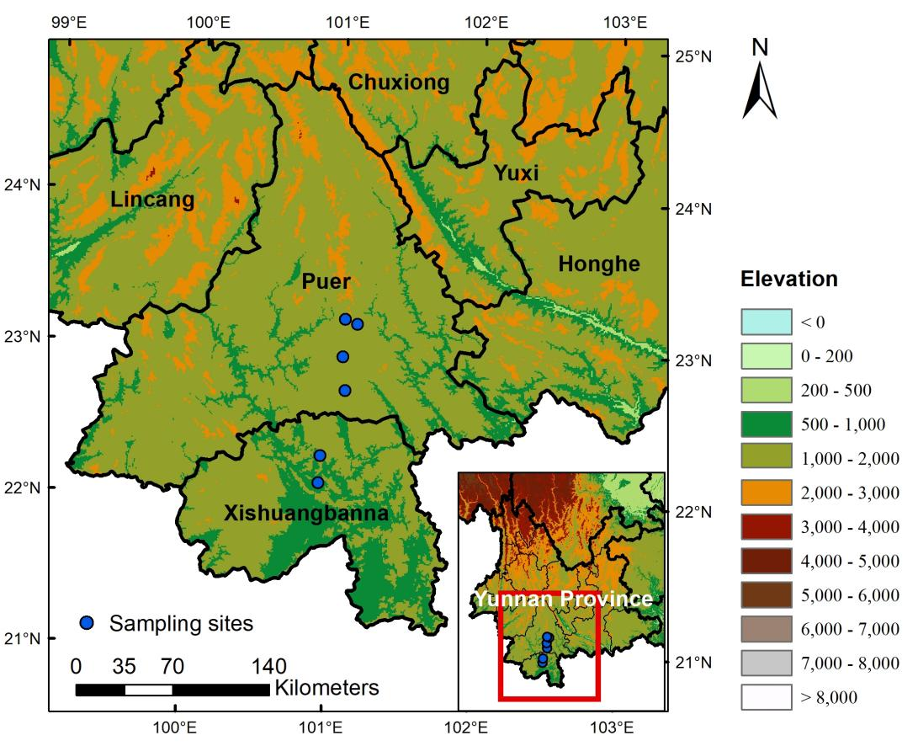
Fig. S1 The sampling sites in Xishuangbanna and Pu'er (Yunnan Province, China). The map comes from the standard map service system of the Ministry of Natural Resources, PRC. The map is authorized for free. http://bzdt.ch.mnr.gov.cn/, and the base map has not been modified.

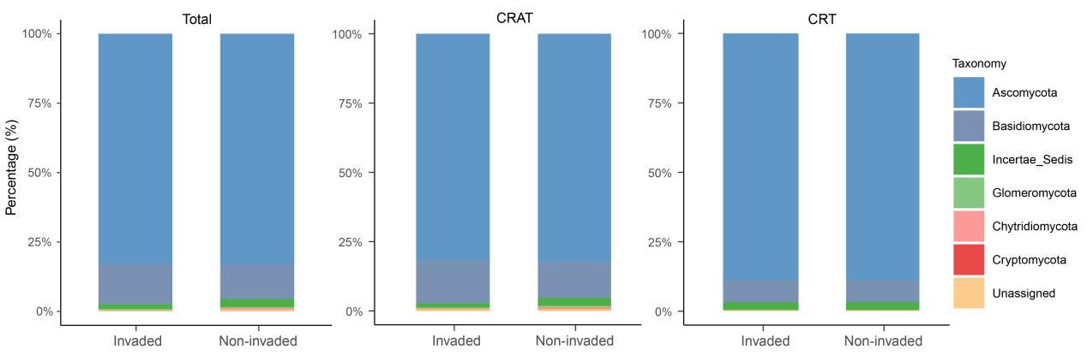
Fig. S2 Community composition of the fungal taxa at phylum level.

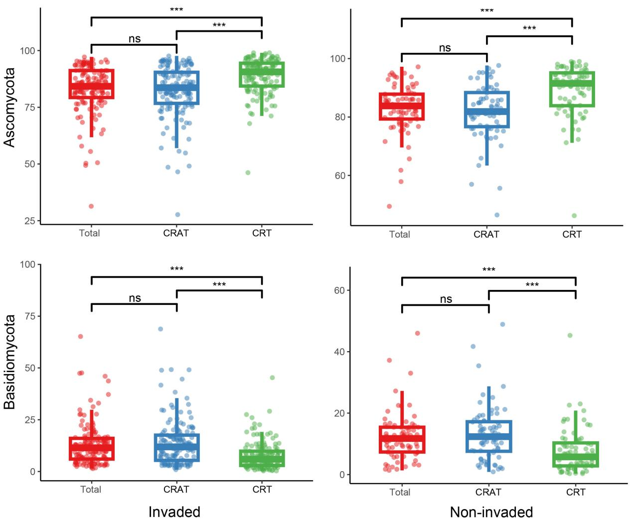
Fig. S3 The dominant phyla abundance of the fungal taxa in the invaded and non-invaded soil samples. *, p < 0.05, **, p < 0.01, ***, p < 0.001, ns, not significant.

