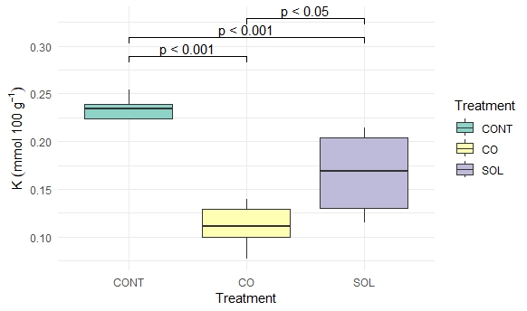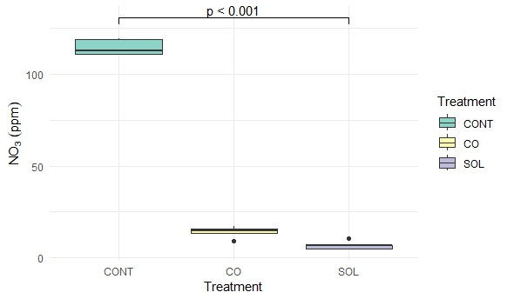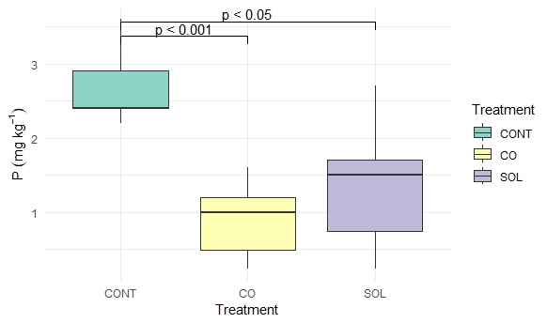
Figure S1. Analysis of variance applied to soil nutrients at the end of the conditioning phase (CONT: control, CO: C. bonarienzis pots, SOL: S. elaeagnifolium pots)
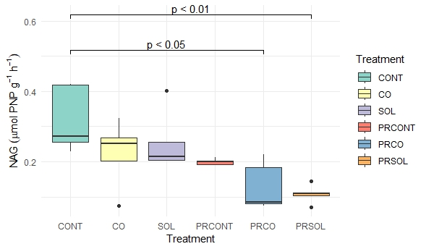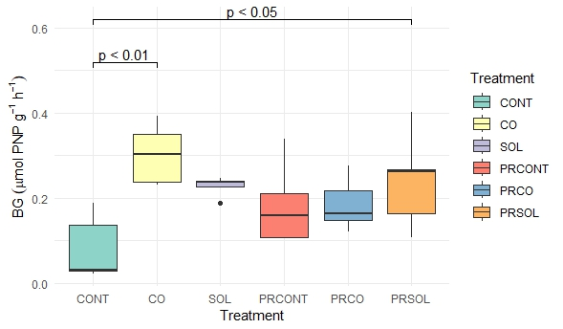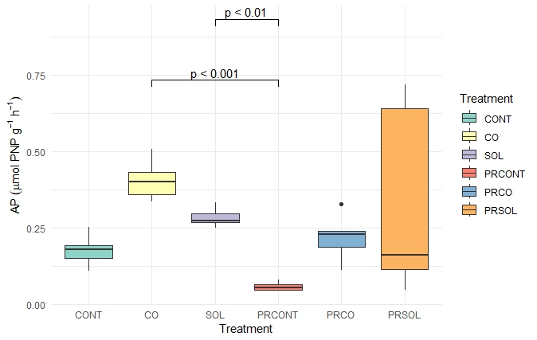

Figure S2. Analysis of variance applied to soil AP (a), NAG (b) and BG (c) (CONT, CO, SOL: conditioning sampling; PRCONT, PRCO, PRSOL: legacy sampling)
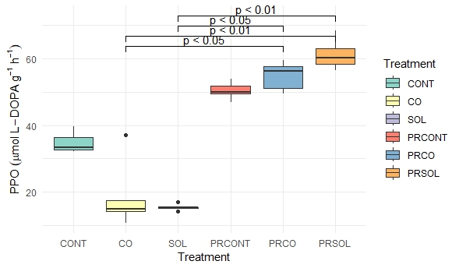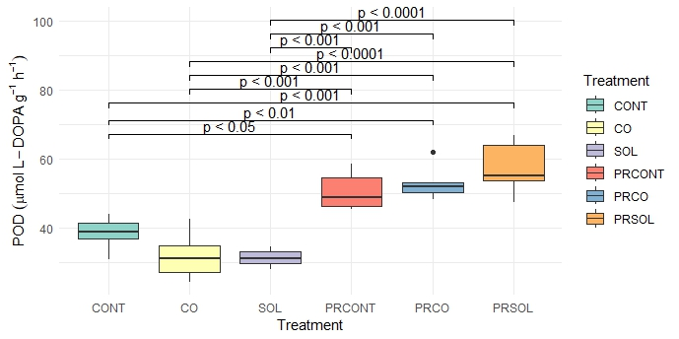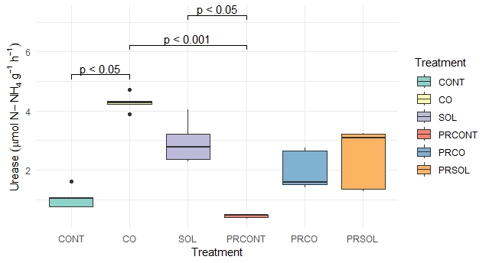
Figure S3. Analysis of variance applied to soil POD (a), PPO (b) and urease (c) (CONT, CO, SOL: conditioning sampling; PRCONT, PRCO, PRSOL: legacy sampling)

CONT | 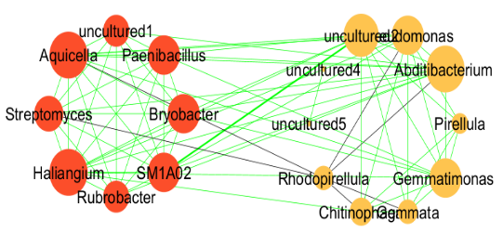 | PRCONT | 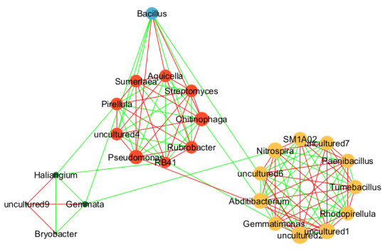
CO | 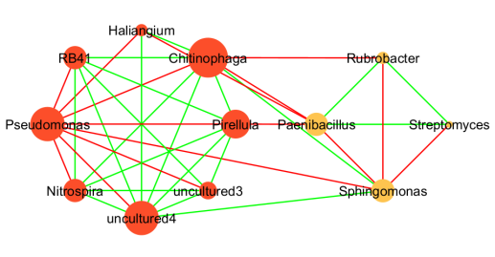 | PRCO | 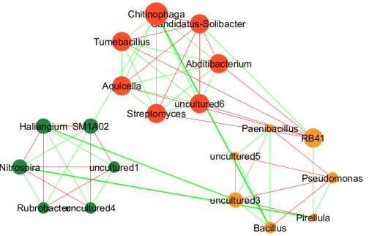
SOL | 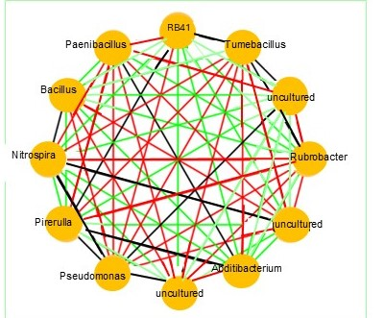 | PRSOL | 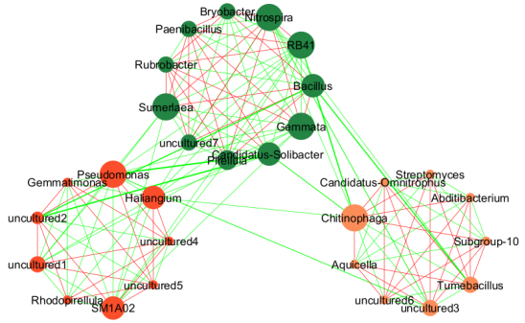

Figure S4. Network of bacterial interactions at different treatments and samplings: conditioning sampling (CONT: control, CO: C. bonarienzis, SOL: S. elaeagnifolium), legacy sampling (PRCONT: previous control with C. intybus, PRCO: previous C. bonarienzis with C. intybus, PRSOL: previous S. elaeagnifolium with C. intybus). Nodes of the same color belong to the same module. Red lines correspond to negative interactions, green lines to positive and black lines to neutral. The size of each node reflects its eigenvector centrality.

