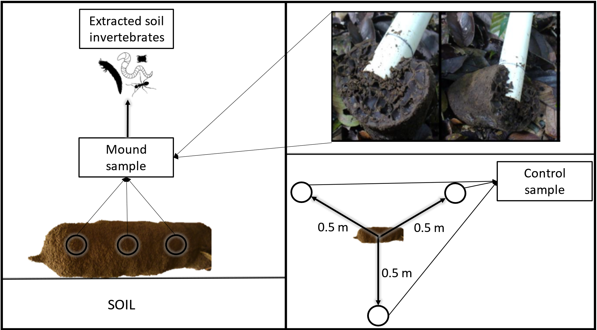
Supplement_2

Figure S1. The scheme of sampling design used in this study for comparing the soil invertebrates living in unoccupied Dicuspiditermes mounds and in the control soil. Whole mounds from the field were sealed into plastic bags and transported to the field laboratory. The control samples were taken 0.5 meters from an individual mound using a tubular soil corer of dimensions 4.0 cm in diameter and 5.0 cm in depth in a triangular layout. In the field laboratory, we placed three subsamples from each mound or control sample into a plastic tray with high rims and gently broke down the soil aggregates. During this time the samples were searched for invertebrates visible to the naked eye by a trained research assistant for ten minutes using a head torch. All invertebrates were collected using entomological tweezers and transferred into 96% ethanol.

