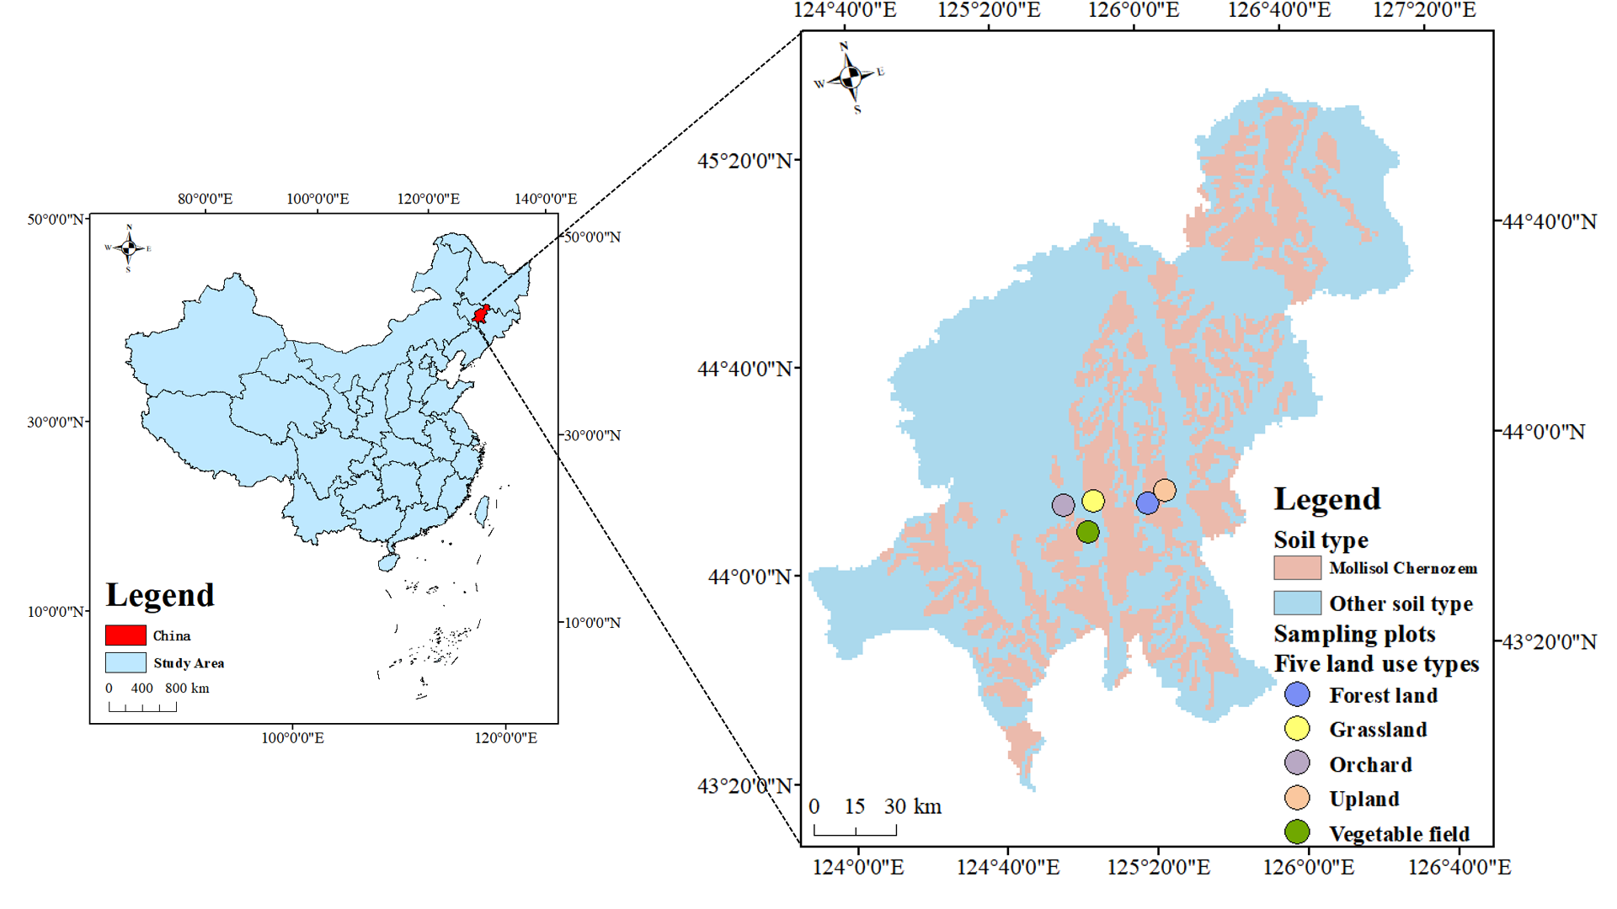
Supplementary Fig. 1 Location map of sampling areas
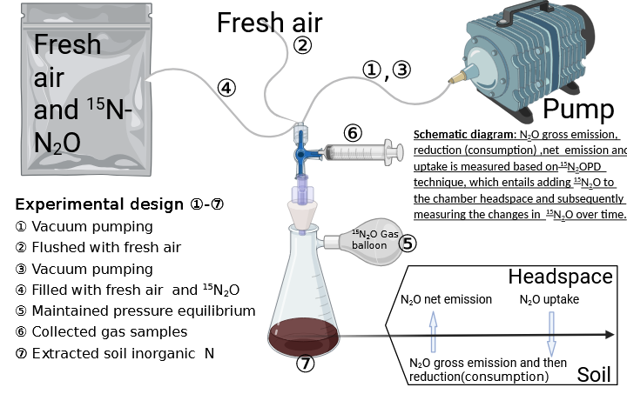
Supplementary Fig. 2 Experimental procedure diagram

