Supporting Information
Roles of straw return in shaping denitrifying bacteria in rice rhizosphere soils through affecting root exudates and soil metabolites
Pei Chen ^{1,3†}, Yu Cheng ^{1,2†}, Ning Wang ^{1,2}*, Jian-Guang Yu ^{1,2}, Zhao Ying ⁴, Li-Hong Xue ^{1,2}

¹ Key Laboratory of Agro-Environment in Downstream of Yangtze Plain, Ministry of Agriculture and Rural Affairs of the People’s Republic of China, Jiangsu Academy of Agricultural Sciences, Nanjing 210014, Jiangsu, People’s Republic of China
² School of the Environment and Safety Engineering, Jiangsu University, Zhenjiang, 212001, Jiangsu, People’s Republic of China
³ School of the Environment and Safety Engineering, Jinan University, Jinan, 212001, Shandong, People’s Republic of China
⁴ School of Environmental Science and Engineering, Yancheng Institute of Technology, Yancheng 224051, Jiangsu, People’s Republic of China
† Pei Chen and Yu Cheng contributed equally to this work
*Corresponding authors: Key Laboratory of Agro-Environment in Downstream of Yangtze Plain, Ministry of Agriculture and Rural Affairs of the People’s Republic of China, Jiangsu Academy of Agricultural Sciences, wang.ning4113@163.com (Ning Wang).
Number of tables: 2
Number of figures: 6
Number of figures: 6

Table S1. Basic properties of two paddy soils collected from Taizhou (TZ) and Yixing (YX), Jiangsu, China and wheat straw used in this study.
 | pH | EC | TOC | TN | AN | AK | AP
 | pH | (μs cm⁻¹) | (g kg⁻¹) | (g kg⁻¹) | (mg kg⁻¹) | (mg kg⁻¹) | (mg kg⁻¹)
TZ | 6.80 ± 0.07ª | 350 ± 3.21ª | 15.9 ± 0.35^{b} | 1.05 ± 0.12^{b} | 36.7 ± 0.58^{b} | 260 ± 12.1^{b} | 44.9 ± 0.54ª
YX | 6.52 ± 0.05^{b} | 343 ± 2.82ª | 28.5 ± 2.96ª | 1.95 ± 0.05ª | 168 ± 6.91ª | 291 ± 13.3ª | 35.4 ± 2.29^{b}
Straw |  |  | 46.5 ± 0.02 | 0.48±0.005
Different upper letters indicated significant (p < 0.05) differences in two types of soil.
Abbreviations: EC, electrical conductivity; TOC, soil organic carbon; TN, total nitrogen; AN, alkali-hydrolyzable nitrogen;
AP, available phosphorus; AK, available potassium.

Table S2. Alpha-diversity based on sobs index of denitrifying bacterial community in rhizosphere soils with and without straw amendment.
Sobs index | nirK | nirS | nosZ
Control_TZ | 620 ± 229^{b} | 902 ± 45.8^{ab} | 444 ± 132^{bc}
Straw_TZ | 738 ± 402^{b} | 623 ± 288^{b} | 549 ± 43.5^{ab}
Control_YX | 998 ± 412^{ab} | 1021 ± 56.5ª | 333 ± 82.0^{c}
Straw_YX | 1642 ± 462ª | 751 ± 274^{ab} | 637 ± 112ª
Different upper letters indicated significant (p < 0.05) differences in two types of soil.
Fig. S1. Non–metric Multidimensional scaling (NMDS) analysis at OTU level to show differences in the nirK- (a), nirS- (b), and nosZ-type (c) denitrifying bacterial communities between control and straw treatments.
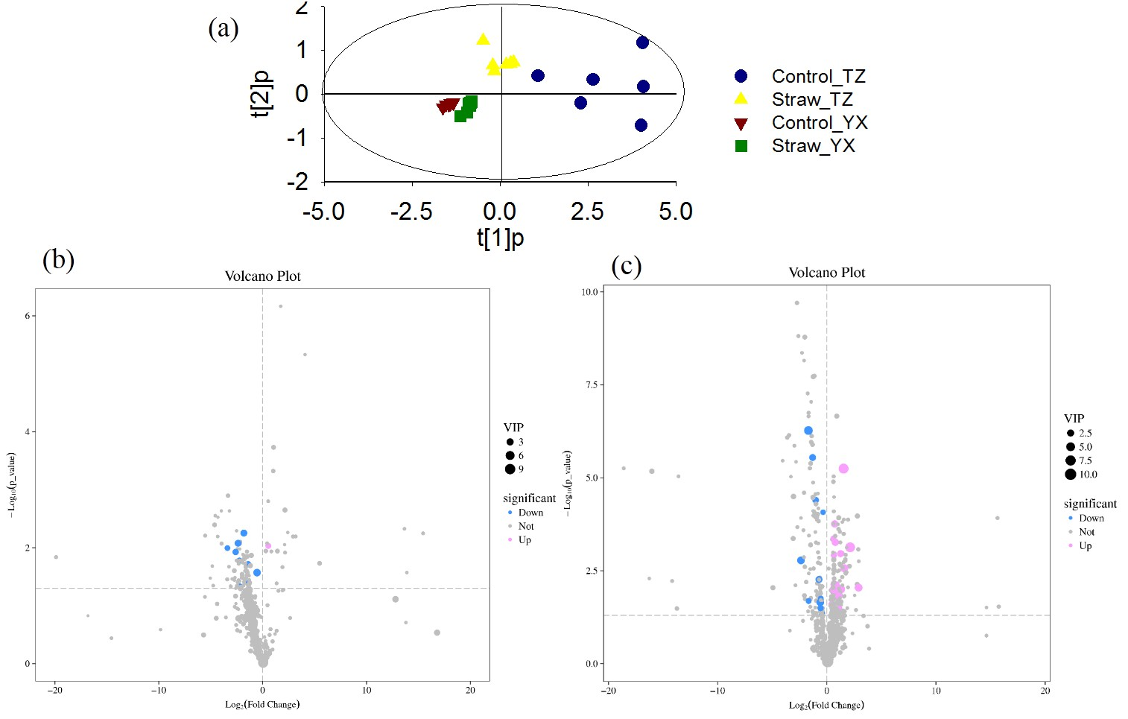
Fig. S2. Effects of wheat straw amendment at 2% (w/w) on root exudates for rice growing in TZ and YX soils. (a) Score scatter plot of OPLS-DA model; (b) Volcano plot showing the up/down-regulated expression of root exudates in TZ straw treatment compared to TZ control treatment; (c) Volcano plot showing the up/down-regulated expression of root exudates in YX straw treatment compared to YX control treatment.
Fig. S3. Effects of wheat straw amendment (2%) on root exudates for rice growing in TZ and YX soils. (a–b) Difference in each category of root excludes (carbohydrates, alcohols, amines, benzenes, amino acids, fatty acids, organic acids) between straw and control treatments of TZ (a) and YX soils (b); (c–d) Fold changes in abundances of differential metabolites for straw treatments of TZ (c) and YX soils (d). Fold changes were calculated by dividing the abundance of a metabolite in the straw treatment to that in the control treatment. Substances with relative contribution < 0.5% were classified as Other. *: significant difference at p < 0.05.

Fig. S4. Composition of soil metabolites in the rhizosphere soils of control and straw amendment treatments for TZ (a, c) and YX (b, d) soils. (a, b): Classification of the known soil metabolites; (c, d) Score scatter plot of OPLS-DA model for soil metabolites in control and straw amendment treatments. Soil metabolites were classified to carbohydrates, alcohols, amines, benzenes, amino acids, fatty acids, organic acids. The percentage of each category of soil metabolites was calculated by dividing the sum of the peak areas of each category by the sum of all peak areas. Substances with relative contribution < 0.5% were classified as Other.

Fig. S5. Fold changes of differential soil metabolites that identified between control and straw amendment treatments for rhizosphere soils of TZ (a) and YX (b). Fold changes were calculated by dividing the abundance of a metabolite in the straw treatment to that in the control treatment.
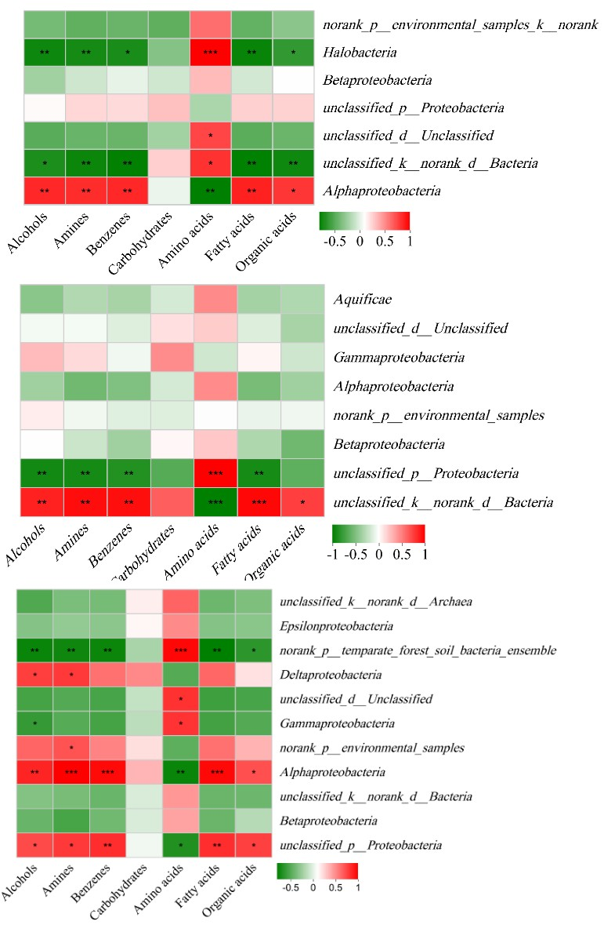
Fig. S6. Pearson correlations between major category of soil metabolites, and major class of denitrifying bacteria in rhizosphere soils. *, **, and ***: significant difference at p < 0.05, 0.01, and 0.001.

