Supporting Information for

The effects of biodegradable microplastics on the enrichment of antibiotic resistance genes depend on their particle size

Mengli Liu^{1,2}, Honghao Cheng¹, Xueya Liu¹, Chong Wang¹, Biao Zhu^{2,3}*

ORCID:
Mengli Liu (https://orcid.org/0000-0002-8357-0978)
Chong Wang (https://orcid.org/0000-0001-8114-3510)
Biao Zhu (https://orcid.org/0000-0001-9858-7943)

- College of Resources and Environmental Sciences, China Agricultural University, Beijing 100193, China
- State Key Laboratory for Vegetation Structure, Function and Construction (VegLab), Ministry of Education Key Laboratory for Earth Surface Processes, and College of Urban and Environmental Sciences, Peking University, Beijing 100871, China
- Ministry of Education Key Laboratory of Ecology and Resource Use of the Mongolian Plateau, Inner Mongolia Key Laboratory of Grassland Ecology, and School of Ecology and Environment, Inner Mongolia University, Huhhot 010021, China
*Corresponding author:
Biao Zhu, Tel.: 86-10-62745258; E-mail:
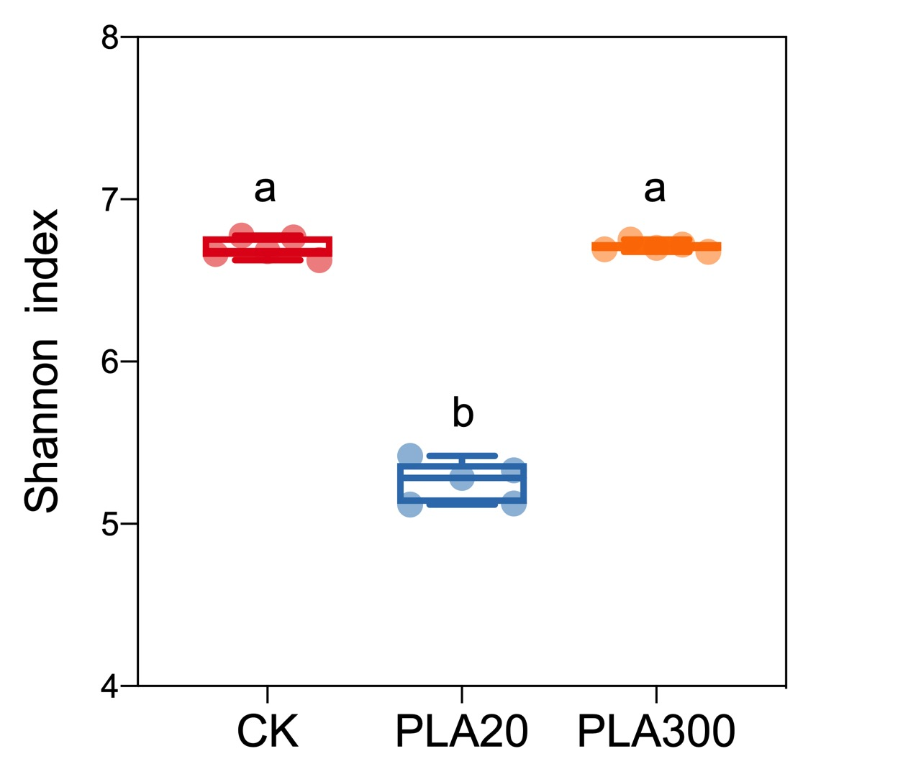
Figure S1 Effects of bio-MPs on the diversity of soil bacterial community.
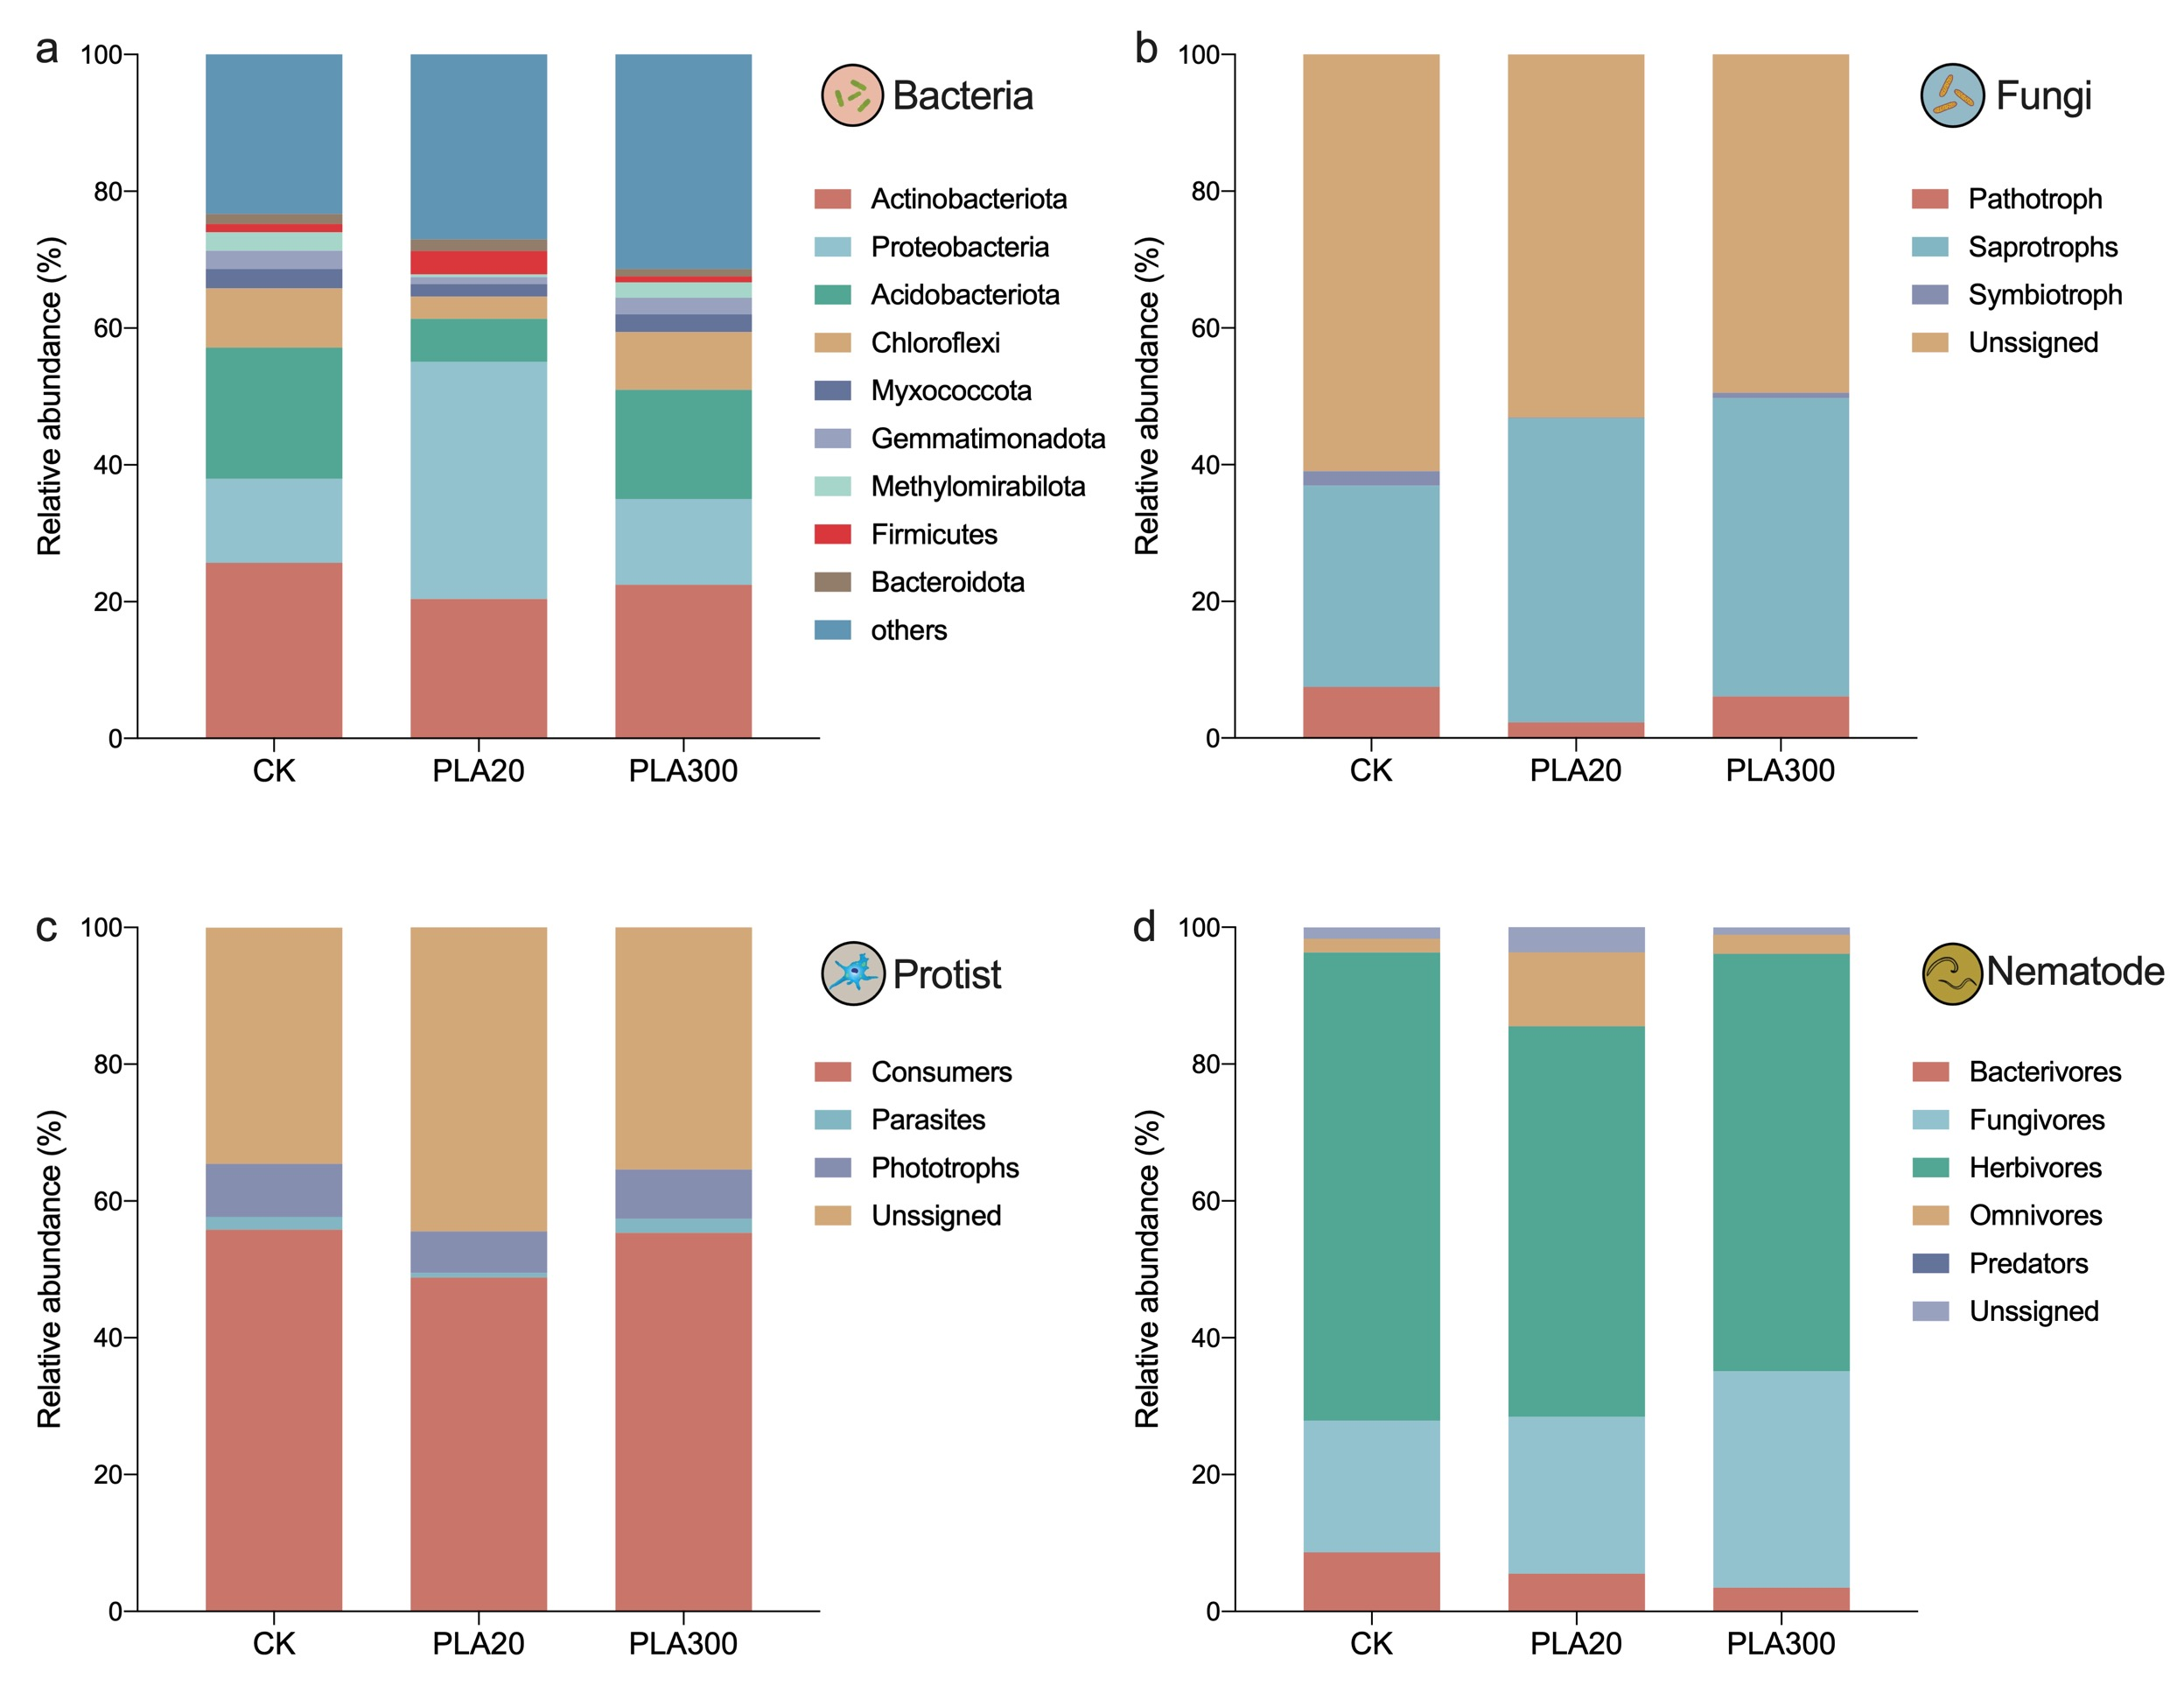
Figure S2 Composition of soil bacterial (a), fungal (b), protist (c), and nematode (d) communities of soil micro-food web.
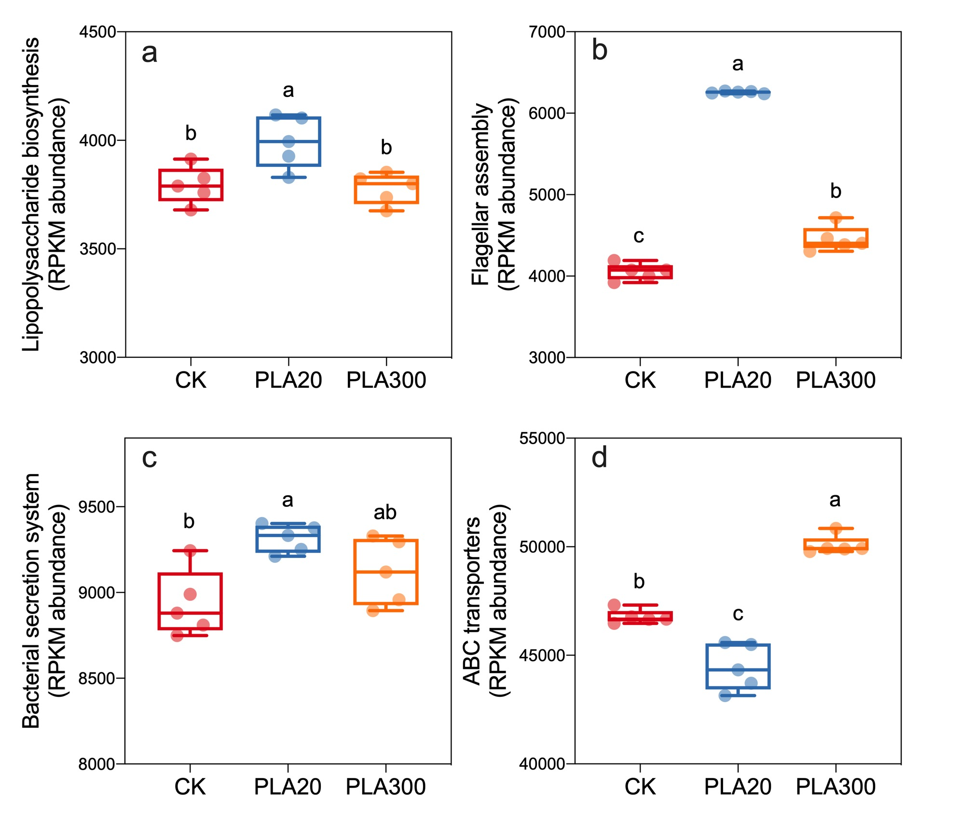
Figure S3 Relative abundance of microbial features essential for antibiotic resistance (membranal structure and transport response) derived from KEGG level 3.
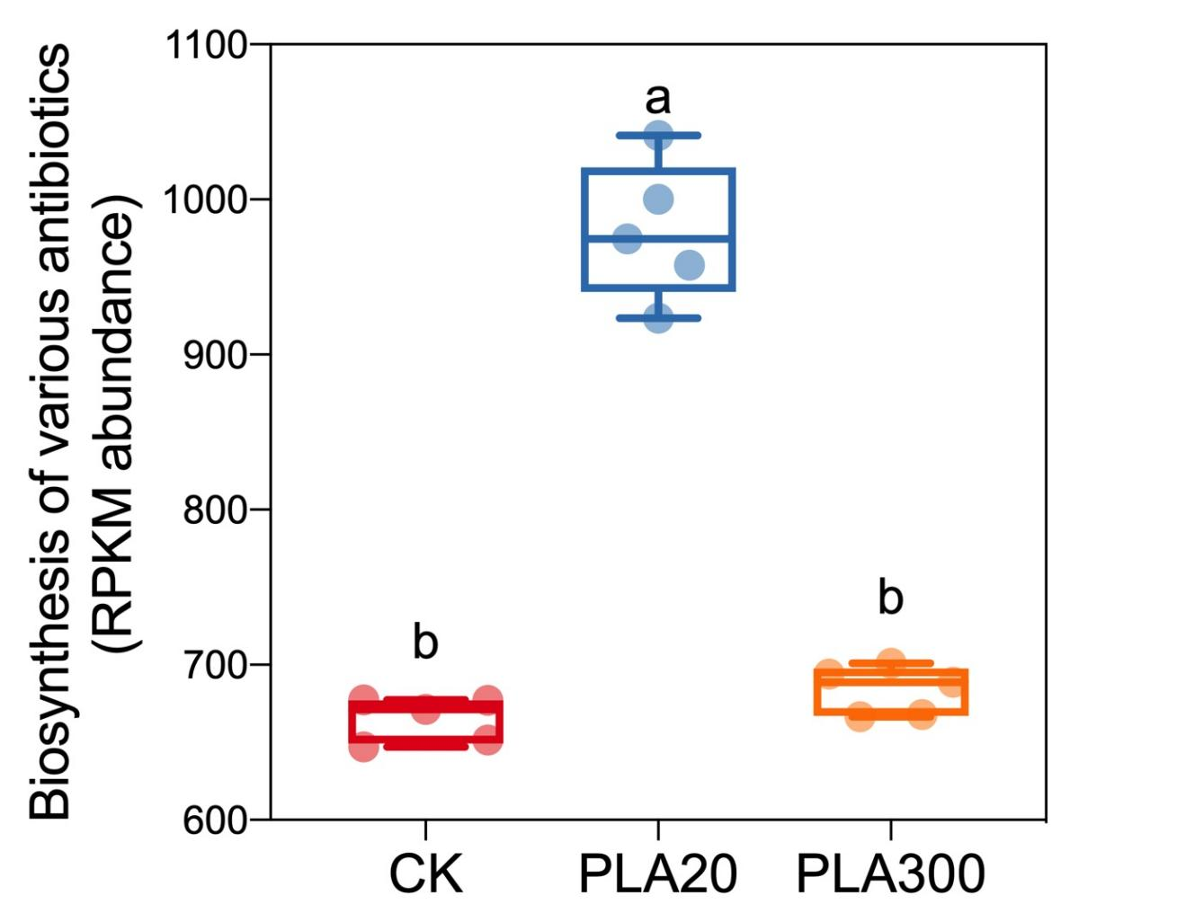
Figure S4 Relative abundance of microbial features essential for biosynthesis of antibiotics derived from KEGG level 3.

