Appendix A: Images of the nine oribatid mite species, confusion matrix heatmaps, and additional figures from the image resolution experiment.

Figure Captions:
Fig. S1 Raw images of oribatid mite specimens (resolution: 5440 × 3648 pixels). Panels (a)–(i) represent A. mahunkai, C. bipilis, H. (P.) peltifer, M. mammillaris, N. (N.) parallela, P. (P.) intermedia, P. (P.) capucinus, R. ovulum, and T. velatus, respectively. Superscripts 1 and 2 denote that the specimens originate from Tianmu Mountain and Guan Mountain, respectively.
Fig. S2 Confusion matrix heatmaps illustrating the performance of CNN models. Panels (a)–(e) correspond to the AlexNet, VGG16, ResNet50, ResNet101, and DenseNet models, respectively. Species Sp.1–Sp.9 represent A. mahunkai, C. bipilis, H. (P.) peltifer, M. mammillaris, N. (N.) parallela, P. (P.) intermedia, P. (P.) capucinus, R. ovulum, and T. velatus, respectively.
Fig. S3 Confusion matrix heatmaps illustrating the performance of the DenseNet model under different image resolutions. Panels (a)–(i) correspond to image resolutions of 32 × 32, 48 × 48, 56 × 56, 64 × 64, 80 × 80, 96 × 96, 112 × 112, 128 × 128, and 224 × 224 pixels, respectively. Species Sp.1–Sp.9 represent A. mahunkai, C. bipilis, H. (P.) peltifer, M. mammillaris, N. (N.) parallela, P. (P.) intermedia, P. (P.) capucinus, R. ovulum, and T. velatus, respectively.
Fig. S4 Confusion matrix heatmaps illustrating the performance of the DenseNet model under varying RGB background color conditions. Panels (a)–(h) correspond to the RGB color values (0,0,0) [Black], (0,0,255) [Blue], (0,255,0) [Green], (0,255,255) [Cyan], (255,0,0) [Red], (255,0,255) [Magenta], (255,255,0) [Yellow], and (255,255,255) [White], respectively. Species Sp.1–Sp.9 represent A. mahunkai, C. bipilis, H. (P.) peltifer, M. mammillaris, N. (N.) parallela, P. (P.) intermedia, P. (P.) capucinus, R. ovulum, and T. velatus, respectively.
Fig. S5 Confusion matrix heatmaps illustrating the performance of the DenseNet model in classifying species from different habitat origins. Panels (a)–(i) correspond to A. mahunkai, C. bipilis, H. (P.) peltifer, M. mammillaris, N. (N.) parallela, P. (P.) intermedia, P. (P.) capucinus, R. ovulum, and T. velatus, respectively.
Fig. S6 Precision values illustrating the performance of the DenseNet model across different image resolutions (32 × 32 to 448 × 448 pixels).
Fig. S7 Recall values illustrating the performance of the DenseNet model across different image resolutions (32 × 32 to 448 × 448 pixels).
Fig. S8 F1-score values illustrating the performance of the DenseNet model across different image resolutions (32 × 32 to 448 × 448 pixels).
Fig. S9 Training time (h) illustrating the performance of the DenseNet model across different image resolutions (32 × 32 to 448 × 448 pixels).

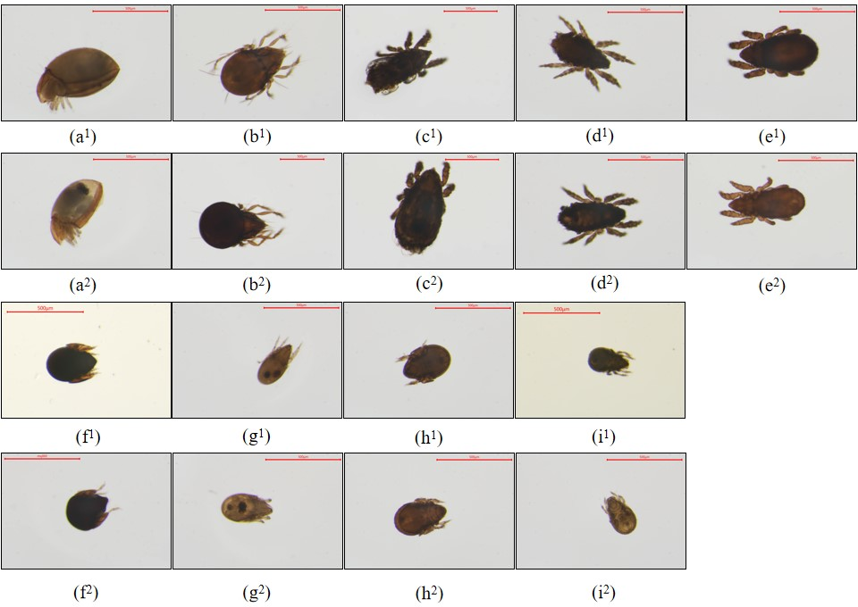
Fig. S1 Raw images of oribatid mite specimens (resolution: 5440 × 3648 pixels). Panels (a)–(i) represent A. mahunkai, C. bipilis, H. (P.) peltifer, M. mammillaris, N. (N.) parallela, P. (P.) intermedia, P. (P.) capucinus, R. ovulum, and T. velatus, respectively. Superscripts 1 and 2 denote that the specimens originate from Tianmu Mountain and Guan Mountain, respectively.
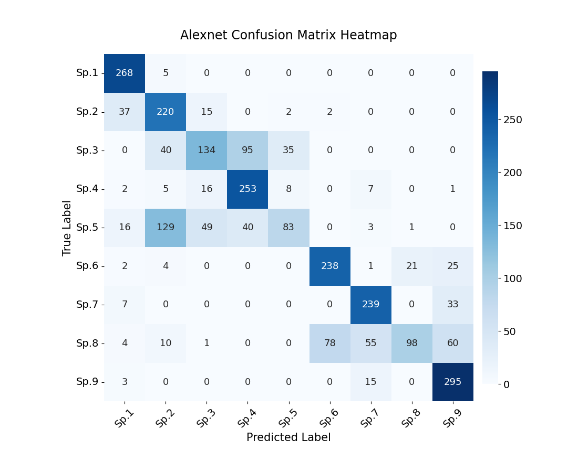
(a)
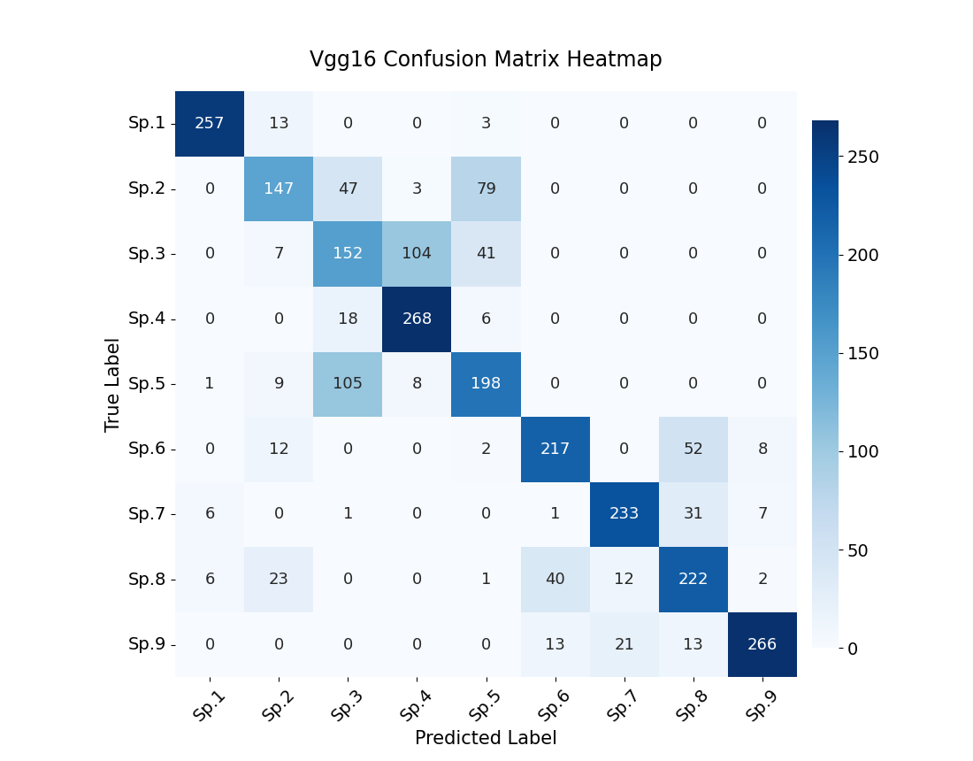
(b)

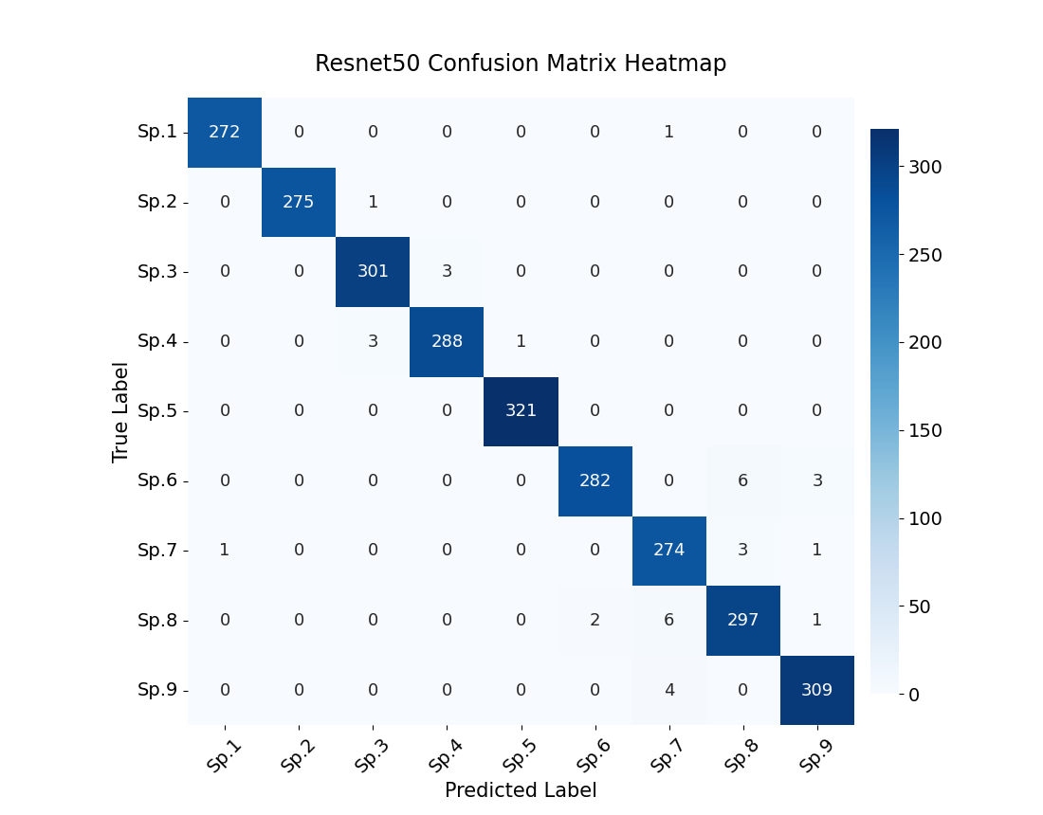
(c)
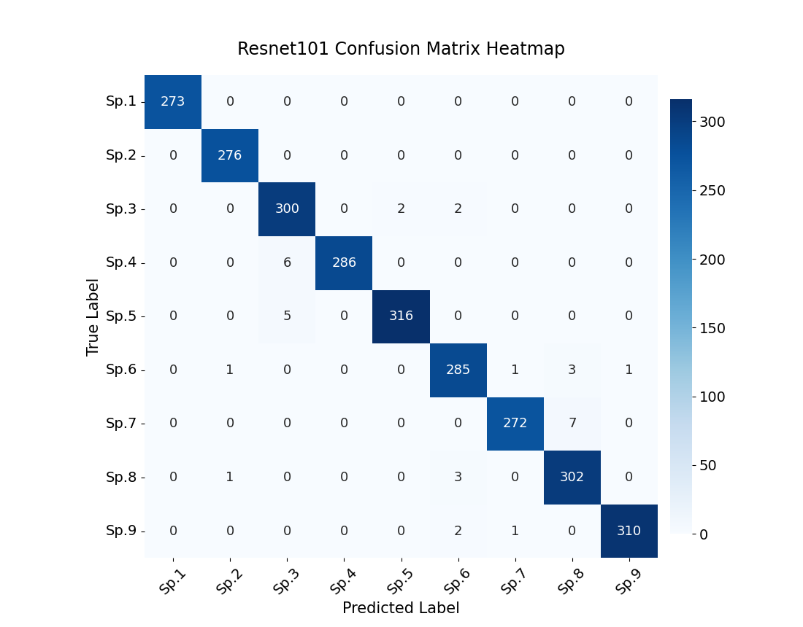
(d)
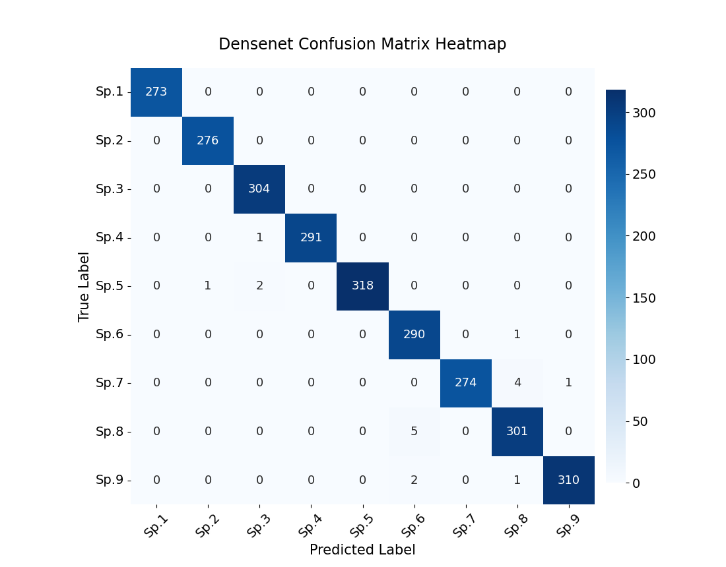
(e)
Fig. S2 Confusion matrix heatmaps illustrating the performance of CNN models. Panels (a)–(e) correspond to the AlexNet, VGG16, ResNet50, ResNet101, and DenseNet models, respectively. Species Sp.1–Sp.9 represent A. mahunkai, C. bipilis, H. (P.) peltifer, M. mammillaris, N. (N.) parallela, P. (P.) intermedia, P. (P.) capucinus, R. ovulum, and T. velatus, respectively.
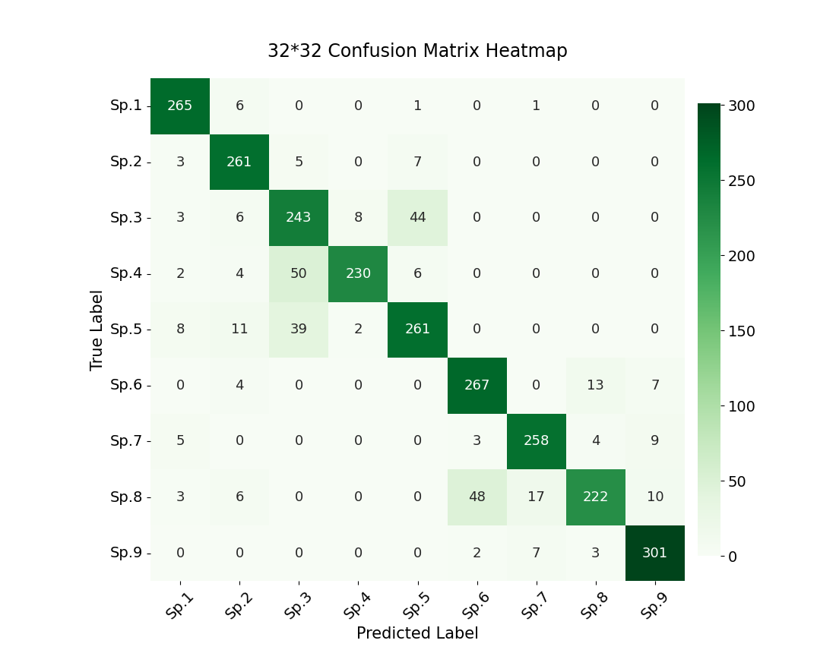
(a)
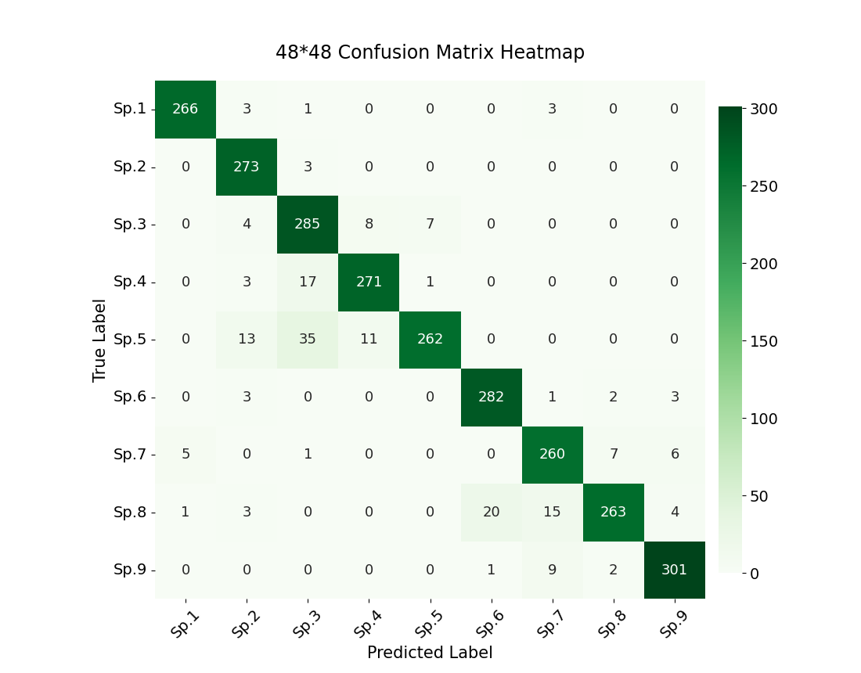
(b)
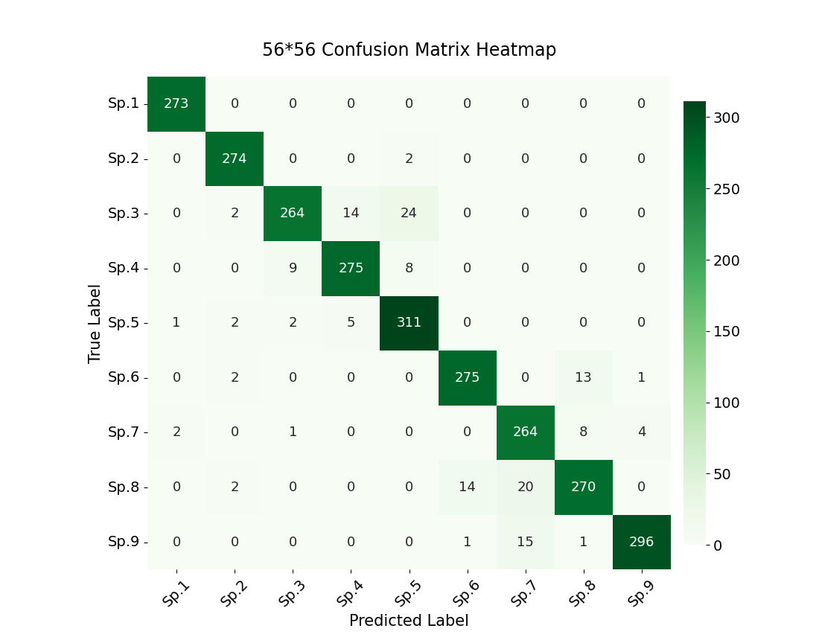
(c)
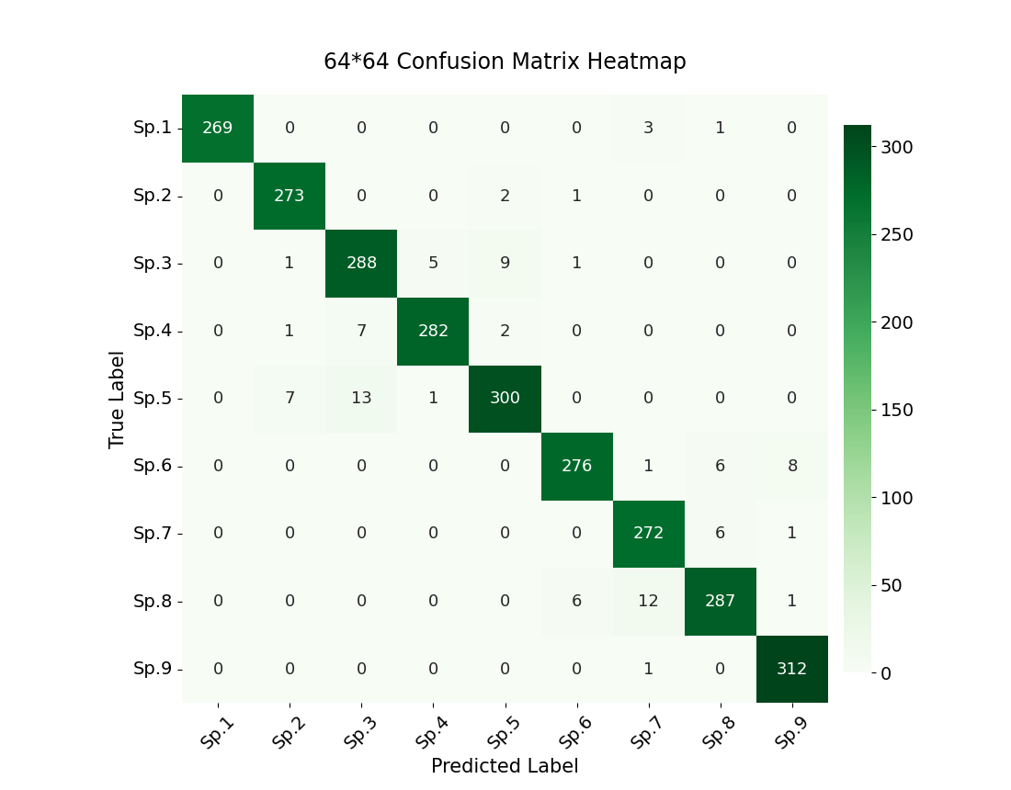
(d)
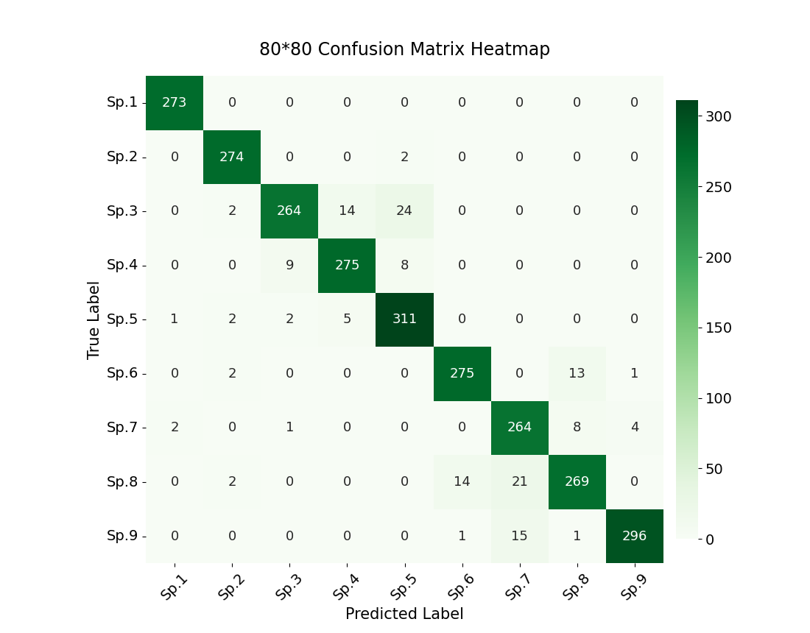
(e)
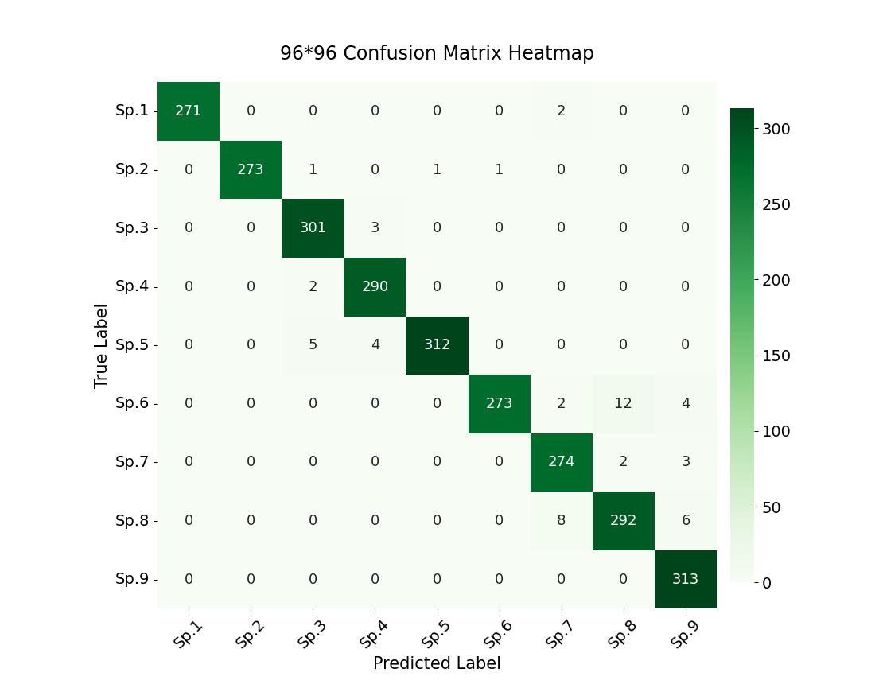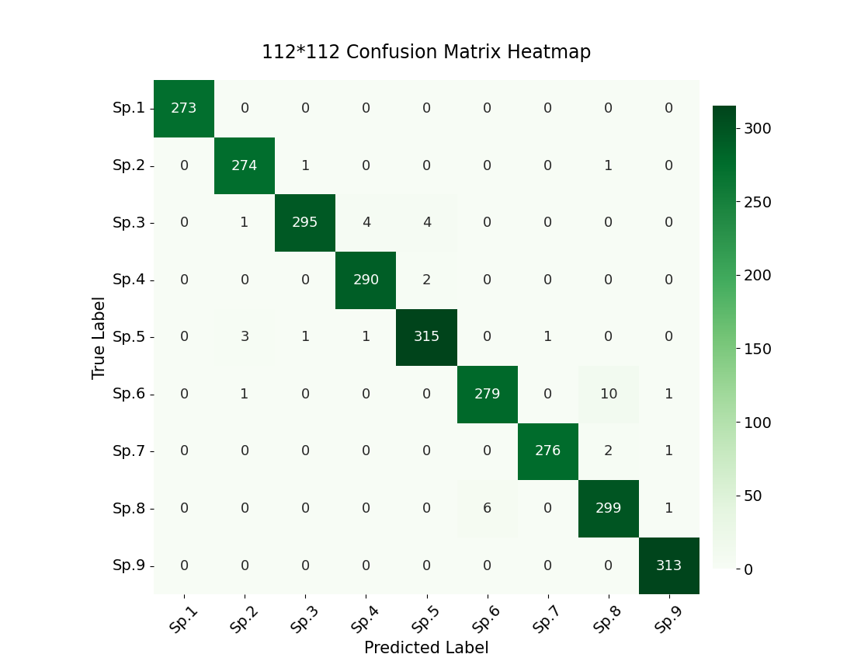
(f)
(g)
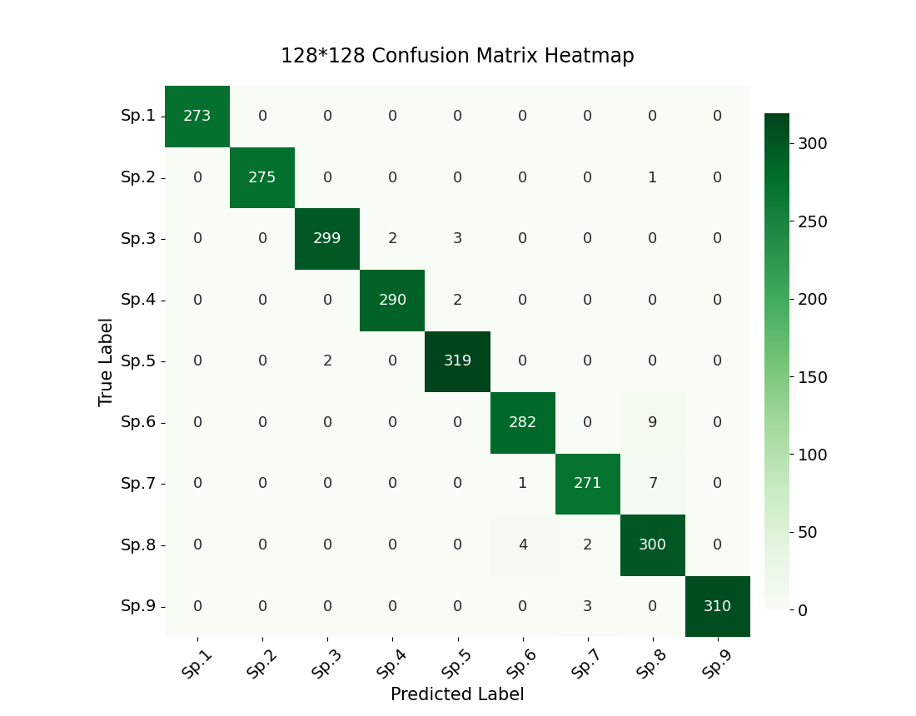
(h)
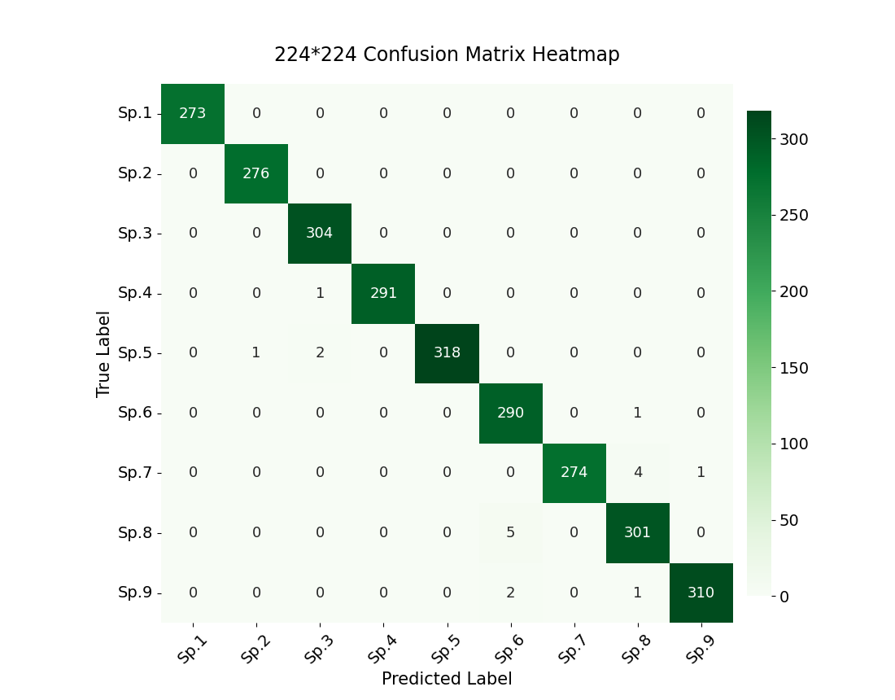
(i)
Fig. S3 Confusion matrix heatmaps illustrating the performance of the DenseNet model under different image resolutions. Panels (a)–(i) correspond to image resolutions of 32 × 32, 48 × 48, 56 × 56, 64 × 64, 80 × 80, 96 × 96, 112 × 112, 128 × 128, and 224 × 224 pixels, respectively. Species Sp.1–Sp.9 represent A. mahunkai, C. bipilis, H. (P.) peltifer, M. mammillaris, N. (N.) parallela, P. (P.) intermedia, P. (P.) capucinus, R. ovulum, and T. velatus, respectively.
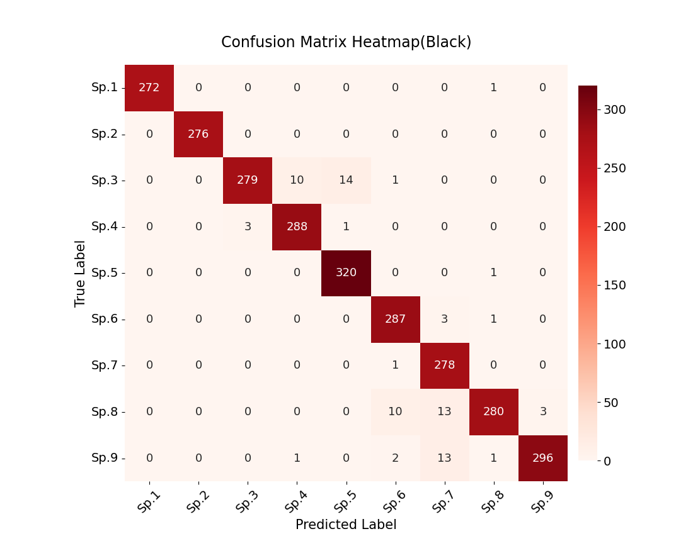
(a)
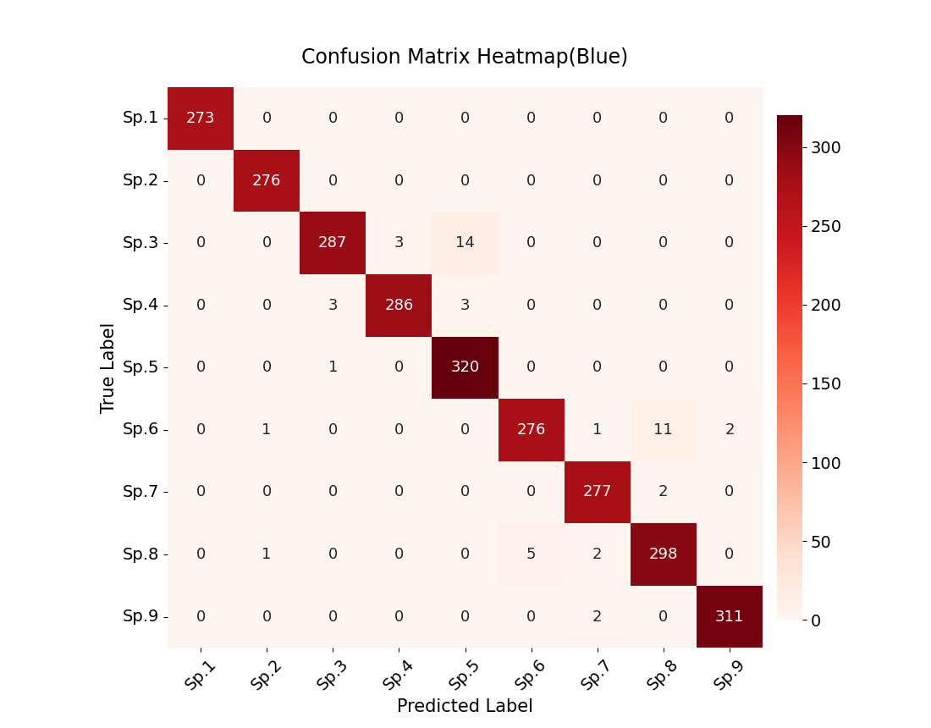
(b)
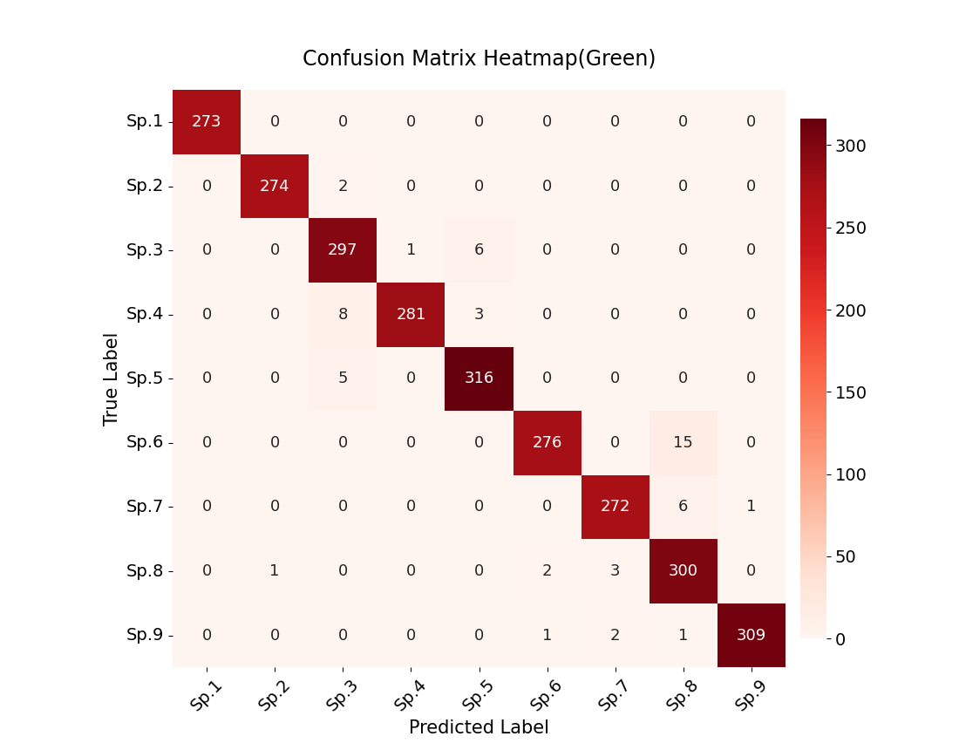
(c)
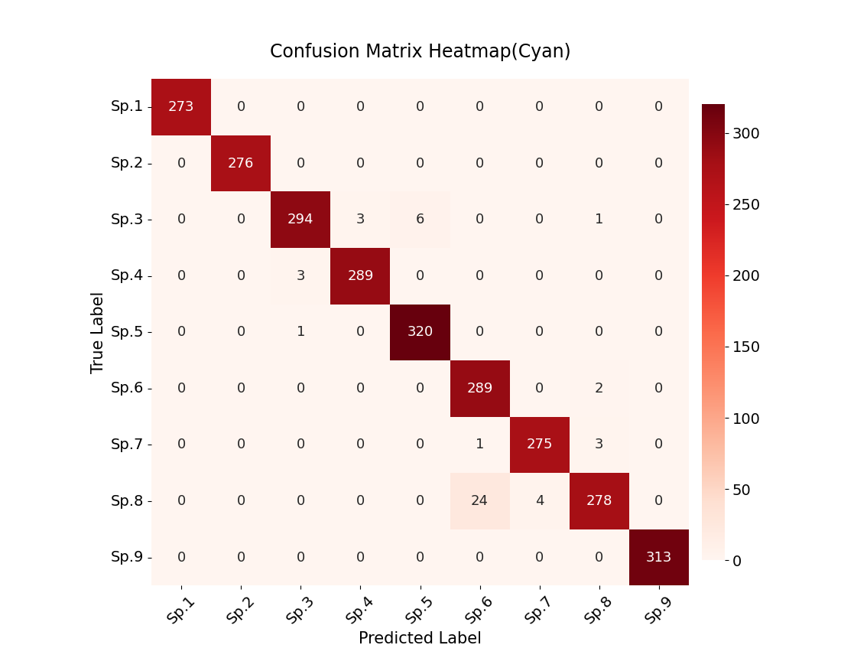
(d)
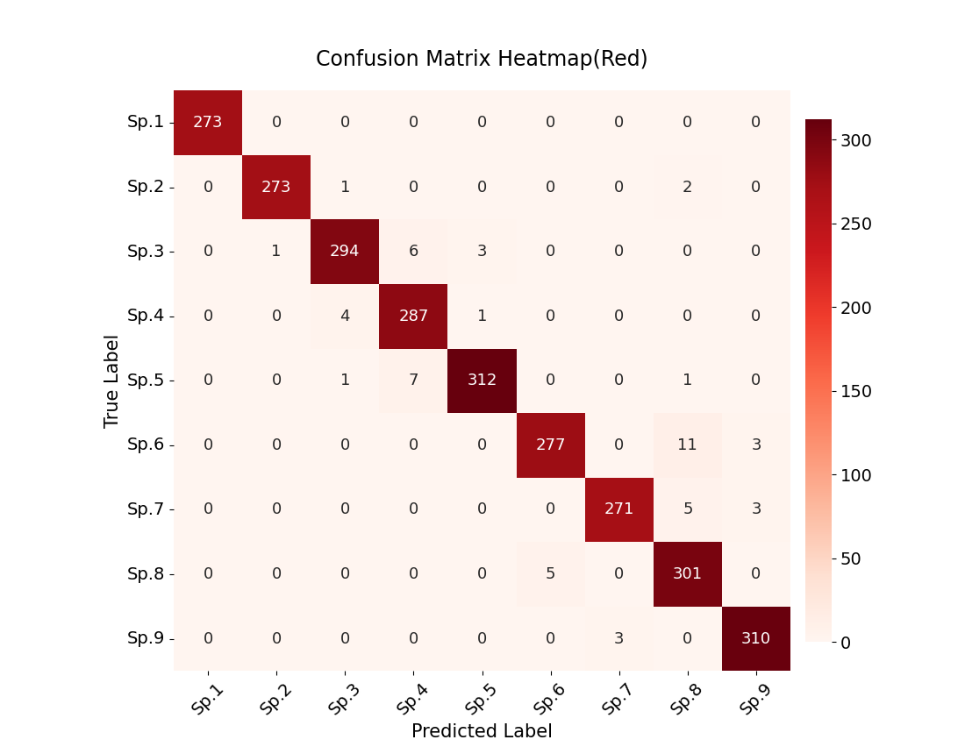
(e)
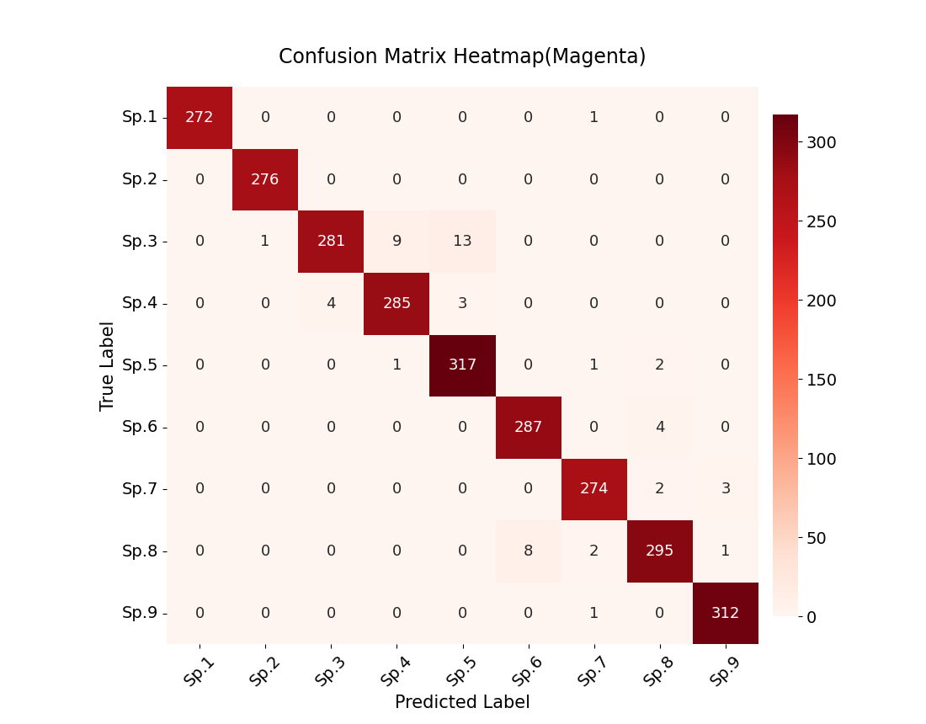
(f)
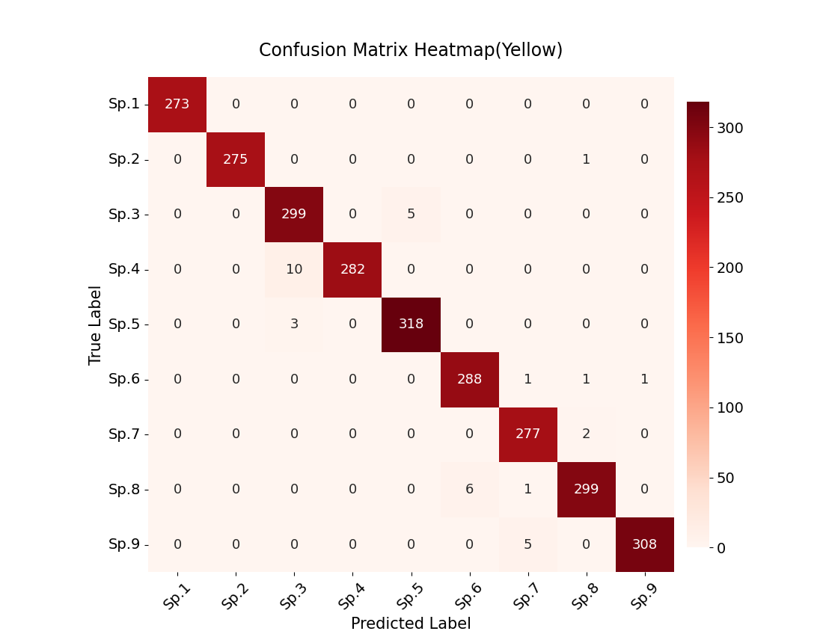
(g)
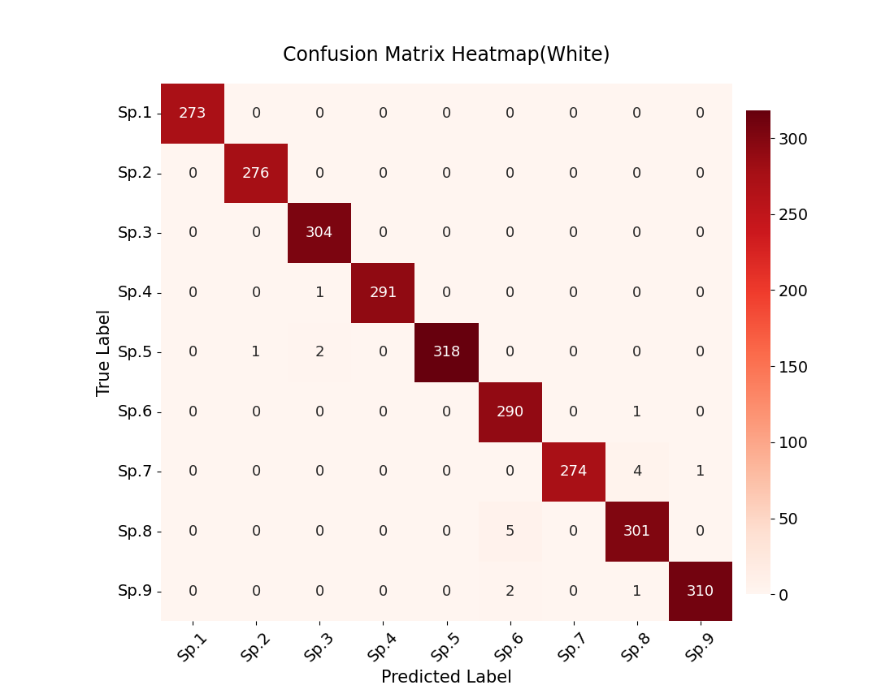
(h)
Fig. S4 Confusion matrix heatmaps illustrating the performance of the DenseNet model under varying RGB background color conditions. Panels (a)–(h) correspond to the RGB color values (0,0,0) [Black], (0,0,255) [Blue], (0,255,0) [Green], (0,255,255) [Cyan], (255,0,0) [Red], (255,0,255) [Magenta], (255,255,0) [Yellow], and (255,255,255) [White], respectively. Species Sp.1–Sp.9 represent A. mahunkai, C. bipilis, H. (P.) peltifer, M. mammillaris, N. (N.) parallela, P. (P.) intermedia, P. (P.) capucinus, R. ovulum, and T. velatus, respectively.

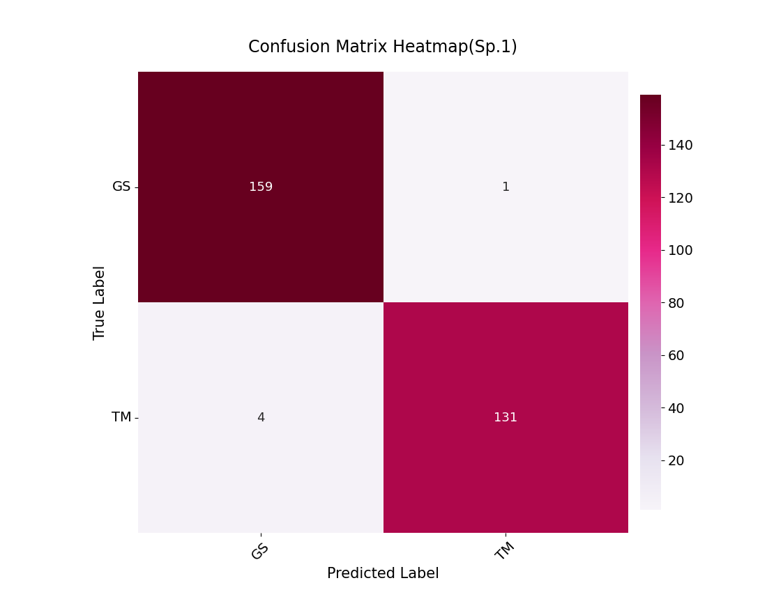
(a)
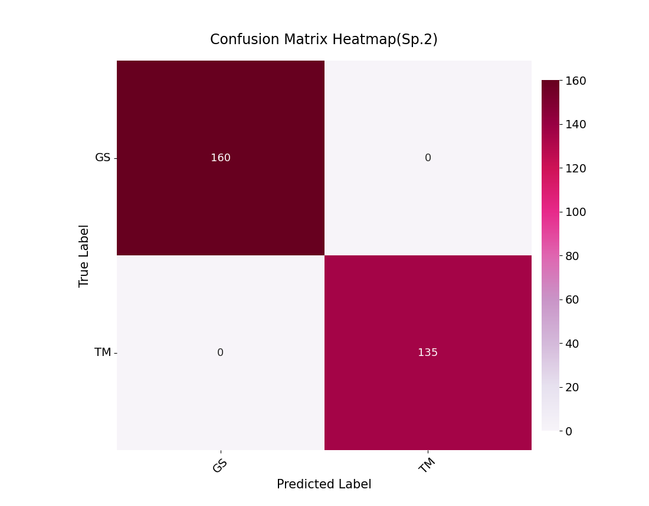
(b)
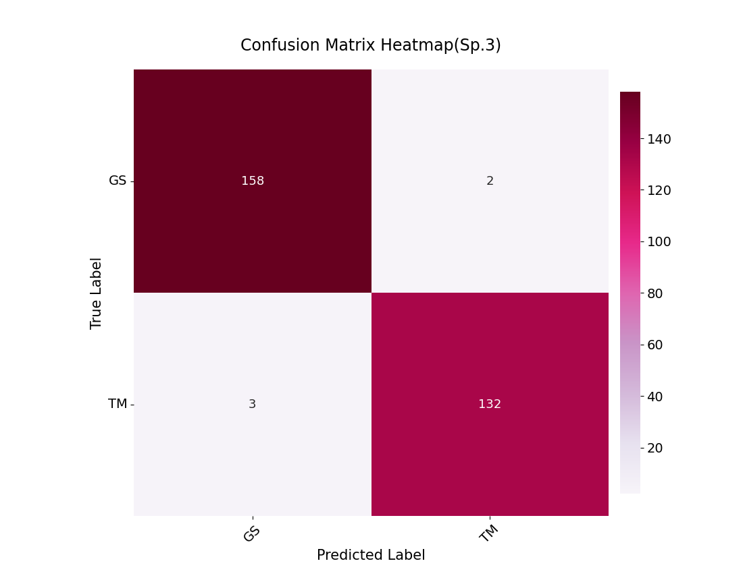
(c)
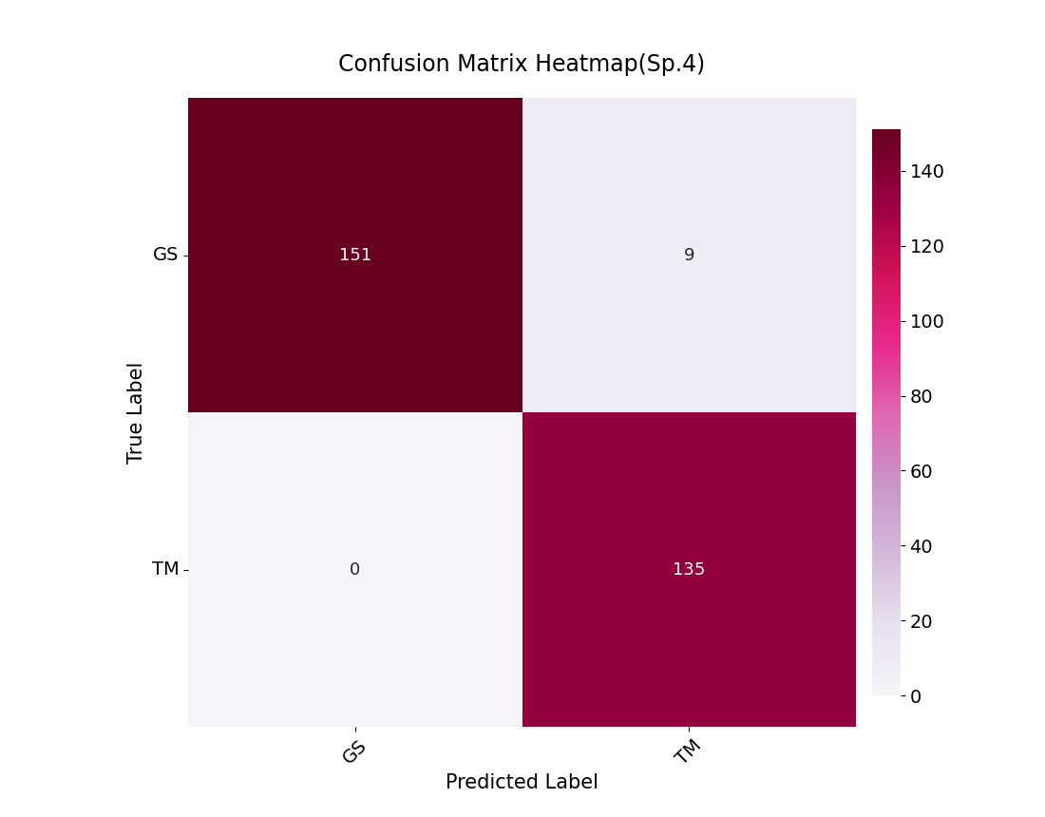
(d)
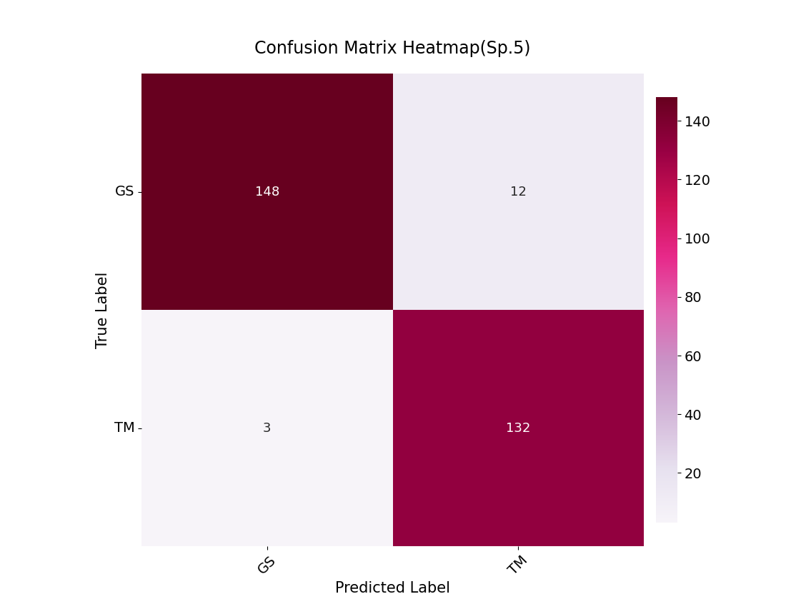
(e)
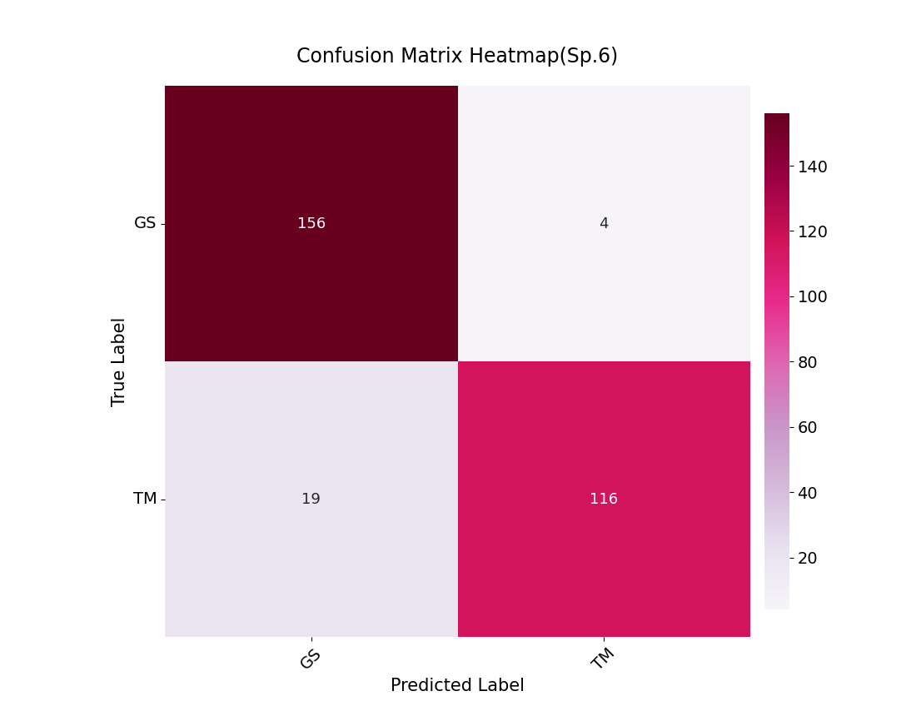
(f)
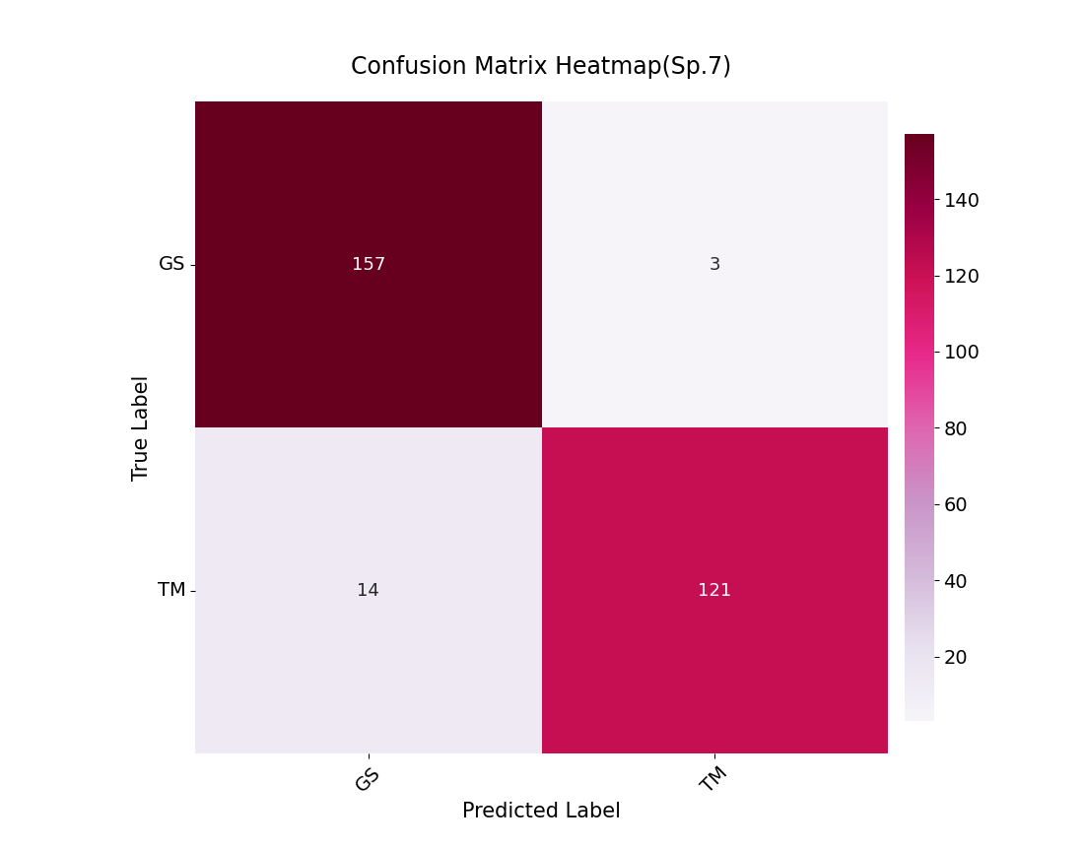
(g)
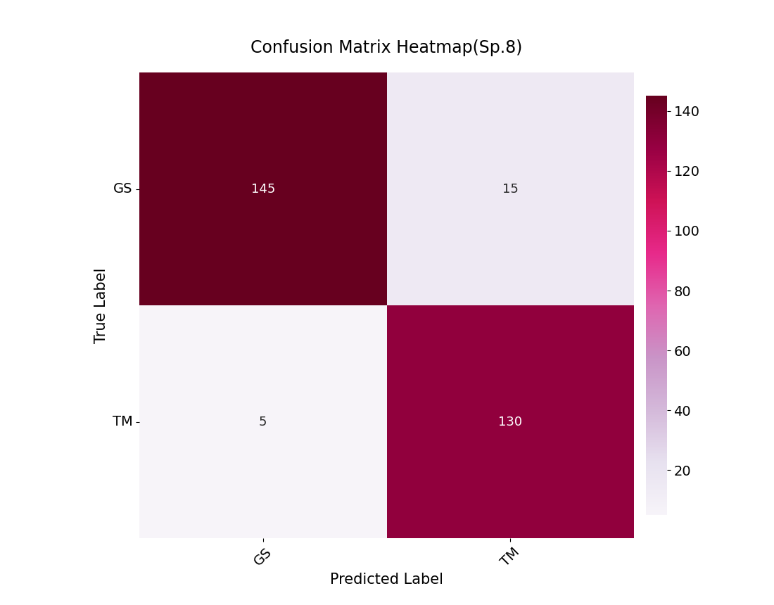
(h)
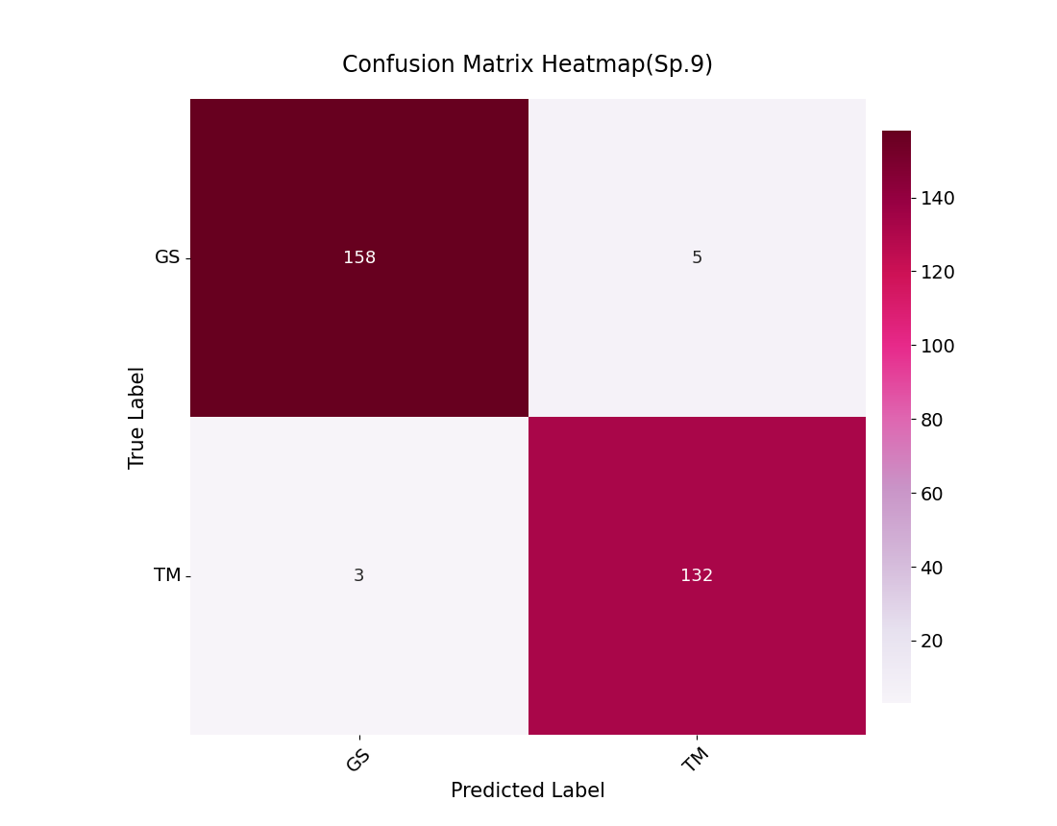
(i)
Fig. S5 Confusion matrix heatmaps illustrating the performance of the DenseNet model in classifying species from different habitat origins. Panels (a)–(i) correspond to A. mahunkai, C. bipilis, H. (P.) peltifer, M. mammillaris, N. (N.) parallela, P. (P.) intermedia, P. (P.) capucinus, R. ovulum, and T. velatus, respectively.

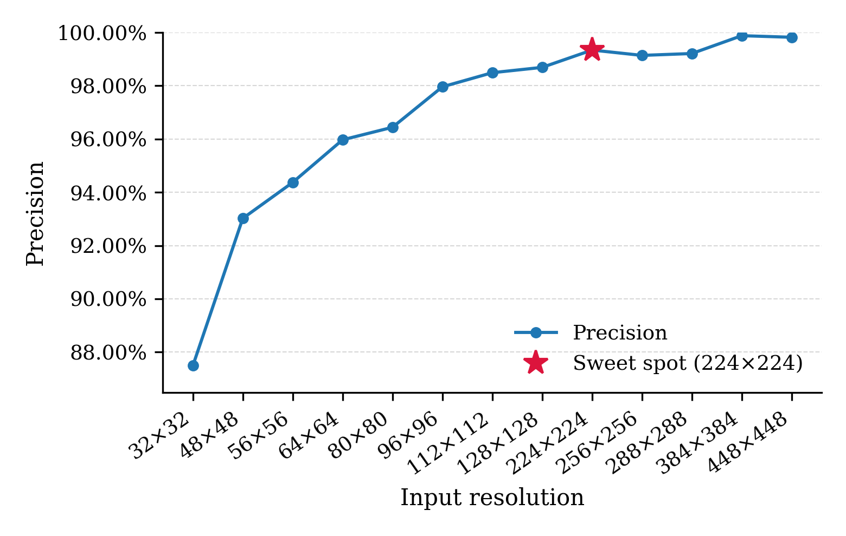
Fig. S6 Precision values illustrating the performance of the DenseNet model across different image resolutions (32 × 32 to 448 × 448 pixels).

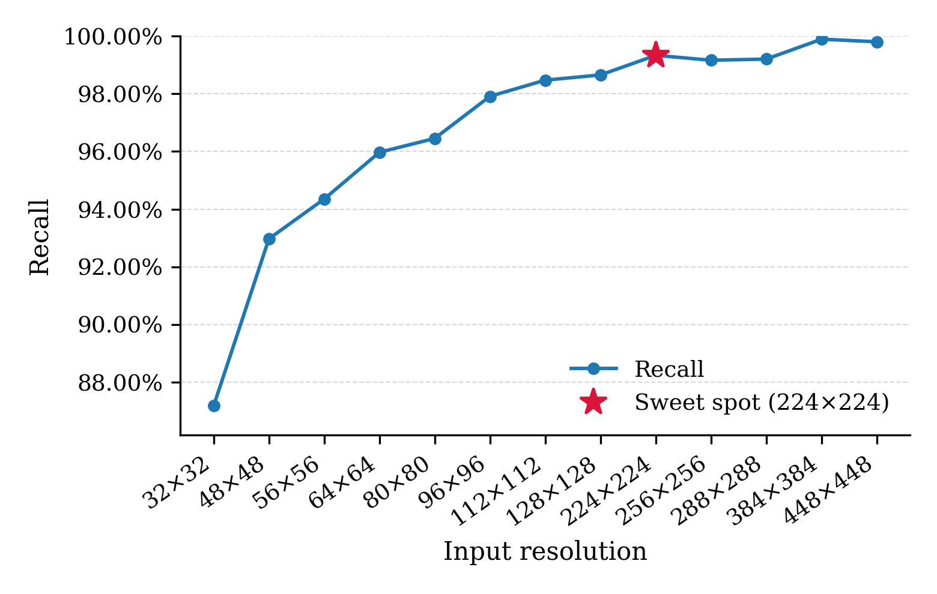
Fig. S7 Recall values illustrating the performance of the DenseNet model across different image resolutions (32 × 32 to 448 × 448 pixels).

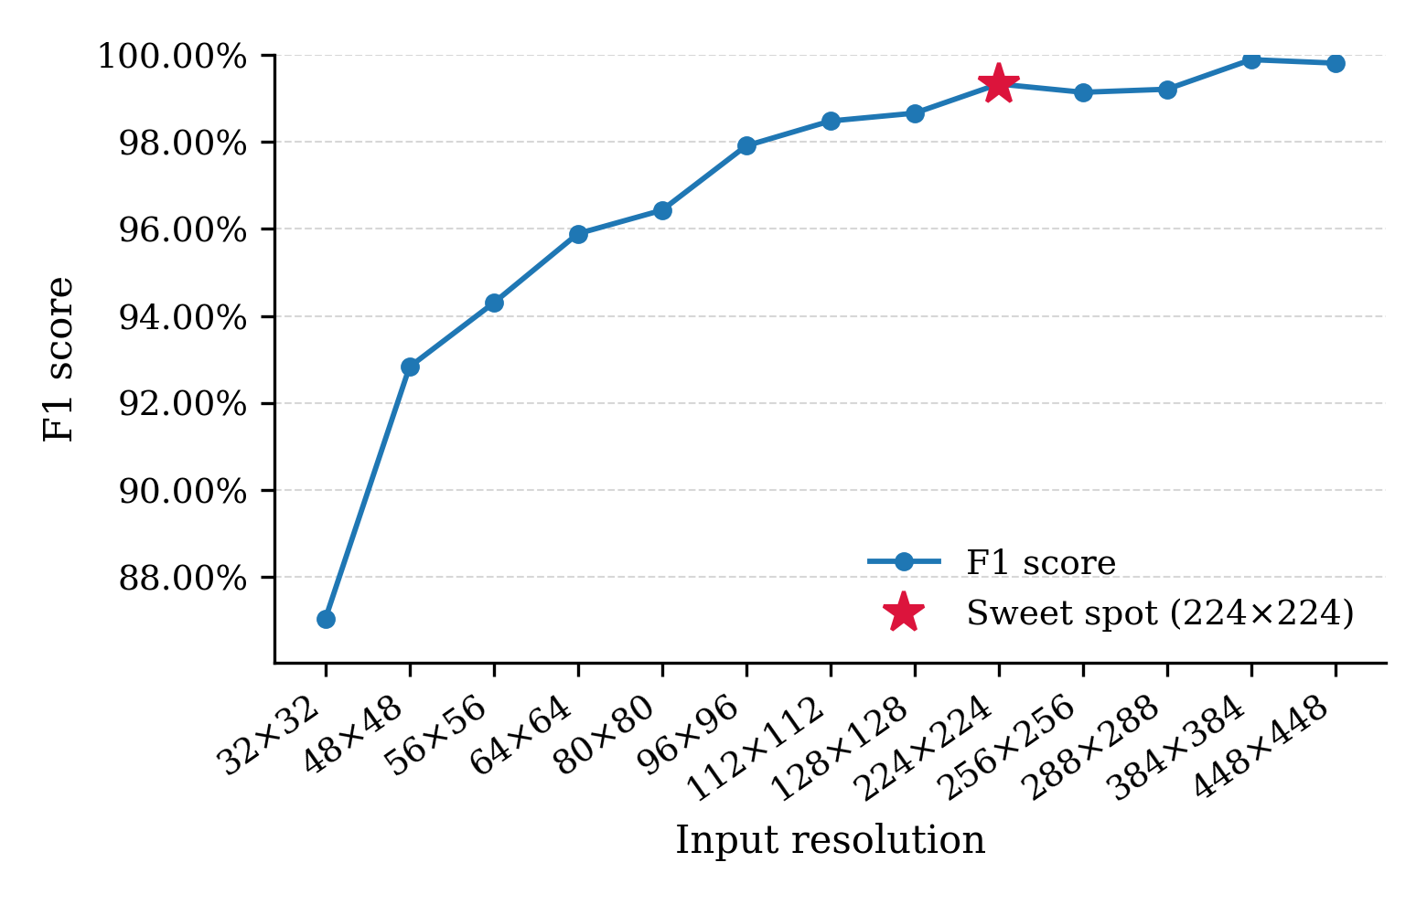
Fig. S8 F1-score values illustrating the performance of the DenseNet model across different image resolutions (32 × 32 to 448 × 448 pixels).

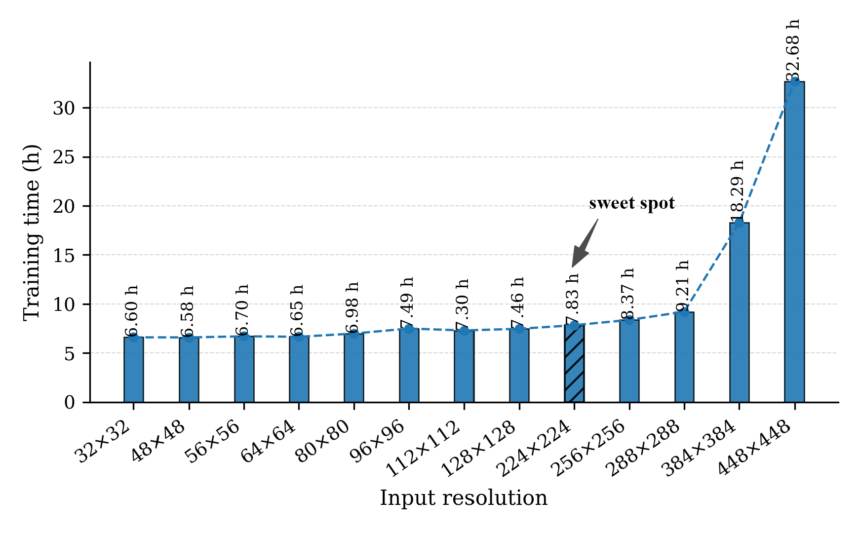
Fig. S9 Training time (h) illustrating the performance of the DenseNet model across different image resolutions (32 × 32 to 448 × 448 pixels).

