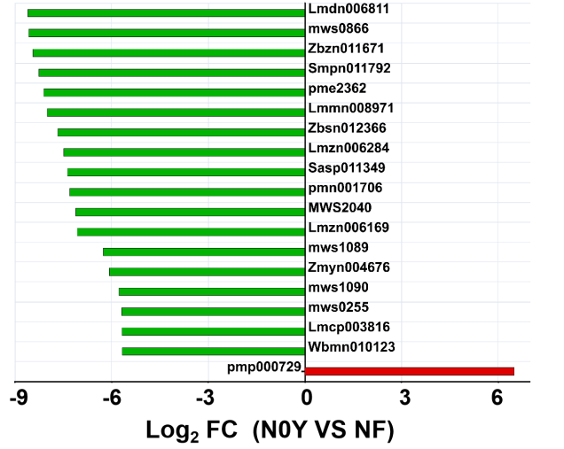
Figure S1. The differential metabolites (Top 20 FC values) of N0Y soil compared to NF soil, with green representing downregulation and red representing upregulation. The corresponding table linking indexes to specific metabolites is showed in Table. S1.

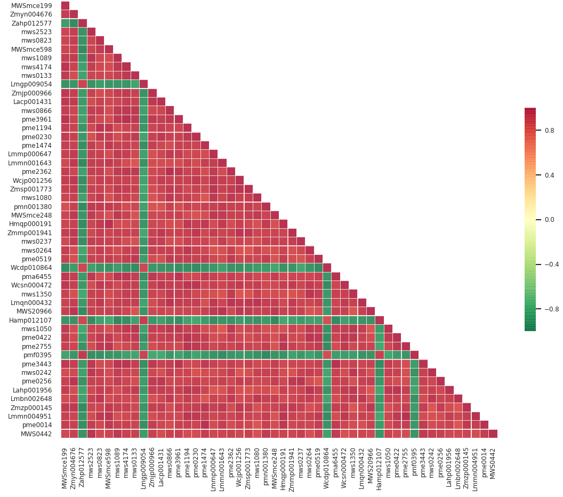

Figure S2. The Spearman Correlation Plot of metabolites with the top 50 VIP values. The corresponding table linking indexes to specific metabolites is showed in Table. S1.
Figure S3. The Shannon diversity index (A) and Chao1 index (B) of rhizosphere bacterial communities. Different lowercase letters denote significant differences (p < 0.05)

Table. S1 The indexes and corresponding Compounds
Index | Compounds
Lmcn009122 | (7Z)-Hexadecenoic acid*
pme2367 | 1,4-Benzoquinone
Lmqn000432 | 1-(sn-Glycero-3-phospho)-1D-myo-inositol
MWS00330g | 1-Amino-1-cyclobutane-carboxylic-acid
MWSmce295 | 1-Arabinosyluracil
pmf0174 | 1-Decanol*
Rfmb320 | 1-Methylpiperidine-2-carboxylic acid
Wafn003633 | 1-O-Acetyl-Glucopyranose 6-Hydroxydecanoate
Zmgp004297 | 1-phenyl-7-(4-hydroxyphenyl)-4-ene-3-heptanone
Waln013216 | 10-Hydroxystearic Acid
mws2623 | 11-Octadecanoic acid(Vaccenic acid)
MWS5235 | 12-Hydroxyoctadecanoic acid
Lmbn005369 | 13(S)-HODE;13(S)-Hydroxyoctadeca-9Z,11E-dienoic acid*
Ymjm000095 | 13,28-Epoxyolean-11-en-3-one
MWS2430 | 13-methylmyristic acid
Wcsn010224 | 14-hydroxy-2,6,10-trimethylpentadeca-2,5,10-trien-4-one*
Lmgp009054 | 15α-Hydroperoxy-guaia-1(10),11-diene
Zmyn004676 | 17-Hydroxylinolenic acid
MW0012723 | 19,20-DiHDPA
Lhwp110301 | 19-Hydroxy-2-(hydroxymethyl)-A(1)-norursa-2,12-dien-28-oic acid (Coleonolic acid)
Lhdp102526 | 19-Hydroxyursolic acid
pme3961 | 2'-Deoxyadenosine
pme1194 | 2'-Deoxycytidine
MWSmce653 | 2'-Hydroxy-4'-Methylacetophenone
Lmxn006423 | 2(3H)-Benzothiazolone
Zahp011689 | 2,2-dimethylchromene-6-carboxylic acid*
Zmpn006881 | 2,3,19-Trihydroxyurs-12-en-28-oic acid (Tormentic acid)*
Lskp211490 | 2,3,23-Trihydroxyurs-12,19-dien-28-oic acid
MWSmce625 | 2,3,5,6-Tetramethylpyrazine; Ligustrazine
Smpn011792 | 2,3-Dihydroxy-12-ursen-28-oic acid*
pmn001706 | 2,3-Dihydroxyolean-12-en-28-oic acid (2-Hydroxyoleanolic acid)*
Qmfp122215 | 2,3-Dihydroxyurs-12,18-dien-28-oic acid (Goreishic Acid I)
Lmcn008512 | 2,4-Di-Tert-Butylphenol
pmf0348 | 2,6-Dimethyl-7-octene-2,3,6-triol
Lmbn001609 | 2-Acetyl-2-Hydroxybutanoic Acid
Lmcp000611 | 2-Amino-4,5-dihydro-1H-imidazole-4-acetic acid
Walp004752 | 2-Aminododecane-1,4-diol
mws0236 | 2-Aminoethanesulfonic acid
Walp007182 | 2-Aminohexadecane-1,15-diol
Walp007043 | 2-Aminohexadecane-1,4-diol
WaYp006462 | 2-Aminohexadecane-1,5,15-triol
Walp007190 | 2-AminoicoSane-1,5,7,19-tetraol
pme3017 | 2-Aminoisobutyric acid
Walp004906 | 2-Aminotetradecane-1,11,13-triol
Walp006011 | 2-Aminotetradecane-1,4-diol
WaYp005128 | 2-Aminotetradecane-1,5,13-triol
pmf0175 | 2-Decanol*
pmb2507 | 2-Deoxyribose-1-phosphate
mws0177 | 2-Furoic acid
Wagp006039 | 2-Hexylphosphoric Acid
Lmmn004951 | 2-Hydroxy-4-methyl-3-undecanoyloxypentanoic acid methyl ester*
Lmmn001643 | 2-Hydroxycinnamic acid*
Lmmn003323 | 2-Hydroxyhexadecanoic acid
Lmzp009620 | 2-Hydroxypyracrenic acid*
Lmzn006284 | 2-Hydroxyursolic acid*
mws0924 | 2-Methylglutaric acid*
Wacn003131 | 2-O-P-Coumaroylhydroxycitric Acid
MWSslk106 | 2-Phenylethylamine
MWSmce460 | 2-Piperidone
Wtmp010557 | 2-benzoyl-4-[(2r)-2-hydroxy-7-methyl-3-methylideneoct-6-en-1-yl]benzene-1,3,5-triol
Qmfp122207 | 24-p-Coumaroyloxy-2,3-dihydroxyurs-12-en-28-oic acid (Guavacoumaric acid)*
Smnp012194 | 2ɑ-hydroxy-3β-trans-p-hydroxycinnamoyloxy oleanolic acid*
Lmzn006169 | 3,19-Dihydroxyurs-12-en-28-oic acid (Pomolic acid)*
Lmdn006811 | 3,24-Dihydroxyolean-12-en-22-one (Soyasapogenol E)*
Cmsp002787 | 3,4'-Dihydroxy-3',5'-dimethoxypropiophenone
Lmyp003951 | 3,4-Dihydroxy-3-methoxypropiophenone
pme2598 | 3,4-Dihydroxybenzeneacetic acid*
Zahp007439 | 3,4-Methylenedioxycinnamaldehyde
HX1191 | 3,4-Secodammara-4(28),20,24-trien-3,26-dioic acid
Lahp002608 | 3,5-Dihydro-2H-Furo[3,2-C]Quinolin-4-One
Latp011219 | 3,5-Dimethyl-2,3-dihydrobenzofuran
Zbqp000579 | 3-(Pyrazol-1-yl)-L-alanine
MWS1039a | 3-Amino-2-methylpropanoic acid
MWS1777 | 3-Chloroaniline
MWSHC20102 | 3-Hydroxy-1-(4-Hydroxy-3-Methoxyphenyl)Propan-1-One
Lmbn001676 | 3-Hydroxy-3-Methyl-2-Oxopentanoic Acid*
MWS04559g | 3-Hydroxy-L-phenylalanine*
MWSmce248 | 3-Hydroxycinnamic Acid*
Lmmn008971 | 3-Hydroxycycloarta-24-ene-26-oic acid (Isomangiferolic acid)*
MWSHC20176 | 3-Hydroxylup-20(29)-en-28-oic acid (Betulinic acid)*
Lmsp013456 | 3-Hydroxytaraxastan-28,20-olide
MWSmce052 | 3-Hydroxyurs-12-en-28-oic acid (3-Epiursolic acid)*
mws0823 | 3-Methyl-2-Oxobutanoic acid
Lmzp010525 | 3-O-Caffeoyl-9-hydroxylup-20(30)-en-7-one (Querspicatin A)*
Smpp010139 | 3-O-Feruloyleuscaphic acid
Sazp010510 | 3-O-Trans-p-Coumaroylmaslinic Acid*
Smnp010489 | 3-O-p-Coumaroyltormentic acid
Zmgn000447 | 3-Phospho-D-glyceric acid
Smpp012073 | 3-[[3-(4-Hydroxyphenyl)propenoyl]oxy]-2-hydroxyurs-12-ene-28-oic acid (Jacoumaric Acid)
Yacp000453 | 3-hydroxy-1-methylpyrrolidin-2-one*
Lamp007163 | 4'-Demethyleucomin glucoside*
MWSslk062 | 4'-Methoxyresveratrol
Zmmp000635 | 4,5-Dehydro-L-leucine
mws0567 | 4-Guanidinobutyric acid
MWSmce466 | 4-Hydroxyacetophenone
mws0628 | 4-Hydroxybenzaldehyde
mws0749 | 4-Hydroxybenzoic acid
pmf0440 | 4-MethoxycinnaMaldehyde
pme2828 | 4-Nitrophenol
pme0275 | 4-Oxopentanoic Acid
Wcsn010254 | 4-[3-(4,8-dimethylnona-3,7-dienyl)-3-methyloxiran-2-yl]butan-2-one*
pme1474 | 5'-Deoxy-5'-(methylthio)adenosine
Zbzp007397 | 5,6,7,7a-tetrahydro-4,4,7a-trimethyl-2(4H)-benzofuranone
pme0151 | 5,6-Dihydrouracil
Zmhn001420 | 5,7-Dihydroxy-1(3H)-isobenzofuranone
Latp002963 | 5-Acetonyl-6-glucosyl-7-hydroxy-2,6-methylchromone
pma3649 | 5-Aminolevulinic Acid
MWSslk149 | 5-Methoxysalicylic acid
MWSmce704 | 5-Methyl-2-thiophenecarboxaldehyde
Wbwp010459 | 5-[(2r,3s,4s,5s)-5-(2h-1,3-benzodioxol-5-yl)-3,4-dimethyloxolan-2-yl]-2-methoxyphenol
Wcfp005519 | 5-hydroxyindene-1,3-dione
Lmln007483 | 6,9,10-Trihydroxyoctadec-7-enoic acid; Sanleng acid*
pme0274 | 6-Aminocaproic acid
pmp001198 | 6-Deoxyfagomine
Yphn012690 | 6-Geranylnaringenin; Mimulone; Bonannione A
mws0972 | 6-Hydroxyhexanoic acid
Zjhp090625 | 7-O-β-D-glucopyranoside-5-hydroxy-3-(4'-hydroxybenzylidene)-chroman-4-one*
Lmmn006246 | 7β-Hydroxydarutigenol
MWS2984 | 8-Azaguanine
Smpn002788 | 8-hydroxythymol
pmn001694 | 9,10,13-Trihydroxy-11-Octadecenoic Acid
pmf0085 | 9,19-Cyclolanost-24-en-3-ol (Cycloartenol)
Wcjp001256 | 9-Alpha-Ribofuranosyladenine*
Zmsp001773 | 9-Arabinosyladenine*
Smpn002867 | 9-hydroxythymol
MW0015391 | 9R-hydroxy-10E,12Z-octadecadienoic acid
Rfmb091 | 9S-Hydroxy-10E,12Z-octadecadienoic acid*
Cmmn012997 | Abietic acid*
MWSHC2054 | Adenine
pme0230 | Adenosine*
mws0208 | Adipic Acid*
MWSslk235 | Allitol
Labp008245 | Alopecurone B
Labp007515 | Alopecurone M
HX1138 | Amurensin B
Zapp005852 | Amurensin C*
HX1153 | Amurensin D*
pmb2654 | Anthranilate-1-O-Sophoroside
pmb2657 | Argininosuccinic acid
MWSprf013 | Asarylaldehyde; 2,4,5-Trimethoxybenzaldehyde
mws0237 | Azelaic acid
pmp000626 | Baptifoline
pmb0069 | Benzamide
MWSmce389 | Beta-asarone
MWSmce548 | Betaine
Wbmn010123 | Cannabifolin F*
Ladp005275 | Caragaphenol A
Lajp007272 | Caraphenol A
MWSHC20163 | Cetostearic acid
Qmjp081002 | Chloranoside A
Lmcp003816 | Chloranthalactone E
pmb0484 | Choline
mws0120 | Choline Alfoscerate
HJAP011 | Chrysoeriol-8-C-glucoside (Scoparin)*
Zmdn011161 | Chrysophanol-9-anthrone
Zbzn011671 | Cordianal C*
Cmjp002319 | Crepidiaside B
ML10181668 | Cycloleucine
pme3732 | Cytidine
mws0255 | Cytosine
MWSmce676 | D-Arabinose*
mws0437 | D-Arabitol*
MWSmce203 | D-Cellobiose
MWS2442 | D-Fructose 6-Phosphate*
mws1164 | D-Fructose*
pmf0139 | D-Galactose*
pmb0786 | D-Glucosamine
mws0866 | D-Glucose 6-phosphate*
mws4170 | D-Glucose*
mws1090 | D-Glucose-1-phosphate*
Lmxn000398 | D-Lactose*
Lmsn000381 | D-Maltose*
mws1155 | D-Mannitol*
pmf0138 | D-Mannose*
pme0500 | D-Melezitose
mws4532g | D-Ornithine
mws1589 | D-Panose*
pme1261 | D-Panthenol
mws0214 | D-Sorbitol
pme0519 | D-Sucrose*
pma0134 | D-Threose
mws0264 | D-Trehalose*
pme3186 | DL-Glyceraldehyde-3-phosphate
MWSmce607 | DL-Threonine
MWSmce056 | DL-Tryptophan
MWSmce682 | DL-Xylose*
Wcfn008271 | Danthron; 1,8-Dihydroxyanthraquinone
Labp005410 | Davidiol A
Labp011022 | Davidone E
Lmyn005330 | Demethyl-dehydroxysecoisolariciresinol
Zbzp011453 | Des-O-Methyllasiodiplodin
MWSHC20164 | Dibutyl phthalate
pme2433 | Diethanolamine
Cmyp007180 | Dihydroactinidiolide
Lmmp010562 | Diisooctyl Phthalate
MWSslk097 | Dimethyl phthalate
pmp000120 | Diosmetin-6-C-glucoside
pmb2640 | Dodecanoic acid (Lauric acid)
pme2237 | Dulcitol*
lsdp210009 | Elaeocarpucin F
MWSmce294 | Elemicin
Hmcp003852 | Elemol
Zbzn008048 | Embelin
Jmcp007378 | Enantio-7(11)eudesmen-4-ol
Zjyp102918 | Epinootkatol
Sazp010202 | Eucalyptic Acid
Lmxp013125 | Eucalyptolic acid
pmn001380 | Eucommiol
mws0014 | Ferulic acid*
mws0376 | Fumaric acid
mws1080 | Galactinol
Zmmp004587 | Glu-Leu-Leu
Lmmp000647 | Glucan
MW0150360 | Gly-Glu-Trp
pme1109 | Guanine
mws0036 | Hesperetin-7-O-rutinoside (Hesperidin)
Wcdp010864 | Hexadecanamide
pmp001264 | Hexadecylsphingosine
Lmnp002845 | Hispidulin-8-C-glucoside*
pma2987 | Histidinol
pme1292 | Homogentisic acid*
MWS04447 | Homoproline
pmb0037 | Hordenine
Zmmp001941 | Hydroxythreonine xyloside
Lmbn006032 | Hypolaetin*
mws0103 | Indole-3-carboxaldehyde
Hmln000297 | Inositol*
Zmpn004713 | Isoetin (5,7,2',4',5'-Pentahydroxyflavone)*
pme0422 | Isoferulic Acid*
pme0183 | Isoguanine
Wmkn004449 | Isokuraridin
mws5038 | Isomaltulose*
pmb0964 | Isopentenyladenine-7-N-glucoside
MWS2044 | Isophorone
Cmmn013275 | Isopimaric acid*
MWSmce040 | Isovanillin
MWSHY0136 | Kaempferol-3-O-glucoside (Astragalin)*
mws0919 | Kaempferol-3-O-rhamnoside (Afzelin)(Kaempferin)
pme1605 | Kaempferol-3-O-robinobioside(Biorobin)
Xmyp005654 | Kaempferol-4'-O-glucoside
MWSslk208 | Kaurenoic Acid*
pmp000651 | Kushenol Ca
mws0438 | L-Arabitol*
mws0260 | L-Arginine
mws0001 | L-Asparagine
mws0219 | L-Aspartic Acid
pmb0464 | L-Aspartic acid-O-diglucoside
pme0008 | L-Citrulline
MWSmce576 | L-Glucose*
pme0014 | L-Glutamic acid
pme0193 | L-Glutamine
mws0254 | L-Histidine
mws0193 | L-Homocitrulline
mws1346 | L-Homoglutamic acid
MWS00327g | L-Isoserine
pme0026 | L-Lysine
pme2617 | L-Methionine Sulfoxide
pme2527 | L-Ornithine
pme0021 | L-Phenylalanine
MWS0811 | L-Pipecolic Acid
pme0010 | L-Serine
mws0230 | L-Threonine
mws0250 | L-Tyrosine*
mws0256 | L-Valine
MWSmce199 | L-Xylose*
Wcsn000472 | Laminaran
Wcdp006912 | Lauryldiethanolamine
Labp009749 | Leachianone B
Labp009687 | Leachianone C
Labp008768 | Leachianone F*
Cmmn013378 | Levopimaric acid*
Qatp010618 | Lignans Machilin F
Hmpp003270 | Luteolin-4'-O-glucoside*
pmp000729 | Mahuannin A*
pmp000731 | Mahuannin C*
Hmcn001415 | Majoroside
Wayn000504 | Malic acid-1-O-diglucoside
MWS1983 | Maltitol
pmp000509 | Maltol
MWSmce598 | Maltopentaose
MWS0442 | Maltotriose
pme2362 | Mandelic acid
mws1333 | Melibiose
pme1014 | Menatetrenone (Vitamin K2)
MWS2040 | Methanesulfonic acid
MWSmce585 | Methyl 3-aminopropanoate
Zmgn004894 | Methyl 4-hydroxybenzoate
mws0470 | Methylmalonic acid*
Labp005127 | Miyabenol C
MWS5136 | Mono-Methyl Glutarate*
pme3207 | Muconic acid
Lhfp112926 | Myricatomentogenin
Yaap009385 | Myrtucommulone B
MWS04412 | N(6),N(6)-Dimethyl-L-lysine
pme3033 | N,N-Dimethylglycine*
MWStz070 | N-(2-Hydroxy-4-methoxyphenyl)acetamide
Lacp001431 | N-(3-hydroxy-4-methoxyphenethyl)-4-hydroxybutanamide
mws2608 | N-Acetyl-D-galactosamine
pme2755 | N-Acetyl-D-glucosamine
mws4174 | N-Acetyl-D-mannosamine
MWS3020 | N-Acetylcadaverine
MWS00204g | N-Ethylglycine*
Wafp004334 | N-Feruloyltyramine 4'-glucoside
Lmqp000427 | N-Methyl-Trans-4-Hydroxy-L-Proline
NK10251888 | NG,NG-Dimethyl-L-arginine
Lazp003665 | Nagilactone C glucoside
mws0133 | Nicotinamide
mws1478 | Nicotine
MWSmce016 | Nicotinic Acid Methyl Ester(Methyl Nicotinate)
mws0043 | Nobiletin (5,6,7,8,3',4'-Hexamethoxyflavone)
Zjyp110103 | Nootkatone
MWSslk108 | O-Acetyl-L-carnitine
mws1050 | O-Acetylserine
Zahp013600 | Octadec-2-enamide
pmb1650 | Octadeca-11E,13E,15Z-trienoic acid
Zahp012577 | Octadecadienamide
pmf0395 | Oleic acid
pmf0096 | Oxalic acid
Zbsn012366 | Oxyallobetulin*
pme2827 | Palmitaldehyde
mws0361 | Palmitoleic Acid*
MWS1848 | Phenyl acetate
pmp001285 | Phthalic anhydride
Lmbn014696 | Pimaric acid*
MWSmce583 | Piperonylic acid
Hmqp000191 | Planteose
Lmmp002795 | Pratensein-7-O-glucoside
MW0109363 | Prolylglutamic acid
MWS2070 | Propyl 4-hydroxybenzoate
Hmgn001653 | Protocatechualdehyde
Lcyp000677 | Prunetin-4'-O-glucoside(Prunitrin)*
pmp000724 | Pseudoephedrine
MWStz040 | Pterolactam*
pme2292 | Putrescine
Lahp001956 | Pyran[3,4-b]indole-2-ketone
mws4516 | Pyroglutamic acid
mws0601 | Pyrrole-2-carboxylic acid
Lmmp003091 | Quercetin-3-O-(4''-O-glucosyl)rhamnoside
pme2125 | Raffinose*
MWSmce174 | Raspberry ketone
mws0213 | Ribitol*
pma6455 | Ribulose-5-phosphate
MWS20966 | S-methyl-L-thiocitrulline
mws2162 | Schisandrin; Schizandrin; Schizandrol A
Hmcn000192 | Sedoheptulose
MWSmce412 | Senkyunolide A
Zmcp102201 | Senkyunolide B*
MW0156685 | Ser-Asp-Ser
pme3443 | Sinapinaldehyde
MWSHY0115 | Sophoraflavanone G*
mws0018 | Spermine
Hamp012107 | Stearamide
mws0242 | Suberic Acid
mws0192 | Succinic acid*
Lmcsp00364 | Succinyl arginine
mws1089 | Sucrose-6-phosphate
mws1350 | Syringaldehyde; 4-Hydroxy-3,5-Dimethoxybenzaldehyde
mws0055 | Tangeretin (4',5,6,7,8-Pentamethoxyflavone)
pme0281 | Terephthalic acid
Wcdp005264 | Tetradecasphinganine
Wcfp007836 | Tetradecyldiethanolamine
Lmgn007652 | Tianshic acid
mws2523 | Trehalose 6-phosphate
Zmzp000145 | Trimethyllysine
MW0110084 | Trp-Trp
mws0458 | Vanillin; 4-Hydroxy-3-Methoxybenzaldehyde
Zmjp000966 | Vidarabine
pmp000445 | Vincoside lactam
pme0256 | Xanthine
pme0513 | Xylitol*
Hahp000801 | alanine betaine
MWSmce482 | alpha-Asarone
Wafn011571 | alpha-Hydroxylinoleic acid*
Ypgn006093 | ampelopsin E
Zazp002547 | cyclo-(Gly-Phe)
Sasp011349 | orthosiphonoic acid
Wasn000410 | sn-glycero-3-phospho-(1'-sn-glycerol)
Zamn00402 | sorbose*
pme3009 | trans-Aconitic acid
mws1622 | α-Cyperone
Lmbn002648 | α-Hydroxycinnamic Acid*
mws0367 | α-Linolenic Acid
mws0147 | β-Hydroxyisovaleric acid

