Supporting Information for
Organic fertilizers shape the bacterial communities harboring pqqC and phoD genes by altering organic acids, leading to improved phosphorus utilization
Liying Zhi ^{a, b}, Bangxiao Zheng ^{c, *}, Yunjie Xu ^{d}, Jiayang Xu ^{a, e}, Josep Peñuelas ^{f, g}, Jordi Sardans ^{f, g}, Yixiao Chang ^{a, b}, Shuquan Jin ^{h}, Hong Ying ^{h}, Kai Ding ^{a, i,} **

ª Key Laboratory of Urban Environment and Health, Institute of Urban Environment, Chinese Academy of Sciences, Xiamen 361021, P. R. China;
^{b} College of JunCao Science and Ecology, Fujian Agriculture and Forestry University, Fuzhou 350002, P. R. China;
^{c} School of Environmental Science and Engineering, Xiamen University of Technology, 361024, P. R. China;
^{d} Bureau of Agriculture and Rural Affairs, Wencheng 325399, P. R. China;
^{e} University of Chinese Academy of Sciences, Beijing 100049, P. R. China;
^{f} CSIC, Global Ecology Unit, CREAF-CSIC-UAB, Bellaterra, Catalonia 08193, Spain;
^{g} CREAF, Cerdanyola del Vallès, Catalonia 08193, Spain;
^{h} Institute of Ecological Environment, Ningbo Academy of Agricultural Sciences, Ningbo 315040, P. R. China.
^{i} Yangtze Delta Region Healthy Agricultural Institute (Zhejiang) CO., LTD, Tongxiang 314500, P. R. China.
The following is included as supporting information for this paper:
number of pages: 12
number of figures: 9
number of tables: 5

We employed PCOA to characterize beta diversity across treatments using Bray-Curtis dissimilarity calculated at the ASV level. The first two principal coordinates (PC1 and PC2) accounted for 32.79%, 41.51%, and 30.76% of the variation in different sample types, respectively (Supplementary Figures 1b, 2c, and 2d).
Fig. S1 Structure and composition of soil bacteria. (a) Alpha indexes of bacterial communities in different sample types. (b) Beta diversity of the bacterial community (PCOA analysis obtained from Bray-Curtis distance calculations.). (c) Bacterial DNA structure and composition at the genus level from different sample types.
Fig. S2 Bacterial population variation of both pqqC and phoD genes. (a) The relative abundance ratio of pqqC and phoD relative to the 16S rRNA gene population. (b) Alpha diversity of pqqC and phoD colonies. (c) β-diversity (PCOA plot calculated based on the Bray-Curtis distance). and genus-level community composition of pqqC gene colonies. (d) β-diversity (PCOA plot calculated based on the Bray-Curtis distance) and genus-level community composition of phoD colonies.

Fig. S3 Structure and composition of bacterial communities carrying phoD genes. By taking the log value of the relative abundance of bacteria. The size of the circle represents the amount of relative abundance of bacteria, and the color of the circle and the asterisk represent the different treatment groups. p-values indicate the variability between the different treatment groups and the control group.
Fig. S4 Structure and composition of bacterial communities carrying pqqC genes. By taking the log value of the relative abundance of bacteria. The size of the circle represents the amount of relative abundance of bacteria, and the color of the circle and the asterisk represent the different treatment groups. p-values indicate the variability between the different treatment groups and the control group.

Fig. S5 Spearman correlation between bacterial communities carrying two functional genes and functional genes in the organic fertilizer group.

Fig. S6 Abundance of three genes in different fertilizer treatments. Different colors of the bar graph represent different treatment groups. Lowercase letters represent the variability of each group from CK1, with different letters representing differences.

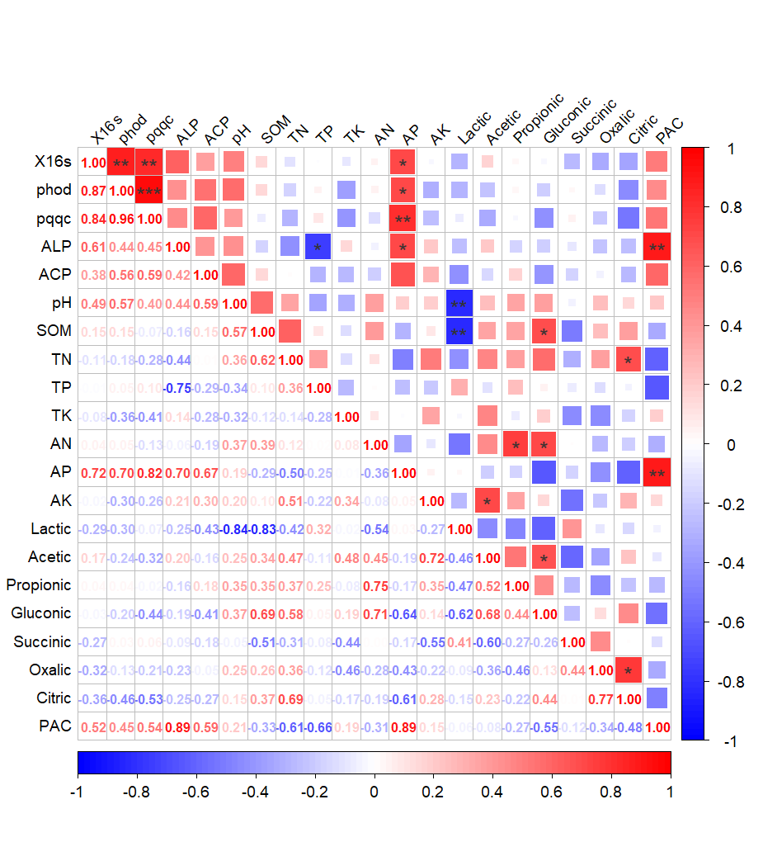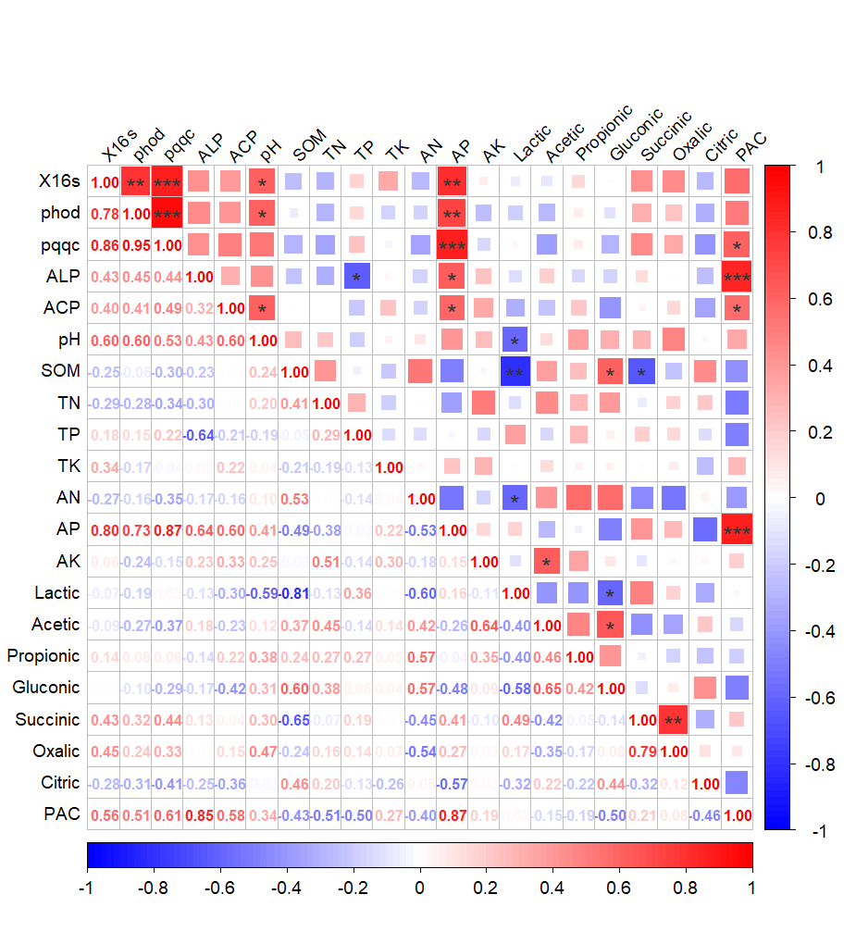
Fig. S7 Spearman's correlation between gene copies and physicochemical properties of three genes in different fertilizer treatments. The upper and lower parts of the figure represent the inorganic and organic fertilizer treatments, respectively.

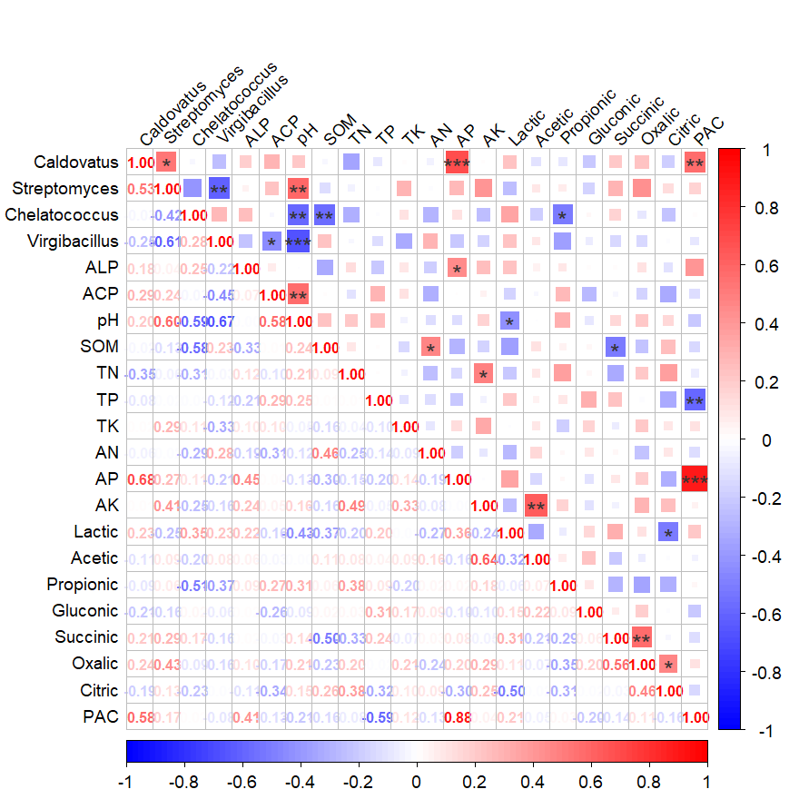
Fig. S8 Spearman's correlation between significant changes in four bacteria and physicochemical.
Fig. S9 Changes and correlations between relative abundance of functional genes and soil physicochemical properties. Red represents a positive correlation, the larger the value the more correlated it is. Conversely, blue represents a negative correlation. An asterisk indicates a significant correlation. *, p < 0.05; **, p < 0.01. PAC is the phosphorus activation rate, obtained by ratios of AP to TP.

Table S1 Fertilizer application in treatment groups (g/kg)
Treatment | Chemical fertilizer |  |  |  | Organic fertilizer
Treatment | CO(NH₂)₂ | Ca(H2PO4)2 | KCl
NCNF | 0 | 0 | 0 |  | 0
CK | 0 | 0 | 0 |  | 0
NK | 0.2 | 0 | 0.13 |  | 0
NKHP | 0.2 | 0.1 | 0.13 |  | 0
NKFP | 0.2 | 0.2 | 0.13 |  | 0
HOM | 0 | 0 | 0 |  | 5
FOM | 0 | 0 | 0 |  | 10
NKPOM | 0.1 | 0.1 | 0.065 |  | 5

Table S2 Amplification efficiency of gene standards
gene | Slope | Y-Inter | R2 | Efficiency(%)
16s | -3.3193 | 40.771 | 0.9913 | 100.11
pqqC | -3.204 | 39.781 | 0.9923 | 105.17
phoD | -3.1542 | 38.319 | 0.9971 | 107.51

Table S3 Table of Physical and Chemical Properties of Soils
 | pH  (g/kg) | SOC  (g/kg) | TN  (g/kg） | TP  (g/kg) | TK  (g/kg) | AN  (mg/kg) | AP  (mg/kg) | AK  (mg/kg)
CK0 | 7.11±  0.03a | 56.46±  2.03b | 4.89±  0.23a | 1.89±  0.36a | 19±  1.31a | 199.29±  3.42c | 140.17±  22.63ab | 1315±  113.54ab
CK1 | 6.36±  0.27d | 56.07±  1.96b | 4.88±  0.07a | 1.81±  0.53a | 18.76±  0.64a | 234.15±  15.78a | 109.10±  23.07bcd | 1254.33±  243.49ab
NK | 6.70±  0.14c | 56.06±  1.46b | 4.77±  0.11a | 1.75±  0.24ab | 19.10±  1.13a | 286.83±  11.24a | 122.72±  5.18abc | 1293.00±  90.50ab
NKHP | 7.11±  0.04a | 57.37±  1.80b | 4.93±  0.17a | 1.91±  0.39a | 18.73±  1.42a | 267.98±  32.13a | 83.93±  8.82d | 1406.67±  131.71a
NKFP | 6.83±  0.03bc | 57.40±  4.37b | 4.97±  0.25a | 1.21±  0.24b | 18.40±  0.95a | 276.96±  41.92a | 150.30±  12.58a | 1310.33±  61.27ab
HOM | 6.87±  0.03bc | 57.48±  2.62b | 4.88±  0.12a | 1.81±  0.12a | 17.93±  0.70a | 255.76±  48.39a | 136.66±  30.50ab | 1140.00±  71.04b
FOM | 6.93±  0.11ab | 62.76±  3.14a | 5.03±  0.11a | 1.75±  0.28ab | 18.63±  0.67a | 290.91±  8.98a | 92.84±  18.22cd | 1310.33±  146.19ab
NKPOM | 7.00±  0.07ab | 55.47±  2.38b | 4.86±  0.15a | 1.92±  0.12a | 19.53±  1.16a | 233.14±  37.56a | 152.45±  16.48a | 1274.00±  100.26ab

Table S4 Table of soil organic acid content
 | Lactic acid  (mg/kg) | Acetic acid  (mg/kg) | Propionic acid  (mg/kg) | Gluconic acid  (mg/kg) | Succinic acid  (mg/kg) | Oxalic acid  (mg/kg) | Citric acid  (mg/kg)
CK0 | 0.15±0.04bc | 0.21±0.01b | 0.16±0.03a | 0.06±0.01cd | 0.15±0.01a | 0.75±0.08a | 0.27±0.02a
CK1 | 0.24±0.03a | 0.19±0.05b | 0.14±0.02a | 0.06±0.01bcd | 0.15±0.01a | 0.67±0.04a | 0.25±0.01a
NK | 0.15±0.05bc | 0.21±0.01b | 0.10±0.01b | 0.08±0.01bc | 0.18±0.03a | 0.75±0.10a | 0.27±0.02a
NKHP | 0.11±0.02c | 0.18±0.02b | 0.16±0.02a | 0.06±0.00d | 0.16±0.01a | 0.75±0.09a | 0.28±0.06a
NKFP | 0.17±0.04abc | 0.17±0.01b | 0.16±0.02a | 0.06±0.01cd | 0.17±0.03a | 0.78±0.07a | 0.29±0.01a
HOM | 0.19±0.03ab | 0.14±0.01b | 0.15±0.02a | 0.07±0.00bcd | 0.16±0.02a | 0.69±0.08a | 0.22±0.07a
FOM | 0.13±0.02bc | 0.35±0.12a | 0.17±0.01a | 0.11±0.00a | 0.14±0.01a | 0.70±0.08a | 0.28±0.02a
NKPOM | 0.20±0.04ab | 0.17±0.02b | 0.16±0.00a | 0.08±0.01b | 0.19±0.03a | 0.84±0.07a | 0.23±0.06a

Table S5 Table of soil enzyme activities
 | CK0 | CK1 | NK | NKHP | NKFP | HOM | FOM | NKPOM
ACP(μmol/d/g) | 15.37±  1.24a | 14.27±  1.61b | 13.97±  0.80b | 15.37±  0.50a | 12.42±  0.86b | 15.29±  0.69a | 14.42±  0.60b | 15.40±  0.94a
ALP(μmol/d/g) | 31.60±  2.96a | 30.79±  2.99a | 30.84±  4.08a | 30.77±  2.49a | 31.55±  0.90a | 32.87±  1.10a | 31.54±  3.17a | 32.15±  1.17a

* Corresponding author. School of Environmental Science and Engineering, Xiamen University of Technology, 600 Ligong Road, Xiamen 361024, China. ** Corresponding author. Key Laboratory of Urban Environment and Health, Institute of Urban Environment, Chinese Academy of Sciences, 1799 Jimei Road, Xiamen 361021, China. E-mail addresses: bangxiao.zheng@xmut.edu.cn (B. Zheng); kding@iue.ac.cn (K. Ding).

