Supplementary Materials
Fig. S1. The average monthly temperature and precipitation in Youxi County from November 2020 to September 2022.
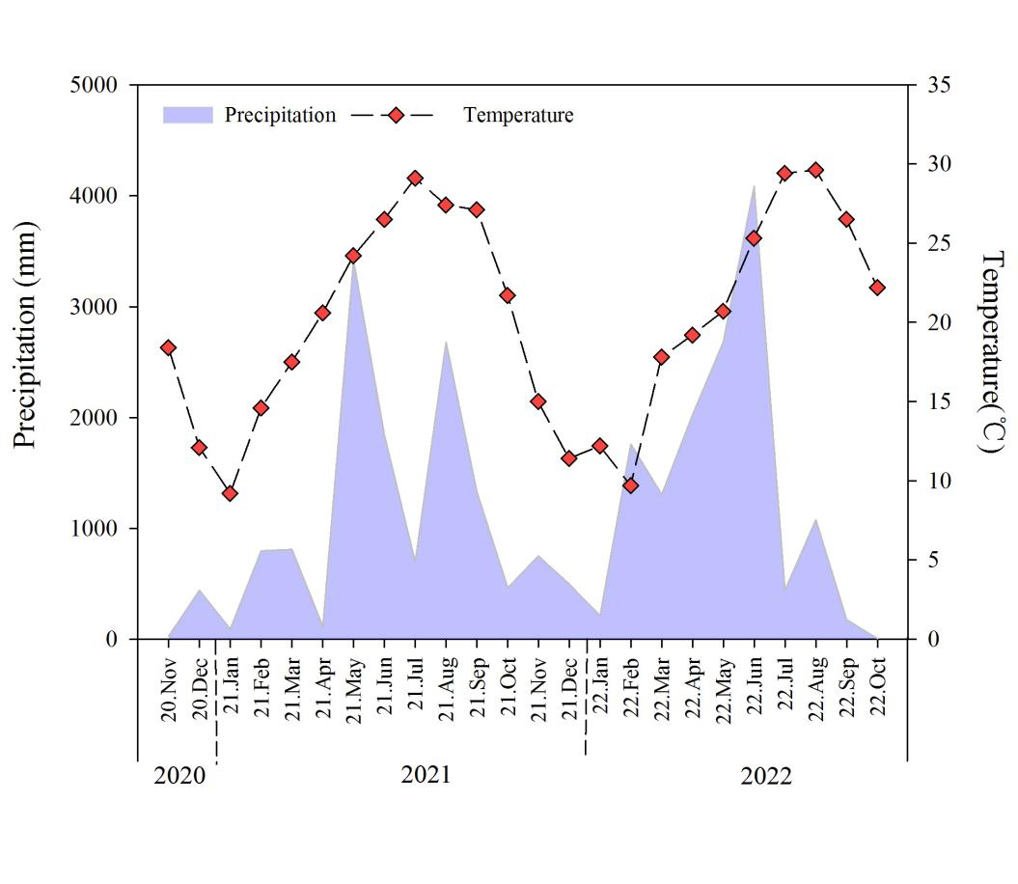

Fig. S2. Pearson correlation analysis of microbial communities at phyla (A) bacterial and (B) fungal between soil properties
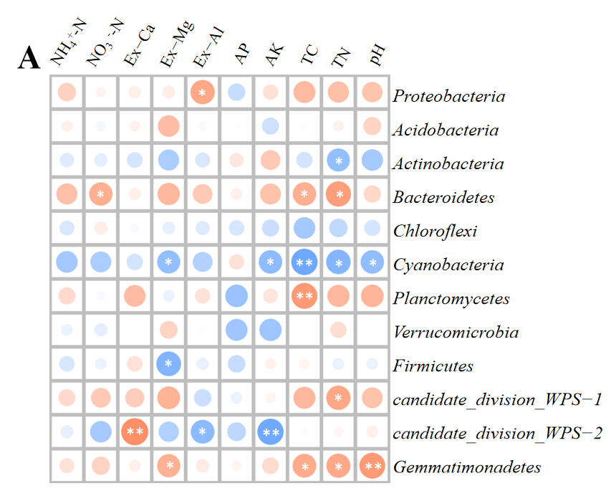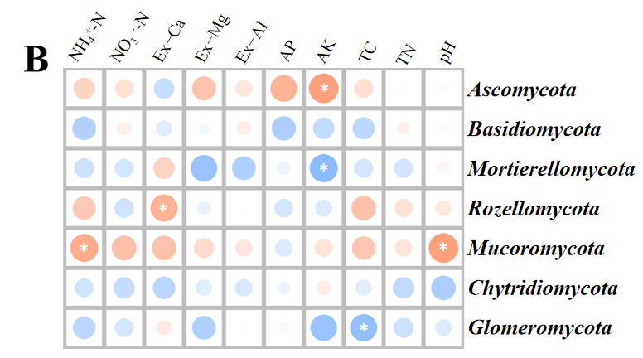
*p < 0.05, **p < 0.01, ***p < 0.001.

Fig. S3. Pearson correlation analysis of tea quality and yield between microbial communities at phyla (A) bacterial and (B) fungal.
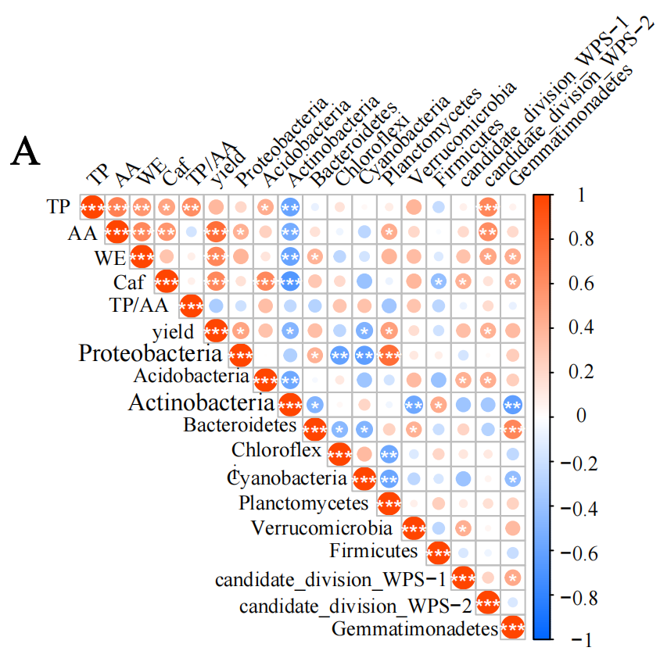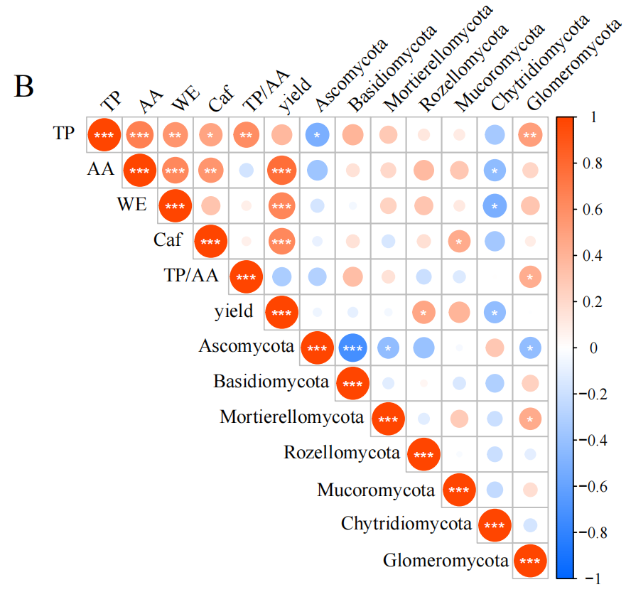
*p < 0.05, **p < 0.01, ***p < 0.001.

Fig. S4. Heatmap of the top 30 bacterial (A and B) and fungal (C and D) genera under different fertilization managements.
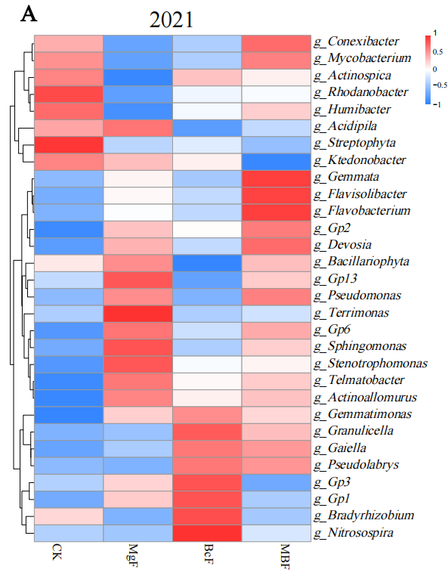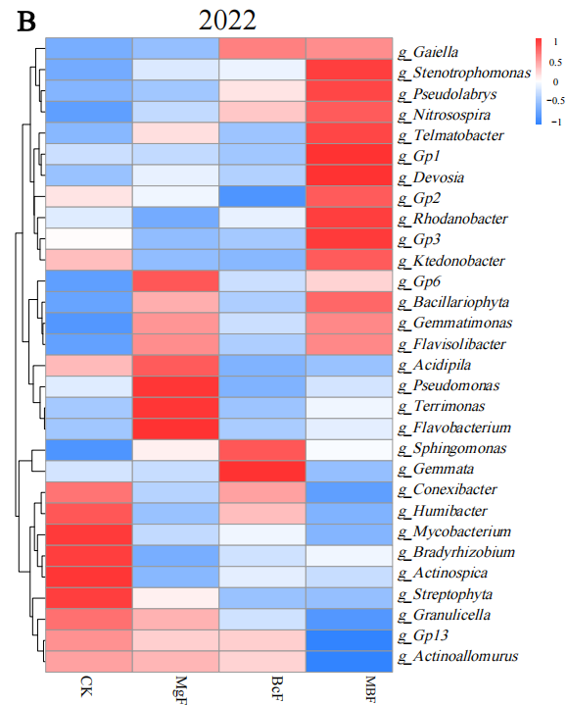
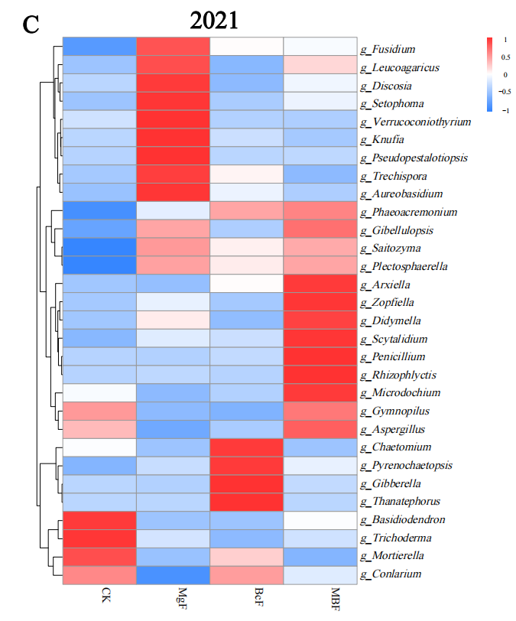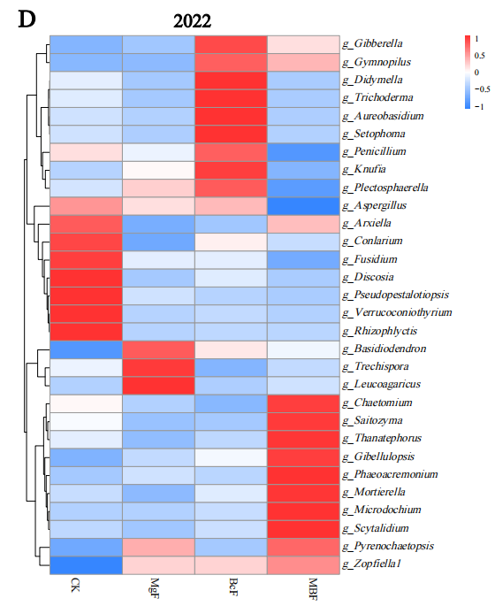
Table S1. The proportion of soil microbial communities at phyla (A) bacterial and (B) fungal after different fertilization managements.
(A) Bacterial % | 2021 |  |  |  |  | 2022
(A) Bacterial % | CK | BcF | MgF | MBF |  | CK | BcF | MgF | MBF
Proteobacteria | 29.76±6.01a | 33.01± 0.38a | 28.71±4.18a | 34.37±1.07a |  | 27.20±4.11b | 27.31±0.91b | 34.40±2.89a | 33.23±1.75a
Acidobacteria | 14.66±1.43c | 23.17±0.31a | 19.08±1.42b | 19.32±2.65b |  | 15.91±1.73b | 20.18±1.42a | 13.26±1.87b | 20.35±2.38a
Actinobacteria | 18.75±0.76a | 14.08±2.04b | 19.17±3.92a | 18.85±0.74a |  | 27.43±3.33a | 17.96±3.18b | 25.21±4.17a | 14.24±4.11b
Bacteroidetes | 2.82±1.54a | 4.95±1.31a | 3.74±2.55a | 4.27±0.27a |  | 1.38±0.36a | 5.32±2.60a | 6.20±3.95a | 7.67±3.96a
Chloroflexi | 6.42±0.11a | 5.41±0.79a | 6.16±0.81a | 3.77±0.72b |  | 5.47±2.63a | 5.74±1.83a | 2.69±1.44a | 5.29±3.32a
Cyanobacteria | 11.33±5.02a | 1.60±0.39b | 2.87±0.76b | 0.34±0.17b |  | 7.33±2.89a | 3.75±2.01b | 0.78±0.51b | 0.48±0.20b
Planctomycetes | 2.68±0.71b | 2.85±0.44ab | 3.04±0.06ab | 3.61±0.07a |  | 2.26±0.51b | 2.32±0.03b | 3.59±0.49a | 3.00±0.21a
Verrucomicrobia | 1.47±0.85a | 1.43±0.59a | 1.10±0.12a | 1.35±0.14a |  | 0.51±0.15a | 2.01±1.23a | 0.52±0.18a | 1.12±0.54a
Firmicutes | 1.03±0.60ab | 0.66±0.21b | 1.52±0.05a | 0.82±0.07b |  | 0.99±0.04a | 0.67±0.25a | 1.02±0.62a | 0.73±0.22a
candidate_division_WPS-1 | 1.23±0.48a | 1.69±1.02a | 2.67±0.70a | 2.43±0.95a |  | 1.43±1.01a | 2.52±0.79a | 1.11±0.66a | 2.64±0.92a
candidate_division_WPS-2 | 1.06±0.19b | 1.44±0.02a | 1.44±0.01a | 1.43±0.06a |  | 0.70±0.34a | 0.68±0.33a | 0.57±0.17a | 0.73±0.38a
Gemmatimonadetes | 0.21±0.02b | 0.75±0.33a | 0.91±0.12a | 0.72±0.25a |  | 0.24±0.16b | 1.10±0.55a | 0.82±0.29a | 1.13±0.37a
unclassified_Bacteria | 7.93±1.17a | 8.28±0.26a | 8.96±1.10a | 8.19±0.29a |  | 8.62±1.03a | 9.50±1.19a | 9.05±0.97a | 8.14±1.85a
Other | 0.66±0.38a | 0.69±0.03a | 0.61±0.20a | 0.93±0.37a |  | 0.53±0.11b | 0.94±0.17ab | 0.79±0.32ab | 1.24±0.27a

(B) Fungal % | 2021 |  |  |  |  | 2022
(B) Fungal % | CK | BF | MF | MBF |  | CK | BF | MF | MBF
Ascomycota | 31.38±12.32b | 53.99±10.71a | 48.79±1.14a | 54.39±2.12a |  | 74.22±10.02a | 61.73±17.92a | 74.28±11.74a | 65.95±20.22a
Basidiomycota | 39.03±18.89a | 35.49±7.45a | 19.54±4.19a | 26.70±9.32a |  | 16.77±11.64a | 30.07±16.59a | 19.00±9.72a | 21.42±12.65a
Mortierellomycota | 22.01±10.54a | 4.54±0.91b | 13.87±4.22a | 3.07±0.40b |  | 0.56±0.17b | 3.10±1.02a | 1.14±0.18b | 2.55±1.13a
Rozellomycota | 5.62±1.48b | 2.88±0.85b | 15.55± 6.42a | 12.37±3.21a |  | 1.58±0.69b | 2.18±0.55b | 2.04±0.32b | 7.12±1.34a
Mucoromycota | 0.61±0.39a | 0.95±0.28a | 1.30±0.73a | 0.95±0.49a |  | 0.32±0.12b | 0.99±0.33a | 0.52±0.25ab | 1.22±0.52a
Chytridiomycota | 0.17±0.07a | 0.44±0.12a | 0.17±0.06a | 0.73±0.53a |  | 6.03±2.23a | 1.02±0.32b | 2.50±0.93b | 0.67±0.18b
Glomeromycota | 0.92±0.62a | 1.37±0.98a | 0.34±0.03a | 0.27±0.07a |  | 0.23±0.14a | 0.21±0.10ab | 0.04±0.02b | 0.11±0.02ab
unclassified_Fungi | 0.28±0.040b | 0.34±0.15b | 0.45±0.01b | 1.53±0.76a |  | 0.27±0.14a | 0.68± 0.38a | 0.47±0.31a | 0.94±0.42a
* CK, traditional fertilizer; BcF, with biochar; MgF, with Mg fertilizer; MBF, combined with biochar and Mg fertilizer. .

