Biochar reshapes phosphorus distribution in soil aggregates and improves rice phosphorus uptake

Jiajun Wu^{a,}, Bin Zhou^{b,}, Zhehao Huang^{c}, Zichuan Liª, Jingyuan Panª, Kaihao Zhangª, Cheng Liuª, Yanjun Chaiª*, Yan Li^{d}*, Muhammad Azeem^{e,f}, Nicholas Clarke^{g}, Shengdao Shanª

ª Key Laboratory of Recycling and Eco-treatment of Waste Biomass of Zhejiang Province, School of Environmental and Natural Resources, Zhejiang University of Science and Technology, Hangzhou 310023, China;
^{b} Animal Husbandry Technology Extension and Breeding Livestock and Poultry Monitoring Station of Zhejiang Province, Hangzhou 310021, China;
^{c} College of Environment, Zhejiang University of Technology, Hangzhou 310014, China;
^{d} Institute of Environmental Resources and Soil Fertilizers, Zhejiang Academy of Agricultural Sciences, Hangzhou 310021, China;
^{e} State Key Laboratory for Ecological Security of Regions and Cities, Ningbo Observation and Research Station, Institute of Urban Environment, Chinese Academy of Sciences, Xiamen 361021, China
^{f} Institute of Soil and Environmental Science, Pir Mehr Ali Shah Arid Agriculture University Rawalpindi, Punjab, 46300, Pakistan;
^{g} Norwegian Institute of Bioeconomy Research (NIBIO), P.O. Box 115, NO-1431 Ås, Norway
∗Corresponding author: Associate Professor Yanjun Chai, Professor Yan Li.
Email: chaiyanjun@zust.edu.cn; liyann0410@163.com
Tel: +86-0571-85070528; Fax: +86-0571-85070528.
Post address: School of Environmental and Natural Resources, Key Laboratory of Recycling and Ecotreatment of Waste Biomass of Zhejiang Province, Zhejiang University of Science and Technology, No 315 Liuhe Road, Xihu District Hangzhou 310023, China

∗ Corresponding author.
Co-first authors.
Jiajun Wu and Bin Zhou contributed to the work equally and should be regarded as co-first authors.

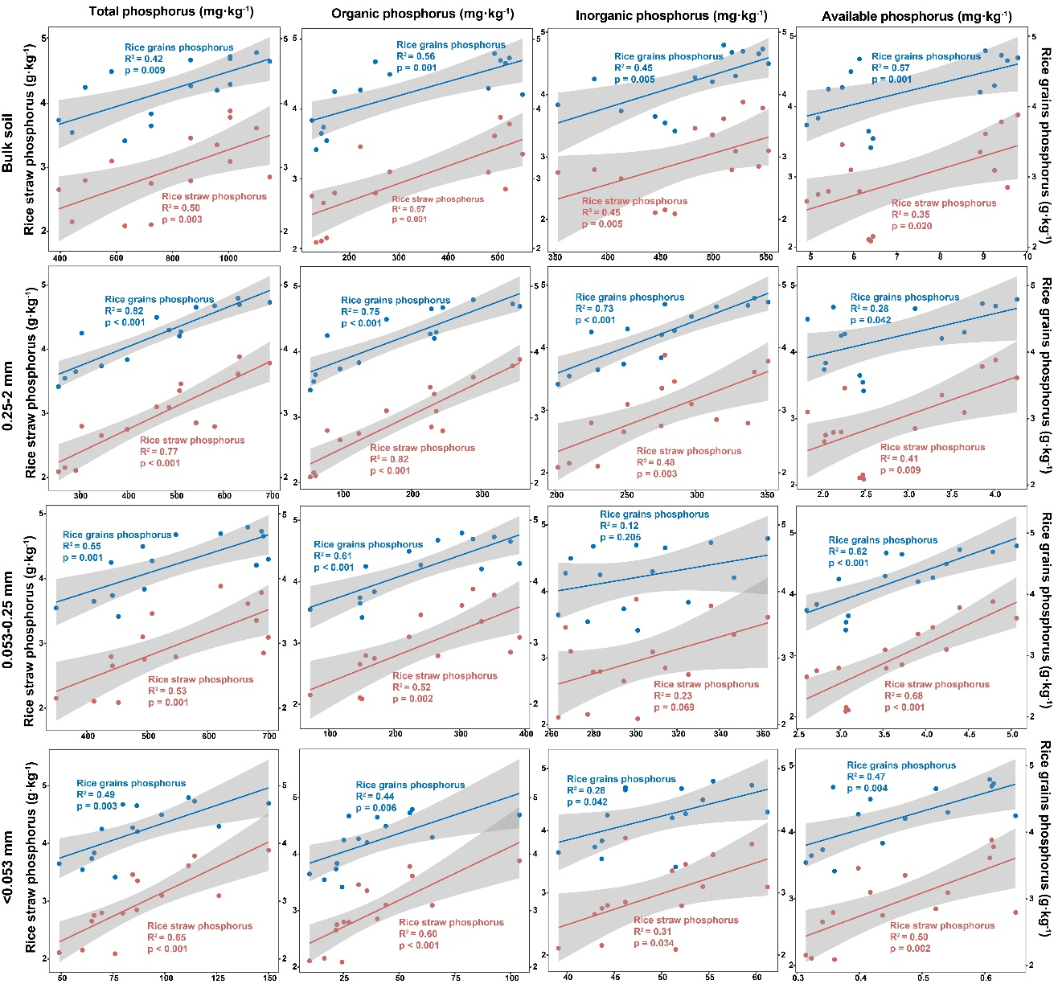
Fig. S1. Linear regression analysis of total phosphorus, organic phosphorus, inorganic phosphorus, available phosphorus, rice straw phosphorus, and rice grain phosphorus in aggregates with different particle sizes. The correlation between variables was analyzed by linear regression. The linear correlation index R² and p values were calculated based on the Pearson method. 0.25-2 mm: macroaggregates, 0.053-0.25 mm: microaggregates, <0.053 mm: silt-clay.

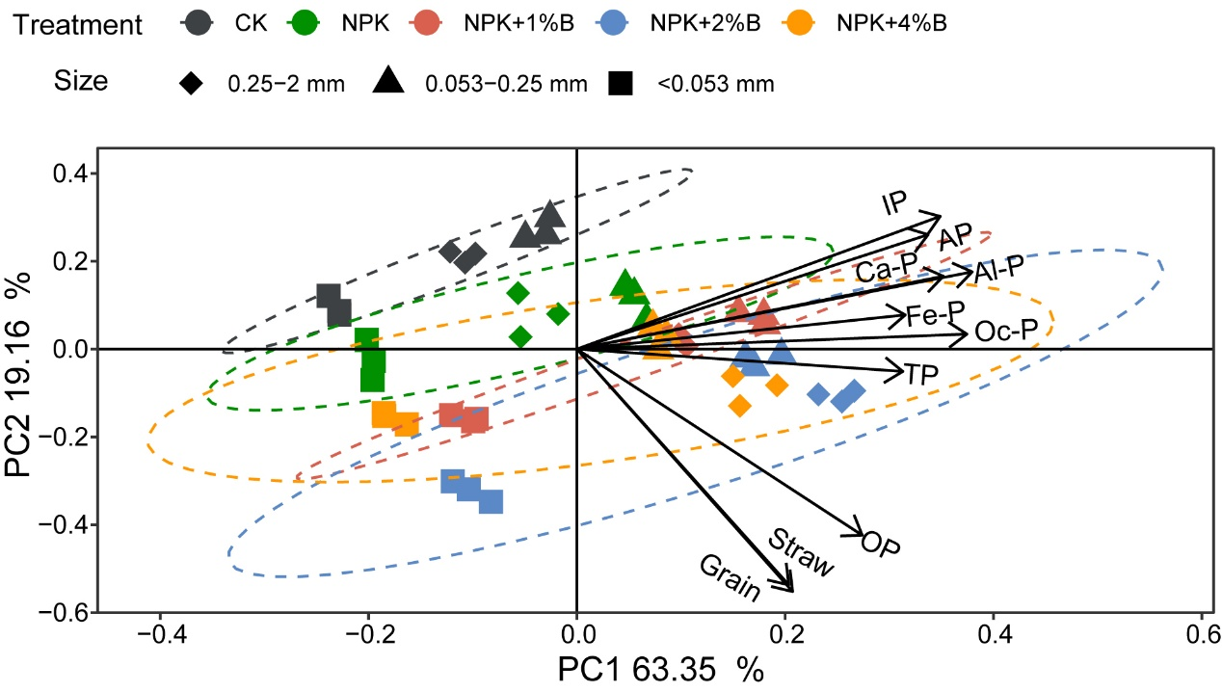
Fig. S2. The relationship between phosphorus fractions and straw and grain phosphorus content. TP: Total phosphorus; OP: Organic phosphorus; IP: Inorganic phosphorus; AP: Available phosphorus. Al-P: Aluminium phosphorus, Fe-P: Iron phosphorus, Oc-P: Occluded phosphorus, Ca-P: Calcium phosphorus. 0.25-2 mm: macroaggregates, 0.053-0.25 mm: microaggregates, <0.053 mm: silt-clay.

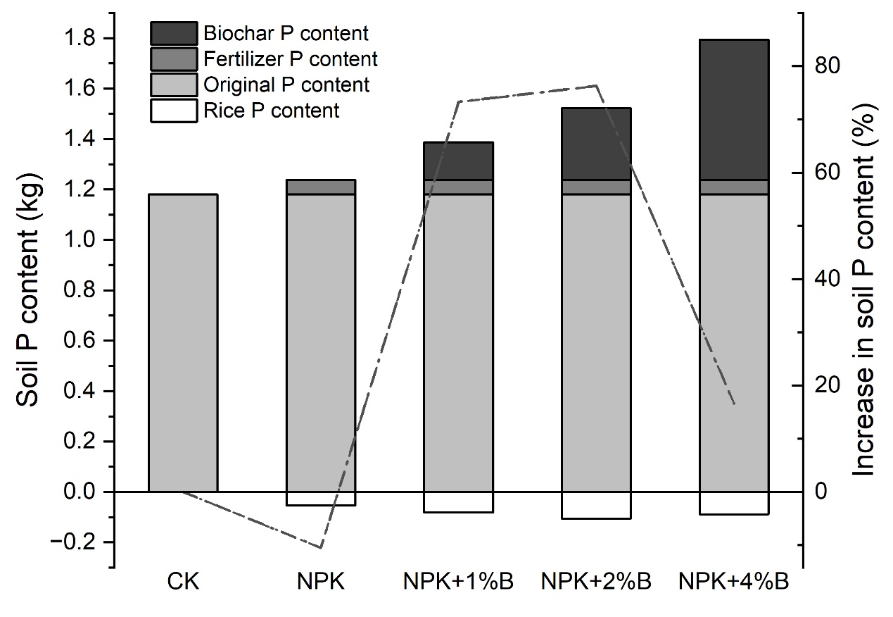
Fig. S3. The relationship between the theoretical input phosphorus content in biochar and fertilizer to the soil in each test plot, the actual uptake of phosphorus in rice, and the actual increase of phosphorus in soil. The bar chart represents Soil phosphorus content, and the line chart represents Increase in soil phosphorus content.

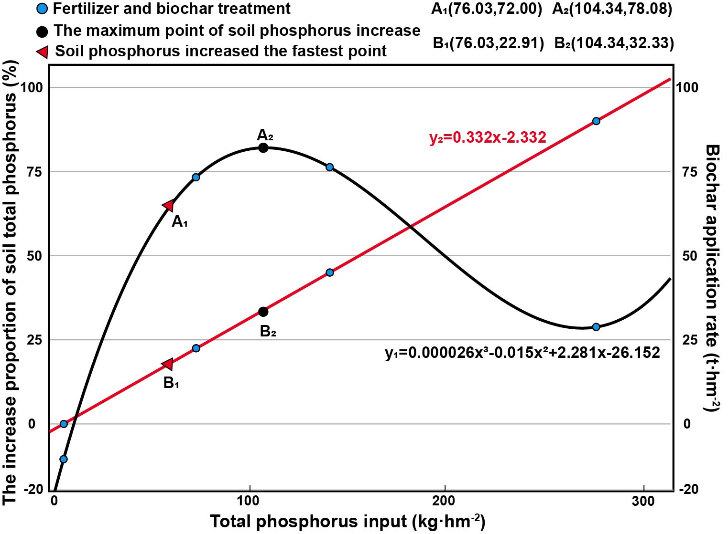
Fig. S4. The relationship between the total phosphorus input in chemical fertilizer, the application amount of rice straw biochar, and the proportion of phosphorus increases in paddy soil. The blue dot represents the amount of chemical fertilizer and three biochar applications. A₁ and B₁ indicate the point where biochar application increases the soil phosphorus content the fastest, and A₂ and B₂ indicate the point where biochar application increases the soil phosphorus content the most.

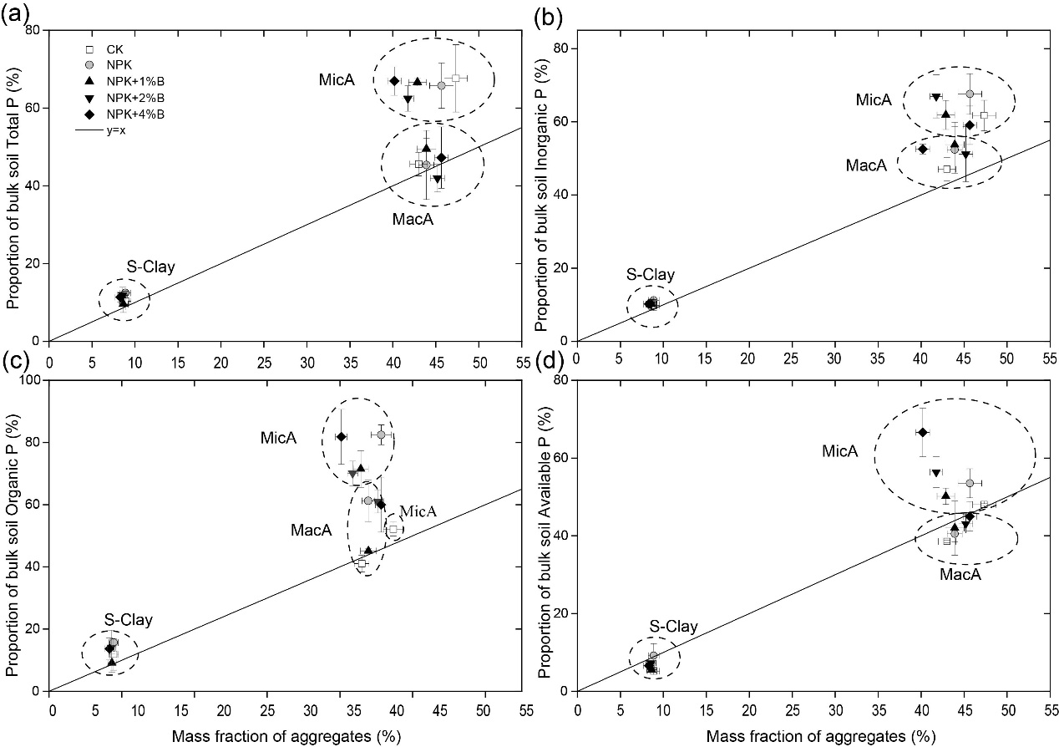 Fig. S5. Contribution (%) by aggregate size fractions to the bulk total phosphorus (a), to the bulk inorganic phosphorus (b), to the bulk organic phosphorus (c), and the bulk available phosphorus (d). The line of y = x indicated no weighted distribution. The scale of the axis was adjusted to best fit the resolution of the distribution among aggregate classes. MacA: macroaggregates, size fraction of 0.25-2 mm, MicA: microaggregates, size fraction of 0.053-0.25 mm, S-Clay: silt-clay, size fraction of <0.053 mm.

