Table S1. Local allometric equations used for calculating aboveground biomass (AGB), adapted from Rahman et al. (2021). In these equations, AGB represents aboveground dry biomass (kg), DBH stands for diameter at breast height (cm), and H denotes mean tree height (m).
Species | Equations
Avicennia spp. | ln(AGB) = -1.56+2.21 ln (DBH)
Bruguiera spp. | ln(AGB) = -1.45+2.29 ln (DBH)
Excoecaria agallocha | ln(AGB) = -2.57+0.862ln (DBH² H)
Hereteira fomes | ln(AGB) = -1.99+2.46ln (DBH)
Lumitzera racemosa | ln(AGB) = -2.12+2.42ln (DBH)
Rhizophoa spp. | ln(AGB) = -2.37+0.895 ln (DBH)
Sonneratia apetala | ln(AGB) = -2.89+0.917 ln (DBH² H)
Xylocarpus spp. | ln(AGB) = -1.92+2.31 ln (DBH)

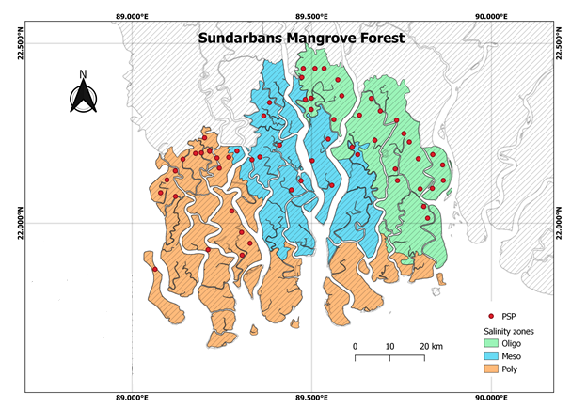
Figure S1. Study area map of Sundarbans mangrove forest. Details salinity zonal classification can be found in Ahmed et al. (2022).
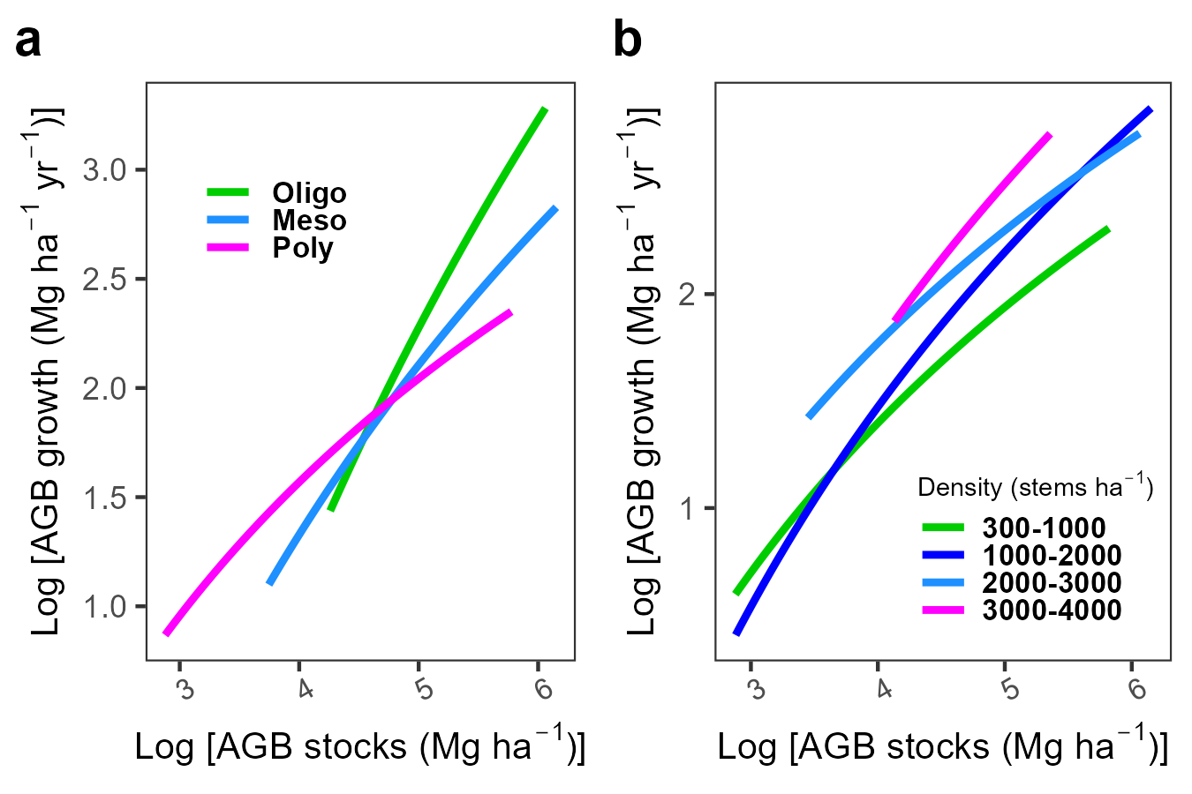

Figure S2. Site conditions (Zones) and density-dependent allometry change. (a) AGB biomass increment relation to standing stand biomass (b) AGB biomass increment related to stand density.

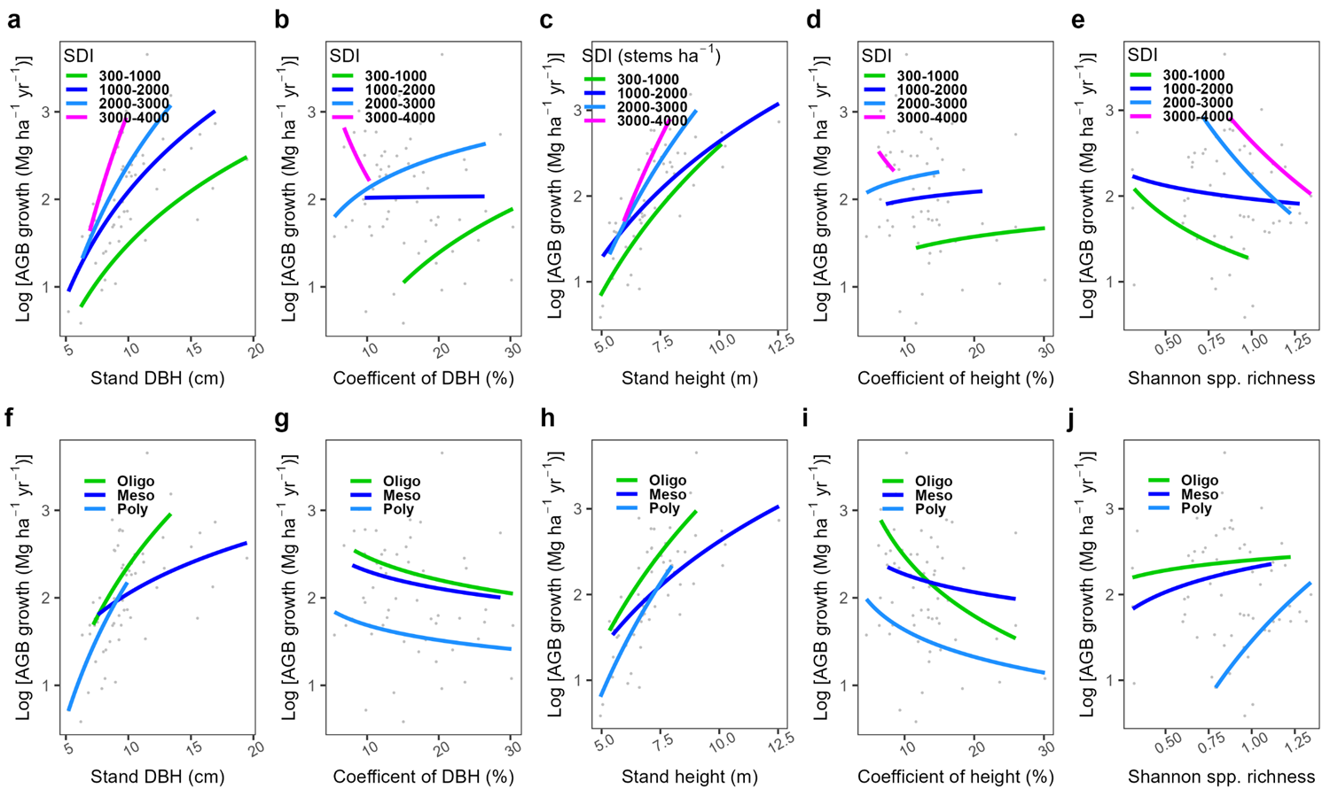
Figure S3. growth response with stand structure across different density and salinity zones

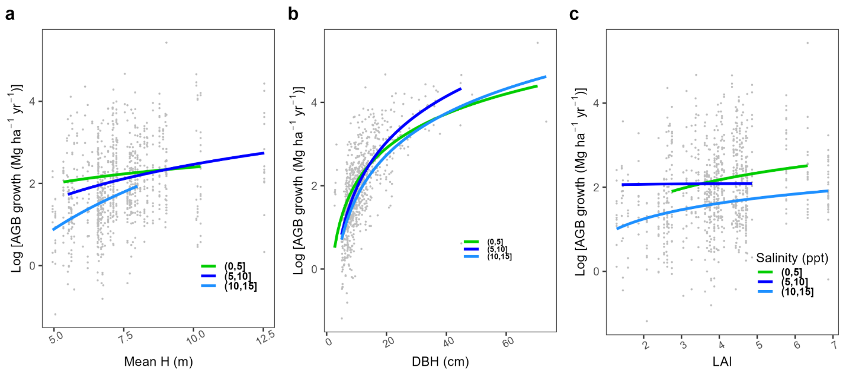
Figure S4. Tree level growth response across different salinity levels.

Ahmed S, Sarker SK, Friess DA, Kamruzzaman M, Jacobs M, Islam MA, et al. Salinity reduces site quality and mangrove forest functions. From monitoring to understanding. Science of The Total Environment 2022; 853: 158662.
Rahman MS, Donoghue DNM, Bracken LJ, Mahmood H. Biomass estimation in mangrove forests: a comparison of allometric models incorporating species and structural information. Environmental Research Letters 2021; 16: 124002.

