Supplementary Material
Table S1 Basic information of sampling sites
Sampling site | Longitude | Latitude | Elevation (m) | MAP (mm) | MAT (℃)
Lasa | E91°24.913’ | N29°41.995’ | 3712 | 514.3 | 7.40
Mishanga | E91°39.380’ | N29°47.508’ | 3780 | 599.8 | 7.11
Mira Mountain | E92°47.820’ | N29°52.562’ | 3874 | 688.0 | 8.40
Nyingchi | E94°39.793’ | N29°36.883’ | 3895 | 770.5 | 9.43
Bomê | E95°37.751’ | N30°01.901’ | 2753 | 915.8 | 9.29
Note: MAP, mean annual precipitation; MAT, mean annual temperature.

Fig.S1 The diversity and composition of microbial community in the rhizosphere soil and root endosphere of Carex cepillacea.
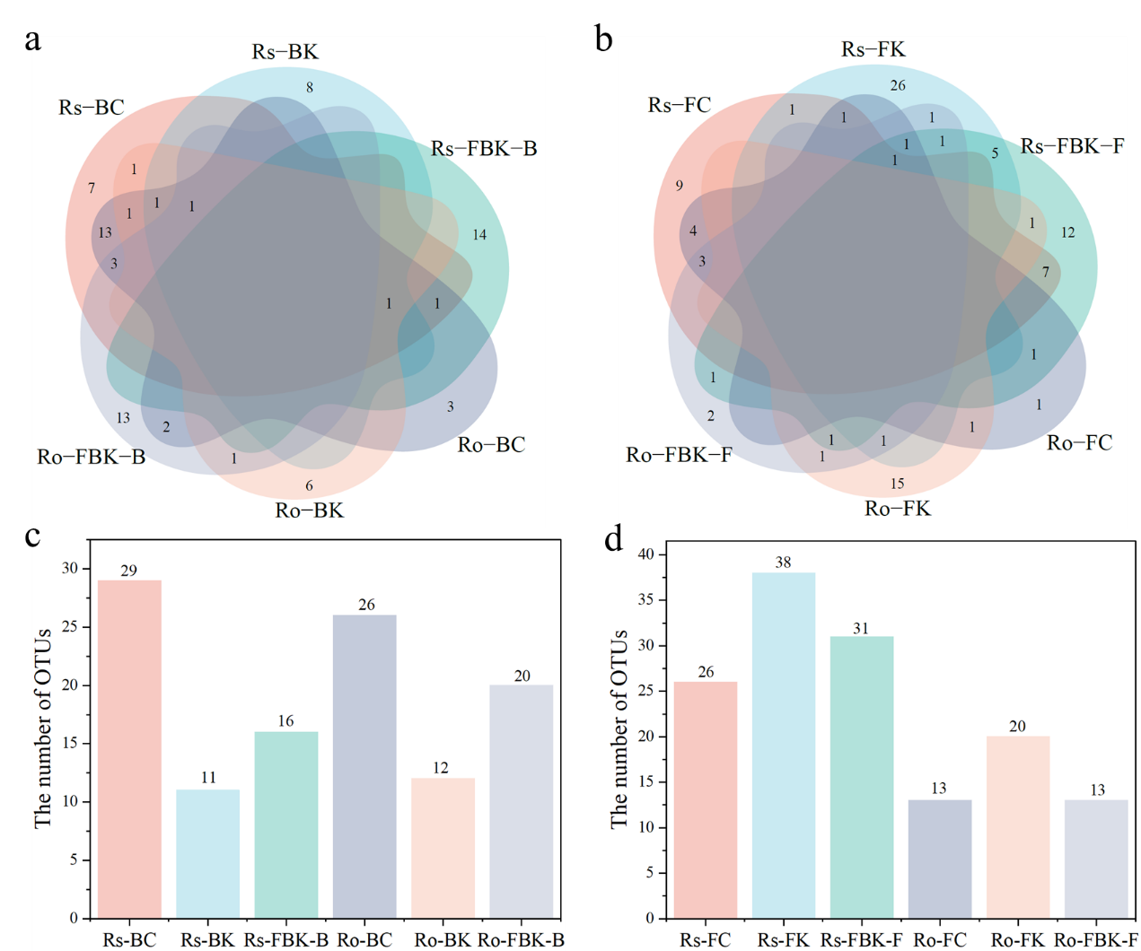
Fig.S2 Bacteria (a) and fungi (b) OTUs numbers shared between different microbiota. Bacteria (c) and fungi (d) OTUs numbers of different microbiota. Rs: rhizosphere soil; Ro: root endosphere; BC: bacterial core taxa; BK: bacterial keystone taxa; FC: fungal core taxa; FK: fungal keystone taxa; FBK: keystone OTUs from the bipartite ecological network; FBK-B: bacterial keystone from the bipartite ecological network; FBK-F: fungal keystone from the bipartite ecological network.

Fig.S3 Heatmaps of relative abundance of core and keystone microbial taxa. The numbers in the table are the value of relative abundance. The shading from white to red represents low-to-high relative abundance. Rs: rhizosphere soil; Ro: root endosphere; B: bacterial community; BC: bacterial core taxa community; BK: bacterial keystone taxa community; F: fungal community; FC: fungal core taxa community; FK: fungal keystone taxa community; FBK: the community of keystone taxa from the bipartite ecological network.

Table S2 Bacterial and fungal community topological properties of the empirical ecological networks in the rhizosphere soil and root endosphere in comparison to the random networks.
Compartment |  | Rhizosphere soil |  | Root endosphere
Empirical network |  | Bacteria | Fungi |  | Bacteria | Fungi
Empirical network | cutoff | 0.89 | 0.57 |  | 0.89 | 0.57
Empirical network | Total nodes | 392 | 208 |  | 391 | 392
Empirical network | Total link | 835 | 3037 |  | 718 | 835
Empirical network | Average degree (avgK) | 4.260 | 29.202 |  | 3.673 | 8.05
Empirical network | Average clustering coefficient (avgCC) | 0.227 | 0.358 |  | 0.205 | 0.220
Empirical network | Average path distance (avgGD) | 5.43 | 2 |  | 6.051 | 5.43
Empirical network | Average graph density (GD) | 0.011 | 0.141 |  | 0.009 | 0.102
Empirical network | Average betweenness centrality (avgBC) | 0.133 | 0.081 |  | 0.084 | 0.192
Empirical network | Harmonic geodesic distance (HD) | 4.381 | 1.827 |  | 4.745 | 4.381
Empirical network | Modularity | 0.671 | 0.256 |  | 0.707 | 0.671
Random network | Average clustering coefficient (avgCC) | 0.01±0.004 | 0.19±0.006 |  | 0.007±0.004 | 0.049±0.018
Random network | Average path distance (GD) | 3.836±0.05 | 1.934±0.003 |  | 4.072±0.054 | 2.292±0.014
Random network | Harmonic geodesic distance (HD) | 3.467±0.035 | 1.792±0.002 |  | 3.666±0.039 | 2.054±0.008
Random network | Modularity (M) | 0.468±0.006 | 0.124±0.003 |  | 0.525±0.006 | 0.271±0.011

Compartment |  | Rhizosphere soil | Root endosphere
Empirical network | Total nodes | 628 | 237
Empirical network | Total link | 6660 | 751
Empirical network | No.fungi(HL) | 174 | 57
Empirical network | Average degree | 21.21 | 6.34
Empirical network | No.Bacteria(LL) | 454 | 180
Empirical network | Positive Link | 3065 | 331
Empirical network | Connectance | 0.084 | 0.073
Empirical network | Web asymmetry | -0.446 | -0.159
Empirical network | Links per species | 10.605 | 3.169
Empirical network | Shannon diversity | 8.804 | 6.621
Empirical network | nestedness | 6.657 | 8.221
Empirical network | cluster coefficient | 0.033 | 0.028
Empirical network | Specialization asymmetry | 0.061 | 0.128
Empirical network | Modularity | 0.29 | 0.38
Empirical network | No.of keystone | 47 | 33
Empirical network | C.score.fungi | 0.795 | 0.873
Empirical network | C.score.bacteria | 0.711 | 0.752
Empirical network | functional.complementarity.fungi | 824.846 | 184.852
Empirical network | functional.complementarity.bacteria | 1257.157 | 248.090
Random network | C.score.HL | 0.723±0.005 | 0.811±0.007
Random network | C.score.LL | 0.620±0.004 | 0.677±0.007
Random network | modularity(fast_greedy) | 0.136±0.002 | 0.303±0.005
Random network | nestedness | 5.314±0.111 | 6.176±0.381
Table S3 Network topological structure properties for the bacteria-fungi bipartite networks of the rhizosphere soil and root endosphere
Table S4 The PERMANOVA of microbial taxa community structure based on Bray-Curtis distance.
 | F. Model | R² | p.value
Bacteria
Rs_BC vs Rs_BK | 93.613 | 0.770 | 0.001
Rs_BC vs Rs_FBK_B | 156.593 | 0.848 | 0.001
Rs_BC vs Ro_BC | 1.473 | 0.050 | 0.194
Rs_BC vs Ro_BK | 40.810 | 0.593 | 0.001
Rs_BC vs Ro_FBK_B | 72.332 | 0.721 | 0.001
Rs_BK vs Rs_FBK_B | 66.916 | 0.705 | 0.001
Rs_BK vs Ro_BC | 61.530 | 0.687 | 0.001
Rs_BK vs Ro_BK | 13.341 | 0.323 | 0.001
Rs_BK vs Ro_FBK_B | 67.785 | 0.708 | 0.001
Rs_FBK_B vs Ro_BC | 94.652 | 0.772 | 0.001
Rs_FBK_B vs Ro_BK | 49.597 | 0.639 | 0.001
Rs_FBK_B vs Ro_FBK_B | 120.910 | 0.812 | 0.001
Ro_BC vs Ro_BK | 27.929 | 0.499 | 0.001
Ro_BC vs Ro_FBK_B | 42.007 | 0.600 | 0.001
Ro_BK vs Ro_FBK_B | 38.575 | 0.579 | 0.001
Fungi
Rs_FC vs Rs_FK | 24.645 | 0.468 | 0.001
Rs_FC vs Rs_FBK_F | 14.289 | 0.330 | 0.001
Rs_FC vs Ro_FC | 8.853 | 0.234 | 0.001
Rs_FC vs Ro_FK | 10.62181 | 0.268 | 0.001
Rs_FC vs Ro_FBK_F | 17.705 | 0.379 | 0.001
Rs_FK vs Rs_FBK_F | 26.804 | 0.498 | 0.001
Rs_FK vs Ro_FC | 62.493 | 0.698 | 0.001
Rs_FK vs Ro_FK | 32.405 | 0.545 | 0.001
Rs_FK vs Ro_FBK_F | 28.200 | 0.511 | 0.001
Rs_FBK_F vs Ro_FC | 24.615 | 0.468 | 0.001
Rs_FBK_F vs Ro_FK | 11.340 | 0.288 | 0.001
Rs_FBK_F vs Ro_FBK_F | 6.326 | 0.184 | 0.003
Ro_FC vs Ro_FK | 17.977 | 0.391 | 0.001
Ro_FC vs Ro_FBK_F | 27.696 | 0.497 | 0.001
Ro_FK vs Ro_FBK_F | 7.993 | 0.222 | 0.002
Rs: rhizosphere soil; Ro: root endosphere; BC: bacterial core taxa; BK: bacterial keystone taxa; FC: fungal core taxa; FK: fungal keystone taxa; FBK: keystone OTUs from the bipartite ecological network; FBK-B: bacterial keystone from the bipartite ecological network; FBK-F: fungal keystone from the bipartite ecological network.

