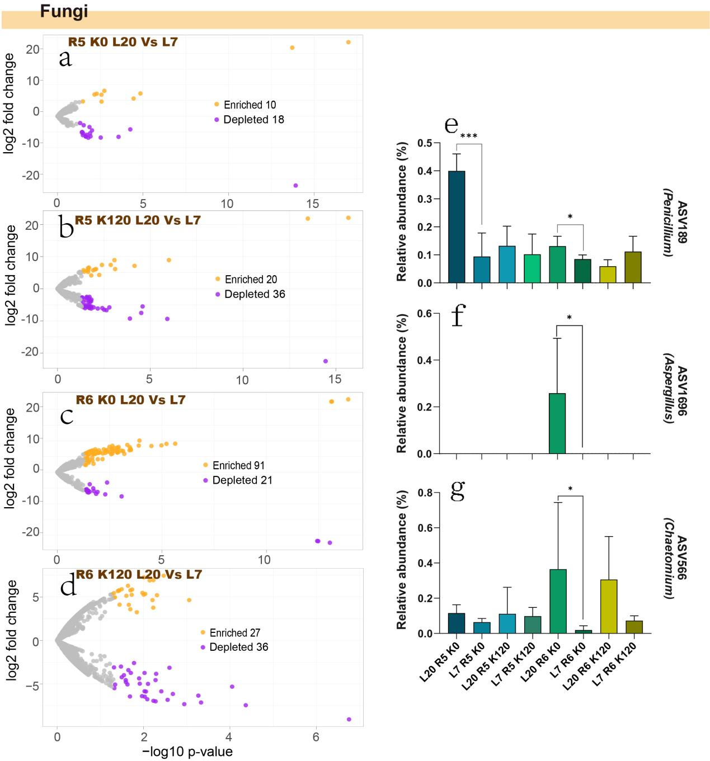
Fig. S2 Differential expression analysis of rhizosphere fungal communities in different K efficiency vegetable soybean types.
(a-d) Volcano plot illustrating the enrichment and depletion patterns of fungal microbiomes in the KHE genotype compared with the KLE genotype under K0 and K120 potassium fertilization treatments in R5 and R6 stages. (e-g) Three fungal isolates matching the up-regulated ASVs in volcano plot. *, P < 0.05; ***, P < 0.001.

