Supporting Methods:Determination and extraction of root metabolites

Liquid chromatography conditions
Analysis was performed using a Vanquish UHPLC System (Thermo Fisher
Scientific, USA) with an ACQUITY UPLC®HSS T3 (150×2.1 mm, 1.8 μm) (Waters, Milford, MA, USA). The column temperature, flow rate and injection volume were 40 ℃, 0.25 mL/min and 2 μL, respectively. For LC-ESI (+)-MS analysis, the mobile phases consisted of (C) 0.1% formic acid in acetonitrile (v/v) and (D) 0.1% formic acid-water (v/v). The separation gradients were set as follows: 0~1 min, 2% C; 1~9 min, 2%~50% C; 9~12 min, 50%~98% C; 12~13.5 min, 98% C; 13.5~14 min, 98%~2% C; 14~20 min, 2% C. The LC-ESI(-)-MS analysis included (A) acetonitrile and (B) ammonium formate (5mM). The separation gradients were set as follows: 0~1 min, 2%A; 1~9 min, 2%~50%A; 9~12 min, 50%~98%A; 12~13.5 min, 98%A; 13.5~14 min, 98%~2%A; 14~17 min, 2%A.

Mass spectrometry detection
ESI ion sources were used in Orbitrap Exploris 120 (Thermo Fisher Scientific, USA) and acquired by MS1 and MS/MS (Full MS-ddMS2 mode, data-dependent MS/MS). The settings were as follows: sheath gas pressure, 30 arb; aux gas flow, 10 arb; spray voltage, 3.50 kV and -2.50 kV for ESI(+) and ESI(-), respectively; capillary temperature, 325 ℃; MS1 range, m/z 100-1000; MS1 resolving power, 60 000 FWHM; number of data dependant scans per cycle, 4; MS/MS resolving power, 15 000 FWHM; normalized collision energy, 30%.

Table S1 Effects of heterogeneous salinity treatment on chlorophyll fluorescence parameters of cucumber
NaCl concentration (mM) | Fv/Fm | Fv/Fo | Y(Ⅱ) | NPQ | ETR | qP | Chlorophyll content  (mg.g⁻¹)
0/0 | 0.77a | 2.94a | 0.68a | 0.10b | 26.93a | 0.92a | 2.17a
200/200 | 0.71c | 2.54b | 0.59b | 0.17a | 17.70b | 0.82b | 1.57b
100/300 | 0.73b | 2.72ab | 0.64ab | 0.12ab | 18.57b | 0.89a | 1.75b
Different lowercase letters indicate significant differences (P < 0.05)
minimum fluorescence (Fo'), maximum fluorescence (Fm'), actual photochemical quantum efficiency of photosystem II (ΦPSII), non-photochemical quenching (NPQ), photochemical quenching coefficient (qP), electron transport rate (ETR), maximum photochemical efficiency (Fv/Fm), PSII potential activity (Fv/Fo)
Table S2 Effects of heterogeneous salinity treatment on rhizosphere soil pH and EC_{1:5} of cucumber

NaCl concentration (mM） | pH | EC_{1:5}（dS·m⁻¹）
Blank | 6.07d | 0.95d
0/0 | 6.10d | 1.03d
200/200 | 6.53b | 5.38b
100/300-100 | 6.26c | 2.35c
100/300-300 | 6.73a | 7.35a
Blank is the soil prior to any treatment. 100/300-100 refer to low salt side of heterogeneous salt treatment and 100/300-300 refer to high salt side of heterogeneous salt treatment. Different lowercase letters indicate significant differences (P < 0.05)

Table S3 Sample sequencing data processing results statistics

Sample ID | Raw Reads | Clean Reads | Effective Reads | AvgLen (bp) | GC (%) | Q20 (%) | Q30 (%) | Effective (%)
A1 | 79957 | 79831 | 75967 | 416 | 54.8 | 99.38 | 97.18 | 95.01
A2 | 79904 | 79785 | 72893 | 415 | 55.23 | 99.41 | 97.26 | 91.23
A3 | 79877 | 79707 | 74432 | 415 | 55.36 | 99.39 | 97.2 | 93.18
A4 | 80018 | 79909 | 76366 | 416 | 54.92 | 99.4 | 97.23 | 95.44
A5 | 79993 | 79858 | 77481 | 416 | 54.75 | 99.39 | 97.2 | 96.86
B1 | 80172 | 80030 | 73769 | 415 | 55.1 | 99.36 | 97.14 | 92.01
B2 | 80184 | 80041 | 76290 | 417 | 54.88 | 99.37 | 97.14 | 95.14
B3 | 79877 | 79748 | 75410 | 417 | 55 | 99.37 | 97.13 | 94.41
B4 | 79871 | 79710 | 72514 | 417 | 54.87 | 99.35 | 97.07 | 90.79
B5 | 79822 | 79665 | 74413 | 416 | 54.73 | 99.36 | 97.09 | 93.22
C1 | 79738 | 79617 | 72813 | 419 | 54.12 | 99.37 | 97.1 | 91.32
C2 | 79824 | 79690 | 71208 | 417 | 54.63 | 99.38 | 97.16 | 89.21
C3 | 79714 | 79567 | 69120 | 420 | 53.93 | 99.36 | 97.08 | 86.71
C4 | 80324 | 80176 | 73752 | 416 | 55.33 | 99.38 | 97.18 | 91.82
C5 | 80118 | 79956 | 71139 | 418 | 54.8 | 99.36 | 97.11 | 88.79
D1 | 79547 | 79428 | 70520 | 419 | 54.14 | 99.35 | 97.06 | 88.65
D2 | 80256 | 80098 | 74597 | 419 | 54.32 | 99.36 | 97.09 | 92.95
D3 | 79256 | 79150 | 68678 | 421 | 54.08 | 99.34 | 97.04 | 86.65
D4 | 79735 | 79613 | 71228 | 419 | 55.02 | 99.36 | 97.11 | 89.33
D5 | 80172 | 80034 | 73111 | 420 | 54.03 | 99.36 | 97.09 | 91.19
Clean Reads are the number of high quality reads obtained after original sequence quality control; Denoised Reads are the number of Reads after Clean Reads denoising; Merged Reads are the number of sequences obtained after Denoised Reads splicing according to overlap; Non-chimeric Reads are is the number of sequence entries after final chimeric removal.

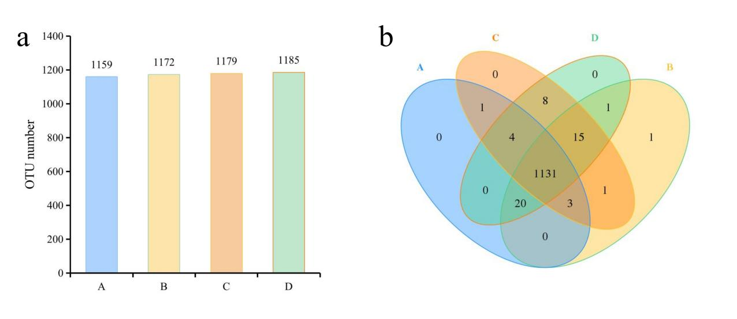
Figure S1 Effects of different treatments on the number and distribution of OTUs
The samples on the 0/0 mM, 200/200 mM, 100/300-100 mM side, and 100/300-300 mM side are named A, B, C, and D respectively.

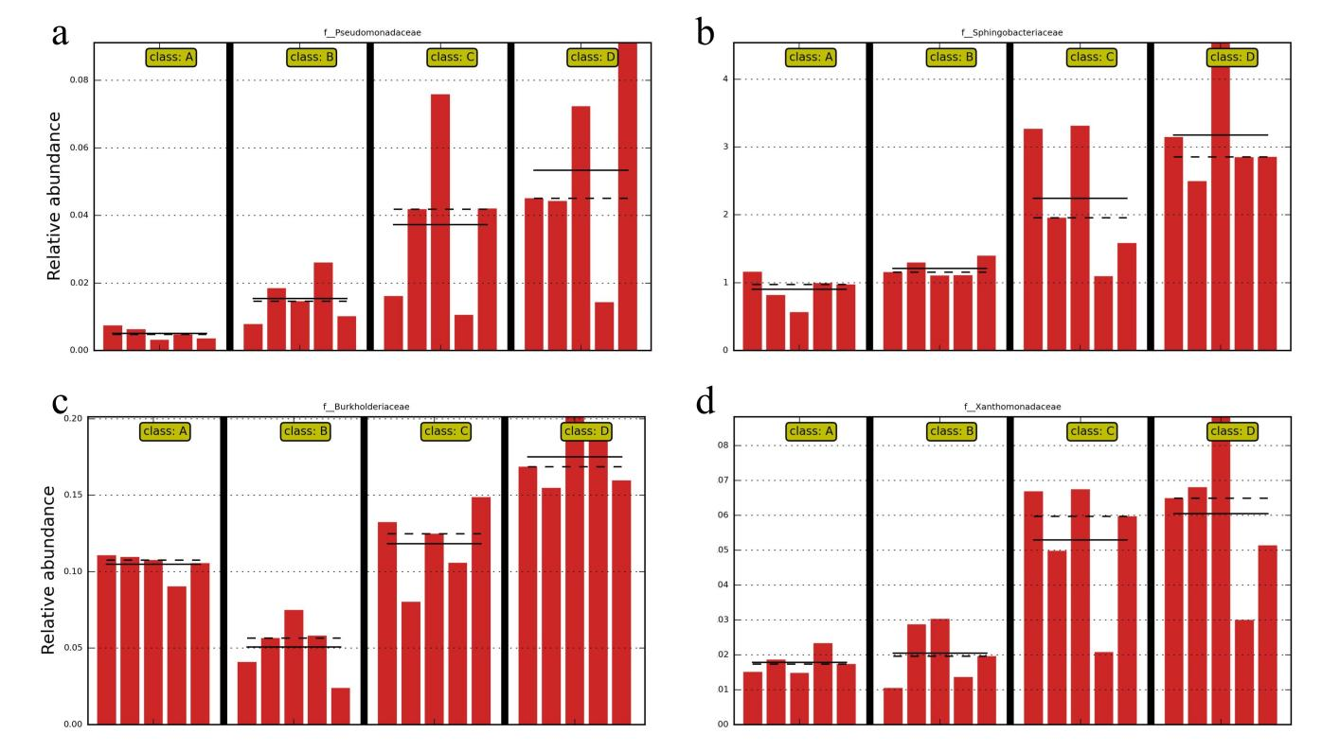
Figure S2 Intergroup abundance histogram of biomarkers
The mean and median relative abundance of the taxonomic unit in each group is marked by solid and dashed lines, respectively.

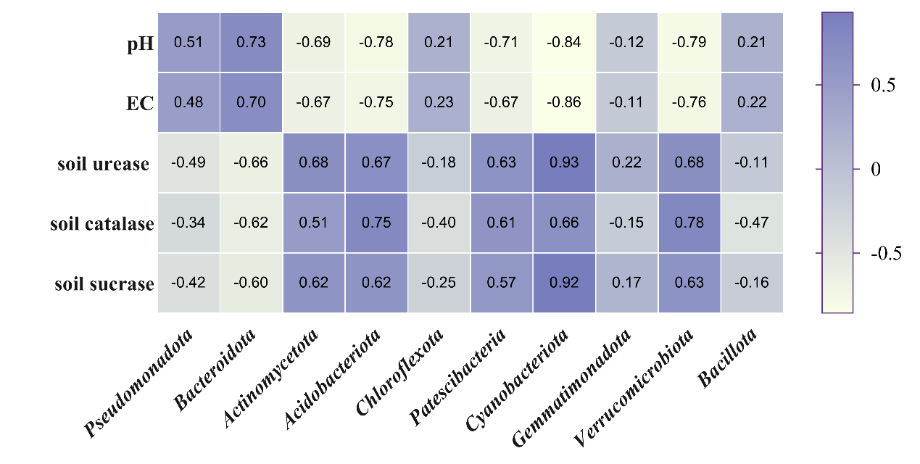
Figure S3 Correlation coefficient between soil index and bacteria phylum
Correlation analysis was performed by measuring the Pearson correlation coefficient. The closer the value of |r| is to 1, the greater the correlation, r > 0 is positive correlation and r < 0 is negative correlation.

