Supplementary materials

Negative effects of Euphorbiaceae cultivation on soil nematode communities in tropical soils

Authors: Chunyu Hou^{1,2}, Hong Chen^{1,2}, Haoran Lei^{1,2}, Jiaojiao Jiao^{1,2}, Shangwen Xia^{3,*}, Jianping Wu^{1,2,*}

Affiliations: ¹State Key Laboratory for Vegetation Structure, Function and Construction (VegLab), School of Ecology and Environmental Science, Yunnan University, Kunming 650500, China
²Ministry of Education Key Laboratory for Transboundary Ecosecurity of Southwest China, Yunnan Key Laboratory of Plant Reproductive Adaptation and Evolutionary Ecology and Institute of Biodiversity, Laboratory of Soil Ecology and Health in Universities of Yunnan Province, Yunnan University, Kunming 650500, China
³CAS Key Laboratory of Tropical Forest Ecology, Xishuangbanna Tropical Botanical Garden, Chinese Academy of Sciences, Mengla, Yunnan 666303, China

* Corresponding authors E-mail: xsw@xtbg.org.cn (S. Xia); jianping.wu@ynu.edu.cn (J. Wu)
Table S1. Results from analysis of linear mixed-effects model as testing the effects of Euphorbiaceae cultivation on soil physicochemical properties and plant traits.
Source of variation | Marginal R² | Conditional R² | F-value | P-value
Soil physicochemical properties
pH | 0.40 | 0.40 | 4.03 | 0.01
SWC | 0.59 | 0.63 | 9.58 | <0.001
SOC | 0.06 | 0.06 | 0.41 | 0.80
TN | 0.13 | 0.28 | 1.04 | 0.42
TP | 0.56 | 0.57 | 7.89 | <0.01
DOC | 0.34 | 0.34 | 3.14 | 0.04
AP | 0.16 | 0.22 | 1.27 | 0.32
NH₄⁺-N | 0.08 | 0.08 | 0.53 | 0.72
NO₃⁻-N | 0.11 | 0.11 | 0.71 | 0.59
Plant traits
LTC | 0.14 | 0.45 | 1.57 | 0.25
LTN | 0.05 | 0.48 | 0.61 | 0.62
LTP | 0.07 | 0.07 | 0.46 | 0.72
LT | 0.59 | 0.63 | 10.03 | <0.01
SLA | 0.73 | 0.74 | 17.57 | <0.001
LTD | 0.68 | 0.73 | 16.25 | <0.001
AGB | 0.68 | 0.68 | 13.71 | <0.001
In this model, treatment was treated as a fixed effect, and block was treated as a random effect. Marginal R² and conditional R² indicate the variance explained by fixed factors and both fixed and random factors, respectively, they are jointly evaluated the fit degree of the model. pH, soil pH; SWC, soil moisture; SOC, soil organic carbon; TN, soil total nitrogen; TP, soil total phosphorus; DOC, soil dissolved organic carbon; AP, soil available phosphorus; NH₄⁺-N, soil ammonium nitrogen; NO₃⁻-N, soil nitrate nitrogen; LTC, leaf carbon content; LTN, leaf nitrogen content; LTP, leaf phosphorus content; LT, leaf thickness; SLA, specific leaf area; LTD, leaf tissue density; AGB, aboveground biomass.
Table S2. Results from analysis of linear mixed-effects model as testing the effects of Euphorbiaceae cultivation on soil microbial and nematode communities.
Source of variation | Marginal R² | Conditional R² | F-value | P-value
Soil microbial
Shannon diversity of bacteria | 0.34 | 0.34 | 3.14 | 0.04
Richness of bacteria | 0.66 | 0.66 | 11.85 | <0.001
Shannon diversity of fungi | 0.21 | 0.21 | 1.56 | 0.22
Richness of fungi | 0.44 | 0.45 | 4.81 | <0.01
Nematode community
Taxonomic richness | 0.68 | 0.74 | 15.9 | <0.001
Shannon diversity | 0.68 | 0.73 | 15.42 | <0.001
Total abundance | 0.83 | 0.83 | 29.61 | <0.001
Bacterivores abundance | 0.42 | 0.42 | 4.3 | 0.01
Fungivores abundance | 0.52 | 0.52 | 6.56 | <0.01
Herbivores abundance | 0.47 | 0.47 | 5.34 | <0.01
Omnivore-predators abundance | 0.37 | 0.52 | 4.6 | 0.01
Total biomass | 0.35 | 0.49 | 4.07 | 0.02
Bacterivores biomass | 0.37 | 0.37 | 3.56 | 0.02
Fungivores biomass | 0.11 | 0.11 | 0.72 | 0.59
Herbivores biomass | 0.67 | 0.70 | 13.41 | <0.001
Omnivore-predators biomass | 0.45 | 0.45 | 4.98 | <0.01
Total energy flux | 0.46 | 0.60 | 6.84 | <0.01
Bacterivores energy flux | 0.38 | 0.38 | 3.64 | 0.02
Fungivores energy flux | 0.33 | 0.33 | 2.91 | <0.05
Herbivores energy flux | 0.35 | 0.37 | 3.34 | 0.04
Omnivore-predators energy flux | 0.42 | 0.59 | 6.15 | <0.01
In this model, treatment was treated as a fixed effect, and block was treated as a random effect. Marginal R² and conditional R² indicate the variance explained by fixed factors and both fixed and random factors, respectively, they are jointly evaluated the fit degree of the model.
Table S3. Pairwise test of PERMANOVA for soil nematode community composition among Euphorbiaceae cultivation.
Comparison | Sums of squares | F-value | R² | P-value
CK vs BR | 0.29 | 1.56 | 0.16 | 0.07
CK vs PE | 0.33 | 2.07 | 0.21 | 0.01
CK vs EA | 0.4 | 2.65 | 0.25 | 0.01
CK vs AY | 0.57 | 3.41 | 0.3 | 0.01
BR vs PE | 0.19 | 0.96 | 0.11 | 0.57
BR vs EA | 0.33 | 1.74 | 0.18 | 0.05
BR vs AY | 0.39 | 1.94 | 0.19 | 0.01
PE vs EA | 0.35 | 2.16 | 0.21 | 0.02
PE vs AY | 0.39 | 2.19 | 0.21 | 0.02
EA vs AY | 0.24 | 1.43 | 0.15 | 0.19
CK, control; PE, Phyllanthus emblica; EA, Excoecaria acerifolia; BR, Baccaurea ramiflora; AY, Aporosa yunnanensis.
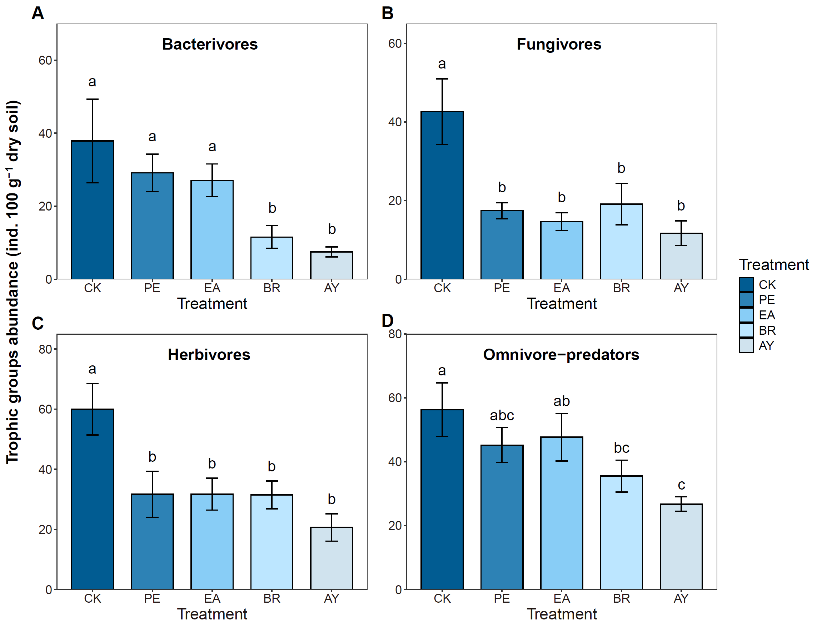
Fig. S1 Effects of Euphorbiaceae cultivation on the abundance of nematode trophic groups. Values are means ± SE. Different lowercase letters indicate significant differences between treatments (P < 0.05). CK, control; PE, Phyllanthus emblica; EA, Excoecaria acerifolia; BR, Baccaurea ramiflora; AY, Aporosa yunnanensis.
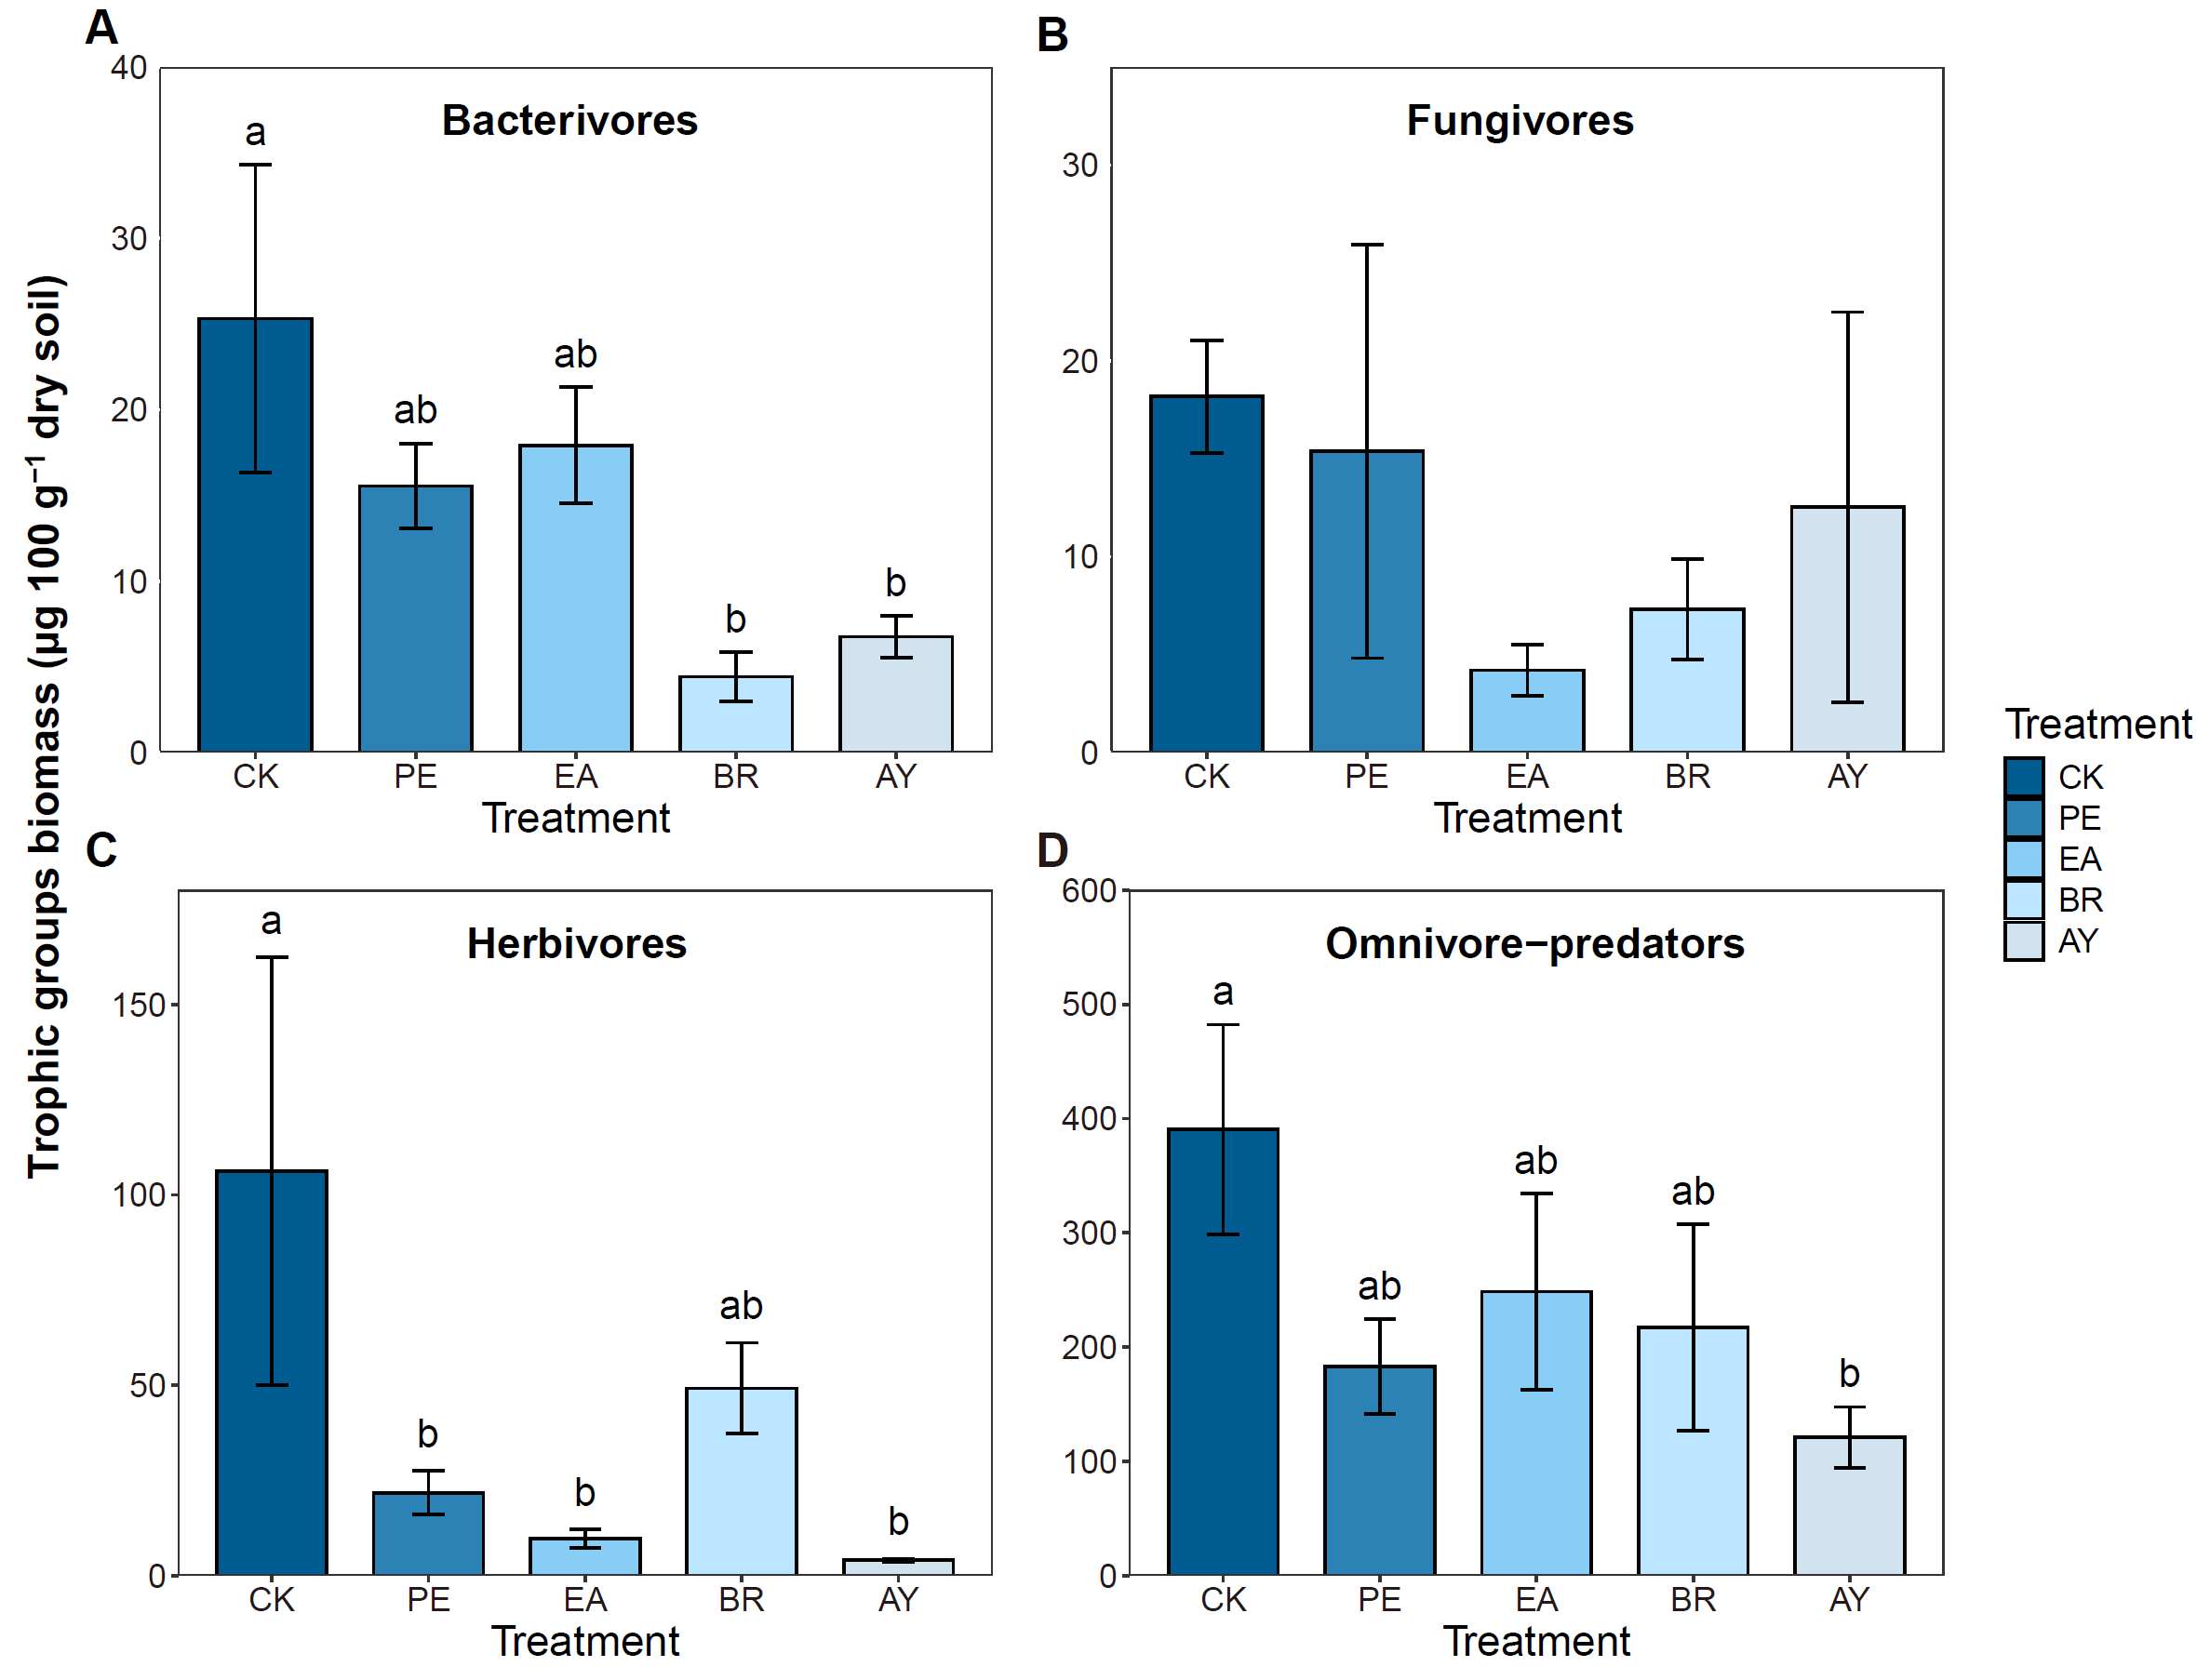
Fig. S2 Effects of Euphorbiaceae cultivation on the biomass of nematode trophic groups. Values are means ± SE. Different lowercase letters indicate significant differences between treatments (P < 0.05). CK, control; PE, Phyllanthus emblica; EA, Excoecaria acerifolia; BR, Baccaurea ramiflora; AY, Aporosa yunnanensis.
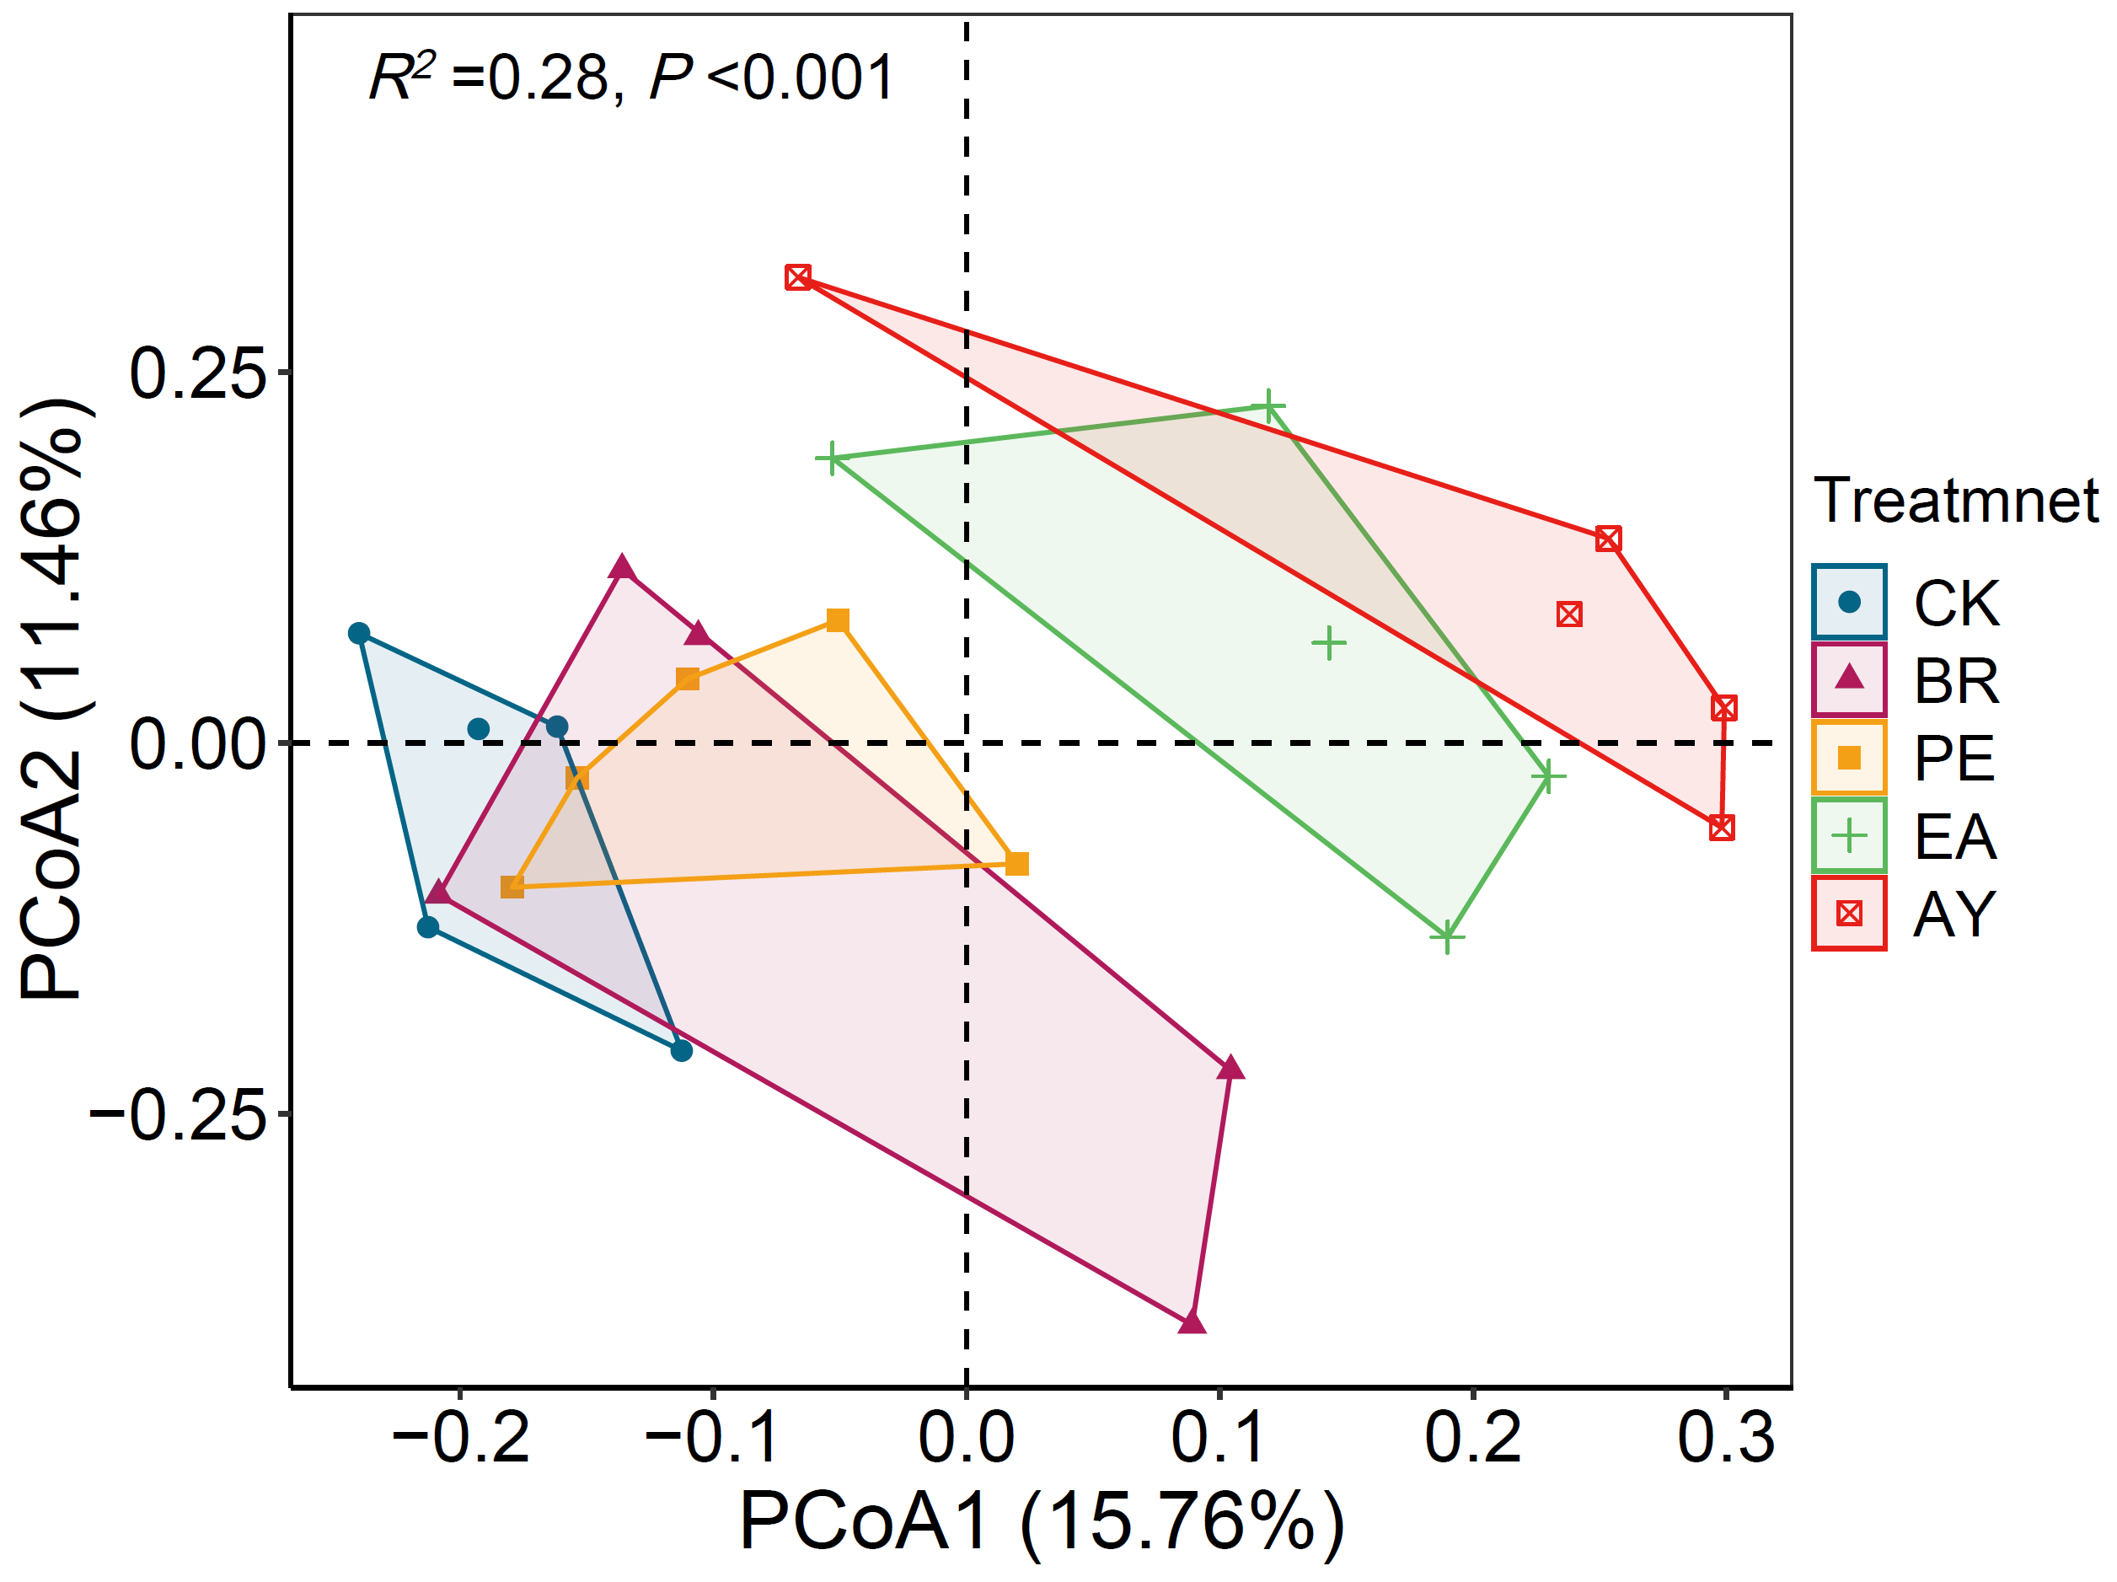
Fig. S3 Soil nematode community structure changes among Euphorbiaceae cultivation. Ellipse represents the 95% confidence interval. CK, control; PE, Phyllanthus emblica; EA, Excoecaria acerifolia; BR, Baccaurea ramiflora; AY, Aporosa yunnanensis.
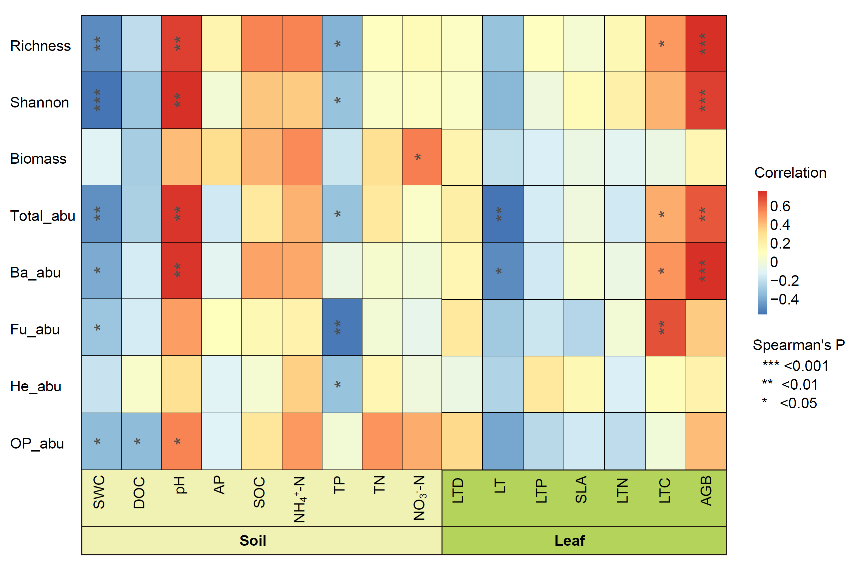
Fig. S4 Spearman correlation analysis on the relationship between soil nematode community and environment factors. Richness, taxonomic richness; Shannon, Shannon diversity; Biomass, total biomass; Total_abu, total nematode abundance; Ba_abu, bacterivores abundance; Fu_abu, fungivores abundance; He_abu, herbivores abundance; OP_abu, omnivore-predators abundance. SWC, soil moisture; DOC, soil dissolved organic carbon; pH, soil pH; AP, soil available phosphorus; SOC, soil organic carbon; NH₄⁺-N, soil ammonium nitrogen; TP, soil total phosphorus; TN, soil total nitrogen; NO₃⁻-N, soil nitrate nitrogen; LTD, leaf tissue density; LT, leaf thickness; LTP, leaf phosphorus content; SLA, specific leaf area; LTN, leaf nitrogen content; LTC, leaf carbon content; AGB, aboveground biomass.

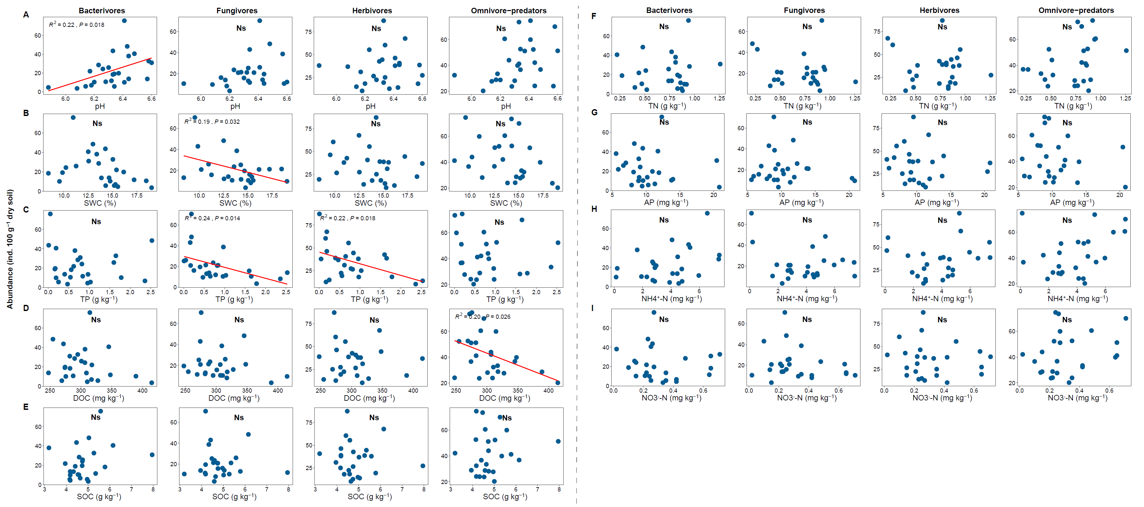
Fig. S5 Relationships between soil physicochemical properties and the abundance of each nematode trophic group. Lines indicate models with statistically significant R² and P-values, NS indicates non-significance. pH, soil pH; SWC, soil moisture; TP, soil total phosphorus; DOC, soil dissolved organic carbon; SOC, soil organic carbon; TN, soil total nitrogen; AP, soil available phosphorus; NH₄⁺-N, soil ammonium nitrogen; NO₃⁻-N, soil nitrate nitrogen.
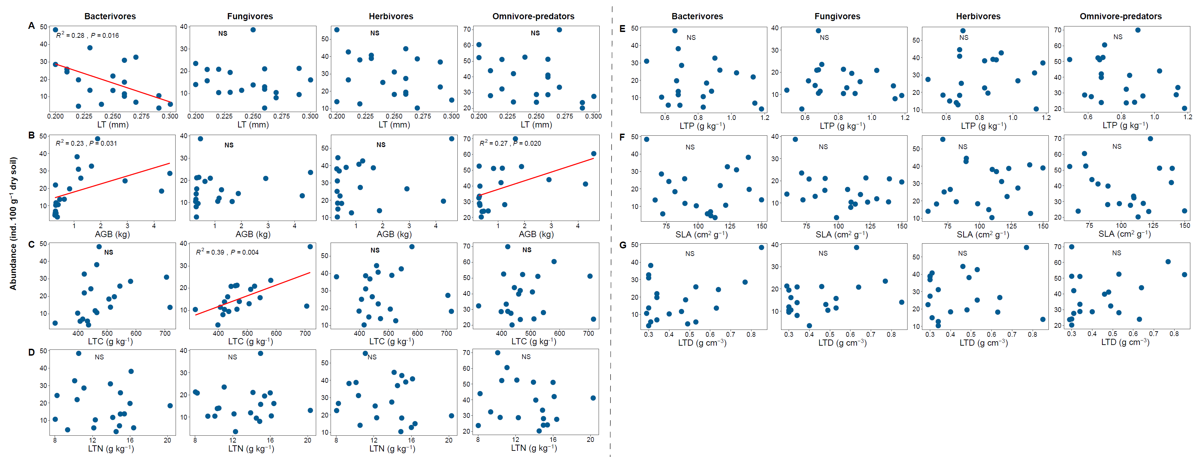
Fig. S6 Relationships between plant traits and the abundance of each nematode trophic group. Lines indicate models with statistically significant R² and P-values, NS indicates non-significance. LT, leaf thickness; AGB, aboveground biomass; LTC, leaf carbon content; LTN, leaf nitrogen content; LTP, leaf phosphorus content; SLA, specific leaf area; LTD, leaf tissue density.

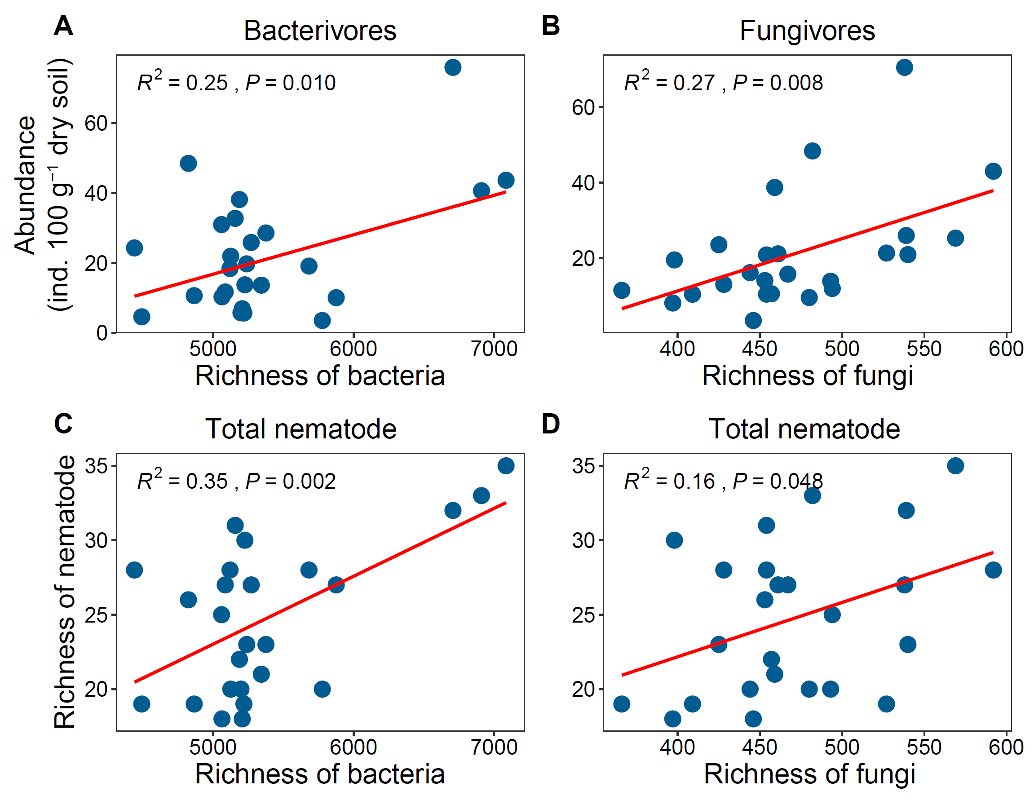
Fig. S7 Relationship between richness of bacteria and fungi and soil nematode community. Lines indicate models with statistically significant R² and P-values.

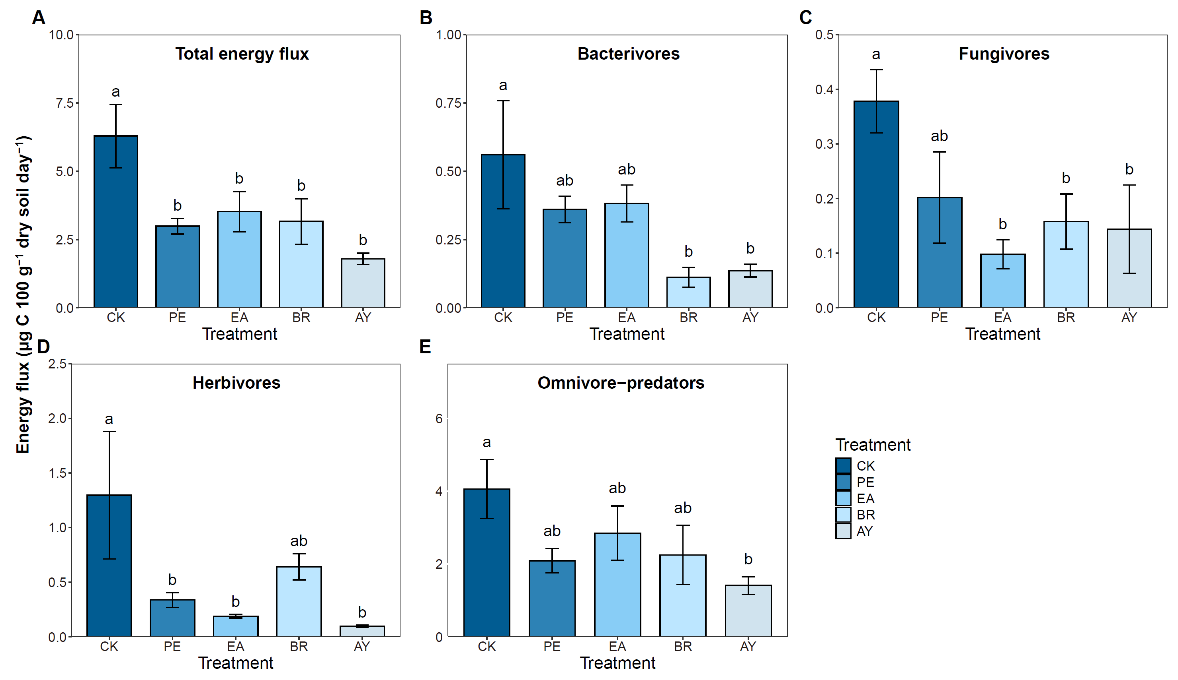
Fig. S8 Effects of Euphorbiaceae cultivation on nematode total energy flux and each trophic group energy flux. Values are means ± SE. Different lowercase letters indicate significant differences between treatments (P < 0.05). CK, control; PE, Phyllanthus emblica; EA, Excoecaria acerifolia; BR, Baccaurea ramiflora; AY, Aporosa yunnanensis.

