Supporting Information S1
Paper: Revisiting soil fungal biomarkers and conversion factors: Interspecific variability in phospholipid fatty acids, ergosterol and rDNA copy numbers
Journal: submitted to Soil Ecology Letters
Authors: Camenzind, T, Haslwimmer, H, Rillig, MC, Ruess, L, Finn, D⁵, Tebbe, C, Hempel, S, Marhan, S
Table S1 Details of the analyzed fungal isolates including taxonomic classification based on long sequence reads of ITS1, 5.8S, ITS2 and partial LSU regions (including DSMZ accession numbers (German Collection of Microorganisms and Cell Cultures GmbH); phylogeny according to Unite database (Nilsson et al., 2018))
strain ID | DSMZ accession number | phylum | class | order | family | taxon name
RLCS01 | DSM100293 | Mucoromycota | Mucoromycetes | Mucorales | Mucoraceae | Mucor fragilis
RLCS02 | DSM100407 | Mortierellomycota | Mortierellomycetes | Mortierellales | Mortierellaceae | Mortierella sp.3
RLCS03 | DSM100285 | Mortierellomycota | Mortierellomycetes | Mortierellales | Mortierellaceae | Mortierella alpina2
RLCS04 | DSM100322- | Mortierellomycota | Mortierellomycetes | Mortierellales | Mortierellaceae | Mortierella sp.2
RLCS05 | DSM100403 | Ascomycota | Sordariomycetes | Hypocreales | Nectriaceae | Fusarium sp.1
RLCS06 | DSM100400 | Ascomycota | Sordariomycetes | Sordariales | Chaetomiaceae | Chaetomium angustispirale1
RLCS07 | DSM100284 | Ascomycota | Sordariomycetes | Xylariales | Bartaliniaceae | Truncatella angustata
RLCS08 | DSM100325 | Ascomycota | Sordariomycetes | Hypocreales | Nectriaceae | Fusarium sp.3
RLCS09 | DSM100406 | Basidiomycota | Agaricomycetes | Polyporales | Polyporaceae | Trametes versicolor
RLCS10 | DSM100286 | Ascomycota | Dothideomycetes | Pleosporales | Pleosporaceae | Alternaria sp.
RLCS11 | DSM100289 | Mortierellomycota | Mortierellomycetes | Mortierellales | Mortierellaceae | Mortierella alpina1
RLCS12 | DSM100405 | Ascomycota | Sordariomycetes | Sordariales | Chaetomiaceae | Chaetomium angustispirale2
RLCS13 | DSM100290 | Ascomycota | Sordariomycetes | Hypocreales | Nectriaceae | Fusarium sp.2
RLCS14 | DSM100404 | Ascomycota | Dothideomycetes | Pleosporales | Didymellaceae | Nothophoma sp.
RLCS15 | DSM100402 | Mortierellomycota | Mortierellomycetes | Mortierellales | Mortierellaceae | Mortierella sp.1
RLCS16 | DSM100408 | Basidiomycota | Agaricomycetes | Agaricales | Pleurotaceae | Pleurotus sp.
RLCS17 | DSM100324 | Basidiomycota | Agaricomycetes | Agaricales | Entolomataceae | Clitopilus sp.
RLCS18 | DSM100287 | Ascomycota | Sordariomycetes | Hypocreales | Nectriaceae | Fusarium gibbosum
RLCS19 | DSM100331 | Mucoromycota | Umbelopsidomycetes | Umbelopsidales | Umbelopsidaceae | Umbelopsis isabellina
RLCS20 | DSM100329 | Ascomycota | Sordariomycetes | Hypocreales | Ophiocordycipitaceae | Purpureocillium lilacinum
RLCS21 | DSM100327 | Ascomycota | Dothideomycetes | Pleosporales | Cucurbitariaceae | Pyrenochaetopsis leptospora
RLCS22 | DSM100401 | Ascomycota | Dothideomycetes | Pleosporales | Phaeosphaeriaceae | Paraphoma chrysanthemicola
RLCS23 | DSM101519 | Ascomycota | Sordariomycetes | Hypocreales | Stachybotryaceae | Paramyrothecium sp.
RLCS24 | DSM100410 | Ascomycota | Sordariomycetes | Hypocreales | Clavicipitaceae | Metarhizium marquandii
RLCS25 | DSM100292 | Ascomycota | Sordariomycetes | Hypocreales | Bionectriaceae | Gliomastix sp.
RLCS26 | DSM100330 | Ascomycota | Leotiomycetes | Helotiales | Helotiaceae | Tetracladium apiense
RLCS27 | DSM100326 | Ascomycota | Sordariomycetes | Sordariales | Chaetomiaceae | Chaetomium subspirilliferum
RLCS28 | DSM100323 | Ascomycota | Leotiomycetes | Helotiales | NA | NA
RLCS30 | DSM100291 | Ascomycota | Eurotiomycetes | Chaetothyriales | Herpotrichiellaceae | Exophiala sp.
RLCS31 | DSM100328 | Ascomycota | Eurotiomycetes | Chaetothyriales | Cyphellophoraceae | Cyphellophora sp.

Soil fungal community analyses in selected soils used as a template for modeling
Three soils were chosen used as standard soils in the priority program SoilSystems (https://soilsystems.net/about/common-experimental-platform/soils/), originating from long-term field experiments. Fertilized and unfertilized soils from the Dikopshof site (University Bonn, Germany; referred to as Soil1 and Soil2), and fertilized soil from Thyrow (Humboldt-Universität Berlin, Germany; Soil3) were chosen. Soils were stored at -20° until analyses. Five hundred milligrams of soil was used for DNA extraction via the FastDNA Spin Kit (MP Biomedicals, Eschwege, Germany) as per the manufacturer’s recommendations. ITS copy numbers were determined by qPCR on 10 ng µL⁻¹ standardised DNA template, using primers NSI1 and 58A2R (Martin and Rygiewicz, 2005) in SYBR green reactions (Thermo Fisher, Osterode am Harz, Germany) on a CFX96 Touch realtime PCR detection system (Biorad laboratories, Neuried, Germany) as described previously (Hemkemeyer et al., 2015) Standard curves were derived from known quantities of Fusarium culmorum, and qPCR efficiency was 93.5%, R² of 98.3%.
For fungal community analyses, partial fungal ITS1 sequences were amplified with barcoded ITS1f and ITS2 primers (Walters et al., 2015; Hoggard et al., 2018) in 25 µL PCR reactions using Q5 high-fidelity DNA polymerase (New England Biolabs, Ipswich, MA, USA) as described previously (Finn et al., 2023). Amplicon products were purified and normalized to 2 ng µL⁻¹ prior to library prep with Ovation Rapid DR Multiplex System 1-96 (NuGEN Technologies, San Carlos, CA, USA) and sequencing on the Illumina MiSeq platform by LGC Genomics GmbH, Berlin, Germany). Sequences were analyzed using the DADA2 ITS Pipeline Workflow (1.8) (https://benjjneb.github.io/dada2/ITS_workflow.html; Callahan et al., 2016). Sequences were assigned to phyla using the UNITE database (Nilsson et al., 2018).

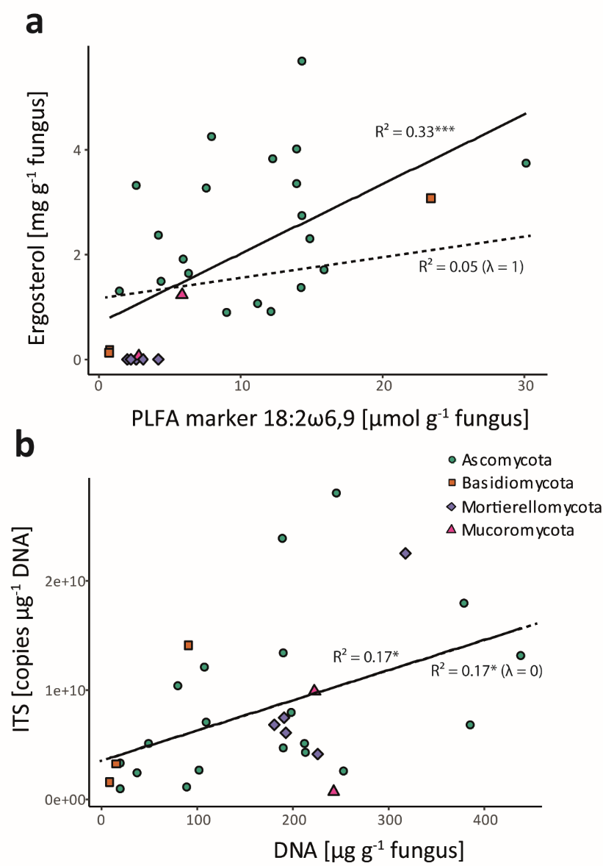
Fig. S1 Significant linear correlations of fungal biomarker contents in individual fungal isolates. Solid lines represent linear regression models, dashed lines phylogenetically corrected linear correlations (phylogenetic generalized least squares (PGLS)). Correlation coefficients (R²), respective P-values (* P < 0.05, *** P < 0.001) and phylogenetic signals are given (pagel´s lambda λ). Symbol shape and colour reflect respective phyla affiliations (see legend).

Reference list
Callahan, B.J., McMurdie, P.J., Rosen, M.J., Han, A.W., Johnson, A.J.A., and Holmes, S.P., 2016. DADA2: High-resolution sample inference from Illumina amplicon data. Nature Methods 13, 581-583.
Finn, D.R., Schroeder, J., Samad, M.S., Poeplau, C., and Tebbe, C.C., 2023. Importance of sample pre-treatments for the DNA-based characterization of microbiomes in cropland and forest soils. Soil Biology and Biochemistry 184, 109077.
Hemkemeyer, M., Christensen, B.T., Martens, R., and Tebbe, C.C., 2015. Soil particle size fractions harbour distinct microbial communities and differ in potential for microbial mineralisation of organic pollutants. Soil Biology and Biochemistry 90, 255-265.
Hoggard, M., Vesty, A., Wong, G., Montgomery, J.M., Fourie, C., Douglas, R.G., Biswas, K., and Taylor, M.W., 2018. Characterizing the Human Mycobiota: A Comparison of Small Subunit rRNA, ITS1, ITS2, and Large Subunit rRNA Genomic Targets. Frontiers in Microbiology 9, 2208.
Martin, K.J., and Rygiewicz, P.T., 2005. Fungal-specific PCR primers developed for analysis of the ITS region of environmental DNA extracts. BMC Microbiology 5, 28.
Nilsson, R.H., Larsson, K.-H., Taylor, A.F S., Bengtsson-Palme, J., Jeppesen, T.S., Schigel, D., Kennedy, P., Picard, K., Glöckner, F.O., Tedersoo, L., Saar, I., Kõljalg, U., and Abarenkov, K., 2018. The UNITE database for molecular identification of fungi: handling dark taxa and parallel taxonomic classifications. Nucleic Acids Research 47, D259-D264.
Walters, W., Hyde Embriette, R., Berg-Lyons, D., Ackermann, G., Humphrey, G., Parada, A., Gilbert Jack, A., Jansson Janet, K., Caporaso, J.G., Fuhrman Jed, A., Apprill, A., and Knight, R., 2015. Improved Bacterial 16S rRNA Gene (V4 and V4-5) and Fungal Internal Transcribed Spacer Marker Gene Primers for Microbial Community Surveys. mSystems 1, 10.1128/msystems.00009-00015.

