Supporting information for
Distinct responses of soil carbon-degrading enzyme activities to warming in two alpine meadow ecosystems on the Tibetan Plateau
Running title: Soil enzyme activities in alpine grasslands under warming
Xinran Wu^{1,2}, Yuanrui Peng^{1,2}, Tao Wang¹, Noman Ahmad³, Xuesong Bai¹, and Ruiying Chang^{1*}

¹CAS Key Laboratory of Mountain Surface Processes and Ecological Regulation, Institute of Mountain Hazards and Environment, Chinese Academy of Sciences, Chengdu, 610041, China, ²College of Resources and Environment, University of Chinese Academy of Sciences, Beijing, 100049, China, ³Institute of Soil and Environmental Sciences, University of Agriculture Faisalabad, Faisalabad, 38040, Pakistan

* Corresponding author. E-mail addresses: changruiying@imde.ac.cn

Contents for Supporting information:
including 1 supplementary table and 4 supplementary figures.

Supplementary Table 1 Properties of 5-20 cm soils of alpine meadow and swamp meadow under different warming treatments
Site | Treatment | SOC  (g·kg⁻¹) | DOC  (mg·kg⁻¹) | MBC  (mg·kg⁻¹) | SWC  （%） | NH₄⁺-N  (mg·kg⁻¹) | Fungi/Bacteria | pH | Total bacterial  (nmol·g⁻¹)
alpine meadow | CK | 21.17 ± | 213.04 ± | 127.31 ± | 28.63 ± | 4.61 ± | 0.28 ± | 8.60 ± | 21.82 ±
alpine meadow |  | 3.73 a | 7.50 a | 14.33 a | 1.81 a | 0.16 a | 0.01 a | 0.14 b | 1.74 a
alpine meadow | LW3 | 27.10 ± | 258.11 ± | 170.37 ± | 32.90 ± | 6.23 ± | 0.28 ± | 8.01 ± | 22.76 ±
alpine meadow |  | 2.83 ab | 13.54 a | 64.71 a | 1.70 ab | 2.21 a | 0.00 a | 0.09 a | 2.40 a
alpine meadow | HW3 | 26.92 ± | 257.37 ± | 230.03 ± | 29.63 ± | 7.62 ± | 0.33 ± | 8.22 ± | 12.26 ±
alpine meadow |  | 3.95 ab | 15.50 a | 9.11 b | 2.42 a | 1.52 a | 0.02 b | 0.08 a | 1.63 a
alpine meadow | LW6 | 31.16 ± | 423.83 ± | 196.51 ± | 36.85 ± | 7.59 ± | 0.29 ± | 8.24 ± | 18.67 ±
alpine meadow |  | 0.93 ab | 7.86 b | 11.59 ab | 0.13 ab | 0.60 a | 0.01 a | 0.06 a | 2.33 a
alpine meadow | HW6 | 33.56 ± | 393.29 ± | 327.42 ± | 38.09 ± | 6.67 ± | 0.29 ± | 8.20 ± | 19.72 ±
alpine meadow |  | 2.99 b | 73.70 b | 36.76 b | 2.59 b | 0.45 a | 0.00 a | 0.10 a | 3.19 a
swamp meadow | CK | 52.54 ± | 372.87 ± | 292.30 ± | 73.29 ± | 11.36 ± | 0.20 ± | 8.28 ± | 17.04 ±
swamp meadow |  | 14.89 a | 105.14 a | 15.29 a | 17.54 a | 4.27 a | 0.02 a | 0.10 a | 2.84 a
swamp meadow | LW3 | 58.82 ± | 334.15 ± | 306.58 ± | 57.88 ± | 5.33 ± | 0.20 ± | 8.18 ± | 24.73 ±
swamp meadow |  | 12.72 a | 31.18 a | 35.54 a | 11.50 a | 0.79 a | 0.01 a | 0.09 a | 4.98 a
swamp meadow | LW6 | 36.39 ± | 296.99 ± | 310.20 ± | 53.87 ± | 12.48 ± | 0.26 ± | 8.13 ± | 15.80 ±
swamp meadow |  | 0.23 a | 13.63 a | 37.23 a | 3.80 a | 1.35 a | 0.00 b | 0.05 a | 0.24 a
swamp meadow | HW6 | 49.52 ± | 342.82 ± | 235.63 ± | 60.96 ± | 13.00 ± | 0.21 ± | 8.29 ± | 21.43 ±
swamp meadow |  | 11.03 a | 40.55 a | 40.84 a | 8.35 a | 2.79 a | 0.00 a | 0.09 a | 1.45 a
Notes: Values not sharing a common lowercase letter indicate a significant difference at a 0.05 level between treatments at the same depth. CK: control treatment; LW3: 3-year of lower warming treatment; LW6: 6-year of lower warming treatment; HW3: 3-year of higher warming treatment; HW6: 6-year of higher warming treatment. Data were presented as mean ± one standard error (n = 3).
Supplementary Fig. 1 Comparison of above-ground biomass and below-ground biomass (in the top 20 cm depth) among different treatments in the alpine meadow (A) and swamp meadow (B). Values are the means ± one standard error (n = 3 for each treatment). Different lowercase letters mean significant differences among different treatments in the above-ground biomass and the below-ground biomass. CK: control treatment; LW: lower warming treatment; HW: higher warming treatment.
Supplementary Fig. 2 Soil extracellular enzyme activities in the surface (0-5 cm) and subsurface (5-20 cm) layers of alpine meadow and swamp meadow under different warming treatments. CK: control treatment; LW3: 3-year of lower warming treatment; LW6: 6-year of lower warming treatment; HW3: 3-year of higher warming treatment; HW6: 6-year of higher warming treatment.
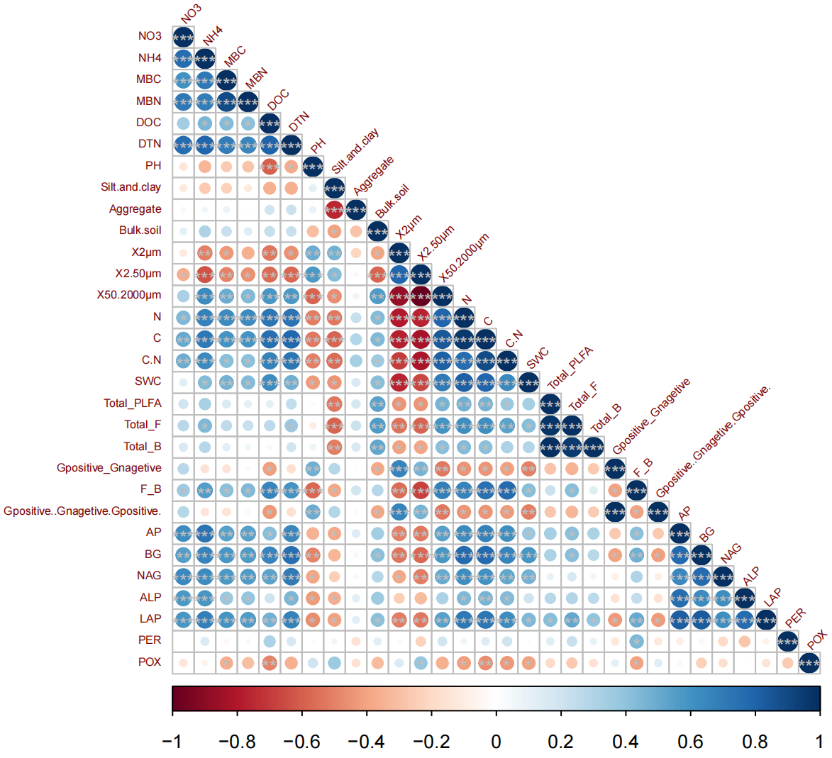Supplementary Fig. 3 Pearson correlation between soil properties and soil carbon-degrading enzyme activities under warming in alpine meadow. BG: β-1,4-glucosidase; PER: peroxidases; POX: phenol oxidase; AGB: above-ground biomass; BGB: below-ground biomass; SOC: soil organic carbon; DOC: dissolved organic carbon; MBC: microbial biomass carbon; SWC: soil water content; ST: soil temperature; NH₄⁺-N: ammonium nitrogen; F/B: fungal to bacterial PLFAs ratio. *: p < 0.05; **: p < 0.01; ***: p < 0.005.
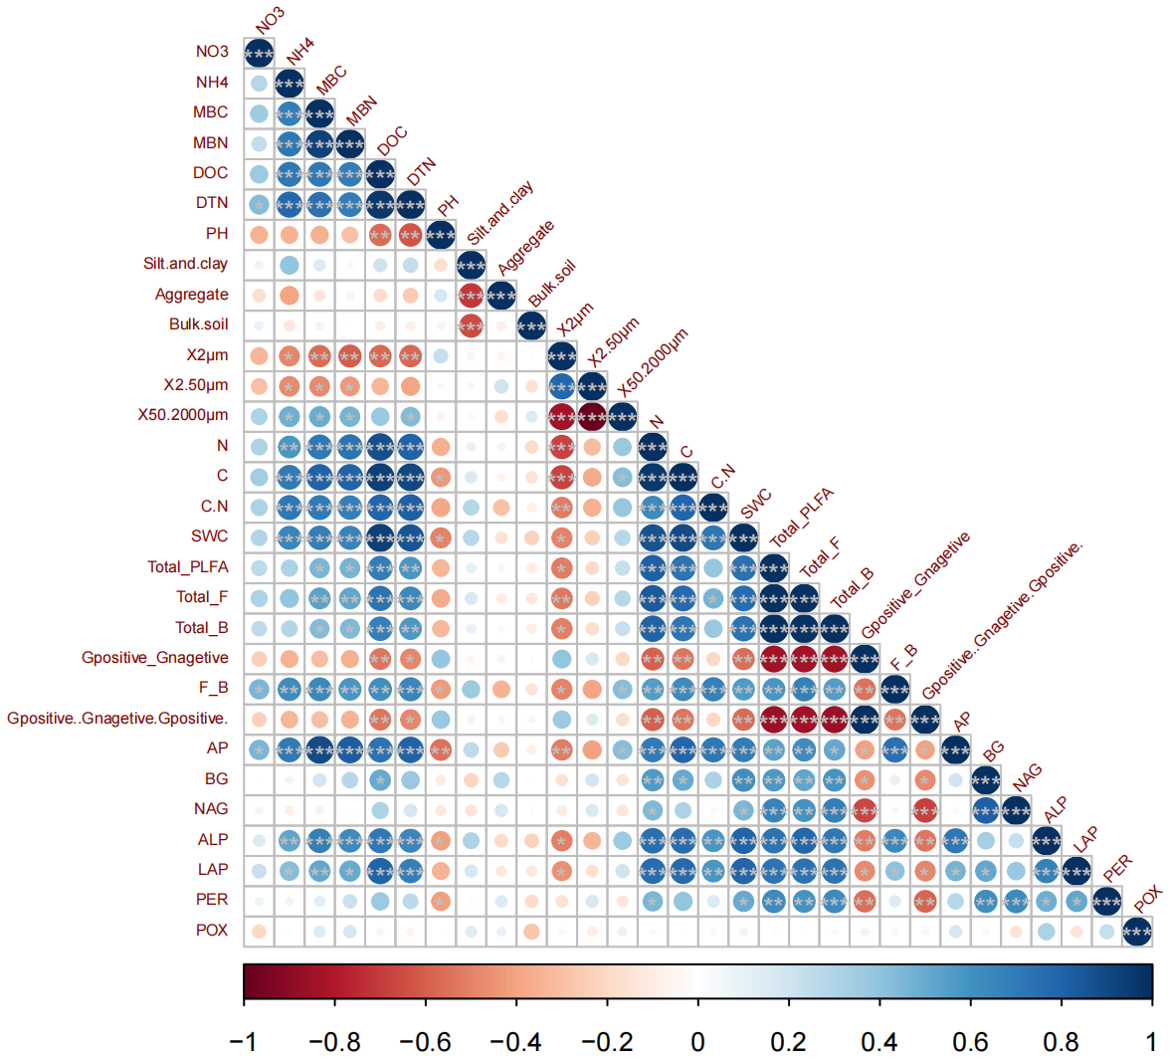Supplementary Fig. 4 Pearson correlation between soil properties and soil carbon-degrading enzyme activities under warming in swamp meadow. BG: β-1,4-glucosidase; PER: peroxidases; POX: phenol oxidase; AGB: above-ground biomass; BGB: below-ground biomass; SOC: soil organic carbon; DOC: dissolved organic carbon; MBC: microbial biomass carbon; SWC: soil water content; ST: soil temperature; NH₄⁺-N: ammonium nitrogen; F/B: fungal to bacterial PLFAs ratio. *: p < 0.05; **: p < 0.01; ***: p < 0.005.
Supplementary Fig. 5 Soil respiration of alpine meadow and swamp meadow under different warming treatments. Different lowercase letters mean significant differences among different treatments in soil respiration. CK: control treatment; LW: lower warming treatment; HW: higher warming treatment.

