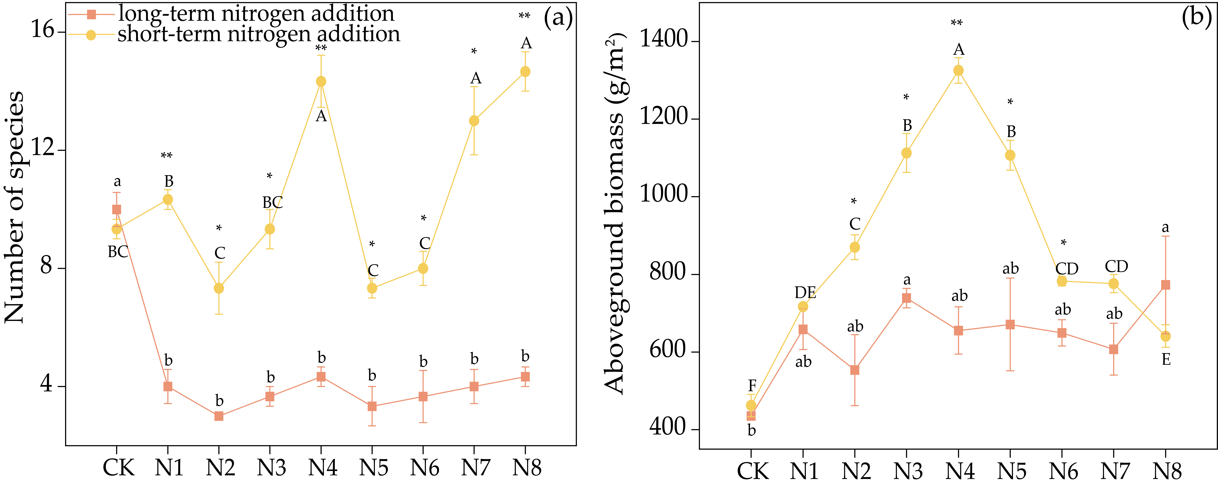
Fig. S1 The impact of long—term and short—term nitrogen addition treatments on number of species (a) and aboveground biomass (b). Mean values are presented with standard errors. Different lowercase letters denote significant differences among treatments in long—term nitrogen addition (p < 0.05), while uppercase letters indicate significant differences in short—term nitrogen addition (p < 0.05). * represent significant differences between long—term and short—term nitrogen addition within the same treatment (p < 0.05), ** indicate extremely significant differences (p < 0.01).
Fig. S2 Relationship between number of species and aboveground biomass in long—term and short—term nitrogen addition.

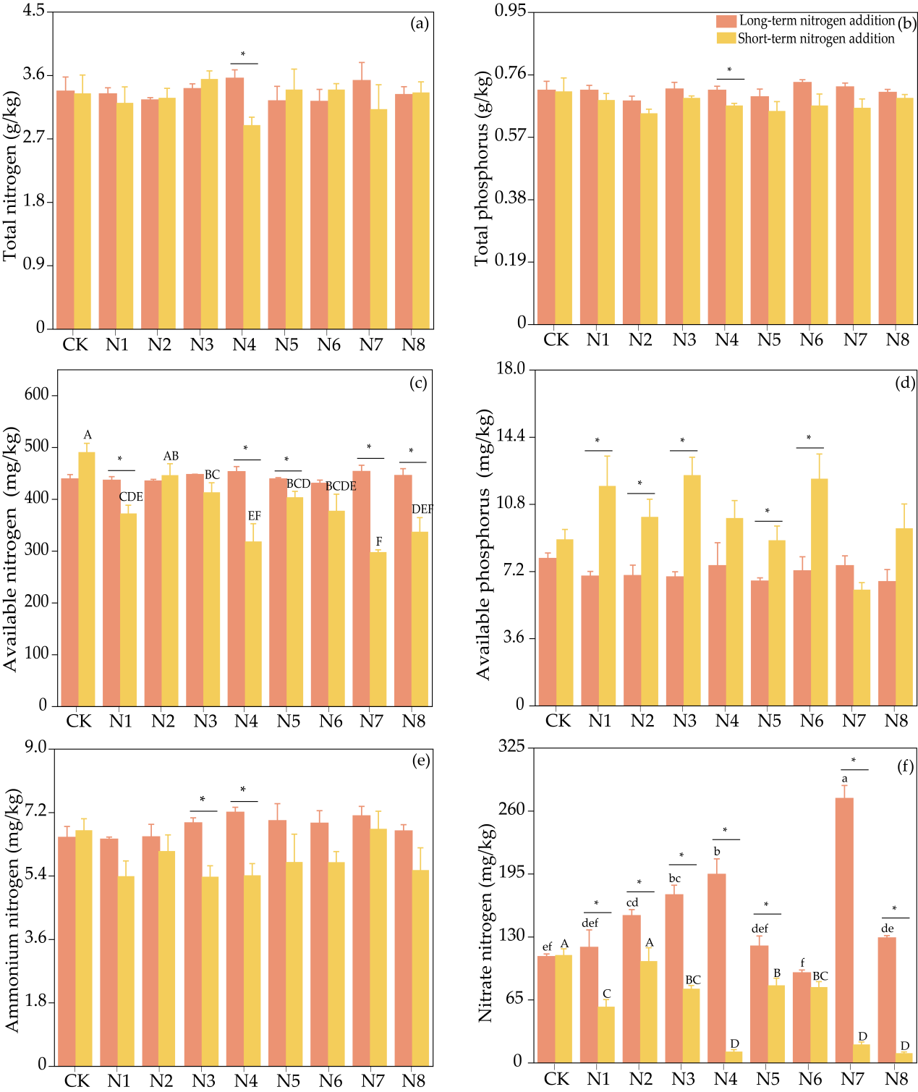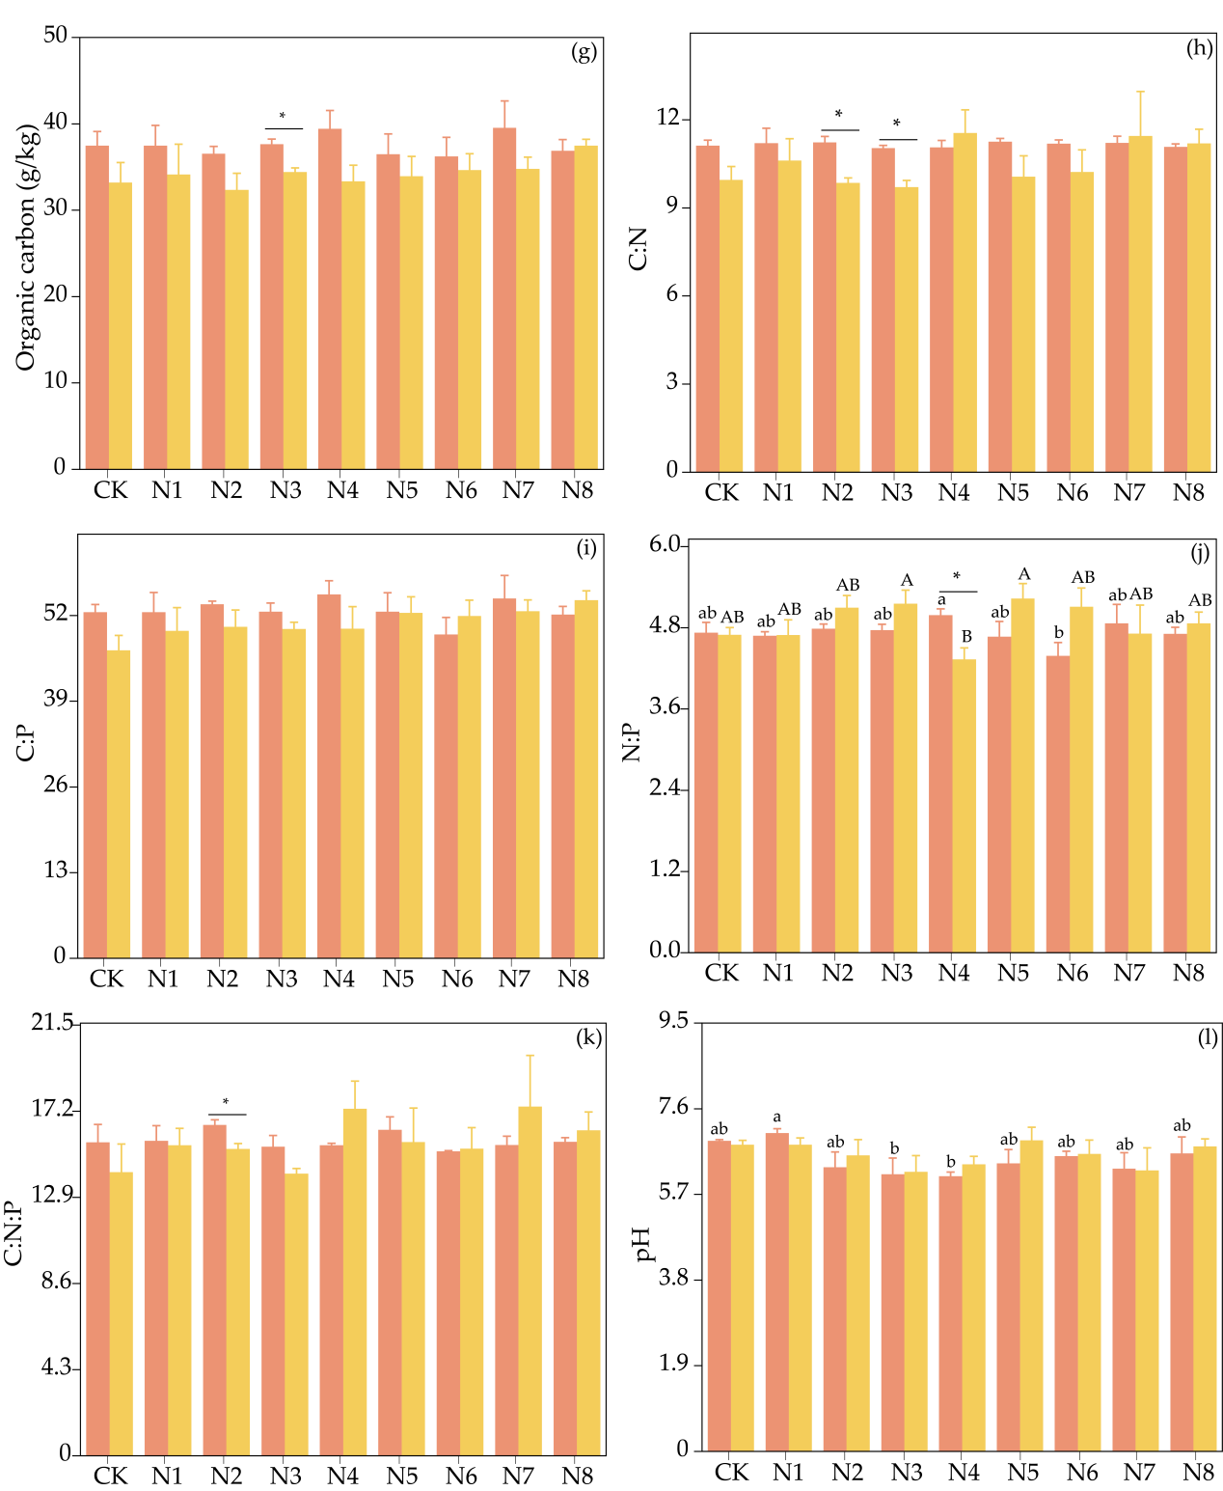
Fig. S3 Effect of long–term and short–term nitrogen addition treatments on soil physicochemical properties.

