Supplementary Information

Title: Characterization of arbuscular mycorrhizal fungal communities in Songnen saline-alkaline soils and potential hydroponic utilization

Authors: Yajie Liu ª, Menghui Yang ª, Na Li ª, Yixin Huang ª, Chunxue Yang ^{a*}

Affiliations:
ª College of Landscape Architecture, Northeast Forestry University, Harbin 150040, China
* Corresponding author: Chunxue Yang
Tel: 0451-82191548
E-mail: senxiu99@163.com
Table S1 Basic information of the five quadrats
Serial number | Latitude and longitude | Altitude | Types of vegetation after succession | Others
Ⅰ | 46°2′52.9″N  125°54′09″E | 143 m | Ajuga multiflora, Stellera chamaejasme, Asparagus cochinchinensis, Potentilla anserina, etc. | Well-coverage areas with loose soil structure
Ⅱ | 46°2′55.3″N  125°53′58″E | 152 m | A. multiflora, Iris lactea, etc. | Densely vegetated zones exhibiting moderate soil compaction
Ⅲ | 46°2′57.1″N  125°53′55″E | 153 m | A. multiflora, Syneilesis aconitifolia, Inula japonica, etc. | Sparsely vegetated, highly alkaline soils with compacted texture
Ⅳ | 46°2′58.1″N  125°53′38″E | 155 m | S. aconitifolia, Medicago falcata, etc. | Expanding sodic patches with increasing soil compaction and surface alkalization
Ⅴ | 46°2′50.3″N  125°52′54″E | 153 m | S. aconitifolia, Artemisia scoparia, etc. | Expanding sodic patches with increasing soil compaction and surface alkalization

Table S2 Physicochemical properties of rhizosphere soil in three stages (Liu et al. 2022)
 | Leymus chinensis | Puccinellia tenuiflora | Suaeda glauca
pH | 9.29±0.26c | 10.14±0.10b | 10.30±0.06a
EC / mS·cm⁻¹ | 0.64±0.30c | 1.80±0.13b | 2.76±0.83a
Carbonate / cmol·kg⁻¹ | 1.46±0.92c | 5.89±0.42b | 8.04±1.61a
Organic Carbon / g·kg⁻¹ | 35.71±6.96a | 12.24±3.90c | 19.35±2.96b
Organic Matter / g·kg⁻¹ | 61.57±12.00a | 21.10±6.72c | 33.36±5.10b
Total Nitrogen / g·kg⁻¹ | 1.44±0.41a | 0.28±0.08c | 0.52±0.09b
Total Phosphorus / g·kg⁻¹ | 0.34±0.05a | 0.26±0.01b | 0.22±0.03c
C/N % | 25.68±5.46b | 43.52±6.47a | 38.05±5.08a
Sucrase / mg·(g·h)⁻¹ | 3.98±0.07a | 2.37±0.28b | 1.88±0.17c
Cellulase / mg·(g·h)⁻¹ | 4.15±0.32b | 6.42±0.74a | 4.24±0.26b
Urease / mg·(g·h)⁻¹ | 5.52±0.32a | 5.02±0.69a | 3.23±0.58b
Catalase / mg·(g·h)⁻¹ | 2.14±0.01a | 2.08±0.06b | 1.95±0.05c
Different letters within the same row indicated significant differences among stages

Table S3 The AM fungi in rhizosphere soils across three vegetation stages
Genus | Species | Communities |  |  | Frequency %  F ( %) | Relative Abundance%  RA (%) | Importance Value %  IV (%)
Genus | Species | I | Ⅱ | Ⅲ | Frequency %  F ( %) | Relative Abundance%  RA (%) | Importance Value %  IV (%)
Glomus | G. reticulatum | + | + | + | 86.67 | 6.15 | 46.41
 | G. pustulatum | + | + | + | 46.67 | 1.88 | 4.28
 | G. multiforum | + | + | + | 33.33 | 0.89 | 17.11
 | G. microaggregatum | + | + |  | 33.33 | 0.79 | 17.06
 | G. melanosporum | + | + |  | 33.33 | 1.59 | 17.46
 | G. fasciculatum | + | + | + | 40.00 | 1.98 | 20.99
 | G. convolutum | + |  | + | 20.00 | 0.40 | 10.20
 | G. pansihalos | + |  |  | 6.67 | 0.20 | 3.43
 | G. halonatum | + | + | + | 20.00 | 0.40 | 10.20
 | G. multicaule | + |  | + | 13.33 | 0.20 | 6.77
 | - hyderabadensis | + |  |  | 6.67 | 0.40 | 3.53
 | G. macrocarpum | + | + |  | 13.33 | 0.20 | 6.77
 | G. minutum | + |  |  | 6.67 | 0.50 | 3.58
 | G. dolichosporum | + |  |  | 6.67 | 0.10 | 3.38
 | G. delhiense |  | + |  | 6.67 | 0.20 | 3.43
 | G. monosporum |  |  | + | 6.67 | 0.20 | 3.43
Acaulospora | A. colombiana | + |  | + | 40.00 | 1.09 | 20.55
 | A. tuberculata | + |  |  | 6.67 | 0.20 | 3.43
 | A. koskei | + | + | + | 26.67 | 0.40 | 13.53
 | A. lacunosa | + |  |  | 13.33 | 0.20 | 6.77
 | A. scrobiculata | + | + | + | 40.00 | 7.04 | 23.52
 | A. denticulata | + |  | + | 26.67 | 1.98 | 14.33
 | A. gedanensis | + | + |  | 33.33 | 0.50 | 16.91
 | A. morrowiae | + | + | + | 53.33 | 1.88 | 27.61
 | A. bireticulata | + |  |  | 6.67 | 0.20 | 3.43
 | A. excavata | + |  |  | 13.33 | 0.30 | 6.82
 | A. spinosa |  | + |  | 6.67 | 0.10 | 3.38
 | A. delicata |  | + | + | 13.33 | 0.20 | 6.67
Ambispora | Am. leptoticha | + | + | + | 46.67 | 2.98 | 24.82
 | Am. reticulata | + | + | + | 53.33 | 4.17 | 28.75
 | Am. jimgerdemannii | + |  |  | 6.67 | 0.10 | 3.38
Rhizophagus | R. intraradices | + | + | + | 46.67 | 4.07 | 25.37
 | R. clarus | + | + | + | 60.00 | 9.13 | 34.56
 | R. aggregatus |  | + | + | 40.00 | 3.27 | 21.64
Septoglomus | Sep. deserticola | + |  |  | 26.67 | 0.60 | 13.63
 | Sep. constrictum | + | + | + | 40.00 | 1.59 | 20.79
Claroideoglomus | C. etunicatum | + | + | + | 40.00 | 1.39 | 20.69
 | C. claroideum | + | + | + | 33.33 | 1.39 | 17.36
 | C. lamellosum | + | + | + | 33.33 | 0.79 | 17.06
 | C. walkeri |  | + | + | 33.33 | 2.68 | 18.01
Sclerocystis | Scl. sinuosa | + | + | + | 73.33 | 7.34 | 40.34
 | Scl. rubiformis |  |  | + | 6.67 | 0.40 | 3.53
Funneliformis | F. geosporum | + |  |  | 6.67 | 0.10 | 3.38
 | F. coronatum | + | + | + | 40.00 | 1.49 | 20.74
 | F. mosseae | + | + | + | 33.33 | 0.89 | 17.11
Scutellospora | Scu. reticulata | + | + |  | 40.00 | 2.18 | 21.09
 | Scu. nigra | + |  | + | 26.67 | 0.69 | 13.68
Pacispora | P. chimonobambusae | + |  |  | 6.67 | 0.10 | 3.38
 | P. boliviana | + |  |  | 6.67 | 0.10 | 3.38
Diversispora | Di. eburnea | + |  |  | 20.00 | 1.59 | 10.79
 | Di. aurantia |  | + | + | 13.33 | 0.20 | 6.77
Paraglomus | Par. occultum | + | + | + | 46.67 | 3.27 | 24.97
Gigaspora | Gi. decipiens | + |  |  | 6.67 | 0.10 | 3.38
Corymbiglomus | Cor. corymbiforme |  | + |  | 6.67 | 0.10 | 3.38
Entrophospora | E. infrequens |  |  | + | 6.67 | 0.10 | 3.38
Redeckera | Red. fulvum |  | + | + | 20.00 | 0.50 | 10.25
Racocetra | Rac. castanea |  | + | + | 26.67 | 0.50 | 13.58
---------------- | sp1 | + | + | + | 100 | 18.06 | 59.03
17 | 58 | 46 | 35 | 35
The Ⅰ, Ⅱ and Ⅲ represented the stages of Leymus chinensis, Puccinellia tenuiflora and Suaeda glauca, respectively.

Table S4 AM fungal colonization in three systems
 | Colonization Rate % | Colonization Intensity % | Arbuscular Abundance % | Vesicle Abundance %
Tube | 72.58±4.46b | 2.18±0.62b | 2.25±1.36b | 21.04±2.76b
Box | 60.00±0.00c | 1.44±0.77b | 2.37±1.42b | 24.84±3.48b
Sand | 86.67±5.77a | 49.55±2.11a | 17.63±0.74a | 60.30±3.97a
Different letters within the same column indicated significant differences among vegetation stages

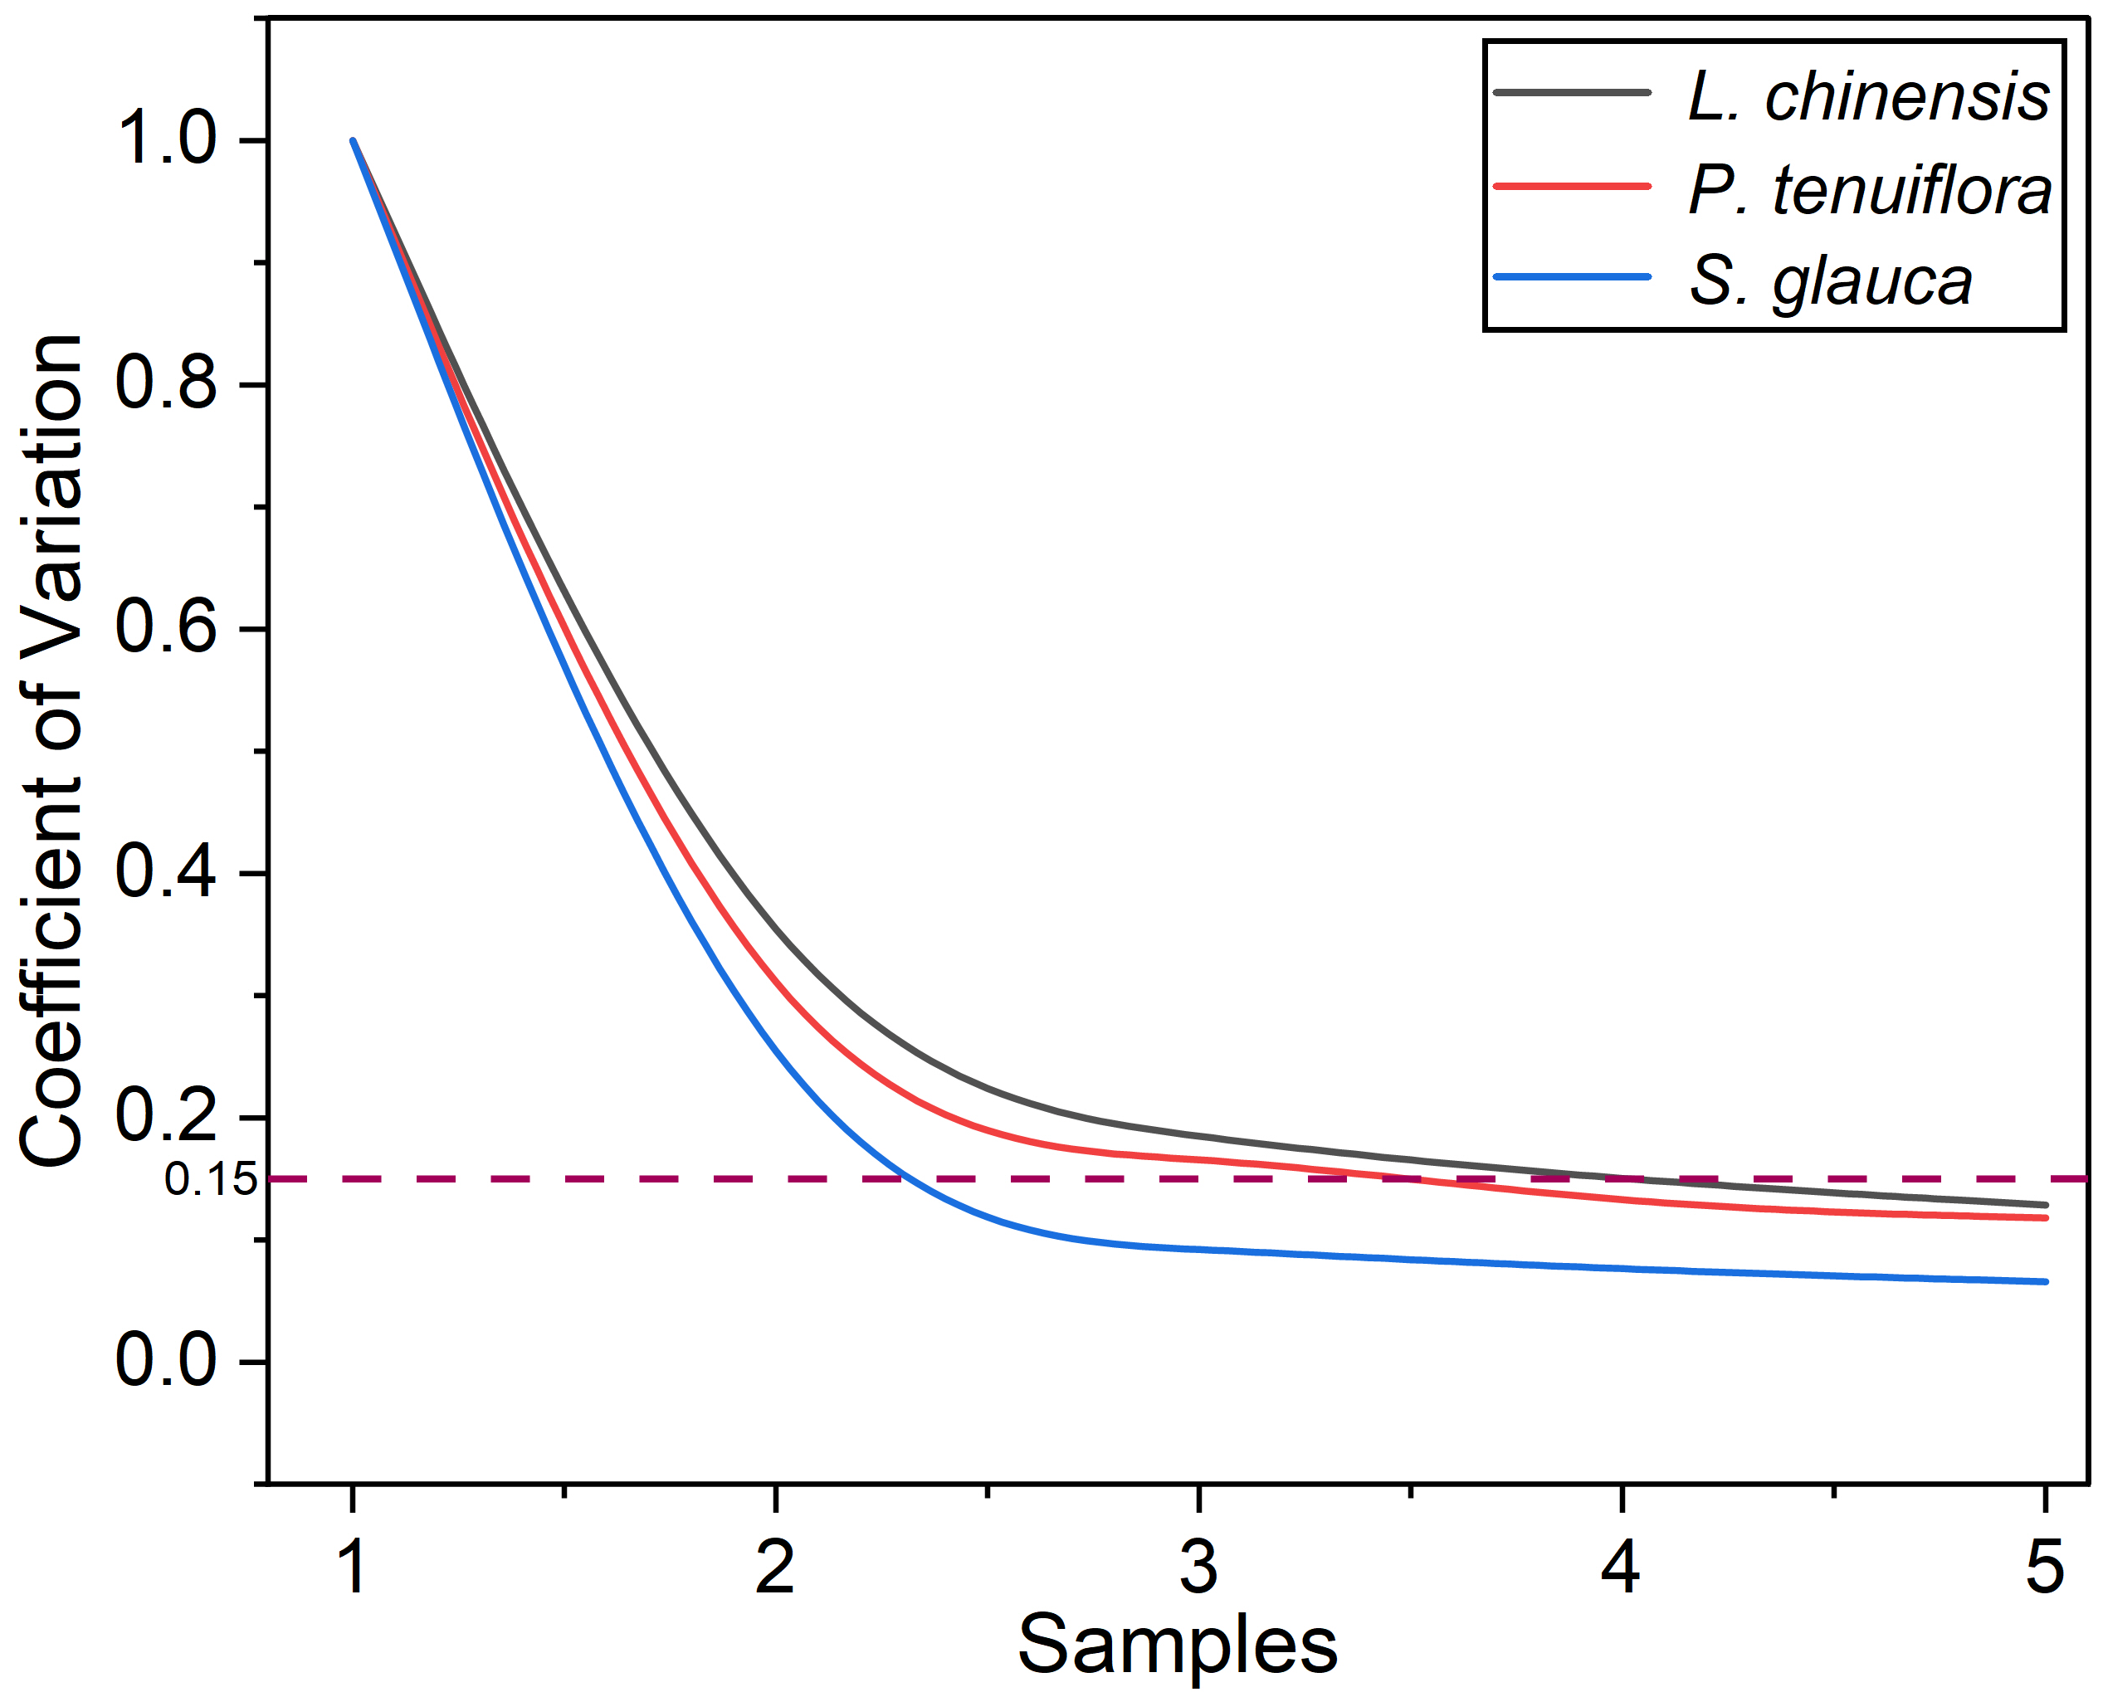
Fig. S1 Dilution curve of variation coefficient for sampling sites
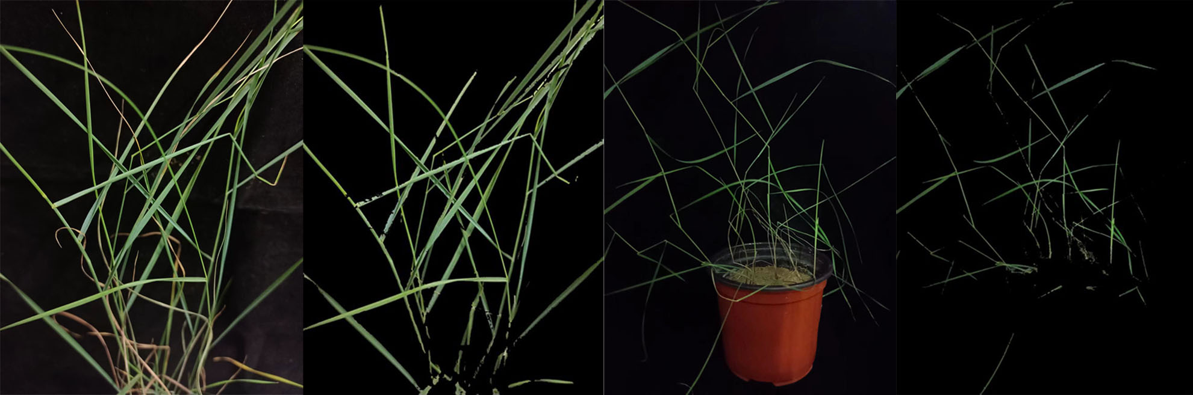
Fig. S2 Leaves extraction efficiency.The original plant images paired with their corresponding computer-extracted results were showed.
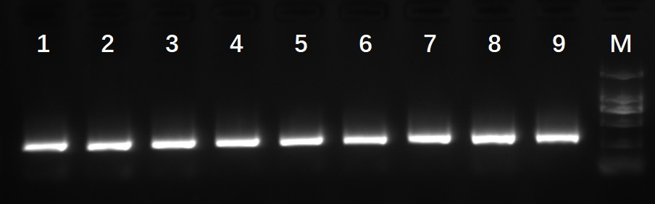
Fig. S3 Agarose gel image of the amplified products. Samples 1-3 were collected from the tube, samples 4-6 were obtained from the box, and the remaining three samples were derived from potted plants.
Fig .S4 Alpha diversity of AM fungi in field. The Shannon-Wiener, Simpson and Pielou of three vegetation stages were calculated based on morphological analysis, the maximum, minimum, and median values were drawn.
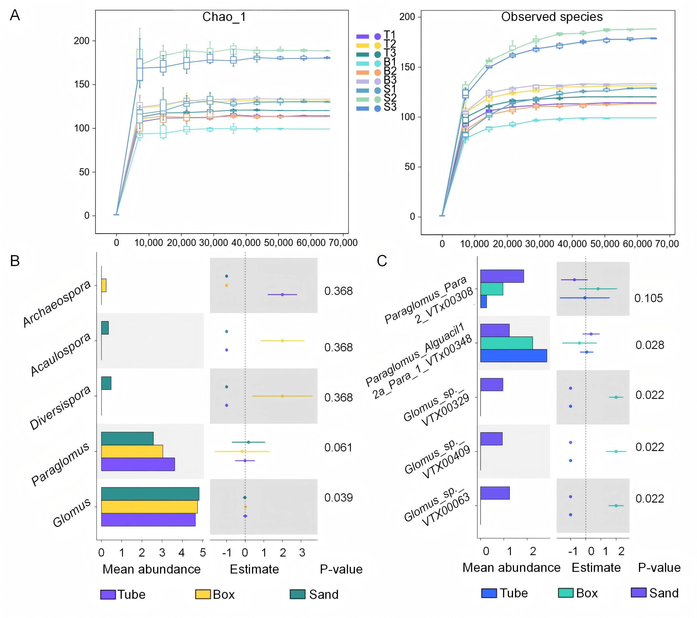
Fig. S5 Sequencing credibility and fungus screening. (A) Rarefaction curves of Chao1 and Observed species indices showing adequate sequencing depth, with samples from different cultivation systems (T: tube; B: box; S: pot-grown roots). (B) demonstrated the remarkable genus, and (C) showed the results at species.
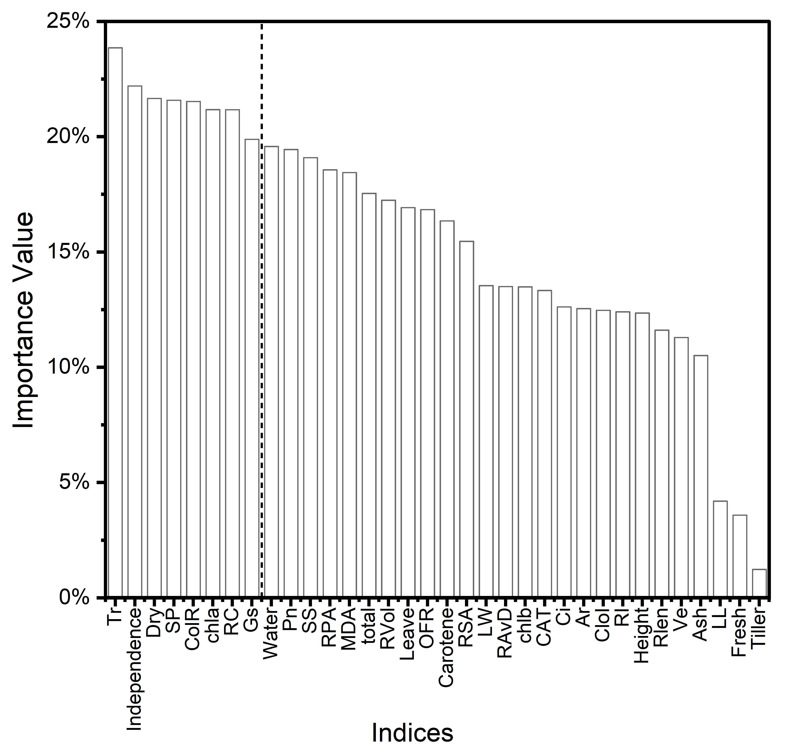
Fig. S6 Importance values of physiological and growth indices. Based on the mean decreased Gini coefficient, six factors other than the mycorrhizal indices were selected: transpiration rate (Tr), dry weight (Dry), soluble protein (SP), chlorophyll a (chla), relative conductivity (RC), and Gas conductance (Gs).
Fig. S7 Autocorrelation fitting test for selected indices

