APPENDIX S1 for
Salinity Drives the Divergence of Nitrogen-Cycling Microbial Communities Across Land-Use Types in the Qaidam Basin
Pan Wang^{1,2,3}, Bicheng Zhang^{1,2,3}, Zhaolong Zhu¹, Bayan Nuralykyzy¹, Xiaoqian Deng¹, Shaoshan An^{1*}
¹ State Key Laboratory of Soil and Water Conservation and Desertification Control, College of Soil and Water Conservation Science and Engineering (Institute of Soil and Water Conservation), Northwest A&F University, Yangling, 712100, China
² Institute of Soil and Water Conservation, CAS & MWR, Yangling, 712100, China
³ University of Chinese Academy of Sciences, Beijing 100049, China
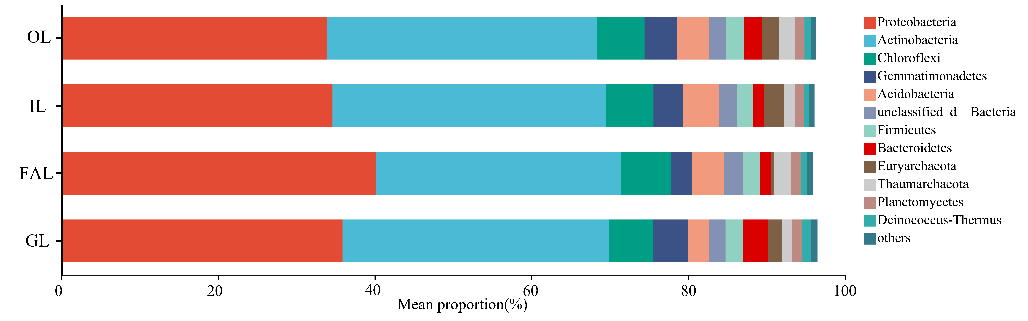
Fig. S1. Composition of N-cycle microbial communities at the phylum level (Relative abundance greater than 1%).
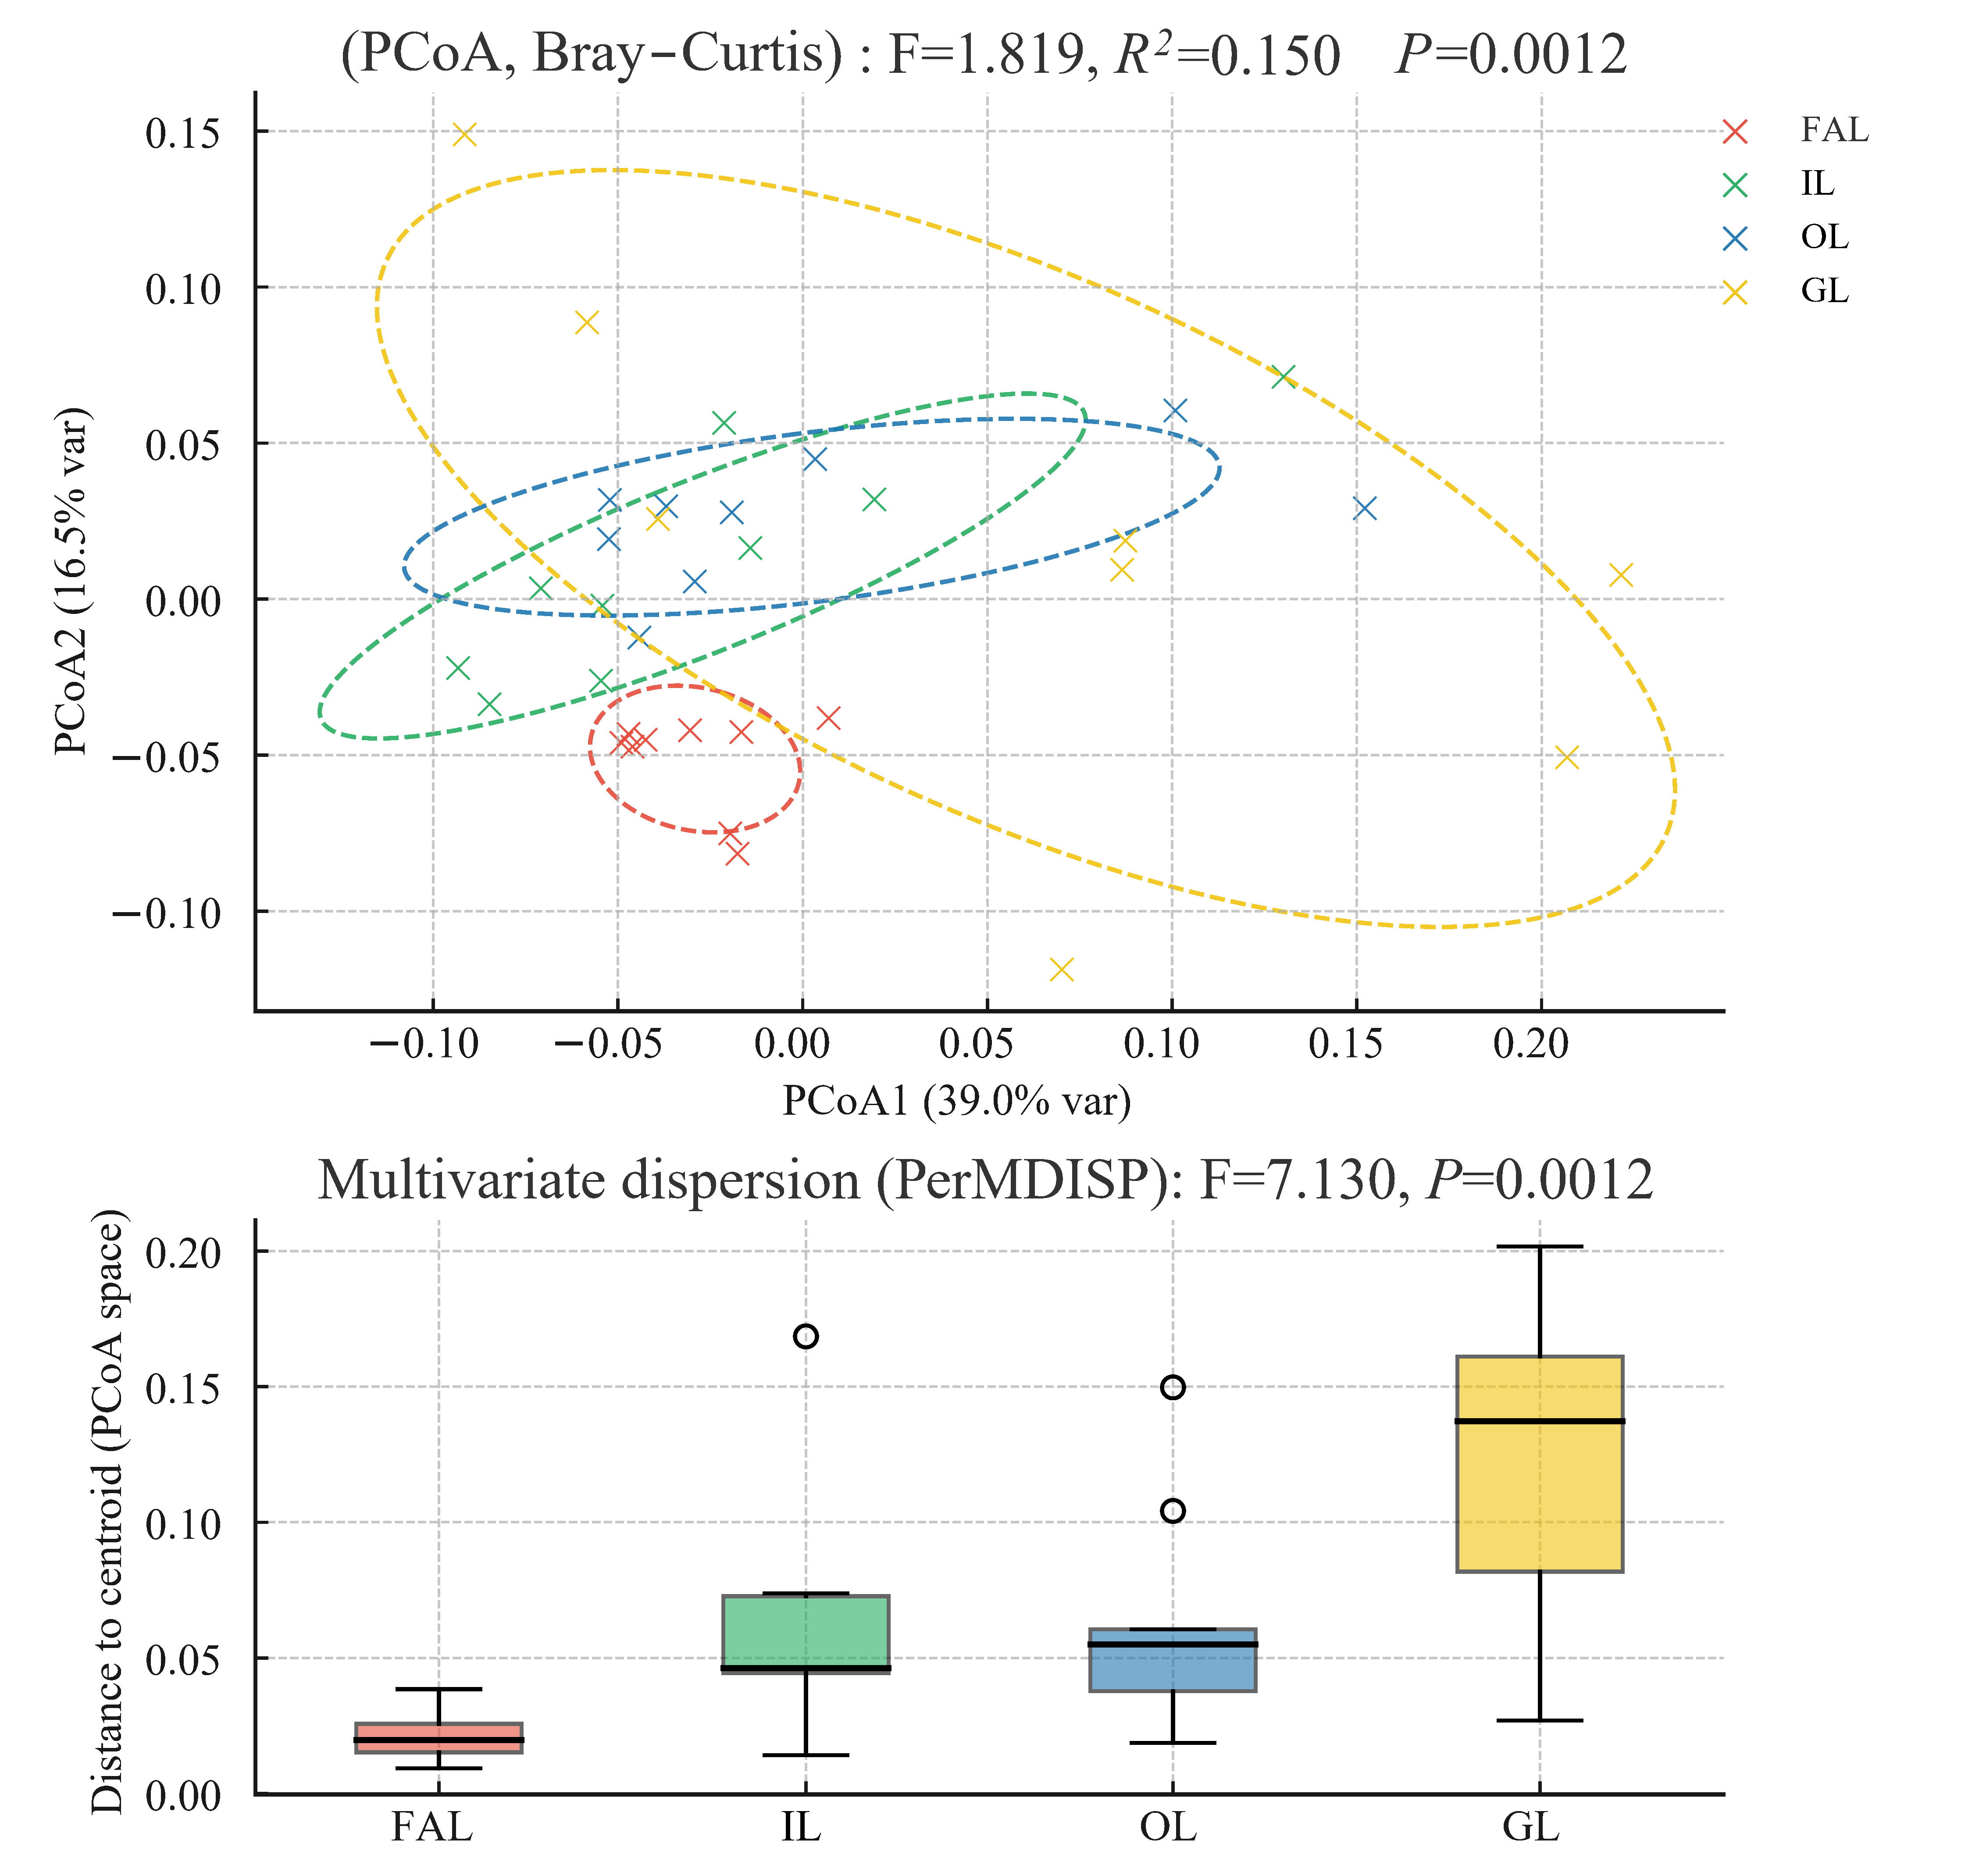
Fig. S2. PCoA of Bray–Curtis dissimilarities (Hellinger-transformed). PERMANOVA shows a significant overall land-use effect (9,999 permutations). PerMDISP indicates heterogeneous dispersion among groups.
Fig. S3. Redundancy analysis of N-cycle microorganisms (Phylum level) and environmental factors (microorganisms selectively displayed); Higher Individual effect indicates that the environmental factor has a greater influence on community structure.
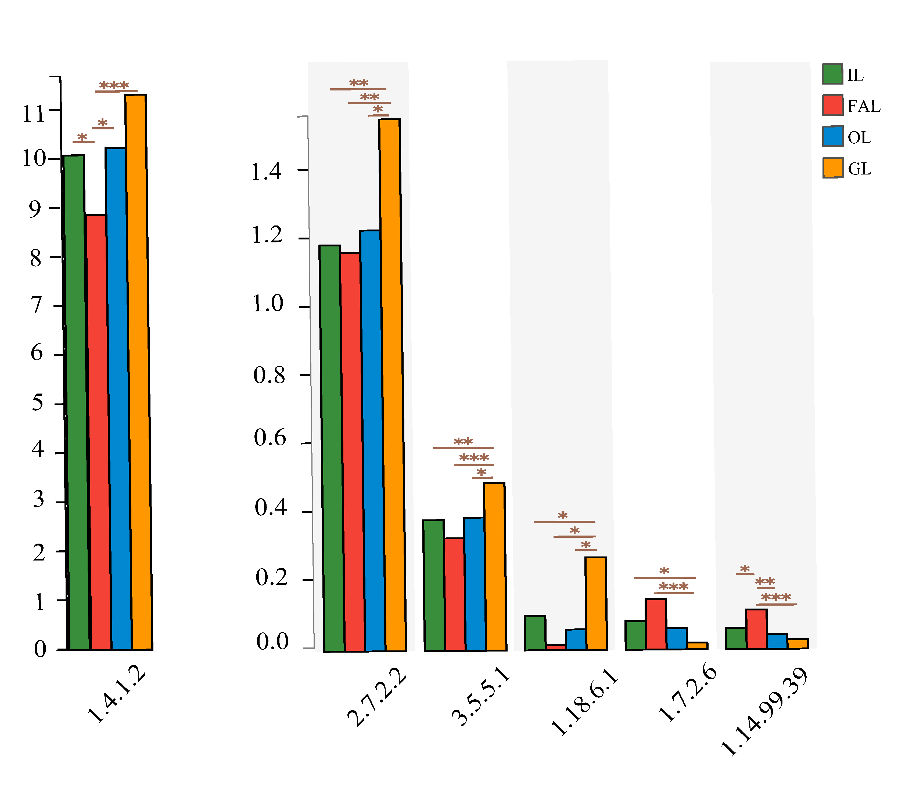
Fig. S4. Functional gene (enzyme level) with significant differences; Asterisks indicate differential abundance by ANCOM-BC2 (W-statistic; BH-adjusted q < 0.05).

Fig. S5. Based on the within-module degree (z score) and participation coefficient value (c score), we define nodes as four types: kinless hubs (z-score > 2.5; c-score > 0.62), module hubs (z-score > 2.5; c-score ≤ 0.62), connectors (z-score ≤ 2.5; c-score > 0.62) and peripherals (z-score ≤ 2.5; c-score ≤ 0.62). The module hubs is regarded as the core node. two core nodes identification of GL. IL, OL, FAL had no network core nodes.
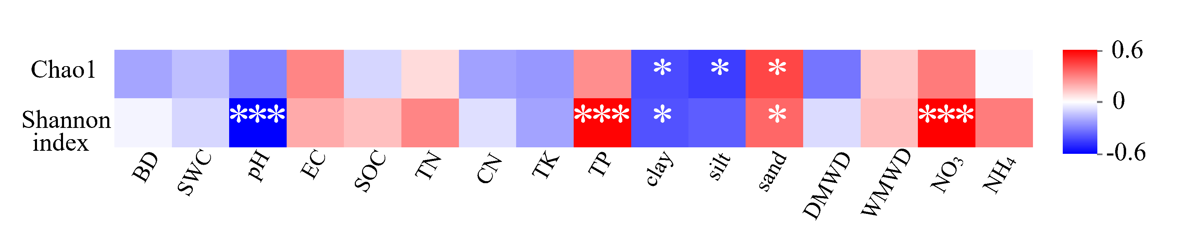
Fig. S6. Heatmap of Spearman correlations (ρ) between N-cycle taxa α-diversity metrics Chao1 richness (Chao1) and Shannon diversity (Shannon index) with soil properties. Color denotes effect size (red = positive, blue = negative; scale −0.6 to 0.6).; * and ** signifies p < 0.05 and p < 0.01, respectively. The same applies to all subsequent figures. Abbreviations: BD, bulk density; SWC, soil water content; pH; EC, electrical conductivity; SOC, soil organic carbon; TN, total nitrogen; C/N, carbon-to-nitrogen ratio; TK, total potassium; TP, total phosphorus; clay/silt/sand, particle-size fractions; DMWD, dry mean weight diameter; WMWD, wet mean weight diameter; NO₃, nitrate-N; NH₄, ammonium-N.
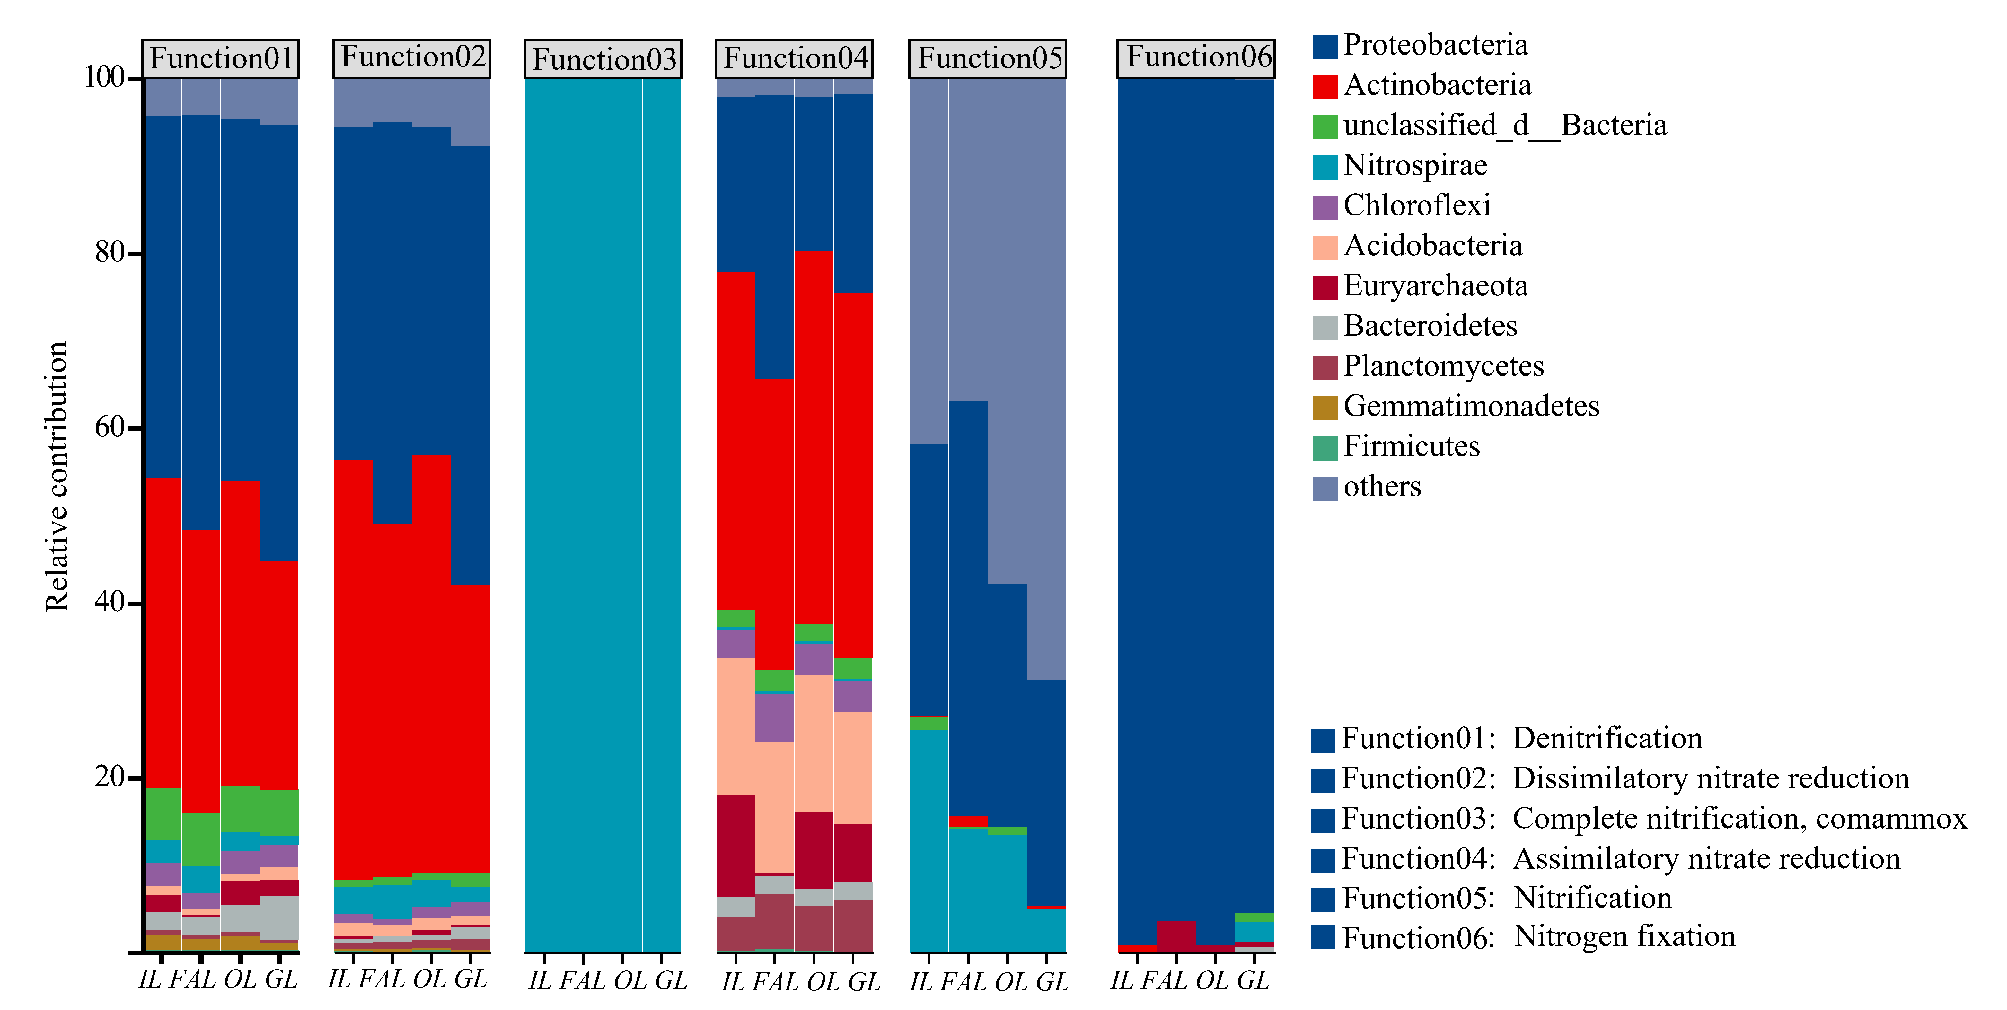
Fig. S7. Contribution of different N-cycle taxa (phylum level) to N-cycle pathways (module level).

Table S1 Basic information about sampling points.
Sample name |  | Coordinates | Fertilizer Additions | Cover vegetation | Tillage and pesticide use | Crop's growth cycle
IL-1 |  | 97.32615017°E  37.35857156°N | 120-160 kg hm⁻² year ⁻¹ of N (NH₄HCO₃, 17% N; CO(NH₂)₂, 46% N; NH₄NO₃, 33% N); | Wheat (Triticum aestivum) | Plowing 3-4 times a year; 2-4 times application per year of Pyrethroids, Phenylpyrazoline herbicides | 90-120 Days (Biennial flowering)
IL-2 |  | 97.31485003°E  37.33881384°N
IL-3 |  | 96.72815144°E  37.33129765°N
IL-4 |  | 95.74547485°E  36.44517358°N
IL-5 |  | 95.77210993°E  36.45163457°N
IL-6 |  | 95.11786862°E  36.42628106°N
IL-7 |  | 96.47800738°E  36.43823550°N
IL-8 |  | 97.81347025°E  36.01591354°N
IL-9 |  | 98.06347031°E  36.27633728°N
OG-1 |  | 97.23094399°E  37.32486136°N | 150–200 kg ha⁻¹ year ⁻¹ of N ((NH₄)₄HPO₄, 21%N ;CO(NH₂)₂, 46% N; (NH₄)₂SO₄, 20%N) | Goji Berries (Licium barbarum L.) | Soil aeration 2-3 times a year; 2-4 times application per year of Benzimidazole fungicide, 1-2 times of Pyridaben, 1-2 times of Gibberellin | 180-210 Days (Bimodal flowering)
OG-2 |  | 96.74501628°E  37.31768676°N
OG-3 |  | 97.43616953°E  37.21718096°N
OG-4 |  | 94.62878868°E  36.40153850°N
OG-5 |  | 95.04854563°E  36.40614527°N
OG-6 |  | 95.74614307°E  36.44538698°N
OG-7 |  | 96.32747328°E  36.43660556°N
OG-8 |  | 97.85113694°E  35.98517568°N
OG-9 |  | 98.11216444°E  36.31051131°N
FAL-1 |  | 97.32144178°E  37.35448871°N | 180–250 kg ha⁻¹ year ⁻¹ of N ((NH₄)₄HPO₄, 21% N; CO(NH₂)₂, 46% N; (NH₄)₂SO₄, 20% N); NH₄HCO₃, 17% N) | Pakchoi (Brassica campestris L. ssp. chinensis Makino), Tomato(Solanum lycopersicum L), cucumber(Cucumis sativus L), Asparagus Bean (Vigna unguiculata subsp. sesquipedalis (L.) Verdc), Eggplant (Solanum melongena L) | Plowing 1-2 times a year, soil aeration 5-7 times a year; 4-5 times application per year of Benzimidazole fungicide, 4-6 times of Pyridaben, 1-3 times of Gibberellin, 2-4 times of Pyrethroids | 200-300 Days (4-5 planting cycles per year)
FAL-2 |  | 97.44382341°E  37.22187284°N
FAL-3 |  | 97.44458668°E  37.22758636°N
FAL-4 |  | 94.76880657°E  36.76583844°N
FAL-5 |  | 94.94556469°E  36.39848639°N
FAL-6 |  | 94.95759595°E  36.39736344°N
FAL-7 |  | 97.81390571°E  36.02203086°N
FAL-8 |  | 98.11517132°E  36.31314711°N
FAL-9 |  | 98.00540664°E  36.27501847°N
GL-1 |  | 97.04865126°E  37.26334835°N | - | Carex moorcroftii, Stipa purpurea, Kalidium foliatum, Salsola collina, Medicago falcata, Oxytropis spp. Stellera chamaejasme ~ | - | -
GL-2 |  | 97.23345677°E  37.03344235°N
GL-3 |  | 97.45746253°E  37.53676645°N
GL-4 |  | 94.81821045°E  36.44939856°N
GL-5 |  | 94.69235458°E  36.44274342°N
GL-6 |  | 95.10638703°E  36.42571357°N
GL-7 | 96.48082365°E  36.44854010°N
GL-8 | 97.93238020°E  36.01288547°N
GL-9 | 98.09359952°E  36.38298406°N
Only aggregate ranges are reported for each land-use type for annual fertilizer N input (kg ha⁻¹ yr⁻¹) and growing-season length (days). To define a management-intensity land-use gradient, we ordered land-use types by the central tendency of these two metrics—using the median when available, or otherwise the midpoint of the reported range. Where ranges overlapped, both metrics were considered jointly and ties were broken by N input. This ordering is intended as an ordinal descriptor, not a precise quantitative index. Thereby defining a management intensity–based land-use gradient (GL → IL → OL → FAL).

Table S2 Physicochemical properties of grassland and cropland soil.
 | FAL | OG | IL | GL
BD g/cm³ | 1.32±0.05 a | 1.33±0.04 a | 1.31±0.04 a | 1.19±0.28 b
EC us/cm | 521.72±360.58 c | 1929.86±1706.26 b | 599.06±595.14 c | 5401±3673 a
pH | 7.86±0.29 c | 8.43±0.24 a | 8.35±0.31 b | 8.65±0.17 a
SWC % | 16.78±4.76 b | 15.56±3.88 b | 18.22±4.44 b | 22.25±28.00 a
TK g/kg | 17.72±2.08 ab | 18.93±0.68 a | 19.48±2.05 a | 15.63±3.83 b
SOC g/kg | 14.12±6.01 ab | 8.39±2.90 b | 9.64±2.75 b | 15.35±10.23 a
TN g/kg | 1.58±0.65 a | 0.95±0.25 b | 0.98±0.24 b | 1.52±1.06 ab
TP g/kg | 0.94±0.23 a | 0.66±0.31 c | 0.68±0.24 b | 0.34±0.06 b
C/N | 9.61±3.00 a | 8.73±1.41 a | 9.78±0.90 a | 9.81±2.00 a
Clay % | 3.30±1.10 a | 3.68±1.07 a | 3.91±1.44 a | 3.49±1.70 a
Silt % | 60.86±16.08 a | 67.77±8.46 a | 67.95±10.25 a | 64.15±15.08 a
Sand % | 35.84±17.08 a | 28.55±9.12 a | 28.14±11.28 a | 32.36±16.48 a
MWD | 1.41±0.66 ab | 0.58±0.25 c | 1.07±0.49 bc | 2.17±1.39 a
WMWD | 3.22±0.69 a | 2.78±0.77 a | 3.36±0.72 a | 2.59±1.74 a
NH₄ mg/kg | 2.08±1.87 a | 1.02±1.08 b | 0.74±0.66 b | 0.65±0.20 b
NO₃ mg/kg | 178±124.32 a | 89.01±68.4 ab | 38.4±28.37 b | 5.67±4.45 c
Data are means ± SE (n = 9). Differences between parameters for grassland and cropland were determined by independent paired t-test. Different lowercase letters represent the significant difference between the four groups (Welch’s ANOVA; Fisher’s LSD with BH adjustment, P < 0.05). The same as below. BD, dry bulk density of soil; EC, electrical conductivity; SWC, soil moisture content; TK, total kalium; SOC, soil organic carbon; TN, total nitrogen; TP, total phosphorus; C/N, the ratio of SOC to TN; Clay, Clay content; Silt, Silt content; Sand, sand content; MWD, Mean soil weight diameter(dry); WMWD, Mean soil weight diameter(wet); NH₄, ammonium nitrogen; NO₃, nitrate nitrogen.

Table S3 α-diversity index of N-related microbial communities under different land uses.
 | FAL | OG | IL | GL
Shannon index | 5.45±0.09 a | 5.40±0.09 a | 5.31±0.10 a | 5.28±0.26 a
Chao1 | 875.89±40.79 a | 899.78±41.33 a | 877.89±49.04 a | 854±125.17 a

Table S4 The genomic repertoire of N-cycle functional genes
Genus / KO | nifHDK | amoABC | hao | gdh2 | arcC | nitrilase
Nitrosomonas (AOB) | — | ✓ | ✓ | ✓ | — | —
Nitrosospira (AOB) | — | ✓ | ✓ | ✓ | — | —
Candidatus Nitrosarchaeum (AOA) | — | ✓ | — | ✓ | — | —
Nitrospira | — | (✓) | (✓) | ✓ | — | —
Azospirillum | ✓ | — | — | ✓ | (✓) | (✓)
Geobacter | ✓ | — | — | ✓ | — | —
Desulfuromonas | (✓) | — | — | ✓ | — | —
Methylobacterium | (✓) | — | — | ✓ | — | (✓)
Zymomonas | (✓) | — | — | ✓ | — | —
Desulfobulbaceae (family) | (✓) | — | — | ✓ | — | —
Sphingomonas / Nocardioides / Solirubrobacter / Rubrobacter / Streptomyces / Lysobacter / Nitriliruptor / Geodermatophilus / Gemmatimonas | — | — | — | ✓ | (✓) | (✓)
Bradyrhizobium | ✓ | — | — | ✓ | (✓) | (✓)
Thioalkalivibrio / Paenibacillus / Archangium / Fodinicurvata / Elioraea | — | — | — | (✓) | (✓) | (✓)
In the table, ✓/-/ (✓) respectively indicate the functional gene is present/absent/present (at the species level).

Table S5 Network topological coefficients under different land use types.
 | Node | Edge | Positive % | Negative % | Average Degree | Diameter | Average Clustering Coefficient | Graph Density
FAL | 342 | 30 | 66.67 | 33.33 | 0.17 | 3 | 0.58 | 0.001
OL | 351 | 170 | 55.88 | 44.12 | 0.97 | 11 | 0.61 | 0.003
IL | 338 | 750 | 58.53 | 41.47 | 4.44 | 10 | 0.49 | 0.013
GL | 443 | 3771 | 84.41 | 15.59 | 17.03 | 13 | 0.53 | 0.039

