Supplemental Table 1. Latitude and longitude of sampling sites in the old and new depositional areas of the Yellow River Delta

Area | Site | Longitude（E） | Latitude（N） | Depth
Old | A1 | 118.4656 | 37.5406 | 0~20cm/20~40cm/40~100cm
Old | A2 | 118.4648 | 37.6323 | 0~20cm/20~40cm/40~100cm
Old | A3 | 118.5368 | 37.5992 | 0~20cm/20~40cm/40~100cm
Old | A4 | 118.5924 | 37.6537 | 0~20cm/20~40cm/40~100cm
Old | A5 | 118.7217 | 37.6321 | 0~20cm/20~40cm/40~100cm
Old | A6 | 118.6622 | 37.7445 | 0~20cm/20~40cm/40~100cm
Old | A7 | 118.7109 | 37.6969 | 0~20cm/20~40cm/40~100cm
Old | A8 | 118.3878 | 37.6495 | 0~20cm/20~40cm/40~100cm
New | B1 | 118.7925 | 37.7403 | 0~20cm/20~40cm/40~100cm
New | B2 | 118.8408 | 37.7260 | 0~20cm/20~40cm/40~100cm
New | B3 | 118.8449 | 37.7021 | 0~20cm/20~40cm/40~100cm
New | B4 | 118.8649 | 37.7387 | 0~20cm/20~40cm/40~100cm
New | B5 | 118.8966 | 37.7950 | 0~20cm/20~40cm/40~100cm
New | B6 | 118.9528 | 37.7695 | 0~20cm/20~40cm/40~100cm
New | B7 | 118.9783 | 37.8042 | 0~20cm/20~40cm/40~100cm
New | B8 | 119.0887 | 37.7816 | 0~20cm/20~40cm/40~100cm

Supplemental Table 2. Shannon indices in the Old and New sedimentation regions and different soil layers
 | Sedimentation |  | Depth
 | Old | New | Upper | Middle | Substratum
Prokaryotes | 7.84±0.61(a) | 7.65±0.70(a) | 8.02±0.55(a) | 7.78±0.58(ab) | 7.49±0.75(b)
Fungi | 3.38±0.87(a) | 2.66±0.90(b) | 3.36±0.87(a) | 2.85±1.00(a) | 2.86±0.94(a)
Cercozoa | 4.36±1.71(a) | 3.68±1.57(a) | 4.68±1.25(a) | 3.87±1.76(a) | 3.53±1.80(a)
Methanogens | 2.69±0.89(a) | 3.07±0.81(a) | 2.78±0.79(a) | 2.86±0.89(a) | 3.01±0.85(a)
Methanotrophs | 1.02±0.77(a) | 1.31±0.94(a) | 1.19±0.90(a) | 0.93±0.79(a) | 1.37±0.90(a)
#Data are shown as mean ± SE. The letters in parenthesis indicate significant difference between Old and New regions or among different depths in each community (Tukey HSD: P<0.05).

Supplemental Table 3. The PERMANOVA test on the Bray-Curtis dissimilarity of the microbial community in the sedimentation regions and soil layers
Group | Df | Prokaryotes |  | Fungi |  | Cercozoa |  | Methanogens |  | Methanotrophs
Group | Df | R² | P | R² | P | R² | P | R² | P | R² | P
Sedimentation | 1 | 0.041 | 0.004 | 0.043 | 0.002 | 0.032 | 0.014 | 0.032 | 0.009 | 0.032 | 0.049
Depth | 2 | 0.067 | 0.003 | 0.041 | 0.520 | 0.045 | 0.276 | 0.055 | 0.012 | 0.051 | 0.229
Sedimentation*Depth | 2 | 0.028 | 0.995 | 0.034 | 0.962 | 0.033 | 0.992 | 0.033 | 0.987 | 0.042 | 0.696

Supplemental Table 4. Some network topological properties of Old and New sedimentation regions
 | Network properties | Old | New
 | Total nodes | 387 | 505
 | Total links | 1725 | 6624
Empirical network | R square of power-law | 0.953 | 0.939
Empirical network | Average degree (avgK) | 8.914 | 26.233
Empirical network | Average clustering coefficient (avgCC) | 0.221 | 0.243
Empirical network | Average path distance (GD) | 4.503 | 3.176
Empirical network | Harmonic geodesic distance (HD) | 3.431 | 2.443
Empirical network | Density (D) | 0.023 | 0.052
Empirical network | Transitivity (Trans) | 0.443 | 0.472
Empirical network | Connectedness (Con) | 0.450 | 0.476
Empirical network | Modularity | 0.356 | 0.149
Random network | Average clustering coefficient (avgCC) | 0.045 +/- 0.005 | 0.096 +/- 0.005
Random network | Average path distance (GD) | 3.052 +/- 0.033 | 2.652 +/- 0.018
Random network | Harmonic geodesic distance (HD) | 2.774 +/- 0.022 | 2.385 +/- 0.011
Random network | Transitivity (Trans) | 0.292 +/- 0.007 | 0.448 +/- 0.003
Random network | Connectedness (Con) | 0.938 +/- 0.022 | 0.977 +/- 0.013
Random network | Modularity (fast greedy) | 0.227 +/- 0.004 | 0.095 +/- 0.002

Supplemental Fig. 1
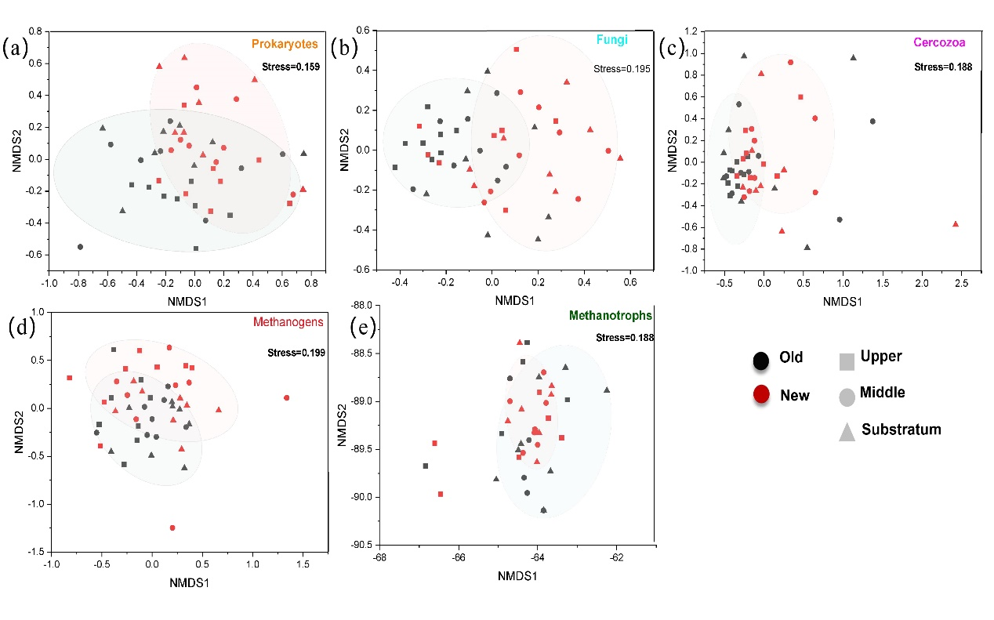
Fig. S1. NMDS analysis of the structure of prokaryotes (a), fungi (b), cercozoa (c), methanogens (d), methanotrophs (e) in Old and New regions and among different soil layers

Supplemental Fig. 2
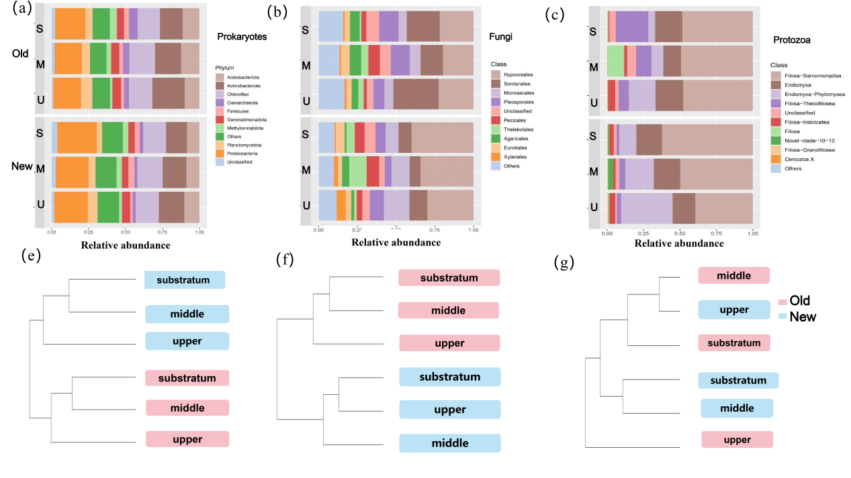
Fig. S2. Relative abundance analysis of prokaryotes (a) (e), fungi (b) (f), cercozoa (c) (g)

