Supporting information
Type of paper: Primary Research Articles
Running title: Leaf and root litter and soil biota
Divergent effects of root and leaf litter on soil microbial diversity decouple soil C-N release
Xinxin Zhang^{1, 2}, Hongying Luo^{1, 2}, Xu Yang^{1, 2}, Ying Lei^{1, 2}, Bing Wang^{1, 2}, Huiling Zhang^{1, 2*}, and Dima Chen^{2*}
¹Engineering Research Center of Eco-Environment in Three Gorges Reservoir Region of Ministry of Education, China Three Gorges University, Yichang, China
²Inner Mongolia Key Laboratory of Grassland Ecology, School of Ecology and Environment, Inner Mongolia University, Hohhot, China
*Corresponding author:
Prof. Dima Chen, E-mail: chendima@imu.edu.cn
Prof. Huiling Zhang, E-mail: zhanghuiling@ctgu.edu.cn

Table S1 The variations in litter identity (leaf litter vs. root litter) and differences between two litter types. Differences are indicated by asterisks for each treatment (one-way ANOVA; #, 0.05 < P ≤ 0.10; *, 0.01 < P ≤ 0.05; **, 0.001 < P ≤ 0.01; ***, P ≤ 0.001). C, carbon; N, nitrogen; P, phosphorus; Al, aluminum; K, potassium; Ca, calcium; Mg, magnesium.
Variable | Leaf litter | Root litter | Litter type
C (mg g⁻¹) | 2.994# | 162.7*** | 10.13**
N (mg g⁻¹) | 14.73*** | 221.8*** | 79.09***
P (mg g⁻¹) | 17.58*** | 414.6*** | 20.62***
C:N | 20.1*** | 200.5*** | 60.08***
C:P | 50.59*** | 472.8*** | 13.22**
N:P | 33.5*** | 74.76*** | 3.017#
Al (mg g⁻¹) | 163.4*** | 78.77*** | 18.34***
K (mg g⁻¹) | 216.0*** | 76.82*** | 51.33***
Ca (mg g⁻¹) | 105.4*** | 215.6*** | 2.662
Mg (mg g⁻¹) | 111.4*** | 105.5*** | 4.704*
Soluble Sugar (g kg⁻¹) | 396.7*** | 533.0*** | 19.96***
Cellulose (mg g⁻¹) | 26.91*** | 33.91*** | 126.7***
Lignin (mg g⁻¹) | 37.49*** | 55.15*** | 31.5***
Lignin:N | 17.37*** | 69.38*** | 129.7***

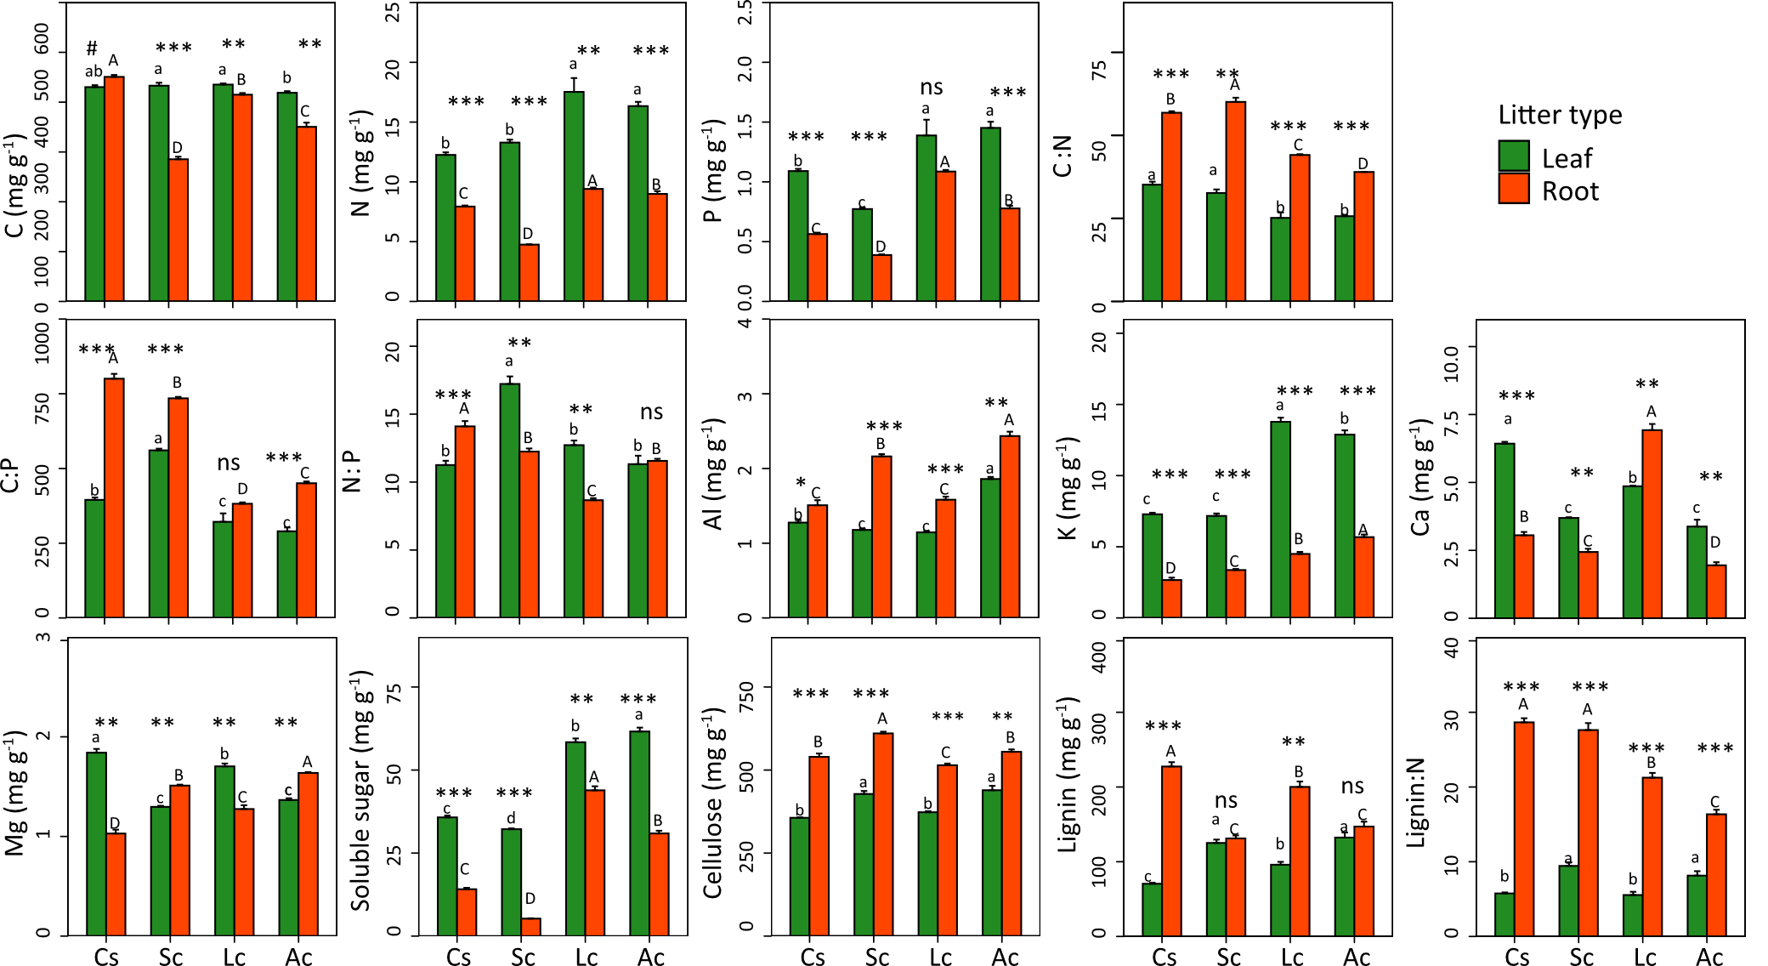
Fig. S1 The initial chemical compositions of four dominant plant species. One-way ANOVA and Tukey’s LSD test were used to compare differences among leaf or root addition treatments (P < 0.05). Cs, Cleistogenes squarrosa; Sc, Stipa capilla; Lc, Leymus chinensis; Ac, Agropyron cristatum. C, carbon; N, nitrogen; P, phosphorus; Al, aluminum; K, potassium; Ca, calcium; Mg, magnesium.

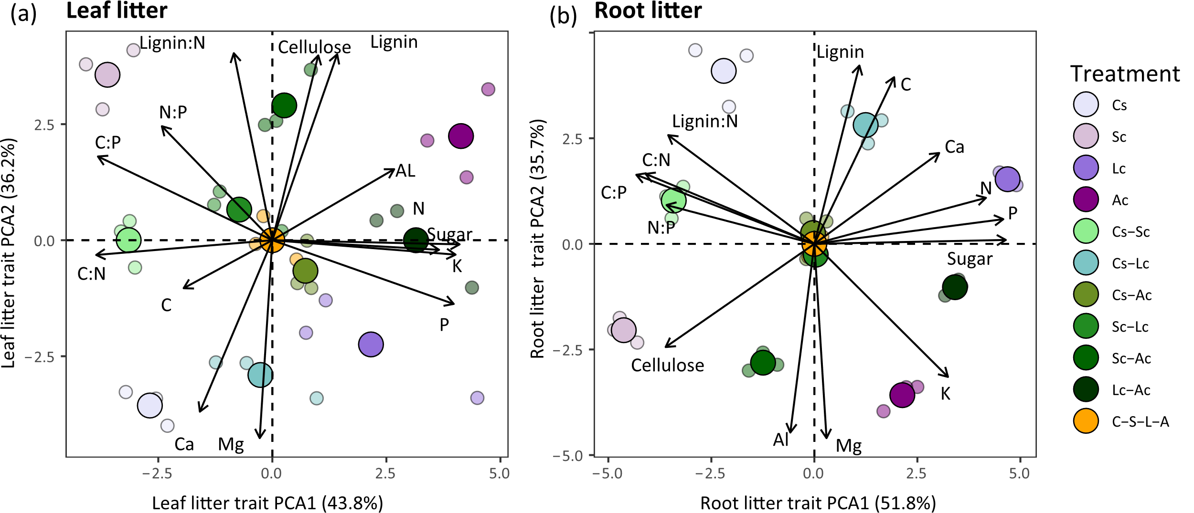
Fig. S2 Principal component analysis (PCA) of the initial chemical properties for (a) leaf litter and (b) root litter of 11 treatments. Leaf and root litter PC1 (r-selected and resource-acquisitive strategy) and PC2 (K-selected and resource-conservative strategy) collectively explain 80-87% of the trait variance. Abbreviations of treatments described in graphical abstracts. C, carbon; N, nitrogen; P, phosphorus; Al, aluminum; K, potassium; Ca, calcium; Mg, magnesium.

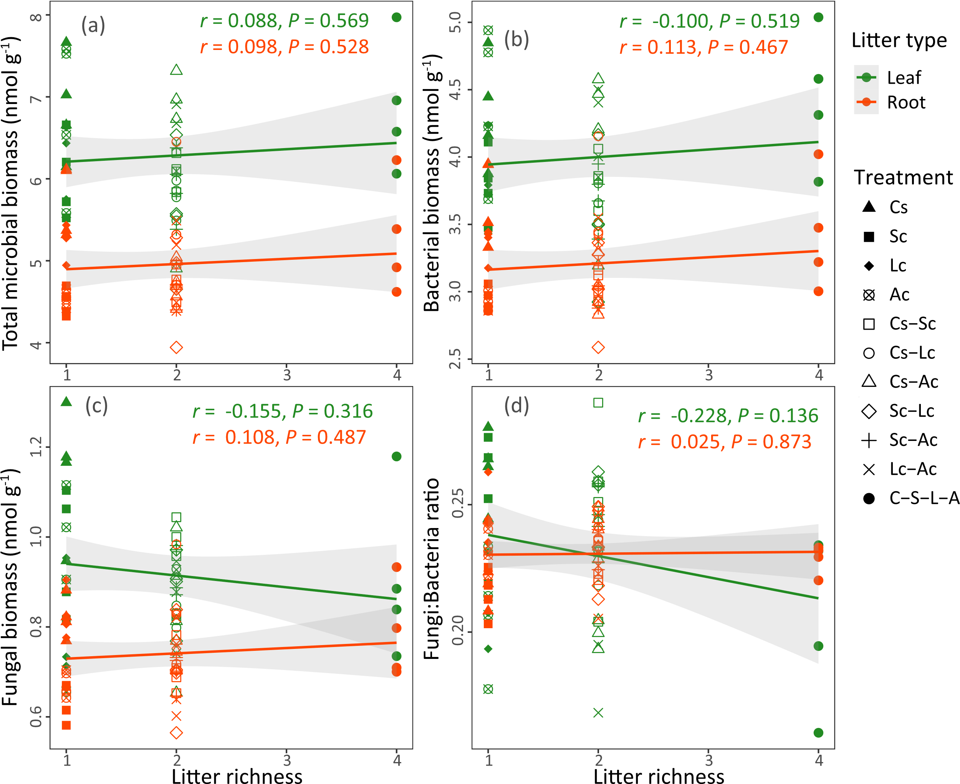
Fig. S3 Relationships between soil bacterial alpha diversity and leaf/root litter richness. The shaded areas represent 95% confidence intervals, and the regression analysis is represented by Pearson’s r and significance levels. Abbreviations of treatments described in graphical abstracts.
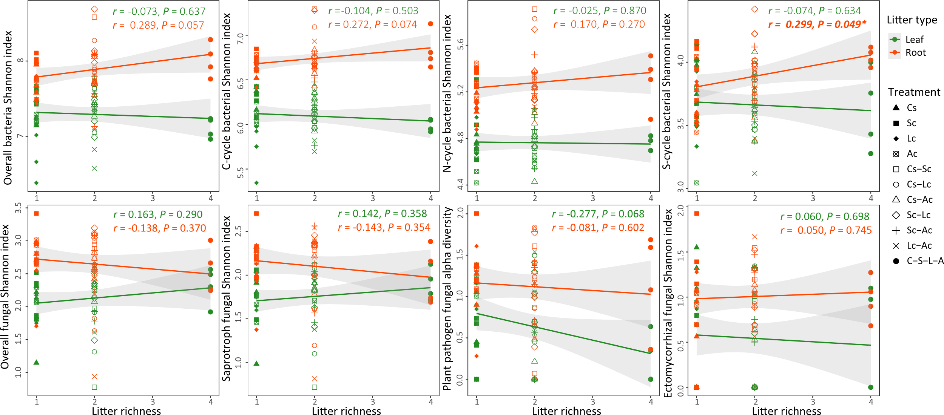
Fig. S4 Relationships between soil microbial alpha diversity and leaf/root litter richness. The shaded areas represent 95% confidence intervals, and the regression analysis is represented by Pearson’s r and significance levels (* indicate 0.01 < P ≤ 0.05). Abbreviations of treatments described in graphical abstracts.

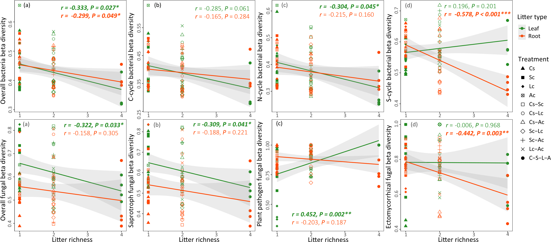
Fig. S5 Relationships between soil microbial beta diversity and leaf/root litter richness. The shaded areas represent 95% confidence intervals, and the regression analysis is represented by Pearson’s r and significance levels (*, **, and *** indicate 0.01 < P ≤ 0.05, 0.001 < P ≤ 0.01, and P ≤ 0.001, respectively). Abbreviations of treatments described in graphical abstracts.

