[Soil Ecology Letters]
Supporting Information for
[Misestimation of forest soil carbon and nitrogen stocks due to rock fragments: A case study in a boreal forest watershed ecosystem of northeast China]
[Jinhao Zhang ^{1, 2} Hans Lambers ³ Yushan Cai ^{1, 2} Tijiu Cai ^{1,2} Yuanyuan Huang ⁴ Liangliang Duan ^{1, 2}]
[¹School of Forestry, Northeast Forestry University, Harbin 150040, China.
²Key Laboratory of Sustainable Forest Ecosystem Management-Ministry of Education, Northeast Forestry University, Harbin 150040, China
³School of Biological Sciences, University of Western Australia, Perth, WA6009, Australia.
⁴Key Laboratory of Ecosystem Network Observation and Modeling, Institute of Geographic Sciences and Natural Resources Research, Chinese Academy of Sciences, Beijing 100101, China
Corresponding author: Liangliang Duan (liangliang.duan@nefu.edu.cn)]
Contents of this file
Figure S1
Introduction
This supporting Information (Figure S1) is to give the reader a better understanding of our sampling method and how the gravel is handled.

Figure S1. Samples Collection of rock fragments
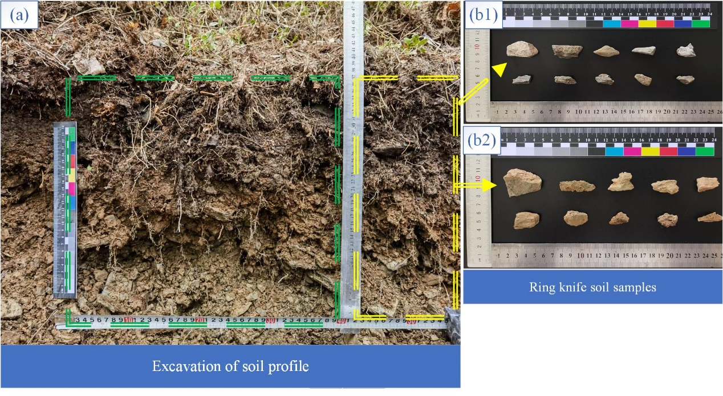
After excavation of the soil profile, the soil is sampled using a special ring knife. The rock fragments in the ring knife are separated from the soil in the laboratory. The surface of the rock fragments was washed with distilled water and all rock fragments larger than 2 mm were retained during the washing process. Air dry the cleaned rock fragments and air-drying again after measuring the volume of rock fragments using the drainage method (Figure S1b1, Figure S1b2). The rock fragments were then ground to pass through a 100-mesh sieve to test for carbon and nitrogen content. More details on sample handling can be found in Zhang et al. (2024).

Reference
Zhang, J., Cai, Y., Duan, L., 2024. Rock fragments significantly affect the carbon and nitrogen distribution in the surface soil - Evidences from large number samples of soil rock fragment interfaces in a boreal forest watershed. Science of The Total Environment 925, 171640.

