Supplementary materials

Similar distribution patterns but distinct drivers of soil bacterial and fungal communities
Xin Xia^{1#}, Xing Huang^{1,2#}, Yuchen Li³, Han Sun⁴, Qian Zhang¹, Yanjun Chai⁴, Marcela Hernández ⁵, Jianming Xu¹, Yong Li^{1*}

¹ Zhejiang Provincial Key Laboratory of Agricultural Resources and Environment, College of Environmental and Resource Sciences, Zhejiang University, Hangzhou
310058, China
² Department of Bacteriology, University of Wisconsin-Madison, Madison, WI, 53706, USA
³ The Second Affiliated Hospital, Zhejiang University School of Medicine, Hangzhou 310058, China
⁴ Key Laboratory of Recycling and Eco-treatment of Waste Biomass of Zhejiang Province, School of Environmental and Natural Resources, Zhejiang University of Science and Technology, Hangzhou 311023, China
⁵ School of Biological Sciences, University of East Anglia, Norwich NR4 7TJ, UK

Xin Xia and Xing Huang contributed equally.
*Corresponding author: Yong Li (liyongcn@zju.edu.cn)
This file includes:
Supplementary Figure S1to S6
Supplementary Table S1 to S3

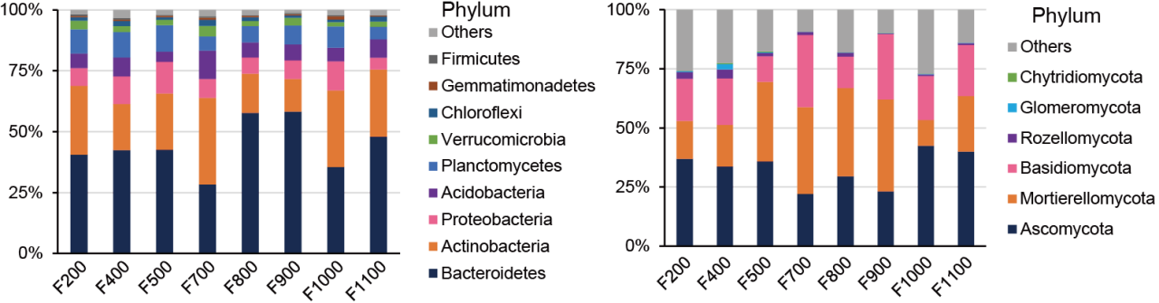
(A)
(B)

Figure S1. Taxonomic compositions of bacterial (A) and fungal (B) communities among elevation categories.

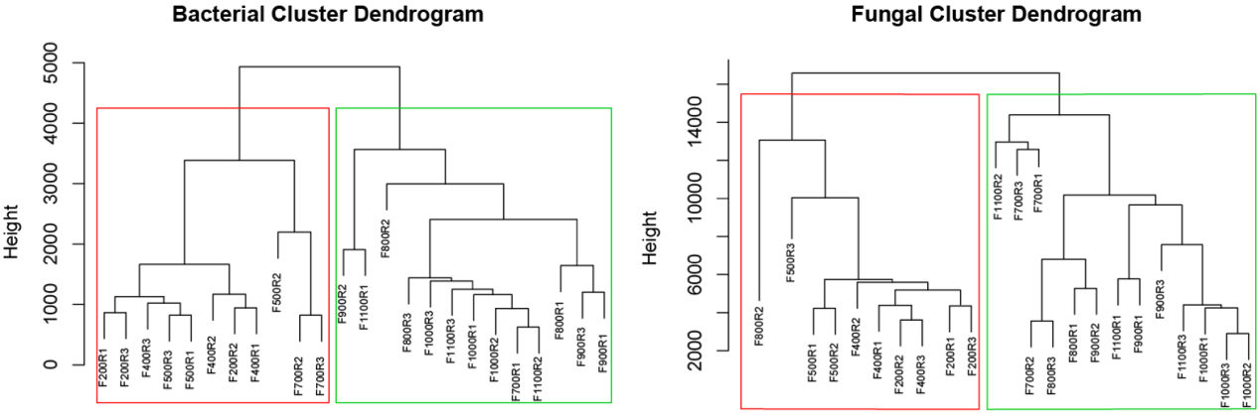
(A)
(B)

Figure S2. The cluster distribution of bacterial (A) and fungal (B) communities’ composition. Green border line indicates the clustered high elevation groups, red border line indicates the clustered low elevation group.

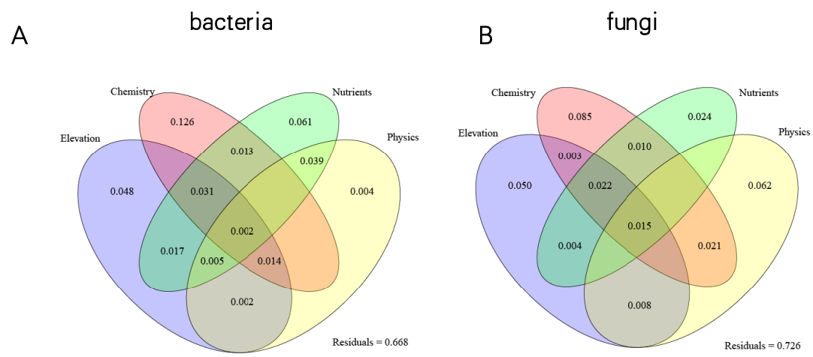

Figure S3. Results of variation partitioning analysis showing the percentages of explained variation for the composition of bacteria (A) and fungi (B). Variation was partitioned by the elevation, the soil chemical properties, the soil nutrients factors, and the soil physical factors.
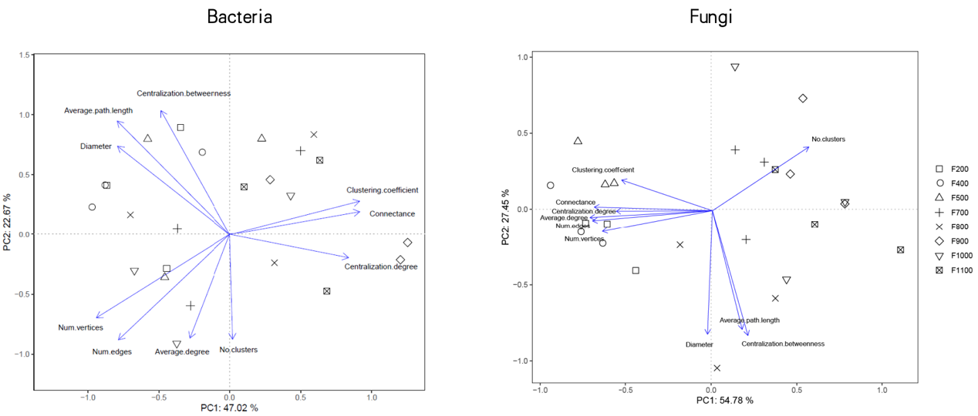
(A)
(B)

Figure S4. Principal component analysis (PCA) of ten subnetworks’ topological features of bacterial (A) and fungal (B) communities based on Euclidean distance.
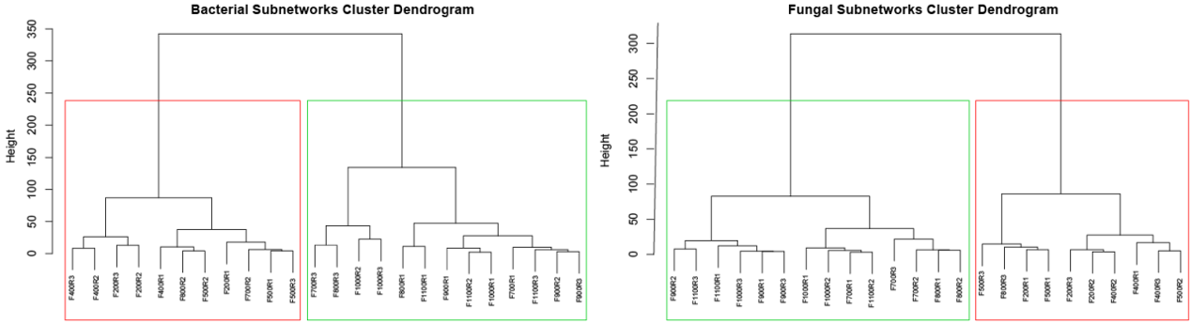
(A)
(B)

Figure S5. The cluster distribution of bacteria (A) and fungal (B) subnetworks’ topological features. Green border line indicates the clustered high elevation groups, red border line indicates the clustered low elevation groups.
(A)
(B)
Figure S6. Heatmap plot the Spearman’s correlation coefficients between environmental variables and topological features of bacterial (A) and fungal (B) subnetworks. Bold values denote the significant relationships. *** p < 0.001; ** p < 0.01; * p < 0.05.
TABLE S1. Summary of main physiochemical properties of each sampling site along the elevation gradient in the Yunhe terrace
Sample | F200 | F400 | F500 | F700 | F800 | F900 | F1000 | F1100
Elevation (m) | 200 | 400 | 500 | 700 | 800 | 900 | 1000 | 1100
pH | 5.38 ± 0.11 | 5.31 ± 0.04 | 5.39 ± 0.12 | 5.27 ± 0.34 | 5.20 ± 0.23 | 5.45 ± 0.07 | 5.64 ± 0.27 | 5.27 ± 0.51
OM (g kg⁻¹) | 39.15 ± 3.74 | 34.00 ± 0.90 | 29.66 ± 2.64 | 50.88 ± 19.15 | 48.68 ± 23.05 | 61.08 ± 5.97 | 49.25 ± 10.98 | 56.21 ± 35.17
DOC (g kg⁻¹) | 106.45 ± 9.50 | 93.99 ± 56.50 | 86.93 ± 14.10 | 62.22 ± 9.41 | 63.98 ±24.45 | 105.15 ± 53.63 | 87.15 ± 10.48 | 85.82 ± 38.72
TN (g kg⁻¹) | 2.07 ± 0.25 | 1.89 ± 0.11 | 1.56 ± 0.14 | 2.42 ± 0.81 | 2.51 ± 1.03 | 2.86 ± 0.28 | 2.31 ± 0.40 | 2.48 ± 1.32
C:N ratio | 10.98 ± 0.55 | 10.44 ± 0.30 | 11.07 ± 0.23 | 12.10 ± 0.86 | 11.08 ± 0.67 | 12.40 ± 0.85 | 12.31 ± 0.73 | 12.64 ± 1.43
Inorganic-N (g kg⁻¹) | 21.41 ± 1.40 | 21.58 ± 3.27 | 20.03 ± 4.10 | 25.72 ± 7.90 | 30.76 ± 12.94 | 30.64 ± 0.65 | 21.98 ± 6.54 | 20.27 ± 11.46
AP (mg kg⁻¹) | 3.62 ± 0.63 | 9.80 ± 3.36 | 4.02 ± 1.30 | 4.82 ± 2.73 | 4.81 ± 3.15 | 2.45 ± 0.38 | 27.07 ± 22.86 | 14.49 ± 18.12
AK (mg kg⁻¹) | 99.61 ± 16.30 | 78.74 ± 27.89 | 95.39 ± 45.20 | 71.09 ± 31.00 | 179.97 ± 38.53 | 74.64 ± 14.19 | 94.67 ± 18.49 | 122.99 ± 58.56
CEC (mol kg⁻¹) | 7.13 ± 0.16 | 8.77 ± 0.33 | 7.77 ± 1.20 | 13.62 ± 3.47 | 11.72 ± 1.15 | 14.28 ± 1.46 | 13.80 ± 2.50 | 12.49 ± 3.30
ExK (mmol kg⁻¹) | 108.36 ± 5.8 | 99.27 ± 29.78 | 109.41 ± 41.57 | 88.34 ± 27.59 | 183.15 ± 33.09 | 86.55 ± 12.81 | 108.37 ± 24.97 | 125.17 ± 48.53
ExNa (mmol kg⁻¹) | 24.17 ± 1.98 | 26.13 ± 4.73 | 25.85 ± 5.12 | 19.34 ± 2.12 | 22.75 ± 3.37 | 23.15 ± 1.17 | 21.12 ± 2.61 | 21.88 ± 4.36
ExCa (mmol kg⁻¹) | 454.18 ± 33.02 | 444.14 ± 54.64 | 507.71 ± 105.47 | 443.25 ± 236.65 | 584.02 ± 265.35 | 545.56 ± 18.36 | 662.67 ± 310.98 | 429.30 ± 244.88
ExMg (mmol kg⁻¹) | 66.44 ± 8.08 | 50.47 ± 23.76 | 78.13 ± 38.31 | 39.17 ± 13.35 | 87.86 ± 45.68 | 31.13 ± 5.11 | 51.29 ± 20.17 | 35.22 ± 6.46
Fe_{d} (mg kg⁻¹) | 14640.27 ± 1481.61 | 13918.37 ± 2721.74 | 19181.91 ± 1797.23 | 19380.08 ± 969.92 | 18608.50 ± 2962.08 | 20277.34 ± 2394.31 | 12249.07 ± 126.91 | 13679.30 ± 4906.08
Fe_{o} (mg kg⁻¹) | 2555.43 ± 518.00 | 2275.65 ± 168.65 | 2965.28 ± 400.00 | 4375.69 ± 1813.81 | 3701.13 ± 166.91 | 3200.00 ± 725.71 | 3243.60 ± 442.33 | 2627.37 ± 315.86
Fe_{o}/Fe_{d} | 0.18 ± 0.04 | 0.17 ± 0.02 | 0.16 ± 0.02 | 0.23 ± 0.10 | 0.20 ± 0.03 | 0.16 ± 0.05 | 0.27 ± 0.04 | 0.20 ± 0.06
Al_{d} (mg kg⁻¹) | 3650.42 ± 691.54 | 9419.75 ± 4432.59 | 3886.45 ± 232.80 | 7340.58 ± 1423.06 | 6425.99 ± 1544.30 | 8216.19 ± 381.31 | 7519.15 ± 1161.51 | 5927.11 ± 1045.12
Al_{o} (mg kg⁻¹) | 2242.70 ± 316.78 | 2438.89 ± 26.29 | 2229.33 ± 100.17 | 2195.14 ± 260.41 | 2540.28 ± 183.90 | 2386.56 ± 248.83 | 1707.45 ± 321.19 | 3798.85 ± 2411.32
Mn_{o} (mg kg⁻¹) | 138.70 ± 36.14 | 166.34 ± 55.60 | 328.92 ± 67.01 | 195.13 ± 94.51 | 271.36 ± 78.95 | 219.57 ± 44.08 | 128.53 ± 21.47 | 272.15 ± 57.55
Cl⁻ (mg kg⁻¹) | 22.03 ± 13.09 | 10.16 ± 1.97 | 11.12 ± 1.17 | 20.95 ± 8.98 | 16.63 ± 6.10 | 18.95 ± 5.90 | 8.55 ± 2.91 | 15.63 ± 10.89
SO₄²⁻ (mg kg⁻¹) | 9.15 ± 1.82 | 6.88 ± 1.88 | 9.47 ± 0.80 | 21.89 ± 6.84 | 26.36 ± 14.24 | 10.56 ± 1.58 | 18.85 ± 9.61 | 11.52 ± 1.27
Moisture (g kg⁻¹) | 22.02 ± 5.07 | 23.60 ± 4.68 | 21.49 ± 0.53 | 26.77 ± 1.96 | 28.45 ± 2.99 | 29.09 ± 2.20 | 27.65 ± 2.97 | 24.32 ± 2.79
Sand (%) | 56.83 ± 1.92 | 46.97 ± 1.46 | 55.48 ± 5.59 | 52.74 ± 7.38 | 47.48 ± 7.57 | 45.59 ± 3.18 | 46.46 ± 2.01 | 63.64 ± 1.83
Silt (%) | 27.26 ± 1.74 | 26.11 ± 1.22 | 22.50 ± 2.96 | 17.39 ± 9.69 | 24.72 ± 4.16 | 24.46 ± 4.07 | 24.95 ± 0.54 | 17.71 ± 2.13
Clay (%) | 15.91 ± 3.11 | 26.93 ± 1.85 | 22.02 ± 2.64 | 29.86 ± 4.19 | 27.80 ± 3.87 | 29.96 ± 1.71 | 28.59 ± 1.80 | 18.65 ± 1.25

Table S2. Dissimilarities in total bacterial operational taxonomic unit (OTU) community composition between elevations in natural soils, as determined by analysis of similarities (ANOSIM) R values.
Elevation | F400 | F500 | F700 | F800 | F900 | F1000 | F1100
F200 | 0.22 | -0.11 | 0.59 | 0.57 | 0.78 | 0.81 | 0.85
F400 |  | 0.07 | 0.93 | 0.49 | 0.85 | 0.89 | 0.89
F500 |  |  | 0.37 | 0.37 | 0.48 | 0.11 | 0.3
F700 |  |  |  | 0.26 | 0.67 | 0.44 | 0.22
F800 |  |  |  |  | 0.11 | -0.04 | -0.22
F900 |  |  |  |  |  | 0.33 | 0.04
F1000 |  |  |  |  |  |  | -0.15

Table S3. Dissimilarities in total fungal operational taxonomic unit (OTU) community composition between elevations in natural soils, as determined by analysis of similarities (ANOSIM) R values.
Elevation | F400 | F500 | F700 | F800 | F900 | F1000 | F1100
F200 | 0.33 | 0.37 | 0.63 | 0.44 | 0.74 | 0.51 | 0.81
F400 |  | 0.5 | 0.67 | 0.7 | 0.31 | 0.89 | 0.96
F500 |  |  | 0.56 | 0.63 | 0.27 | 0.59 | 0.7
F700 |  |  |  | 0.66 | 0.17 | 0.15 | 0.33
F800 |  |  |  |  | 0.05 | 0.67 | 0.63
F900 |  |  |  |  |  | -0.15 | 0.27
F1000 |  |  |  |  |  |  | -0.11

