Supplementary Information

Metagenomic analysis identified organic nitrogen metabolism as the key process underlying enhanced soil nitrogen retention after partial organic substitution of chemical fertilizers.

Hongqian Hou^{1,2,3,4}, Xianjin Lan^{1,2,3,4}, Jingshang Xiao^{1,2,3,4}, Zhenzhen Lv^{1,2,3,4}, Xiumei Liu^{1,2,3,4}, Yiren Liu^{1,2,3,4}, Jianhua Ji^{1,2,3,4*}

¹ Institute of Soil, Fertilizer, Resources and Environment, Jiangxi Academy of Agricultural Sciences, Nanchang, 330200, China
² National Engineering and Technology Research Center for Red Soil Improvement, Nanchang, 330200, China
³ Key Laboratory of Acidified Soil Amelioration and Utilization, Ministry of Agriculture and Rural Affairs, Nanchang, 330200, China
⁴ National Agricultural Experimental Station for Agricultural Environment, Yichun, 336000, China

*Correspondence
Jianhua Ji, E-mail: jron_jijianhua@126.com; Tel: +8613576990955
Institute of Soil, Fertilizer, Resources and Environment, Jiangxi Academy of Agricultural Sciences, Nanchang, Jiangxi 330200, China

Table S1
Selected soil properties of buck soil after a 36-year paddy soil experiment in Nanchang, China.
Treatments | Control | NPK | 70F+30M | 50F+50M | 30F+70M
SOM (%) | 3.08 ± 0.67 c | 4.23 ±0.45 b | 4.98 ±0.42 ab | 5.06 ±0.21 a | 5.61 ±0.13 a
TN (g kg⁻¹) | 2.35 ± 0.10 e | 2.94 ± 0.02d | 3.23 ± 0.08 c | 3.55 ± 0.07 b | 3.88 ± 0.12 a
AN (mg kg⁻¹) | 154 ±14 c | 193 ±22 b | 210 ±20 b | 225 ±15 ab | 253 ±22 a
AP (mg kg-1) | 8.95 ±0.94 d | 60.8 ±0.6 c | 75.5 ±5.9 b | 81.0 ±4.6 ab | 84.4 ±3.8 a
pH | 5.16 ±0.20 c | 5.12 ±0.10 c | 5.41 ±0.02 b | 5.48 ±0.02 b | 5.74 ±0.03 a
Control, no fertilization; NPK, chemical fertilization; 70F + 30 M, 70% of chemical N plus 30% of organic N; 50F + 50 M, 50% of chemical N plus 50% of organic N; 30F + 70 M, 30% of chemical N plus 70% of organic N; SOM, soil organic matter; TN, total soil N; AN, available N; AP, available P. The data represent the mean ± S.D.; n = 3. Different letters within each row indicate significant differences among fertilizer treatments at the p ≤ 0.05 level (Duncan’s test).

Table S2
Properties of interaction network graph constructed based on the correlation of functional gene.
Network Diagram Properties
Number of nodes | 52 | Positive edges | 135
Number of edges | 199 | Negative edges | 64
Average degree | 7.804 | Average clustering coefficient | 0.445
Average weighted degree | 4.870 | Average path length | 1.405
Network diameter | 2.953 | Modularity index | 0.305

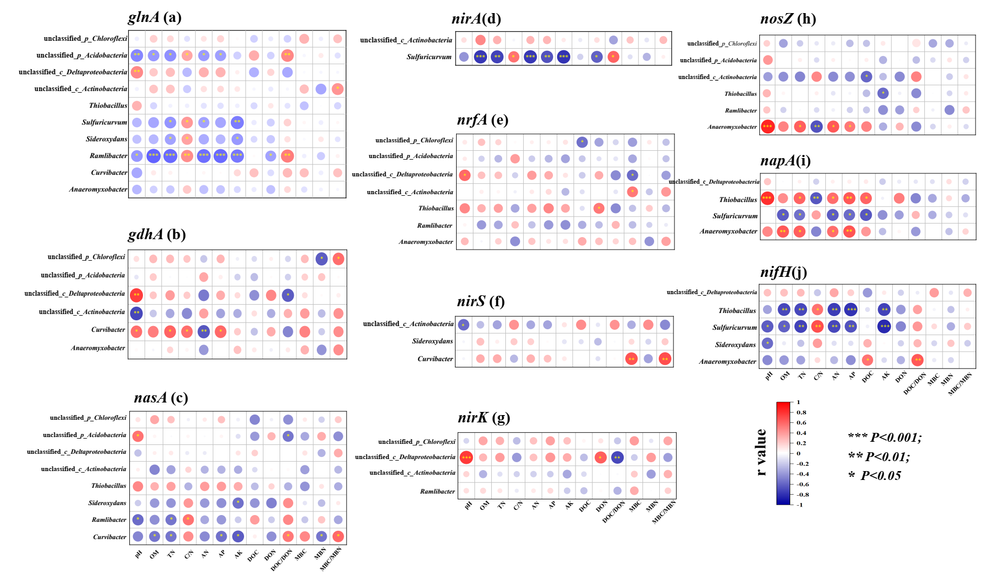
Fig. S1 Correlation analysis of dominant genus abundance with soil biochemical properties.

Fig. S2 The relation between the abundance of the glnA gene and gross mineralization rates (M; a) and gross NH₄ ⁺ immobilization rates (I_{NH4}; b). Data on N transformation rates were sourced from Hou et al. (2022).

References
Hou, H., Liu, X., Zhou, W., Ji, J., Lan, X., Lv, Z., Liu, Y., Zhang, J., Müller, C., 2022. N transformation mechanisms and N dynamics of organic fertilisers as partial substitutes for chemical fertilisers in paddy soils. J. Soils Sediments 22, 2516–2529.

