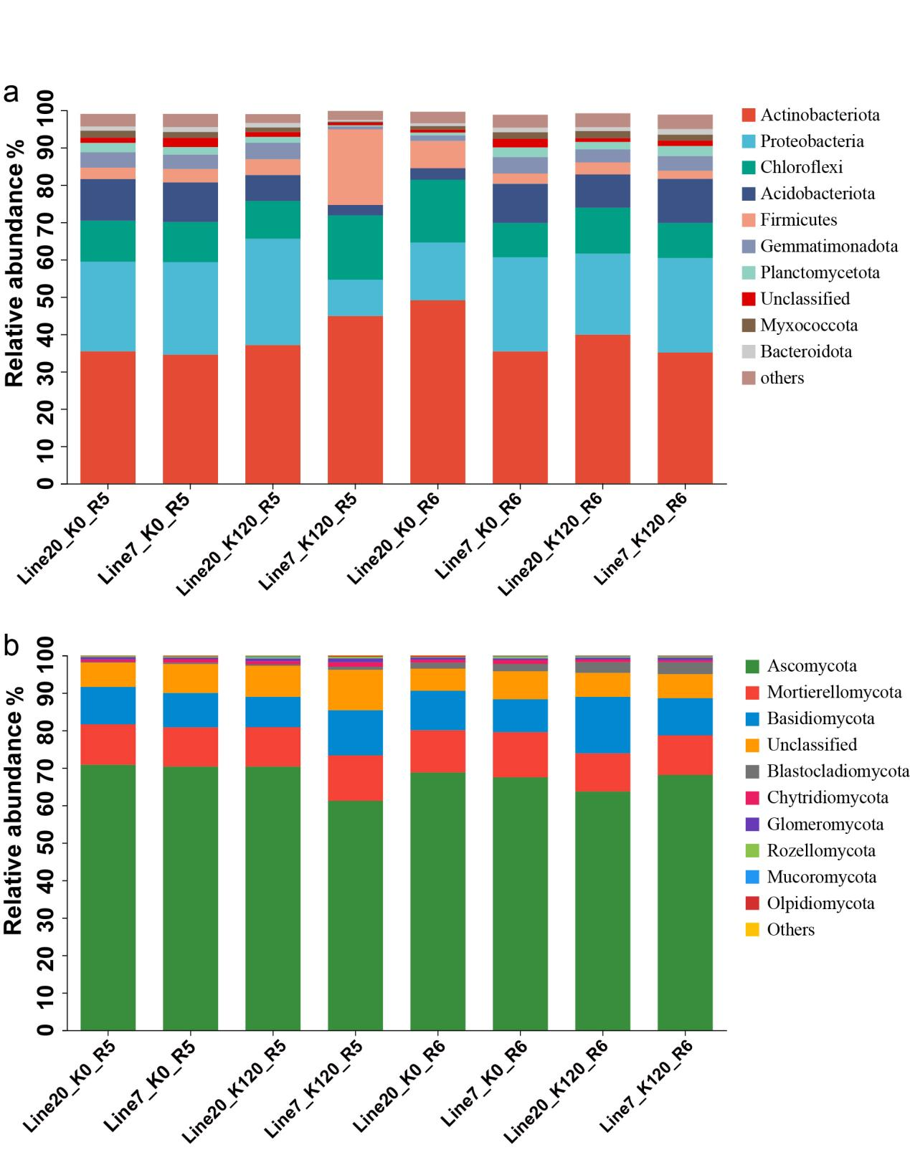
Figure S1. Average relative abundance of bacteria (a) and fungi (b) phyla with and without K application in two K efficiency genotypes in R5 and R6 stages

