Supplemental information

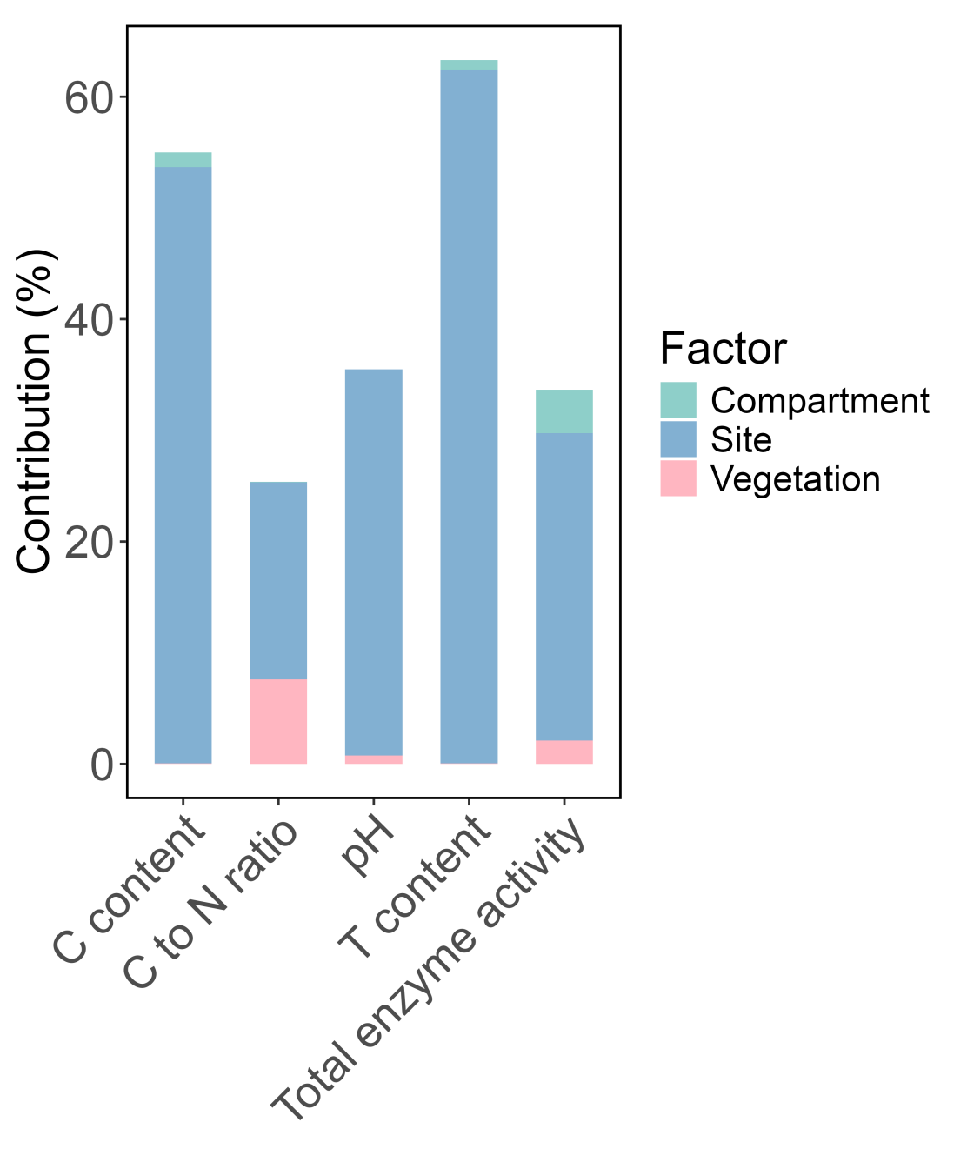
Fig. S1. Contribution analysis based on the results of the three-way ANOVA, illustrating the relative contribution of tree species, soil compartments, and geographic sites to the variation in soil properties. The relative contribution of each factor was calculated as: Contribution (%) = SS_factor / SS_total × 100, where SS denotes the sum of squares obtained from the three-way ANOVA.

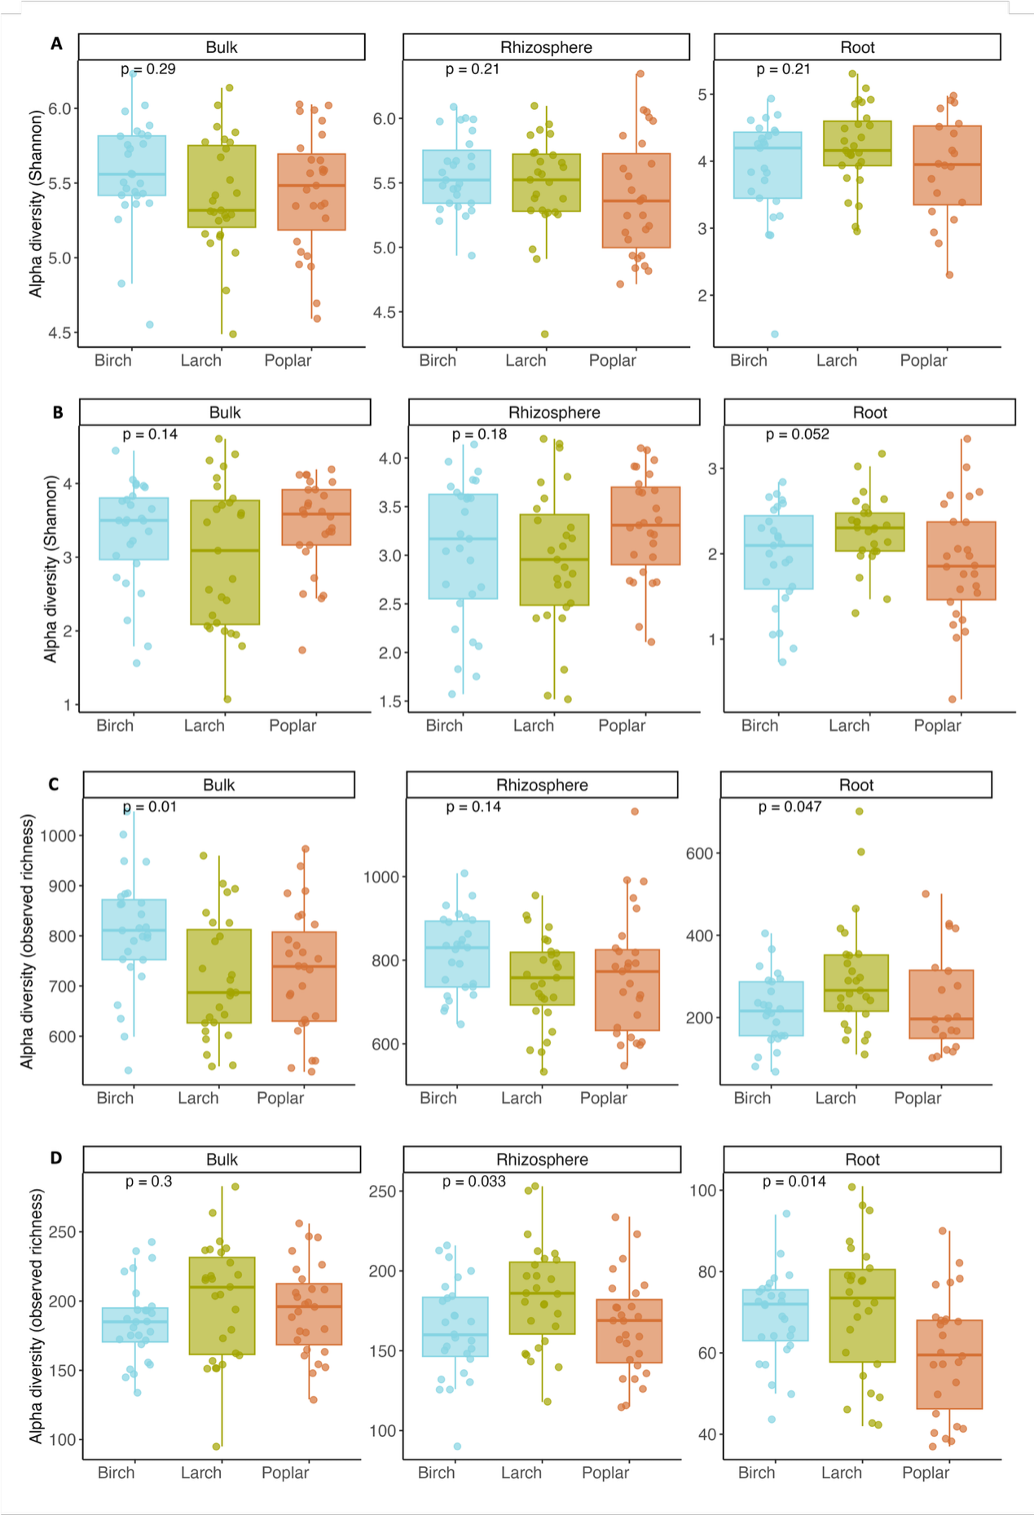
Fig. S2. The alpha diversity (Shannon-index, Richness-index) of bacterial and fungal communities between different vegetation types. A. Shannon diversity of bacterial communities; B. Shannon diversity of fungal communities. C. Richness of bacterial communities; D. Richness of fungal communities.

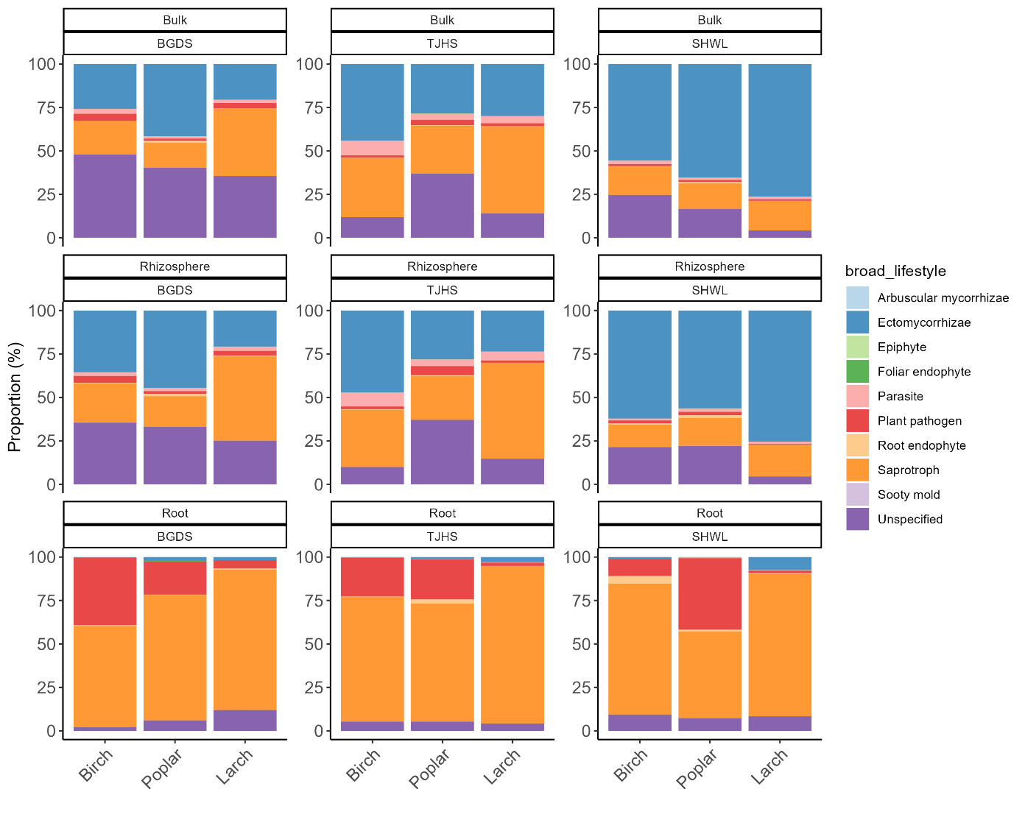
Fig. S3. Functional diversity of fungal communities in different compartment (roots, rhizosphere soil, and bulk soil).

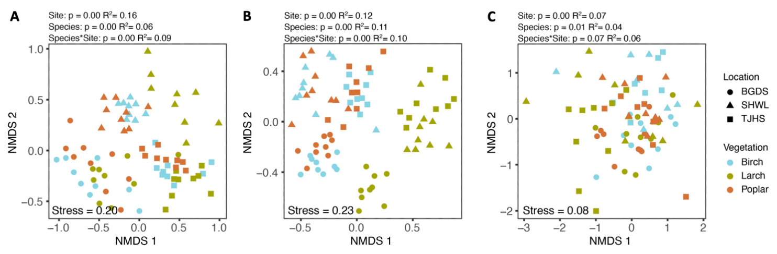

Fig. S4. The composition of EcM(A), saprotrophic(B), and pathogenic fungi(C) in the rhizosphere soil.

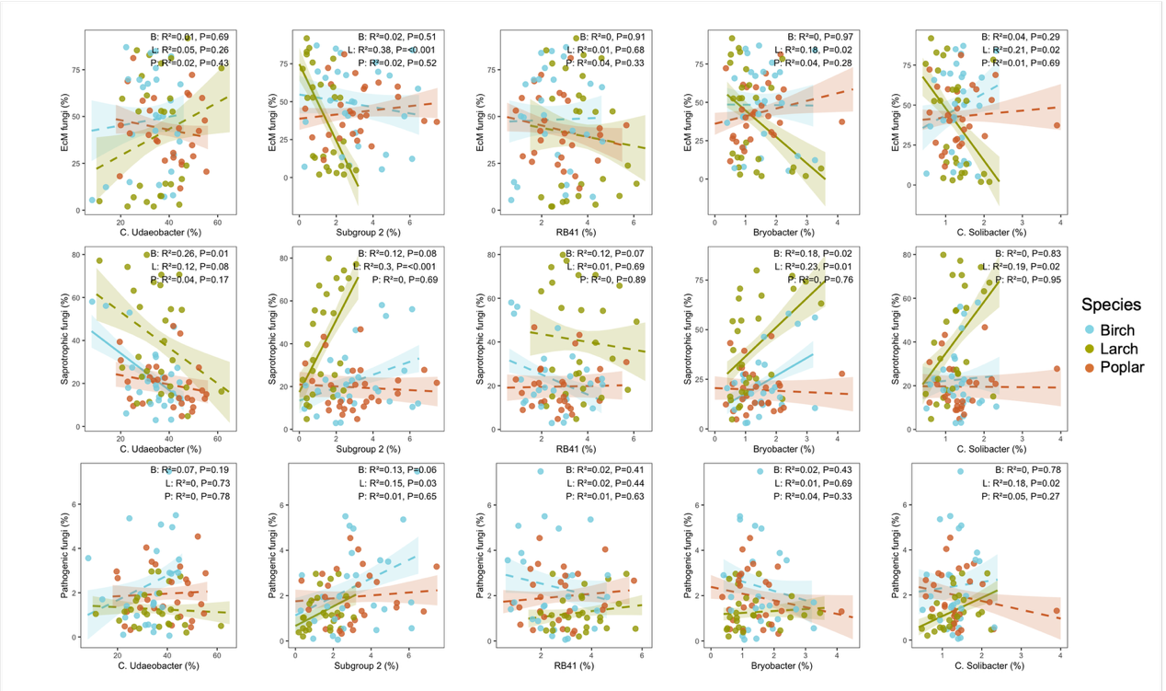
Fig. S5. Covariation patterns between dominant bacterial genera and fungal functional groups in rhizosphere soil based on compositional relative-abundance data. B: Birch, L: Larch, P: Poplar. (dominant bacterial genera: g Candidatus_Udaeobacter (Verrucomicrobiota), Subgroup_2 (Acidobacteriota), RB41 (Acidobacteriota), Bryobacter (Acidobacteriota), Candidatus_Solibacter (Acidobacteriota)).

Fig. S6. Covariation patterns between dominant bacterial genera and fungal functional groups in root based on compositional relative-abundance data. B: Birch, L: Larch, P: Poplar. (dominant bacterial genera: Ralstonia (Proteobacteria), Acidibacter (Proteobacteria), Burkholderia-Caballeronia-Paraburkholderia, BCP group (Proteobacteria), Kineosporia (Actinobacteriota), Allorhizobium-Neorhizobium-Pararhizobium-Rhizobium (Proteobacteria)).

Tab. S1. Beta regression analysis of the relative abundance of pathogenic fungi in the root.
 | Estimate | Std error | Z value | P value
(Intercept) | 2.49 | 0.25 | 9.82 | <2e-16***
Saprotroph (root) | -5.85 | 0.29 | -20.40 | <2e-16***
EcM (rhizosphere) | -0.54 | 0.27 | -2.02 | 0.04*
FEAST influx | 0.29 | 1.47 | 0.20 | 0.84
Species Larch | -0.93 | 0.19 | -4.97 | 6.6e-07***
Species Poplar | -0.07 | 0.16 | -0.43 | 0.67
(phi) | 33.85 | 6.01 | 5.63 | 1.8e-08***
Pseudo-R² = 0.854
‘*’ represents p < 0.05, ‘***’ represents p < 0.001.

