Title: Soil ammonia-oxidizing archaea in alpine grasslands exhibit the highest temperature sensitivity in northern Chinese grasslands
Running title: Alpine grassland AOA most temperature sensitive
Authors: Sixue Chen^{1,2,3,4}, Shuang Pang^{3,4}, Yichen Zhu^{1,2}, Zonghao Hu^{3,4}, Yiheng Tao⁵, Changhui Wang^{1,2†}, Huili Jia^{1,2*} and Ximei Zhang^{3,4*}
Affiliations: ¹College of Grassland Science, Shanxi Agriculture University, Taigu 030801, China. ²Shanxi Key Laboratory of Grassland Ecological Protection and Native Grass Germplasm Innovation, Taigu 030801, China. ³Key Laboratory of Dryland Agriculture, Ministry of Agriculture, Institute of Environment and Sustainable Development in Agriculture, Chinese Academy of Agricultural Sciences, Beijing 100081, China. ⁴State Key Laboratory of Efficient Utilization of Agricultural Water Resources, CAU/CAAS, Beijing, China. ⁵College of Land and Environment, Shenyang Agricultural University, Shenyang 110161, China.
*Corresponding author: Huili Jia (Email: jiahuilisxau@126.com) and Ximei Zhang (Email: zhangximei@caas.cn)
†Note: Professor Changhui Wang (Shanxi Agricultural University), a beloved colleague, co-author, and supervisor of the first author, passed away in November 2023. She was a leading expert in grassland biogeochemistry. Her foundational contributions to this work were invaluable, and she is deeply missed.
Supplementary Information
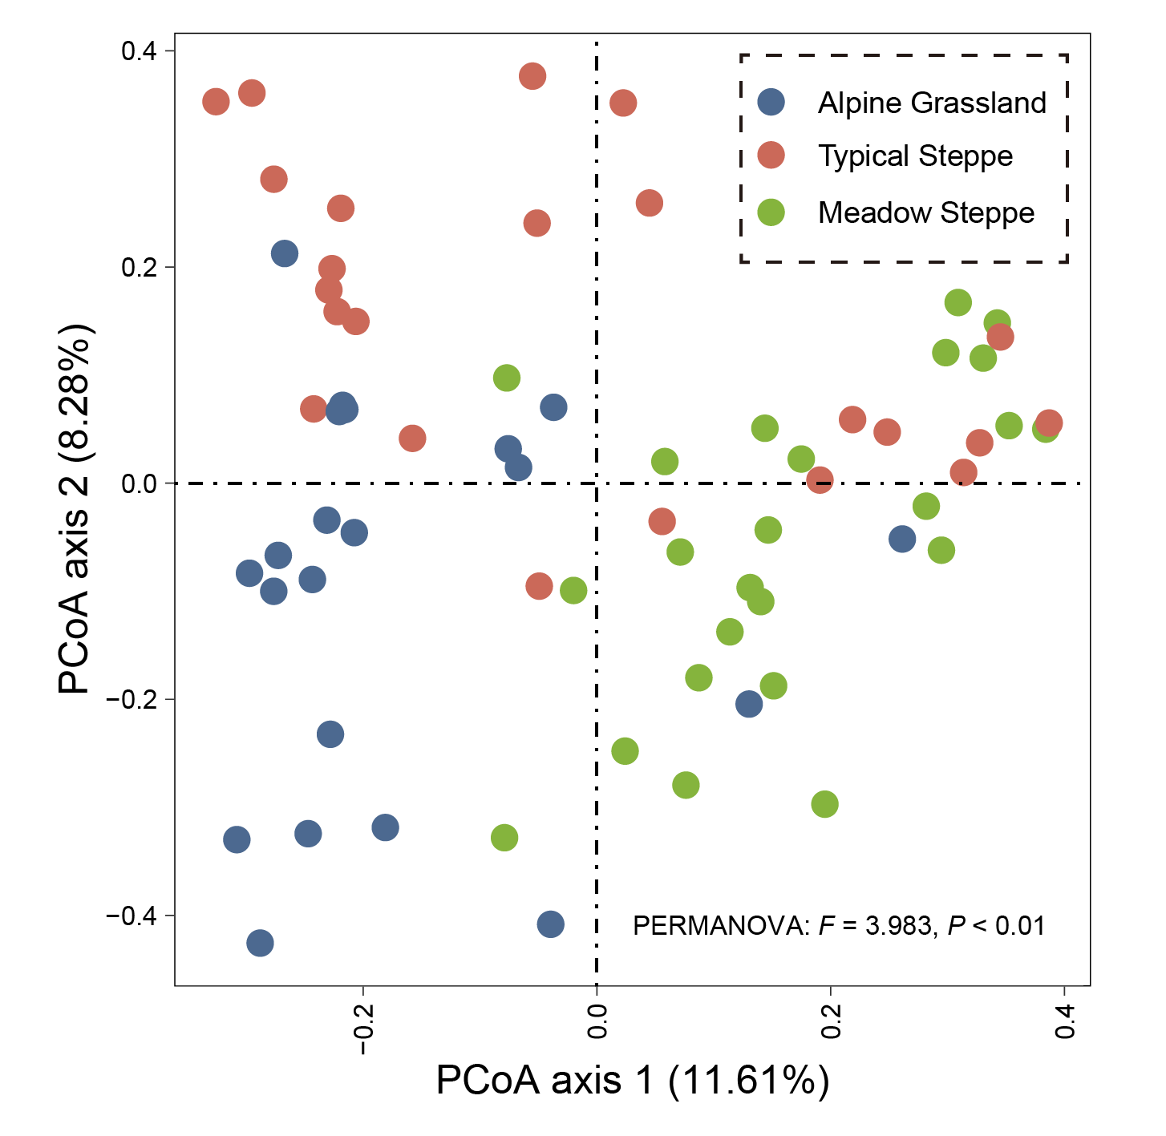
Supplementary Figure 1 PCoA ordination illustrating the structural differences in soil ammonia-oxidizing bacteria (AOB) communities among grassland types. Different colors represent the three grassland types.

Supplementary Figure 2 Drivers of soil ammonia-oxidizing bacteria (AOB) community composition across grassland types. Bar plots show the individual effects (adjusted R²) of various predictors for (a-d) AOB-amoA gene relative abundance (log10-transformed) and (e-h) AOB-amoA gene richness across different grassland types. (i-l) dbRDA ordination plots for each grassland type. Points represent individual samples, colored by their site-specific mean annual temperature (MAT) on a blue (cool) to red (warm) gradient and shaped by grassland type. Black vectors represent environmental variables; their length and direction indicate the strength and correlation of each variable with the community composition patterns.
Abbreviations: MAT, mean annual temperature; MAP, mean annual precipitation; AN, available nitrogen; AP, available phosphorus; NDVI, Normalized Difference Vegetation Index; RA, Relative abundance.
Significant: *P < 0.10, **P < 0.05, ***P < 0.01.
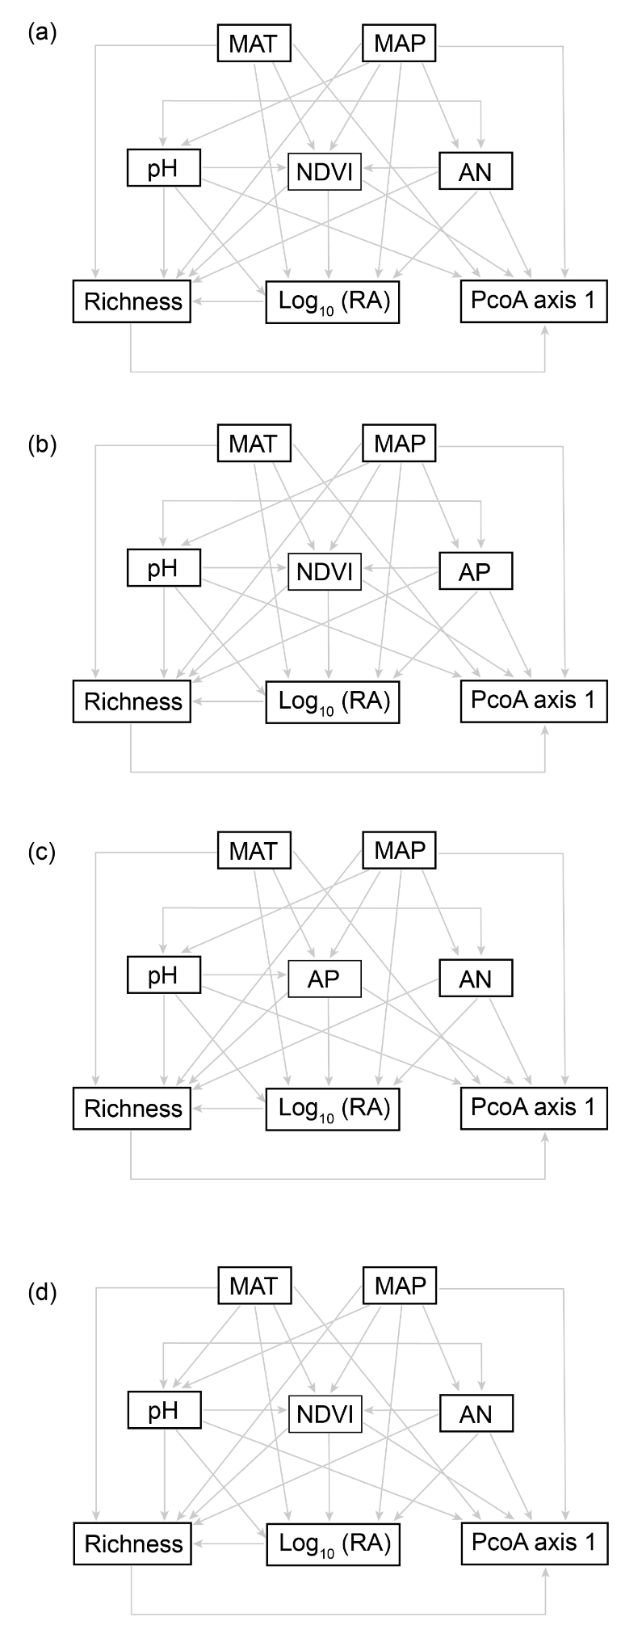
Supplementary Figure 3 A priori structural equation models (SEMs) for testing direct and indirect effects of climate on AOA communities. Conceptual diagrams outline the hypothesized pathways through which mean annual temperature (MAT) influences AOA community attributes both directly and indirectly (via soil properties and vegetation) across all grassland types. (a) Pooled model (all sites). (b) Meadow steppe-specific model. (c) Typical steppe-specific model. (d) Alpine grassland-specific model. Single-headed arrows represent hypothesized causal relationships.
Abbreviations: MAT, mean annual temperature; MAP, mean annual precipitation; AN, available nitrogen; AP, available phosphorus; NDVI, Normalized Difference Vegetation Index; RA, Relative abundance.

Supplementary Table 1 Summary of sampling site information and environmental characteristics: geographic location, Climate, vegetation, and soil property
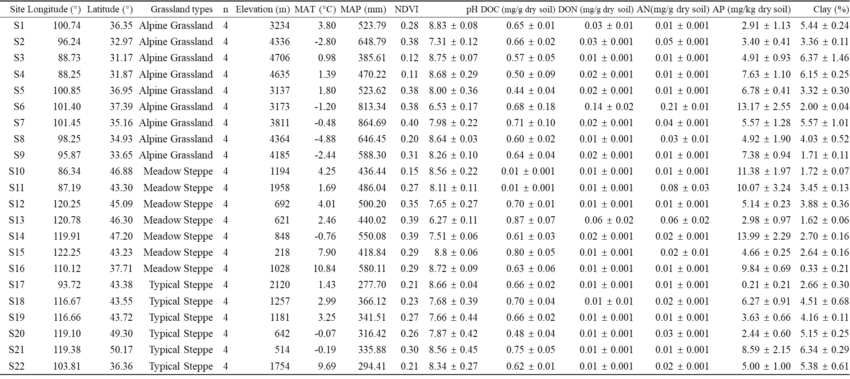
Note. Sites are grouped by grassland type: Alpine grassland, Typical steppe, and Meadow steppe. Values are expressed as mean ± standard error.
Abbreviations: MAT, mean annual temperature; MAP, mean annual precipitation; AN, available nitrogen; AP, available phosphorus; NDVI, Normalized Difference Vegetation Index; RA, Relative abundance; n, replicate number of samples.

