Supplementary Material
Reduced water and nitrogen inputs boost microbial necromass carbon contributions to greenhouse soil organic carbon
Running title: Impact of water-nitrogen practices on MNC dynamics
Zhou Jia ^{1, 2}, Jianshuo Shi^{1, 2}, Chengzhang Wang³, Longgang Jiang^{1, 2}, Meng Li^{4, 5}, Ruonan Li^{1, 2}, Li Guo^{1, 2}, Yihong Li^{1, 2}, Liying Wang^{1, 2, *}, Erxiong Zhu^{6, 7, *}
¹Institute of Agricultural Resources and Environment, Hebei Academy of Agriculture and Forestry Sciences, Shijiazhuang 050051, China
²Hebei Fertilizer Technology Innovation Center, Shijiazhuang 050051, China
³Yellow River Institute of Eco-Environmental Research, Henan Zhengzhou, 450004, China
⁴College of Biology & Pharmacy, China Three Gorges University, Yichang, Hubei 443000, China;
⁵Collage of Hydraulic and Environmental Engineering, China Three Gorges University, Yichang, Hubei 443000, China;
⁶MEE Key Laboratory of Regional Eco-process and Function Assessment and State Key Laboratory of Environmental Criteria and Risk Assessment, Chinese Research Academy of Environmental Sciences, Beijing, 100012, China
⁷Guangdong-Hong Kong-Macao Center for Eco-environmental Sciences, Guangzhou, 510530, China
*Correspondence: wangliying5@163.com; Tel.: +86-311-87652228; zhuerxiong@nwsuaf.edu.cn Tel.: +86-010-62836961

Fig. S1-S5
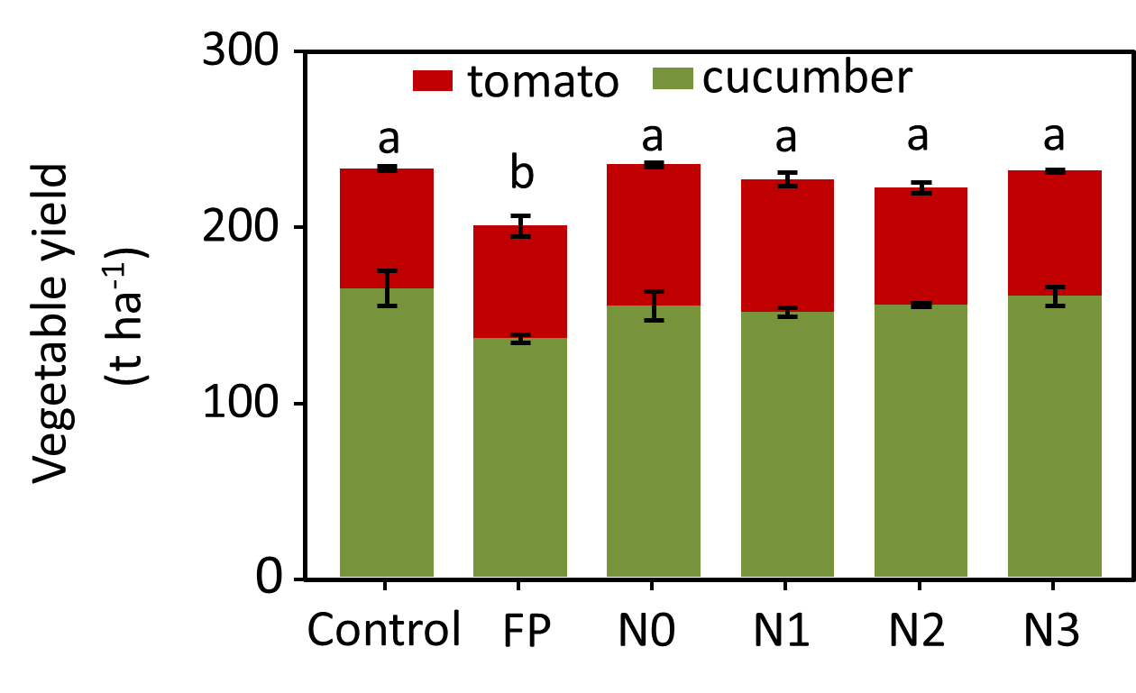
Fig. S1. The vegetable yield under different water and nitrogen fertilizer treatments in 2022. Mean values are shown with standard error (n = 3). Different lowercase letters indicate significant differences among treatments (p < 0.05). Control: high irrigation with no N fertilizer; FP: high irrigation with high chemical nitrogen fertilizer consisted with local farmer practices; N0: reduced irrigation with no chemical nitrogen fertilizer; N1: reduced irrigation with low chemical nitrogen fertilizer; N2: reduced irrigation with middle chemical nitrogen fertilizer; N3: reduced irrigation with high chemical nitrogen fertilizer.

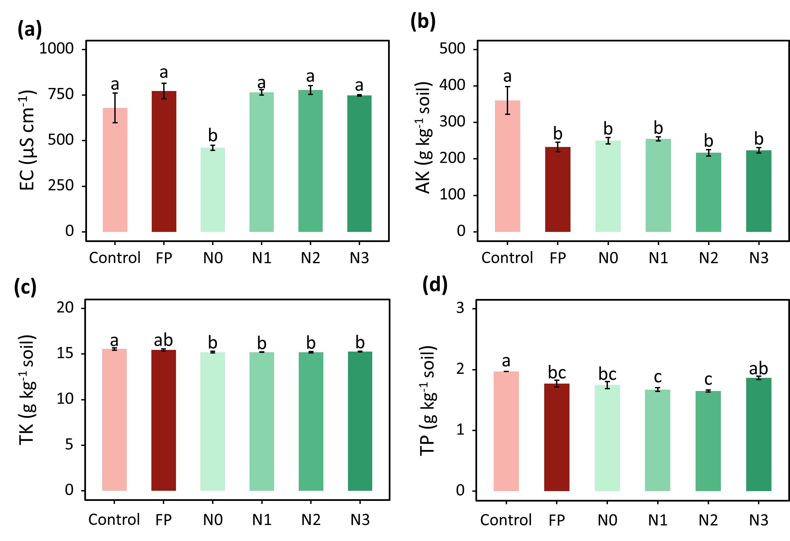
Fig. S2. Changes in soil physicochemical properties under different water and nitrogen fertilizer treatments. Mean values are shown with standard error (n = 3). Different lowercase letters indicate significant differences among treatments (p < 0.05). Abbreviations: EC, electrical conductivity; AK, available potassium; TK, total potassium; TP, available phosphorus. Other abbreviations are given in Fig. S1.
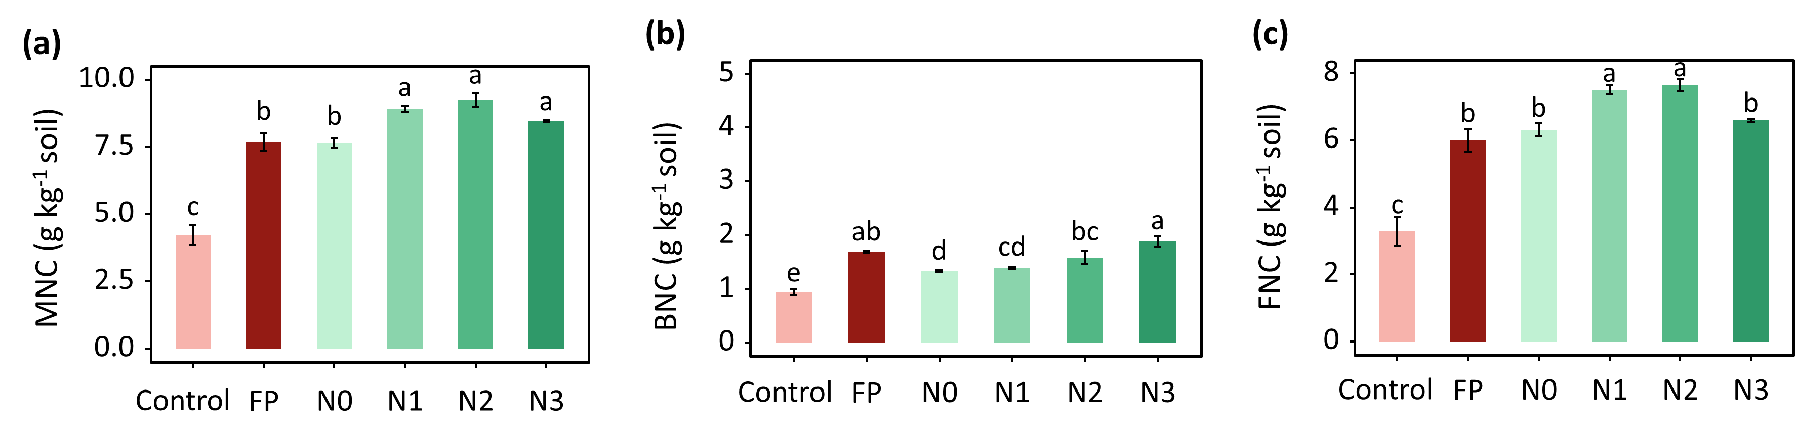
Fig. S3. The total microbial necromass carbon (MNC) (a), bacterial necromass carbon (BNC) (b), and fungal necromass C (FNC) (c) under different water and nitrogen fertilizer treatments. Mean values are shown with standard error (n = 3). Different lowercase letters indicate significant differences among treatments (p < 0.05). Other abbreviations are given in Fig. S1.
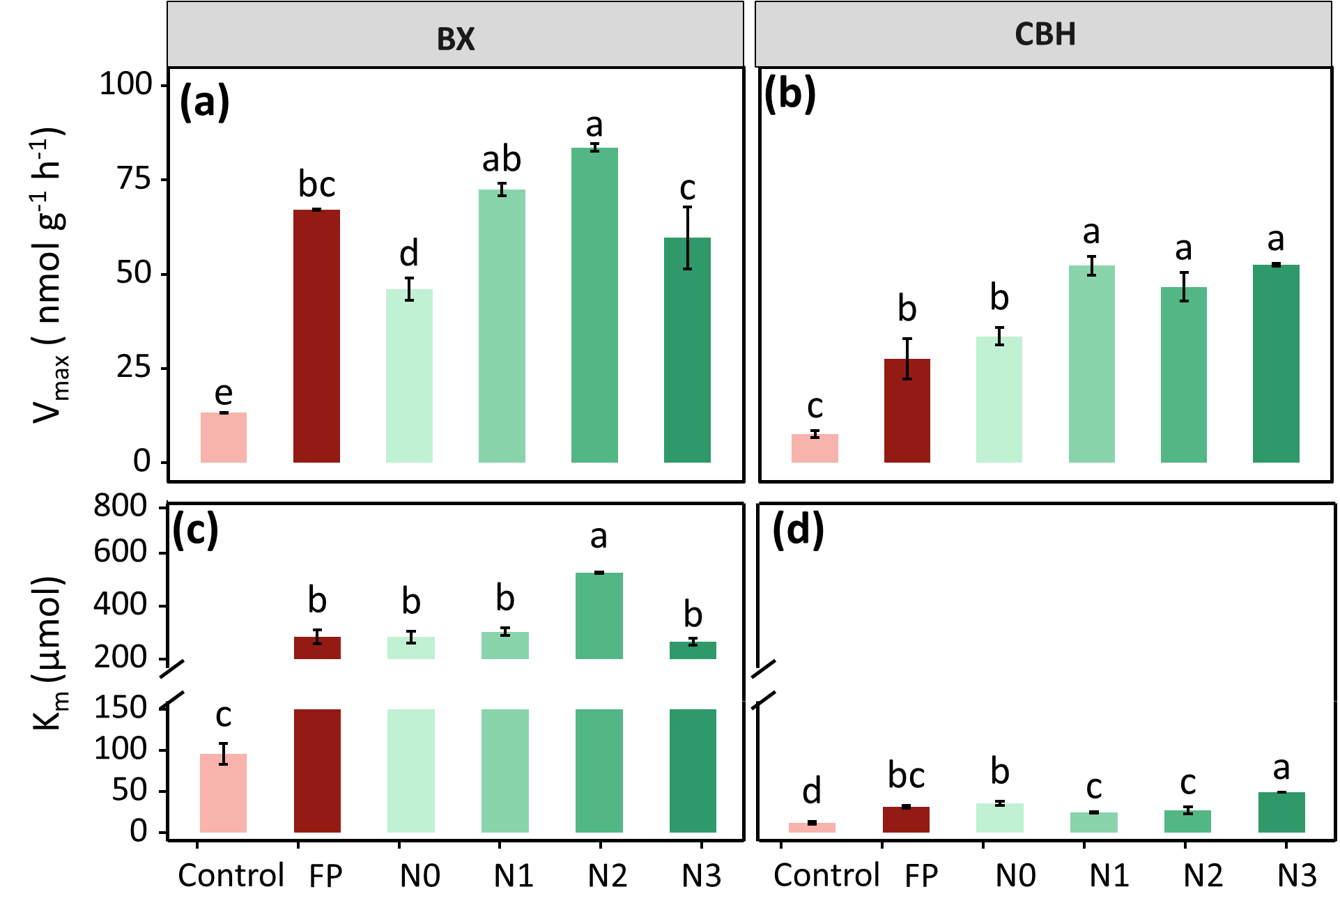
Fig. S4. The V_{max} and K_{m} of extracellular β-xylosidase (BX; a, c), cellobiohydrolase (CBH; b, d) under different water and nitrogen fertilizer treatments. Mean values are shown with standard error (n = 3). Different lowercase letters indicate significant differences among treatments (p < 0.05). V_{max} represents the enzyme's maximum catalytic velocity under saturated substrate conditions, while K_{m} denotes the substrate concentration at half-maximal reaction rate. Other abbreviations are given in Fig. S1.
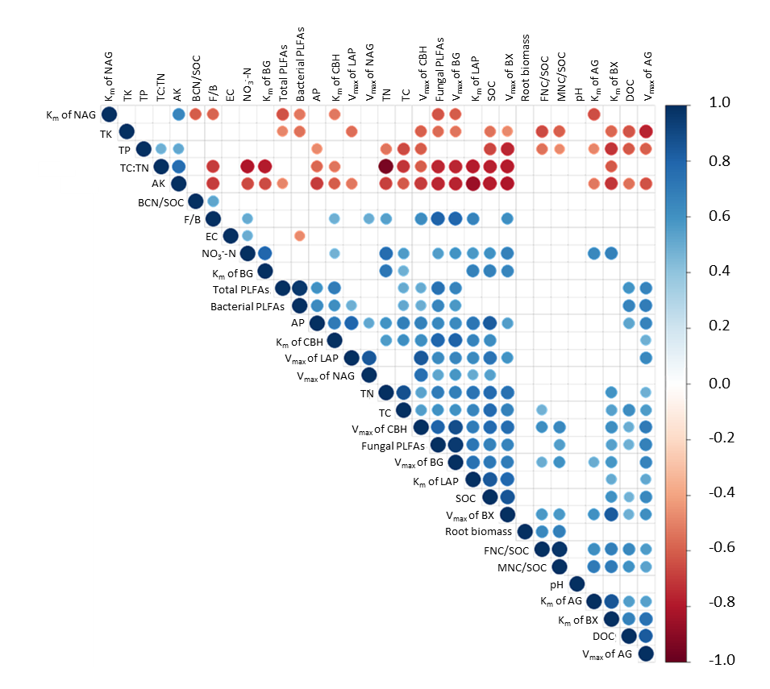
Fig. S5. The correlations among bulk soil properties, microbial community structure and root biomass, enzyme kinetics and FNC/SOC, MNC/SOC, BNC/SOC. Abbreviations: NAG, nitrogen-acetyl-glucosaminidase; TC, total carbon; TN, total nitrogen; F/B, the ratio of fungal to bacterial; NO₃⁻-N, nitrate; BG, β-glucosidase; PLFAs, phospholipid fatty acids; AP, available phosphorus; LAP, leucine aminopeptidase; NAG, nitrogen-acetyl-glucosaminidase; SOC, soil organic carbon. Other abbreviations are given in Figs. S1-S4.

