Deep learning method for collembola identification using single species and community combinations images
Xiaohao Zhuang¹, Bin Wang², Zhijing Xie², Zhihong Qiao², Jun Feng², Jocelyn E. Behm³, Clément Schneider⁴, Beining Shi¹, Jiayin Zheng¹, Yunyi Gu¹, Yuanyuan Meng¹, Xin Sun²*, Shengjie Liu¹*
¹School of Ecology, Shenzhen Campus of Sun Yat-sen University, Guangzhou 518107, China
²Key Laboratory of Urban Environment and Health, Ningbo Observation and Research Station, Institute of Urban Environment, Chinese Academy of Sciences, Xiamen, 361021, China
³Department of Biology, Temple University, Philadelphia, USA
⁴Senckenberg Gesellschaft für Naturforschung, Abteilung Bodenzoologie, Görlitz, Germany
Correspondence: Xin Sun, xsun@iue.ac.cn; Shengjie Liu, liushj63@mail.sysu.edu.cn

Table S1. Description of collembola species.
Family | Latin name | Images | Body length/‌μm
Arrhopalitidae | Arrhopalites nanjingensis | 30 | 260.64
Isotomidae | Cryptopygus thermophilus | 258 | 754.23
 | Desoria tianshanica | 50 | 1588.47
 | Folsomia octoculata | 100 | 775.13
 | Folsomides parvulus | 104 | 393.46
 | Folsomina wuyanensis | 100 | 464.73
 | Heteroisotoma sinorossica | 100 | 600.6
 | Isotoma gracilliseta | 90 | 542.51
 | Isotoma viridis | 100 | 2027.19
 | Isotomiella leksawasdii | 100 | 549.13
 | Isotomurus quadrisetosus | 50 | 484.24
 | Proisotoma fraterna | 102 | 485.01
 | Semicerura sp.1 | 100 | 802.05
 | Vertagopus arborata | 101 | 853.58
Onychiuridae | Bionychiurus changbaiensis | 100 | 979.9
 | Leeonychiurus gulinensis | 50 | 548.9
 | Spinonychiurus sinensis | 100 | 1328.11
Katiannidae | Sminthurinus cantonensis | 125 | 220.11
 | Sminthurinus pallescens | 51 | 444.17
 | Sminthurinus sp.1 | 50 | 985.15
Hypogastruridae | Ceratophysella baichengensis | 50 | 652.4
 | Ceratophysella sinensis | 352 | 708.37
 | Ceratophysella succinea | 23 | 307.06
 | Ceratophysella yinae | 101 | 828.29
 | Ceratophysella zhangi | 100 | 824.21
 | Monobella grassei | 51 | 509.73
Neanuridae | Paleonura formosana | 100 | 520.04
 | Pseudachorutes cheni | 108 | 351.75
 | Vitronura sp.1 | 100 | 1236.3
Dicyrtomidae | Dicyrtoma fusca | 75 | 472.7
Entomobryidae | Coecobrya islandica | 100 | 399.49
 | Dicranocentrus wangi | 125 | 1353.97
 | Drepanura sp.1 | 100 | 455.61
 | Entomobrya huangi | 127 | 629.48
 | Entomobrya japonica | 151 | 1992.11
 | Entomobrya leonensis | 50 | 1819.55
 | Entomobrya sp.1 | 50 | 995.3
 | Homidia koreana | 25 | 2135.74
 | Homidia laha | 100 | 794.7
 | Homidia sinensis | 105 | 550.76
 | Homidia socia | 176 | 1157.13
 | Lepidocyrtus felipei | 52 | 583.39
 | Lepidocyrtus fimetarius | 102 | 599.93
 | Lepidocyrtus hankowi | 125 | 735.68
 | Orchesellides sinensis | 50 | 1758.33
 | Pseudosinella caoi | 179 | 788.56
 | Rambutsinella grinnellia | 127 | 448.17
 | Sinella curviseta | 151 | 1108.49
 | Sinella pseudobrowni | 103 | 572.07
 | Sinella umesaoi | 51 | 1430.29
 | Sinella zhangi | 50 | 970.1

Table S2. More details of original and community collembolan datasets
Dataset | Hierarchy | Diversity Gradient | Number | Images
Origin | Individual | 1 | 1 | 5020
Family | Community | 2-6 | 5 | 226
Genus | Community | 2-9 | 16 | 100
Species | Community | 3-23 | 1 | 501

Table S3. Model parameters for training
Models | Yolov8n | Yolov8s | Yolov8m | Faster R-CNN | Yolov8m-cls
mode | detect |  |  | detect | classify
Input Size | 2560×2560 |  |  | 1000×600 | 224
Params | 3.2×10⁶ | 11.2×10⁶ | 25.9×10⁶ | 23.5×10⁶ | 17.0 ×10⁶
Epochs | 50 |  |  | 50 | 50
Optimizer | Auto |  |  | SGD | Auto
Learning rate | Auto |  |  | 0.02 | Auto

Table S4a. The training results of four indicate value at family level.
Models | Diversity of Family | Precision | Recall | mAP50 | mAP95 | Precision-SD | Recall-SD | mAP50-SD | mAP95-SD
yolov8n | 2 | 91.43% | 89.00% | 92.16% | 91.15% | 5.25% | 5.96% | 4.07% | 4.13%
yolov8n | 3 | 98.16% | 97.40% | 98.22% | 97.75% | 1.76% | 2.46% | 1.24% | 1.38%
yolov8n | 4 | 99.21% | 99.00% | 99.02% | 98.40% | 0.78% | 0.92% | 0.52% | 0.73%
yolov8n | 5 | 98.86% | 98.65% | 98.89% | 98.41% | 0.87% | 1.11% | 0.55% | 0.49%
yolov8n | 6 | 96.53% | 95.74% | 97.26% | 96.61% | 1.79% | 2.08% | 1.19% | 1.21%
yolov8s | 2 | 85.73% | 83.78% | 87.67% | 85.90% | 7.59% | 7.76% | 6.76% | 6.57%
yolov8s | 3 | 97.70% | 96.08% | 97.45% | 96.71% | 1.86% | 3.44% | 1.80% | 1.76%
yolov8s | 4 | 99.06% | 98.88% | 98.98% | 98.28% | 0.91% | 1.13% | 0.53% | 0.70%
yolov8s | 5 | 97.92% | 97.44% | 98.12% | 97.56% | 1.47% | 1.77% | 1.02% | 0.86%
yolov8s | 6 | 96.92% | 95.94% | 97.26% | 96.69% | 1.23% | 1.94% | 1.09% | 1.02%
yolov8m | 2 | 78.14% | 74.89% | 77.29% | 73.30% | 10.99% | 9.37% | 12.37% | 12.27%
yolov8m | 3 | 95.43% | 93.88% | 96.15% | 95.30% | 1.92% | 2.75% | 1.43% | 1.40%
yolov8m | 4 | 97.53% | 96.28% | 97.71% | 97.14% | 1.04% | 1.83% | 0.79% | 0.79%
yolov8m | 5 | 96.88% | 96.09% | 97.61% | 97.23% | 1.39% | 1.64% | 0.92% | 0.96%
yolov8m | 6 | 96.80% | 96.40% | 97.54% | 97.13% | 1.33% | 1.60% | 0.82% | 0.78%
Faster R-CNN(ResNet50) | 2 | 61.66% | 78.21% | 72.15% | 68.34% | 4.62% | 3.21% | 2.14% | 2.01%
Faster R-CNN(ResNet50) | 3 | 92.08% | 62.10% | 83.47% | 80.12% | 2.10% | 2.89% | 1.43% | 1.37%
Faster R-CNN(ResNet50) | 4 | 88.75% | 68.43% | 82.91% | 79.65% | 3.40% | 3.15% | 2.01% | 1.92%
Faster R-CNN(ResNet50) | 5 | 86.22% | 71.89% | 81.23% | 78.21% | 5.26% | 3.98% | 2.47% | 2.35%
Faster R-CNN(ResNet50) | 6 | 86.33% | 73.15% | 80.67% | 77.34% | 4.56% | 4.12% | 2.29% | 2.18%

Table S4b. The training results of four indicate value at genus level.
Models | Family | Diversity of Genus | Precision | Precision-SD | Recall | Recall-SD | mAP50 | mAP50-SD | mAP95 | mAP95-SD
YOLOv8n | Isotomidae | 2 | 99.18% | 0.26% | 100.00% | 0.00% | 99.50% | 0.00% | 99.08% | 0.44%
YOLOv8n | Entomobryidae | 2 | 94.52% | 3.87% | 98.14% | 2.20% | 99.11% | 0.75% | 97.58% | 1.38%
YOLOv8n | Isotomidae | 3 | 98.72% | 1.20% | 98.66% | 3.16% | 99.50% | 0.00% | 99.29% | 0.33%
YOLOv8n | Entomobryidae | 3 | 81.46% | 11.70% | 85.33% | 5.39% | 90.64% | 5.23% | 88.49% | 5.20%
YOLOv8n | Isotomidae | 4 | 97.40% | 1.07% | 98.29% | 1.57% | 99.02% | 0.76% | 98.35% | 0.85%
YOLOv8n | Entomobryidae | 4 | 94.41% | 2.97% | 95.42% | 2.21% | 97.69% | 1.39% | 91.25% | 1.91%
YOLOv8n | Isotomidae | 5 | 98.61% | 0.71% | 99.04% | 0.93% | 99.45% | 0.11% | 99.34% | 0.19%
YOLOv8n | Entomobryidae | 5 | 82.97% | 5.00% | 90.21% | 5.00% | 92.47% | 2.38% | 90.24% | 2.35%
YOLOv8n | Isotomidae | 6 | 96.90% | 1.40% | 97.82% | 1.40% | 99.30% | 0.22% | 96.51% | 0.63%
YOLOv8n | Entomobryidae | 6 | 91.90% | 2.15% | 94.37% | 2.65% | 97.92% | 1.27% | 94.24% | 2.11%
YOLOv8n | Isotomidae | 7 | 98.38% | 0.66% | 99.09% | 0.97% | 99.49% | 0.04% | 99.08% | 0.27%
YOLOv8n | Entomobryidae | 7 | 94.35% | 2.48% | 91.67% | 3.54% | 96.72% | 1.63% | 94.31% | 1.93%
YOLOv8n | Isotomidae | 8 | 96.91% | 1.60% | 98.65% | 0.93% | 99.36% | 0.24% | 97.39% | 0.72%
YOLOv8n | Entomobryidae | 8 | 88.59% | 3.75% | 88.93% | 5.11% | 94.18% | 1.41% | 92.23% | 1.59%
YOLOv8n | Isotomidae | 9 | 96.40% | 2.43% | 98.82% | 0.73% | 99.31% | 0.37% | 97.55% | 0.85%
YOLOv8n | Entomobryidae | 9 | 87.93% | 4.72% | 90.47% | 3.00% | 95.26% | 1.91% | 92.62% | 2.05%
YOLOv8s | Isotomidae | 2 | 39.16% | 11.00% | 67.72% | 10.77% | 50.95% | 12.36% | 20.68% | 5.35%
YOLOv8s | Entomobryidae | 2 | 35.51% | 16.49% | 60.02% | 13.43% | 43.69% | 11.33% | 15.44% | 4.65%
YOLOv8s | Isotomidae | 3 | 39.75% | 9.40% | 76.81% | 13.54% | 57.78% | 14.20% | 31.48% | 12.31%
YOLOv8s | Entomobryidae | 3 | 39.77% | 18.70% | 68.39% | 10.37% | 54.63% | 15.21% | 33.11% | 19.44%
YOLOv8s | Isotomidae | 4 | 90.82% | 3.70% | 94.36% | 4.84% | 96.18% | 1.91% | 93.79% | 2.28%
YOLOv8s | Entomobryidae | 4 | 77.77% | 8.84% | 82.41% | 6.32% | 87.94% | 4.57% | 78.76% | 4.08%
YOLOv8s | Isotomidae | 5 | 91.85% | 3.33% | 94.59% | 2.36% | 97.39% | 1.81% | 97.10% | 1.71%
YOLOv8s | Entomobryidae | 5 | 67.30% | 8.65% | 77.23% | 7.59% | 75.78% | 6.80% | 72.58% | 6.88%
YOLOv8s | Isotomidae | 6 | 94.02% | 2.82% | 97.54% | 2.44% | 98.68% | 1.45% | 95.60% | 1.65%
YOLOv8s | Entomobryidae | 6 | 80.03% | 7.06% | 88.10% | 2.91% | 91.06% | 4.13% | 86.30% | 3.60%
YOLOv8s | Isotomidae | 7 | 96.74% | 1.46% | 96.98% | 1.66% | 98.90% | 0.62% | 98.37% | 0.77%
YOLOv8s | Entomobryidae | 7 | 81.57% | 7.49% | 88.29% | 3.09% | 90.10% | 3.17% | 87.41% | 3.40%
YOLOv8s | Isotomidae | 8 | 96.40% | 2.36% | 98.19% | 1.12% | 99.08% | 0.71% | 97.17% | 1.37%
YOLOv8s | Entomobryidae | 8 | 87.30% | 4.87% | 89.87% | 4.93% | 94.48% | 3.08% | 92.40% | 2.98%
YOLOv8s | Isotomidae | 9 | 96.92% | 1.60% | 98.41% | 1.12% | 99.40% | 0.13% | 97.79% | 0.52%
YOLOv8s | Entomobryidae | 9 | 86.76% | 4.13% | 86.48% | 6.14% | 92.56% | 4.26% | 89.61% | 4.52%
YOLOv8m | Isotomidae | 2 | 27.86% | 19.81% | 41.56% | 6.28% | 29.53% | 7.77% | 11.25% | 3.11%
YOLOv8m | Entomobryidae | 2 | 18.51% | 9.26% | 36.49% | 9.50% | 22.24% | 11.53% | 10.14% | 2.93%
YOLOv8m | Isotomidae | 3 | 32.94% | 12.54% | 65.21% | 12.35% | 45.91% | 12.99% | 18.02% | 6.16%
YOLOv8m | Entomobryidae | 3 | 27.28% | 13.53% | 39.83% | 8.05% | 32.01% | 10.47% | 12.01% | 4.01%
YOLOv8m | Isotomidae | 4 | 22.79% | 11.28% | 51.01% | 20.68% | 35.98% | 16.70% | 14.86% | 7.55%
YOLOv8m | Entomobryidae | 4 | 31.13% | 6.61% | 45.16% | 12.95% | 36.55% | 11.96% | 14.16% | 5.65%
YOLOv8m | Isotomidae | 5 | 47.72% | 16.81% | 71.02% | 14.09% | 59.81% | 18.82% | 51.42% | 22.72%
YOLOv8m | Entomobryidae | 5 | 24.28% | 18.57% | 36.24% | 15.68% | 23.70% | 10.30% | 11.77% | 9.07%
YOLOv8m | Isotomidae | 6 | 79.27% | 9.26% | 85.67% | 6.29% | 88.04% | 6.82% | 84.08% | 6.58%
YOLOv8m | Entomobryidae | 6 | 47.58% | 16.44% | 71.50% | 10.56% | 60.21% | 17.54% | 48.91% | 23.37%
YOLOv8m | Isotomidae | 7 | 89.79% | 7.24% | 92.75% | 4.92% | 95.28% | 4.06% | 93.88% | 4.76%
YOLOv8m | Entomobryidae | 7 | 49.45% | 9.76% | 74.49% | 7.52% | 61.37% | 7.65% | 56.72% | 9.46%
YOLOv8m | Isotomidae | 8 | 89.63% | 3.04% | 94.43% | 2.48% | 97.19% | 0.59% | 94.89% | 0.90%
YOLOv8m | Entomobryidae | 8 | 72.47% | 14.31% | 77.59% | 13.36% | 78.79% | 15.35% | 77.12% | 15.31%
YOLOv8m | Isotomidae | 9 | 96.38% | 2.49% | 98.39% | 0.91% | 99.38% | 0.23% | 97.91% | 0.59%
YOLOv8m | Entomobryidae | 9 | 83.19% | 5.27% | 84.07% | 3.02% | 89.71% | 3.69% | 87.75% | 3.55%

Table S4c. The training results of four indicate value at species level.
Models | Precision | Recall | mAP50 | mAP95 | Precision-SD | Recall-SD | mAP50-SD | mAP95-SD
yolov8n | 97.18% | 96.81% | 99.07% | 96.27% | 0.51% | 0.73% | 0.44% | 0.64%
yolov8s | 97.35% | 98.29% | 99.24% | 96.78% | 0.35% | 0.75% | 0.48% | 0.65%
yolov8m | 97.59% | 98.84% | 99.47% | 97.22% | 0.33% | 0.66% | 0.02% | 0.30%

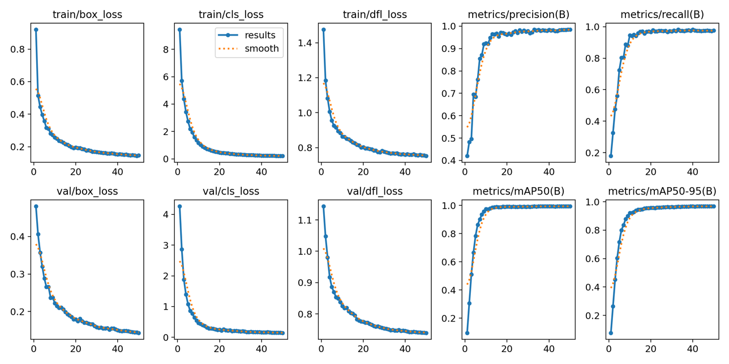
Figure S1. The curves of loss functions and metrics about yolov8s after training 51 species.

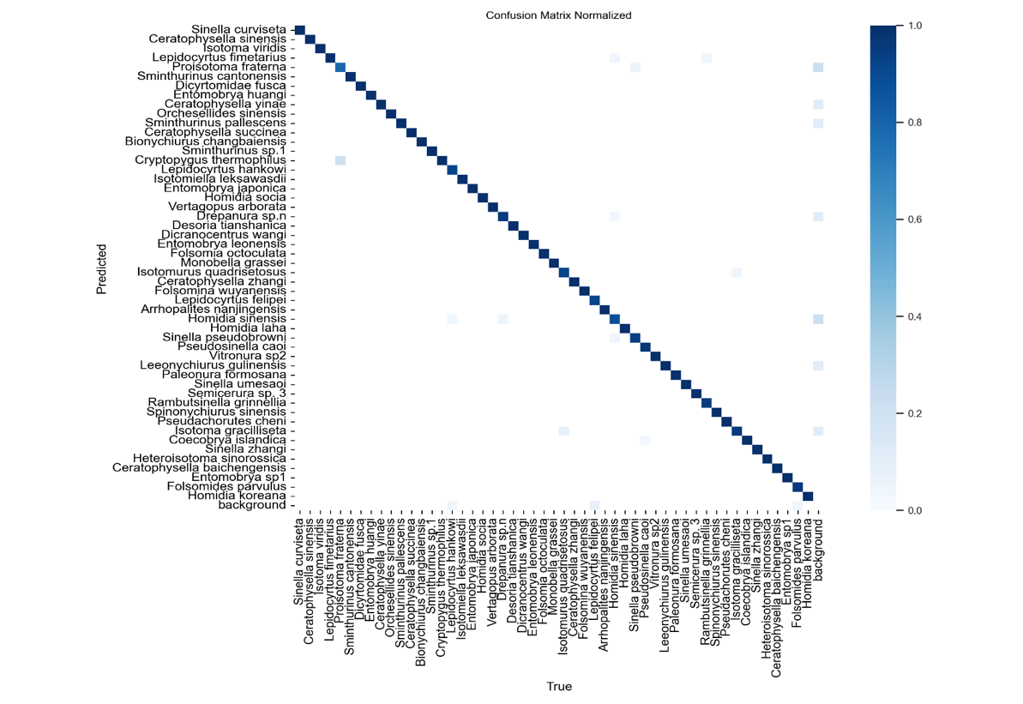
Figure S2. The normalized confusion matrix of yolov8s after training 51 species.

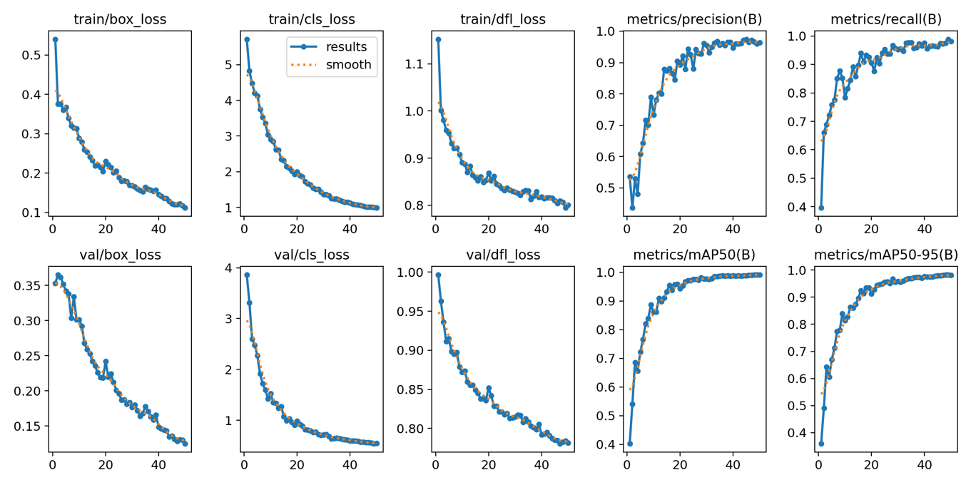
Figure S3. The curves of loss functions and metrics about yolov8n after training 6 families.

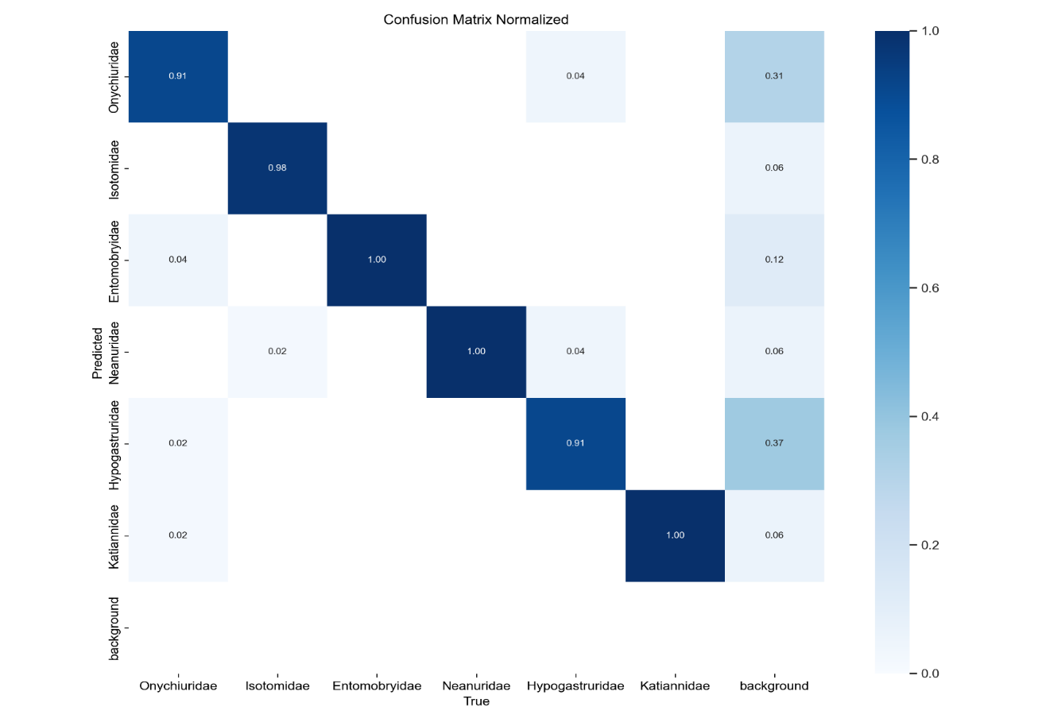
Figure S4. The normalized confusion matrix of yolov8n after training 6 families.

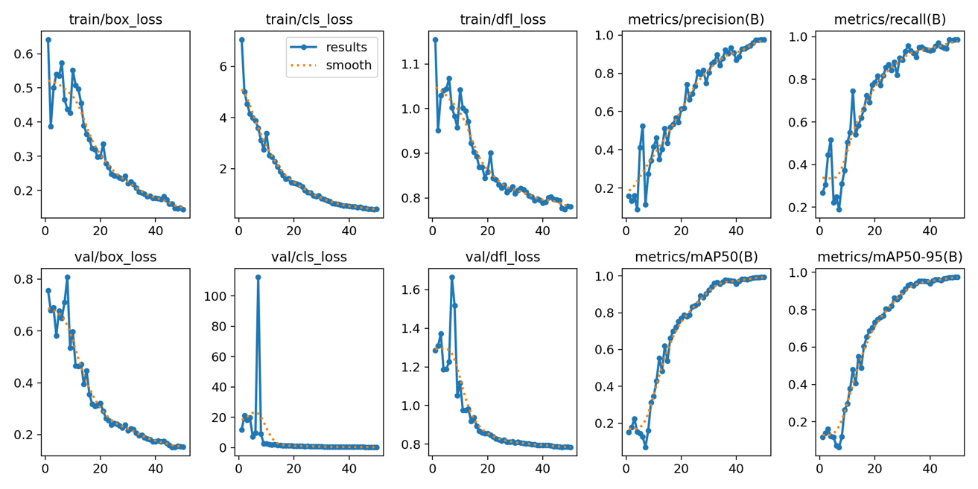
Figure S5. The curves of loss functions and metrics about yolov8m after training 9 genus for Isotomidae.

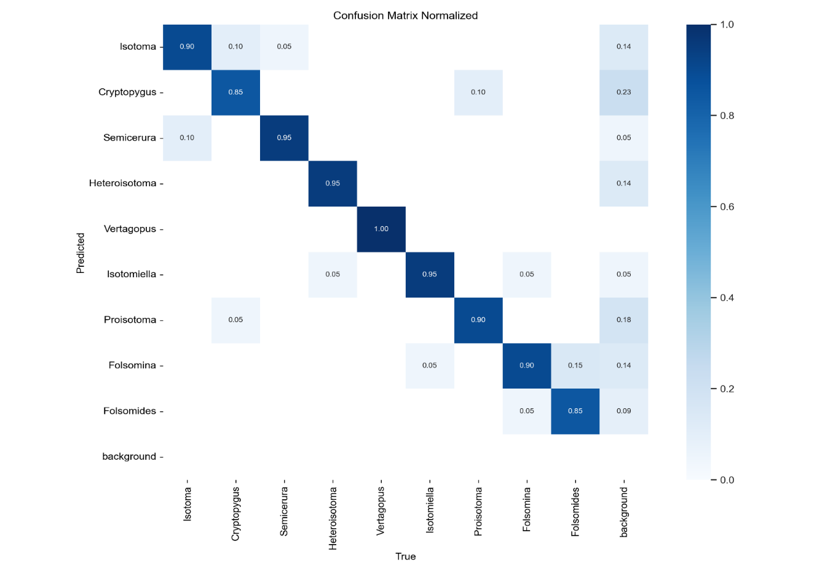
Figure S6. The normalized confusion matrix of yolov8m after training 9 genus for Isotomidae.

Algorithm S1. Cut-Paste Augmentation Input:
D ← Diversity gradient
I_list ← Source image list
A_list ← Annotation list (with taxonomic hierarchy)
B ← Blank background image (W×H×3)
Output:
I_syn ← Synthetic image
A_syn ← Synthetic annotation file
1: Initialize:
placed_boxes = [] # Store coordinates of pasted objects
cur_ diversity = 0
2: while (cur_ diversity <= D) do
3: Randomly select (I, A) ∈ (I_list, A_list) # Pair image with annotation
4: bbox ← extract_bbox(A) # (x_min, y_min, x_max, y_max)
5: patch ← crop(I, bbox) # Extract sub-image
6: for attempt in 1 to max_attempts do
7: (x_new, y_new) ← random_position (B.width - bbox.w, B.height - bbox.h)
8: new_box = (x_new, y_new, x_new + bbox.w, y_new + bbox.h)
9: if not check_overlap(new_box, placed_boxes, overlap_threshold=0) then
10: B.paste(patch, (x_new, y_new)) # Alpha blending recommended
11: placed_boxes.append(new_box)
12 # Write annotation
13: A_syn.append({
14: 'taxon': A.taxonomic_hierarchy,
15: 'bbox': new_box,
16: })
17: break
18: end if
19: end for
20: end while

