Appendixes

CO₂ removal with enhanced wollastonite weathering in acidic and calcareous soils

Chenxia Su^{1,2,6}, Ronghua Kang^{1,2,3,5,*}, Wentao Huang⁴, Ang Wang^{1,2,3,6,7}, Xue Li¹, Kai Huang^{1,2}, Qiang Zhou^{1,2}, Yunting Fang^{1,2,3,*}

¹Institute of Applied Ecology, Chinese Academy of Sciences, Shenyang, China
²Key Laboratory of Isotope Techniques and Applications, Shenyang, China
³CAS Key Laboratory of Forest Ecology and Silviculture, Institute of Applied Ecology, Chinese Academy of Sciences, Shenyang, China
⁴College of Land and Environment, Shenyang Agricultural University, Shenyang, China
⁵Weifang Academy of Modern Agriculture and Ecological Environment, Weifang, Shandong, China
⁶Northeast Geological S&T Innovation Center of China Geological Survey, China
⁷Key Laboratory of Black Soil Evolution and Ecological Effect, Shenyang, China

Corresponding Author
*Tel: +86-24-83970302; E-mail: fangyt@iae.ac.cn
*Tel: +86-24-83970517; E-mail: kangrh@iae.ac.cn
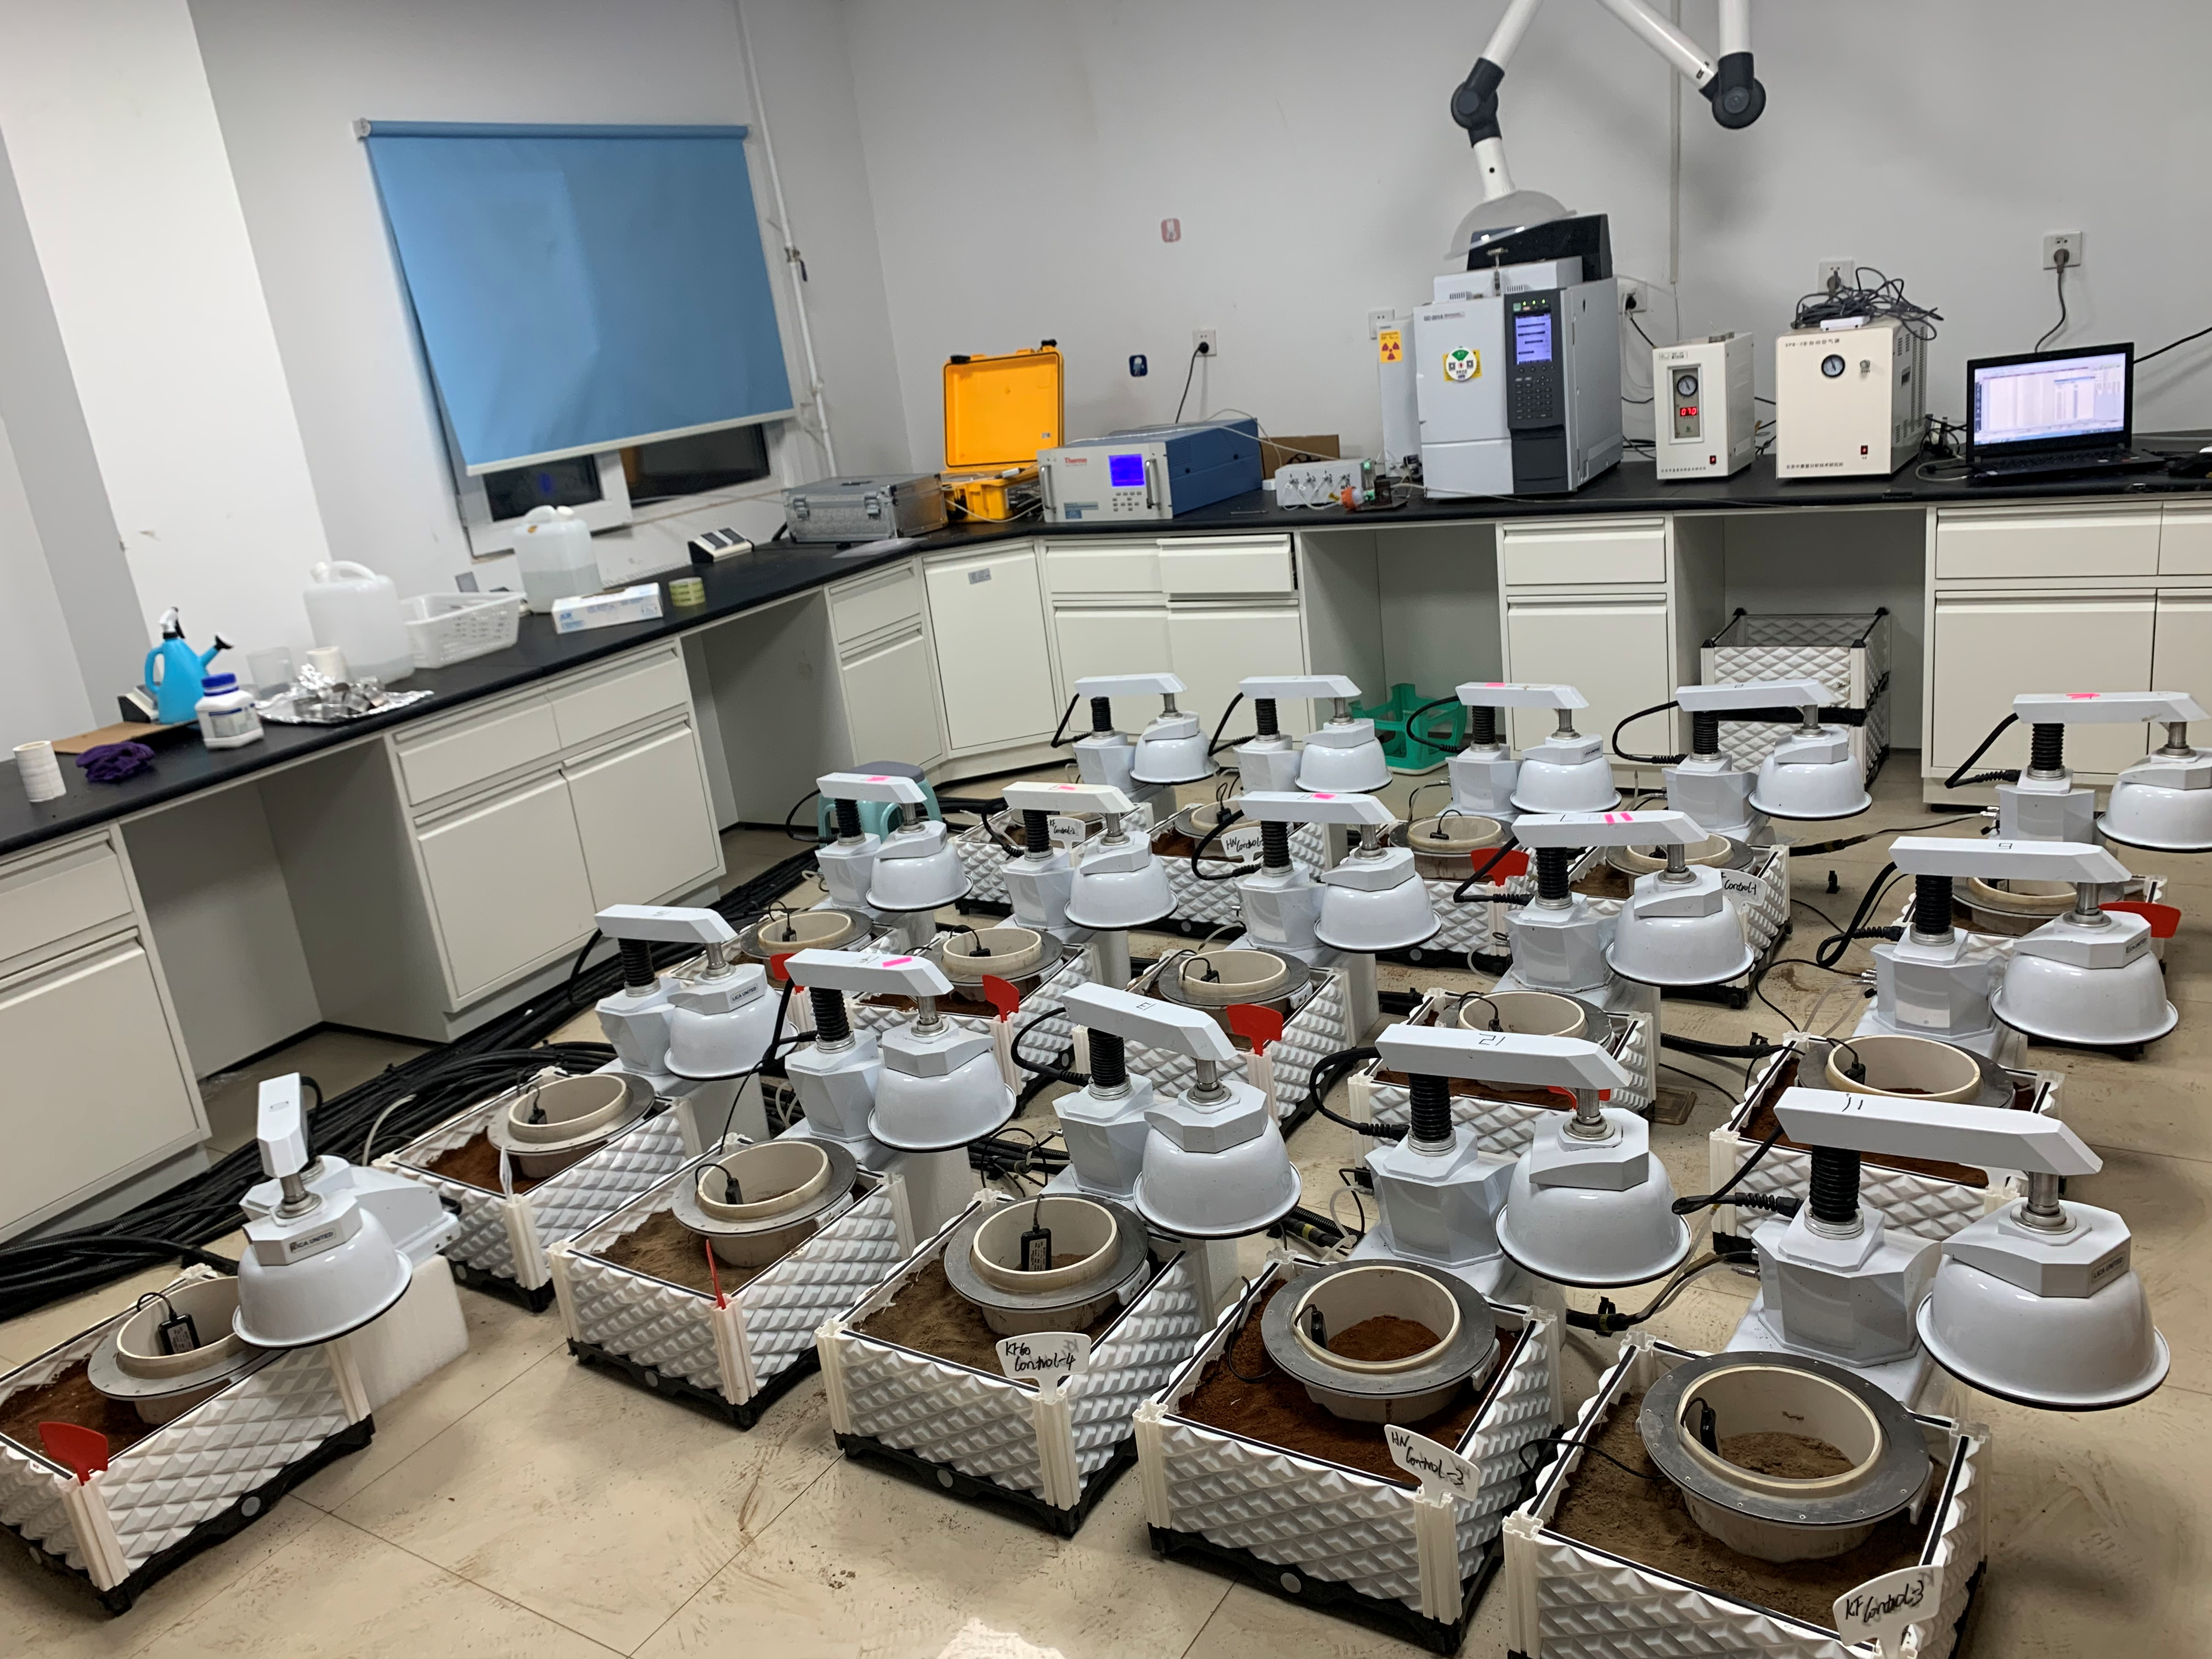
Fig. S1 A photo showing the soil incubation experiment in this study

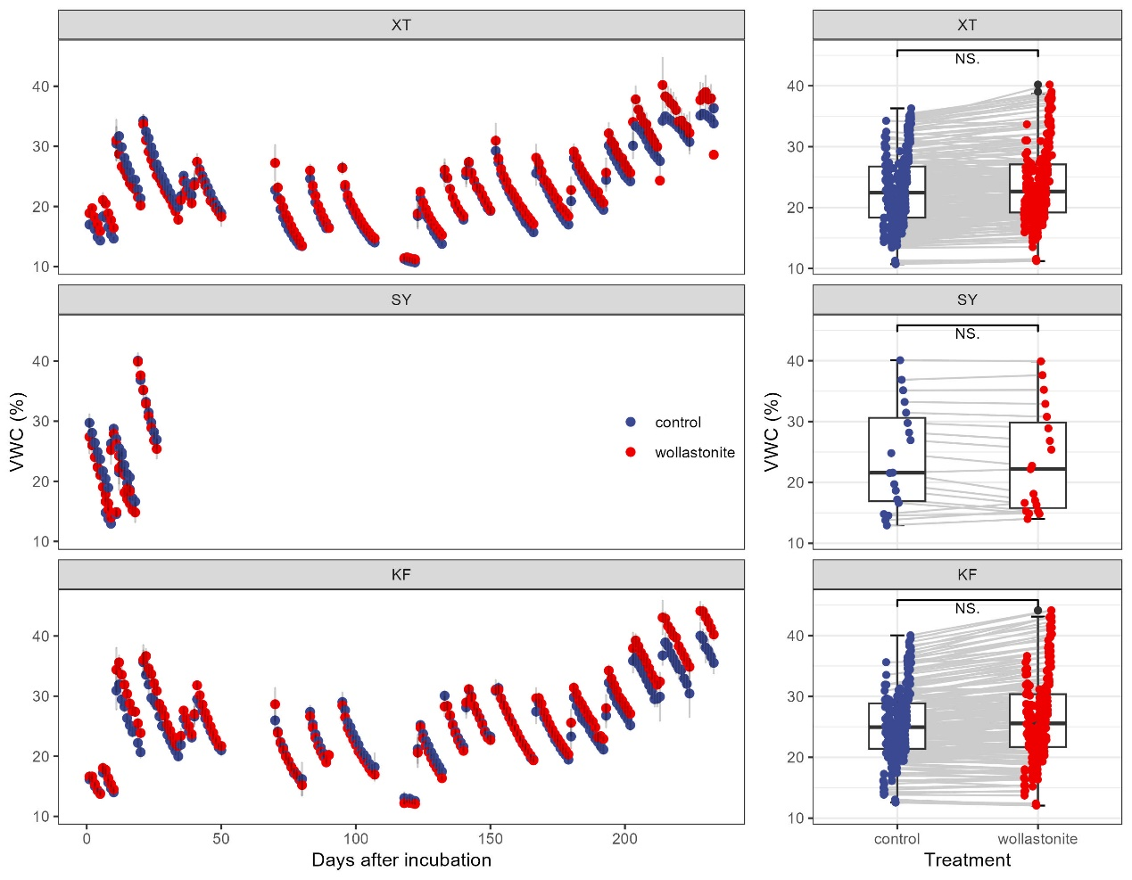
Fig. S2 Changes of daily soil moisture (expressed as VWC) in three soils during the experiment period (left plot). The box plot illustrating the distribution and variability of control and wollastonite addition treatment across multiple measurements from three type of soils. NS. in the right planes indicates no significant differences between control and wollastonite addition treatment.
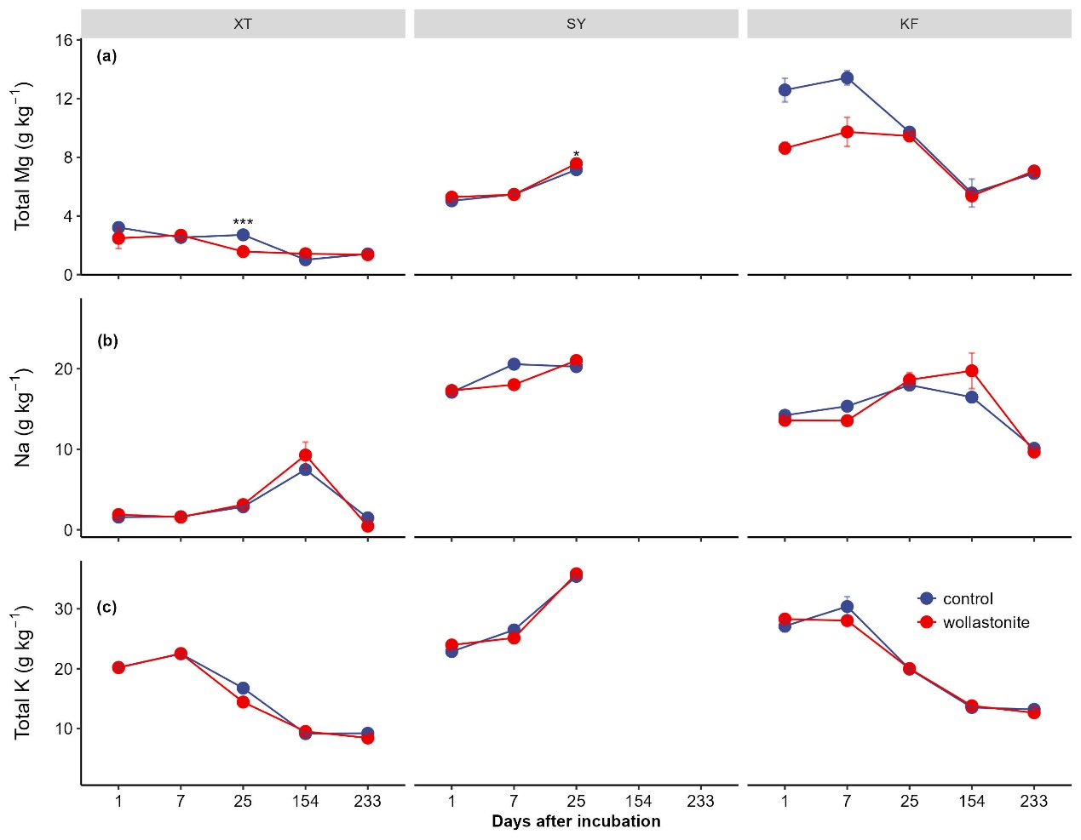
Fig. S3 Changes in content of total Mg, Na and K from three soils during the experiment period. Data shown are mean ± deviation (n = 4). Asterisks indicating statistical significance between control and wollastonite treatment at each sampling time: * = 0.01 < p < 0.05; ** = p < 0.01; *** = p < 0.001.
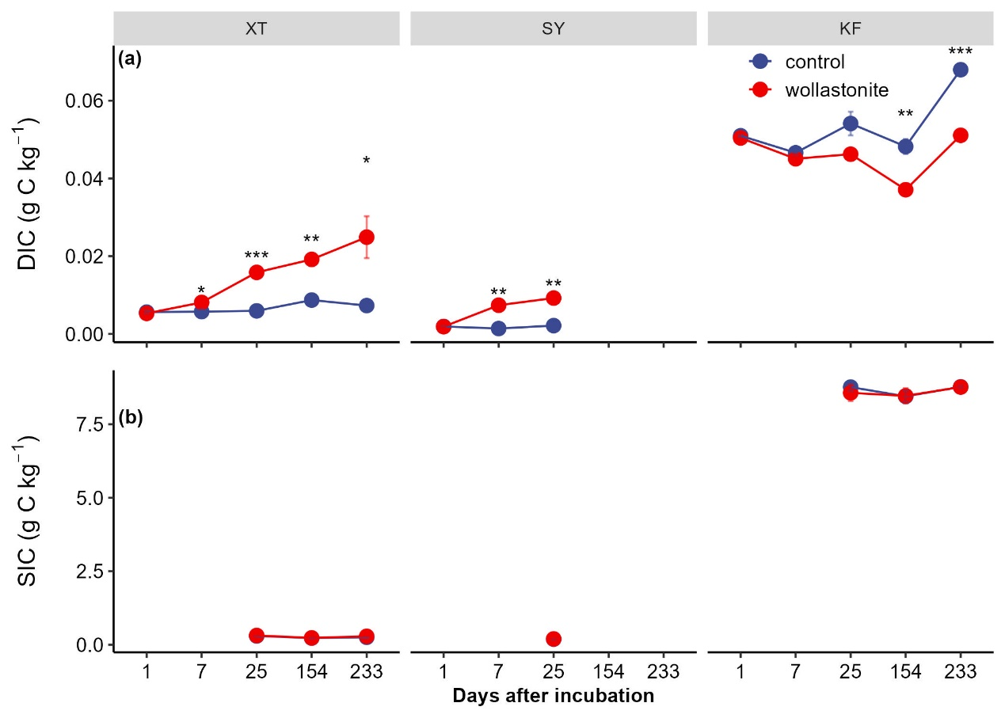
Fig. S4 Changes in DIC and SIC from three soils during the experiment period. Data shown are mean±deviation (n = 4). Asterisks indicating statistical significance between control and wollastonite treatment at each sampling time: * = 0.01 < p < 0.05; ** = p < 0.01; *** = p < 0.001.
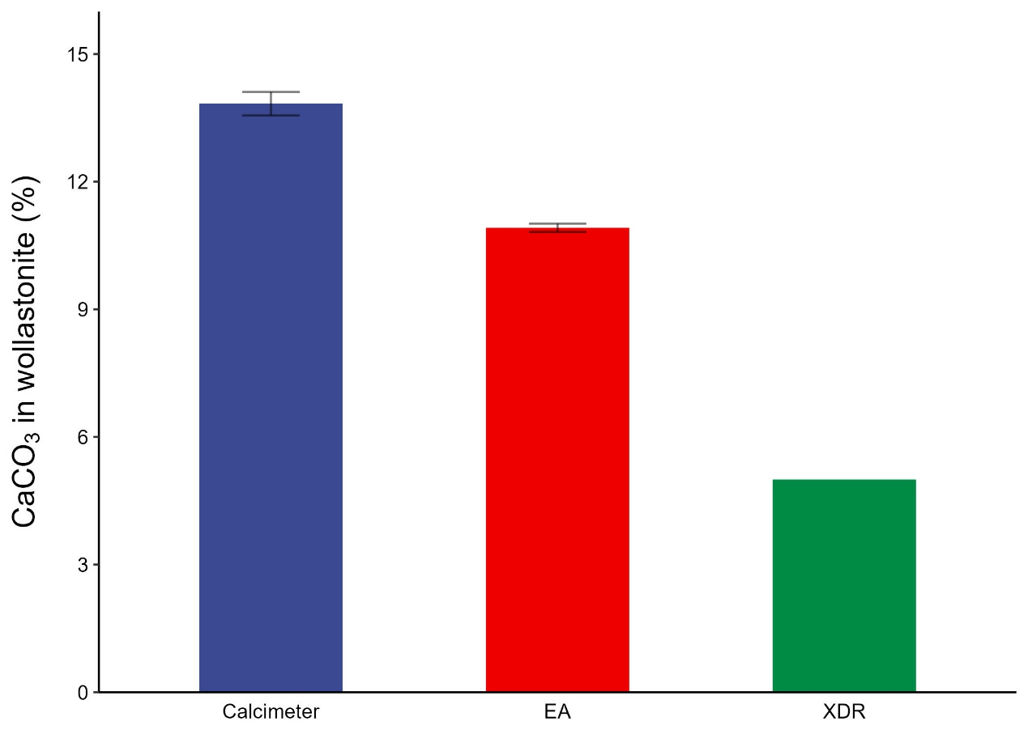
Fig. S5 Initial CaCO₃ contained in wollastonite used in the present study, compared three methods, Calcimeter, elemental analyzer and XDR, respectively.

