Ecoenzymatic stoichiometry reveals increased phosphorus limitation of microbial metabolism in tropical forests along elevation gradients
Luhui Kuang^{a,b,c}, Zhijian Mou^{a,b,c}, Yuanwen Kuang^{a,b}, Dexiang Chen^{d}, Jun Wang^{a,b,c}, Dafeng Hui^{e}, Hans Lambers^{f,} Josep Peñuelas^{g,h}, Jordi Sardans^{g,h}, Hai Ren^{a,b,c}, Zhanfeng Liu^{a,b,c*}
ªGuangdong Provincial Key Laboratory of Applied Botany, South China Botanical Garden, Chinese Academy of Sciences, Guangzhou 510650, China
^{b}Key Laboratory of National Forestry and Grassland Administration on Plant Conservation and Utilization in Southern China, South China Botanical Garden, Chinese Academy of Sciences, Guangzhou 510650, China
^{c}Guangdong Heshan National Observation and Research Station for Forest Ecosystem, South China Botanical Garden, Chinese Academy of Sciences, Guangzhou 510650, China
^{d}Research Institute of Tropical Forestry, Chinese Academy of Forestry, Guangzhou, 510520, China
^{e}Department of Biological Sciences, Tennessee State University, Nashville, TN 37209, USA
^{f}School of Biological Sciences, University of Western Australia, Perth, WA 6009, Australia
^{g}CSIC, Global Ecology Unit CREAF-CEAB-UAB, Cerdanyola del Valles, 08193 Catalonia, Spain
^{h}CREAF, Cerdanyola del Valles, 08193 Catalonia, Spain
*Corresponding author: Zhanfeng Liu
E-mail: liuzf@scbg.ac.cn; Tel: +86-20-37252592; ORCID: 0000-0002-6602-6196

Fig.S1 Extracellular soil absolute enzyme activities along elevation gradients in DHSBR, LHSNR and JFLNR. Values are means ± standard errors (n=5). ns, not significant; ***, p < 0.001. BG, β-1,4-glucosidase; NAG, β-N-acetyl glucosaminidase; AP, Acid phosphatase.

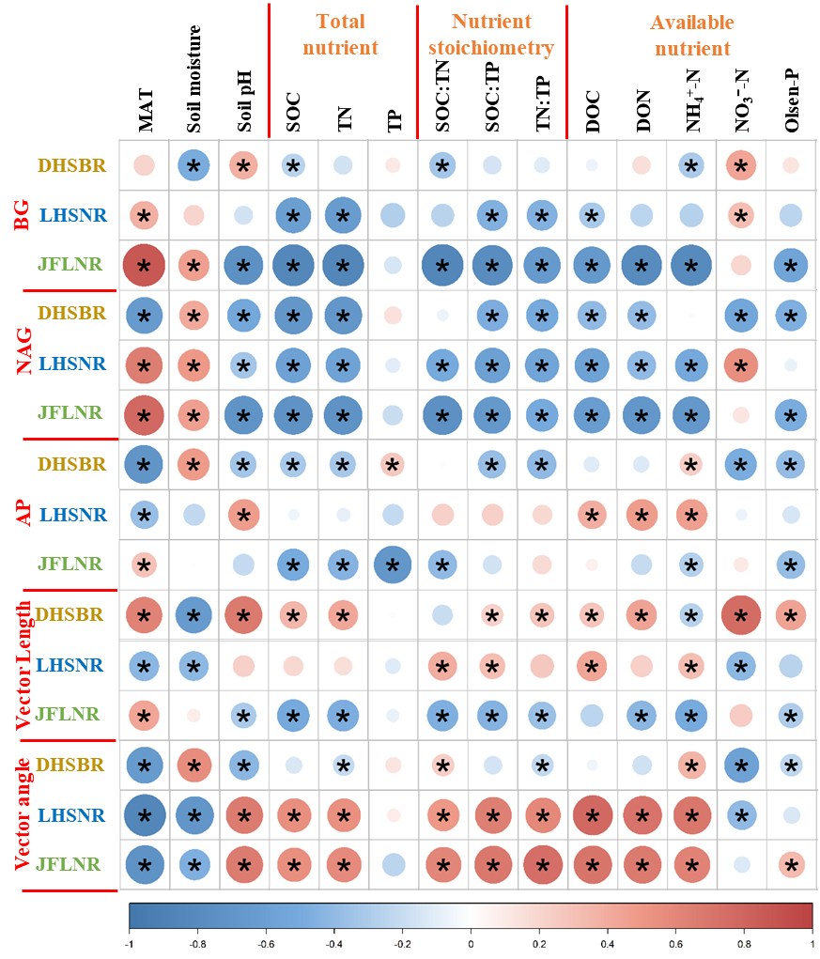
Fig.S2 Pearson correlation of environmental factors with extracellular soil enzyme activities and microbial metabolic limitations in DHSBR, LHSNR and JFLNR. The scale bar represents the correlation coefficient. Colored circles with * represent a significant correlation at p < 0.05, and the circle sizes means the correlation coefficient values. BG, β-1,4-glucosidase; NAG, β-N-acetyl glucosaminidase; AP, Acid phosphatase; vector length vector length indicates microbial C limitation; vector angle indicates microbial N/P limitation. MAT, mean annual temperature; SOC, soil organic carbon; TN, total nitrogen; TP, total phosphorous; DOC, dissolved organic carbon; DON, dissolved organic nitrogen; NH₄⁺-N, ammonium nitrogen; NO₃⁻-N, nitrate nitrogen; Olsen-P, soil available phosphorus.

