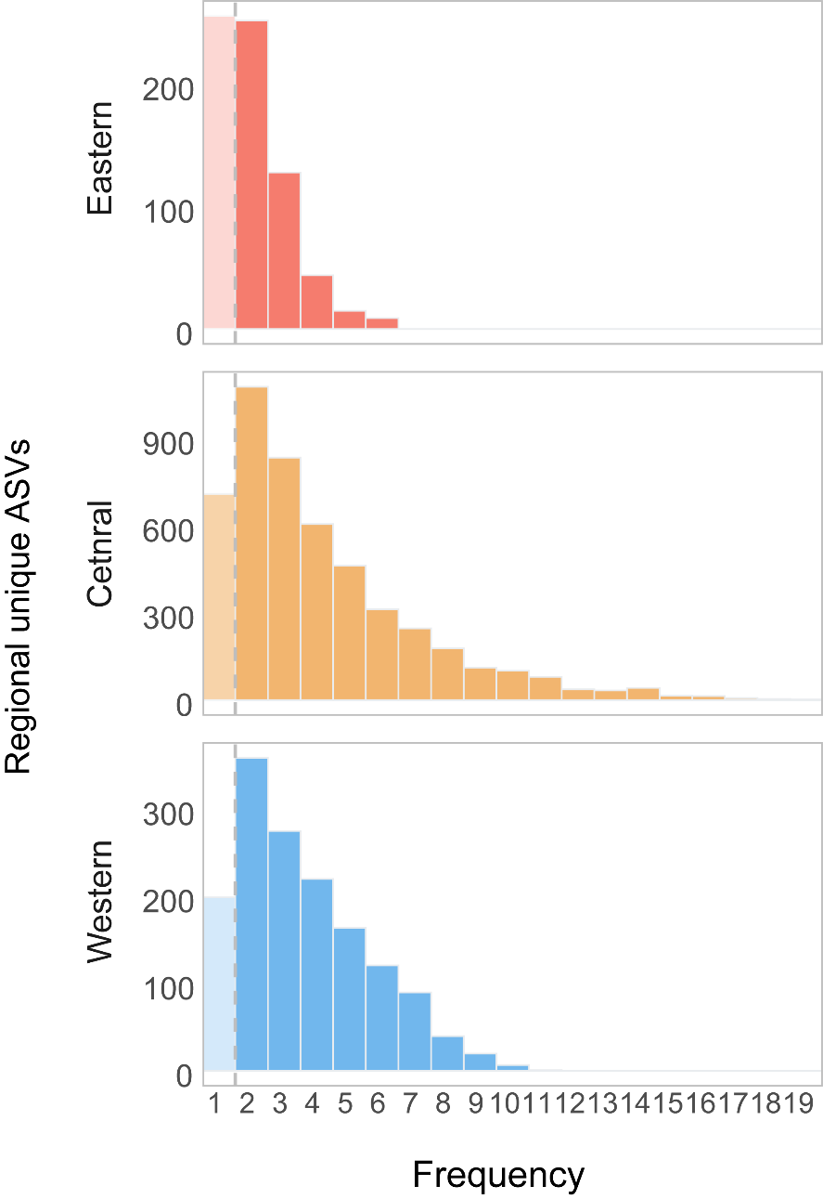
Fig.S1. Occurrence frequency of bacteria ASVs across sites within this region.

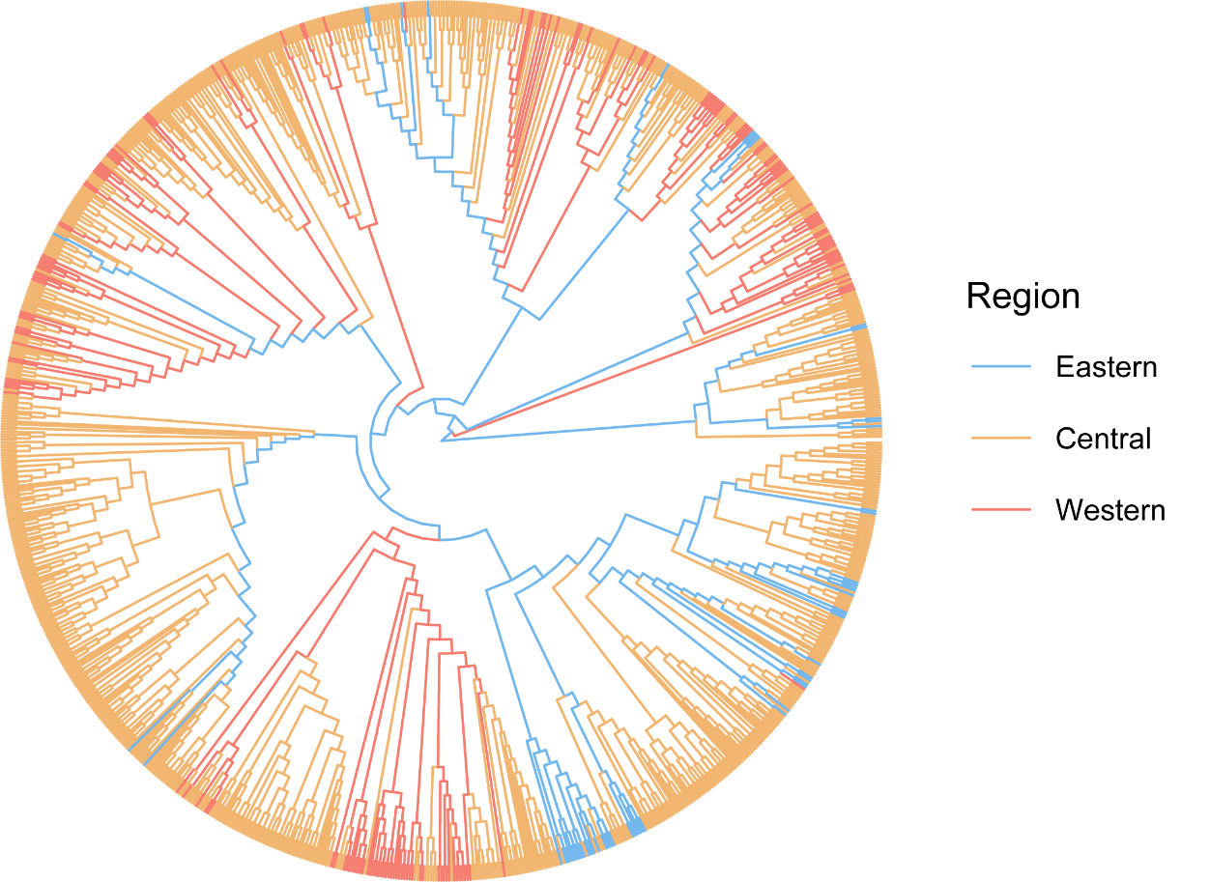
Fig.S2. The phylogenetic tree of regional unique Chloroflexi group across three regions.
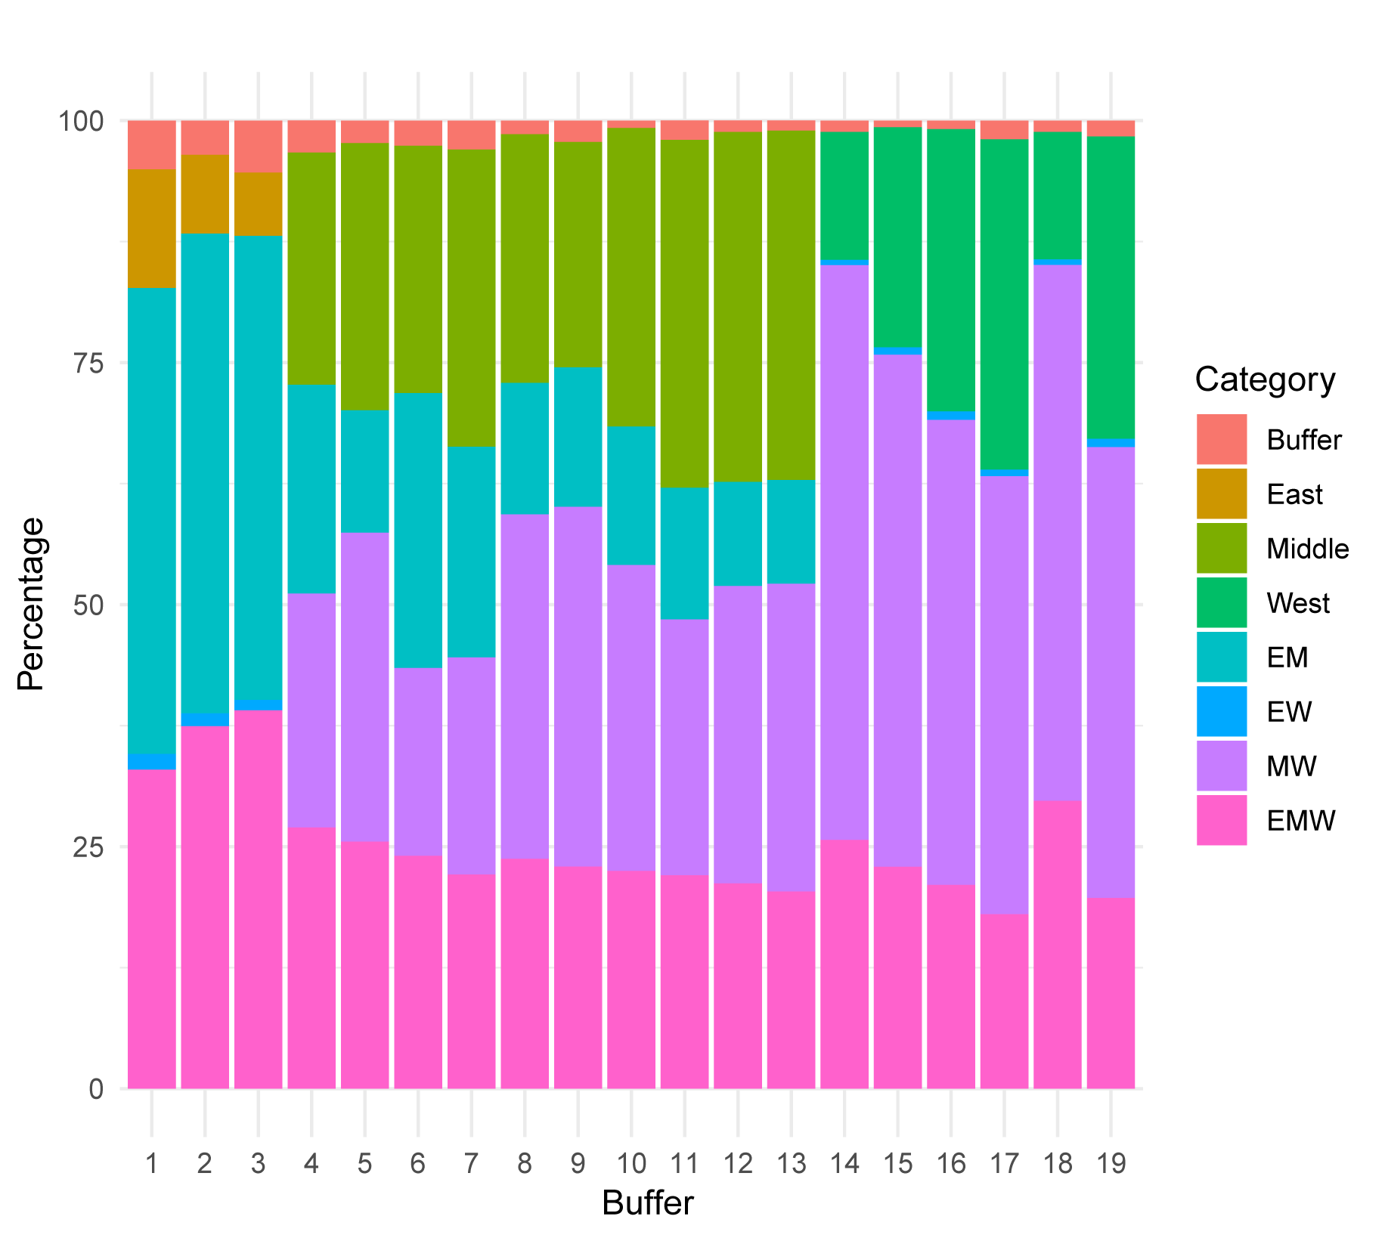
Fig.S3. The distribution of the site ASVs pool across three regions. Buffer: only occurs in this site, East: only occurs in the eastern area, Middle: only occurs in the central area, West: only occurs in the western area, EM: occurs in both eastern and central areas, EW: occurs in both eastern and western areas, MW: occurs in both central and western areas, EMW: occurs in eastern, central, and western areas.

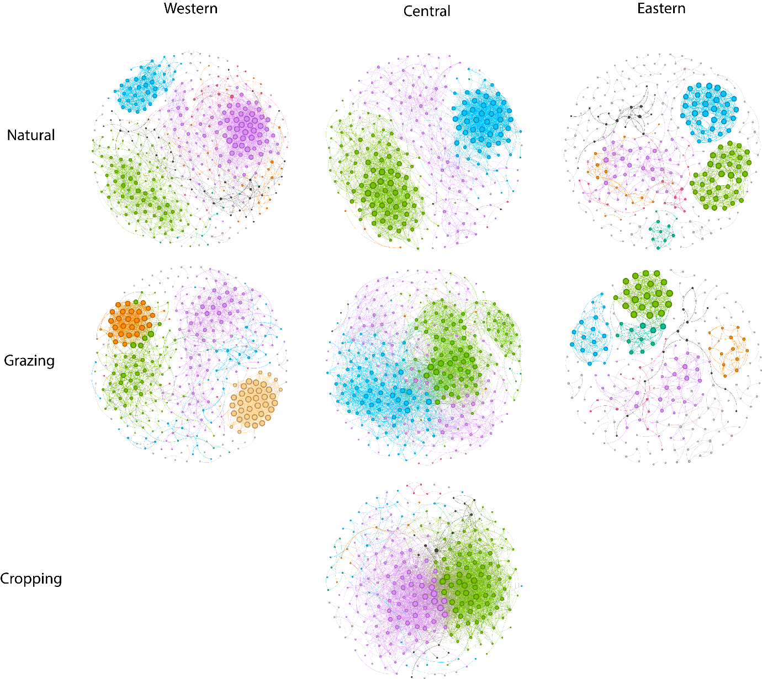
Fig.S4. Bacterial co-occurrence networks in three regions affected by different land uses. In the networks, each node represents an individual ASV, and the size of the node corresponds to its degree. The edges represent significant Spearman correlations (with a ρ > 0.7 and P < 0.01). Modules are labelled with different colours in each network.

Fig.S5. Relationship between bacterial diversity (PCoA1 and PCoA2) with environmental factors.

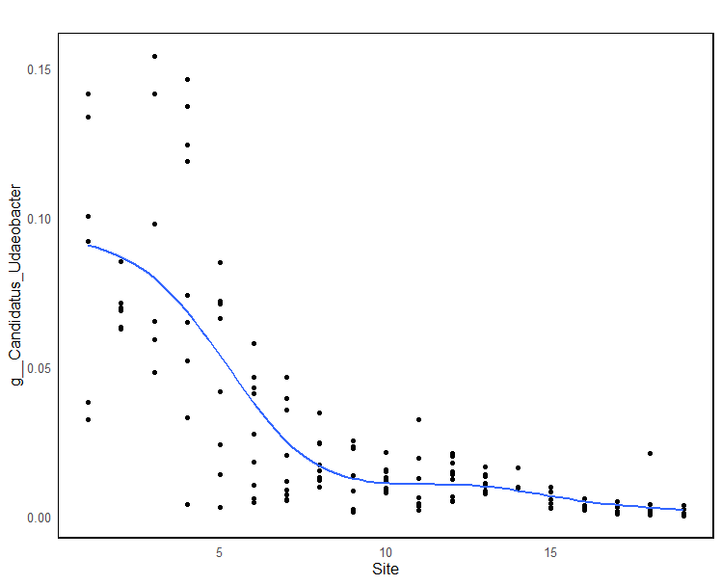
Fig.S6. The change of relative abundance of Candidatus_Udaeobacter along the transect from the Eastern to Western

Table.S1 Co-occurrence networks indexes of soil bacteria community in different land use for the three regions, respectively.
 |  | Nodes | Edges | Average  degree | Average_  path_length | Network  _diameter | Clustering  _coefficient | Density | Heterogeneity | Centralization | Modularity
Western | Natural | 378 | 2365 | 12.513 | 3.672 | 10 | 0.611 | 0.033 | 0.948 | 0.094 | 0.615
 | Grazing | 345 | 1768 | 10.249 | 4.74 | 11 | 0.76 | 0.03 | 1.042 | 0.069 | 0.694
Central | Natural | 266 | 2048 | 15.398 | 2.861 | 8 | 0.686 | 0.058 | 0.909 | 0.131 | 0.584
 | Grazing | 308 | 2923 | 18.981 | 2.393 | 8 | 0.511 | 0.062 | 0.817 | 0.163 | 0.448
 | Cropping | 262 | 2835 | 21.641 | 2.19 | 7 | 0.539 | 0.083 | 1.026 | 0.231 | 0.303
Eastern | Natural | 302 | 928 | 6.146 | 3.21 | 11 | 0.723 | 0.02 | 1.034 | 0.053 | 0.773
 | Grazing | 219 | 587 | 5.361 | 3.241 | 10 | 0.806 | 0.025 | 1.073 | 0.076 | 0.767

