Supplementary materials for
Newly Discovered Tetrataenite in Chang'E-6 Lunar Soil: A Potential Carrier Mineral for Magnetic Anomalies

Rui Li¹, Chen Li², Yang Li^{1*}, Dongsheng Song³, Zhenhao Hu^{1,4}, Li Liu⁵, Xiongyao Li¹, Jianzhong Liu¹, Shijie Wang¹, and Ziyuan Ouyang¹

¹Center for Lunar and Planetary Sciences, Institute of Geochemistry, Chinese Academy of Sciences, Guiyang 550081, China.
²School of Engineering, Yunnan University, Kunming 650500, China
³Institutes of Physical Science and Information Technology, Anhui University, Hefei 230601, China.
⁴College of Earth and Planetary Sciences, University of Chinese Academy of Sciences, Beijing 101408, China.
⁵Deep Space Exploration Lab, Beijing 100195, China.
* Correspondence to: liyang@mail.gyig.ac.cn

This file includes:
Supplementary Figs. 1-6
Supplementary Table 1

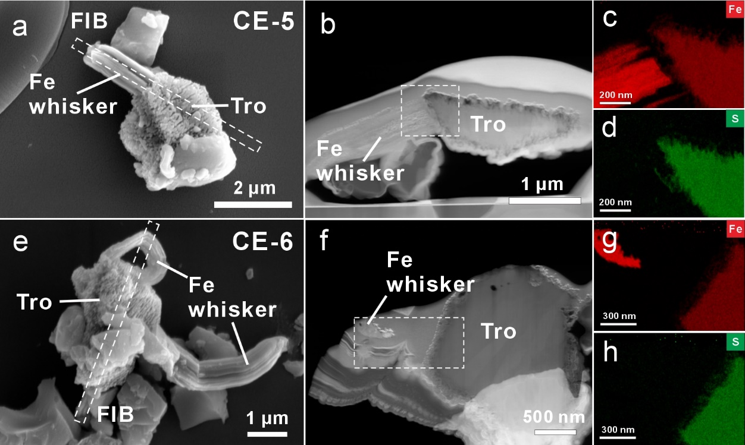
Fig. S1 Morphology and composition of iron-sulfide grains in Chang’E-5 (CE-5) and Chang’E-6 (CE-6) lunar soils. (a, e) Scanning electron microscopy images of iron-sulfide grains in the CE-5 and CE-6 lunar soils, respectively. The white dot rectangles indicate the extraction locations of the focused ion beam (FIB) sections. (b, f) High angle annular dark-field (HAADF) images of FIB foils in panel a and e, respectively. Quantitative energy-dispersive spectroscopy (EDS) element maps of Fe (c) and S (d) from the white dashed box in panel b, as well as Fe (g) and S (h) from the white dashed box in panel f.

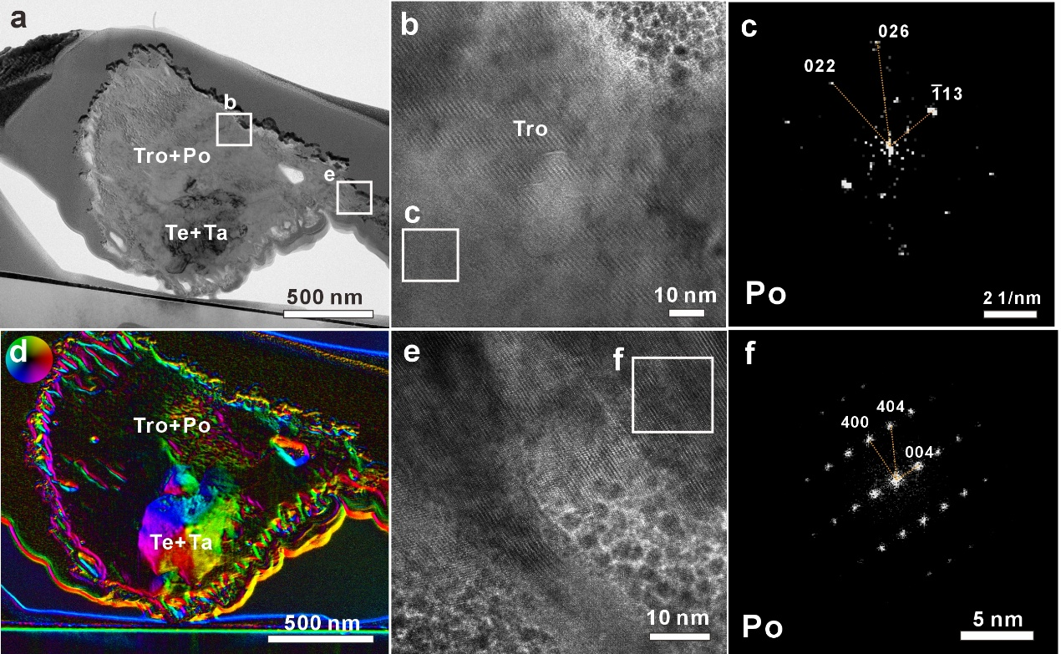
Fig. S2 Crystal structure determination of pyrrhotite and magnetic measurement results of magnetic minerals. (a) Bright-field TEM image of the iron-sulfide grain in CE-6 lunar soil. (b,c) high-resolution TEM image and SEAD pattern of the middle region at the top of the grain show a weakly pyrrhotite. (d) Magnetic property test results of different minerals. (e,f) high-resolution TEM image and SEAD pattern of the edge region at the right of the grain show a pyrrhotite.

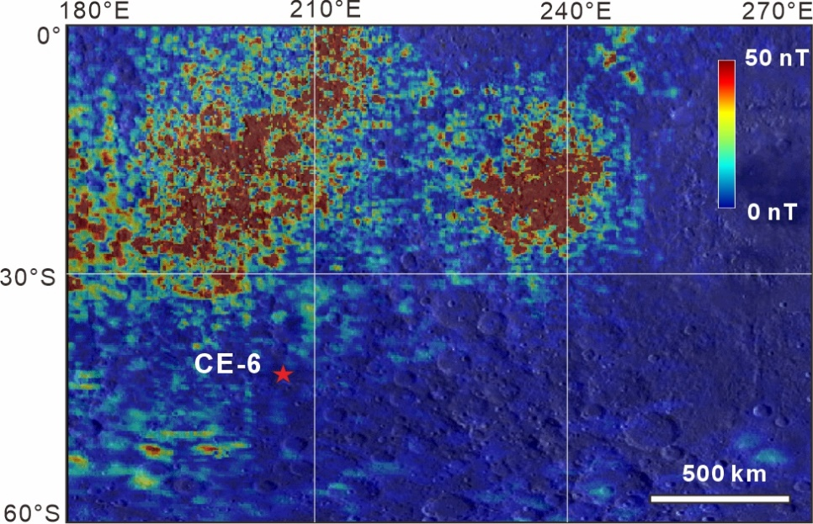
Fig. S3 Local total intensity of the lunar magnetic anomaly map on the farside of the Moon. The magnetic field data sourced from Kaguya and Lunar Prospector magnetometers. The red pentagram denotes the CE-6 landing site.

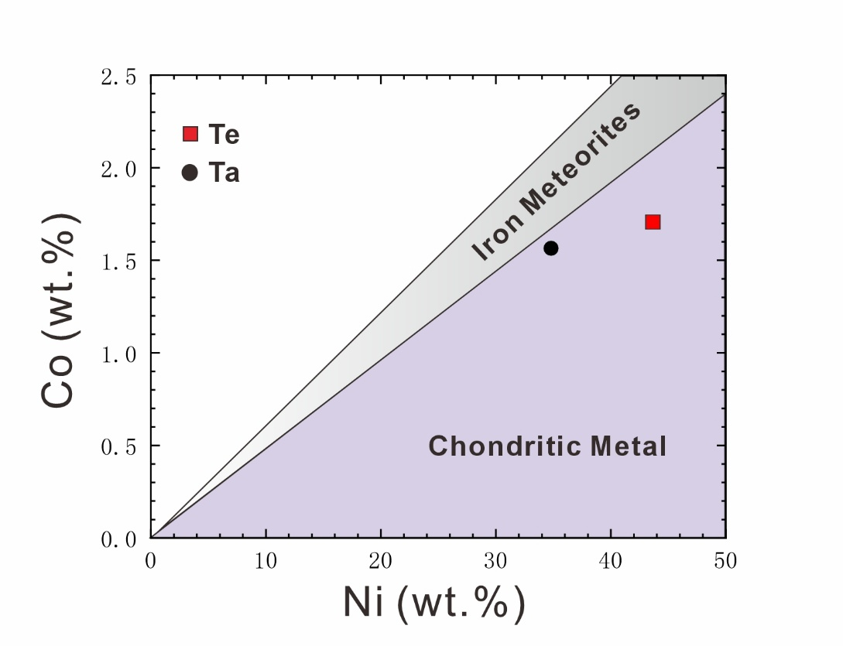
Fig. S4 Nickel versus cobalt diagram for FeNi metal grain in CE-6 lunar soil. The classification of shadow areas is referenced from James M. D. DAY (2020).

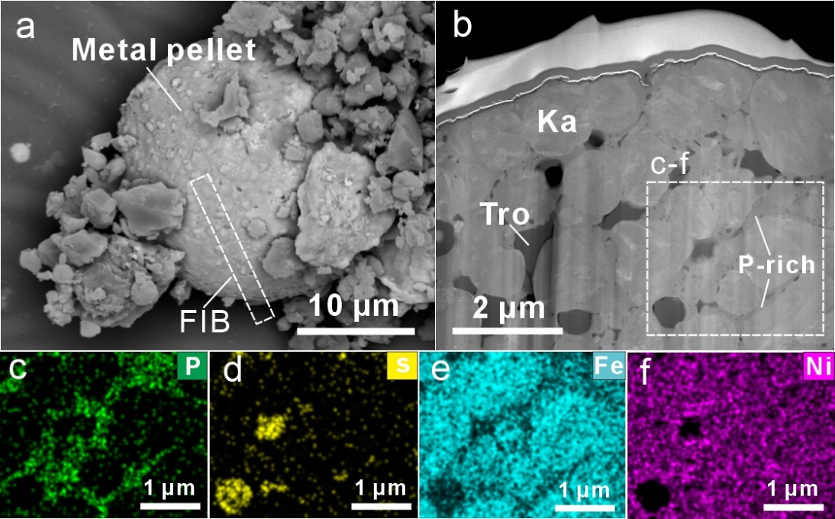
Fig. S5 An Fe–Ni metal grain in CE-6 lunar soil. (a) SEM image of an Fe–Ni metal pellet in CE-6 lunar soil. The white dotted box indicates the extraction location of an FIB foil. (b) HAADF image of the TEM foil of the Fe–Ni metal. Kamacite (Ka) and troilite (Tro) particles are mixed with P-rich melt. (c-f) Quantitative EDS element maps of phosphorus (P), sulfur (S), iron (Fe), and nickel (Ni), corresponding to the image in the dotted box in panel b.

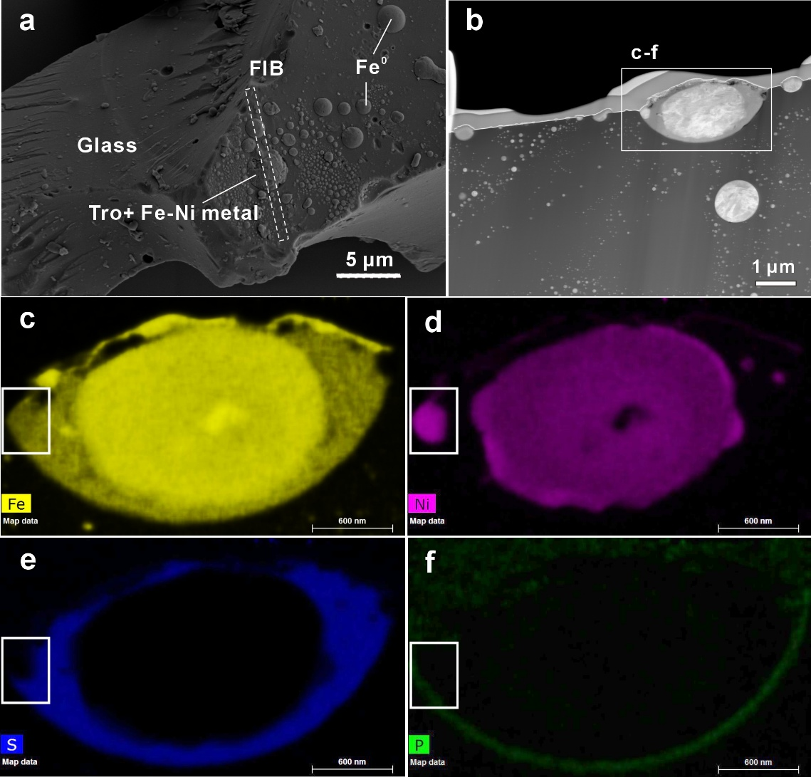
Fig. S6 An impact glass particle in CE-6 lunar soil. (a) SEM image of an impact glass particle in CE-6 lunar soil. The white dotted box indicates the extraction location of an FIB foil. (b) HAADF image of the TEM foil. (c-f) Quantitative EDS element maps of iron (Fe), nickel (Ni), sulfur (S), and phosphorus (P), corresponding to the image in the white box in panel b.

Table S1 Quantitative TEM-EDS analyses of various phases in the iron-sulfide grain
 | Te (10) | Ta (9) | Fe⁰ (2) | Fe whisker (1) | Tro+Po (3)
Fe | 51.01 | 58.59 | 88.24 | 97.40 | 49.86
Ni | 40.70 | 32.15 | 2.32 | 0.08 | 0.71
S | 0.65 | 2.36 | 1.13 | 0.67 | 41.29
Co | 1.58 | 1.44 | 1.85 | - | 1.55
O | 4.30 | 4.18 | 4.30 | 0.65 | 6.00
Si | 1.76 | 1.28 | 2.16 | 0.67 | 1.62
Number in brackets is the number of EDS analyses performed in different regions.
All data is the average value obtained by normalizing the initial measured data (at. %).

