Responses to the Comments
[paper Manu ID: 2025-11-0004]：Atmospheric Composition and the Feasibility of In-Situ Resource Utilization on Venus
Dear Editor and Reviewers,
Thank you for taking the time to review the manuscript 2025-11-0004 titled " Atmospheric Composition and the Feasibility of In-Situ Resource Utilization on Venus. " We sincerely appreciate your valuable comments and constructive suggestions, which have significantly improved the quality of our work.
We have carefully revised the manuscript based on your feedback. Below, we provide a detailed, point-by-point response to each of the comments. The comments are presented in black italic, while our replies are shown in blue. All changes in the manuscript have been highlighted in yellow for clarity and are presented in this response.
We hope that the revised manuscript adequately addresses all the issues raised and meets the standards of the journal. Thank you again for your time and effort in reviewing our work. We look forward to your feedback on the revised version.

Sincerely,
The authors

Editor comments:
- Insufficient Discussion on Innovation and Comparative Analysis: It is recommended to explicitly highlight the technological advancements of the proposed solution compared to existing missions (e.g., NASA's DAVINCI and Venera-D). For instance, the advantages of the proposed system in terms of sensitivity, stability, and volume/power efficiency should be emphasized. A dedicated section at the end of the "Introduction" summarizing the limitations of current Venus atmospheric exploration technologies and clearly stating the breakthroughs of this study would strengthen the argument
Response: Thank you for your suggestion. In paragraphs 135 to 139 of the "Introduction" section, we have listed the gas detection precision of NASA's DAVINCI and Russia's Venera-D mission
Line135: The laser spectrometer onboard NASA's DAVINCI mission demonstrates limited measurement precision, with an accuracy of less than 2% for gases such as H₂O, SO₂, and H₂S, and a D/H isotope precision lower than 2‰. However, it lacks the capability to detect other trace gases, such as PH₃ and NH₃, which are critical for understanding the atmospheric composition and potential chemical processes of Venus. While the Venera-D mission is designed to measure several key atmospheric components, the detection accuracy of its instruments has yet to be disclosed.
- Lack of Details on the Enrichment Module: The manuscript mentions the enrichment of SO₂, PH₃, and CH₄. However, CH₄ is not listed as a primary target gas elsewhere in the paper. Please clarify which gases are specifically targeted for enrichment in the proposed system
Response: Thank you for your suggestion. The primary gases targeted for enrichment in the paper are NH₃, H₂S, and PH₃.
Line296: The enrichment module is designed to achieve efficient concentration of trace gases in Venus’s atmosphere, such as NH₃, H₂S, and PH₃. This module operates using a two-stage adsorption process: first, a molecular sieve is employed to efficiently adsorb the background gas CO₂ (with an adsorption selectivity ratio greater than 100:1); subsequently, the trace target gases are captured by another molecular sieve with high selectivity for these species. The main body of the module adopts an adsorption bed structure, internally packed with molecular sieves. During the adsorption process, a vacuum pump assembly drives the gas flow through the adsorption bed, while the pressure is regulated to optimize adsorption efficiency. This process lasts approximately 5 minutes, during which the target trace gases are efficiently captured.
- Insufficient Explanation of Data Acquisition and Operational Modes: The paper presents two operational modes: remote sensing and in-situ detection, which is a significant advantage. It is recommended to provide a clearer explanation of how these two modes will work synergistically during the mission. For example, will the remote sensing mode be used to identify "hotspot" regions of interest, guiding the platform (such as an orbiter or aerostat) to deploy the in-situ detection module to target areas? Additionally, how long is the expected duration for a complete in-situ measurement cycle, including sampling, filtration, enrichment, and spectral analysis
Response: Thank you for your suggestion. The synergistic operation of the remote sensing mode and in-situ detection mode has been explained in detail in the article.
Line176: In the remote sensing mode, the orbiter is oriented toward the Sun. Solar radiation passing through the Venusian atmosphere enters the laser spectrometer and is heterodyned with a wavelength-tunable local oscillator laser. This configuration retrieves key information about the major atmospheric components, macroscopic structure, and dynamic evolution of the Venusian atmosphere. The orbiter will conduct four flybys around Venus, enabling observations of the upper atmosphere. The remote sensing mode will be used to identify areas of interest, guiding the orbiter to deploy the instruments to target regions.
In the in-situ detection mode, Atmospheric gas molecules first pass through a series of preprocessing modules, including filtration and enrichment, before entering spectroscopic detection. Below 70 km in the atmosphere, sampling, filtration, enrichment, and spectral analysis will be conducted, with an estimated total duration of 2 hours, of which the spectral detection will take approximately 30 minutes.
- Issues with Figures: In Figure 12, the label (d) for the H₂O spectral simulation line should be (c) H₂O, while the label (c) for the H₂S spectral simulation should be (d) H₂S.
Response: Thank you for your suggestion. We have corrected the labels in Figure 12. 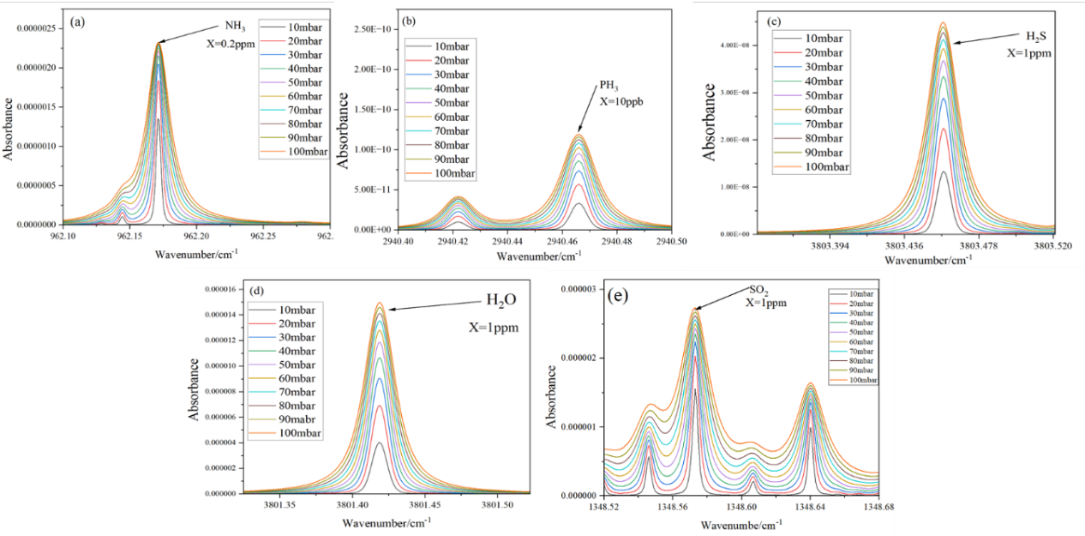
Fig.12 Spectral simulation calculation diagram under pressures ranging from 10 mbar to 100 mbar. (a) NH₃ gas simulation at a concentration of 0.2 ppm, (b) PH₃ gas simulation at a concentration of 10 ppb, (c) H₂S gas simulation at a concentration of 1 ppm, (d) H₂O gas simulation at a concentration of 1 ppm, (e) SO₂ gas simulation at a concentration of 1 ppm.

