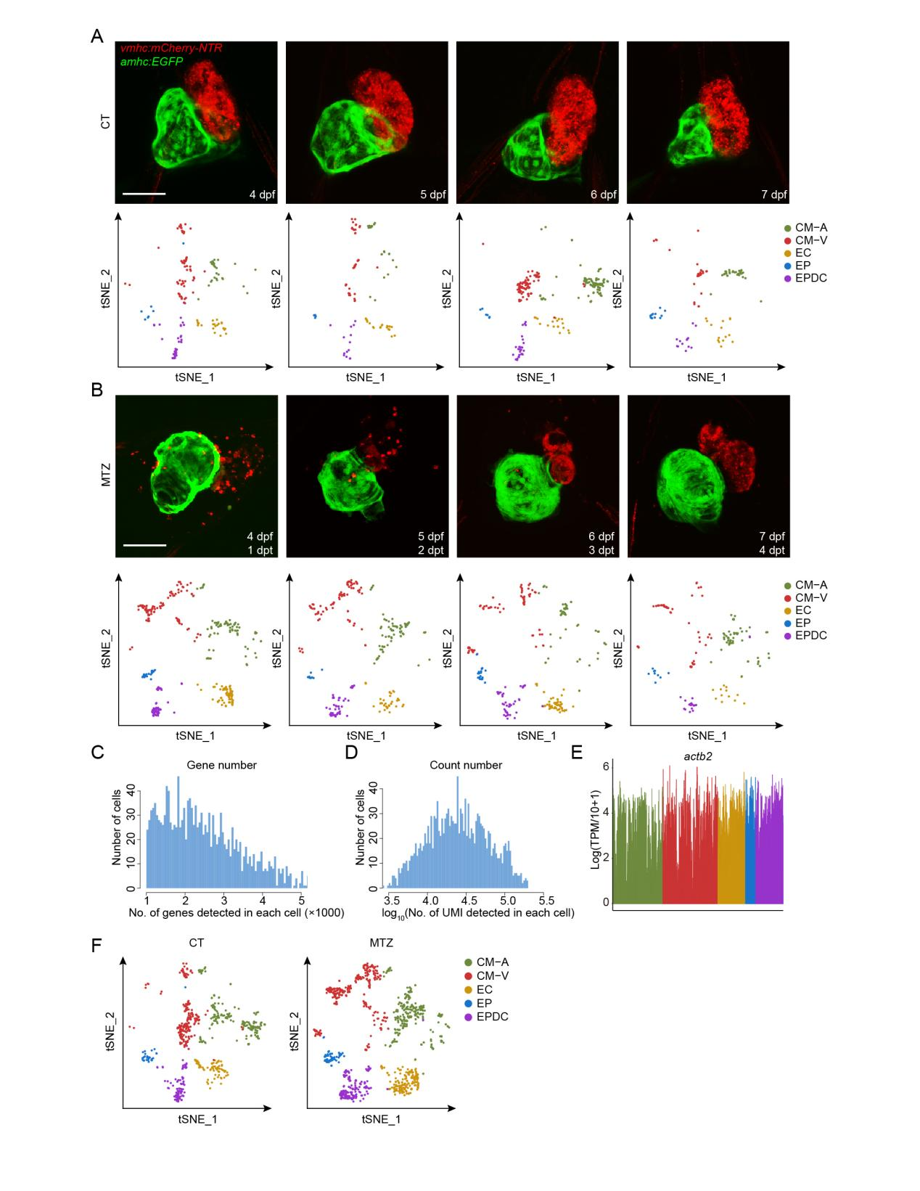Figure S1. Genetic ablation of ventricular CM causes specific ventricular CM death and subsequent regeneration in the zebrafish embryo.
(A and B) Maximum intensity projections of Tg(vmhc:mCherry-NTR; amhc:EGFP) zebrafish embryos, showing the process of normal heart development (A) and cardiac regeneration after MTZ treatment (B). Alongside, t-SNE analysis showed the distribution of cells at the corresponding developmental or regeneration stage. Cluster identification and t-SNE coordinates are the same as in Figure 1B. dpt, days post-treatment. Red, ventricular cardiomyocytes; Green, atrial cardiomyocytes; Scale bar, 50 μm.
(C and D) Histograms showing the distribution of numbers of genes (C) and unique molecular identifiers (UMI) (D) detected in each cell.
(E) Line plot showing the uniform expression pattern of housekeeping gene actb2 in all sequenced cells.
(F) Separate t-SNE maps of cells from Fig. 1B, showing the distribution of untreated (CT) and MTZ-treated cells in zebrafish embryos. Each dot represents one cell and colored by clusters.

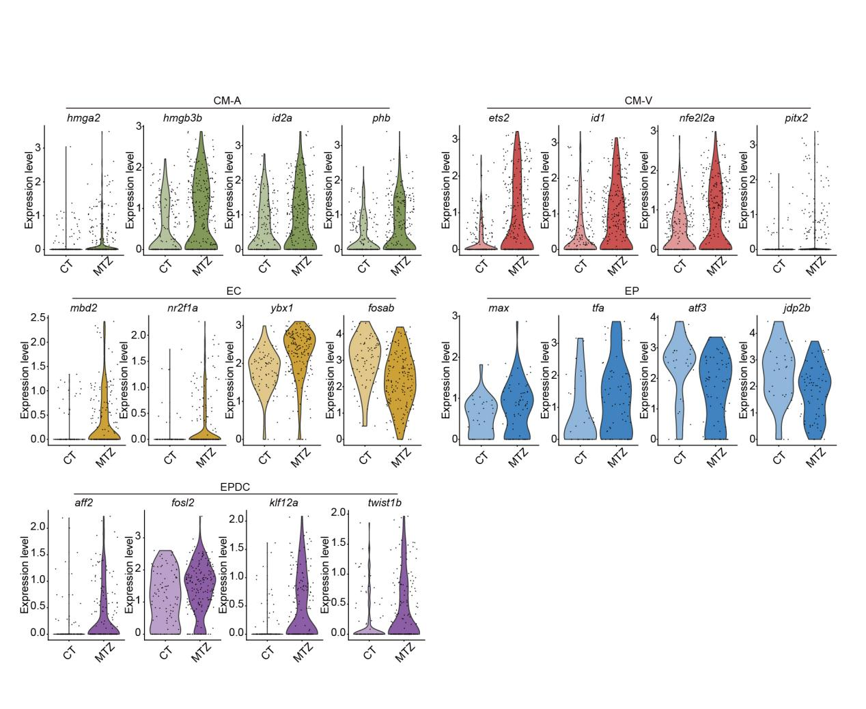Figure S2. Representative differentially expressed transcription factor genes during zebrafish heart development and regeneration derived from scRNA-seq data.
Violin plots showing representative transcription factor genes differentially expressed in CT and MTZ cells from CM-A, CM-V, EC, EP or EPDC clusters.

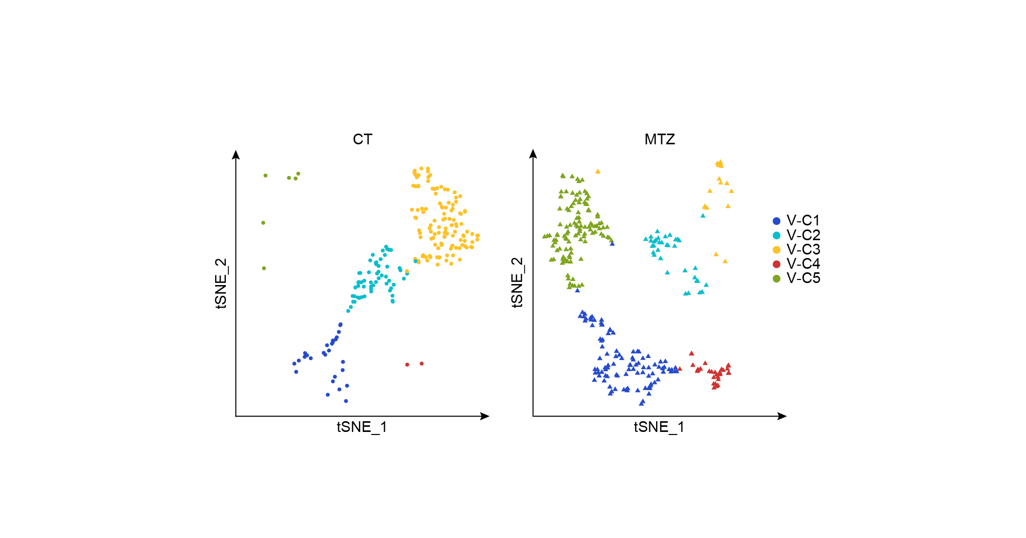Figure S3. t-SNE analysis of CM-V during zebrafish heart development and regeneration.
Separate t-SNE maps of CM-V populations from Fig. 2A, showing the distribution of untreated (CT) and MTZ-treated CM-V cells in zebrafish embryos. Each dot represents one cell, and colored by clusters and shaped by sample conditions. n = 510 cells.

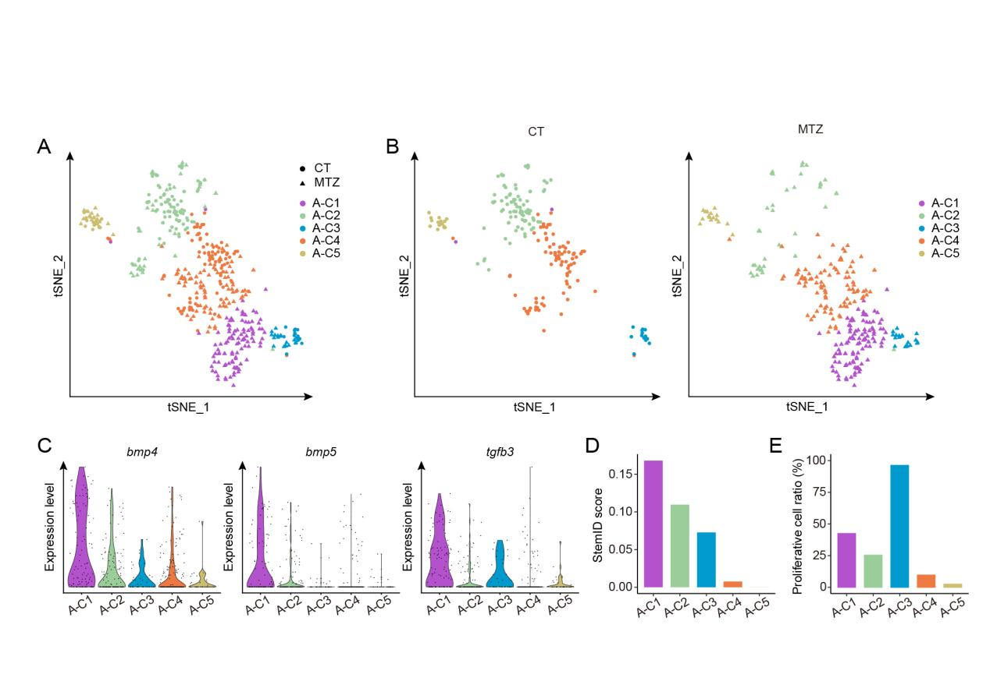Figure S4. Molecular characteristics of atrial cardiomyocytes during larval zebrafish heart regeneration.
(A) t-SNE analysis results of CM-A from both untreated (CT) and MTZ-treated zebrafish embryos, colored by clusters and shaped by sample conditions.
(B) Separate t-SNE maps of CM-A from (A), showing the distribution of cells from untreated (CT) and MTZ-treated zebrafish embryos, colored by clusters and shaped by sample conditions.
(C) Violin plots showing the expression patterns of bmp4, bmp5, and tgfb3 in different subpopulations of CM-A.
(D and E) StemID analysis (D) and cell cycle analysis (E) of CM-A subpopulations.

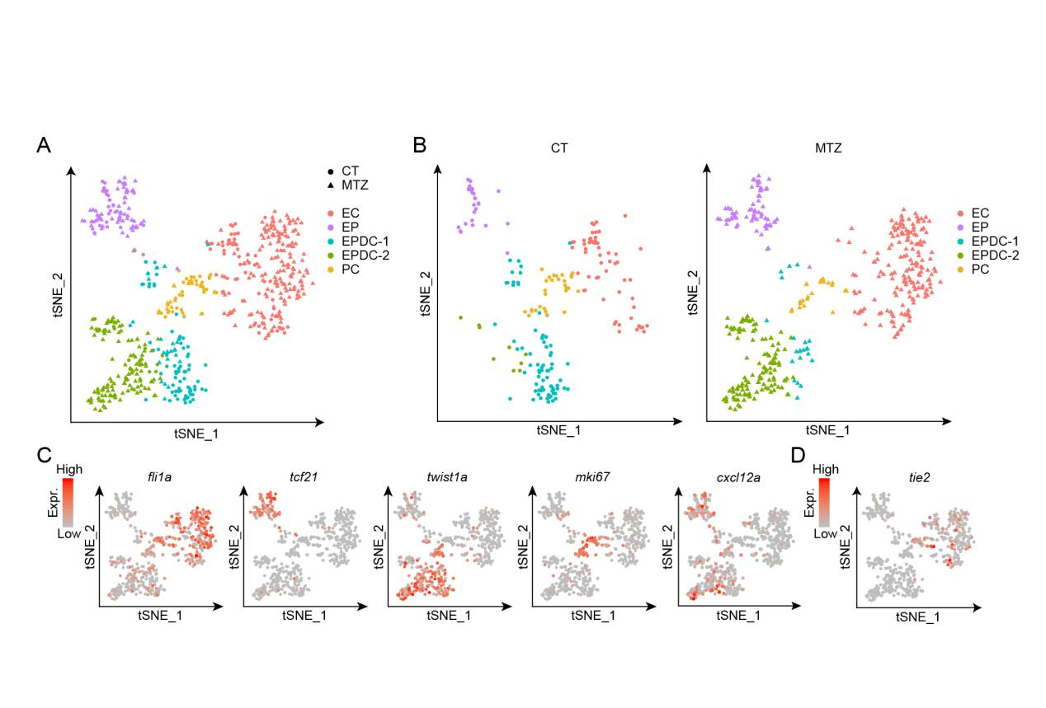Figure S5. Molecular features of the non-muscle cardiac cells during zebrafish heart development and regeneration.
(A and B) t-SNE analysis showing heterogeneity of the non-muscle cardiac cells, shaped by experimental conditions (CT or MTZ). The EPDC could be subdivided into two clusters, EPDC-C1 and EPDC-C2. CT, untreated control embryos; MTZ, MTZ-treated embryos.
(C) The expression pattern of some non-muscle cardiac cell marker genes displayed in the t-SNE map.
(D) t-SNE map showing the expression pattern of tie2.

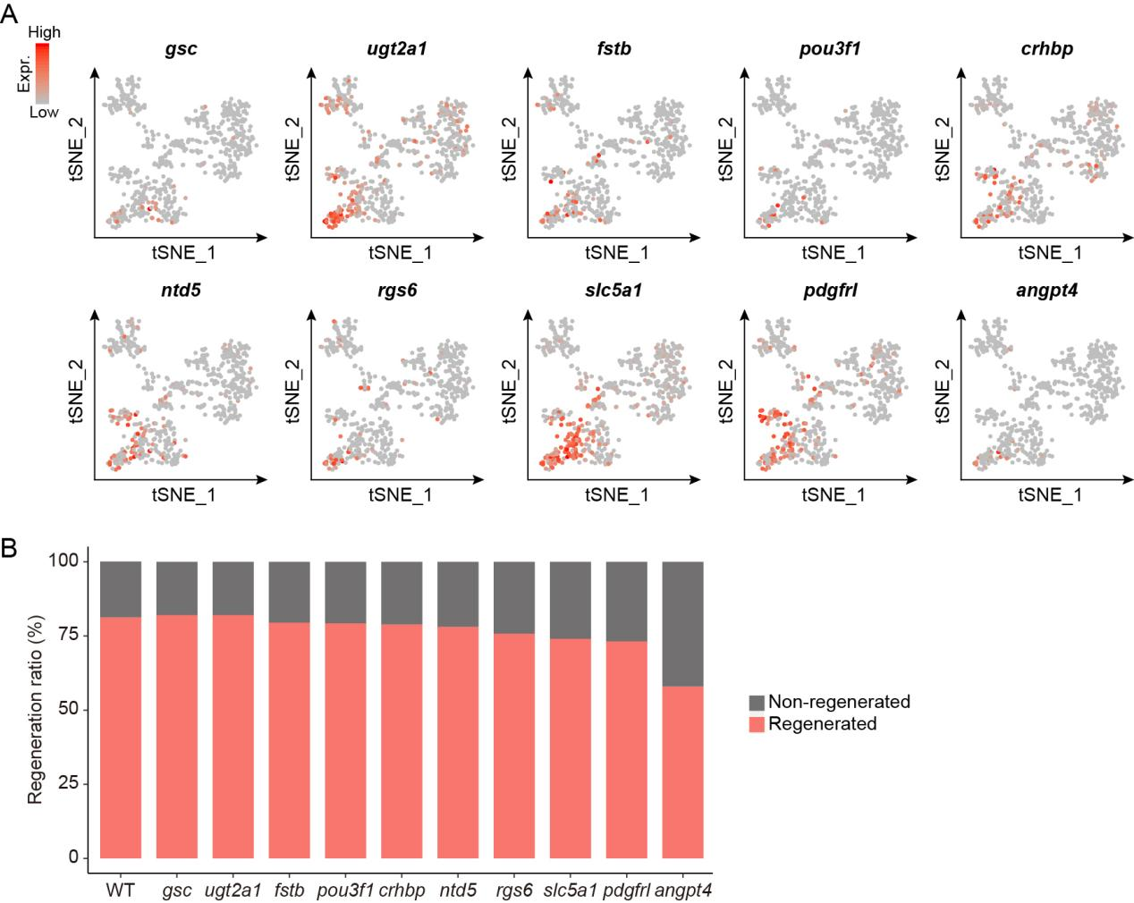Figure S6. The expression pattern and functional screen of genes specifically up-regulated in the RIC population.
(A) The expression pattern shown in the t-SNE map of the ten genes selected for functional screening by the CRISPR/Cas9 knockout strategy.
(B) Successful rate of heart regeneration in WT and mosaic zebrafish embryos after injection of Cas9 protein and 4x gRNAs targeting each corresponding gene in (A).

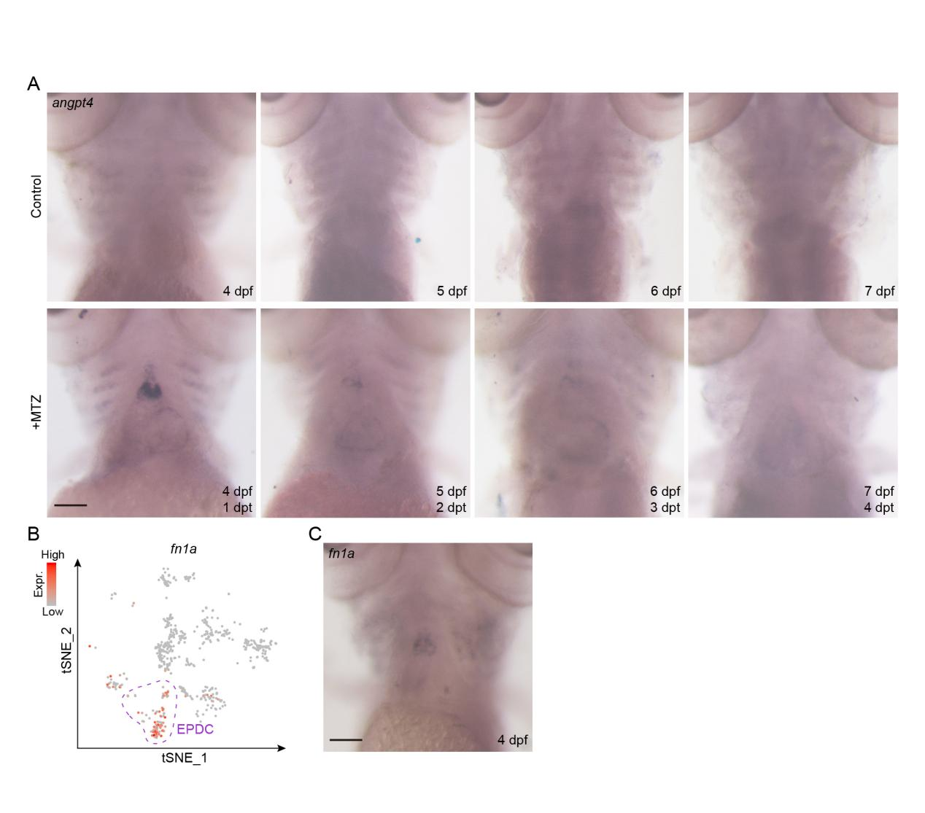Figure S7. angpt4 was up-regulated during larval zebrafish heart regeneration.
(A) Whole-mount in situ hybridization results showed expression pattern of angpt4 in Tg(vmhc:mCherry-NTR; amhc:EGFP) zebrafish heart during normal development and after MTZ treatment. The embryos are shown as ventral view with anterior on top. Scale bar, 100 μm.
(B) t-SNE map of control cells from Fig. 1B showed fn1a was highly expressed in the EPDC population during zebrafish heart development.
(C) Whole-mount in situ hybridization result showed fn1a was mainly expressed in the OFT region in 4 dpf zebrafish heart during normal development. Scale bar, 100 μm.
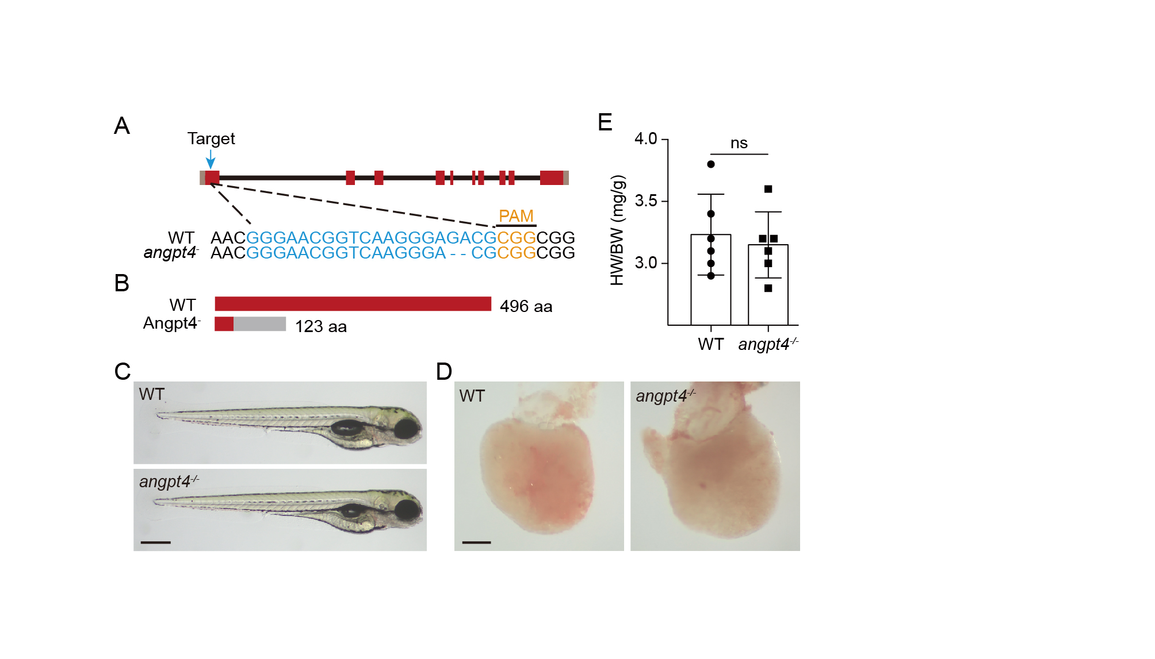

Figure S8. angpt4 is dispensable for zebrafish normal development.
(A) Schematic diagram of zebrafish angpt4 gene structure and the CRISPR/Cas9 target site as well as the mutant allele sequence. A 2-bp deletion in exon 1 was identified in the stable angpt4 mutant. Blue letters represent the CRISPR/Cas9 target site. Red, coding sequence. Brown, untranslated region.
(B) Predicted truncated protein product of the 2-bp deletion allele of angpt4. Red, in-frame peptide sequence. Grey, the peptide encoded by the frame-shifted coding sequence.
(C) Embryo morphology of wildtype and angpt4^{-/-} zebrafish embryos at 4 dpf. Scale bar, 400 μm.
(D) Heart morphology of wildtype and angpt4^{-/-} adult zebrafish. Scale bar, 200 μm.
(E) Quantification results of heart weight (HW) to body weight (BW) ratio of wildtype and angpt4^{-/-} zebrafish embryos. Two-tailed Student’s t-test, ns, not significant. n = 6 for each group. Error bar represents standard deviation.
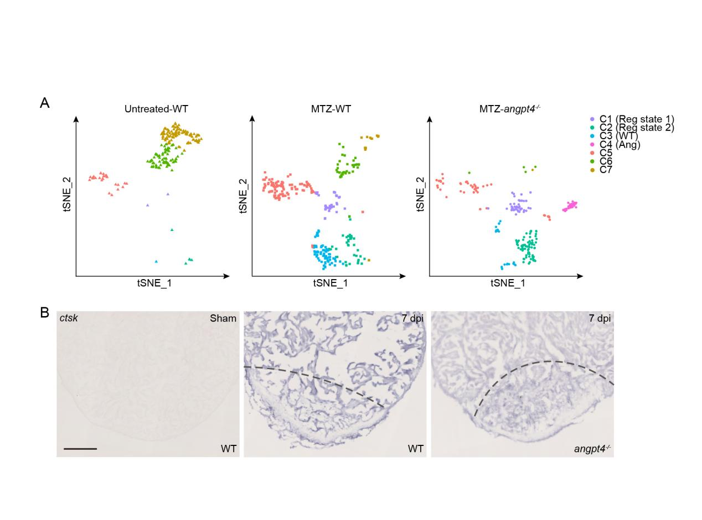
Figure S9. t-SNE analysis of CM-V from WT zebrafish and angpt4 mutants.
(A) Separate t-SNE maps of CM-V populations from Fig. 5A, showing the distribution of CM-V cells in control (untreated) and MTZ-treated WT embryos, and MTZ-treated angpt4 mutants. Cells are colored by clusters and shaped by sample conditions.
(B) In situ hybridization results showing expression pattern of ctsk in sham-operated WT, WT at 7 dpi, and angpt4 mutants at 7 dpi. Representative images of three replicates are shown. Scale bar, 100 μm.

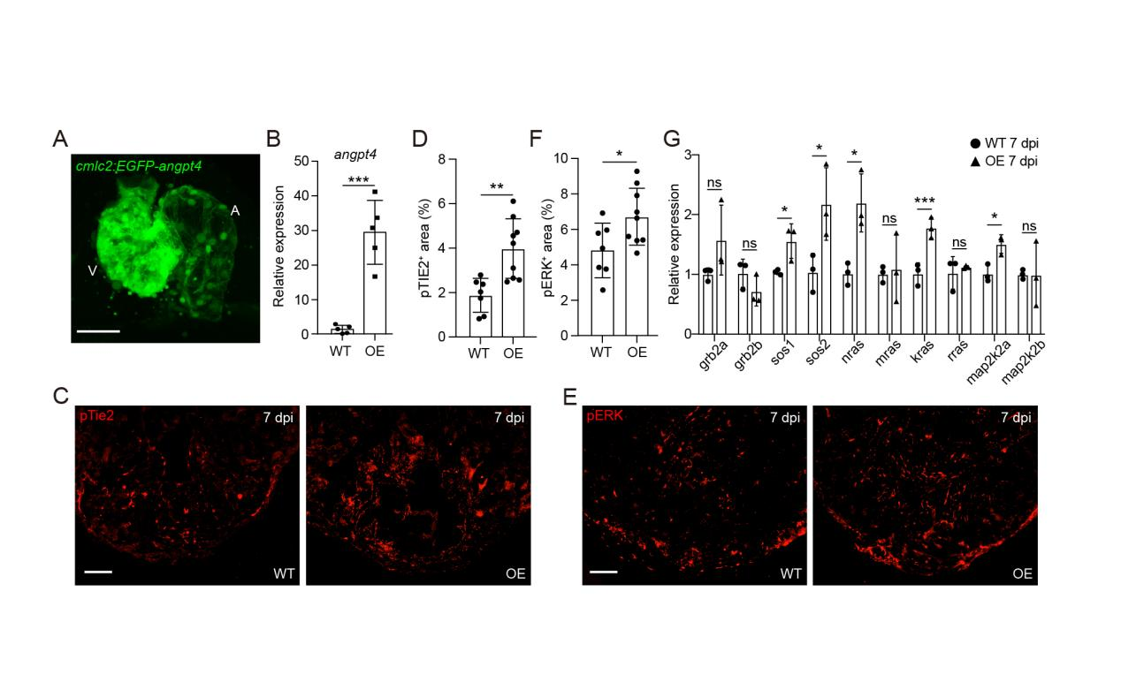
Figure S10. angpt4 overexpression activates pTie2 and pERK signaling during zebrafish heart regeneration.
(A) Maximum intensity projection of the heart from Tg(cmlc2:EGFP-angpt4) fish at 3 dpf. Scale bar, 50 μm.
(B) qRT-PCR results of angpt4 expression level in WT and Tg(cmlc2:EGFP-angpt4) embryos at 3 dpf. OE, Tg(cmlc2:EGFP-angpt4) fish. n = 5 for each group. Two-tailed Student’s t-test, *** p < 0.001.
(C) Immunofluorescence staining showing pTie2 signals in WT and angpt4 OE hearts at 7 dpi. Scale bar, 100 μm.
(D) Statistical analysis results of relative pTie2 signals in WT and angpt4 OE hearts at 7 dpi from (C). Two-tailed Student’s t-test, ** p < 0.01. n = 7-9 for each group. Error bar represents standard deviation.
(E) Immunofluorescence staining showing pERK signals in WT and angpt4 OE hearts at 7 dpi. Scale bar, 100 μm.
(F) Statistical analysis results of relative pERK signals in WT and angpt4 OE hearts at 7 dpi from (E). Two-tailed Student’s t-test, * p < 0.05. n = 7-9 for each group. Error bar represents standard deviation.
(G) qRT-PCR results showing the expression level of several genes in the MAPK signaling pathway in WT and angpt4 OE hearts at 7 dpi. Two-tailed Student’s t-test, ns, not significant, * p < 0.05, *** p < 0.001. n = 3 for each group. Error bar represents standard deviation.

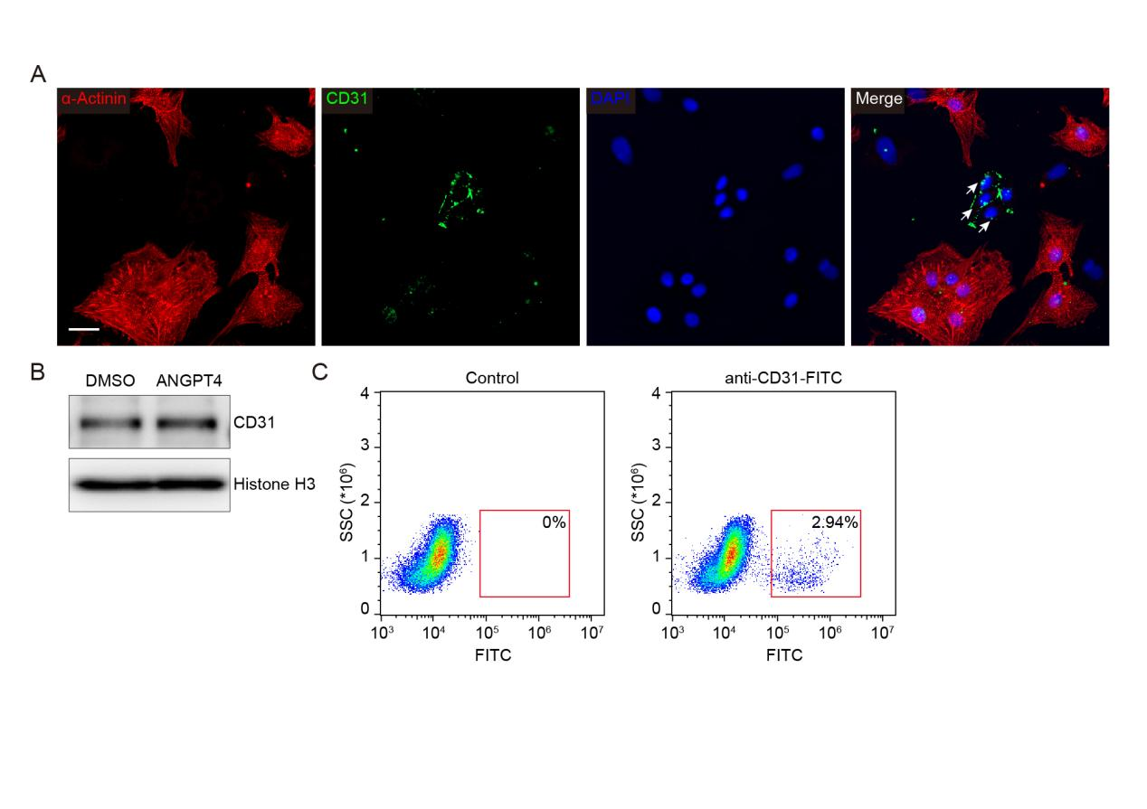
Figure S11. in vitro culture of neonatal rat cardiac cells
(A) Immunostaining of anti-α-actinin (red) and anti-CD31 (green), showing co-culture system of neonatal rat cardiomyocytes and endocardial cells. Arrows indicate CD31-positive cells. Scale bar, 25 μm.
(B) Western blot result showed existence of CD31-positive endocardial cells in cultured neonatal rat cardiac cells.
(C) FACS analysis result showed the percentage of CD31-positive endocardial cells after 3 days of in vitro culture of neonatal rat cardiac cells. Cells without anti-CD31-FITC incubation were used as negative control.

